Report on DQN-Based Tank Battle Game Design and Reinforcement Learning Implementation

1. Introduction
This project implements a 2D tank battle game using Deep Q-Network (DQN), a reinforcement learning algorithm, to train an AI agent to learn combat strategies autonomously. Developed in Python with Pygame and PyTorch, the code is hosted on GitHub, debugged on Google Colab, and demonstrated via a YouTube video.
The goal is for the AI tank to defeat the human-controlled tank by learning movement, shooting, and evasion strategies through trial and error. Unlike rule-based game AIs, the DQN agent adapts to real-time game states, showcasing reinforcement learning’s strengths in sequential decision-making. By designing a clear state/action space, a dual-incentive reward function, and applying ε-greedy exploration and experience replay, the project achieves a stable AI-human confrontation.

2. Game Design

2.1 Game Rules and Core Objectives
The game is a two-player confrontation: the blue tank is human-controlled, and the red tank is AI-controlled, both starting with 3 lives. The player uses WSAD keys to move and the space bar to shoot, while the AI makes autonomous decisions. Bullets can hit enemy tanks or destructible walls (thick walls with 3 HP, thin walls with 2 HP). The game ends when either tank’s health is exhausted, and the surviving side wins.

2.2 State Space and Action Space
State Space: A 23-dimensional continuous vector encoding core game states, including 8 dimensions for the normalized positions, directions, and health of both tanks, plus 15 dimensions for up to 5 bullets (3 dimensions per bullet). Unused bullet dimensions are filled with 0 for fixed input size.Action Space: A 6-dimensional discrete set (move up/down/left/right, shoot, stay stationary), covering all feasible AI behaviors and enabling flexible strategy formulation.

2.3 Reward Function Design
The reward function guides AI learning with multi-dimensional incentives and penalties:
- Survival Reward: +0.05 per frame to prioritize survival.
- Attack Reward: +50 for hitting the player’s tank to reinforce offense.
- Being Hit Penalty: -40 for being hit by the player to encourage evasion.
- Position Penalty: -0.8 near map edges to avoid passive corner-hiding.
- Idle Penalty: -1.0 for 15 consecutive stationary frames to promote active exploration.
- Shooting Incentive/Penalty: +0.5 for shooting with ≤1 AI bullet on field, -1.0 otherwise to avoid random shooting.

2.4 Game Class Design and UI Implementation
The code is split into modular classes for clarity:
- Tank Class: Base class for basic functions (movement, drawing, direction adjustment).
- PlayerTank/AITank Classes: Inherit from Tank, implementing keyboard control and AI decision-making.
- Bullet Class: Manages bullet movement and collision detection.
- Game Class: Core class for global management (initialization, state update, collision detection, reward calculation, UI rendering).
The Pygame-based UI displays health bars, real-time rewards, the AI’s current action, and game frames. A dual-mode design (training/play) disables UI rendering in training mode for speed and enables full UI in play mode for a smooth user experience.

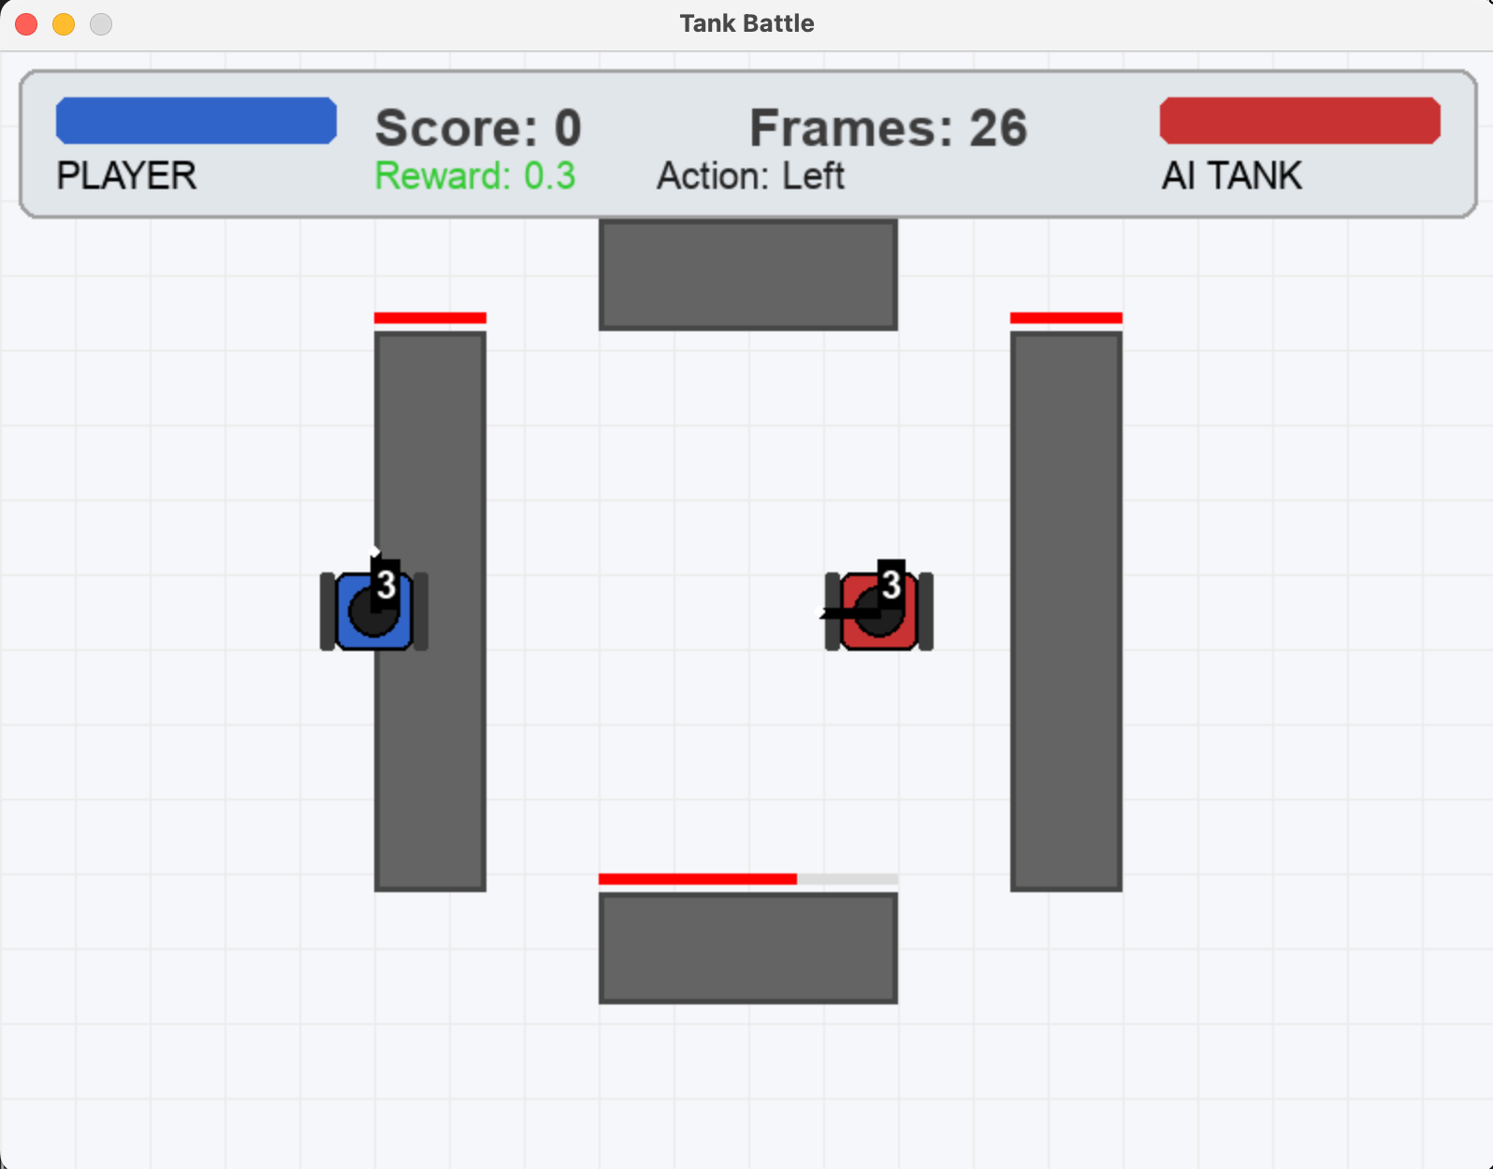
Figure 1: Tank Battle Game Play Interface

3. DQN Algorithm Implementation
Traditional Q-learning uses Q-tables, which are unsuitable for continuous high-dimensional state spaces. This project adopts DQN, using a neural network to approximate the Q-value function. Key implementation details:
- Network Structure: A 3-layer fully connected network—input layer (23-dimensional state vector), hidden layers (128/64 neurons with ReLU activation and 0.1 dropout), output layer (Q-values for 6 discrete actions).
- ε-greedy Exploration: Initial ε=1.0 (full random exploration), decaying by 0.995 per action to a minimum of 0.05, balancing exploration and exploitation.
- Experience Replay: A 10,000-capacity buffer stores AI experiences (state, action, reward, next state, game end flag); 64 random experiences are sampled for training batches to break temporal correlation.
- Target Network: An independent target network with the same structure as the main network; main network weights are synchronized to it every 30 episodes to calculate stable target Q-values and avoid training oscillations.
- Hyperparameters: Adam optimizer (learning rate=0.0005), discount factor γ=0.95, 1000 training episodes (ending when either tank’s health is exhausted).

4. Experimental Setup and Result Analysis

4.1 Experimental Setup
The experiment runs on Google Colab (CPU only), with each episode taking 16-17 seconds and 1000 episodes totaling ~10 minutes of training. Total reward, ε value, and average loss per episode are saved to reward_log.csv for visualization. Trained model weights are stored in the models folder for play mode.

4.2 Result Analysis
The total reward line chart from reward_log.csv reflects the model’s learning effect, with two key stages:
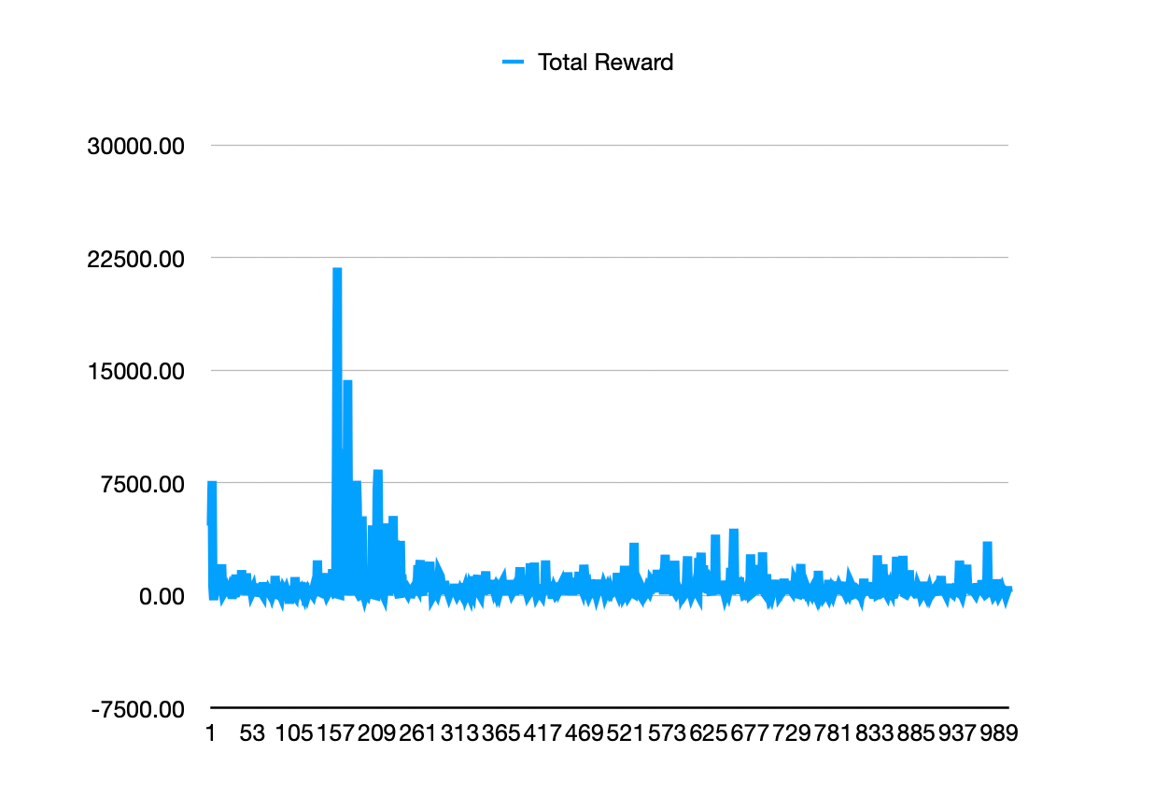
Figure 2: Total Reward Line Chart of DQN Model in 1000 Training Episodes
- Exploration Stage (Episodes 1-200): High ε leads to random AI exploration, causing extreme reward fluctuations and occasional high peaks from accidental continuous hits on the player. The model has not yet learned effective combat behaviors.
- Convergence Stage (Episodes 200-1000): ε decays to 0.05, and the AI exploits learned strategies. Reward fluctuations decrease and stabilize at 0-2000, indicating the AI has mastered comprehensive survival, evasion, and attack strategies, achieving stable confrontation with players.
Average loss gradually decreases with training episodes, proving the DQN network’s Q-value predictions become more accurate and strategies are optimized, realizing the goal of maximizing cumulative reward.

5. Project Challenges and Solutions
Three core problems were encountered during development and training:
- Imbalanced Reward Function: The initial over-high attack reward caused blind AI offense and frequent hits. Solution: Reduced attack reward weight, increased survival/being hit penalty weights, and added position/idle penalties to balance AI behaviors.
- Severe Training Oscillation: Initial training without a target network led to extreme Q-value oscillations and non-convergence. Solution: Introduced a target network for interval weight synchronization, calculating stable target Q-values to effectively suppress oscillations.
- Conflict Between UI and Training Mode: Pygame UI rendering in training mode slowed training and caused freezes. Solution: Added a global TRAIN_MODE variable to disable UI and set an SDL virtual driver in training mode, enabling full UI in play mode to separate training and play.

6. Conclusion
This project successfully designs and develops a DQN-based tank battle game, complying with all assignment requirements: a game environment with clear rules, well-defined state/action spaces, and a dual-incentive reward function is built; the DQN algorithm is implemented in Python with ε-greedy exploration, experience replay, and target network to balance exploration/exploitation, enabling the model to learn a cumulative reward-maximizing strategy; a Pygame-based intuitive UI displays game states and AI behaviors, ensuring user experience; all deliverables (Colab debugging, GitHub hosting, YouTube demo) are completed.
Through this project, I have gained a deep understanding of reinforcement learning core ideas and DQN implementation details, and realize that reward function design and training stability optimization are the keys to reinforcement learning projects. Future optimizations can include Double DQN to reduce Q-value overestimation, or adding state features (wall occlusion, bullet speed) to make AI strategies more intelligent. The project proves that reinforcement learning can enable AI to autonomously learn complex strategies in game environments, with broad application prospects in game AI development.

References
[1] KI-cheng. (2025). QlearningTankWar [Computer software]. GitHub.[2] Anonymous. (2025). Tetris-deep-Q-learning-pytorch [Computer software]. GitCode.[3] Pygame Development Team. (2025). Pygame Official Documentation [Technical Manual]. https://www.pygame.org/docs/

