上肢助力外骨骼的仿真验证
Simulation-Based Validation of an Upper-Limb Assist Exoskeleton
右臂 · 肩侧 + 肘部 · 桌面固定式
Right arm · shoulder + elbow · table-mounted
MuJoCo 软件在环验证 | MuJoCo software-in-the-loop validation
2026-10-28
说明：本文所有数字均为仿真模型假设下的结果，未与实物台架对标。
Note: every number here is a model estimate; no bench comparison has been made.

摘要 / Abstract
本项目为一套右臂助力外骨骼（肩侧电机 + 肘部电机，桌面固定式）建立了 MuJoCo 仿真环境，把固件中真实运行的控制代码编译成主机库接入仿真，用同一套代码、同一套参数比较“不穿戴 / 穿戴不通电 / 穿戴并助力”三种条件下的省力效果。人体使用 MyoArm 肌肉骨骼模型，外骨骼几何来自 CAD 导出件。结果显示：相对穿戴不通电，前三角肌激活下降 11.7–20.3%，与已发表的肩部外骨骼研究处于同一区间；相对裸臂的净收益约 3%，因为装置主要抵消的是自身重量。爆发动作的收益仅 4.5–6.4%，原因是峰值力矩以惯性为主。
This project builds a MuJoCo environment for a right-arm assist exoskeleton (shoulder and elbow motors, table-mounted), compiles the real firmware control code into a host library and drives the simulation with that same code and the same parameters. Three conditions are compared: bare arm, worn but unpowered, and worn with assistance. The human arm is the MyoArm musculoskeletal model; the exoskeleton geometry comes from the CAD export. Against the unpowered case the anterior deltoid activation falls by 11.7–20.3%, the same range as published shoulder-exoskeleton studies, while the net gain against the bare arm is about 3% because the device mainly cancels its own weight. Burst movements gain only 4.5–6.4% because their peak torque is inertia-dominated.
1. 研究目标 / 1. Objective
① 用仿真印证固件控制程序确实省力，并给出量化结果；② 建立可在其中迭代优化的试验场，改控制逻辑后先在仿真里看结果，不必每次上实机。
(1) Confirm in simulation that the firmware control law actually reduces effort, with numbers; (2) provide a test bed for iterating on the control logic without going to the bench every time.
2. 系统与模型 / 2. System and Model
仿真由四部分组成：人体、外骨骼、桌子/支架、绑带。所有物理参数集中在 model/params.json，每项标注来源与状态（实测 / 估计 / 假设）。
The scene has four parts: the human arm, the exoskeleton, the table and stand, and the straps. Every physical parameter lives in model/params.json with its source and status (measured, estimated, assumed).
组成 / Part | 来源 / Source | 关键参数 / Key parameters
人体 / Human | MyoSim 0.2.3 myoarm_r | 站立、躯干固定；保留肩前屈与屈肘 2 个自由度；63 块肌肉
外骨骼 / Exoskeleton | CAD 导出包（只读副本） | 右臂外侧；沿调节轨加长到 290.5 mm 与人肘对齐；上臂 0.656 kg、前臂 0.177 kg
桌子与支架 / Table | 代码构建 | 桌面 0.90 m；竖杆 Ø14 mm 穿过夹持座孔（孔心由 STL 截面算出）
绑带 / Straps | 两个软 weld | 上臂与前臂各一；solref 0.05 s、torquescale 0.03

3. 控制架构与参数 / 3. Control Architecture and Parameters
固件控制代码（App/control/*.c 与 App/application/s5_site.c）编译成主机库，仿真每 10 ms 调用一次——与真机同一份代码、同一套参数，不是重新实现。人体侧有两种模型：理想关节力矩，以及肌肉驱动（计算力矩 → 静态优化 → 63 块肌肉）。
The firmware control code (App/control/*.c and App/application/s5_site.c) is compiled into a host library that the simulation calls every 10 ms: the same code and the same parameters as on the device, not a re-implementation. The human side has two models: an ideal joint torque, and a muscle-driven arm (computed torque, static optimisation, 63 muscles).
参数 / Parameter | 值 / Value | 说明 / Meaning
肩重力模型 | 1.64 N·m × sin(肩角) | 外骨骼肩侧自重模型
肩增益 | 1.5 | 连人臂的一部分也一起补
肩输出上限 | 300 mNm 转子 = 2.4 N·m 关节 | 约为电机额定的一半
肩 Amplify | 300 mNm，>10°/s 触发，瞬时切换 | 抬臂方向的额外增量
肘重力模型 | 10 A × 0.02 N·m/A × sin(肩+肘) | 肘部姿态相关助力
肘 Amplify | 10 A，按运动方向叠加 | 快速伸展（锤击）也助力
输出周期 | 10 ms（100 Hz） | 爆发响应的主要延迟来源
控制库验证 | 主机测试 125 项全部通过 | 含合成、限幅、Amplify 时序用例

4. 实验设计 / 4. Experimental Design
4.1 三种条件 / 4.1 Conditions
条件 / Condition | 含义 / Meaning
C0 | 裸臂：不绑外骨骼（关掉绑带约束）
C1 | 穿戴但外骨骼不通电：人还要承担外骨骼自重
C2 | 穿戴且由固件控制库驱动（本项目的真实控制代码）

4.2 姿势与动作 / 4.2 Postures and Motions
编号 / ID | 内容 / Content | 时长 / Duration | 用途 / Purpose
A | 工作空间扫描：肩 5–60° × 肘 30–110°（12×9 网格） | 静态计算 | 助力有效区
P1 | 器械与桌面平行：肩 20° / 肘 100° | 保持 60 s | 静态省力
P4 | 近身：肩 30° / 肘 110° | 保持 60 s | 静态省力
P5 | 远端：肩 60° / 肘 70° | 保持 60 s | 静态省力（重力最大）
G1 | 锤击：肘 100°→45°，180 ms，重复 10 次 | 约 24 s | 爆发（肘主导）
G2 | 快速抬举：肩 5°→45°，250 ms，重复 10 次 | 约 25 s | 爆发（肩主导）
T1–T3 | 静态保持 / 慢抬放 / 快抬放 / 自由变姿态 | 10–25 s | 理想力矩模型对照

4.3 指标 / 4.3 Metrics
• 人体关节力矩（主指标）：肩、肘执行器输出的力矩，越低越省力。
Human joint torque (primary): the torque the arm's own actuators apply; lower is better.
• 肌肉激活量（次指标）：对同一力矩做静态优化得到的 63 块肌肉激活之和与单块肌肉值。
Muscle activation (secondary): the static-optimisation solution for that torque, reported as the sum over 63 muscles and per muscle.
• 爆发专用：峰值力矩、动作时间、稳态误差、人体正功（∫τ·q̇ dt）。
Burst-specific: peak torque, movement time, steady-state error and positive human work.
• 交互与安全：绑带力、输出饱和占比、软限暂停与故障次数。
Interaction and safety: strap force, output saturation, soft-limit pauses and faults.
4.4 参数汇总 / 4.4 Parameter Summary
项目 / Item | 值 / Value
人体 | 70 kg / 1.75 m（缺省假设）；上臂 2.0 kg、前臂+手 1.78 kg
桌高 | 0.90 m
外骨骼质量 | 上臂组 0.656 kg、前臂组 0.177 kg（STL 体积 × ABS 1.1 g/cm³）
绑带 | solref 0.05 s、torquescale 0.03
仿真步长 | 1 ms；控制 10 ms；记录 1 ms（爆发）/ 5 ms（静态）
人体控制器 | PD + 计算力矩前馈 → 静态优化 → 肌肉激励
软件版本 | MuJoCo 3.16.0、MyoSim 0.2.3、Python 3.13

5. 结果 / 5. Results
5.1 工作空间：助力在哪里有效 / 5.1 Workspace: Where Assistance Helps
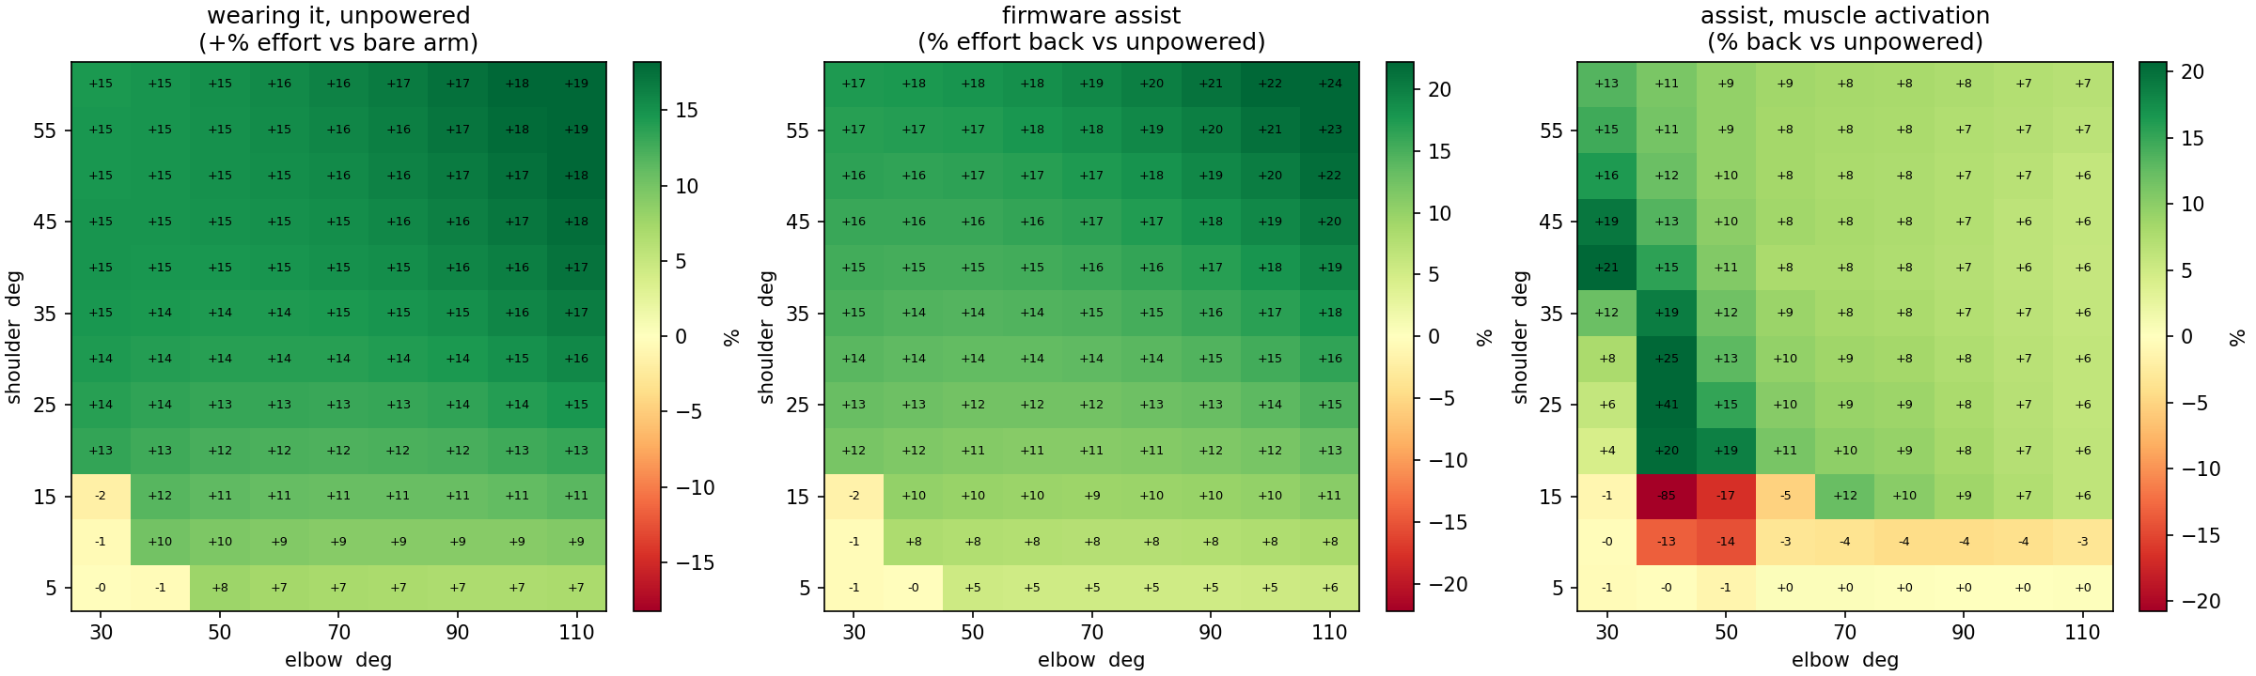
图 1 工作空间热力图：穿戴代价、助力收益、肌肉激活收益
Figure 1 Workspace maps: cost of wearing, assistance benefit, activation benefit
看什么：左图是“穿上不通电比裸臂多费多少力”，中间是“助力能收回多少”，右边是激活量的收益。抬臂越高、肘越弯，助力越有效（肩 60°/肘 70–110° 处 12–16%）；而低抬臂（肩 5–20°）+ 小屈肘（30–60°）区域是红色——助力反而让肌肉更累，说明该姿态下自重补偿“帮过头”，需要在台架小角度复核。
What to look at: The left panel is how much more effort the unpowered device costs, the middle how much the assist gives back, the right the activation benefit. Assistance works better the higher and more flexed the arm is (12–16% at 60° shoulder, 70–110° elbow), while the low-elevation, small-elbow region is red: there the assist raises activation, i.e. it over-compensates, and that region should be checked on the bench.
5.2 静态姿势：三种条件的直接对照 / 5.2 Static Postures: Three Conditions
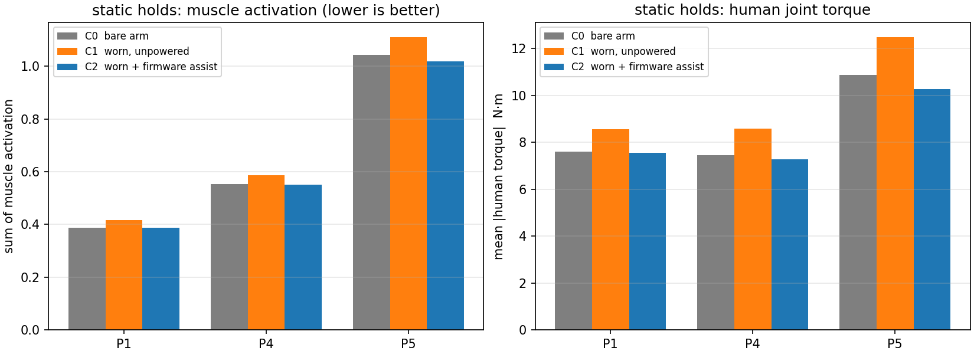
图 2 三个手术姿势的肌肉激活与人体力矩
Figure 2 Muscle activation and human torque for the three surgical postures
看什么：橙色（穿戴不通电）总是最高，说明外骨骼自重确实压在人臂上；蓝色（助力）回落到灰色（裸臂）附近甚至更低。以 P5 为例：肩力矩 8.93 → 10.42 → 8.35 N·m，助力把穿戴带来的 1.49 N·m 全部收回，还多补了 0.58 N·m。
What to look at: Orange (worn, unpowered) is always the highest, so the exoskeleton's own weight really does load the arm; blue (assisted) comes back to the grey bare-arm level or below. For P5 the shoulder torque goes 8.93 → 10.42 → 8.35 N·m: the assist removes the whole 1.49 N·m the device added and another 0.58 N·m of the arm's own load.
5.3 论文口径：前三角肌 / 5.3 Paper Convention: Anterior Deltoid
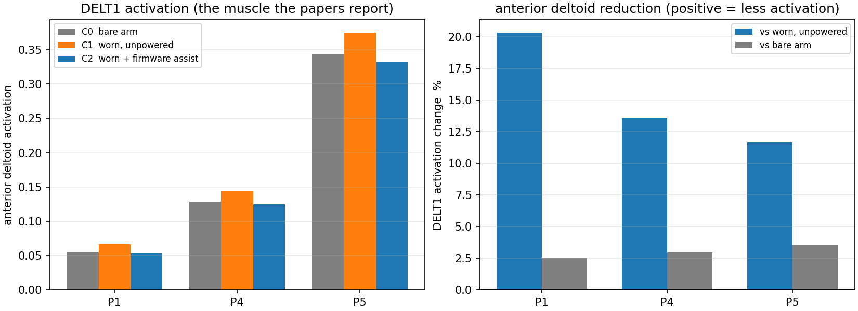
图 3 前三角肌激活（论文常用口径）与降幅
Figure 3 Anterior deltoid activation and its reduction
看什么：肩部外骨骼文献普遍只报三角肌。左图三条柱子的关系与图 2 一致；右图把“相对穿戴不通电”和“相对裸臂”分开：相对穿戴降低 11.7–20.3%，相对裸臂只有约 3%。这正是与文献比较时应该用的数字，也是解释“为什么看起来不明显”的关键。
What to look at: Shoulder-exoskeleton papers usually report the deltoid only. The left panel mirrors Figure 2; the right panel separates the two baselines: 11.7–20.3% against the unpowered case but only about 3% against the bare arm. The first is the number to compare with the literature, the second explains why the effect can look small.
5.4 爆发动作 / 5.4 Burst Movements
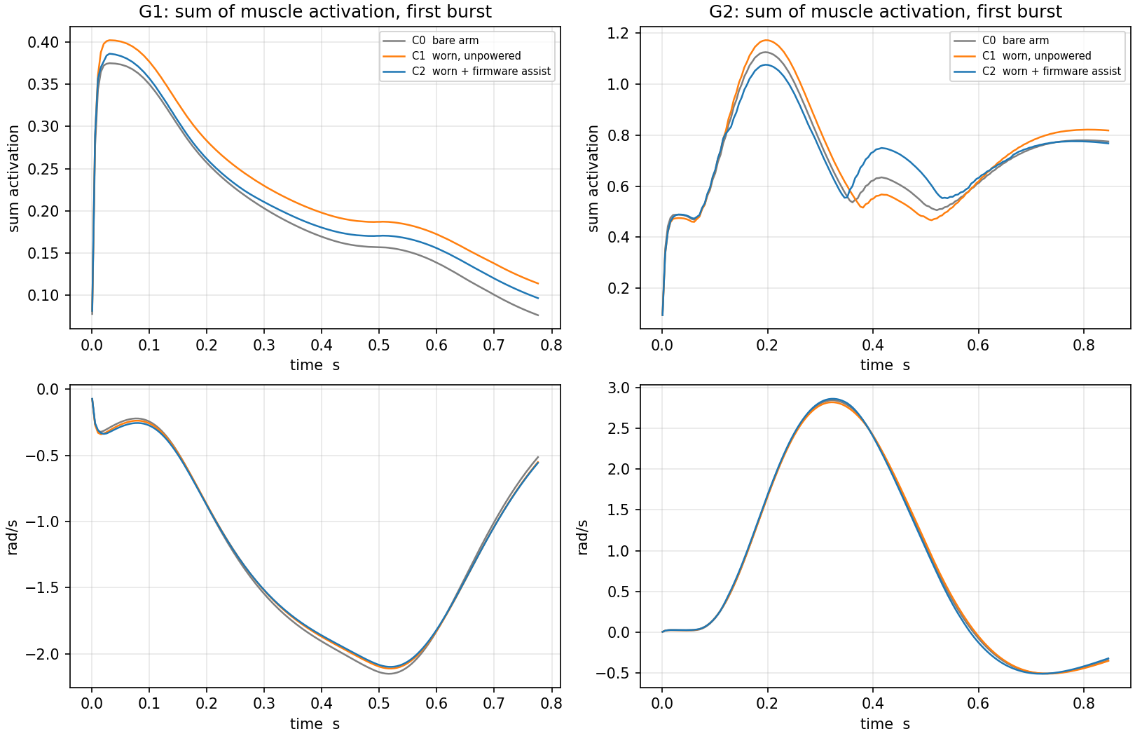
图 4 爆发动作的肌肉激活与关节角速度
Figure 4 Muscle activation and joint velocity in the bursts
看什么：上排是激活量、下排是角速度，左列锤击（肘）、右列快速抬举（肩）。G1 中蓝色（助力）全程压在橙色下方，说明助力确实参与了动作；G2 在加速段三条曲线几乎重合——爆发以惯性为主，重力补偿帮不上；而爆发结束后蓝色反而高于橙色，对应“放下阶段被助力顶住”的现象（见第 7 节）。
What to look at: Top row activation, bottom row velocity; the left column is the elbow strike, the right the shoulder lift. In G1 the blue curve stays below orange throughout, so the assist really takes part; in G2 the three curves overlap during the acceleration because the burst is inertia-dominated, and after the burst blue rises above orange, which is the assist pushing during lowering (see Section 7).
指标 / Metric | G1 锤击 / strike | G2 快速抬举 / lift
峰值力矩 C0/C1/C2 (N·m) | 4.69 / 4.87 / 4.56 | 44.7 / 46.5 / 46.1
人体正功 C0/C1/C2 (J) | 18.8 / 19.5 / 18.7 | 119.6 / 123.0 / 124.5
外骨骼正功 (J) | 2.0 | 13.3
动作时间 (ms) | 430 / 435 / 435 | 225（参考 250）
稳态误差 (°) | 1.2 | 0.2

5.5 总览图 / 5.5 Overview
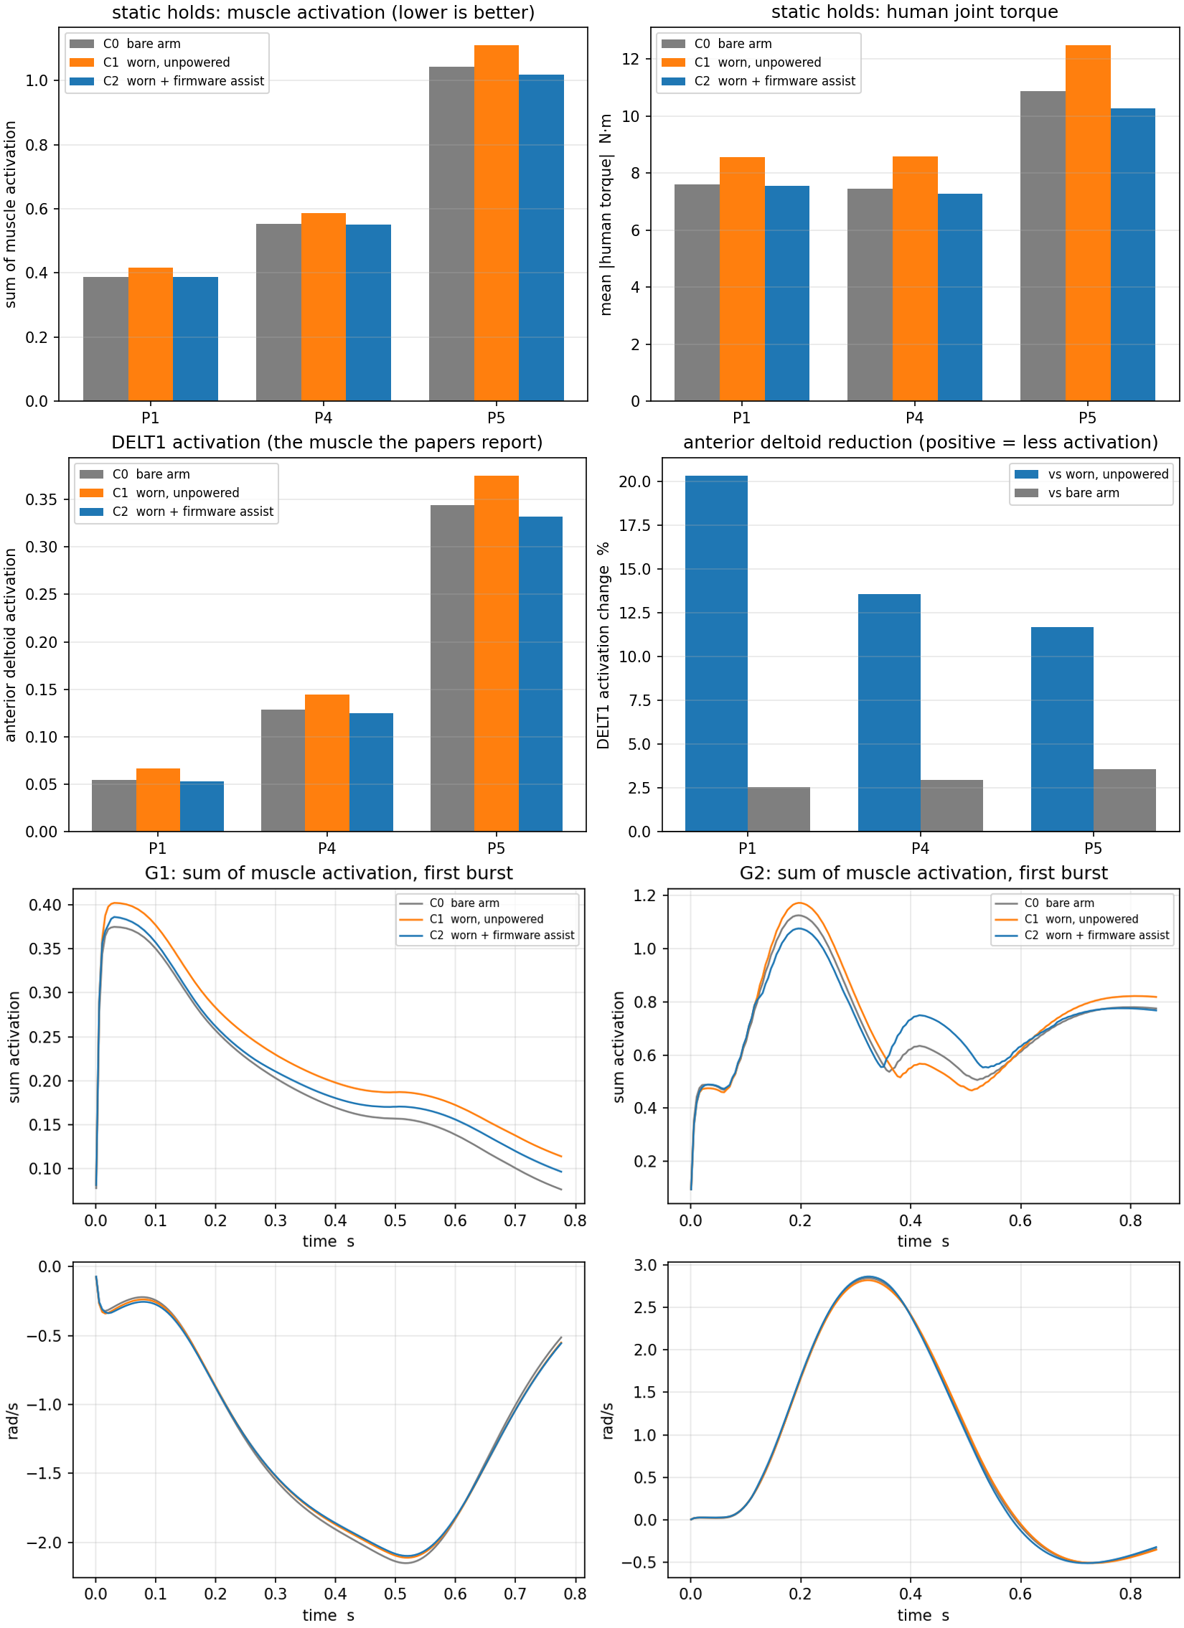
图 5 静态、三角肌、爆发三张结果图拼合
Figure 5 Static, deltoid and burst results combined
看什么：用于作品集的一页式总览：上排是静态姿势的两种口径，下排是爆发的时序曲线。
What to look at: A one-page summary for a portfolio: the static postures in two conventions on top, the burst time series below.
5.6 与文献对比 / 5.6 Comparison with the Literature
研究 / Study | 报告的数字 / Reported | 与本项目的关系 / Relation
Frontiers Bioeng. 2024（MIS 肩外骨骼） | 三角肌前束 −21.0%、中束 −14.6%、后束 −8.3% | 同一区间（本机 −11.7…−20.3%，相对穿戴）
Ergonomics 2026（模拟腹腔镜，5 个姿势） | 前三角肌各姿势均有下降 | 同上量级
Applied Ergonomics 2024（助力 60–100%） | 抬臂最多 −61~64%；下放阶段伸肌 +127% | 方向一致，但本机助力幅值更小
ArmeoPower（整臂完全失重） | 峰值关节力矩 −74.8% | 远高于本机，属“全支撑”设备

6. 讨论：为什么“相对裸臂”只有约 3% / 6. Discussion: Why Only ~3% Against the Bare Arm
• 助力幅值只覆盖一部分：肩上限 2.4 N·m，而 P5 人臂需要 8.93 N·m，覆盖约 23%。
The assist covers only part of the load: the shoulder cap is 2.4 N·m against 8.93 N·m needed at P5, about 23%.
• 外骨骼自身很重：0.83 kg 挂在 3.78 kg 的手臂上，给手臂增加约 22% 的负担。
The device is heavy relative to the arm: 0.83 kg on a 3.78 kg arm, about 22% more.
• 两者相抵，净收益自然小——这是设计定位（助力而非全支撑）决定的，不是控制逻辑问题。
The two cancel out, so the net gain is small by construction: the device is designed to assist, not to carry the whole arm.
爆发收益小的原因已定量：250 ms 动作的峰值惯性项 80.75 N·m，重力项只有 7.61 N·m（8.6%）；本机 4.6 N·m 的极限仅为惯性项的 6%。把 Amplify 的时序从 200 ms 斜坡改为瞬时切换后，增量介入时刻由 241 ms 提前到 121 ms，肘部爆发收益从 4.5% 提升到 6.4%。
The burst gain is small for a quantified reason: at 250 ms the peak inertial term is 80.75 N·m against 7.61 N·m of gravity (8.6%), and the device's 4.6 N·m ceiling is only 6% of the inertial term. Making Amplify switch instantly instead of ramping over 200 ms moved its engagement from 241 ms to 121 ms and raised the elbow strike gain from 4.5% to 6.4%.
7. 局限性 / 7. Limitations
• 模型只有两个自由度：肩前屈与屈肘。肩外展、内外旋、前臂旋转未建模，因此三角肌中束、冈上/冈下肌在模型中激活为 0，不能用本报告评估这些肌肉。
Only two degrees of freedom: shoulder flexion and elbow flexion. Abduction, internal and external rotation and forearm pronation are not modelled, so the middle deltoid, supraspinatus and infraspinatus read zero and cannot be assessed here.
• “人”是简化控制器：PD + 计算力矩 + 最小激活优化，不是真实运动控制模型。真人会协同收缩、有反射与疲劳，被助力后会改变策略。因此数字适合作相对比较，不是真人用力的绝对预测。
The human is a simplified controller: PD plus computed torque plus a minimum-activation optimisation, not a real motor-control model. Real people co-contract, have reflexes and fatigue, and change strategy when assisted. The numbers support relative comparisons, not absolute predictions of human effort.
• 物理参数多为估计：外骨骼质量按 STL 体积 × ABS 密度、绑带软度与关节阻尼为假设、人体尺寸取 70 kg / 1.75 m 缺省值、桌高 0.90 m 为常用值。
Most physical parameters are estimates: exoskeleton mass from STL volume times ABS density, strap compliance and joint damping assumed, the human at the default 70 kg / 1.75 m, the table at a typical 0.90 m.
• 没有台架对标：与实物日志的比对（原 M5）已取消，因此这些数字没有经过实测校准。
No bench comparison: the planned comparison with bench logs (M5) was cancelled, so these numbers are not calibrated against measurements.
• 镜像已编译未刷写：固件镜像通过构建与 125 项主机测试，但没有上板；100 Hz 输出下的 CAN 稳定性、10 A 肘电流的热裕量、编码器噪声是否误触发 Amplify，都还没有验证。
The images are built but not flashed: they pass the build and 125 host tests but have never run on the board; CAN stability at 100 Hz, the thermal margin at 10 A elbow current, and whether encoder noise false-triggers Amplify are all unverified.
• 放下阶段未处理：按阶段拆分显示抬臂 −6.8%、保持 −14.2%，但放下阶段 +10.5%（重力基线仍向上推）。这与文献报告的现象一致，本轮未做方向相关基线。
The lowering phase is not handled: splitting a cycle gives −6.8% while raising and −14.2% while holding, but +10.5% while lowering, because the gravity baseline keeps pushing up. The literature reports the same effect; no direction-dependent baseline was implemented in this round.
• 单一虚拟受试者：没有跨受试者的变异性分析（原计划的虚拟队列已取消）。
A single virtual subject: no across-subject variability analysis (the planned virtual cohort was dropped).
8. 复现 / 8. Reproducibility
所有结果可由以下命令重跑（在 firmware/Exoskeleton_F446 目录）：
All results can be regenerated with the commands below (from firmware/Exoskeleton_F446):
build\sim-venv\Scripts\python.exe sim\mujoco_arm\scripts\report_muscle_all.py
build\sim-venv\Scripts\python.exe sim\mujoco_arm\scripts\workspace_scan.py
build\sim-venv\Scripts\python.exe sim\mujoco_arm\scripts\check_static.py
build\sim-venv\Scripts\python.exe sim\mujoco_arm\docs\make_report_docx.py
模型与参数：sim/mujoco_arm/model/params.json；控制参数：App/application/s5_site.c；报告与图：sim/mujoco_arm/docs/。
Model and parameters: sim/mujoco_arm/model/params.json; control parameters: App/application/s5_site.c; report and figures: sim/mujoco_arm/docs/.
9. 图表索引 / 9. Figure Index
文件 / File | 内容 / Content
figures/01_overview.png | 总览：静态 + 三角肌 + 爆发 / overview
figures/02_static.png | 静态姿势：激活与力矩 / static postures
figures/03_deltoid.png | 前三角肌口径 / anterior deltoid
figures/04_burst.png | 爆发时序 / burst time series
figures/05_workspace.png | 工作空间热力图 / workspace maps
figures/06–08_p1/p4/p5.png | 三个姿势的场景图 / scene stills

