GITEA

Objective:
To set up Gitea as a Docker Swarm service for managing Git repositories.

Step 1: Verify Docker Installation
Step 2: Initialize Docker Swarm
docker swarm init
Step 3: Create Docker Volume
docker volume create gitea_data
Step 4: Deploy Gitea as a Swarm Service
docker service create \
--name gitea_service \
--publish 3000:3000 \
--publish 2222:22 \
--mount type=volume,source=gitea_data,target=/data \
gitea/gitea:latest
Step 5: Verify the Service
docker service ls
Step 6: Verify Using Portainer
Step 7: Access Gitea Web Interface
http://localhost:3000

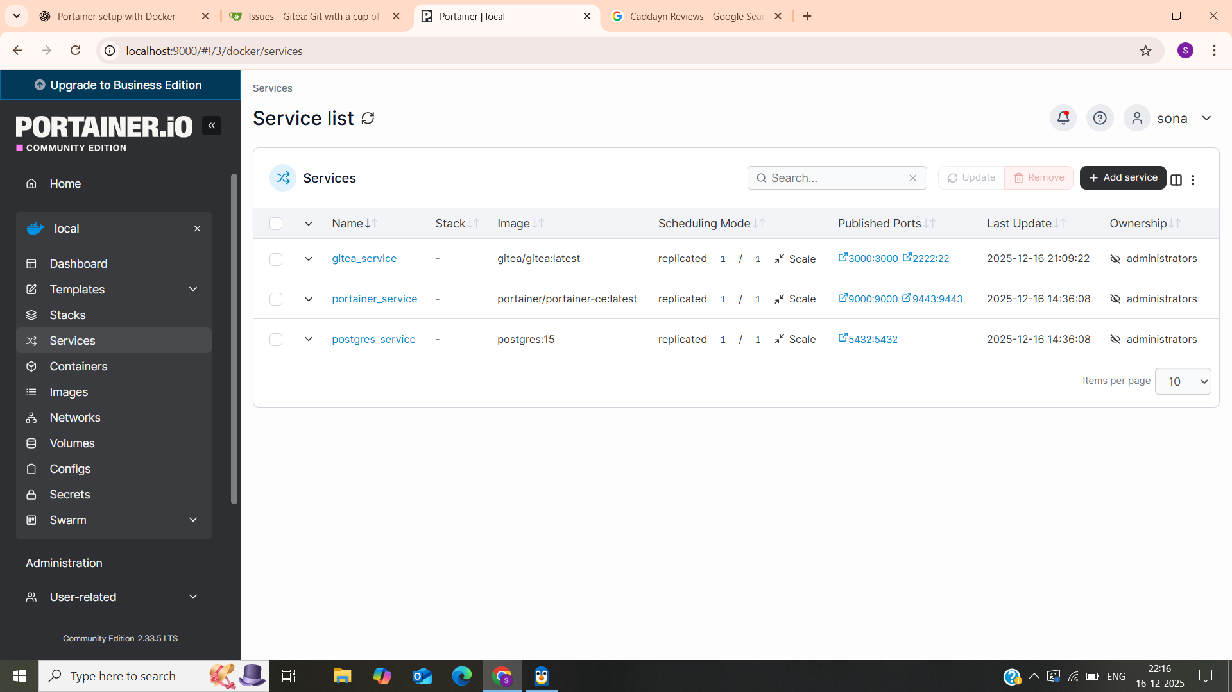

Objective:
To configure email notifications in Gitea using Gmail SMTP while running Gitea as a Docker Swarm service.

Step 1: Enable 2-Step Verification in Gmail
Step 2:Create Gmail App Password
https://myaccount.google.com/apppasswords

Step 3:Configure Gitea Mailer Using Docker Swarm
docker service update --env-add GITEA__mailer__ENABLED=true --env-add GITEA__mailer__PROTOCOL=smtps --env-add GITEA__mailer__SMTP_ADDR=smtp.gmail.com --env-add GITEA__mailer__SMTP_PORT=465 --env-add GITEA__mailer__USER=YOUR_EMAIL@gmail.com --env-add GITEA__mailer__PASSWD=YOUR_APP_PASSWORD --env-add GITEA__mailer__FROM=YOUR_EMAIL@gmail.com --env-add GITEA__mailer__TLS=true gitea_service
Step 4: Restart and Verify Gitea Service
docker service ps gitea_service
Step 5: Test Email Configuration in Gitea UI
http://localhost:3000
Navigate to: Site Administration → Configuration → Mailer Configuration
Enter the Gmail address and click Send
Step 6: Verify Email Delivery
