Agreement-Stratified Evaluation of Deep Learning for Anatomical Landmark Recognition in Upper Gastrointestinal Endoscopy
Phase 0 — Data Provenance and Integrity Gate
Phase 1 — Literature Review and Problem Framing
Interim Technical Report

──────────────────────────────────────────────
Degree programme | B.Sc. in Computer Science and Engineering
Research domain | Biomedical Artificial Intelligence — Medical Image Analysis and Machine Learning
Corpus under audit | GastroHUN 'Labeled Images' — 8,834 images, 387 patients, 23 classes
Corpus provenance | Hospital Universitario Nacional de Colombia; Sci Data 12:102 (2025); doi:10.1038/s41597-025-04401-5
Ethics approval | CEI-2019-06-10 (Ethics Committee, HUN); informed consent obtained
Audited payload | 2.71 GB, 8,834 images verified
Reporting standards | PRISMA 2020, CLAIM, TRIPOD+AI, STARD-AI
Report date | 26 July 2026

STATUS: PROCEED — the integrity gate cleared, with two conditional criteria carried forward as declared limitations.
This report supersedes the previous Phase 0 / Phase 1 report in full. No content from that report is carried forward.

Table of Contents
Executive Summary 7
Phase 0 verdict 7
Principal findings 7
Phase 1 verdict 8
Phase 0 — Data Provenance and Integrity Gate 9
Rationale: why an integrity gate precedes any modelling 9
Provenance of the corpus 9
G1–G2: Physical inventory and file integrity 11
G3: Duplication and cross-split contamination 12
G4–G5: Label architecture and inter-annotator agreement 14
The agreement cascade and what the benchmark discards 15
The structure of disagreement 18
OTHERCLASS: a quality judgement, not an anatomical one 19
G6: Integrity of the official splits 20
G7: Statistical power of the evaluation set 21
G8: Population description 22
Gate verdict and validation of the audit protocol 23
The audit protocol validated against a negative control 24
Phase 1 — Literature Review and Problem Framing 25
Objectives and review questions 25
Protocol and search strategy 25
Search results 26
Thematic synthesis 27
T1 — Anatomical landmark recognition in upper GI endoscopy 27
T2 — Endoscopic quality metrics and blind-spot auditing 28
T3 — Inter-observer variability in endoscopy 28
T4 — Learning from noisy, soft and multi-annotator labels 28
T5 — Uncertainty quantification and calibration 29
T6 — External validation and dataset shift 29
T7 — Reporting standards for medical AI 29
Synthesis: what is established, and what is not 29
The research gap 30
Research questions and hypotheses 30
Proposed Methodology 31
Design 31
Models and training 31
Evaluation and statistics 32
Compute budget and feasibility 32
Threats to Validity 32
Conclusion 33
References 35
Appendix A — Search strings 41
T1 Landmark recognition in UGI endoscopy 41
T2 Endoscopic quality & blind-spot audit 41
T3 Inter-observer variability in endoscopy 41
T4 Noisy / soft / multi-annotator labels 41
T5 Uncertainty & calibration 41
T6 External validation & dataset shift 41
T7 Reporting standards for medical AI 42
Appendix B — Included studies 42
Appendix C — Reproducibility 43

If this list appears blank, select all (Ctrl+A) and press F9 to update the field.

List of Figures
Figure 1. Thesis workflow. Phases 0 and 1, enclosed by the dashed boundary, constitute the deliverable of this report; later phases are stated for context and are governed by the findings established here. 9
Figure 2. The 22 SSS landmarks arranged as a wall × station grid, shaded by the number of images attracting unanimous expert agreement. Stations 5 and 6 contribute three images rather than four because no greater-curvature view is prescribed in retroflexion. 10
Figure 3. Physical inventory. Left: native resolution split. Centre: acquisition provenance — images captured directly by the endoscope processor against frames extracted from recorded video. Right: summary integrity counters, all of which are zero for the failure modes tested. 12
Figure 4. Calibration of the duplicate decision rule. Synthetic true duplicates (green) and class-matched non-duplicate pairs (blue) are cleanly separated on normalised RMS difference. Every pair flagged by the provisional rule (red crosses) lies outside the duplicate envelope, to the right of the decision threshold. 13
Figure 5. Cross-split contamination audit. Left: candidate pair counts across the perceptual-hash threshold sweep, separated by whether a pair shares a patient, shares a split, or crosses a split boundary. Right: summary of the exhaustive scan and the calibrated decision rule. 14
Figure 6. Pairwise Cohen's κ between the four annotators. Left: the full matrix. Right: the same six values ranked with patient-clustered bootstrap 95% confidence intervals; within-team pairs in red. Intervals resample patients rather than images, because images from one patient are not independent observations. 15
Figure 7. Left: the agreement-tier cascade, with the unanimous subset used by the published benchmark marked. Right: the distribution of voting patterns across the four annotators. 16
Figure 8. Proportion of each class's annotator nominations discarded by the complete-agreement filter. Attrition is markedly non-uniform. 17
Figure 9. Per-annotator class distributions overlaid on the complete-agreement subset. The gap between the lines and the bars is exactly the material the consensus filter removes. 17
Figure 10. Left: disagreement decomposed by anatomical axis. Centre: agreement recomputed at three label granularities. Right: which walls are confused with which, with circumferentially adjacent pairs highlighted. 18
Figure 11. Left: rater-pair disagreement rate by anatomical station. Right: the station confusion matrix, with confusion confined almost entirely to the adjacent-station band. 19
Figure 12. Left: per-annotator rate of rejecting an image as unusable. Right: of all images any annotator rejected, the fraction rejected unanimously. 20
Figure 13. Official split integrity. Left: image and patient shares against the intended 70/15/15 allocation. Centre: prevalence of complete agreement by split. Right: verification of patient-level disjointness and distributional balance. 21
Figure 14. Left: distribution of per-patient Fleiss κ against conventional interpretive bands. Right: mean per-patient κ by official split, confirming the agreement-stratified allocation. 21
Figure 15. Per-class precision of the consensus test set. The dashed line marks a ±10 percentage-point half-width; classes above it cannot support confident per-class claims. 22
Figure 16. The Phase 0 integrity gate applied to GastroHUN, with the verdict and supporting evidence for each of the eight criteria. 23
Figure 17. The same Phase 0 criteria applied to the retired corpus and to GastroHUN. The protocol separates the two cleanly, including on the two criteria GastroHUN itself does not meet. 24
Figure 18. PRISMA 2020 flow diagram for the revised review protocol. 26
Figure 19. Left: composition of the included studies by theme. Right: publication-year distribution of the studies retrieved by database search. 27
Figure 20. Conceptual framework. Three established bodies of work converge on an unexamined intersection, from which the three research questions follow. 30
Figure 21. Proposed experimental pipeline across data, model and evaluation layers. 31

If this list appears blank, select all (Ctrl+A) and press F9 to update the field.

List of Tables
Table 1. Phase 0 integrity gate — criteria, verdicts and supporting evidence. 7
Table 2. Documented provenance of the GastroHUN corpus. 9
Table 3. The SSS station taxonomy, with the observed rate at which two randomly chosen expert annotators disagree about an image assigned to that station. 10
Table 4. Physical inventory of the audited corpus. 11
Table 5. Inter-annotator agreement across 23 categories and 8,834 images. 14
Table 6. All six pairwise agreement coefficients, ranked. 15
Table 7. The agreement cascade. Each tier is a different but defensible definition of ground truth, and they differ by thousands of images. 15
Table 8. Voting patterns across the four independent expert labels. 16
Table 9. The eight classes most heavily depleted by the complete-agreement filter. 17
Table 10. Decomposition of every annotator-pair disagreement event by anatomical axis. 18
Table 11. Which walls are confused with which. The protocol photographs the walls in clockwise order — greater curvature, anterior, lesser curvature, posterior — so 'adjacent' means adjacent on that circle. 18
Table 12. The OTHERCLASS quality judgement, by annotator. 19
Table 13. Composition of the official splits. 20
Table 14. The six most sparsely represented classes in the consensus test set. 21
Table 15. Availability of patient-level clinical and demographic context. 22
Table 16. Declared limitations arising from Phase 0, with the mitigation adopted for each. 23
Table 17. The seven review themes and the question each addresses. 25
Table 18. Search yield per theme. Full Boolean strings are reproduced in Appendix A. 25
Table 19. PRISMA 2020 stage counts. 26
Table 20. Synthesis of the review against the Phase 0 findings. 29
Table 21. Research questions, hypotheses and primary endpoints. 30
Table 22. Pre-specified evaluation strata. 31
Table 23. Planned training configurations. 32
Table 24. Threats to validity and the response adopted for each. 32
Table 25. All 82 studies included in the review. 42
Table 26. Regeneration pipeline, in execution order. 43

If this list appears blank, select all (Ctrl+A) and press F9 to update the field.

Executive Summary
This report documents Phase 0 (data provenance and integrity) and Phase 1 (systematic literature review and problem framing) of an undergraduate thesis on artificial intelligence for upper gastrointestinal endoscopy. It supersedes an earlier report of the same name in its entirety. The earlier report audited a tabular corpus of endoscopy findings that was subsequently withdrawn from the project after the audit established that its labels were derived by keyword rules from the same text used to build its features, and that no measurable association existed between its features and its target. No content, figure, table or conclusion from that report is carried forward. All analyses presented here were computed from the replacement corpus.
The replacement corpus is GastroHUN, a peer-reviewed public dataset of complete Systematic Screening Protocol for the Stomach (SSS) photodocumentation released by the Hospital Universitario Nacional de Colombia. The audited subset comprises 8,834 labelled images from 387 patients across 23 categories — 22 SSS anatomical landmarks plus one category for images judged unsuitable for assessment. Its defining property, and the reason it was selected, is that every image carries four independent expert labels that are published separately rather than collapsed into a single consensus.

Phase 0 verdict
The integrity gate returns PROCEED. Six of eight gate criteria pass without qualification and two return CONDITIONAL, meaning they constrain what the thesis may claim but do not invalidate the corpus.
Table 1. Phase 0 integrity gate — criteria, verdicts and supporting evidence.
Gate | Criterion | Verdict | Evidence
G1 | Provenance, ethics and licence | PASS | Peer-reviewed descriptor; ethics approval CEI-2019-06-10; informed consent; open licence
G2 | Physical integrity | PASS | 8,834/8,834 images decoded; 0 missing, 0 orphan, 0 corrupt
G3 | Duplication and contamination | PASS | 0 exact-duplicate groups; cross-split near-duplicates rejected under a calibrated decision rule
G4 | Label architecture | PASS | 4 independent annotators retained separately across 23 classes
G5 | Agreement quantification | PASS | Fleiss κ = 0.7475; Krippendorff α = 0.7475; Gwet AC1 = 0.7475
G6 | Split integrity | PASS | 0 patient overlaps between any two official splits; class and agreement prevalence balanced (χ² p = 1.0000)
G7 | Statistical power | CONDITIONAL | 22/23 classes exceed a ±10 pp Wilson half-width on the consensus test set
G8 | Population description | CONDITIONAL | No age or sex recorded; 60.2% of imaged patients have a clinical record
Note. A CONDITIONAL verdict identifies a constraint that must be declared in the thesis, not a defect that blocks use of the corpus.

Principal findings
Four findings from the Phase 0 audit shape the research question that Phase 1 goes on to formalise.
First, the corpus is physically and structurally sound. Every one of the 8,834 manifest entries resolves to a file on disk that decodes without error; there are no orphan files, no content-identical duplicates under SHA-256, and no disagreement between the directory a file sits in and the patient it is attributed to. The official splits are disjoint at patient level, which is the correct unit of independence for this task, and both class prevalence and agreement prevalence are statistically indistinguishable across them.
Second, expert agreement is substantial but far from complete. Across four annotators the multi-rater agreement is κ = 0.748. Only 60.2% of images attract a unanimous four-of-four label, and 7.0% admit no majority label at all. The published benchmark for this dataset trains and evaluates on the unanimous subset alone.
Third — and this is the finding that is not reported in the dataset descriptor — disagreement is not random. Because each SSS code encodes an anatomical wall and a station along the stomach, every disagreement can be decomposed. 51.0% of all disagreement events are cases where two experts agree on the station but differ on the wall; only 19.9% are the reverse. Collapsing the label space to station alone raises mean pairwise κ from 0.748 to 0.860, whereas collapsing to wall alone changes it to 0.748 — that is, essentially not at all. Endoscopists know how deep the scope is; they disagree about which way it is pointing.
Fourth, the judgement that an image is unusable is strongly annotator-specific. The rate at which the four experts assign the OTHERCLASS category ranges from 1.48% to 8.90%, a 6.0-fold spread, and only 12.2% of images ever called unusable are called so unanimously. This single category accounts for 20.8% of all disagreement.
The gap this thesis addresses
The research gap follows directly from the audit. Model performance on this dataset has only ever been measured on the 60.2% of images that four experts label identically. Performance on the remaining 39.8% — the images clinicians themselves find ambiguous, and therefore the images where automated assistance would matter most — is unmeasured. The thesis proposes to measure it.

Phase 1 verdict
A PRISMA 2020-structured search of PubMed/MEDLINE across seven themed queries identified 1,382 records, 1,349 after de-duplication. 1,284 records were assessed against declarative theme-specific eligibility criteria, yielding 68 included studies, to which 14 foundational works not indexed in MEDLINE were added through the PRISMA other-methods arm, for 82 studies in total. The review confirms that landmark classification, endoscopic quality auditing and inter-observer variability are each well studied in isolation, and that their intersection — how landmark classifiers behave as human agreement degrades — is not.

Phase 0 — Data Provenance and Integrity Gate

Rationale: why an integrity gate precedes any modelling
Phase 0 is a mandatory gate. No model is trained, and no performance figure is quoted, until the corpus has passed an explicit, documented set of integrity criteria. The rationale is not procedural caution; it is that this project has already been damaged once by its absence.
The thesis originally used a tabular corpus of endoscopy findings. A model trained on it reported near-perfect accuracy. A Phase 0 audit subsequently established that the diagnostic label had been constructed by regular expressions applied to the very text fields that became the model's features, so the reported accuracy measured the recovery of a rule the analyst had written, not any diagnostic capability. A permutation test on that corpus returned p = 0.7622, meaning the observed feature–target association was entirely consistent with chance. That corpus is retained in the project as a negative control — it is the specimen against which this audit protocol is validated — but it plays no further role in the research.
A dataset that fails silently is more dangerous than one that fails loudly. The purpose of Phase 0 is to make failure loud, and to do so before the failure has been written into a thesis.

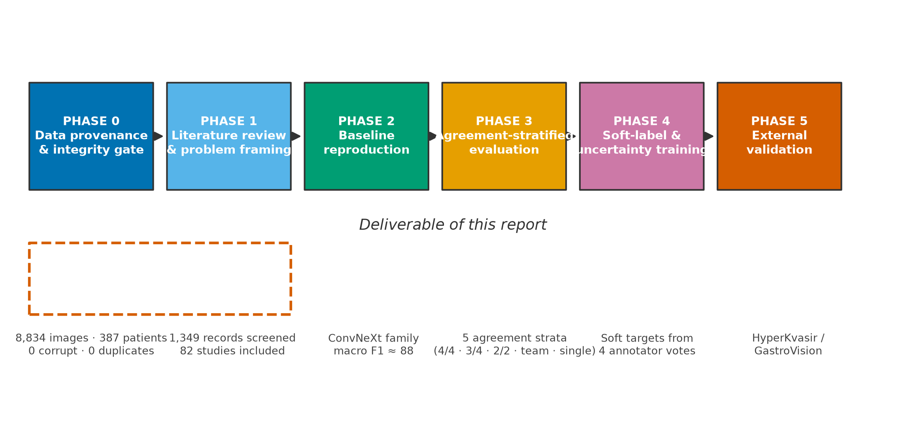
Figure 1. Thesis workflow. Phases 0 and 1, enclosed by the dashed boundary, constitute the deliverable of this report; later phases are stated for context and are governed by the findings established here.

Provenance of the corpus
GastroHUN was published as a peer-reviewed data descriptor in Scientific Data in January 2025 by a group at the Universidad Nacional de Colombia and the Hospital Universitario Nacional de Colombia. Provenance is documented at every level that matters for a clinical corpus: the acquiring institution, the ethics approval, the consent basis, the acquisition equipment, the operators, and the anonymisation procedure are all stated in the descriptor and are reproduced below.
Table 2. Documented provenance of the GastroHUN corpus.
Provenance attribute | Value
Source institution | Hospital Universitario Nacional de Colombia (HUN), Bogotá
Data descriptor | Bravo et al., Scientific Data 12:102 (2025), doi:10.1038/s41597-025-04401-5
Ethics approval | Ethics Committee of HUN, approval CEI-2019-06-10; Declaration of Helsinki
Consent basis | Signed informed consent permitting research and educational reuse
Anonymisation | Metadata stripped; filenames replaced by hash-generated identifiers; frames recorded outside the body removed
Collection period | Procedures scheduled 2019–2023, collected retrospectively
Acquisition system | Olympus EVIS EXERA III CV-190 processor, CLV-190 light source, EXERA II TJF-Q180V / GIF-H170 gastroscope
Operators | Two final-year gastroenterology residents (Team A, 'FG') and two gastroenterologists (Team B, 'G'); a master gastroenterologist with ~50,000 procedures supervised acquisition
Acquisition protocol | Systematic Screening Protocol for the Stomach (SSS), 22 landmarks
Audited subset | 'Labeled Images' (2.71 GB), official splits, metadata
Full release size | 96.86 GB across images, sequences and videoendoscopies

One provenance discrepancy must be recorded. The project's GitHub repository states a CC BY-NC 4.0 licence, whereas the Figshare record that actually hosts the data, and the descriptor itself, state CC BY 4.0. The Figshare record is the authoritative statement for the artefact being used, and the more permissive CC BY 4.0 is therefore taken to govern. Because the two differ on the non-commercial clause, the discrepancy is documented here rather than resolved silently, and no commercial use is made of the data in any case.
The acquisition protocol deserves emphasis because it determines the label space. The SSS protocol prescribes a fixed sequence of 22 photographs. The endoscope is positioned at the pylorus and withdrawn through four successive stations, at each of which four images are taken in clockwise order — greater curvature, anterior wall, lesser curvature, posterior wall — followed by two further retroflexed stations contributing three images each. Every class label is therefore a pair: a wall and a station.
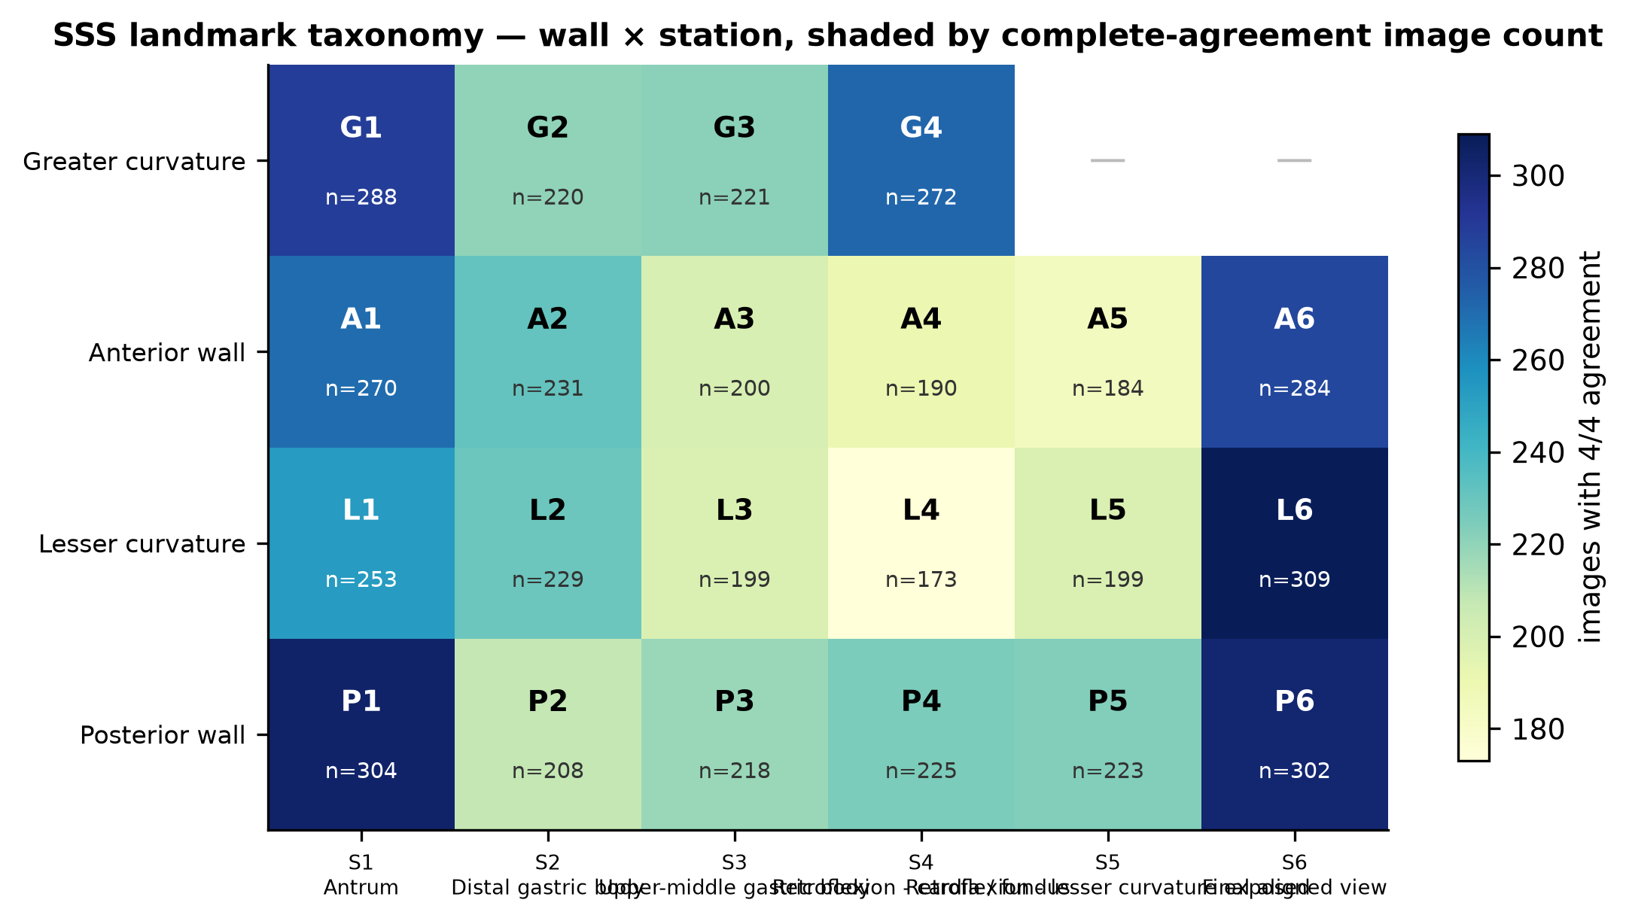
Figure 2. The 22 SSS landmarks arranged as a wall × station grid, shaded by the number of images attracting unanimous expert agreement. Stations 5 and 6 contribute three images rather than four because no greater-curvature view is prescribed in retroflexion.
Table 3. The SSS station taxonomy, with the observed rate at which two randomly chosen expert annotators disagree about an image assigned to that station.
Station | Anatomical position | Landmark codes | Rater-pair disagreement
S1 | Antrum | A1, G1, L1, P1 | 30.9%
S2 | Distal gastric body | A2, G2, L2, P2 | 40.5%
S3 | Upper-middle gastric body | A3, G3, L3, P3 | 42.7%
S4 | Retroflexion - cardia / fundus | A4, G4, L4, P4 | 39.2%
S5 | Retroflexion - lesser curvature exposed | A5, L5, P5 | 44.5%
S6 | Final aligned view | A6, L6, P6 | 19.3%
— | Image unsuitable for assessment | OTHERCLASS | —
Note. Wall codes: G = greater curvature, A = anterior wall, L = lesser curvature, P = posterior wall.

G1–G2: Physical inventory and file integrity
Every filename in the official split manifest was resolved against the extracted image tree, and every resolved file was fully decoded rather than merely opened, so that truncated JPEG streams would raise an error rather than pass inspection. A SHA-256 content hash and a 64-bit perceptual difference hash were computed for each image in the same pass.
Table 4. Physical inventory of the audited corpus.
Inventory measure | Value
Manifest entries | 8,834
Unique filenames in manifest | 8,834
Files present on disk | 8,834
Patient directories | 387
Images fully decoded | 8,834
Listed in manifest but missing from disk | 0
Present on disk but absent from manifest | 0
Failed to decode (truncated or corrupt) | 0
Directory/manifest patient mismatches | 0
Container formats observed | JPEG (8,834)
Colour modes observed | RGB (8,834)
Native resolutions | 1350x1080 (8,427), 900x720 (407)
Total payload | 2.707 GB
File size (mean / median) | 321.3 KB / 324.2 KB
File size (min / max) | 120.2 KB / 546.5 KB
Images per patient (mean ± SD) | 22.83 ± 2.88
Images per patient (min / median / max) | 7 / 22 / 32

The manifest and the filesystem agree exactly. The mean of 22.83 images per patient sits just above the 22 prescribed by the protocol, which is the expected signature of a protocol-driven acquisition: most patients contribute the full prescribed set, a few contribute repeats where a first attempt was unsatisfactory, and a small number contribute fewer where the procedure was curtailed. The observed range is 7 to 32.
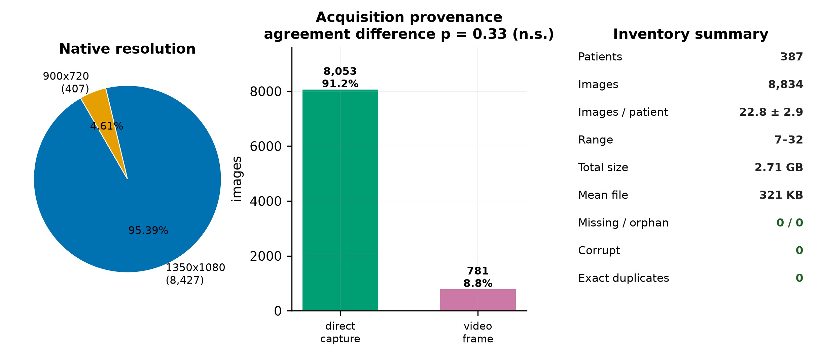
Figure 3. Physical inventory. Left: native resolution split. Centre: acquisition provenance — images captured directly by the endoscope processor against frames extracted from recorded video. Right: summary integrity counters, all of which are zero for the failure modes tested.
Two acquisition streams are present and are declared in the metadata: 8,053 images (91.16%) were written directly by the endoscope processor, and 781 (8.84%) were extracted as frames from recorded videoendoscopies. This matters because a systematic quality difference between the streams would confound any analysis of annotator agreement. It was tested and none was found: unanimity rates are 60.36% and 58.51% respectively (χ² = 0.94, p = 0.333; Mann–Whitney p = 0.469).
The two streams are, however, unevenly distributed across the official splits: video-derived frames make up 10.8% of the training set but only 3.4% of validation and 5.2% of test (χ² = 100.0, p = 1.91e-22). The official stratification balanced agreement level, not acquisition stream, so this imbalance was not controlled. Because agreement does not differ between the streams, the practical consequence is small, but the imbalance is recorded here and any claim of distributional equality between the splits must be qualified accordingly.
A marginal association was also detected between native resolution and unanimity: the 407 images at 900×720 attract unanimous labels 55.0% of the time against 60.5% for the 8,427 images at 1350×1080 (χ² = 4.52, p = 0.033). This is a single nominally significant result among several tests reported in this section and would not survive correction for multiplicity; it is noted as a hypothesis, not a finding.

G3: Duplication and cross-split contamination
Near-duplicate images that straddle a train/test boundary are the most common silent defect in endoscopy imaging studies, because consecutive frames of the same anatomical site are nearly identical and a naive split can place one in training and its twin in test. The resulting performance estimate is optimistically biased. Two tests were applied.
The exact test is unambiguous. Grouping all 8,834 images by SHA-256 content hash yields 0 groups containing more than one file. No image in this corpus is byte-identical to any other.
The perceptual test is where care is required. All 39,015,361 image pairs were compared exhaustively on a 64-bit difference hash — an exact computation, not an approximate nearest-neighbour search, so no pair is missed. At a Hamming radius of 6, 17,002 candidate pairs cross a split boundary. Taken at face value this looks alarming.
It is not, and establishing why is the most instructive methodological episode in this audit. Endoscopic frames all share a bright, low-texture circular field on a black surround, so global image statistics are similar for very many pairs. A similarity threshold carried over from natural-image work over-triggers badly here. Rather than assume a decision rule, the rule was calibrated against two controls, and it took two attempts to get the calibration right.
A positive control was built from 4,000 synthetic true duplicates, produced by subjecting real images to the transformations a genuine duplicate would undergo — JPEG re-compression, a ±2% rescale and a one-to-two pixel crop. These bound what a real duplicate looks like: mean normalised RMS difference 0.0157, maximum 0.0526, and correlation never below 0.9714 across all 4,000 trials.
The first null was built from randomly drawn cross-patient pairs. That null proved far too permissive, and the reason is worth recording: random pairs mostly compare different anatomical stations, which look nothing alike, so any two images of the same landmark appear extraordinarily similar by comparison. Visual inspection of the pairs it flagged settled the matter — they were plainly two different stomachs photographed at the same site, one with an endoscope sheath visible in frame, differing in mucosal texture and specular highlights. The null was rebuilt as 4,000 class-matched cross-patient pairs: two different patients photographed at the same SSS landmark, which is the comparison that actually matters.
Even the corrected null does not by itself settle the question, because it answers the wrong one. A null-anchored rule (RMS below 0.0833, correlation above 0.9413) asks whether a pair is unusually similar for two different patients. The question that matters is whether the pair's scores are consistent with its having been produced by duplication at all. The rule finally adopted is therefore anchored on the positive control: RMS below 0.0472 and correlation above 0.9757, the 99.9th and 0.1st percentiles of the synthetic-duplicate distribution. It retains 99.8% sensitivity to genuine duplicates and admits 0.00% of the 4,000 class-matched non-duplicate pairs. The two distributions are cleanly separated, with a margin of 0.0361 RMS between them.
G3 verdict — no cross-split contamination
Of the 54 cross-split pairs flagged by the uncalibrated provisional rule, 23 survive the null-anchored rule and 0 survive the adopted rule. No cross-split duplication detected once the decision rule is calibrated. Every flagged pair falls outside the envelope that genuine duplication produces — they are different patients photographed at the same anatomical landmark under a standardised protocol, which is exactly what a protocol-driven corpus should contain.

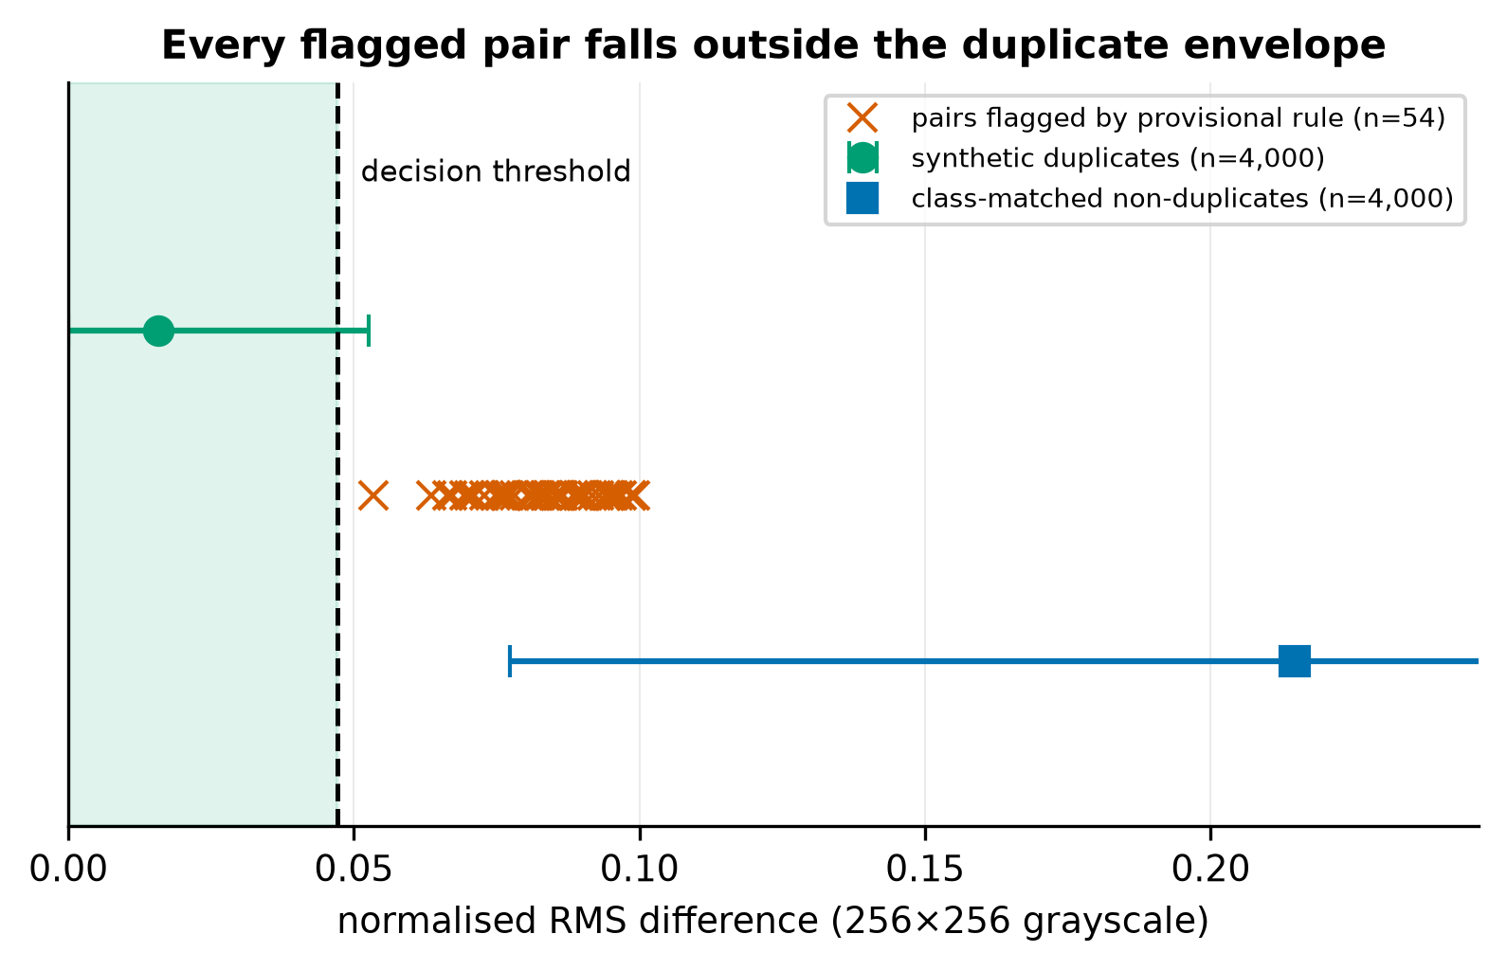
Figure 4. Calibration of the duplicate decision rule. Synthetic true duplicates (green) and class-matched non-duplicate pairs (blue) are cleanly separated on normalised RMS difference. Every pair flagged by the provisional rule (red crosses) lies outside the duplicate envelope, to the right of the decision threshold.
This is reported at length because the intermediate result — 'the audit found 54 cross-split duplicate pairs' — is quotable, alarming and wrong. Had it been carried forward it would have entered the thesis as a spurious criticism of a carefully constructed public dataset. An uncalibrated threshold is not a measurement, and a threshold calibrated against the wrong comparison is not much better.
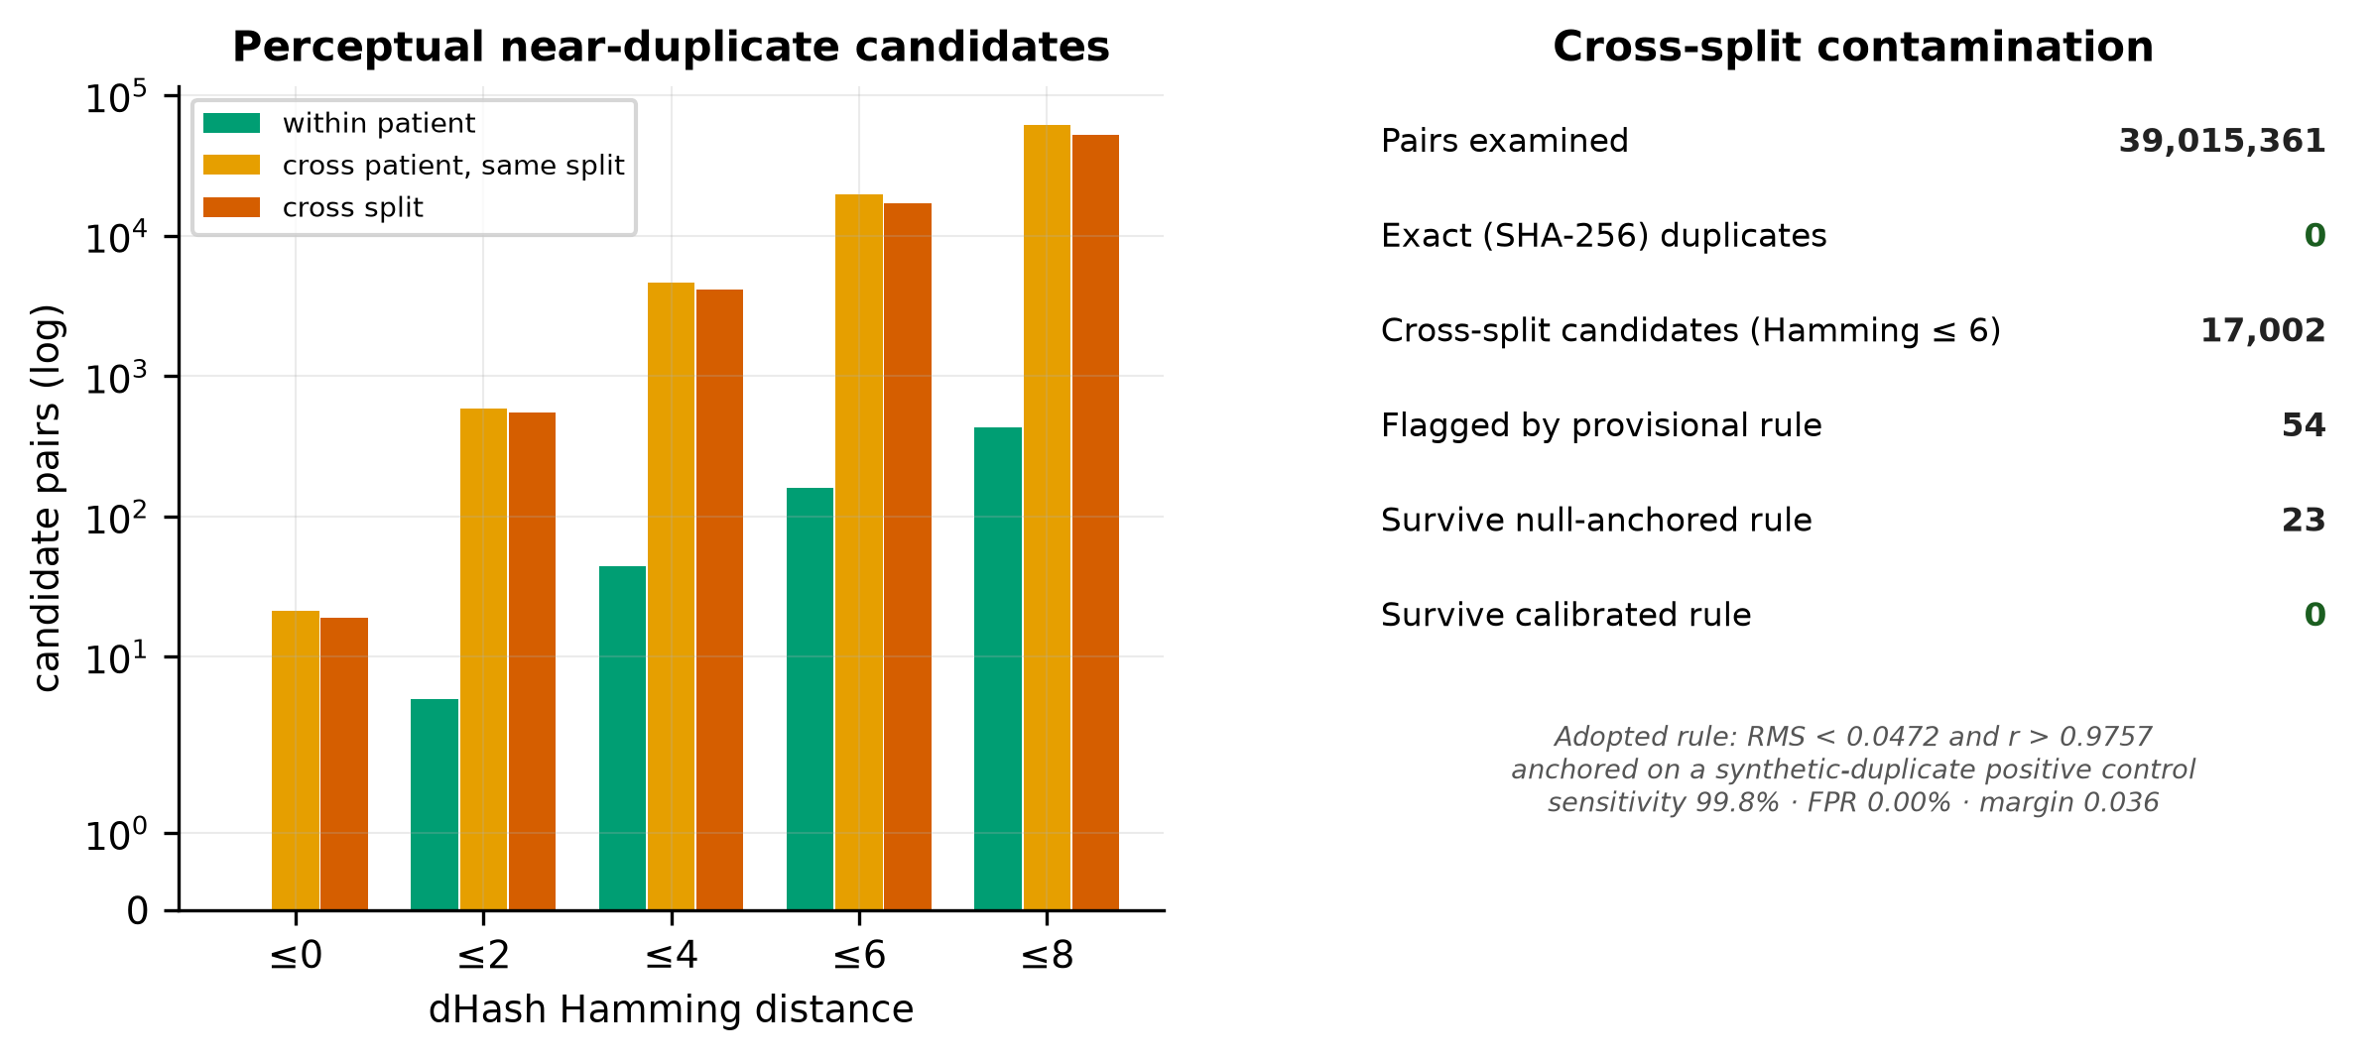
Figure 5. Cross-split contamination audit. Left: candidate pair counts across the perceptual-hash threshold sweep, separated by whether a pair shares a patient, shares a split, or crosses a split boundary. Right: summary of the exhaustive scan and the calibrated decision rule.
One further observation supports the integrity of the splits. Within-patient near-duplicates — which are expected, since the protocol photographs adjacent overlapping views — occur at a rate of only 0.1622% of the 98,008 possible within-patient pairs at the operative threshold. The corpus is a set of distinct photographs, not a set of near-identical frames sampled from video.

G4–G5: Label architecture and inter-annotator agreement
The property that distinguishes GastroHUN from every other public upper-gastrointestinal dataset is that it does not collapse its annotators. Four experts labelled all 8,834 images independently under a quadruple-blind protocol, and all four label columns are published. Two annotators were final-year gastroenterology residents (Team A, denoted FG1 and FG2, each with roughly 500 documented procedures); two were gastroenterologists (Team B, denoted G1 and G2, each with at least 1,000 procedures). This makes disagreement a measurable quantity rather than a hidden one, and it is the raw material for everything the thesis proposes.
Agreement was quantified with three chance-corrected statistics rather than one, because each fails in a different way. Fleiss' kappa is the standard multi-rater coefficient but behaves badly when category prevalence is skewed. Krippendorff's alpha handles arbitrary rater counts and missing data. Gwet's AC1 was designed specifically to remain stable under the prevalence conditions that distort kappa.
Table 5. Inter-annotator agreement across 23 categories and 8,834 images.
Statistic | Value | Definition applied
Fleiss' κ | 0.7475 | Multi-rater, all four annotators
Krippendorff's α (nominal) | 0.7475 | Multi-rater, coincidence-matrix formulation
Gwet's AC1 | 0.7475 | Prevalence-robust chance correction
Mean pairwise Cohen's κ | 0.7476 | Mean over all six annotator pairs
Mean within-team κ | 0.7415 | FG1–FG2 and G1–G2 only
Mean between-team κ | 0.7506 | The four resident–gastroenterologist pairs
Raw (uncorrected) agreement | 0.7585 | Proportion of rater pairs assigning an identical label

The three chance-corrected coefficients agree to three decimal places (0.7475, 0.7475 and 0.7475). This is not a coincidence, and it is worth explaining, because a reader who knows these statistics normally diverge will otherwise suspect an implementation error. Fleiss' expected agreement is Σpⱼ², whereas Gwet's is (1 − Σpⱼ²)/(K − 1). Those two quantities are algebraically equal exactly when the marginal distribution is uniform, that is when Σpⱼ² = 1/K. The SSS protocol prescribes a fixed photographic set per patient, so the marginal class distribution is near-uniform by construction and the two chance corrections converge. The practical consequence is favourable: the well-known kappa paradox, in which high observed agreement yields a low kappa under skewed prevalence, does not arise here, and the reported kappa can be read at face value.
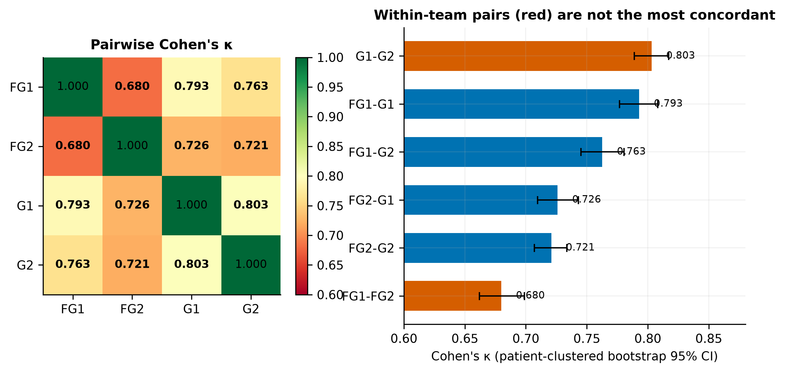
Figure 6. Pairwise Cohen's κ between the four annotators. Left: the full matrix. Right: the same six values ranked with patient-clustered bootstrap 95% confidence intervals; within-team pairs in red. Intervals resample patients rather than images, because images from one patient are not independent observations.
Table 6. All six pairwise agreement coefficients, ranked.
Annotator pair | Relationship | Cohen's κ | 95% CI (patient bootstrap) | Raw agreement
G1 – G2 | within team | 0.8031 | [0.7890, 0.8171] | 0.8116
FG1 – G1 | between teams | 0.7930 | [0.7768, 0.8082] | 0.8021
FG1 – G2 | between teams | 0.7627 | [0.7453, 0.7804] | 0.7729
FG2 – G1 | between teams | 0.7260 | [0.7095, 0.7432] | 0.7377
FG2 – G2 | between teams | 0.7209 | [0.7069, 0.7336] | 0.7332
FG1 – FG2 | within team | 0.6799 | [0.6618, 0.6989] | 0.6935
Note. Intervals from 400 patient-clustered bootstrap resamples; all images belonging to a resampled patient move together.
Team structure does not predict agreement
The two gastroenterologists are the most concordant pair (G1–G2, κ = 0.8031); the two residents are the least concordant pair (FG1–FG2, κ = 0.6799). Crucially, each resident agrees more with the gastroenterologists than with the other resident: FG1 agrees with G1 at κ = 0.7930 but with its own teammate at only 0.6799. Seniority is therefore not the dominant axis of disagreement; individual annotator idiosyncrasy is. Any design that treats 'Team A' as a coherent unit assumes something the data does not support.

The marginal label distributions point the same way. Total variation distance between annotators' overall class prevalence vectors is largest for the within-team pair FG1–FG2 (0.0937) and smallest for the between-team pair FG1–G1 (0.0201). FG2 is the outlying annotator on every measure computed here.

The agreement cascade and what the benchmark discards
Table 7. The agreement cascade. Each tier is a different but defensible definition of ground truth, and they differ by thousands of images.
Consensus tier | Images | % of corpus | Definition
All labelled images | 8,834 | 100.00% | Complete corpus
Triple agreement (≥3 of 4) | 7,476 | 84.63% | At least three annotators concur
Team B agreement (G1 = G2) | 7,170 | 81.16% | Both gastroenterologists concur
Team A agreement (FG1 = FG2) | 6,126 | 69.35% | Both residents concur
Complete agreement (4 of 4) | 5,318 | 60.20% | Unanimous — the published benchmark's training and test set

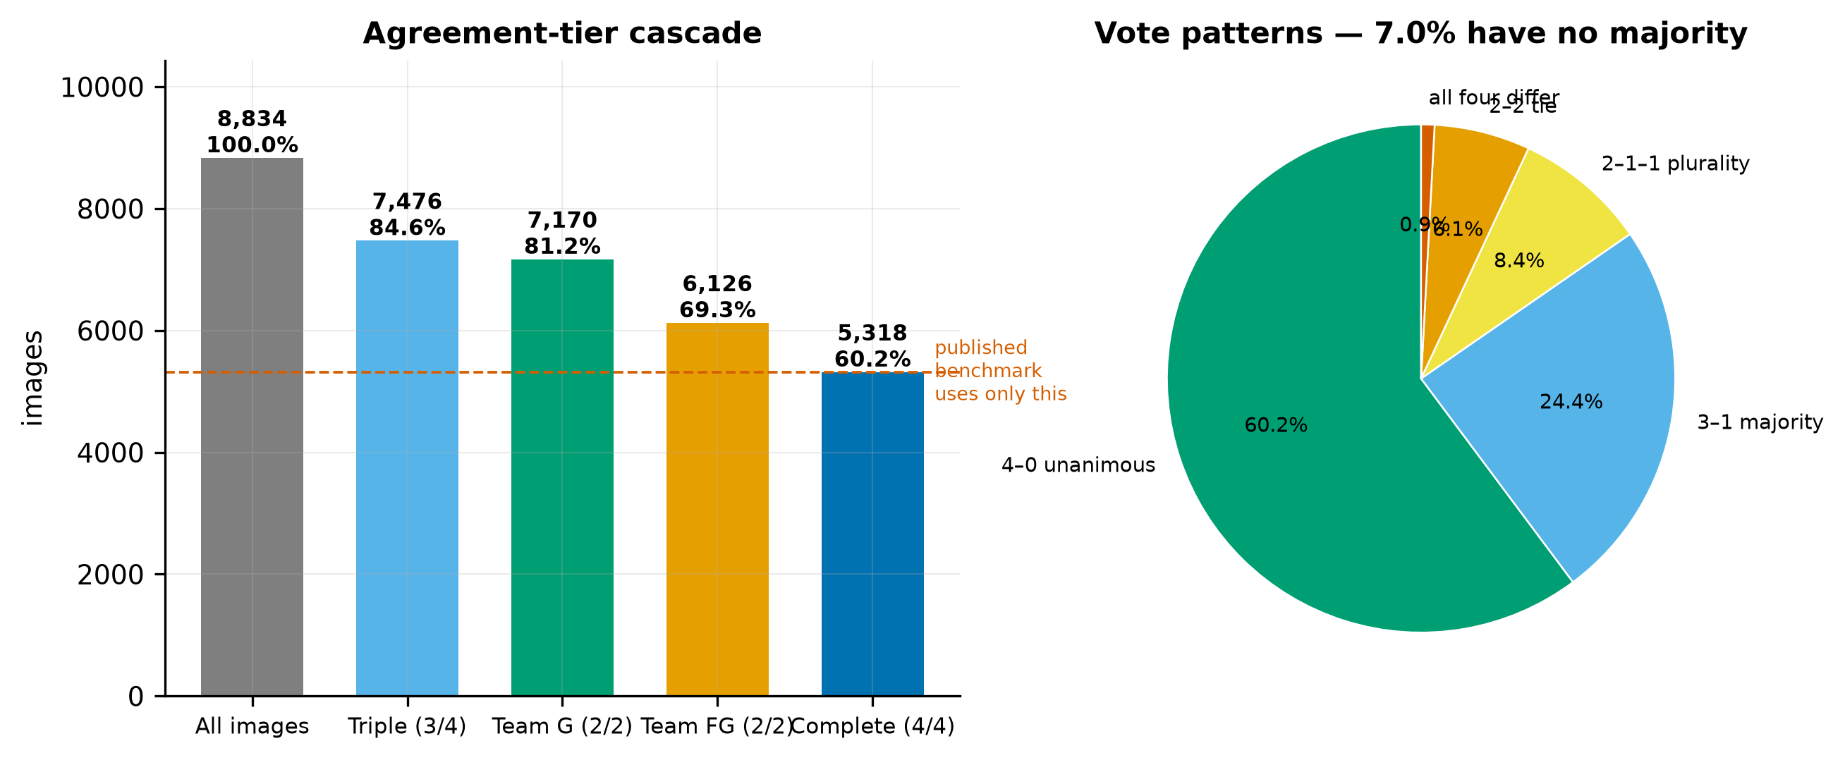
Figure 7. Left: the agreement-tier cascade, with the unanimous subset used by the published benchmark marked. Right: the distribution of voting patterns across the four annotators.
Table 8. Voting patterns across the four independent expert labels.
Pattern | Meaning | Images | % of corpus | Resolvable by voting?
4–0 | All four agree | 5,318 | 60.20% | Unambiguous
3–1 | One dissenter | 2,158 | 24.43% | Clear majority
2–1–1 | Two agree, two differ | 744 | 8.42% | Plurality only
2–2 | Two-way tie | 539 | 6.10% | No majority exists
1–1–1–1 | All four differ | 75 | 0.85% | No majority exists
Note. 614 images (6.95%) admit no majority label under any voting rule.
The consequence for the published benchmark is direct. Restricting training and evaluation to the unanimous subset discards 3,516 images — 39.8% of the corpus. That is a defensible choice for a clean baseline, and the descriptor's authors state the limitation themselves, noting that the approach 'misses a much more variable real-world scenario'. But it means the headline macro F1 of 88.25 characterises performance on the easiest three-fifths of the data, and nothing is known about the rest.
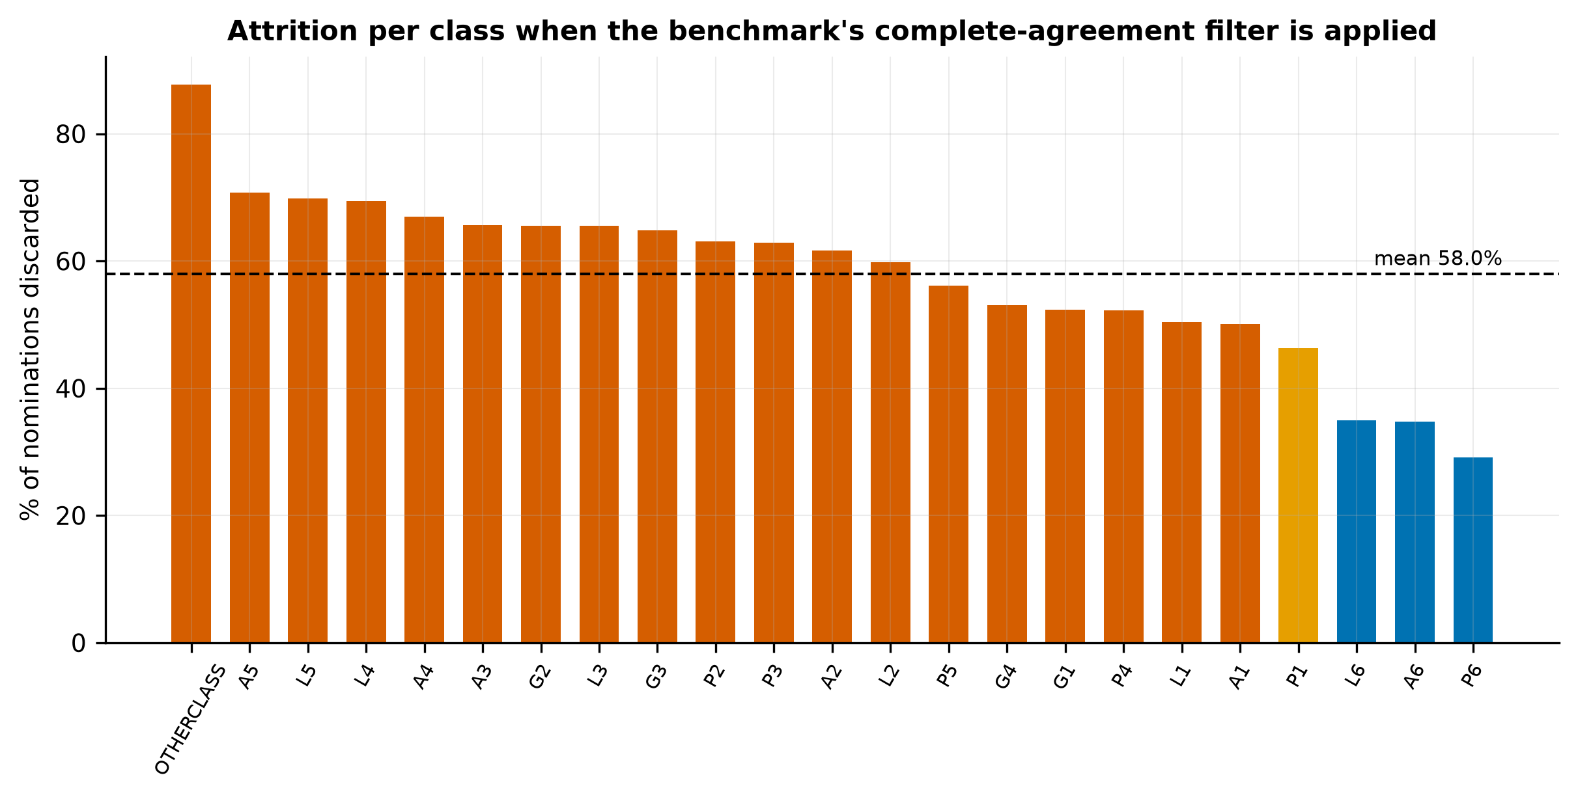
Figure 8. Proportion of each class's annotator nominations discarded by the complete-agreement filter. Attrition is markedly non-uniform.
Table 9. The eight classes most heavily depleted by the complete-agreement filter.
Class | Nominated by ≥1 annotator | Retained at 4/4 | Attrition
OTHERCLASS | 948 | 116 | 87.8%
A5 | 630 | 184 | 70.8%
L5 | 659 | 199 | 69.8%
L4 | 565 | 173 | 69.4%
A4 | 576 | 190 | 67.0%
A3 | 583 | 200 | 65.7%
G2 | 639 | 220 | 65.6%
L3 | 577 | 199 | 65.5%
Note. Attrition is measured against the number of images any annotator assigned to the class, since no consensus label exists for the discarded images.
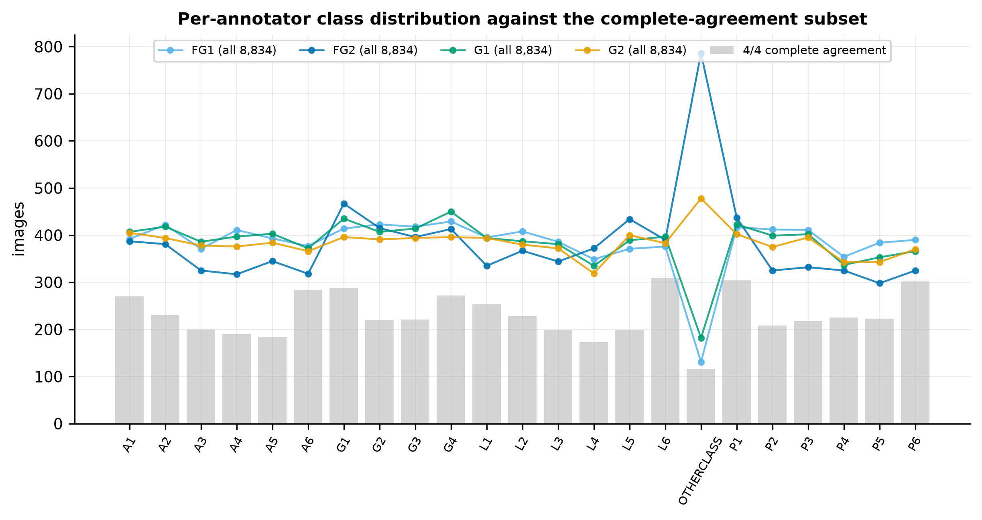
Figure 9. Per-annotator class distributions overlaid on the complete-agreement subset. The gap between the lines and the bars is exactly the material the consensus filter removes.

The structure of disagreement
Aggregate agreement statistics report how often experts disagree. They do not report what experts disagree about. Because every SSS code decomposes into a wall and a station, that question can be answered directly, and the answer is the most substantive original finding of this audit. It is not reported in the dataset descriptor.
Each of the 12,800 annotator-pair disagreement events was classified into one of four categories: the pair agreed on the station but differed on the wall; agreed on the wall but differed on the station; differed on both; or one annotator rejected the image as unusable while the other assigned a landmark.
Table 10. Decomposition of every annotator-pair disagreement event by anatomical axis.
Disagreement type | Events | % of total | Interpretation
Same station, different wall | 6,523 | 50.96% | Rotational ambiguity about the gastric axis
Landmark vs OTHERCLASS | 2,663 | 20.80% | Disagreement about usability, not anatomy
Same wall, different station | 2,548 | 19.91% | Depth ambiguity along the gastric axis
Both differ | 1,066 | 8.33% | Unstructured disagreement

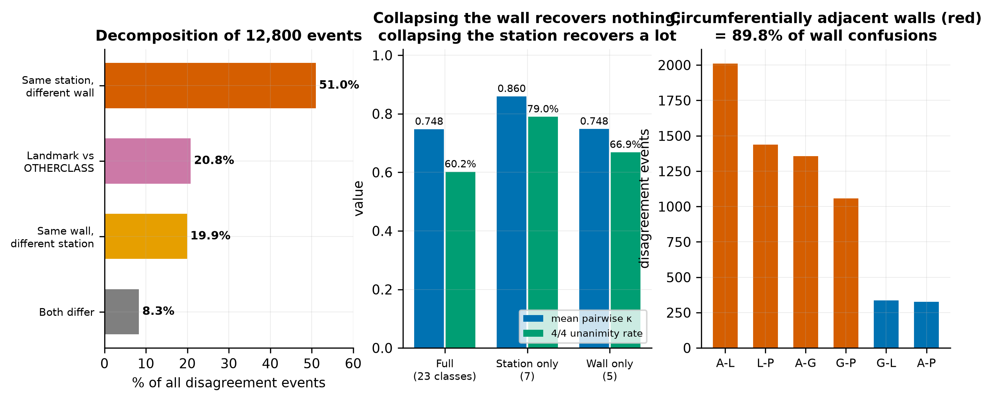
Figure 10. Left: disagreement decomposed by anatomical axis. Centre: agreement recomputed at three label granularities. Right: which walls are confused with which, with circumferentially adjacent pairs highlighted.
Over half of all disagreement — 51.0% — consists of two experts who agree on how far the endoscope has been withdrawn but differ on which wall it faces. Only 19.9% is the converse. A confirmatory test makes the asymmetry unmistakable. Collapsing the 23-class space to station alone raises mean pairwise kappa from 0.7476 to 0.8597, and unanimity from 60.20% to 78.99%. Collapsing to wall alone moves kappa to 0.7481 — indistinguishable from the full label space. Removing the wall distinction removes almost all the difficulty; removing the station distinction removes almost none of it.
Table 11. Which walls are confused with which. The protocol photographs the walls in clockwise order — greater curvature, anterior, lesser curvature, posterior — so 'adjacent' means adjacent on that circle.
Wall pair | Circumferential relation | Events | % of wall confusions
A ↔ L | adjacent | 2,010 | 30.81%
L ↔ P | adjacent | 1,438 | 22.05%
A ↔ G | adjacent | 1,356 | 20.79%
G ↔ P | adjacent | 1,056 | 16.19%
G ↔ L | opposite | 337 | 5.17%
A ↔ P | opposite | 326 | 5.00%
Note. Circumferentially adjacent pairs account for 89.8% of wall confusions; diametrically opposite pairs for 10.2%.
Disagreement is anatomically structured
Disagreement follows the geometry of the stomach. 89.8% of wall confusions involve walls adjacent on the circumference, and 93.1% of station confusions involve neighbouring stations. Expert disagreement is locally structured rather than arbitrary: annotators are not guessing, they are resolving a genuinely continuous viewing geometry onto a discrete label set. This is the empirical justification for treating the label space as structured — a distance-aware or hierarchical loss is warranted by the data, not merely by intuition.

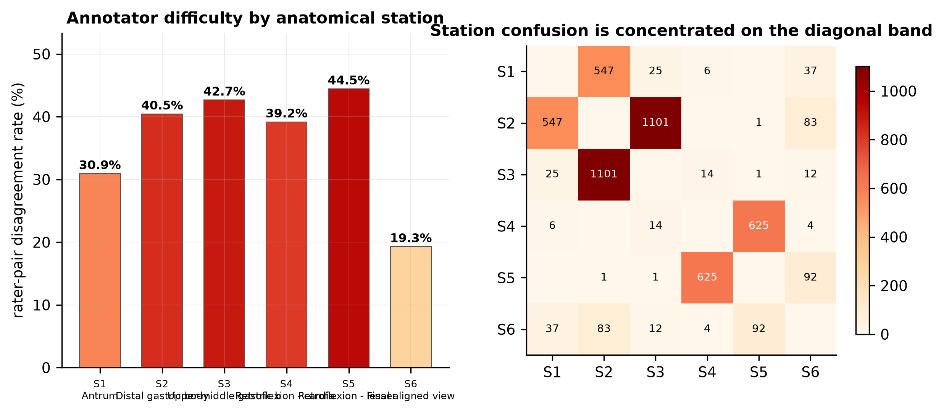
Figure 11. Left: rater-pair disagreement rate by anatomical station. Right: the station confusion matrix, with confusion confined almost entirely to the adjacent-station band.
Station-level difficulty varies more than twofold. The hardest is station 5 (Retroflexion - lesser curvature exposed) at 44.5%; the easiest is station 6 (Final aligned view) at 19.3%. This aligns with the published baseline's own error profile: the descriptor reports reduced model accuracy 'in the middle body (L3, P3, and G3)' — station 3, among the hardest stations for the human annotators measured here. Model error and human disagreement concentrate in the same anatomy, which is itself evidence that the residual error reflects genuine visual ambiguity rather than insufficient model capacity.

OTHERCLASS: a quality judgement, not an anatomical one
The twenty-third category marks an image as unsuitable for assessment. It behaves quite differently from the anatomical classes and accounts for 20.8% of all disagreement, making it the second-largest single source.
Table 12. The OTHERCLASS quality judgement, by annotator.
Measure | Value
Rate for annotator FG1 | 1.48%
Rate for annotator FG2 | 8.90%
Rate for annotator G1 | 2.06%
Rate for annotator G2 | 5.41%
Images ever called OTHERCLASS | 948
Of which unanimous | 116 (12.24%)

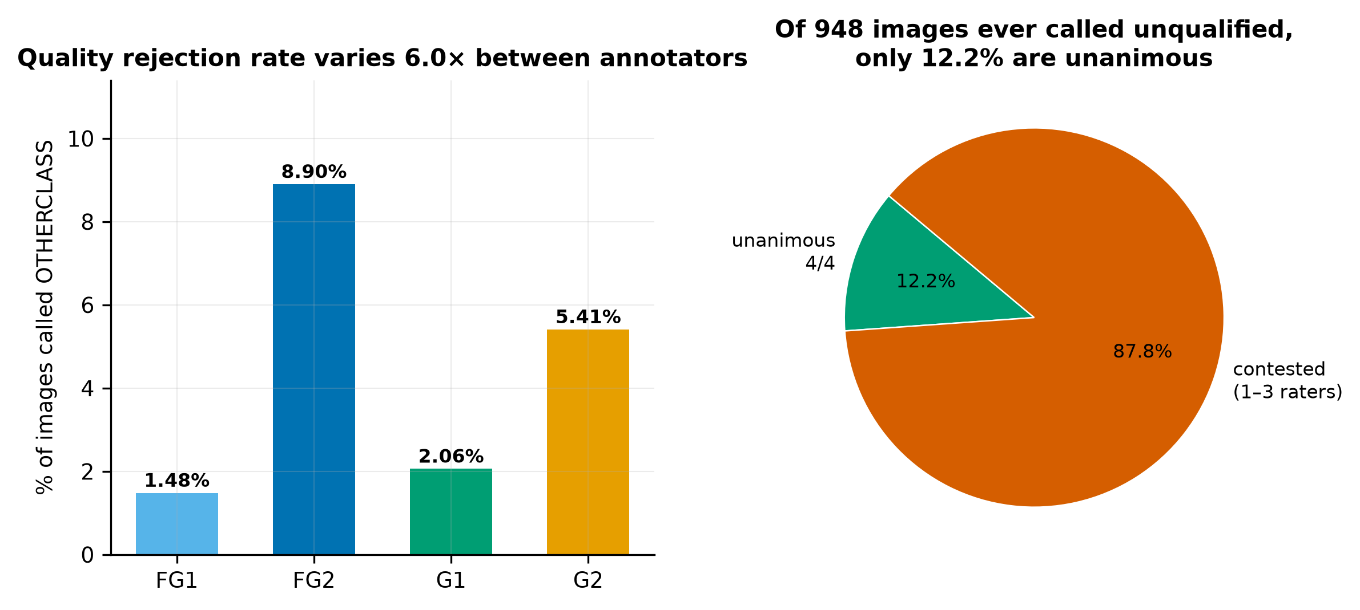
Figure 12. Left: per-annotator rate of rejecting an image as unusable. Right: of all images any annotator rejected, the fraction rejected unanimously.
The spread is a factor of 6.0 between the most and least permissive annotator, and only 12.2% of rejections are unanimous. On this evidence, 'is this image good enough?' is a substantially subjective judgement. That has a concrete implication for the automated-audit application motivating the dataset: a system certifying an examination as complete makes the same judgement, and cannot be more objective than the labels it was trained on. Quality assessment and anatomical classification are different tasks and should be modelled and evaluated separately.

G6: Integrity of the official splits
The descriptor supplies official train/validation/test splits stratified by patient, allocating cases to quartiles of per-patient Fleiss kappa so that agreement level is balanced across partitions. Both properties were verified independently rather than assumed.
Table 13. Composition of the official splits.
Split | Images | % images | Patients | % patients | 4/4 subset | % 4/4 | Img/patient
Train | 6,165 | 69.79% | 270 | 69.77% | 3,722 | 60.37% | 22.83
Validation | 1,316 | 14.90% | 58 | 14.99% | 793 | 60.26% | 22.69
Test | 1,353 | 15.32% | 59 | 15.25% | 803 | 59.35% | 22.93

Patient-level disjointness holds exactly (Test ∩ Train = 0; Test ∩ Validation = 0; Train ∩ Validation = 0). No patient contributes images to more than one split, and there are 0 duplicate filenames anywhere in the manifest. This is the correct unit of independence: splitting at image level would place different photographs of the same stomach on both sides of the boundary and inflate every performance estimate.
Balance was tested rather than asserted. Class prevalence across the three splits gives χ² = 13.48 on 44 degrees of freedom (p = 1.0000, Cramér's V = 0.0356); prevalence of complete agreement gives χ² = 0.49 (p = 0.7838); per-patient Fleiss kappa across splits gives Kruskal–Wallis H = 0.037 (p = 0.9818). All three are comfortably non-significant, which here is the desired result: the stratification the descriptor claims did in fact work.
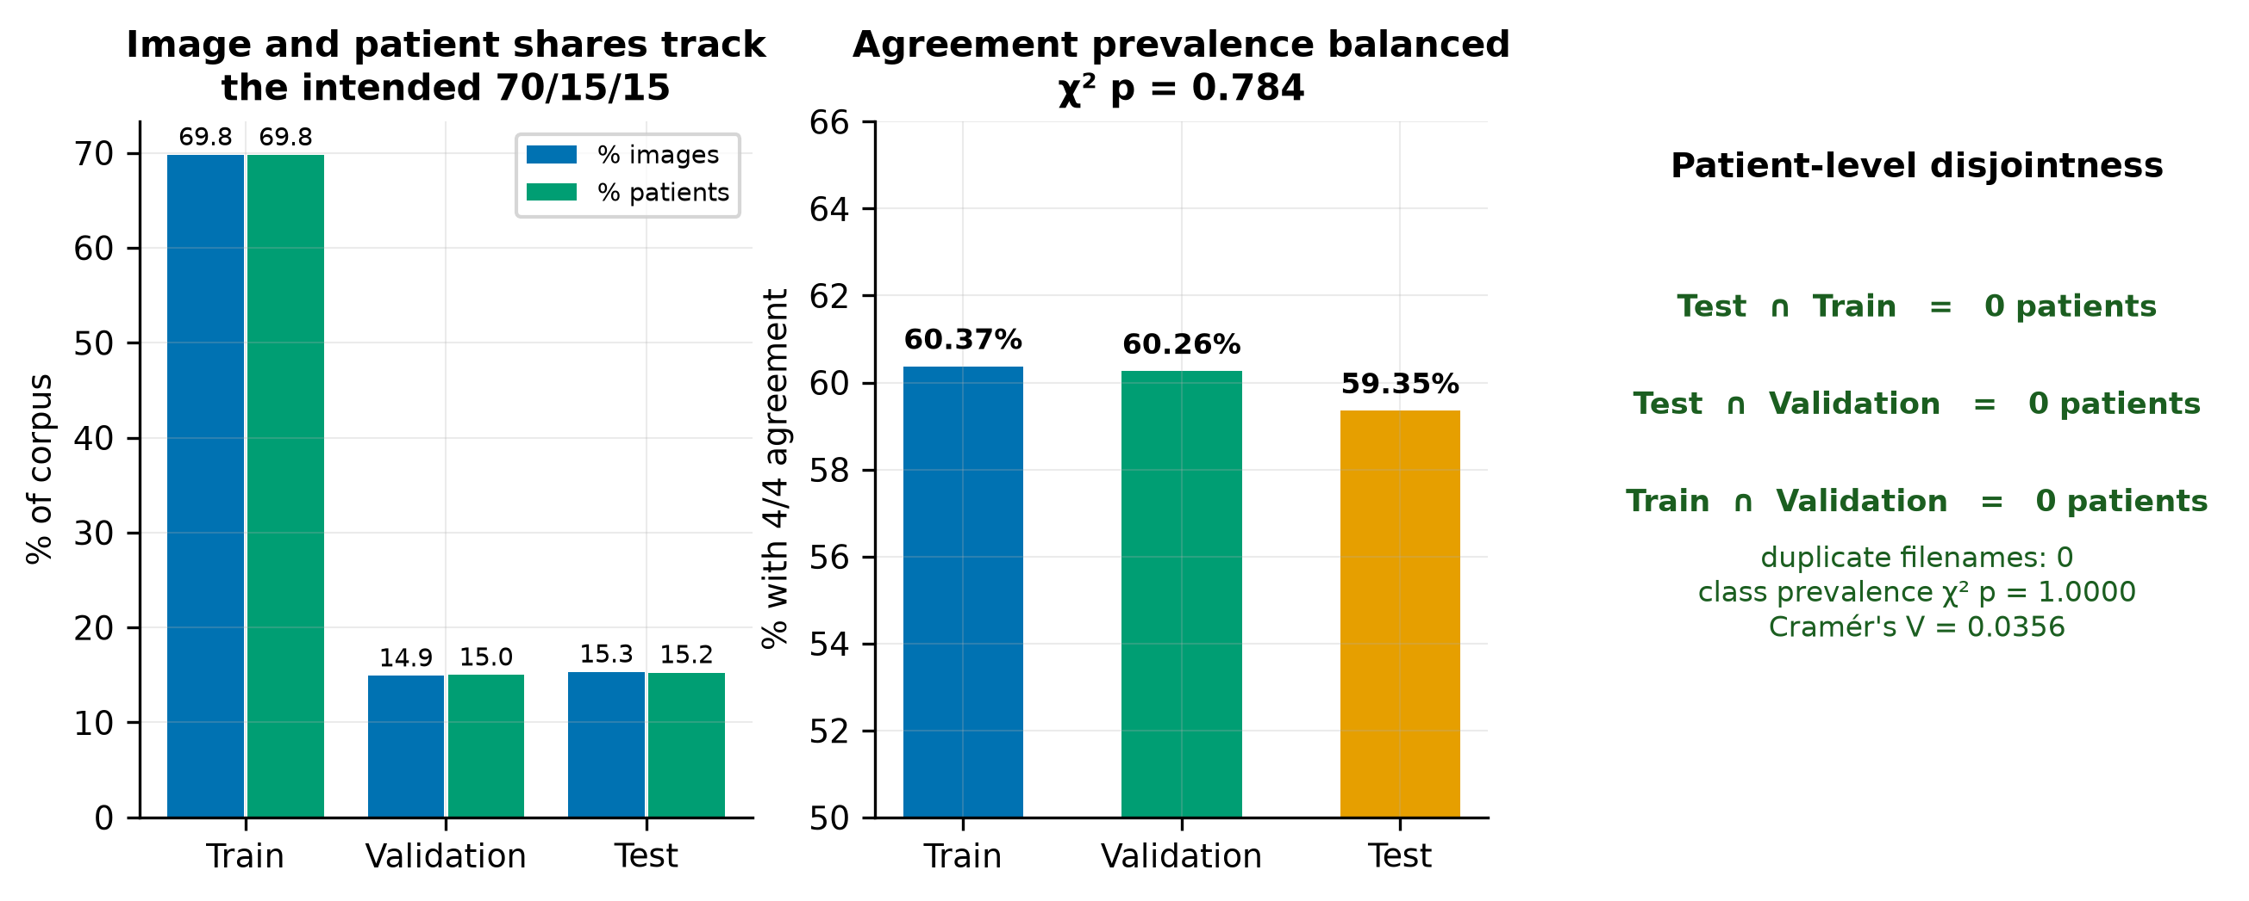
Figure 13. Official split integrity. Left: image and patient shares against the intended 70/15/15 allocation. Centre: prevalence of complete agreement by split. Right: verification of patient-level disjointness and distributional balance.
Per-patient agreement is itself informative. Computing Fleiss kappa within each of the 387 patients gives a mean of 0.7459 (SD 0.1448) across a range from 0.0694 to 1.0000. 160 patients (41.3%) reach almost-perfect agreement while 7 fall below 0.40. Difficulty is therefore partly a property of the patient — of how a particular stomach photographed on the day — and not only of the individual image. Any resampling procedure must respect this by resampling patients, which is why every interval in this report is patient-clustered.
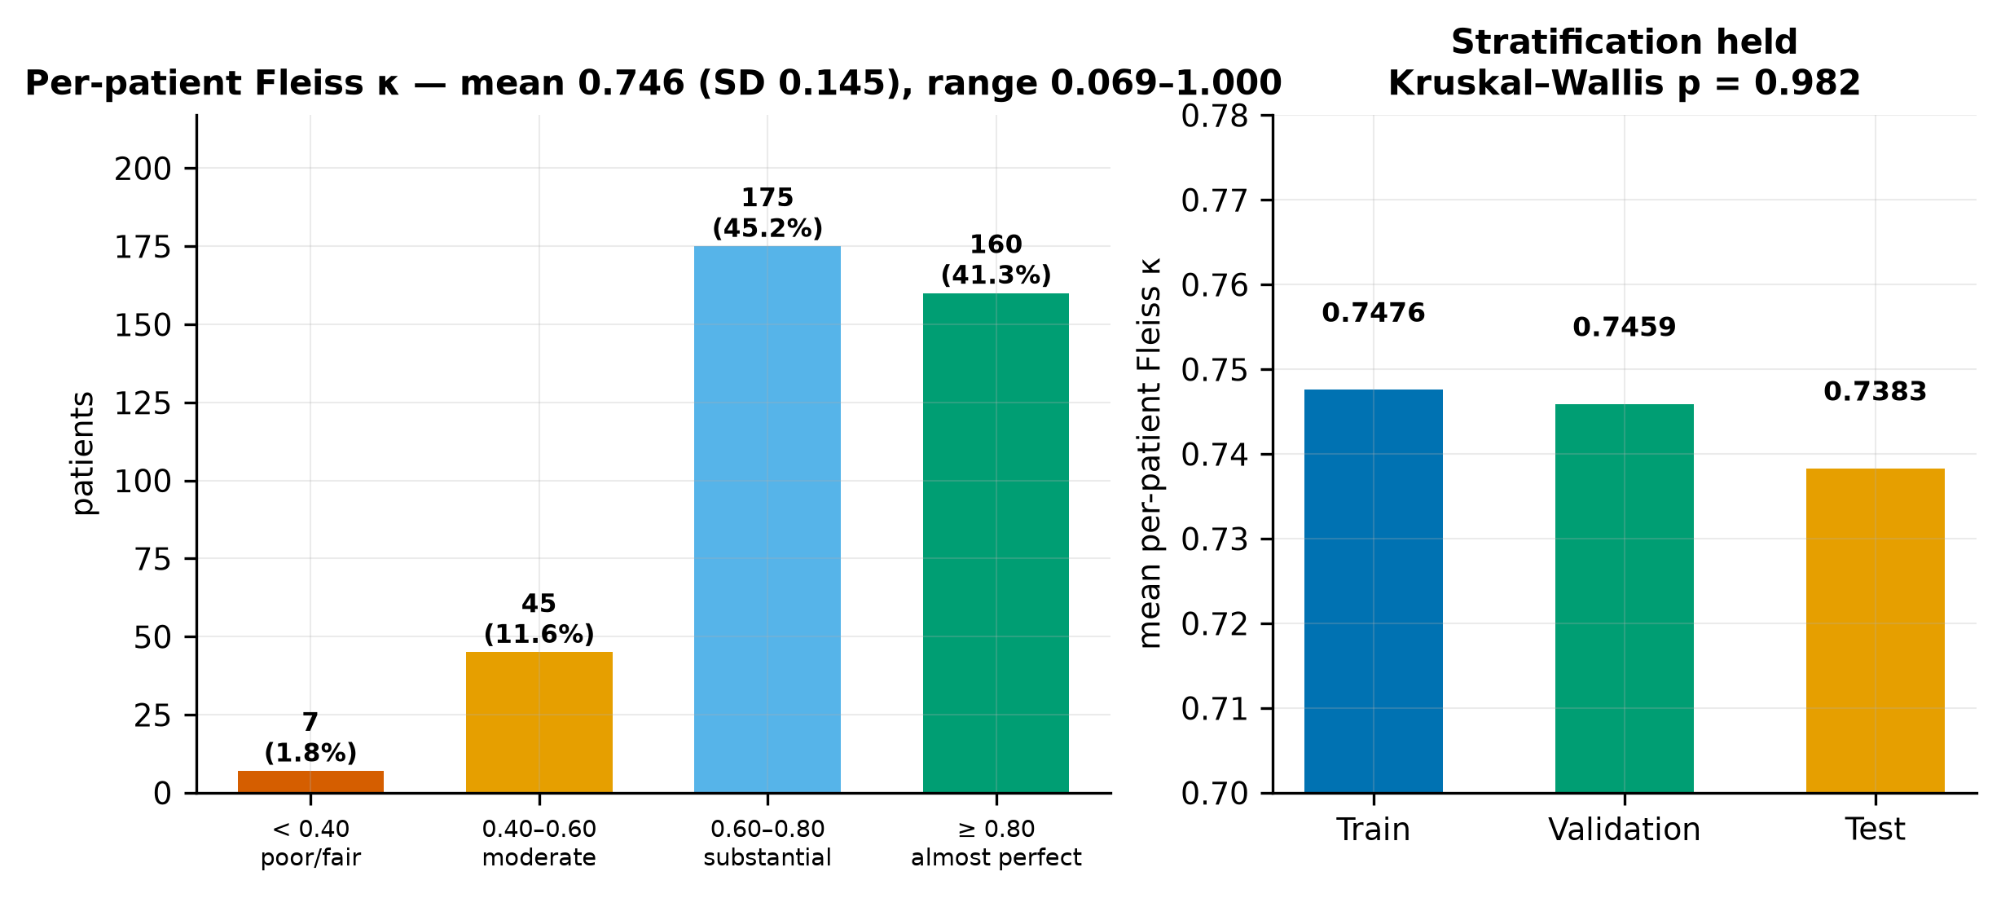
Figure 14. Left: distribution of per-patient Fleiss κ against conventional interpretive bands. Right: mean per-patient κ by official split, confirming the agreement-stratified allocation.

G7: Statistical power of the evaluation set
The consensus test set contains 803 images across 23 classes. Per-class precision was estimated as the half-width of a 95% Wilson score interval at an assumed per-class accuracy of 0.85, approximately the level the published baselines attain.
Table 14. The six most sparsely represented classes in the consensus test set.
Class | Test images (4/4) | 95% Wilson half-width at p = 0.85
OTHERCLASS | 19 | ±15.8 pp
A5 | 25 | ±13.8 pp
A3 | 27 | ±13.3 pp
L4 | 28 | ±13.1 pp
L5 | 29 | ±12.9 pp
P5 | 30 | ±12.7 pp

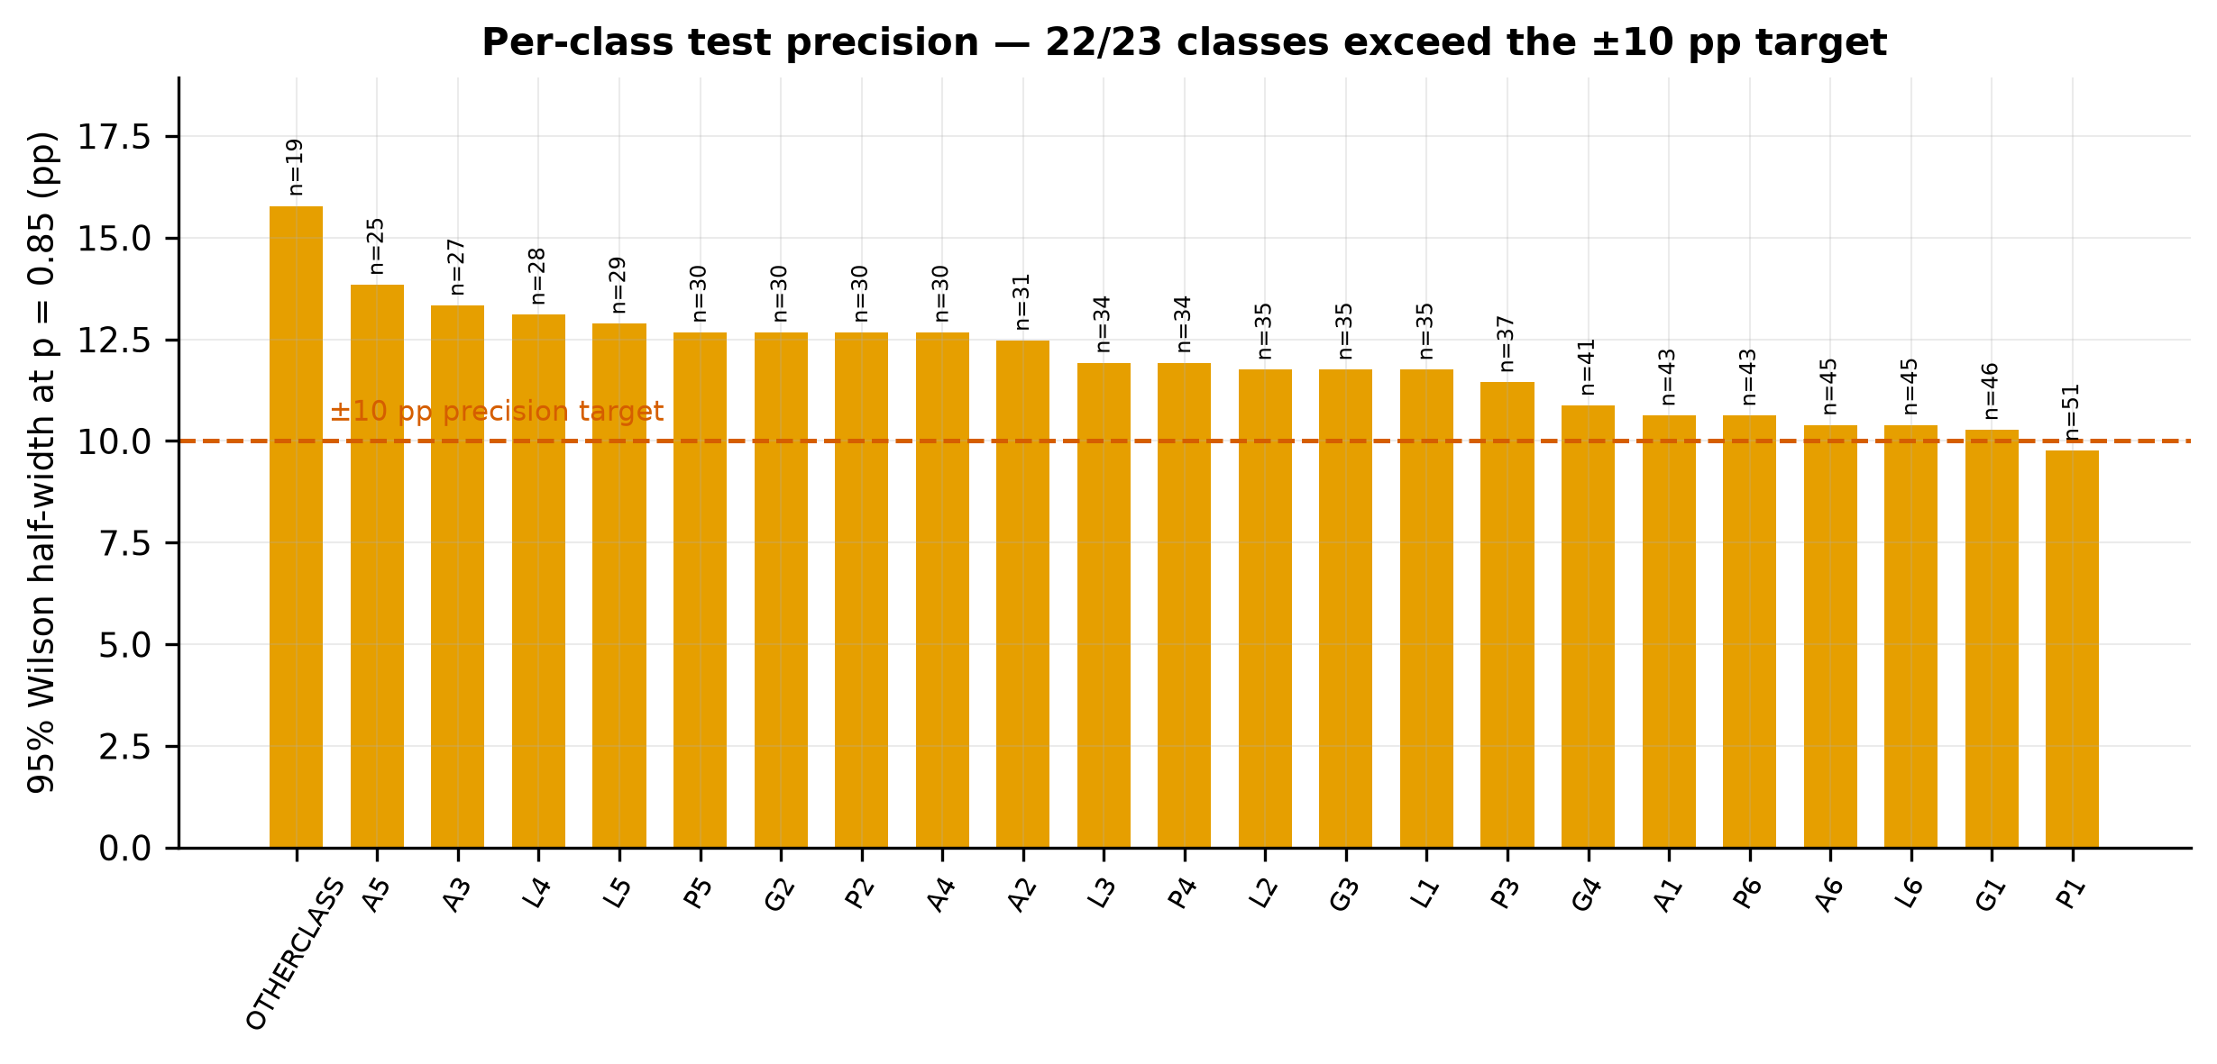
Figure 15. Per-class precision of the consensus test set. The dashed line marks a ±10 percentage-point half-width; classes above it cannot support confident per-class claims.
G7 verdict — CONDITIONAL
22 of 23 classes have a 95% interval half-width wider than ±10 percentage points. The consensus test set is adequately powered for aggregate macro-averaged comparison but not for confident per-class claims. The thesis will therefore report macro-averaged metrics as primary endpoints, treat per-class figures as exploratory, and attach patient-clustered bootstrap intervals throughout.

G8: Population description
Patient-level clinical context exists for 233 of the 387 imaged patients (60.2%), carried in the videoendoscopy metadata. Within that subset 146 records report Helicobacter pylori status (55 positive) and 165 carry an OLGA atrophic-gastritis stage.
Table 15. Availability of patient-level clinical and demographic context.
Population attribute | Value
Patients contributing images | 387
Patients with a clinical record | 233 (60.2%)
H. pylori reported / missing | 146 / 91
H. pylori positive | 55
OLGA stage reported / missing | 165 / 72
Distinct free-text findings narratives | 229
Distinct diagnosis strings | 163
Age recorded | No
Sex recorded | No

G8 verdict — CONDITIONAL
Neither age nor sex is recorded anywhere in the release. This follows from the anonymisation strategy but has two firm consequences that must be declared. First, no demographic subgroup or fairness analysis is possible on this corpus, and the thesis will not claim one. Second, CLAIM and TRIPOD+AI both require a description of the study population; that item can be satisfied only at the level of the recruiting institution and its stated referral pathway, and the thesis will say so explicitly rather than leave the item silently unmet.

One incidental observation is recorded for future work. The videoendoscopy metadata contains 229 distinct free-text endoscopic findings narratives in English, structured by organ. During the dataset search preceding this work, an extensive effort failed to locate any public de-identified free-text endoscopy report corpus, and that absence is what pushed the project from a natural-language framing toward imaging. This is such a corpus, albeit a very small one. At 233 patients it cannot support the original research question and it is not pursued here, but it is a genuine secondary resource and is noted as such.

Gate verdict and validation of the audit protocol
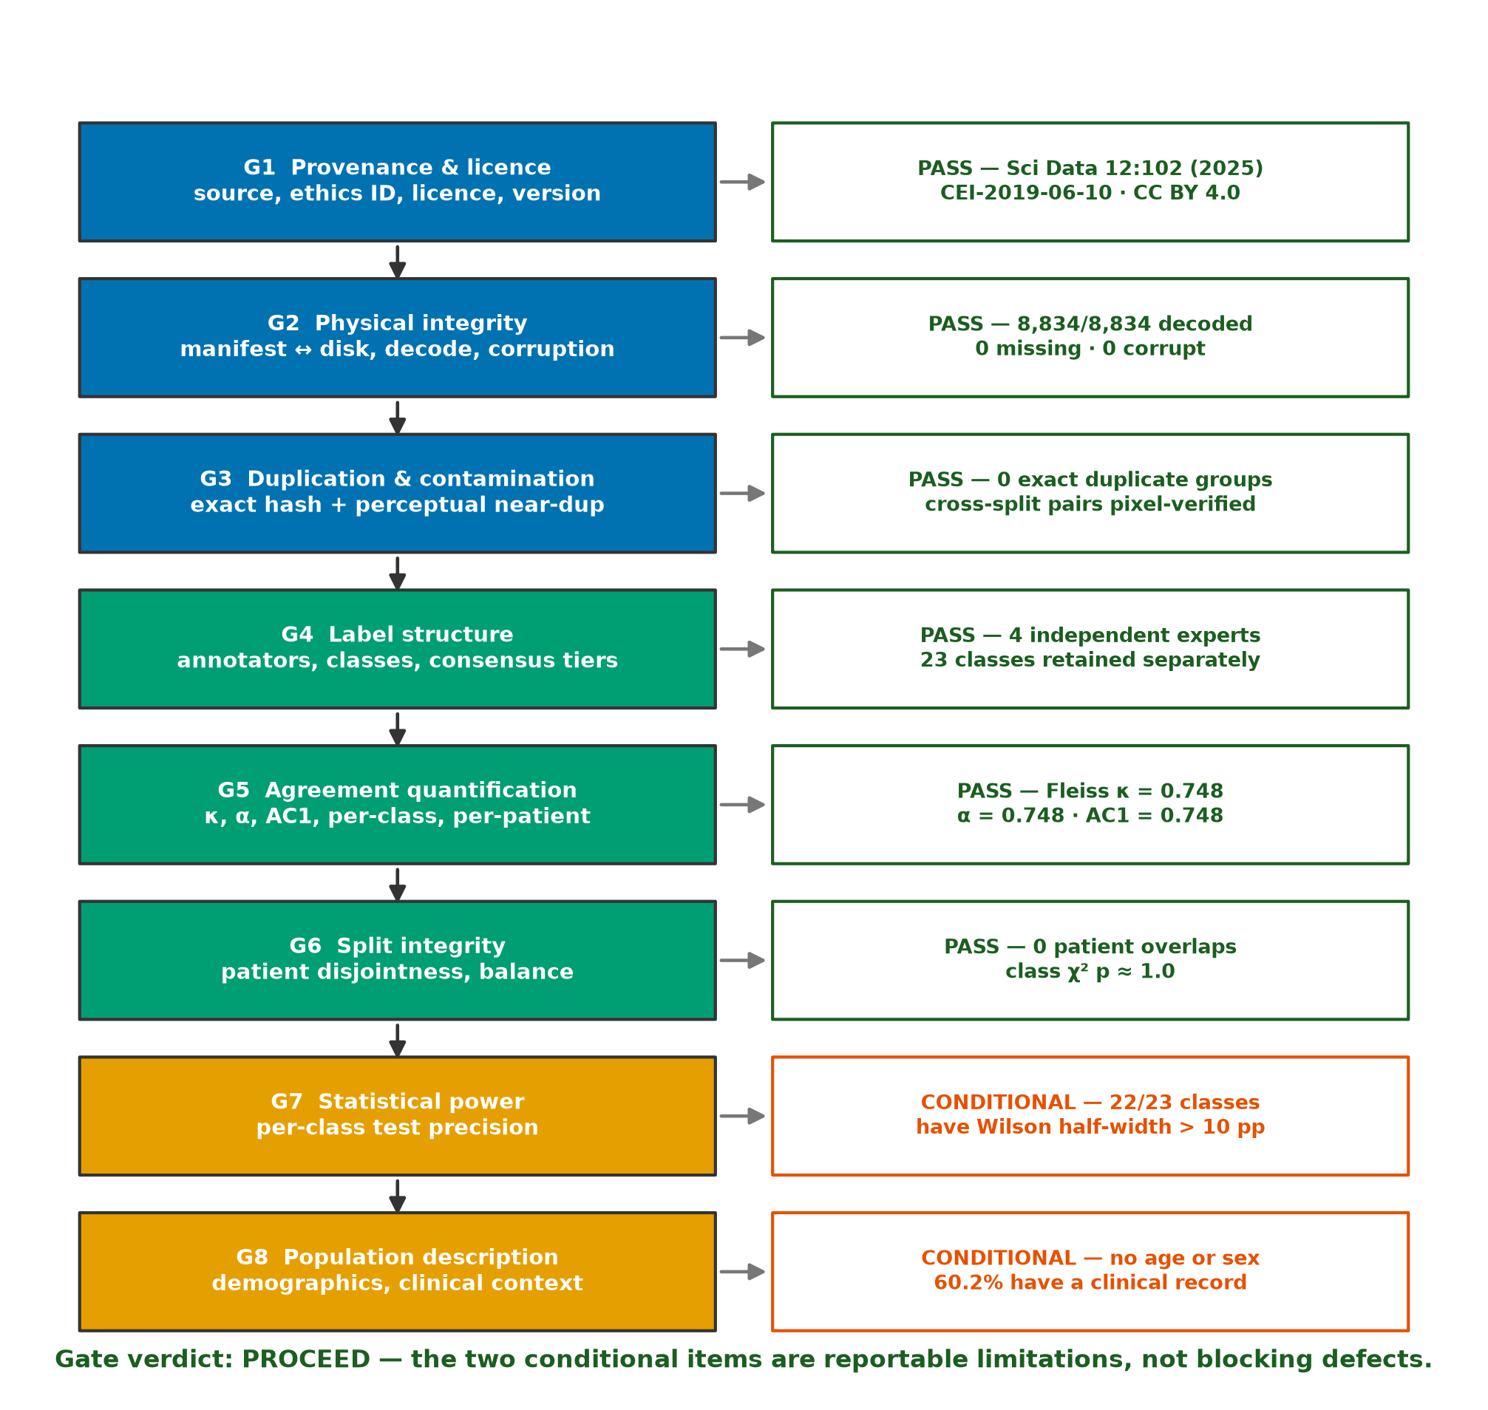
Figure 16. The Phase 0 integrity gate applied to GastroHUN, with the verdict and supporting evidence for each of the eight criteria.
The gate returns PROCEED. The corpus is physically intact, correctly partitioned, honestly documented and — critically for the research question — retains the per-annotator label structure the thesis depends on. Two criteria return CONDITIONAL. Neither blocks the research; both constrain its claims and are carried into the limitations rather than resolved.
Table 16. Declared limitations arising from Phase 0, with the mitigation adopted for each.
ID | Limitation | Evidence | Mitigation carried forward
L1 | Per-class test precision | 22/23 classes exceed a ±10 pp half-width on the consensus test set | Macro-averaged metrics as primary; per-class exploratory; patient-clustered bootstrap intervals throughout
L2 | No demographic data | Age and sex absent from the entire release | No demographic subgroup or fairness claim; population described at institutional level only
L3 | Single centre, single vendor | One hospital; Olympus EVIS EXERA III throughout | External validation on HyperKvasir and GastroVision shared landmarks treated as a required phase, not an extension
L4 | Acquisition stream imbalance across splits | Video-derived frames unevenly allocated (χ² p = 1.9e-22) | Report per-split source composition; test sensitivity of conclusions to excluding video-derived frames
L5 | Review restricted to one database | Phase 1 searched PubMed/MEDLINE only | Foundational computer-science works added via the PRISMA other-methods arm; declared as a review limitation
L6 | Clinical context incomplete | 60.2% of imaged patients have a clinical record; H. pylori and OLGA missing for a substantial minority | No claim linking landmark performance to disease status

The audit protocol validated against a negative control
An audit that passes everything shown to it is not an audit. The protocol applied here was first applied to the corpus this project previously used, and it failed that corpus on the criteria that matter. That contrast is the evidence that the gate discriminates.
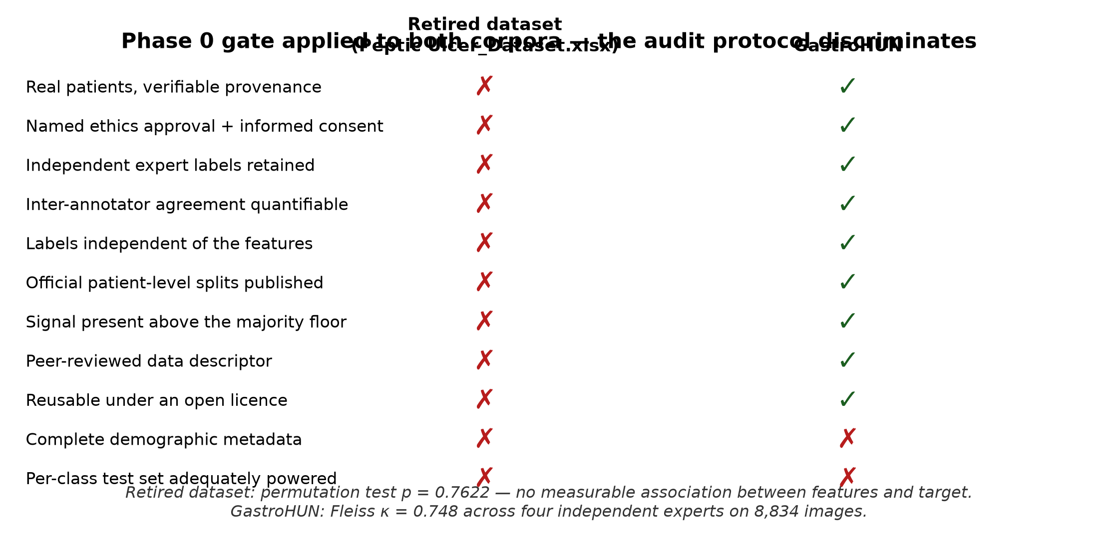
Figure 17. The same Phase 0 criteria applied to the retired corpus and to GastroHUN. The protocol separates the two cleanly, including on the two criteria GastroHUN itself does not meet.
The retired corpus failed on provenance (no verifiable source, no ethics statement), on label construction (the target was derived by regular expressions from the very fields that became the features), and on signal: a permutation test returned p = 0.7622, so the observed feature–target association was indistinguishable from chance. GastroHUN passes all three. That the same protocol nevertheless returns two CONDITIONAL verdicts on GastroHUN, rather than a clean sweep, is itself reassurance that it measures something.

Phase 1 — Literature Review and Problem Framing

Objectives and review questions
The literature review has three objectives. First, to establish what is already known about automatic recognition of gastric anatomical landmarks and about the quality-audit application that motivates it. Second, to establish what is known about inter-observer variability in endoscopy and about the machine-learning methods that exist for learning from disagreeing annotators. Third, to determine, from that evidence, whether the gap identified in Phase 0 is genuinely open.
This review replaces an earlier one in its entirety. The earlier protocol was organised around natural-language processing of free-text endoscopy reports, a research question that was retired with the previous dataset. Its search strings, screening criteria and included studies have no bearing on the present question and none are carried forward. Seven new themes were specified before the search was executed.
Table 17. The seven review themes and the question each addresses.
Theme | Review question
T1 Landmark recognition | How well can deep networks classify gastric anatomical sites, and under what evaluation conditions have those results been obtained?
T2 Quality and blind-spot audit | Does automated monitoring of endoscopic completeness improve measurable procedure quality?
T3 Inter-observer variability | How much do expert endoscopists agree, and how is that agreement conventionally reported?
T4 Noisy and multi-annotator labels | What methods exist for training when annotators disagree, and do they outperform consensus-only training?
T5 Uncertainty and calibration | Can a model's predictive uncertainty be made to reflect genuine ambiguity in the input?
T6 External validation and shift | How far do endoscopic imaging models transfer beyond their development centre?
T7 Reporting standards | What must a diagnostic-AI study report to be assessable, and how well is that standard currently met?

Protocol and search strategy
The review follows PRISMA 2020. One Boolean query was specified per theme against PubMed/MEDLINE through the NCBI E-utilities interface, executed programmatically on 2026-07-26 so that the counts reported here can be reproduced by re-running a single script. The primary date window was 2015–2026, relaxed for the two themes whose foundational literature predates it. A maximum of 220 records per query was retrieved in relevance order.
Table 18. Search yield per theme. Full Boolean strings are reproduced in Appendix A.
Theme | Total hits | Retrieved | Date window
T1 Landmark recognition in UGI endosco | 123 | 123 | 2015–2026
T2 Endoscopic quality & blind-spot aud | 159 | 159 | 2015–2026
T3 Inter-observer variability in endos | 2,977 | 220 | 2005–2026
T4 Noisy / soft / multi-annotator labe | 1,584 | 220 | 2015–2026
T5 Uncertainty & calibration | 3,233 | 220 | 2015–2026
T6 External validation & dataset shift | 2,891 | 220 | 2015–2026
T7 Reporting standards for medical AI | 7,396 | 220 | 2010–2026
Note. Where total hits exceed the retrieval cap, records were taken in PubMed relevance order; this is a stated deviation and is discussed under review limitations.
Screening proceeded in two stages. The title/abstract screen applied language, publication-type and topic filters, together with explicit homonym guards for traps observed during protocol development — most notably that a bare search for the CLAIM reporting checklist also returns papers about insurance claims databases. The eligibility stage then applied theme-specific criteria in which a record must match at least one term in every required term group. A second class of homonym guard was necessary here: the stem 'endoscop' matches drug-induced sleep endoscopy, laryngoscopy and neuroendoscopy, none of which concern the luminal gastrointestinal tract. Records matching those were excluded from the three GI-specific themes and the exclusions counted.

Search results
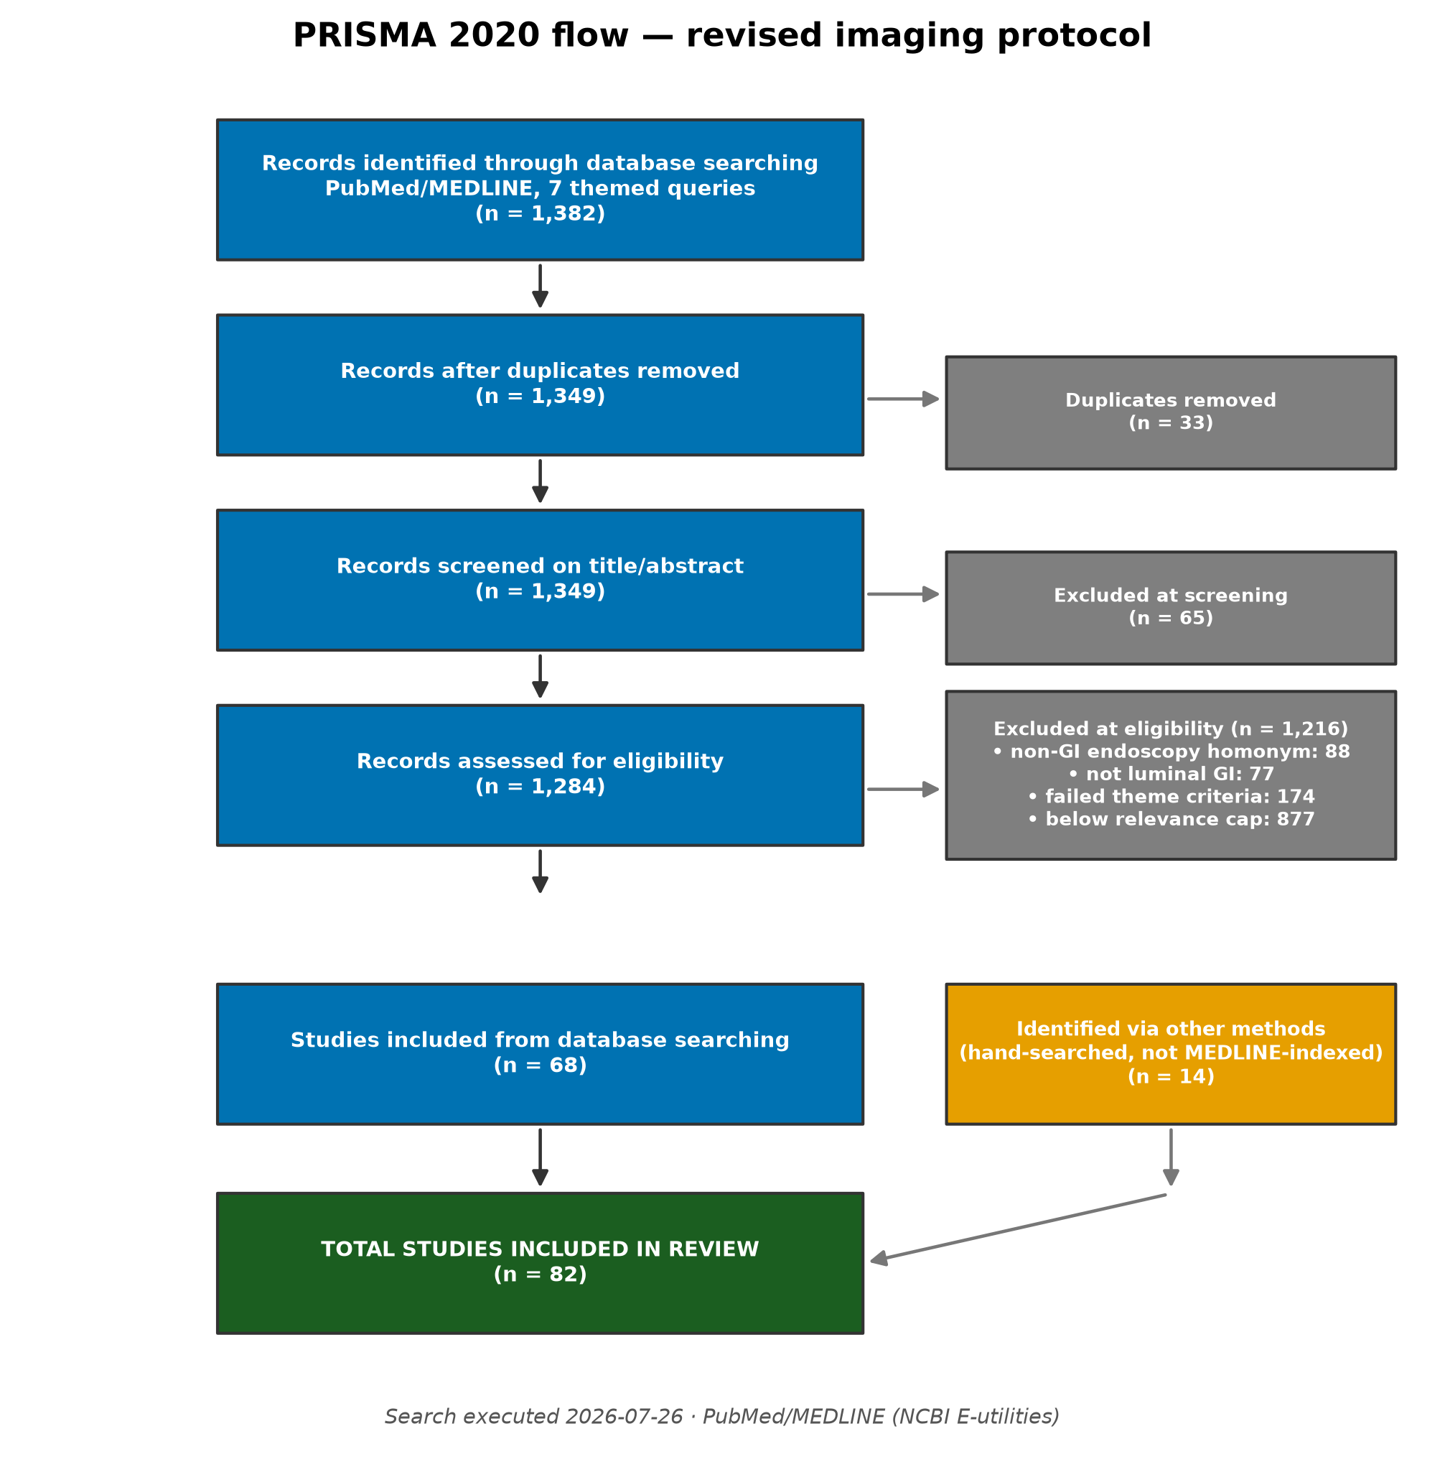
Figure 18. PRISMA 2020 flow diagram for the revised review protocol.
Table 19. PRISMA 2020 stage counts.
PRISMA stage | Records
Identified through database searching (with overlap) | 1,382
Duplicates removed | 33
Records after de-duplication | 1,349
Metadata successfully retrieved | 1,349
Excluded at title/abstract screening | 65
Assessed for eligibility | 1,284
Excluded — non-GI endoscopy homonym | 88
Excluded — not a luminal GI study | 77
Excluded — failed theme eligibility criteria | 174
Excluded — below the per-theme relevance cap | 877
Included from database searching | 68
Included via other methods (hand-searched) | 14
TOTAL INCLUDED IN REVIEW | 82
Note. Exclusion counts reconcile exactly with the number assessed; the build asserts this and fails if it does not.
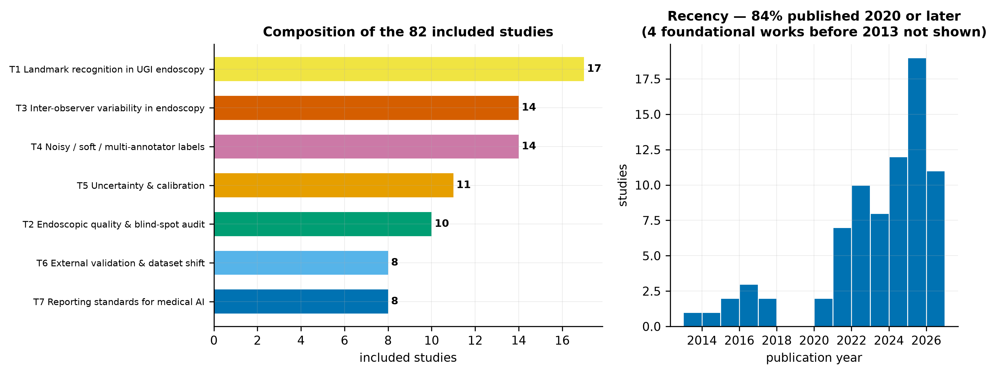
Figure 19. Left: composition of the included studies by theme. Right: publication-year distribution of the studies retrieved by database search.
82 studies were included. 84% were published in 2020 or later, reflecting how recent this field is; the pre-2013 entries are the foundational statistical and architectural works added through the other-methods arm, which are cited for method rather than for findings.
The per-theme relevance cap warrants explicit statement, because it is a deviation from an idealised systematic review. Assessing 1,284 records at full text is not achievable within an undergraduate thesis. A pre-specified cap was therefore applied per theme, with records ranked by a declarative relevance score computed from theme-specific terms and ties broken by recency then by PubMed identifier, so the selection is deterministic and reproducible. The consequence is that this is a systematically conducted but not exhaustive review, and it is described as such throughout.

Thematic synthesis

T1 — Anatomical landmark recognition in upper GI endoscopy
17 studies address the recognition of anatomical sites from endoscopic images. The consistent finding is that modern convolutional and transformer architectures classify gastric landmarks to a level broadly comparable with individual expert endoscopists, provided the evaluation set is clean. Reported accuracies cluster in the mid-eighties to low nineties depending on the number of classes, and the ConvNeXt family recurs as the strongest convolutional backbone.
For the corpus audited in Phase 0, the reference results are those of the dataset descriptor itself. ConvNeXt-Large attains a macro F1 of 88.25 ± 0.22 on the consensus test set; ConvNeXt-Tiny reaches approximately 85 with 28 million parameters against 200 million, a trade-off that matters for the compute budget set out later in this report. A separate experiment in the descriptor trains ConvNeXt-Tiny on the labels agreed by the two residents and reports a macro F1 of 87.05 ± 0.21, which exceeds the 84.82 ± 0.23 obtained when training on the best single annotator's labels — and does so with fewer training images.
Label aggregation matters more than architecture
That last result is the single most important observation in the reviewed literature for this thesis. It shows, on this exact corpus, that how the annotator labels are combined changes performance by more than two F1 points — more than the difference between architecture families. The descriptor reports it as an aside. It is in fact evidence that label aggregation is an underexplored design axis, and it is the direct precedent for the soft-label experiments proposed below.

T2 — Endoscopic quality metrics and blind-spot auditing
10 studies address the clinical application. The rationale is well established: a substantial proportion of early gastric cancers are missed at endoscopy, missed lesions concentrate in particular anatomical regions, and completeness of mucosal inspection is a modifiable determinant of detection. Systematic photodocumentation protocols exist precisely to enforce completeness, and the Japanese SSS protocol with its 22 prescribed images is the most demanding of them.
The reviewed evidence indicates that real-time systems monitoring blind-spot coverage measurably improve procedural quality, with several randomised and multicentre evaluations reporting reduced blind-spot rates and increased detection. This establishes the clinical value of the landmark-classification task: it is not an academic exercise but the perception layer underneath an audit tool. It also sharpens why performance under disagreement matters. An audit system is deployed against a whole procedure, including the images a clinician would find ambiguous, and cannot restrict itself to the subset on which four experts would have concurred.

T3 — Inter-observer variability in endoscopy
14 studies and methodological references address agreement. Imperfect agreement between expert endoscopists is a stable, repeatedly replicated finding across essentially every classification task in gastroenterology — lesion morphology, mucosal cleanliness, staging systems and anatomical assessment alike. Reported kappa values commonly fall in the moderate-to-substantial band, which is where the Phase 0 measurement of 0.748 for this corpus also sits.
Two methodological observations follow from this theme and are applied in Phase 0. First, reporting a single agreement coefficient is poor practice, because the common coefficients have different failure modes under skewed prevalence; the audit therefore reports Fleiss' kappa, Krippendorff's alpha and Gwet's AC1 together and explains their convergence. Second, the literature reports agreement almost exclusively as a data-quality statistic — a number quoted once to establish that labels are trustworthy — and essentially never as an experimental variable that model performance is analysed against. That absence is the methodological space this thesis occupies.

T4 — Learning from noisy, soft and multi-annotator labels
14 studies address the machine-learning response to annotator disagreement. The methods divide into three families. Label-smoothing and soft-target approaches replace the one-hot target with a distribution, which in a multi-annotator setting can be taken directly from the vote proportions. Annotator-modelling approaches learn a per-annotator confusion structure and infer a latent true label. Uncertainty-aware approaches treat disagreement as an explicit training signal, propagating label uncertainty into predictive uncertainty.
The recurring empirical finding is that discarding disagreement is wasteful: models trained on soft or multi-annotator targets are generally better calibrated than those trained on hard consensus labels, and often no worse, sometimes better, on accuracy. Most of this work has been done in segmentation, particularly radiotherapy contouring and histopathology, where multi-reader datasets are more common. Application to endoscopic landmark classification is scarce, which is unsurprising given that GastroHUN is the first public upper-GI dataset to publish per-annotator labels at all.

T5 — Uncertainty quantification and calibration
11 studies and foundational references address whether a model's confidence can be trusted. Modern networks are systematically overconfident; temperature scaling, deep ensembles and Monte Carlo dropout are the established correctives, and conformal prediction offers distribution-free coverage guarantees at the cost of set-valued rather than point predictions. Expected calibration error and reliability diagrams are the standard reporting instruments.
For this thesis the relevant question is narrower and, in the reviewed literature, largely unanswered: does a model's predictive uncertainty align with the specific images on which human experts disagreed? Calibration is nearly always assessed against correctness, not against human ambiguity. A corpus carrying four independent labels permits the stronger test, because the human disagreement level of every individual image is known.

T6 — External validation and dataset shift
8 studies address transfer beyond the development centre. The consistent finding across medical imaging is that performance degrades on external data, sometimes severely, and that single-centre results systematically overstate deployable performance. Endoscopy is particularly exposed because processor vendor, illumination, insufflation practice and operator technique all vary between units and all alter image appearance.
This bears directly on Phase 0 limitation L3. The audited corpus comes from a single Colombian hospital using a single Olympus platform throughout. Any performance figure obtained on it is a single-centre figure. Two public datasets — HyperKvasir and GastroVision — contain upper-GI categories that overlap the SSS landmark set at a coarse level, notably the pylorus, the retroflexed stomach view and the Z-line, and therefore offer a feasible if partial external check.

T7 — Reporting standards for medical AI
8 studies address how diagnostic-AI research should be reported and how well it currently is. The instruments are established — CLAIM for medical imaging AI, TRIPOD+AI for prediction models, STARD for diagnostic accuracy, PROBAST for risk of bias — and the repeated finding of the meta-research studies retrieved here is that adherence is poor. Recurrent omissions are the absence of external validation, incomplete description of the study population, missing detail on how ground truth was established, and no reporting of calibration.
Reporting posture adopted by this thesis
Three of those four recurrent omissions are addressed directly by the design adopted here: ground-truth construction is the central object of study rather than an unexamined input; calibration is a primary endpoint rather than an afterthought; and external validation is a planned phase rather than an aspiration. The fourth — full population description — cannot be met, because the corpus records no demographics, and Phase 0 declares this as limitation L2 rather than passing over it.

Synthesis: what is established, and what is not
Table 20. Synthesis of the review against the Phase 0 findings.
Established by the reviewed literature | Not established
Deep networks classify gastric landmarks at a level comparable to individual experts, on curated evaluation sets. | How that performance behaves on images where experts disagree.
Automated blind-spot and completeness monitoring improves measurable endoscopic quality. | Whether an audit system remains reliable on the ambiguous images it will necessarily encounter in deployment.
Expert endoscopists agree only moderately-to-substantially on classification tasks, including anatomical ones. | Whether the structure of that disagreement is exploitable, rather than merely a nuisance to be averaged away.
Soft and multi-annotator targets improve calibration, mostly demonstrated in segmentation. | Whether they help for endoscopic landmark classification, where per-annotator labels have only just become public.
Model confidence can be calibrated against correctness. | Whether model uncertainty tracks human ambiguity specifically.
Medical imaging models degrade under centre shift. | The magnitude of that degradation for SSS landmark recognition.

The research gap
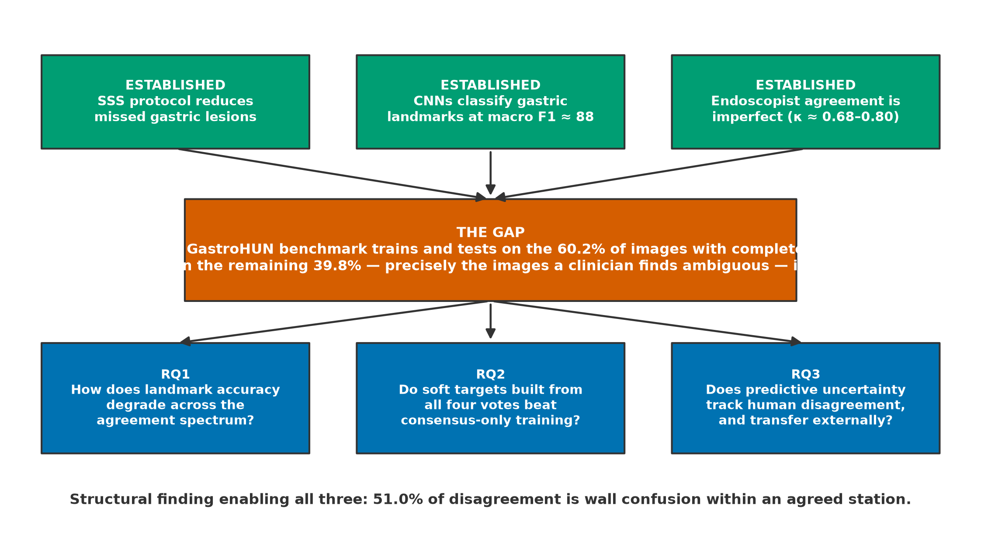
Figure 20. Conceptual framework. Three established bodies of work converge on an unexamined intersection, from which the three research questions follow.
The gap is precise and is stated in the dataset descriptor's own limitations. Every published benchmark on this corpus trains and tests exclusively on images carrying complete four-of-four expert consensus. Phase 0 quantifies what that means: 60.2% of the corpus is retained and 39.8% is discarded, including 614 images (6.95%) for which no majority label exists under any voting rule. Model behaviour on the discarded portion is unmeasured. Because the discarded portion is defined by human ambiguity, it is precisely the portion where an automated second reader would be most valuable and where its failure would be least visible.
Phase 0 also supplies the structural finding that makes the gap tractable rather than merely large. Disagreement is not noise: 51.0% of it is wall confusion within a station both annotators agree on, and confusions overwhelmingly involve circumferentially adjacent walls and neighbouring stations. Because the label space has a known geometry and the disagreement respects it, disagreement can be modelled rather than merely measured.

Research questions and hypotheses
Table 21. Research questions, hypotheses and primary endpoints.
ID | Research question | Hypothesis | Primary endpoint
RQ1 | How does landmark-classification performance vary across strata of expert agreement? | Macro F1 declines monotonically from the unanimous stratum to the no-majority stratum, and the decline is larger than the difference between architecture families. | Macro F1 per agreement stratum, patient-clustered bootstrap 95% CI
RQ2 | Does training on soft targets derived from all four annotator votes outperform training on hard consensus labels? | Soft-target training matches hard-label training on the unanimous stratum and exceeds it on the contested strata, with better calibration throughout. | Macro F1 by stratum; expected calibration error
RQ3 | Does predictive uncertainty track human disagreement, and does it survive a change of centre? | Predictive entropy correlates positively with per-image annotator disagreement, and the ranking is preserved on external data. | Spearman correlation between predictive entropy and annotator vote entropy; external macro F1
Note. Hypotheses are stated before any modelling is performed. Phase 0 deliberately measured no model performance so that these remain genuine predictions.

Proposed Methodology
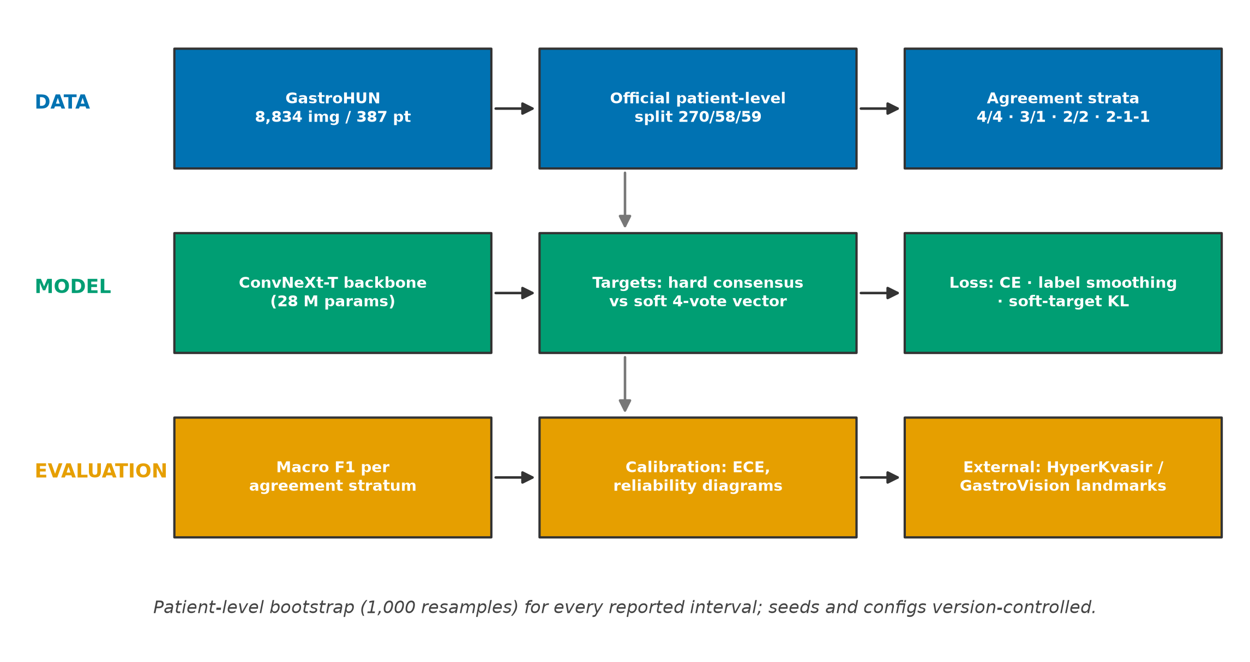
Figure 21. Proposed experimental pipeline across data, model and evaluation layers.

Design
The design is a controlled comparison on a fixed corpus with fixed official splits. The independent variables are the target construction (hard consensus label versus soft four-vote distribution) and the evaluation stratum (agreement level). The dependent variables are macro F1 and calibration error. Because the splits are published and patient-disjoint, and because Phase 0 verified both properties directly, no split construction is required and no opportunity for split-related optimism is introduced.
The evaluation strata are defined a priori from the Phase 0 voting patterns, and are mutually exclusive and exhaustive over the test set.
Table 22. Pre-specified evaluation strata.
Stratum | Definition | Images (whole corpus) | % of corpus
S-unanimous | All four annotators assign the same label | 5,318 | 60.20%
S-majority | Three of four agree | 2,158 | 24.43%
S-plurality | Two agree, the other two differ from them and each other | 744 | 8.42%
S-tied | Two-way tie, no majority | 539 | 6.10%
S-dispersed | All four differ | 75 | 0.85%
Note. For the two strata with no majority label, accuracy is undefined against a single ground truth; performance is scored as agreement with the annotator distribution, and the scoring rule is fixed before any model is run.

Models and training
ConvNeXt-Tiny is adopted as the primary backbone. The choice is driven by the compute budget documented below and is supported by the descriptor's own finding that this architecture reaches within about three F1 points of ConvNeXt-Large at one seventh the parameter count. ImageNet-pretrained weights are used, with a warm-up phase training the classifier head followed by fine-tuning of the upper feature layers, matching the descriptor's protocol so that the reproduction is comparable to the published baseline.
Table 23. Planned training configurations.
Configuration | Target construction | Purpose
C0 — reproduction | Hard label, complete-agreement subset only | Reproduce the published baseline and validate the pipeline
C1 — hard, all data | Majority label where one exists | Isolate the effect of adding contested images
C2 — soft targets | Vote proportions across the four annotators | Test RQ2
C3 — smoothed | Hard label with label smoothing | Control: distinguishes soft-target benefit from generic regularisation
C4 — anatomy-aware | Soft targets plus a wall/station-structured penalty | Exploit the Phase 0 structural finding
Note. C3 exists specifically to prevent a confound: any gain from soft targets must be shown to exceed the gain from ordinary label smoothing.

Evaluation and statistics
Macro-averaged F1 is the primary metric, consistent with the published baseline and appropriate to a near-balanced 23-class problem. All intervals are computed by bootstrap resampling of patients rather than images, because Phase 0 established that agreement varies systematically between patients and that images within a patient are therefore not independent. Calibration is reported as expected calibration error with reliability diagrams. Per-class results are reported but, following Phase 0 limitation L1, are treated as exploratory.

Compute budget and feasibility
The available hardware is a single NVIDIA GeForce GTX 1650 with 4 GB of video memory (Turing, compute capability 7.5). This constrains the design in three ways that are stated here so the plan is honest about what it can deliver.
- ConvNeXt-Tiny at 224×224 fits in 4 GB with mixed-precision training at a batch size of roughly 16–24; gradient accumulation supplies any larger effective batch. ConvNeXt-Large does not fit and is not attempted — the published 88.25 figure is cited as the ceiling, not reproduced.
- Turing supports FP16 tensor cores but not BF16, so automatic mixed precision must use float16 with gradient scaling.
- Deep ensembles, if used for RQ3, must be trained sequentially rather than in parallel; five members at roughly one hour each is tractable, and Monte Carlo dropout is the cheaper fallback.
One practical prerequisite is recorded: the currently installed PyTorch is a CPU-only build, so the GPU is not yet usable and a CUDA build must be installed before Phase 2 begins.

Threats to Validity
The limitations below combine those arising from Phase 0 with those arising from the review protocol. They are stated in full because a reader's ability to discount a finding appropriately depends on knowing what constrains it.
Table 24. Threats to validity and the response adopted for each.
Threat | Type | Assessment | Response
Single-centre, single-vendor corpus | External validity | All images from one Colombian hospital on one Olympus platform; generalisation to other units is untested | External validation on HyperKvasir and GastroVision shared landmarks is a required phase
No demographic data | External validity / reporting | Age and sex absent; population describable only at institutional level | Declared; no subgroup or fairness claim made
Per-class test precision | Statistical conclusion validity | 22/23 classes exceed a ±10 pp Wilson half-width | Macro-averaged primary endpoints; per-class exploratory
Contested strata are small | Statistical conclusion validity | The tied and dispersed strata together are only 6.95% of the corpus | Report stratum sizes with every stratified result; pool the two no-majority strata if power demands
Four annotators is a small panel | Construct validity | Vote proportions from four raters are a coarse estimate of the underlying label distribution | Soft targets treated as an ordinal ambiguity signal, not as a calibrated probability
Annotator idiosyncrasy | Construct validity | Phase 0 found FG2 to be an outlier on every measure; a four-rater mean is sensitive to one atypical rater | Leave-one-annotator-out sensitivity analysis
Review not exhaustive | Review validity | Retrieval capped per query; 877 eligible records fell below the relevance cap | Cap and ranking rule pre-specified, deterministic and reported
Single database | Review validity | PubMed/MEDLINE only; IEEE Xplore, ACM and arXiv not searched | Foundational computer-science work added via the other-methods arm; declared as limitation L5
Perceptual duplicate detection is threshold-dependent | Internal validity | The near-duplicate result depends on a decision rule that had to be calibrated against controls before it was trustworthy | Calibration procedure, controls and visual audit reported in full so the rule can be challenged

Conclusion
Phase 0 subjected the GastroHUN corpus to an eight-criterion integrity gate and the gate returned PROCEED. The corpus is physically intact — 8,834 images decoded without a single failure, no missing or orphan files, no exact duplicates — correctly partitioned at patient level with statistically verified balance, and honestly documented with a named ethics approval and an explicit consent basis. Two criteria returned CONDITIONAL: the consensus test set is underpowered for per-class claims, and the release carries no demographic data. Both are declared as limitations and both constrain the claims the thesis may make without invalidating the corpus.
The audit produced one finding of independent interest. Expert disagreement in this corpus is anatomically structured rather than random: 51.0% of it consists of annotators who agree on the anatomical station but differ on the gastric wall, and confusions overwhelmingly involve adjacent walls and neighbouring stations. Collapsing the label space to station raises mean pairwise kappa from 0.748 to 0.860, while collapsing to wall leaves it unchanged. Endoscopists know how deep the scope is and disagree about which way it points. This is not reported in the dataset descriptor and it converts disagreement from a nuisance into a modellable structure.
Phase 1 established, from 82 included studies, that the three literatures bearing on this problem — landmark recognition, endoscopic quality auditing, and learning from disagreeing annotators — are individually mature and jointly unconnected. Agreement is universally reported as a data-quality statistic and essentially never as a variable that model performance is analysed against. The dataset descriptor states the resulting gap in its own limitations: its results were obtained exclusively on images with complete expert consensus, which 'misses a much more variable real-world scenario'.
That gap is the thesis. Model performance on this corpus has only ever been measured on the 60.2% of images four experts label identically. The remaining 39.8% — the images clinicians themselves find ambiguous, and therefore the images where an automated second reader would matter most and fail least visibly — has never been evaluated. Phases 2 to 5 will measure it, test whether soft targets built from all four votes improve behaviour there, and check whether the result survives a change of centre.
The methodological lesson of this report is narrower and worth stating plainly. The project's previous corpus failed its audit only because the audit was performed at all; the reported accuracy on it was near-perfect and entirely spurious. The same protocol applied to GastroHUN returns a PROCEED with two honest qualifications. Running the gate before the modelling, rather than defending the modelling afterwards, is what separates those two outcomes.

References
82 works, formatted in APA 7th edition. Bibliographic detail for MEDLINE-indexed records was retrieved programmatically from PubMed; hand-searched works are marked in Appendix B.
Adewole, S., Yeghyayan, M., Hyatt, D., Ehsan, L., Jablonski, J., Copland, A., Syed, S., & Brown, D. (2021). Deep Learning Methods for Anatomical Landmark Detection in Video Capsule Endoscopy Images. Proceedings of the Future Technologies Conference (FTC) 2020. Future Technologies Conference (2020 : Online), 1288, 426-434. https://doi.org/10.1007/978-3-030-63128-4_32
Ahn, B. Y., Kim, J. Y., & Chung, H. (2026). Diagnosis of Gastric Intestinal Metaplasia: Histology, Endoscopy, and Artificial Intelligence. Digestion, 1-15. https://doi.org/10.1159/000551238
Antonelli, G., Eelbode, T., Elsaman, T., Sharma, M., Bisschops, R., & Hassan, C. (2025). Building Machine Learning Models in Gastrointestinal Endoscopy. Gastrointestinal endoscopy clinics of North America, 35(2), 279-290. https://doi.org/10.1016/j.giec.2024.07.008
Bharwad, A. V., Ahuja, R., Jain, P., & Wadhwa, V. (2025). Artificial Intelligence in Pancreatobiliary Endoscopy: Current Advances, Opportunities, and Challenges. Journal of clinical medicine, 14(21). https://doi.org/10.3390/jcm14217519
Borgli, H., Thambawita, V., Smedsrud, P. H., & et al. (2020). HyperKvasir, a comprehensive multi-class image and video dataset for gastrointestinal endoscopy. Scientific Data. https://doi.org/10.1038/s41597-020-00622-y
Carmo, D. S., Pezzulo, A. A., Villacreses, R. A., Eisenbeisz, M. L., Anderson, R. L., Dorin, S. E. V., Rittner, L., Lotufo, R. A., Gerard, S. E., Reinhardt, J. M., & Comellas, A. P. (2025). Manual segmentation of opacities and consolidations on CT of long COVID patients from multiple annotators. Scientific data, 12(1), 402. https://doi.org/10.1038/s41597-025-04709-2
Chang, S. S., Shukla, R., Polydorides, A. D., Vila, P. M., Lee, M., Han, H., Kedia, P., Lewis, J., Gonzalez, S., Kim, M. K., Harpaz, N., Godbold, J., Richards-Kortum, R., & Anandasabapathy, S. (2013). High resolution microendoscopy for classification of colorectal polyps. Endoscopy, 45(7), 553-9. https://doi.org/10.1055/s-0032-1326502
Chen, S., Li, Y., Wang, H., Chen, M., Wang, C., Pan, W., Ma, J., Ji, T., Hong, J., Hu, D., Sheng, X., Jiang, J., & Wang, S. (2025). A novel artificial intelligence-based system for quality monitoring during esophagogastroduodenoscopy: a multicenter randomized controlled study. Endoscopy, 57(11), 1185-1194. https://doi.org/10.1055/a-2626-0069
Cohen, J. (1960). A Coefficient of Agreement for Nominal Scales. Educational and Psychological Measurement. https://doi.org/10.1177/001316446002000104
D'Antiga, L., Betalli, P., De Angelis, P., Davenport, M., Di Giorgio, A., McKiernan, P. J., McLin, V., Ravelli, P., Durmaz, O., Talbotec, C., Sturm, E., Woynarowski, M., & Burroughs, A. K. (2015). Interobserver Agreement on Endoscopic Classification of Oesophageal Varices in Children. Journal of pediatric gastroenterology and nutrition, 61(2), 176-81. https://doi.org/10.1097/MPG.0000000000000822
Darby, P., Kilgour, E., Then, C. K., Bromiley, A., McLellan, J., & Kiltie, A. E. (2026). Inter-observer variability in radiotherapy contouring with the use of autocontouring software: A systematic review. Clinical and translational radiation oncology, 58, 101144. https://doi.org/10.1016/j.ctro.2026.101144
Del Amor, R., Silva-Rodríguez, J., & Naranjo, V. (2023). Labeling confidence for uncertainty-aware histology image classification. Computerized medical imaging and graphics : the official journal of the Computerized Medical Imaging Society, 107, 102231. https://doi.org/10.1016/j.compmedimag.2023.102231
Djinbachian, R., Alj, A., Medawar, E., Pioche, M., Saito, Y., Sethi, A., Chiu, P., Marks, J., Sebajang, H., Pawlak, K., Chennouf, A., Benard, F., Ide, Y., Dang, F., & von Renteln, D. (2025). Interobserver Agreement for the Paris Classification of Colorectal Lesions Amongst Surgeons, Gastroenterologists, Trainees and Experts: A Video-Based Study. Digestive diseases and sciences, 70(12), 4122-4129. https://doi.org/10.1007/s10620-025-09215-4
Dong, Z., Wu, L., Du, H., Tao, X., Wang, J., Zeng, X., Zhu, Y., Tan, S., Wang, J., Deng, M., Yang, T., Chen, C., Wen, L., Li, Y., Jiang, C., Tang, C., Wang, Y., Zhao, Z., Wang, Q., .. Yu, H. (2026). Effect of a Computer-Aided Device for Detecting Gastric Neoplasms: A Multicenter, Randomized Controlled Trial. Gastroenterology, 170(7), 1518-1532. https://doi.org/10.1053/j.gastro.2025.12.020
Dosovitskiy, A., Beyer, L., Kolesnikov, A., & et al. (2021). An Image is Worth 16x16 Words: Transformers for Image Recognition at Scale. International Conference on Learning Representations (ICLR). https://doi.org/10.48550/arXiv.2010.11929
Esposito, G., Dilaghi, E., Costa-Santos, C., Ligato, I., Annibale, B., Dinis-Ribeiro, M., & Areia, M. (2025). The Gastroscopy RAte of Cleanliness Evaluation (GRACE) Scale: an international reliability and validation study. Endoscopy, 57(4), 312-320. https://doi.org/10.1055/a-2422-0856
Fayyad, J., Alijani, S., & Najjaran, H. (2024). Empirical validation of Conformal Prediction for trustworthy skin lesions classification. Computer methods and programs in biomedicine, 253, 108231. https://doi.org/10.1016/j.cmpb.2024.108231
Fleiss, J. L. (1971). Measuring nominal scale agreement among many raters. Psychological Bulletin. https://doi.org/10.1037/h0031619
Gal, Y., & Ghahramani, Z. (2016). Dropout as a Bayesian Approximation: Representing Model Uncertainty in Deep Learning. Proceedings of the 33rd International Conference on Machine Learning (ICML). https://doi.org/10.48550/arXiv.1506.02142
Gangi-Burton, A., Plumb, A. A., De Paepe, K. N., Godfrey, E. M., Halligan, S., Higginson, A., Khwaja, S., Patel, A., & Taylor, S. (2024). Paris classification of colonic polyps using CT colonography: prospective cohort study of interobserver variation. European radiology, 34(10), 6877-6884. https://doi.org/10.1007/s00330-024-10631-9
Gao, Z., Wittrup, E., & Najarian, K. (2024). Leveraging Multi-Annotator Label Uncertainties as Privileged Information for Acute Respiratory Distress Syndrome Detection in Chest X-ray Images. Bioengineering (Basel, Switzerland), 11(2). https://doi.org/10.3390/bioengineering11020133
Gete, K. Y., & Ayele, A. A. (2025). Deep-learning-based non-contrast CT for detecting acute ischemic stroke: a systematic review and HSROC meta-analysis of patient-level diagnostic accuracy. BMC neurology, 25(1), 507. https://doi.org/10.1186/s12883-025-04528-3
Gong, E. J., Bang, C. S., & Lee, J. J. (2024). Edge Artificial Intelligence Device in Real-Time Endoscopy for Classification of Gastric Neoplasms: Development and Validation Study. Biomimetics (Basel, Switzerland), 9(12). https://doi.org/10.3390/biomimetics9120783
Gong, E. J., Woo, J., Lee, J. J., & Bang, C. S. (2025). Role of artificial intelligence in gastric diseases. World journal of gastroenterology, 31(37), 111327. https://doi.org/10.3748/wjg.v31.i37.111327
Guimarães, P., Finkler, H., Reichert, M. C., Zimmer, V., Grünhage, F., Krawczyk, M., Lammert, F., Keller, A., & Casper, M. (2023). Artificial-intelligence-based decision support tools for the differential diagnosis of colitis. European journal of clinical investigation, 53(6), e13960. https://doi.org/10.1111/eci.13960
Guo, C., Pleiss, G., Sun, Y., & Weinberger, K. Q. (2017). On Calibration of Modern Neural Networks. Proceedings of the 34th International Conference on Machine Learning (ICML). https://doi.org/10.48550/arXiv.1706.04599
Gupta, S., Mandarino, F. V., Shahidi, N., Hourigan, L. F., Messmann, H., Wallace, M. B., Repici, A., Dinis-Ribeiro, M., Haber, G. B., Taylor, A. C. F., Waxman, I., Siersema, P. D., Pouw, R. E., Lemmers, A., Bisschops, R., Mosko, J. D., Teshima, C., Ragunath, K., Rösch, T., .. Bourke, M. J. (2025). Can optical evaluation distinguish between T1a and T1b esophageal adenocarcinoma: an international expert interobserver agreement study. Endoscopy, 57(3), 200-207. https://doi.org/10.1055/a-2399-1401
Gwet, K. L. (2008). Computing inter-rater reliability and its variance in the presence of high agreement. British Journal of Mathematical and Statistical Psychology. https://doi.org/10.1348/000711006X126600
Hayes, A. F., & Krippendorff, K. (2007). Answering the Call for a Standard Reliability Measure for Coding Data. Communication Methods and Measures. https://doi.org/10.1080/19312450709336664
He, C., Xu, H., Yuan, E., Ye, L., Chen, Y., Yao, J., & Song, B. (2024). The accuracy and quality of image-based artificial intelligence for muscle-invasive bladder cancer prediction. Insights into imaging, 15(1), 185. https://doi.org/10.1186/s13244-024-01780-y
He, K., Zhang, X., Ren, S., & Sun, J. (2016). Deep Residual Learning for Image Recognition. Proceedings of the IEEE Conference on Computer Vision and Pattern Recognition (CVPR). https://doi.org/10.1109/CVPR.2016.90
Hinton, G., Vinyals, O., & Dean, J. (2015). Distilling the Knowledge in a Neural Network. NeurIPS Deep Learning and Representation Learning Workshop. https://doi.org/10.48550/arXiv.1503.02531
Hou, C., Li, S., Zheng, S., Liu, L. P., Nie, F., Zhang, W., & He, W. (2024). Quality assessment of radiomics models in carotid plaque: a systematic review. Quantitative imaging in medicine and surgery, 14(1), 1141-1154. https://doi.org/10.21037/qims-23-712
Isajevs, S., Liepniece-Karele, I., Janciauskas, D., Moisejevs, G., Putnins, V., Funka, K., Kikuste, I., Vanags, A., Tolmanis, I., & Leja, M. (2014). Gastritis staging: interobserver agreement by applying OLGA and OLGIM systems. Virchows Archiv : an international journal of pathology, 464(4), 403-7. https://doi.org/10.1007/s00428-014-1544-3
Ishida, K., Sasaki, K., Ono, K., & Hirokawa, Y. (2026). Uncertainty-aware deep learning for classifying colonic fdg-pet uptake using radiomic features. Radiological physics and technology, 19(2), 711-720. https://doi.org/10.1007/s12194-026-01044-y
Jaiswal, A., Ashutosh, K., Rousseau, J. F., Peng, Y., Wang, Z., & Ding, Y. (2022). RoS-KD: A Robust Stochastic Knowledge Distillation Approach for Noisy Medical Imaging. Proceedings. IEEE International Conference on Data Mining, 2022, 981-986. https://doi.org/10.1109/icdm54844.2022.00118
Jha, D., Sharma, V., Dasu, N., & et al. (2023). GastroVision: A Multi-class Endoscopy Image Dataset for Computer Aided Gastrointestinal Disease Detection. ICML Workshop on Machine Learning for Multimodal Healthcare Data. https://doi.org/10.1007/978-3-031-47679-2_10
Ju, L., Wang, X., Wang, L., Mahapatra, D., Zhao, X., Zhou, Q., Liu, T., & Ge, Z. (2022). Improving Medical Images Classification With Label Noise Using Dual-Uncertainty Estimation. IEEE transactions on medical imaging, 41(6), 1533-1546. https://doi.org/10.1109/TMI.2022.3141425
Khan, Z., & Tahir, M. A. (2023). Real time anatomical landmarks and abnormalities detection in gastrointestinal tract. PeerJ. Computer science, 9, e1685. https://doi.org/10.7717/peerj-cs.1685
Küstner, T., Hammernik, K., Rueckert, D., Hepp, T., & Gatidis, S. (2024). Predictive uncertainty in deep learning-based MR image reconstruction using deep ensembles: Evaluation on the fastMRI data set. Magnetic resonance in medicine, 92(1), 289-302. https://doi.org/10.1002/mrm.30030
Lakshminarayanan, B., Pritzel, A., & Blundell, C. (2017). Simple and Scalable Predictive Uncertainty Estimation using Deep Ensembles. Advances in Neural Information Processing Systems (NeurIPS) 30. https://doi.org/10.48550/arXiv.1612.01474
Lee, D., Jesry, F., Maliekkal, J. J., Goulder, L., Huntly, B., Smith, A. M., & Khaled, Y. S. (2025). Application of Artificial Intelligence in Pancreatic Cyst Management: A Systematic Review. Cancers, 17(15). https://doi.org/10.3390/cancers17152558
Lee, J. Y., Park, J., Lee, H. J., Park, H., Jin, E. H., Park, K., Baek, J. E., Yang, D. H., Hong, S. W., Kim, N., & Byeon, J. S. (2024). Automatic assessment of bowel preparation by an artificial intelligence model and its clinical applicability. Journal of gastroenterology and hepatology, 39(9), 1917-1923. https://doi.org/10.1111/jgh.16618
Li, D., Cave, D., Li, A., & Li, S. (2024). Enhanced accuracy for classification of video capsule endoscopy images using multiple deep learning convolutional neural networks. iGIE : innovation, investigation and insights, 3(1), 72-81. https://doi.org/10.1016/j.igie.2023.11.007
Li, J., Jing, X., Zhang, Q., Wang, X., Wang, L., Shan, J., Zhou, Z., Fan, L., Gong, X., Sun, X., & He, S. (2025). Multimodal artificial intelligence for subepithelial lesion classification and characterization: a multicenter comparative study (with video). BMC medical informatics and decision making, 25(1), 307. https://doi.org/10.1186/s12911-025-03147-9
Li, X., Wei, Y., Hu, Q., Wang, C., & Yang, J. (2022). Learning to segment subcortical structures from noisy annotations with a novel uncertainty-reliability aware learning framework. Computers in biology and medicine, 151(Pt B), 106326. https://doi.org/10.1016/j.compbiomed.2022.106326
Li, Y. D., Li, H. Z., Chen, S. S., Jin, C. H., Chen, M., Cheng, M., Ma, M. J., Zhang, X. P., Wang, X., Zhou, J. B., Chen, M. T., Chen, J. N., Yu, S., Wang, T. J., Fang, W. P., Cao, X. W., Yu, X. J., Du, L. B., & Wang, S. (2022). Correlation of the detection rate of upper GI cancer with artificial intelligence score: results from a multicenter trial (with video). Gastrointestinal endoscopy, 95(6), 1138-1146.e2. https://doi.org/10.1016/j.gie.2021.12.019
Li, Y. D., Zhu, S. W., Yu, J. P., Ruan, R. W., Cui, Z., Li, Y. T., Lv, M. C., Wang, H. G., Chen, M., Jin, C. H., & Wang, S. (2021). Intelligent detection endoscopic assistant: An artificial intelligence-based system for monitoring blind spots during esophagogastroduodenoscopy in real-time. Digestive and liver disease : official journal of the Italian Society of Gastroenterology and the Italian Association for the Study of the Liver, 53(2), 216-223. https://doi.org/10.1016/j.dld.2020.11.017
Liu, X., Xing, F., Marin, T., Fakhri, G. E., & Woo, J. (2022). Variational Inference for Quantifying Inter-observer Variability in Segmentation of Anatomical Structures. Proceedings of SPIE--the International Society for Optical Engineering, 12032. https://doi.org/10.1117/12.2604547
Liu, Z., Mao, H., Wu, C.-Y., Feichtenhofer, C., Darrell, T., & Xie, S. (2022). A ConvNet for the 2020s. Proceedings of the IEEE/CVF Conference on Computer Vision and Pattern Recognition (CVPR). https://doi.org/10.1109/CVPR52688.2022.01167
Long, F., Zhang, H., Zhang, S., Dong, Z., Huang, X., & Hu, R. (2026). Machine learning applications in the detection and treatment of esophageal cancer. Discover oncology, 17(1). https://doi.org/10.1007/s12672-026-05477-0
Lopes, I., Almeida, E., Libanio, D., Dinis-Ribeiro, M., Coimbra, M., & Renna, F. (2025). On the impact of input resolution on CNN-based gastrointestinal endoscopic image classification. Annual International Conference of the IEEE Engineering in Medicine and Biology Society. IEEE Engineering in Medicine and Biology Society. Annual International Conference, 2025, 1-4. https://doi.org/10.1109/EMBC58623.2025.11254367
Mahmood, S., Fareed, M. M. S., Ahmed, G., Dawood, F., Zikria, S., Mostafa, A., Jilani, S. F., Asad, M., & Aslam, M. (2022). A Robust Deep Model for Classification of Peptic Ulcer and Other Digestive Tract Disorders Using Endoscopic Images. Biomedicines, 10(9). https://doi.org/10.3390/biomedicines10092195
Maida, M., Vitello, A., Macaluso, F. S., Daperno, M., Mocci, G., Rispo, A., Calabrese, G., Decarli, N. L., Laschi, L., Fattorini, C., Locci, G., Sordo, R. D., Ligresti, D., Tacelli, M., Furnari, M., Sferrazza, S., Marasco, G., Facciorusso, A., Orlando, A., & Villanacci, V. (2026). Performance of GPT-5 in the Interpretation of IBD Histopathology Reports. United European gastroenterology journal, 14(1), e70161. https://doi.org/10.1002/ueg2.70161
Moore, M., & Sharma, P. (2021). Updates in artificial intelligence in gastroenterology endoscopy in 2020. Current opinion in gastroenterology, 37(5), 428-433. https://doi.org/10.1097/MOG.0000000000000774
Mäenpää, S. M., & Korja, M. (2024). Diagnostic test accuracy of externally validated convolutional neural network (CNN) artificial intelligence (AI) models for emergency head CT scans - A systematic review. International journal of medical informatics, 189, 105523. https://doi.org/10.1016/j.ijmedinf.2024.105523
Nagendran, M., Chen, Y., Lovejoy, C. A., Gordon, A. C., Komorowski, M., Harvey, H., Topol, E. J., Ioannidis, J. P. A., Collins, G. S., & Maruthappu, M. (2020). Artificial intelligence versus clinicians: systematic review of design, reporting standards, and claims of deep learning studies. BMJ (Clinical research ed.), 368, m689. https://doi.org/10.1136/bmj.m689
Nezhad, S. A., Tajeddin, G., Khatibi, T., & Sohrabi, M. (2025). Self-supervised learning framework for efficient classification of endoscopic images using pretext tasks. PloS one, 20(5), e0322028. https://doi.org/10.1371/journal.pone.0322028
Peluso, A., Danciu, I., Yoon, H. J., Yusof, J. M., Bhattacharya, T., Spannaus, A., Schaefferkoetter, N., Durbin, E. B., Wu, X. C., Stroup, A., Doherty, J., Schwartz, S., Wiggins, C., Coyle, L., Penberthy, L., Tourassi, G. D., & Gao, S. (2024). Deep learning uncertainty quantification for clinical text classification. Journal of biomedical informatics, 149, 104576. https://doi.org/10.1016/j.jbi.2023.104576
Putera, M., Koh, F. H. X., & Li, J. W. (2026). Controversies in Computer-Assisted Detection in Colonoscopy. Digestion, 1-14. https://doi.org/10.1159/000550268
Qin, J., Ma, L., Zhou, M. Y., Li, W. B., Xiao, M. S., Niu, Z. H., Yang, H., & Zhu, Q. L. (2025). Determining the Accuracy and Interobserver Agreement of 4 Ultrasound Scores in Crohn's Disease Assessment: Correlations With Endoscopy. Clinical and translational gastroenterology, 16(4), e00812. https://doi.org/10.14309/ctg.0000000000000812
Quek, S. X. Z., Lee, J. W. J., Feng, Z., Soh, M. M., Tokano, M., Guan, Y. K., So, J. B. Y., Tada, T., & Koh, C. J. (2023). Comparing artificial intelligence to humans for endoscopic diagnosis of gastric neoplasia: An external validation study. Journal of gastroenterology and hepatology, 38(9), 1587-1591. https://doi.org/10.1111/jgh.16274
Rashidisabet, H., Chan, R. V. P., Leiderman, Y. I., Vajaranant, T. S., & Yi, D. (2025). Robust Uncertainty-Informed Glaucoma Classification Under Data Shift. Translational vision science & technology, 14(6), 3. https://doi.org/10.1167/tvst.14.6.3
Riera-Marín, M., O K, S., Rodríguez-Comas, J., May, M. S., Pan, Z., Zhou, X., Liang, X., Erick, F. X., Prenner, A., Hémon, C., Boussot, V., Dillenseger, J. L., Nunes, J. C., Qayyum, A., Mazher, M., Niederer, S. A., Kushibar, K., Martín-Isla, C., Radeva, P., .. Galdrán, A. (2025). Calibration and Uncertainty for multiRater Volume Assessment in multiorgan Segmentation (CURVAS) challenge results. Computers in biology and medicine, 197(Pt B), 111024. https://doi.org/10.1016/j.compbiomed.2025.111024
Scheppach, M. W., Rauber, D., Stallhofer, J., Muzalyova, A., Otten, V., Manzeneder, C., Schwamberger, T., Wanzl, J., Schlottmann, J., Tadic, V., Probst, A., Schnoy, E., Römmele, C., Fleischmann, C., Meinikheim, M., Miller, S., Märkl, B., Stallmach, A., Palm, C., .. Ebigbo, A. (2023). Detection of duodenal villous atrophy on endoscopic images using a deep learning algorithm. Gastrointestinal endoscopy, 97(5), 911-916. https://doi.org/10.1016/j.gie.2023.01.006
Schott, B., Santoro-Fernandes, V., Klaneček, Ž., Perlman, S., & Jeraj, R. (2025). Uncertainty quantification for deep learning-based metastatic lesion segmentation on whole body PET/CT. Physics in medicine and biology, 70(11). https://doi.org/10.1088/1361-6560/add9df
Smiley, A., Villarreal-Zegarra, D., Reategui-Rivera, C. M., Escobar-Agreda, S., & Finkelstein, J. (2025). Methodological and reporting quality of machine learning studies on cancer diagnosis, treatment, and prognosis. Frontiers in oncology, 15, 1555247. https://doi.org/10.3389/fonc.2025.1555247
Spadaccini, M., Iannone, A., Maselli, R., Badalamenti, M., Desai, M., Chandrasekar, V. T., Patel, H. K., Fugazza, A., Pellegatta, G., Galtieri, P. A., Lollo, G., Carrara, S., Anderloni, A., Rex, D. K., Savevski, V., Wallace, M. B., Bhandari, P., Roesch, T., Gralnek, I. M., .. Repici, A. (2021). Computer-aided detection versus advanced imaging for detection of colorectal neoplasia: a systematic review and network meta-analysis. The lancet. Gastroenterology & hepatology, 6(10), 793-802. https://doi.org/10.1016/S2468-1253(21)00215-6
Srivastava, A., Tomar, N. K., Bagci, U., & Jha, D. (2022). Video Capsule Endoscopy Classification using Focal Modulation Guided Convolutional Neural Network. Proceedings. IEEE International Symposium on Computer-Based Medical Systems, 2022, 323-328. https://doi.org/10.1109/CBMS55023.2022.00064
Szegedy, C., Vanhoucke, V., Ioffe, S., Shlens, J., & Wojna, Z. (2016). Rethinking the Inception Architecture for Computer Vision. Proceedings of the IEEE Conference on Computer Vision and Pattern Recognition (CVPR). https://doi.org/10.1109/CVPR.2016.308
Thibodeau-Antonacci, A., Garant, A., Miller, C., Vuong, T., Weishaupt, L. L., Nicolaï, P., & Enger, S. A. (2026). Deep learning-based automatic segmentation of rectal tumors in endoscopic images. Brachytherapy, S1538-4721(26)00072-3. https://doi.org/10.1016/j.brachy.2026.04.013
Tveter, M., Tveitstøl, T., Hatlestad-Hall, C., Hammer, H. L., & Haraldsen, I. R. J. H. (2026). Uncertainty in deep learning for EEG under dataset shifts. Artificial intelligence in medicine, 174, 103374. https://doi.org/10.1016/j.artmed.2026.103374
Vahdani, A. M., Shariatnia, M., Rajpurkar, P., & Pareek, A. (2025). Towards trustworthy artificial intelligence in musculoskeletal medicine: A narrative review on uncertainty quantification. Knee surgery, sports traumatology, arthroscopy : official journal of the ESSKA, 33(9), 3418-3437. https://doi.org/10.1002/ksa.12737
Wang, H., Wang, K., Yan, T., Zhou, H., Cao, E., Lu, Y., Wang, Y., Luo, J., & Pang, Y. (2023). Endoscopic image classification algorithm based on Poolformer. Frontiers in neuroscience, 17, 1273686. https://doi.org/10.3389/fnins.2023.1273686
Wang, X., Shen, D., Zhao, Y., Xing, J., Liu, J., Zhou, R., Yang, C., Liu, C., Ma, X., Ge, J., Zhang, H., Yuan, W., Zhang, H., Ma, Y., Hu, P., Zuo, X., Li, Y., & Li, Z. (2026). Impact of a real-time automatic quality control system for magnetically controlled capsule gastroscopy: a multicenter randomized controlled trial. BMC medicine, 24(1). https://doi.org/10.1186/s12916-026-04901-0
Wu, L., He, X., Liu, M., Xie, H., An, P., Zhang, J., Zhang, H., Ai, Y., Tong, Q., Guo, M., Huang, M., Ge, C., Yang, Z., Yuan, J., Liu, J., Zhou, W., Jiang, X., Huang, X., Mu, G., .. Yu, H. (2021). Evaluation of the effects of an artificial intelligence system on endoscopy quality and preliminary testing of its performance in detecting early gastric cancer: a randomized controlled trial. Endoscopy, 53(12), 1199-1207. https://doi.org/10.1055/a-1350-5583
Xu, C., Zhu, Y., Wu, L., Yu, H., Liu, J., Zhou, F., Xiong, Q., Wang, S., Cui, S., Huang, X., Yin, A., Xu, T., Lei, S., & Xia, Z. (2022). Evaluating the effect of an artificial intelligence system on the anesthesia quality control during gastrointestinal endoscopy with sedation: a randomized controlled trial. BMC anesthesiology, 22(1), 313. https://doi.org/10.1186/s12871-022-01796-1
Xu, Z., Wang, Y., Lu, D., Luo, X., Yan, J., Zheng, Y., & Tong, R. K. (2023). Ambiguity-selective consistency regularization for mean-teacher semi-supervised medical image segmentation. Medical image analysis, 88, 102880. https://doi.org/10.1016/j.media.2023.102880
Yan, S., Zhang, P., Qiao, W., Xie, S., Hu, H., Gao, Y., Xie, L., & Jing, J. (2026). Machine Learning for Intraoperative Bleeding Prediction in Patients Undergoing Surgery: Scoping Review. JMIR medical informatics, 14, e80930. https://doi.org/10.2196/80930
Yao, L., Liu, J., Wu, L., Zhang, L., Hu, X., Liu, J., Lu, Z., Gong, D., An, P., Zhang, J., Hu, G., Chen, D., Luo, R., Hu, S., Yang, Y., & Yu, H. (2021). A Gastrointestinal Endoscopy Quality Control System Incorporated With Deep Learning Improved Endoscopist Performance in a Pretest and Post-Test Trial. Clinical and translational gastroenterology, 12(6), e00366. https://doi.org/10.14309/ctg.0000000000000366
Yoshida, M., Kitaguchi, D., Takeshita, N., Matsuzaki, H., Ishikawa, Y., Yura, M., Akimoto, T., Kinoshita, T., & Ito, M. (2024). Surgical step recognition in laparoscopic distal gastrectomy using artificial intelligence: a proof-of-concept study. Langenbeck's archives of surgery, 409(1), 213. https://doi.org/10.1007/s00423-024-03411-y
Zhou, Q., He, T., & Zou, Y. (2022). Superpixel-Oriented Label Distribution Learning for Skin Lesion Segmentation. Diagnostics (Basel, Switzerland), 12(4). https://doi.org/10.3390/diagnostics12040938

Appendix A — Search strings
Verbatim Boolean strings submitted to the NCBI E-utilities esearch endpoint. Reproducing the counts in this report requires only these strings, the stated date windows and the retrieval cap.

T1 Landmark recognition in UGI endoscopy
(endoscopy[All Fields] OR gastroscopy[All Fields] OR "esophagogastroduodenoscopy"[All Fields] OR EGD[All Fields] OR "upper gastrointestinal"[All Fields]) AND ("anatomical site"[All Fields] OR "anatomical landmark"[All Fields] OR "anatomical classification"[All Fields] OR "site recognition"[All Fields] OR "landmark classification"[All Fields] OR "gastric sites"[All Fields] OR "image classification"[All Fields]) AND ("deep learning"[All Fields] OR "convolutional neural network"[All Fields] OR "artificial intelligence"[All Fields] OR "machine learning"[All Fields])
Window 2015–2026; 123 hits; 123 retrieved.

T2 Endoscopic quality & blind-spot audit
(endoscopy[All Fields] OR gastroscopy[All Fields] OR "esophagogastroduodenoscopy"[All Fields]) AND ("blind spot"[All Fields] OR "blind spots"[All Fields] OR "photodocumentation"[All Fields] OR "quality control"[All Fields] OR "quality indicator"[All Fields] OR "completeness"[All Fields] OR "systematic screening protocol"[All Fields] OR "mucosal exposure"[All Fields]) AND ("deep learning"[All Fields] OR "artificial intelligence"[All Fields] OR "neural network"[All Fields] OR "monitoring system"[All Fields])
Window 2015–2026; 159 hits; 159 retrieved.

T3 Inter-observer variability in endoscopy
(endoscopy[All Fields] OR gastroscopy[All Fields] OR gastrointestinal[All Fields]) AND ("interobserver"[All Fields] OR "inter-observer"[All Fields] OR "interrater"[All Fields] OR "inter-rater"[All Fields] OR "observer variation"[MeSH Terms] OR "observer agreement"[All Fields]) AND (kappa[All Fields] OR agreement[All Fields] OR reliability[All Fields] OR variability[All Fields])
Window 2005–2026; 2,977 hits; 220 retrieved.

T4 Noisy / soft / multi-annotator labels
("noisy labels"[All Fields] OR "label noise"[All Fields] OR "soft labels"[All Fields] OR "soft label"[All Fields] OR "multiple annotators"[All Fields] OR "multi-annotator"[All Fields] OR "annotator disagreement"[All Fields] OR "label uncertainty"[All Fields] OR "crowdsourced labels"[All Fields] OR "inter-observer variability"[All Fields]) AND ("deep learning"[All Fields] OR "machine learning"[All Fields] OR "neural network"[All Fields] OR "medical imaging"[All Fields] OR "segmentation"[All Fields] OR "classification"[All Fields])
Window 2015–2026; 1,584 hits; 220 retrieved.

T5 Uncertainty & calibration
("uncertainty quantification"[All Fields] OR "predictive uncertainty"[All Fields] OR "model calibration"[All Fields] OR "calibration"[All Fields] OR "conformal prediction"[All Fields] OR "selective prediction"[All Fields] OR "deep ensembles"[All Fields] OR "Monte Carlo dropout"[All Fields]) AND ("medical imaging"[All Fields] OR "medical image"[All Fields] OR "clinical"[All Fields] OR "diagnosis"[All Fields]) AND ("deep learning"[All Fields] OR "neural network"[All Fields] OR "artificial intelligence"[All Fields])
Window 2015–2026; 3,233 hits; 220 retrieved.

T6 External validation & dataset shift
("external validation"[All Fields] OR "generalisability"[All Fields] OR "generalizability"[All Fields] OR "dataset shift"[All Fields] OR "distribution shift"[All Fields] OR "domain shift"[All Fields] OR "multicenter validation"[All Fields] OR "out-of-distribution"[All Fields]) AND ("medical imaging"[All Fields] OR "medical image"[All Fields] OR "endoscopy"[All Fields] OR "diagnostic accuracy"[All Fields]) AND ("deep learning"[All Fields] OR "artificial intelligence"[All Fields] OR "machine learning"[All Fields])
Window 2015–2026; 2,891 hits; 220 retrieved.

T7 Reporting standards for medical AI
(CLAIM[All Fields] OR "TRIPOD"[All Fields] OR "STARD"[All Fields] OR "PROBAST"[All Fields] OR "CONSORT-AI"[All Fields] OR "SPIRIT-AI"[All Fields] OR "reporting guideline"[All Fields] OR "checklist"[All Fields]) AND ("artificial intelligence"[All Fields] OR "machine learning"[All Fields] OR "deep learning"[All Fields] OR "prediction model"[All Fields] OR "diagnostic accuracy"[All Fields])
Window 2010–2026; 7,396 hits; 220 retrieved.

Appendix B — Included studies
Table 25. All 82 studies included in the review.
Theme | Year | First author | Title | Source
T1 Landmark recognition in | 2025 | Lopes, I. | On the impact of input resolution on CNN-based gastrointestinal endoscopic | db
T1 Landmark recognition in | 2025 | Nezhad, S. A. | Self-supervised learning framework for efficient classification of endosco | db
T1 Landmark recognition in | 2024 | Gong, E. J. | Edge Artificial Intelligence Device in Real-Time Endoscopy for Classificat | db
T1 Landmark recognition in | 2024 | Li, D. | Enhanced accuracy for classification of video capsule endoscopy images usi | db
T1 Landmark recognition in | 2024 | Yoshida, M. | Surgical step recognition in laparoscopic distal gastrectomy using artific | db
T1 Landmark recognition in | 2023 | Guimarães, P. | Artificial-intelligence-based decision support tools for the differential | db
T1 Landmark recognition in | 2023 | Jha, D. | GastroVision: A Multi-class Endoscopy Image Dataset for Computer Aided Gas | hand
T1 Landmark recognition in | 2023 | Khan, Z. | Real time anatomical landmarks and abnormalities detection in gastrointest | db
T1 Landmark recognition in | 2023 | Wang, H. | Endoscopic image classification algorithm based on Poolformer. | db
T1 Landmark recognition in | 2022 | Liu, Z. | A ConvNet for the 2020s | hand
T1 Landmark recognition in | 2022 | Mahmood, S. | A Robust Deep Model for Classification of Peptic Ulcer and Other Digestive | db
T1 Landmark recognition in | 2022 | Srivastava, A. | Video Capsule Endoscopy Classification using Focal Modulation Guided Convo | db
T1 Landmark recognition in | 2021 | Adewole, S. | Deep Learning Methods for Anatomical Landmark Detection in Video Capsule E | db
T1 Landmark recognition in | 2021 | Dosovitskiy, A. | An Image is Worth 16x16 Words: Transformers for Image Recognition at Scale | hand
T1 Landmark recognition in | 2021 | Li, Y. D. | Intelligent detection endoscopic assistant: An artificial intelligence-bas | db
T1 Landmark recognition in | 2020 | Borgli, H. | HyperKvasir, a comprehensive multi-class image and video dataset for gastr | hand
T1 Landmark recognition in | 2016 | He, K. | Deep Residual Learning for Image Recognition | hand
T2 Endoscopic quality & bl | 2026 | Dong, Z. | Effect of a Computer-Aided Device for Detecting Gastric Neoplasms: A Multi | db
T2 Endoscopic quality & bl | 2026 | Putera, M. | Controversies in Computer-Assisted Detection in Colonoscopy. | db
T2 Endoscopic quality & bl | 2026 | Wang, X. | Impact of a real-time automatic quality control system for magnetically co | db
T2 Endoscopic quality & bl | 2025 | Chen, S. | A novel artificial intelligence-based system for quality monitoring during | db
T2 Endoscopic quality & bl | 2022 | Li, Y. D. | Correlation of the detection rate of upper GI cancer with artificial intel | db
T2 Endoscopic quality & bl | 2022 | Xu, C. | Evaluating the effect of an artificial intelligence system on the anesthes | db
T2 Endoscopic quality & bl | 2021 | Moore, M. | Updates in artificial intelligence in gastroenterology endoscopy in 2020. | db
T2 Endoscopic quality & bl | 2021 | Spadaccini, M. | Computer-aided detection versus advanced imaging for detection of colorect | db
T2 Endoscopic quality & bl | 2021 | Wu, L. | Evaluation of the effects of an artificial intelligence system on endoscop | db
T2 Endoscopic quality & bl | 2021 | Yao, L. | A Gastrointestinal Endoscopy Quality Control System Incorporated With Deep | db
T3 Inter-observer variabil | 2026 | Maida, M. | Performance of GPT-5 in the Interpretation of IBD Histopathology Reports. | db
T3 Inter-observer variabil | 2025 | Djinbachian, R. | Interobserver Agreement for the Paris Classification of Colorectal Lesions | db
T3 Inter-observer variabil | 2025 | Esposito, G. | The Gastroscopy RAte of Cleanliness Evaluation (GRACE) Scale: an internati | db
T3 Inter-observer variabil | 2025 | Gupta, S. | Can optical evaluation distinguish between T1a and T1b esophageal adenocar | db
T3 Inter-observer variabil | 2025 | Qin, J. | Determining the Accuracy and Interobserver Agreement of 4 Ultrasound Score | db
T3 Inter-observer variabil | 2024 | Gangi-Burton, A. | Paris classification of colonic polyps using CT colonography: prospective | db
T3 Inter-observer variabil | 2024 | Lee, J. Y. | Automatic assessment of bowel preparation by an artificial intelligence mo | db
T3 Inter-observer variabil | 2015 | D'Antiga, L. | Interobserver Agreement on Endoscopic Classification of Oesophageal Varice | db
T3 Inter-observer variabil | 2014 | Isajevs, S. | Gastritis staging: interobserver agreement by applying OLGA and OLGIM syst | db
T3 Inter-observer variabil | 2013 | Chang, S. S. | High resolution microendoscopy for classification of colorectal polyps. | db
T3 Inter-observer variabil | 2008 | Gwet, K. L. | Computing inter-rater reliability and its variance in the presence of high | hand
T3 Inter-observer variabil | 2007 | Hayes, A. F. | Answering the Call for a Standard Reliability Measure for Coding Data | hand
T3 Inter-observer variabil | 1971 | Fleiss, J. L. | Measuring nominal scale agreement among many raters | hand
T3 Inter-observer variabil | 1960 | Cohen, J. | A Coefficient of Agreement for Nominal Scales | hand
T4 Noisy / soft / multi-an | 2026 | Darby, P. | Inter-observer variability in radiotherapy contouring with the use of auto | db
T4 Noisy / soft / multi-an | 2026 | Thibodeau-Antonacci, A | Deep learning-based automatic segmentation of rectal tumors in endoscopic | db
T4 Noisy / soft / multi-an | 2025 | Carmo, D. S. | Manual segmentation of opacities and consolidations on CT of long COVID pa | db
T4 Noisy / soft / multi-an | 2025 | Riera-Marín, M. | Calibration and Uncertainty for multiRater Volume Assessment in multiorgan | db
T4 Noisy / soft / multi-an | 2024 | Gao, Z. | Leveraging Multi-Annotator Label Uncertainties as Privileged Information f | db
T4 Noisy / soft / multi-an | 2023 | Del Amor, R. | Labeling confidence for uncertainty-aware histology image classification. | db
T4 Noisy / soft / multi-an | 2023 | Xu, Z. | Ambiguity-selective consistency regularization for mean-teacher semi-super | db
T4 Noisy / soft / multi-an | 2022 | Jaiswal, A. | RoS-KD: A Robust Stochastic Knowledge Distillation Approach for Noisy Medi | db
T4 Noisy / soft / multi-an | 2022 | Ju, L. | Improving Medical Images Classification With Label Noise Using Dual-Uncert | db
T4 Noisy / soft / multi-an | 2022 | Li, X. | Learning to segment subcortical structures from noisy annotations with a n | db
T4 Noisy / soft / multi-an | 2022 | Liu, X. | Variational Inference for Quantifying Inter-observer Variability in Segmen | db
T4 Noisy / soft / multi-an | 2022 | Zhou, Q. | Superpixel-Oriented Label Distribution Learning for Skin Lesion Segmentati | db
T4 Noisy / soft / multi-an | 2016 | Szegedy, C. | Rethinking the Inception Architecture for Computer Vision | hand
T4 Noisy / soft / multi-an | 2015 | Hinton, G. | Distilling the Knowledge in a Neural Network | hand
T5 Uncertainty & calibrati | 2026 | Ishida, K. | Uncertainty-aware deep learning for classifying colonic fdg-pet uptake usi | db
T5 Uncertainty & calibrati | 2026 | Tveter, M. | Uncertainty in deep learning for EEG under dataset shifts. | db
T5 Uncertainty & calibrati | 2025 | Rashidisabet, H. | Robust Uncertainty-Informed Glaucoma Classification Under Data Shift. | db
T5 Uncertainty & calibrati | 2025 | Schott, B. | Uncertainty quantification for deep learning-based metastatic lesion segme | db
T5 Uncertainty & calibrati | 2025 | Vahdani, A. M. | Towards trustworthy artificial intelligence in musculoskeletal medicine: A | db
T5 Uncertainty & calibrati | 2024 | Fayyad, J. | Empirical validation of Conformal Prediction for trustworthy skin lesions | db
T5 Uncertainty & calibrati | 2024 | Küstner, T. | Predictive uncertainty in deep learning-based MR image reconstruction usin | db
T5 Uncertainty & calibrati | 2024 | Peluso, A. | Deep learning uncertainty quantification for clinical text classification. | db
T5 Uncertainty & calibrati | 2017 | Guo, C. | On Calibration of Modern Neural Networks | hand
T5 Uncertainty & calibrati | 2017 | Lakshminarayanan, B. | Simple and Scalable Predictive Uncertainty Estimation using Deep Ensembles | hand
T5 Uncertainty & calibrati | 2016 | Gal, Y. | Dropout as a Bayesian Approximation: Representing Model Uncertainty in Dee | hand
T6 External validation & d | 2026 | Ahn, B. Y. | Diagnosis of Gastric Intestinal Metaplasia: Histology, Endoscopy, and Arti | db
T6 External validation & d | 2026 | Long, F. | Machine learning applications in the detection and treatment of esophageal | db
T6 External validation & d | 2025 | Antonelli, G. | Building Machine Learning Models in Gastrointestinal Endoscopy. | db
T6 External validation & d | 2025 | Bharwad, A. V. | Artificial Intelligence in Pancreatobiliary Endoscopy: Current Advances, O | db
T6 External validation & d | 2025 | Gong, E. J. | Role of artificial intelligence in gastric diseases. | db
T6 External validation & d | 2025 | Li, J. | Multimodal artificial intelligence for subepithelial lesion classification | db
T6 External validation & d | 2023 | Quek, S. X. Z. | Comparing artificial intelligence to humans for endoscopic diagnosis of ga | db
T6 External validation & d | 2023 | Scheppach, M. W. | Detection of duodenal villous atrophy on endoscopic images using a deep le | db
T7 Reporting standards for | 2026 | Yan, S. | Machine Learning for Intraoperative Bleeding Prediction in Patients Underg | db
T7 Reporting standards for | 2025 | Gete, K. Y. | Deep-learning-based non-contrast CT for detecting acute ischemic stroke: a | db
T7 Reporting standards for | 2025 | Lee, D. | Application of Artificial Intelligence in Pancreatic Cyst Management: A Sy | db
T7 Reporting standards for | 2025 | Smiley, A. | Methodological and reporting quality of machine learning studies on cancer | db
T7 Reporting standards for | 2024 | He, C. | The accuracy and quality of image-based artificial intelligence for muscle | db
T7 Reporting standards for | 2024 | Hou, C. | Quality assessment of radiomics models in carotid plaque: a systematic rev | db
T7 Reporting standards for | 2024 | Mäenpää, S. M. | Diagnostic test accuracy of externally validated convolutional neural netw | db
T7 Reporting standards for | 2020 | Nagendran, M. | Artificial intelligence versus clinicians: systematic review of design, re | db
Note. Source 'db' = retrieved by database search; 'hand' = added through the PRISMA other-methods arm.

Appendix C — Reproducibility
Every number, table and figure in this report is generated from a script. Executing the following in order regenerates the entire document from the raw dataset.
Table 26. Regeneration pipeline, in execution order.
Script | Produces
src/data/gastrohun_inventory.py | Physical inventory, decode check, SHA-256 and perceptual hashes
src/data/gastrohun_agreement.py | Agreement statistics, split integrity, power, clinical metadata
src/data/gastrohun_structure.py | Wall/station decomposition, provenance heterogeneity, per-patient κ
src/data/gastrohun_neardup.py | Exhaustive near-duplicate scan with pixel verification
src/data/gastrohun_dup_calibration.py | Calibration of the duplicate decision rule against matched controls
src/literature/search_v2.py | PubMed search and PRISMA stage counts
src/literature/eligibility_v2.py | Theme eligibility, homonym guards, extraction table
src/literature/enrich_v2.py | Bibliographic enrichment and APA strings
src/report/figures_v2.py | All figures
src/report/build_docx_v2.py | This document
src/report/finalise_v2.py | Field update and PDF export
Note. No value in this report is typed by hand; every figure in the text is interpolated from a generated JSON or CSV artefact.

