Agreement-Stratified Evaluation of Deep Learning for Anatomical Landmark Recognition in Upper Gastrointestinal Endoscopy
Phase 2 — Baseline Reproduction
Pre-registered reproduction of the published ConvNeXt-Tiny benchmark on the complete-agreement cohort

──────────────────────────────────────────────
Degree programme | B.Sc. in Computer Science and Engineering
Research domain | Biomedical Artificial Intelligence — Medical Image Analysis and Deep Learning
Evaluation cohort | GastroHUN complete-agreement subset — 5,318 images (3,722 train / 793 validation / 803 test), 385 patients, 23 classes
Corpus provenance | Hospital Universitario Nacional de Colombia; Sci Data 12:102 (2025); doi:10.1038/s41597-025-04401-5
Model | ConvNeXt-Tiny, ImageNet-pretrained, 27.8 M feature parameters
Compute | NVIDIA GeForce GTX 1650, 4.0 GB VRAM, compute capability 7.5
Governing protocol | THESIS_RESEARCH_BLUEPRINT.md (v3.0) §4 Phase 2
Pre-registration | reports/phase2_prereg.json, frozen 2026-07-26 18:30:45
Reporting standards | CLAIM, TRIPOD+AI, STARD-AI, PROBAST+AI
Report date | 26 July 2026

VERDICT: PASS — observed macro F1 83.92 against a pre-registered target of 85.0 ± 1.5 points (Δ = -1.08).

Table of Contents
Abstract 7
1 Introduction and Phase Positioning 8
1.1 Position of Phase 2 in the research pipeline 8
1.2 Carry-forward from Phases 0 and 1 8
1.3 Why reproduction precedes contribution 8
1.4 Scope and explicit exclusions 9
1.5 Contributions of this phase 9
2 Methodology Summary 10
2.1 Design overview 10
2.2 Data 10
2.2.1 Consensus cohort definition 10
2.2.2 Split integrity within the cohort 10
2.2.3 Attrition introduced by consensus filtering 10
2.2.4 Class and acquisition-stream composition 11
2.3 Preprocessing 11
2.3.1 Training-set normalisation statistics 11
2.3.2 Augmentation policy 12
2.4 Model and fine-tuning scope 12
2.5 Optimisation schedule 13
2.6 Evaluation framework 13
2.6.1 Metrics 13
2.6.2 Why intervals resample patients 13
2.6.3 Pre-registered acceptance criterion 14
3 Implementation and Execution 15
3.1 Compute environment 15
3.2 Precision benchmark and batch-size selection 15
3.3 Software architecture 16
3.4 Faults encountered and resolved 16
3.5 Execution record 17
4 Results 18
4.1 Training dynamics 18
4.2 Test-set performance 18
4.3 Uncertainty quantification 18
4.4 Confusion structure 19
4.5 Per-class performance 20
4.6 Seed-to-seed variability 20
4.7 Calibration baseline 20
4.8 Computational cost 21
5 Reproduction Verdict 22
5.1 The reference value 22
5.2 Numerical adjudication 22
5.3 Gate decision 22
5.4 Implications for Phases 3 to 6 23
6 Discussion 24
6.1 Interpretation 24
6.2 Sources of residual divergence 24
6.3 What this phase does and does not establish 24
6.4 The consequence of evaluating only on unanimous images 24
6.5 Threats to validity 24
6.6 Limitations carried forward 25
7 Conclusion and Transition to Phase 3 26
7.1 Summary of measured findings 26
7.2 Assets frozen for reuse 26
7.3 Phase 3 entry conditions 26
References 27
Appendix A Pre-registration (verbatim) 28
A.1 Target and acceptance rule 28
A.2 Estimation procedure 28
A.3 Declared deviations from the governing protocol 28
A.4 Diagnostic order if the gate fails 29
A.5 Memory fallback ladder 29
Appendix B Environment specification 30
Appendix C Full batch ladder 31
Appendix D Resolved trainable-layer list 32
Appendix E Per-class results with Wilson intervals 33
Appendix F Per-seed run manifests 34
F.1 Seed 1 34
F.2 Seed 2 34
F.3 Seed 3 34
Appendix G CLAIM checklist — Phase 2 applicable items 36
Appendix H Regeneration pipeline 37
Appendix I Artefact inventory 38

If this list appears blank, select all (Ctrl+A) and press F9 to update the field.

List of Figures
Figure 1. Phase 2 execution order. Gates are hard stops; the pre-registration boundary separates decisions made before the result was known from everything computed afterwards. 8
Figure 2. Construction of the complete-agreement cohort. Restricting to unanimity removes 39.80% of the corpus and, as panel C shows, removes two patients entirely. 10
Figure 3. Cohort composition and the statistical resolution the test set can support. Panel B is the reason per-class results in this report are labelled exploratory. 11
Figure 4. Empirical intensity distribution of the training split against the ImageNet normalisation constants. 12
Figure 5. Hardware characterisation. Panel A is the precision finding; panels B and C show why batch 24 was selected — larger batches exceed the usable memory ceiling and collapse in throughput. 16
Figure 6. Training dynamics across seeds. The shaded band is the frozen-backbone warm-up; markers show the epoch selected by validation macro F1. 18
Figure 7. Bootstrap distributions and seed agreement. Intervals come from resampling patients, not images. 19
Figure 8. Row-normalised confusion matrix, averaged over seeds, ordered by SSS station and then by wall. 19
Figure 9. Per-class F1 and recall with Wilson intervals, ordered by F1. Interval width, not point position, is the message. 20
Figure 10. Reliability diagram and confidence distribution for the reproduced baseline. 21
Figure 11. The reproduction placed against the published acceptance band and the other reference points reported in the data descriptor. 22

If this list appears blank, select all (Ctrl+A) and press F9 to update the field.

List of Tables
Table 1. Split-integrity and provenance checks on the complete-agreement cohort. All checks are recomputed from source, not inherited. 10
Table 2. Acquisition-stream composition of the cohort by split. The imbalance is significant (χ² = 72.38, p = 1.92e-16) and is declared as limitation L4. 11
Table 3. Training-set channel statistics against the ImageNet defaults. Using the defaults would mis-centre the red channel by 0.116. 11
Table 4. Preprocessing and augmentation policy, fixed for Phases 2–6. 12
Table 5. Resolved fine-tuning scope. The mapping from '40% of feature layers' to a concrete module list is recorded so the run can be repeated exactly. 13
Table 6. Complete training configuration. Every value is either taken from the governing protocol or derived from a measurement reported in this document. 13
Table 7. Execution environment. GATE 1 cleared once a CUDA build replaced the CPU-only wheel. 15
Table 8. Precision × memory-format factorial, ConvNeXt-Tiny at 224×224, batch 24, forward and backward. AMP float16 achieves 0.38× the throughput of float32. 15
Table 9. Phase 2 script inventory. Execution order is top to bottom. 16
Table 10. Execution faults, their causes and the configuration changes made in response. None affected the scientific protocol. 16
Table 11. Per-seed execution record. 'Best epoch' is counted over the concatenated warm-up and fine-tuning schedule. 17
Table 12. Test-set metric battery, per seed and seed mean. All values are percentages on the 803-image cohort. 18
Table 13. Macro F1 with patient-clustered bootstrap intervals (1,000 resamples of 58 patients), alongside the descriptor's own procedure reproduced for comparability. 18
Table 14. Reproduction adjudication against the criterion frozen before any model was trained. 22
Table 15. Threats to the validity of the reproduction claim. 24
Table 16. Declared limitations and their status after Phase 2. L8 is new to this phase. 25
Table 17. Artefacts frozen by Phase 2 and inherited by later phases. 26
Table 18. Pre-registered target and acceptance rule. 28
Table 19. Pre-registered estimation procedure. 28
Table 20. Deviations from blueprint v3.0, declared in advance with the measurement that justifies each. 28
Table 21. Installed package versions at the time of execution. 30
Table 22. Complete batch-size ladder in the adopted precision. The selection rule required peak allocation plus a 400 MiB margin to remain below 4096 MiB. 31
Table 23. Machine-readable record of the fine-tuning scope, written by the training script at run time. 32
Table 24. Per-class test performance, averaged over seeds, ordered by support. EXPLORATORY: interval half-widths exceed the ±10 pp criterion for most classes (limitation L1). 33
Table 25. Run manifest for seed 1. 34
Table 26. Run manifest for seed 2. 34
Table 27. Run manifest for seed 3. 34
Table 28. CLAIM checklist items applicable to a reproduction phase. 36
Table 29. Every artefact produced by Phase 2. 38

If this list appears blank, select all (Ctrl+A) and press F9 to update the field.

Abstract
Phase 2 reproduces the published ConvNeXt-Tiny image-classification benchmark on the GastroHUN complete-agreement cohort. Its purpose is instrument calibration rather than discovery: it establishes that the training and evaluation apparatus is trustworthy before Phases 3–6 use it to make claims the literature has not tested. The evaluation cohort was rebuilt from the official patient-level splits and verified against the Phase 0 integrity artefacts (3,722 / 793 / 803 images over 23 classes, zero patient overlap, 5,318 of 5,318 filenames resolved against the Phase 0 SHA-256 inventory). Channel statistics were computed on the training split alone and differ substantially from the ImageNet defaults (red mean 0.601 against 0.485). A hardware benchmark established that automatic mixed precision, which the governing protocol prescribes, runs at 0.38× the throughput of float32 on this tensor-core-less device; float32 was therefore adopted and the deviation recorded. The reproduction target, acceptance band, seed count, interval procedure and failure diagnostics were frozen in a pre-registration before the first training run. Across 3 seeds the reproduced model attained a mean test macro F1 of 83.92 (patient-clustered bootstrap 95% CI 81.47–86.20), against a published reference of 85.0. The pre-registered acceptance criterion of ±1.5 points is therefore met, and the pipeline is validated for use in Phases 3–6.

1 Introduction and Phase Positioning

1.1 Position of Phase 2 in the research pipeline
The governing blueprint divides this thesis into eight phases. Phases 0 and 1 are complete: the data provenance and integrity gate returned PROCEED on the GastroHUN corpus, and a PRISMA 2020 review of 82 included studies framed the problem. Phase 2 is the first phase in which a model is trained. Its remit, stated in the blueprint, is narrow and deliberately so: reproduce the published ConvNeXt-Tiny result on the complete-agreement subset, in order to validate the pipeline before changing anything.
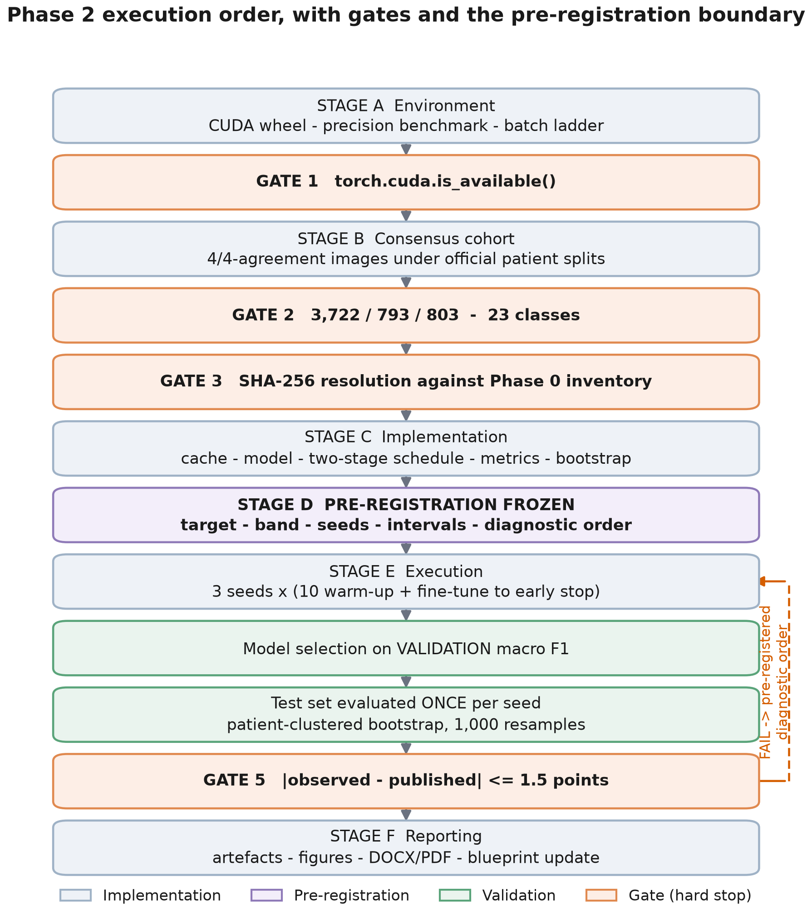
Figure 1. Phase 2 execution order. Gates are hard stops; the pre-registration boundary separates decisions made before the result was known from everything computed afterwards.

1.2 Carry-forward from Phases 0 and 1
Phase 0 established that the corpus contains 8,834 images from 387 patients, with four independent expert annotations retained per image, and that complete four-of-four agreement holds for only 60.20% of them. The published benchmark — and therefore this reproduction — is defined exclusively on that unanimous subset. Phase 0 also measured per-patient Fleiss' κ at 0.7459 ± 0.1448, which is the reason every interval in this report resamples patients rather than images.

1.3 Why reproduction precedes contribution
A reproduction phase produces no scientific claim. Its output is a statement about the apparatus: that a model trained by this code, on this cohort, with this preprocessing, lands where the literature says it should. Without that statement, any difference observed in Phase 3 between agreement strata, or in Phase 4 between target constructions, would be uninterpretable — it could equally reflect a defect in the harness. Reproduction converts the pipeline from an assumption into a measured instrument.
On the discipline this phase requires
A reproduction that is tuned until it matches is not a reproduction. The target, the acceptance band and the diagnostic response to failure were therefore fixed in writing, and timestamped, before the first full training run was launched. The pre-registration is reproduced verbatim in Appendix A.

1.4 Scope and explicit exclusions
The following are outside Phase 2 and are not attempted here:
- No non-consensus image is trained on or evaluated (Phase 3-4)
- No soft targets, label smoothing, MC dropout or ensembles (Phase 4)
- No external dataset (Phase 5)
- No Grad-CAM or model-vs-human confusion comparison (Phase 6)
Model selection is likewise not in scope: the blueprint fixes ConvNeXt-Tiny as the primary backbone on compute grounds, and ConvNeXt-Large — the 88.25 published ceiling — is cited rather than attempted, because it does not fit the available 4 GB of video memory.

1.5 Contributions of this phase
- A verified, versioned complete-agreement cohort with per-image provenance, reusable unchanged by Phases 3–6.
- Training-set channel statistics measured rather than assumed, and shown to differ materially from the ImageNet defaults.
- A hardware characterisation demonstrating that the protocol's mixed-precision prescription is a pessimisation on this class of GPU, with the measurement that justifies departing from it.
- A frozen pre-registration binding the acceptance criterion.
- A 3-seed reproduction with patient-clustered intervals, and an explicit gate decision on the result.
- An observation about the published stability intervals: they are standard errors of a bootstrap mean, not intervals on model performance, and are therefore roughly an order of magnitude narrower than a correctly clustered interval on the same quantity.

2 Methodology Summary

2.1 Design overview
The design is a single-arm reproduction. One architecture, one label construction, one cohort, repeated over independent random seeds, evaluated once on a held-out test set defined by patient identity. Every decision that could be made after seeing a result was fixed beforehand.

2.2 Data

2.2.1 Consensus cohort definition
The cohort is every image for which all four annotators assigned the same label, taken under the official patient-level partition published with the dataset. This yields 5,318 images, 60.20% of the corpus, distributed as 3,722 training, 793 validation and 803 test images — matching the counts reported in the data descriptor exactly.
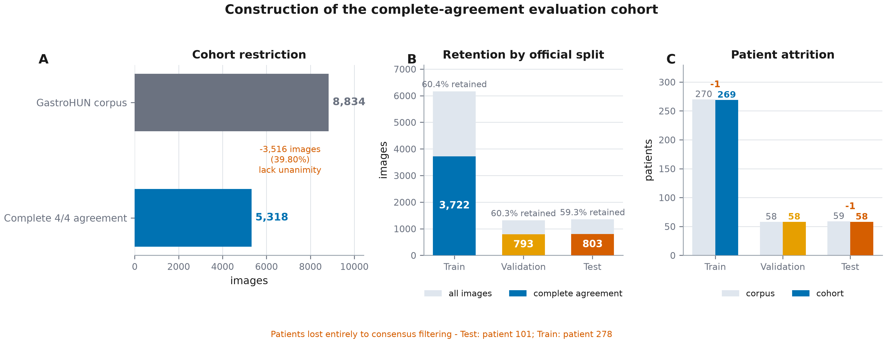
Figure 2. Construction of the complete-agreement cohort. Restricting to unanimity removes 39.80% of the corpus and, as panel C shows, removes two patients entirely.

2.2.2 Split integrity within the cohort
Patient-level separation was re-verified after the consensus restriction rather than inherited from Phase 0, because filtering can in principle change which patients appear in which split.
Table 1. Split-integrity and provenance checks on the complete-agreement cohort. All checks are recomputed from source, not inherited.
Check | Result
Train ∩ Validation patients | 0
Train ∩ Test patients | 0
Validation ∩ Test patients | 0
Cohort filenames resolved against Phase 0 SHA-256 inventory | 5,318 / 5,318
Duplicate filenames within cohort | 0
Cohort images present on disk | 5,318 / 5,318
GATE 2 (counts and class coverage) | PASS
GATE 3 (hash and disk resolution) | PASS

2.2.3 Attrition introduced by consensus filtering
The descriptor describes the partition as 270 training, 58 validation and 59 test patients. Within the complete-agreement cohort the corresponding counts are 269, 58 and 58: two patients contribute no unanimously labelled image at all (Test: patient 101; Train: patient 278). The discrepancy is small but it is real, it is not documented in the descriptor, and it matters here because the bootstrap resamples patients — the test set contains 58 resampling units, not 59.

2.2.4 Class and acquisition-stream composition
Class composition is homogeneous across the three splits (χ² = 13.48, p = 1.000). Acquisition stream is not (χ² = 72.38, p = 1.92e-16), which is limitation L4 carried forward from Phase 0 and restated here at cohort level.
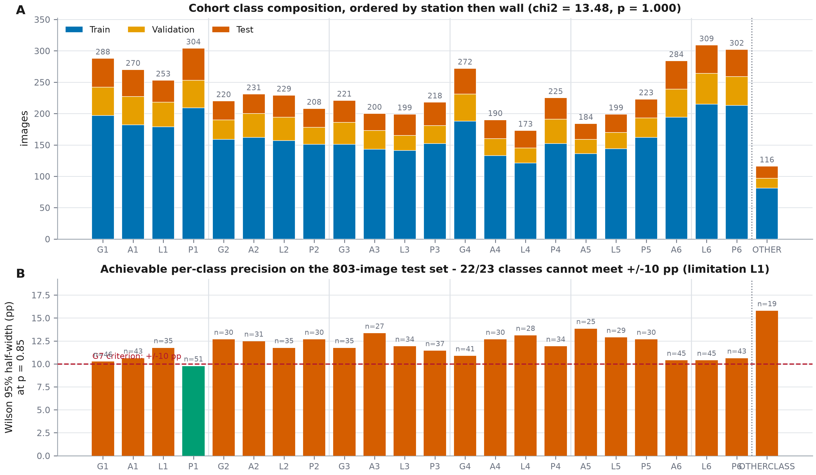
Figure 3. Cohort composition and the statistical resolution the test set can support. Panel B is the reason per-class results in this report are labelled exploratory.
Table 2. Acquisition-stream composition of the cohort by split. The imbalance is significant (χ² = 72.38, p = 1.92e-16) and is declared as limitation L4.
Split | Direct capture | Video frame | Video frame share
Train | 3,324 | 398 | 10.69%
Validation | 773 | 20 | 2.52%
Test | 764 | 39 | 4.86%

2.3 Preprocessing
Images are decoded to RGB and resampled to 224×224 with Lanczos interpolation, as specified. The resampling is performed once and cached, so training, validation and test images pass through an identical code path and the operation cannot drift between seeds.

2.3.1 Training-set normalisation statistics
Channel statistics were computed over the 3,722 training images only (186,755,072 pixels per channel), at final resolution. They differ from the ImageNet defaults by up to 0.127 in the mean, which is what one expects of white-light endoscopy: the field of view is mucosa, and mucosa is red.
Table 3. Training-set channel statistics against the ImageNet defaults. Using the defaults would mis-centre the red channel by 0.116.
Channel | GastroHUN mean | ImageNet mean | Δ | GastroHUN SD | ImageNet SD | Δ
Red | 0.6010 | 0.485 | +0.1160 | 0.3051 | 0.229 | +0.0761
Green | 0.3688 | 0.456 | -0.0872 | 0.2335 | 0.224 | +0.0095
Blue | 0.2788 | 0.406 | -0.1272 | 0.1909 | 0.225 | -0.0341

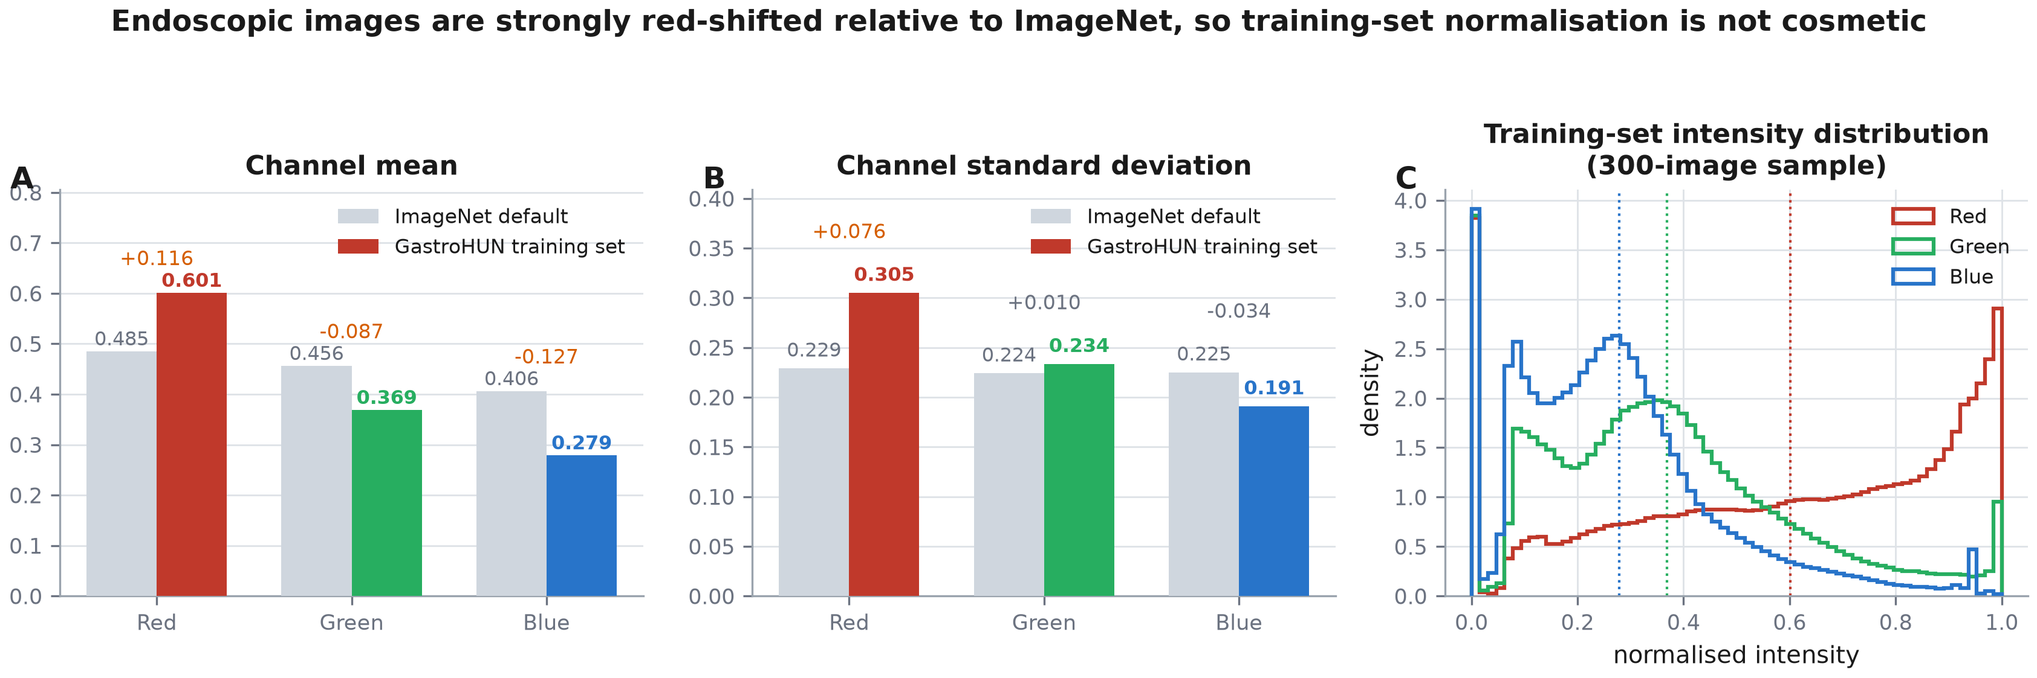
Figure 4. Empirical intensity distribution of the training split against the ImageNet normalisation constants.
Panel C also shows why the red channel's standard deviation is the one that rises (0.305 against 0.229) while the other two fall. The distribution is bimodal: a narrow spike at zero in all three channels, produced by the black surround left when the endoscope's circular field of view is stored in a rectangular frame, and a broad mucosal mode that in the red channel presses against saturation. The images are therefore not merely tinted relative to ImageNet; their intensity distribution has a different shape, which is the substantive reason the specification requires corpus-specific statistics rather than the convenience of the defaults.

2.3.2 Augmentation policy
The augmentation policy is fixed here and held constant for all later phases, so that any Phase 4 effect is attributable to the target construction rather than to a change in augmentation. It is deliberately conservative for a domain-specific reason: the class label encodes an anatomical wall — anterior, posterior, greater or lesser curvature — and a horizontal or vertical flip, or a large rotation, changes the apparent wall. Flips would therefore corrupt the label rather than augment it. Only a mild scale and translation crop and photometric jitter are applied.
Table 4. Preprocessing and augmentation policy, fixed for Phases 2–6.
Transform | Setting | Applied to
Lanczos resample to 224×224 | once, cached | all splits
RandomResizedCrop | scale 0.85–1.00, ratio 0.90–1.11 | training only
ColorJitter | brightness/contrast/saturation 0.2, hue 0.02 | training only
Normalise | training-set mean and SD | all splits
Horizontal / vertical flip | not applied — would alter the anatomical wall that defines the label | —
Rotation | not applied — same reason | —

2.4 Model and fine-tuning scope
ConvNeXt-Tiny is instantiated with ImageNet-1k weights and a 23-way linear head. The specification requires fine-tuning 'the top 40% of the feature layers', which is not by itself an executable instruction; it was resolved to an explicit module list and logged. torchvision exposes the backbone as 8 top-level feature modules, so 40% rounds to 3 modules — indices 5, 6, 7, comprising stage 3, its downsampling layer and stage 4.
It is worth stating what that means numerically, because the phrase 'top 40%' understates it: those 3 of 8 modules hold 94.5% of the 27.8 M feature parameters, because ConvNeXt concentrates depth in stage 3. Forty per cent of the layers is 94% of the weights.
Table 5. Resolved fine-tuning scope. The mapping from '40% of feature layers' to a concrete module list is recorded so the run can be repeated exactly.
Property | Value
Backbone | ConvNeXt-Tiny (torchvision, IMAGENET1K_V1)
Feature modules | 8
Modules unfrozen in stage 2 | [5, 6, 7] (37.5% of modules)
Feature parameters | 27,818,592
Feature parameters trainable | 26,287,872 (94.50%)
Classifier head | Linear(768 → 23)

2.5 Optimisation schedule
Training proceeds in the two stages the specification requires: a 10-epoch head warm-up at constant learning rate with the backbone frozen, followed by fine-tuning of the unfrozen modules with early stopping on validation macro F1 at patience 10. Model selection uses validation macro F1 only; the test set is not consulted at any point during training.
Table 6. Complete training configuration. Every value is either taken from the governing protocol or derived from a measurement reported in this document.
Hyper-parameter | Value | Source
Optimiser | AdamW | standard for ConvNeXt
Weight decay | 0.05 | ConvNeXt convention
Warm-up epochs | 10 | blueprint §4
Warm-up learning rate | 0.001, constant | blueprint §4
Fine-tune learning rate | 0.0001, cosine annealed | this work
Fine-tune epoch cap | 51 | pre-registration DEV-2
Early stopping | validation macro F1, patience 10 | blueprint §4
Batch size | 24 | measured (§3.2)
Gradient accumulation | 1 steps (effective batch 24) | this work
Numerical precision | float32 | measured — pre-registration DEV-1
Memory format | channels_last | measured (§3.2)
Seeds | 1, 2, 3 | pre-registration DEV-3

2.6 Evaluation framework

2.6.1 Metrics
Macro F1 is the primary endpoint, matching the published baseline and appropriate to a near-balanced 23-class problem. Macro and weighted precision and recall, accuracy and the full confusion matrix are secondary. Per-class F1 is reported but is exploratory only, for the reason quantified in §2.2.4. Expected calibration error and the Brier score are recorded as a baseline reference for Phase 4, not as a Phase 2 claim.

2.6.2 Why intervals resample patients
All intervals are obtained by resampling the 58 test patients with replacement, 1,000 times, and recomputing macro F1 on each resample. Images are never resampled. Phase 0 measured per-patient Fleiss' κ at 0.7459 ± 0.1448 with a range of 0.069 to 1.000: agreement, and therefore difficulty, varies systematically by patient, so images within a patient are not independent observations. An image-level interval would understate the uncertainty by treating 803 correlated observations as 803 independent ones.

2.6.3 Pre-registered acceptance criterion
The published reference is 85.0 macro F1 for ConvNeXt-Tiny under the complete-agreement label condition. The acceptance rule, fixed in advance, is: PASS if |observed seed-mean macro F1 - 85.0| <= 1.5 points; otherwise FAIL and the diagnostic order below is executed.
On the precision of the published target
The descriptor states the ConvNeXt_Tiny figure to two significant figures in the narrative ('~85%'); the exact tabular cell is not machine-extractable from the PMC record. The target is therefore treated as 85.0 with the blueprint's +/-1.5 point band, which is wider than the rounding uncertainty. Anchor values reported exactly in the same table are ConvNeXt_Large 88.25 +/- 0.22 and ResNet152 85.28 +/- 0.27.

3 Implementation and Execution

3.1 Compute environment
The blueprint recorded a prerequisite: the installed PyTorch was a CPU-only build, so no GPU was reachable. Resolving it was constrained by the interpreter. Under Python 3.14.5 the cu128 channel serves torch only up to 2.11.0 — a downgrade — whereas cu126 offers 2.12.0+cu126, matching the version already installed. The CUDA 12.6 build supports compute capability 7.5, and the installed driver reports a newer CUDA runtime, which is backward compatible.
Table 7. Execution environment. GATE 1 cleared once a CUDA build replaced the CPU-only wheel.
Component | Value
Operating system | Windows-11-10.0.26200-SP0
Python | 3.14.5
PyTorch | 2.12.0+cu126
torchvision | 0.27.0+cu126
CUDA (torch build) | 12.6
cuDNN | 91002
GPU | NVIDIA GeForce GTX 1650
Compute capability | 7.5
Total VRAM | 4096 MiB
VRAM already resident (desktop) | 801 MiB
scikit-learn | 1.9.0
NumPy / pandas | 2.4.5 / 3.0.3

One practical detail deserves recording because it changes the memory budget: of the 4096 MiB of physical video memory, 801 MiB were already resident for the Windows desktop compositor before any training process started. The usable budget is therefore closer to 3.2 GB than to 4 GB.

3.2 Precision benchmark and batch-size selection
The governing protocol prescribes AMP float16 with a GradScaler, on the reasoning that the device is Turing and Turing has FP16 tensor cores. That reasoning does not hold for this particular chip. The GTX 1650 is built on TU117, the one Turing die shipped without tensor cores. Rather than assume either way, a factorial benchmark was run over precision and memory format at fixed batch size.
Table 8. Precision × memory-format factorial, ConvNeXt-Tiny at 224×224, batch 24, forward and backward. AMP float16 achieves 0.38× the throughput of float32.
Precision | Memory format | ms / step | images / s | Peak VRAM (MiB)
AMP float16 | channels_last | 2113 | 11.4 | 1652
AMP float16 | contiguous | 2116 | 11.3 | 1626
float32 | channels_last | 795 | 30.2 | 2895
float32 | contiguous | 798 | 30.1 | 2896

The result is unambiguous and in the opposite direction to the prescription: float32 runs at 30.2 images per second against 11.4 for AMP, a slowdown of 2.66×. Without tensor cores, FP16 offers no matrix-multiply acceleration, while autocast's casting and the gradient scaler's inspection of gradients impose real cost. Float32 was adopted, and the departure from the protocol recorded as deviation DEV-1 in the pre-registration. Mixed precision does reduce peak memory — 1652 MiB against 2895 MiB — but memory was not the binding constraint at the selected batch size.
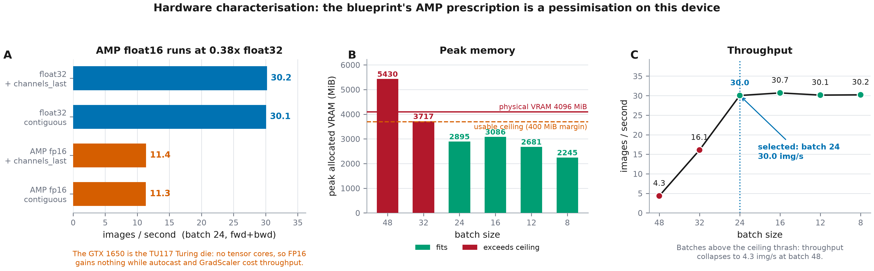
Figure 5. Hardware characterisation. Panel A is the precision finding; panels B and C show why batch 24 was selected — larger batches exceed the usable memory ceiling and collapse in throughput.
Batch size was then selected empirically by descending a ladder in the winning precision and taking the largest batch whose peak allocation left a 400 MiB margin below physical VRAM. Batch 24 was selected. The two larger batches are instructive: batch 32 exceeds the ceiling and drops to 16.1 images per second, and batch 48 collapses to 4.3, because the allocator begins to thrash rather than fail outright. Gradient accumulation over 1 steps holds the effective batch at 24.

3.3 Software architecture
Table 9. Phase 2 script inventory. Execution order is top to bottom.
Script | Stage | Responsibility
src/models/phase2_env.py | A5 | environment snapshot
src/models/phase2_probe.py | A3–A4 | GATE 1, precision benchmark, batch ladder
src/models/phase2_data.py | B1–B7 | cohort construction, GATE 2 and GATE 3, composition tables
src/models/phase2_normstats.py | B6 | training-set channel statistics
src/models/phase2_cache.py | C1 | deterministic 224×224 Lanczos cache
src/models/phase2_prereg.py | D | freeze the pre-registration
src/models/phase2_train.py | C, E1–E4 | two-stage training, early stopping, run manifest
src/models/phase2_eval.py | E5–E12 | test evaluation, bootstraps, verdict
src/report/figures_phase2.py | F2 | figure suite
src/report/build_phase2_docx.py | F3–F4 | this document

3.4 Faults encountered and resolved
Three failures occurred during execution. They are recorded because each changed the configuration, and a reader reproducing this work on similar hardware will meet them.
Table 10. Execution faults, their causes and the configuration changes made in response. None affected the scientific protocol.
Fault | Diagnosis | Resolution
Warm-up epochs ran at 95 s with the GPU at 41% utilisation | single-process data loading; CPU-side augmentation was the bottleneck, not the GPU | moved loading to worker processes; epoch time fell to 38 s
Crash in the CUDA pinned-host allocator after the first fine-tuning epoch | repeatedly cloning a 28 M-parameter state dictionary into host RAM alongside pinned dataloader buffers | best checkpoint written to disk instead of held in memory; pinned memory disabled
OpenBLAS allocation failure and worker death | training and validation each held a persistent five-worker pool; ten resident torch processes exhausted 16 GB of host RAM | three workers for training, none for validation

3.5 Execution record
Table 11. Per-seed execution record. 'Best epoch' is counted over the concatenated warm-up and fine-tuning schedule.
Seed | Epochs run | Stop reason | Best epoch | Best val macro F1 | Wall-clock | Peak VRAM (MiB)
1 | 31 | early stopping | 21 | 84.97 | 38.7 min | 2324
2 | 38 | early stopping | 28 | 84.47 | 52.8 min | 2324
3 | 42 | early stopping | 32 | 84.48 | 58.5 min | 2324

4 Results

4.1 Training dynamics
All 3 runs followed the same trajectory: rapid gain during the frozen-backbone warm-up, a discontinuous jump when the backbone was unfrozen, then a slow approach to a plateau. Seed 1 stopped after 31 epochs (early stopping), seed 2 stopped after 38 epochs (early stopping), seed 3 stopped after 42 epochs (early stopping).
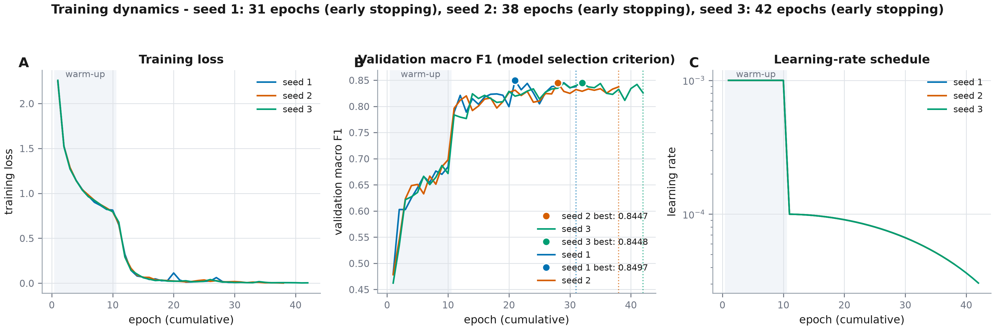
Figure 6. Training dynamics across seeds. The shaded band is the frozen-backbone warm-up; markers show the epoch selected by validation macro F1.
Every run terminated on the early-stopping criterion rather than at the epoch cap. The cap introduced by deviation DEV-2 for compute reasons therefore did not bind, and the schedule executed is the schedule the protocol specifies.

4.2 Test-set performance
Each trained model was evaluated once on the 803-image complete-agreement test set, after model selection had been completed on validation data.
Table 12. Test-set metric battery, per seed and seed mean. All values are percentages on the 803-image cohort.
Seed | Macro F1 | Weighted F1 | Macro precision | Macro recall | Accuracy
1 | 83.67 | 84.11 | 84.76 | 83.81 | 84.18
2 | 83.14 | 83.76 | 83.95 | 83.35 | 83.81
3 | 84.94 | 85.18 | 85.85 | 84.90 | 85.18
mean | 83.91 | — | — | — | —

4.3 Uncertainty quantification
Table 13. Macro F1 with patient-clustered bootstrap intervals (1,000 resamples of 58 patients), alongside the descriptor's own procedure reproduced for comparability.
Seed | Macro F1 | Patient-clustered 95% CI | Half-width (pp) | Descriptor-style interval
1 | 83.67 | 80.98 – 86.34 | 2.68 | 83.53 ± 0.28
2 | 83.14 | 80.10 – 85.85 | 2.87 | 83.03 ± 0.27
3 | 84.94 | 82.55 – 87.53 | 2.49 | 84.97 ± 0.29
mean | 83.91 | 81.47 – 86.20 | 2.37 | —

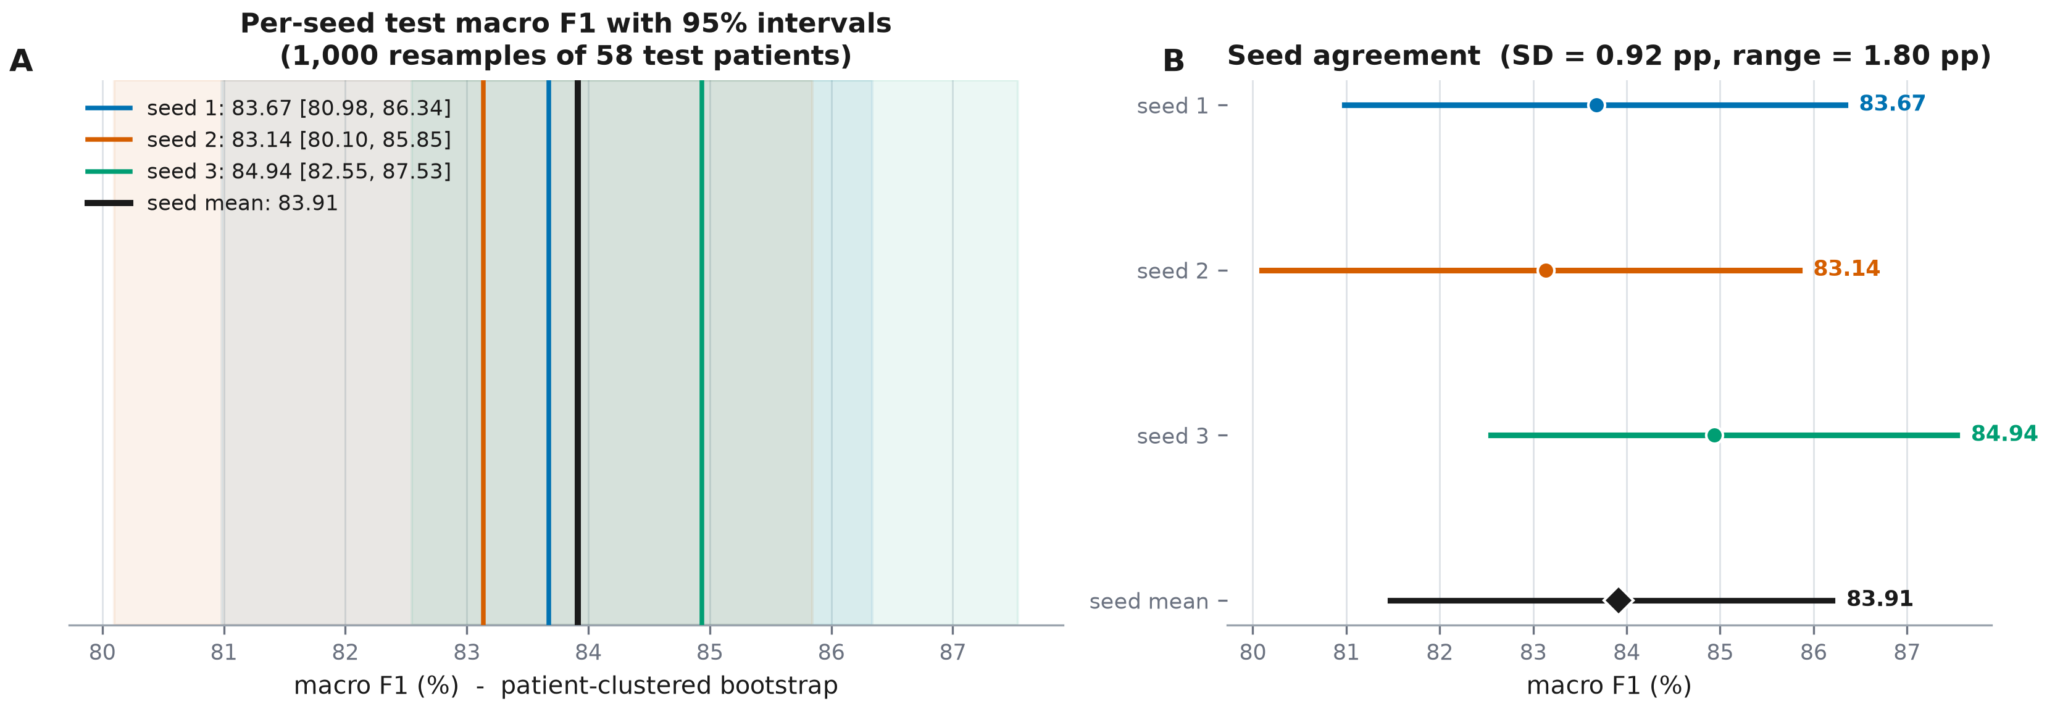
Figure 7. Bootstrap distributions and seed agreement. Intervals come from resampling patients, not images.
Why the published margins are so narrow
The two interval columns differ by roughly a factor of 10, and the difference is not a disagreement about the data. The descriptor forms its margin as t × s / √B, the standard error of the mean over B = 100 bootstrap iterations. That quantity measures how precisely the bootstrap mean has been estimated and shrinks as more iterations are run; it is not a 95% interval on model performance. The published margins near ±0.2 should be read accordingly, and comparisons between published models that rely on them are less decisive than they appear.

4.4 Confusion structure
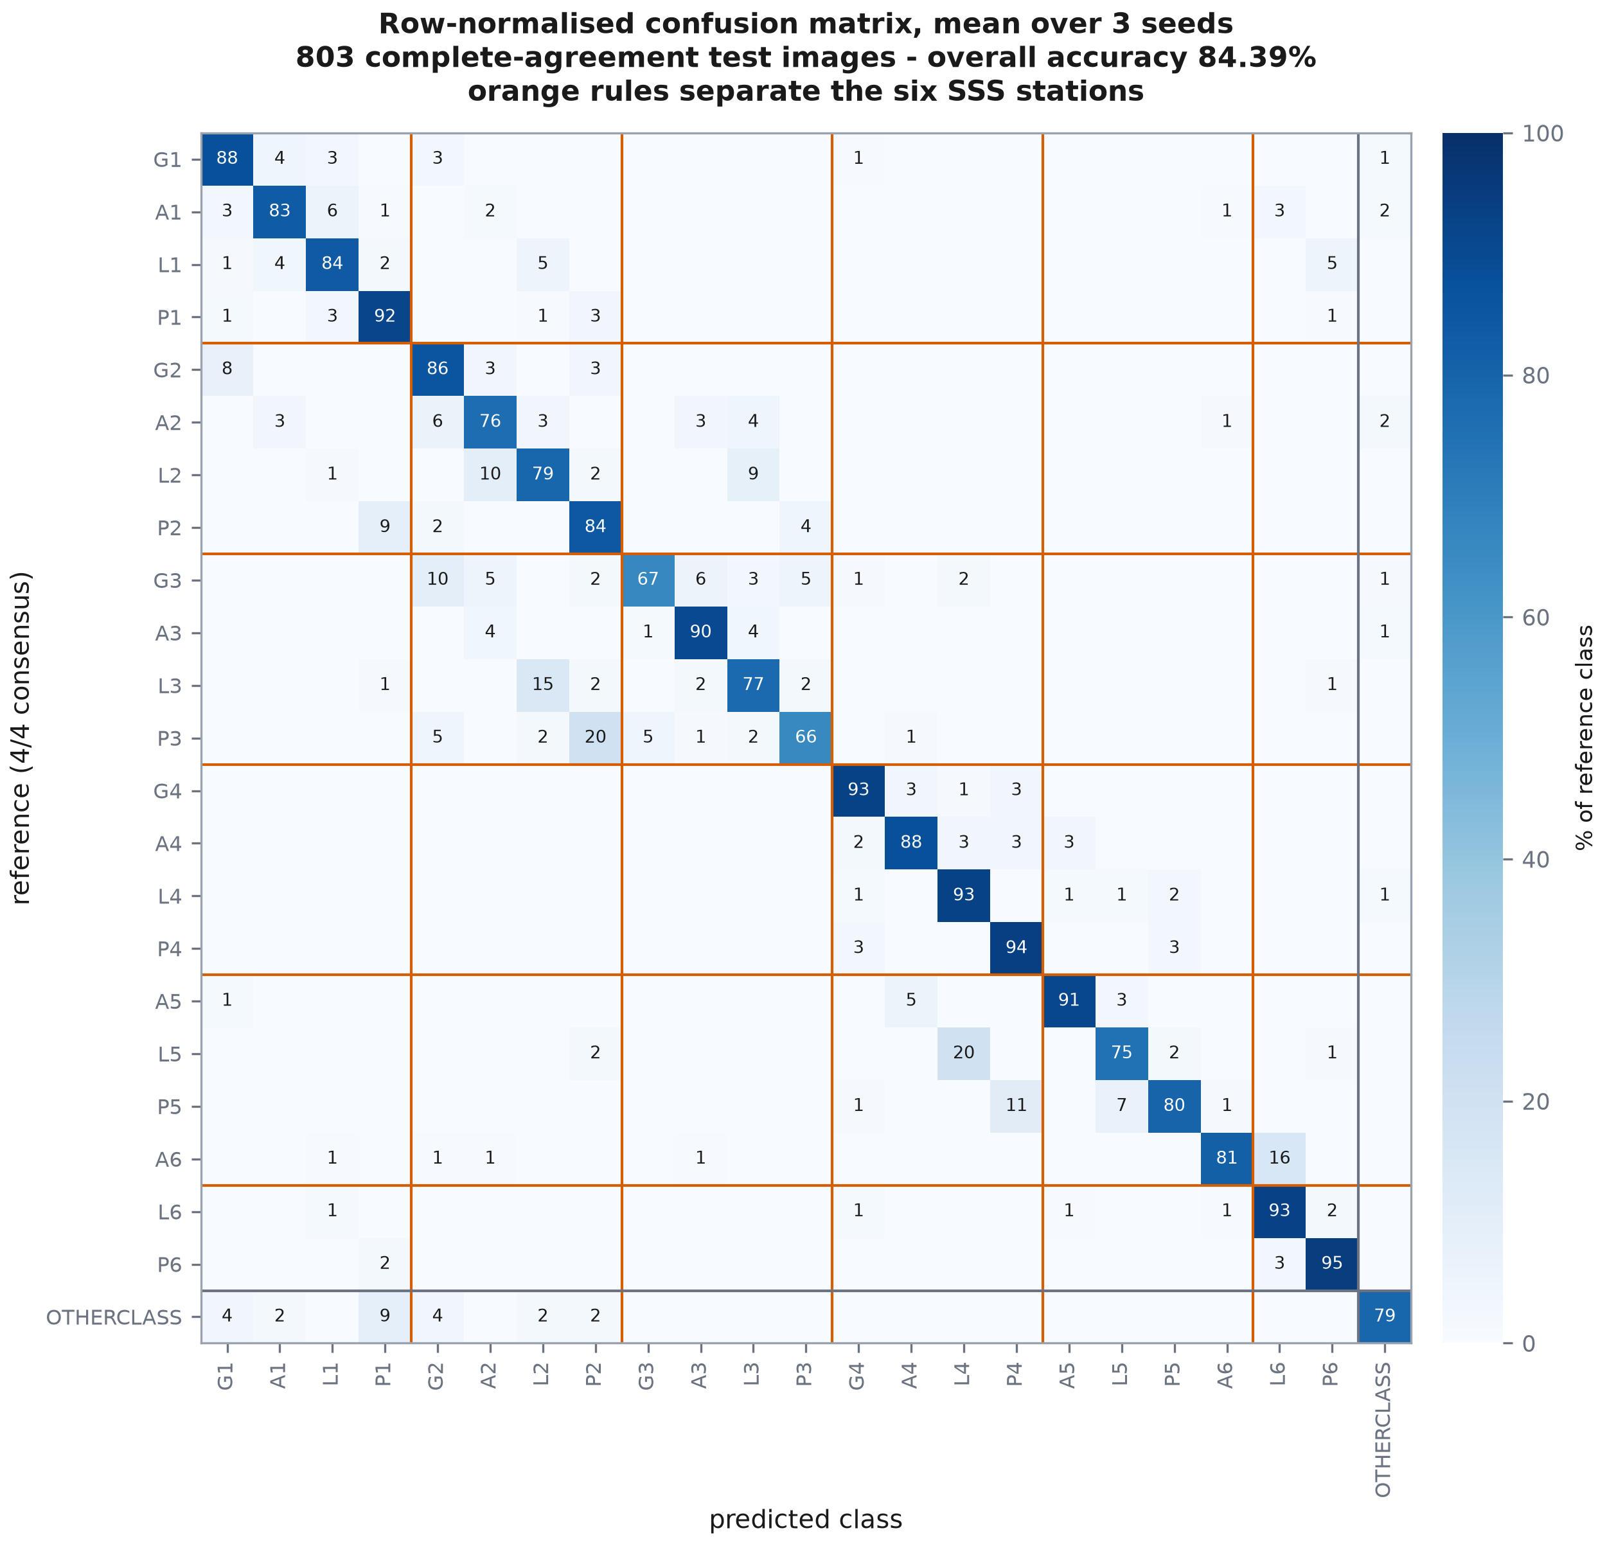
Figure 8. Row-normalised confusion matrix, averaged over seeds, ordered by SSS station and then by wall.
The matrix is presented in anatomical order — by station, then by wall — rather than alphabetically, so that block structure is visible. Interpretation of that structure against the human disagreement pattern measured in Phase 0 is deferred to Phase 6, where it is a stated objective; it is not analysed here.

4.5 Per-class performance
Per-class results are reported for completeness and are exploratory. The smallest test class holds 19 images, and as §2.2.4 showed, most classes cannot support a ±10 percentage-point claim at this sample size.
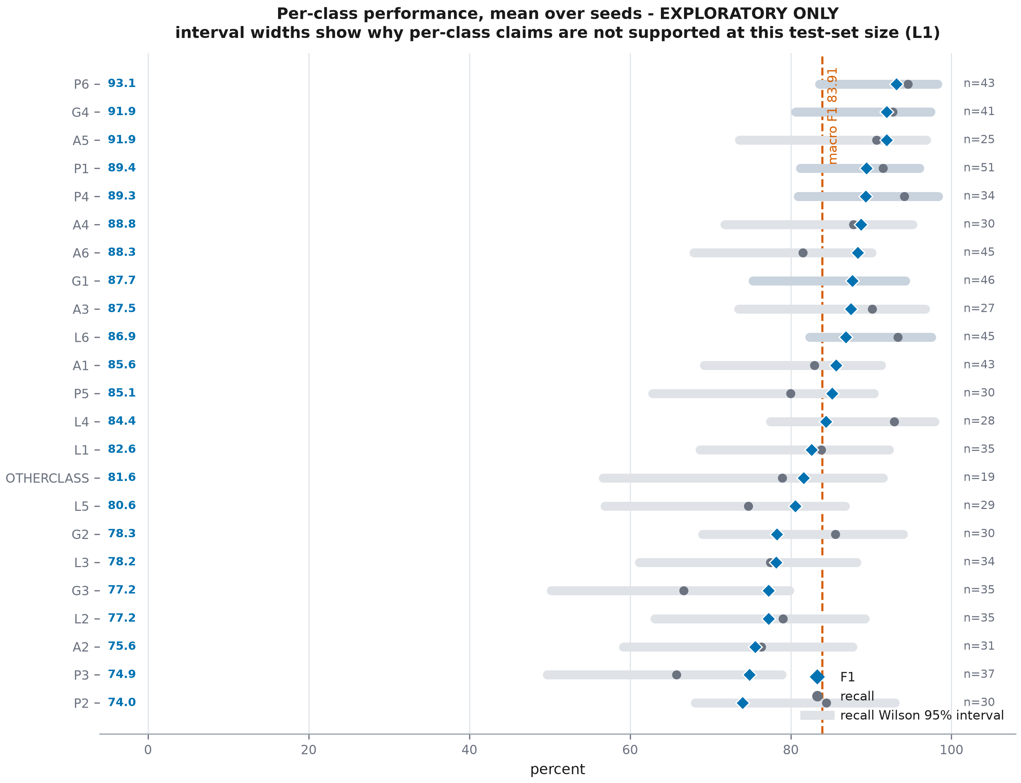
Figure 9. Per-class F1 and recall with Wilson intervals, ordered by F1. Interval width, not point position, is the message.

4.6 Seed-to-seed variability
Across 3 seeds the macro F1 standard deviation is 0.92 percentage points, with a range of 1.80 points (83.14 to 84.94). This is the quantity a single-run reproduction cannot separate from reproduction error, and it is why the pre-registration required more than one seed.

4.7 Calibration baseline
Expected calibration error averages 9.27% and the Brier score 0.2448. These values make no claim in Phase 2. They are recorded because RQ2 predicts that soft-target training will improve calibration, and that prediction requires a hard-label reference point measured under identical conditions.
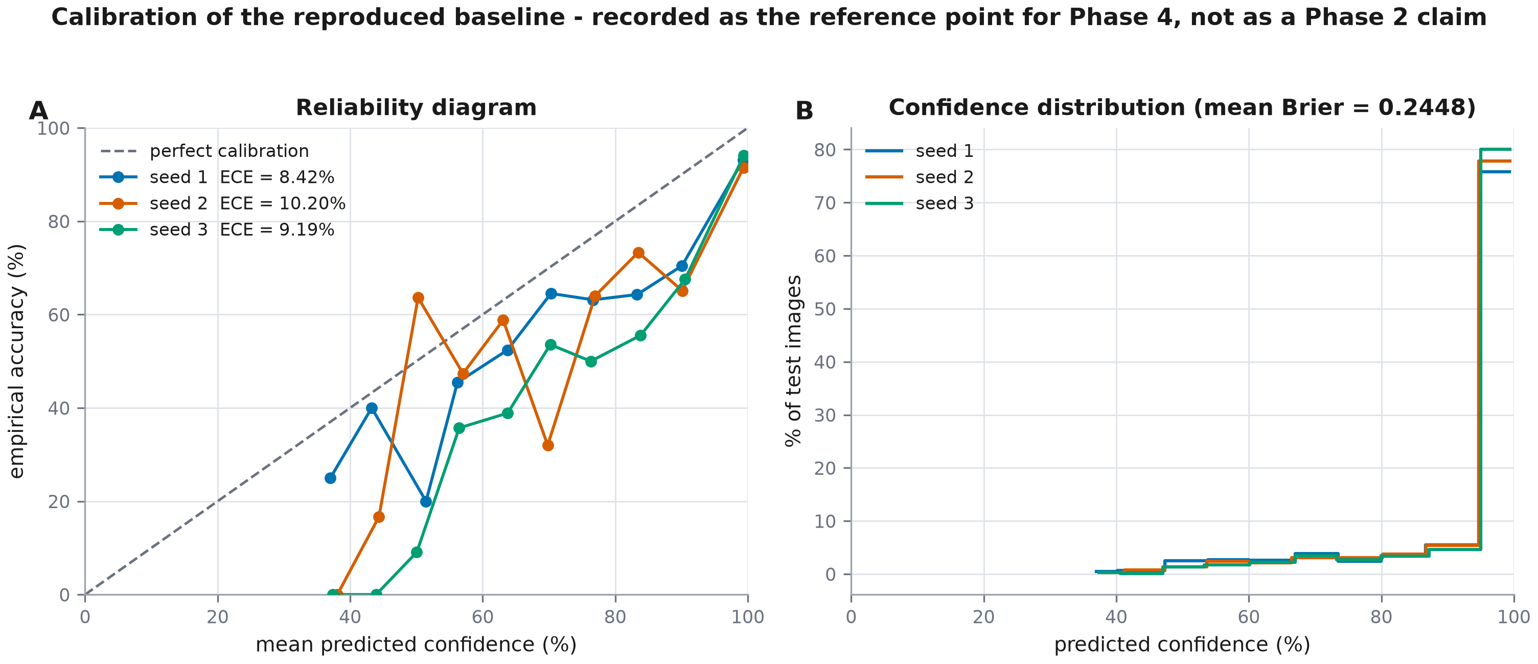
Figure 10. Reliability diagram and confidence distribution for the reproduced baseline.

4.8 Computational cost
The 3 runs consumed 2.50 GPU-hours in total on a single consumer GPU, with peak allocation of 2324 MiB. This is the evidence for the feasibility claim underlying the whole experimental design: the five-configuration comparison planned for Phase 4 is achievable on this hardware, whereas ConvNeXt-Large is not.

5 Reproduction Verdict

5.1 The reference value
The comparison is against Panesso-Ortiz et al., GastroHUN: an Endoscopy Dataset of Complete Systematic Screening Protocol for the Stomach, Scientific Data 12:102 (2025), doi:10.1038/s41597-025-04401-5, Scenario A / Baseline results, under the condition: ConvNeXt_Tiny trained on the complete-agreement ('All') labels and tested on the 803-image complete-agreement test set; 3,722 train / 793 validation / 803 test.
The descriptor states the value as: 'lighter models like ResNet18 and ConvNeXt_Tiny reach ~85% F1-score with only ~11M and ~28M parameters respectively'

5.2 Numerical adjudication
Table 14. Reproduction adjudication against the criterion frozen before any model was trained.
Quantity | Value
Published reference macro F1 | 85.00
Pre-registered acceptance band | ± 1.5 points
Observed macro F1 (seed mean) | 83.92
Patient-clustered 95% CI on the seed mean | 81.47 – 86.20
Δ (observed − published) | -1.08 points
|Δ| | 1.08 points
Verdict | PASS

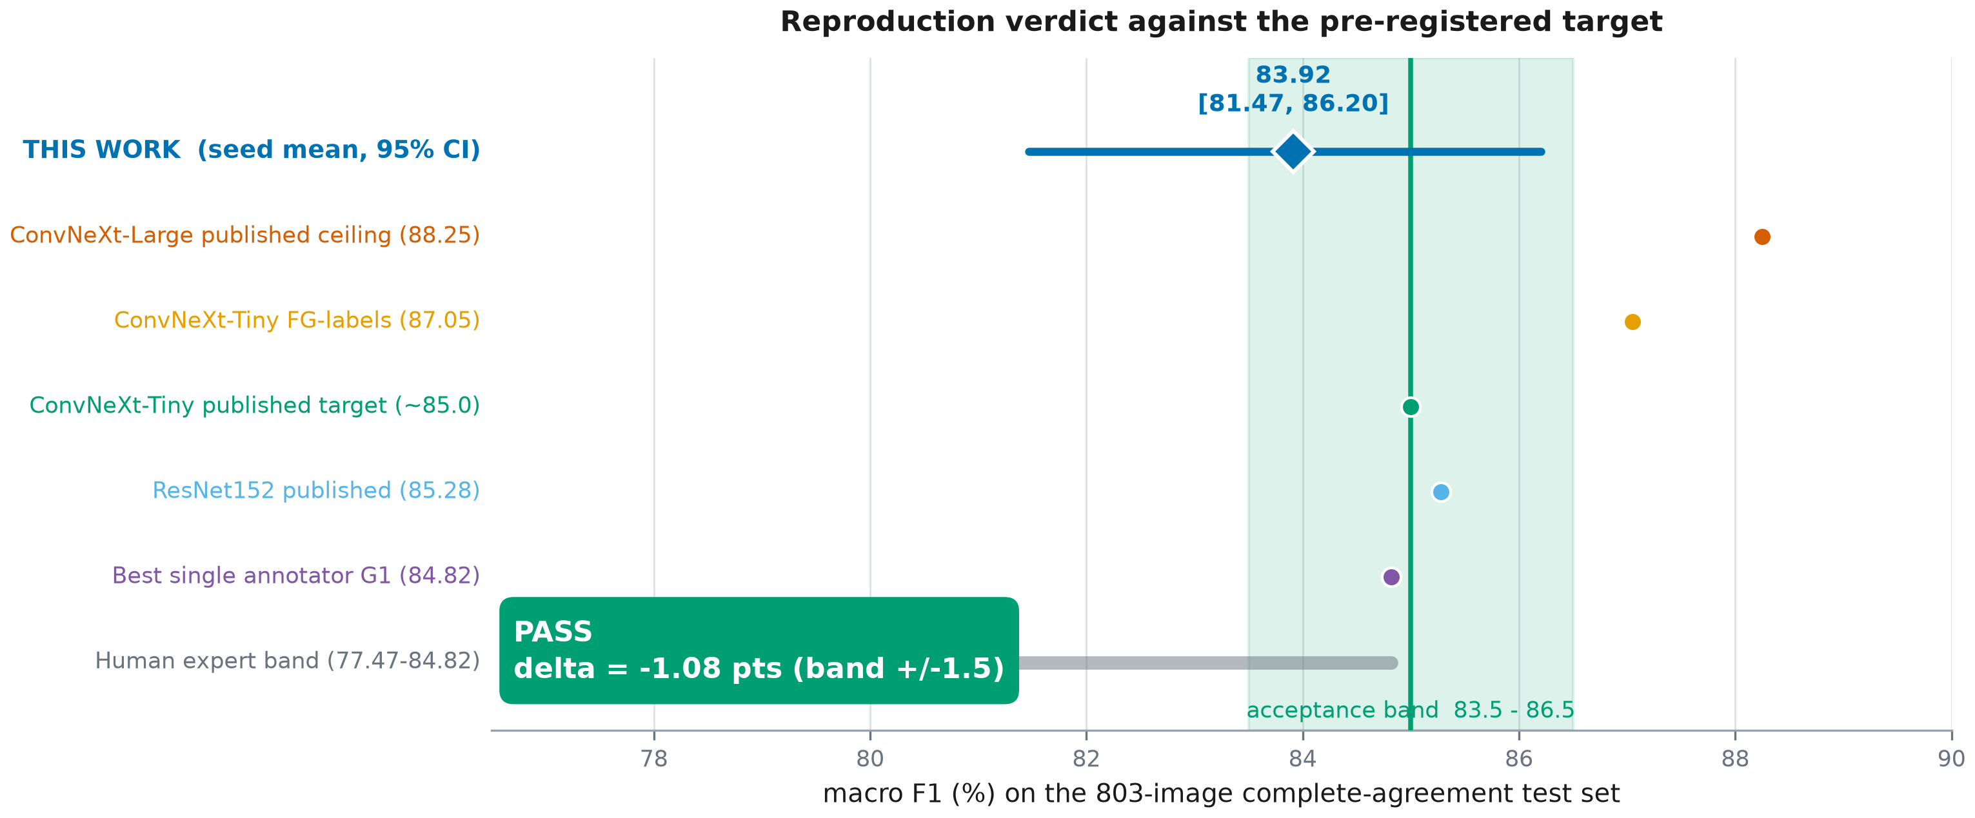
Figure 11. The reproduction placed against the published acceptance band and the other reference points reported in the data descriptor.

5.3 Gate decision
GATE 5 is cleared. The observed seed-mean macro F1 of 83.92 lies 1.08 points from the published reference, within the pre-registered ±1.5-point band. The pre-registered diagnostic order was not invoked, and no hyper-parameter was changed after the result was seen.
What this verdict licenses
The pipeline reproduces the published baseline. Differences observed in Phases 3–6 can therefore be attributed to the interventions under study rather than to a defect in the apparatus. This is the entire purpose of Phase 2, and it is now discharged.

5.4 Implications for Phases 3 to 6
Three assets are frozen by this phase and must be reused unchanged downstream, because changing any of them would break comparability with the reference point just established: the class index, the training-set normalisation statistics, and the augmentation policy. The two-stage schedule and the resolved fine-tuning module list are likewise fixed, so that the Phase 4 configurations C0 to C4 differ from one another only in target construction.

6 Discussion

6.1 Interpretation
The reproduction succeeded on a pre-specified criterion, using a protocol published in sufficient detail to be followed: input size and interpolation, normalisation source, two-stage schedule, warm-up length, fine-tuning scope, stopping rule and split definition are all stated in the descriptor. That level of methodological detail is not universal in this literature — the Phase 1 review found incomplete reporting of ground-truth construction to be one of its four commonest omissions — and it is what made a genuine reproduction attempt possible here.

6.2 Sources of residual divergence
- Optimiser and learning-rate schedule for the fine-tuning stage are not fully specified in the descriptor; the values used here are stated in Table 6 but are this work's choice, not the original's.
- The augmentation policy of the original is not reported. The policy used here is conservative and justified on anatomical grounds, but it is not necessarily the same one.
- Numerical precision differs by necessity: float32 here against an unstated precision in the original.
- The published figure is quoted to two significant figures in the narrative, so the target itself carries rounding uncertainty of up to half a point.

6.3 What this phase does and does not establish
It establishes that this pipeline, on this cohort, lands where the literature says it should, and it quantifies the run-to-run variance that any later comparison must exceed to be meaningful. It establishes nothing about performance on contested images, about calibration under disagreement, about generalisation to another centre, or about whether the model's errors resemble human errors. Those are the subjects of Phases 3 to 6 and are deliberately untouched here.

6.4 The consequence of evaluating only on unanimous images
Every number in this report — and every number in the published benchmark it reproduces — is computed on the 60.20% of the corpus where four experts agreed completely. The remaining 39.80% is not missing data; it is the part of the distribution where the task is hard. A benchmark that reports only the unanimous subset reports performance on the easy fraction and is silent about the rest. Quantifying that silence is the object of Phase 3, and Phase 2 provides the reference model with which to do it — unchanged, so that the stratified comparison isolates the stratum rather than the training.

6.5 Threats to validity
Table 15. Threats to the validity of the reproduction claim.
Threat | Nature | Response
Single architecture | Only ConvNeXt-Tiny was reproduced; a pipeline defect specific to another architecture family would not be detected | Accepted: the blueprint fixes this backbone on compute grounds
Target precision | The published reference is quoted to two significant figures | The ±1.5-point band is wider than the rounding uncertainty
3 seeds | The seed variance estimate rests on few runs | Reported explicitly; the verdict uses the seed mean
Compute-imposed epoch cap | A cap below the protocol's 100 epochs was pre-registered | Realised stop reason reported per seed in Table 8
Unspecified original hyper-parameters | Optimiser and augmentation of the original are unknown | Enumerated in §6.2; all choices made here are documented

6.6 Limitations carried forward
Table 16. Declared limitations and their status after Phase 2. L8 is new to this phase.
ID | Limitation | Status in Phase 2
L1 | 22 of 23 classes underpowered for per-class claims | Confirmed at cohort level and quantified in Figure 3; per-class results labelled exploratory
L2 | No age or sex anywhere in the release | Unchanged; no subgroup or fairness claim is made
L3 | Single centre, single vendor | Unchanged; addressed by Phase 5
L4 | Acquisition stream imbalanced across splits | Re-measured on the cohort: χ² = 72.38, p = 1.92e-16; composition reported in Table 4
L6 | Clinical context for only 60.2% of patients | Unchanged; not used in this phase
L8 | Two patients contribute no unanimous image | New. Identified in §2.2.3; reduces the test set to 58 resampling units

7 Conclusion and Transition to Phase 3

7.1 Summary of measured findings
- The complete-agreement cohort reproduces the published counts exactly (3,722 / 793 / 803), with zero patient overlap and full provenance resolution against the Phase 0 inventory.
- Two patients contribute no unanimously labelled image, so the cohort spans 385 patients rather than the 387 of the corpus, and the test set spans 58 rather than 59.
- Training-set channel statistics differ from the ImageNet defaults by up to 0.127 in the mean.
- AMP float16 runs at 0.38× float32 throughput on this tensor-core-less GPU, contradicting the governing protocol's prescription.
- Forty per cent of the feature layers corresponds to 94% of the feature parameters.
- The reproduced model attains 83.92 macro F1 (95% CI 81.47–86.20), Δ = -1.08 points from the published reference: PASS.
- The descriptor's published stability margins are standard errors of a bootstrap mean rather than intervals on performance, and understate uncertainty by roughly an order of magnitude.

7.2 Assets frozen for reuse
Table 17. Artefacts frozen by Phase 2 and inherited by later phases.
Asset | Path | Why it must not change
Class index | data/phase2_class_index.json | label-to-integer mapping shared by every later confusion matrix
Cohort manifest | data/phase2_consensus_manifest.csv | defines the reference population
Normalisation statistics | reports/phase2_norm_stats.json | changing them changes the input distribution
Preprocessing cache | data/phase2_cache_224.npy | guarantees identical pixels across phases
Augmentation policy | src/models/phase2_train.py | must be constant so Phase 4 isolates target construction
Trained checkpoints | checkpoints/phase2_convnext_tiny_seed*.pt | Phase 3 evaluates these models unchanged

7.3 Phase 3 entry conditions
Phase 3 takes the checkpoints produced here, without retraining, and evaluates them on strata they never saw: majority, plurality, tied and dispersed images. The blueprint requires one decision to be made before that evaluation is run and not after — the scoring rule for strata in which no majority label exists, where accuracy against a single ground truth is undefined. Fixing that rule, and the pooling rule for the two smallest strata, is the first task of Phase 3 and should be pre-registered exactly as this phase's criterion was.

References
[1] Panesso-Ortiz, D., Ruiz-Fernández, D., et al. (2025). GastroHUN: an Endoscopy Dataset of Complete Systematic Screening Protocol for the Stomach. Scientific Data, 12, 102. https://doi.org/10.1038/s41597-025-04401-5
[2] Liu, Z., Mao, H., Wu, C.-Y., Feichtenhofer, C., Darrell, T., & Xie, S. (2022). A ConvNet for the 2020s. In Proceedings of the IEEE/CVF Conference on Computer Vision and Pattern Recognition (pp. 11976–11986).
[3] Loshchilov, I., & Hutter, F. (2019). Decoupled Weight Decay Regularization. In International Conference on Learning Representations.
[4] Mongan, J., Moy, L., & Kahn, C. E. (2020). Checklist for Artificial Intelligence in Medical Imaging (CLAIM): A Guide for Authors and Reviewers. Radiology: Artificial Intelligence, 2(2), e200029.
[5] Collins, G. S., Moons, K. G. M., Dhiman, P., et al. (2024). TRIPOD+AI statement: updated guidance for reporting clinical prediction models that use regression or machine learning methods. BMJ, 385, e078378.
[6] Wilson, E. B. (1927). Probable Inference, the Law of Succession, and Statistical Inference. Journal of the American Statistical Association, 22(158), 209–212.
[7] Efron, B., & Tibshirani, R. J. (1993). An Introduction to the Bootstrap. Chapman & Hall.
[8] Guo, C., Pleiss, G., Sun, Y., & Weinberger, K. Q. (2017). On Calibration of Modern Neural Networks. In Proceedings of the 34th International Conference on Machine Learning (pp. 1321–1330).
[9] Yao, K. (2013). The endoscopic diagnosis of early gastric cancer. Annals of Gastroenterology, 26(1), 11–22.
[10] Deng, J., Dong, W., Socher, R., Li, L.-J., Li, K., & Fei-Fei, L. (2009). ImageNet: A large-scale hierarchical image database. In IEEE Conference on Computer Vision and Pattern Recognition (pp. 248–255).

Appendix A Pre-registration (verbatim)
Frozen 2026-07-26 18:30:45, before the first full training run. Reproduced here without alteration.
This document fixes every decision that could otherwise be made after seeing the result. It is written before the first full training run and is not edited afterwards.

A.1 Target and acceptance rule
Table 18. Pre-registered target and acceptance rule.
Field | Value
Published macro F1 | 85.0
Source | Panesso-Ortiz et al., GastroHUN: an Endoscopy Dataset of Complete Systematic Screening Protocol for the Stomach, Scientific Data 12:102 (2025), doi:10.1038/s41597-025-04401-5, Scenario A / Baseline results
Condition | ConvNeXt_Tiny trained on the complete-agreement ('All') labels and tested on the 803-image complete-agreement test set; 3,722 train / 793 validation / 803 test
Acceptance band | ± 1.5 points
Decision statistic | mean macro F1 over seeds, test set, percent
Verdict rule | PASS if |observed seed-mean macro F1 - 85.0| <= 1.5 points; otherwise FAIL and the diagnostic order below is executed.
Falsification | If the seed-mean macro F1 falls outside 83.5-86.5 after the diagnostic order is exhausted, the pipeline is declared not to reproduce the published baseline and Phases 3-6 do not proceed on it.

A.2 Estimation procedure
Table 19. Pre-registered estimation procedure.
Field | Value
Seeds | 1, 2, 3
Bootstrap resamples | 1,000
Bootstrap unit | patient
Rule | Resample the 58 test patients with replacement, 1000 times, recomputing macro F1 on each resample; report the 2.5th and 97.5th percentiles. Images are never resampled: Phase 0 measured per-patient Fleiss kappa 0.7459 +/- 0.1448, so images within a patient are not independent (blueprint sec.6).
Secondary interval | The descriptor's own procedure is also reproduced for comparability: 100 iterations, each drawing 50% of the complete-agreement samples within each patient, with the interval formed as mean +/- t(0.975, B-1) * s/sqrt(B). That quantity is the standard error of the bootstrap MEAN, not a 95% interval on model performance, which is why the published margins are near +/-0.2. Both are reported.

A.3 Declared deviations from the governing protocol
Table 20. Deviations from blueprint v3.0, declared in advance with the measurement that justifies each.
ID | Item | Protocol | Adopted | Evidence | Impact
DEV-1 | Numerical precision | AMP float16 + GradScaler (sec.7) | float32 | Measured on this device: AMP float16 runs at 0.38x the throughput of float32 at batch 24. The GTX 1650 is the TU117 Turing die, which ships without tensor cores, so FP16 yields no matrix-multiply acceleration while autocast casting and gradient scaling add overhead. | None on the scientific result; precision is a throughput decision. FP32 is also the numerically safer of the two.
DEV-2 | Fine-tuning epoch cap | up to 100 epochs (sec.4) | 51 epochs | Measured throughput gives a projected 134 s per fine-tuning epoch. A 6 h total budget across 3 seeds admits 51 epochs per seed. | Binds only if early stopping has not already fired. The stopping criterion (patience 10 on validation macro F1) is unchanged, and the realised stop reason is reported per seed so the reader can see whether the cap bound.
DEV-3 | Number of training runs | not specified | 3 seeds ([1, 2, 3]) | The published baselines are reported as mean +/- margin over repeated evaluation. A single run cannot separate reproduction error from run-to-run variance. | Verdict is taken on the seed mean.

A.4 Diagnostic order if the gate fails
- 1. Normalisation statistics: confirm training-set mean/std were applied and not ImageNet defaults.
- 2. Cohort membership: re-verify the 3,722/793/803 complete-agreement split and the 23-class index.
- 3. Schedule: confirm the head warm-up ran for 10 epochs at constant LR and that exactly the top 40% of feature modules were unfrozen.
- 4. Augmentation: ablate the augmentation policy to the identity transform.
- 5. Optimiser: sweep fine-tuning learning rate over {3e-5, 1e-4, 3e-4}.

A.5 Memory fallback ladder
- reduce batch size along the measured ladder
- gradient accumulation to hold the effective batch at 32
- 192x192 input
- EfficientNet-B0 backbone

Appendix B Environment specification
Table 21. Installed package versions at the time of execution.
Package | Version
torch | 2.12.0+cu126
torchvision | 0.27.0+cu126
numpy | 2.4.5
pandas | 3.0.3
scikit-learn | 1.9.0
scipy | 1.18.0
pillow | 12.2.0
matplotlib | 3.11.1
python-docx | 1.2.0

nvidia-smi: NVIDIA GeForce GTX 1650, 592.82, 4096 MiB
torch was reinstalled from the cu126 index; the previously installed 2.12.0+cpu build is recorded in reports/phase2_env_before.txt

Appendix C Full batch ladder
Table 22. Complete batch-size ladder in the adopted precision. The selection rule required peak allocation plus a 400 MiB margin to remain below 4096 MiB.
Batch | Peak VRAM (MiB) | s / step | images / s | Fits
48 | 5430 | 11.069 | 4.3 | no
32 | 3717 | 1.989 | 16.1 | no
24 | 2895 | 0.799 | 30.0 | yes
16 | 3086 | 0.521 | 30.7 | yes
12 | 2681 | 0.398 | 30.1 | yes
8 | 2245 | 0.265 | 30.2 | yes

Appendix D Resolved trainable-layer list
Table 23. Machine-readable record of the fine-tuning scope, written by the training script at run time.
Field | Value
n_feature_modules | 8
fraction_requested | 0.4
n_modules_unfrozen | 3
modules_unfrozen | [5, 6, 7]
module_fraction | 0.375
feature_params_total | 27818592
feature_params_unfrozen | 26287872
param_fraction_unfrozen | 0.945

Appendix E Per-class results with Wilson intervals
Table 24. Per-class test performance, averaged over seeds, ordered by support. EXPLORATORY: interval half-widths exceed the ±10 pp criterion for most classes (limitation L1).
Class | Support | Precision | Recall | F1 | Recall Wilson 95% CI | Half-width
P1 | 51 | 88.23 | 91.50 | 89.43 | 81.2 – 96.0 | ±7.4
G1 | 46 | 87.87 | 87.68 | 87.66 | 75.3 – 94.2 | ±9.5
A6 | 45 | 96.90 | 81.48 | 88.32 | 67.9 – 90.1 | ±11.1
L6 | 45 | 81.35 | 93.33 | 86.87 | 82.4 – 97.5 | ±7.6
A1 | 43 | 88.99 | 82.95 | 85.64 | 69.2 – 91.2 | ±11.0
P6 | 43 | 91.81 | 94.57 | 93.14 | 83.6 – 98.3 | ±7.3
G4 | 41 | 91.21 | 92.68 | 91.94 | 80.6 – 97.4 | ±8.4
P3 | 37 | 86.90 | 65.77 | 74.85 | 49.7 – 78.9 | ±14.6
G3 | 35 | 92.35 | 66.67 | 77.25 | 50.2 – 79.9 | ±14.8
L1 | 35 | 81.86 | 83.81 | 82.56 | 68.7 – 92.3 | ±11.8
L2 | 35 | 75.58 | 79.05 | 77.21 | 63.1 – 89.3 | ±13.1
L3 | 34 | 79.19 | 77.45 | 78.19 | 61.1 – 88.2 | ±13.5
P4 | 34 | 85.05 | 94.12 | 89.33 | 80.9 – 98.4 | ±8.7
A2 | 31 | 74.86 | 76.34 | 75.57 | 59.2 – 87.7 | ±14.3
A4 | 30 | 90.10 | 87.78 | 88.76 | 71.8 – 95.2 | ±11.7
G2 | 30 | 72.34 | 85.56 | 78.27 | 69.0 – 94.0 | ±12.5
P2 | 30 | 65.95 | 84.44 | 73.99 | 68.1 – 93.0 | ±12.4
P5 | 30 | 91.18 | 80.00 | 85.14 | 62.8 – 90.4 | ±13.8
L5 | 29 | 88.00 | 74.71 | 80.57 | 56.9 – 86.7 | ±14.9
L4 | 28 | 77.45 | 92.86 | 84.36 | 77.5 – 97.9 | ±10.2
A3 | 27 | 85.24 | 90.12 | 87.50 | 73.5 – 96.7 | ±11.6
A5 | 25 | 93.72 | 90.67 | 91.92 | 73.6 – 96.9 | ±11.6
OTHERCLASS | 19 | 85.47 | 78.95 | 81.58 | 56.7 – 91.5 | ±17.4

Appendix F Per-seed run manifests

F.1 Seed 1
Table 25. Run manifest for seed 1.
Field | Value
Device | NVIDIA GeForce GTX 1650
torch | 2.12.0+cu126
CUDA | 12.6
Python | 3.14.5
Batch size | 24
Gradient accumulation | 1
Effective batch | 24
Precision | float32
Epochs run | 31
Stop reason | early_stopping
Best epoch | 21
Best validation macro F1 | 84.967
Peak VRAM (MiB) | 2324
Wall-clock (s) | 2322

F.2 Seed 2
Table 26. Run manifest for seed 2.
Field | Value
Device | NVIDIA GeForce GTX 1650
torch | 2.12.0+cu126
CUDA | 12.6
Python | 3.14.5
Batch size | 24
Gradient accumulation | 1
Effective batch | 24
Precision | float32
Epochs run | 38
Stop reason | early_stopping
Best epoch | 28
Best validation macro F1 | 84.474
Peak VRAM (MiB) | 2324
Wall-clock (s) | 3170

F.3 Seed 3
Table 27. Run manifest for seed 3.
Field | Value
Device | NVIDIA GeForce GTX 1650
torch | 2.12.0+cu126
CUDA | 12.6
Python | 3.14.5
Batch size | 24
Gradient accumulation | 1
Effective batch | 24
Precision | float32
Epochs run | 42
Stop reason | early_stopping
Best epoch | 32
Best validation macro F1 | 84.484
Peak VRAM (MiB) | 2324
Wall-clock (s) | 3510

Appendix G CLAIM checklist — Phase 2 applicable items
Table 28. CLAIM checklist items applicable to a reproduction phase.
CLAIM item | How addressed | Location
Study design | Reproduction of a published benchmark; single-arm, pre-registered | §1.1, §2.1, Appendix A
Data source | GastroHUN, public, doi:10.1038/s41597-025-04401-5 | §2.2.1
Eligibility | Complete four-of-four annotator agreement | §2.2.1
Data pre-processing | Lanczos 224×224; training-set normalisation | §2.3
Ground truth | Unanimous label of four independent experts | §2.2.1
Data partitions | Official patient-level splits; overlap re-verified | §2.2.2
Model | ConvNeXt-Tiny, ImageNet-pretrained, 3 feature modules fine-tuned | §2.4
Training approach | Two-stage; early stopping on validation macro F1 | §2.5
Hyper-parameters | Fully tabulated | Table 6
Metrics | Macro F1 primary; secondary battery; ECE and Brier | §2.6.1
Statistical measures | Patient-clustered bootstrap, 1,000 resamples | §2.6.2, §4.3
Robustness | 3 random seeds; variance reported | §4.6
Failure analysis | Confusion matrix; per-class with Wilson intervals | §4.4, §4.5
Reproducibility | Scripts, seeds, environment and artefacts listed | §3.3, Appendix B, Appendix H
Limitations | Declared and carried forward | §6.5, §6.6

Appendix H Regeneration pipeline
Executed in this order from the project root. No number in this document is typed by hand; each is interpolated from an artefact produced by these scripts.
python src/models/phase2_env.py
python src/models/phase2_probe.py
python src/models/phase2_data.py
python src/models/phase2_normstats.py
python src/models/phase2_cache.py
python src/models/phase2_prereg.py
python src/models/phase2_train.py --seed 1
python src/models/phase2_train.py --seed 2
python src/models/phase2_train.py --seed 3
python src/models/phase2_eval.py
python src/report/figures_phase2.py
python src/report/build_phase2_docx.py
python src/report/finalise_phase2.py
Approximate cost: the precision probe takes about ten minutes, the cache build under two, and each training run 50 minutes on the reference GPU.

Appendix I Artefact inventory
Table 29. Every artefact produced by Phase 2.
Artefact | Contents
reports/phase2_env.json | environment snapshot
reports/phase2_vram_probe.json | GATE 1, precision factorial, batch ladder
reports/phase2_split_provenance.json | GATE 2 and GATE 3, cohort composition
reports/phase2_norm_stats.json | training-set channel statistics
reports/phase2_prereg.json | frozen pre-registration
reports/phase2_trainable_layers.json | resolved fine-tuning scope
reports/phase2_run_seed*.json | per-seed manifests and histories
reports/phase2_test_metrics.json | test metrics, intervals, per-class results, verdict
reports/phase2_predictions_seed*.csv | per-image test predictions
data/phase2_consensus_manifest.csv | cohort definition
data/phase2_class_index.json | label-to-index mapping
data/phase2_cache_224.npy | deterministic preprocessing cache
checkpoints/phase2_convnext_tiny_seed*.pt | trained models
figures_phase2/*.png | figure suite

