External Validation and the Limits of the Available Label Spaces
Phase 5 — Transfer of an Agreement-Aware Gastric Landmark Classifier to HyperKvasir and GastroVision

Table 1. The verdicts this phase produced, stated before the reader meets any argument for them.
Pre-registered endpoint | Verdict
P5-A retroflexion transfer | TRANSFERS
P5-B out-of-protocol rejection | REJECTS OUT-OF-PROTOCOL IMAGES
P5-C calibration ordering | PRESERVED

A prediction this phase got wrong
The P5-B pre-registered hypothesis was FALSIFIED, and in the favourable direction. This report states the prediction that was frozen before scoring, and then the result that contradicted it.

Table of Contents
Abstract 5
1. Introduction 6
1.1 What Phase 4 established, and what it left untested 6
1.2 The label spaces do not line up, and that is a finding 6
1.3 Research questions and pre-registered hypotheses 6
2. Methods 8
2.1 The external corpora 8
2.2 The mapping table 8
2.3 What is held fixed 8
2.4 Which arms were carried, and why all five 9
2.5 Evaluation and the pre-registered precision target 9
3. Results 10
3.1 P5-A: does the retroflexion distinction transfer? 10
3.2 P5-B: out-of-protocol rejection, and a falsified prediction 10
3.3 P5-C: does the calibration ordering survive the shift? 11
3.4 Sensitivity: the ambiguous mapping decisions, re-run 12
4. Discussion 13
4.1 What the label-space finding means 13
4.2 A 19-point drop, and what it is not 13
4.3 The result that changes the thesis's recommendation 13
4.4 Out-of-protocol rejection is the deployment-relevant endpoint 13
4.5 Limitations specific to this phase 13
4.6 Implications for Phases 6 and 7 14
5. Conclusion 15
5.1 Answers 15
5.2 Carry-forward decisions 15
Appendices 16
Appendix A. The full mapping table 16
Appendix B. Per-seed results 18
Appendix C. Pre-registration record 18
Appendix D. Script and artefact manifest 19
Appendix E. Analyses not executed, and what they would cost 19

If this list appears blank, select all (Ctrl+A) and press F9 to update the field.

List of Figures
Figure 1. What the frozen mapping does with the external images, and how the 23-class GastroHUN label space collapses into the groups the external labels can express. 6
Figure 2. Class inventory of each corpus, coloured by the mapping decision. 8
Figure 3. Left: binary macro F1 internally and externally, per arm, with the majority-class floor. Right: the drop, with its 95% CI. 10
Figure 4. Left: OTHERCLASS rate on images that are not gastric stations at all, against the chance floor. Right: mean top-1 confidence on those same images. 11
Figure 5. Left: external ECE by arm. Right: each arm's ECE internally and externally, showing which orderings survive. 11

If this list appears blank, select all (Ctrl+A) and press F9 to update the field.

List of Tables
Table 1. The verdicts this phase produced, stated before the reader meets any argument for them. 1
Table 2. The two external corpora, as acquired. Counts are realised from the extracted archives, not quoted from the papers. 8
Table 3. The frozen mapping, in totals. The per-class table with every rationale is Appendix A. 8
Table 4. Gates on the 17,122-image external inference. P5.5c is the load-bearing one: 12 of 12 arm-seeds reproduced the Phase 4 internal probabilities bit-identically, so the external numbers and the internal comparator come from the same pipeline. 9
Table 5. P5-A on 3,125 external gastric images (764 retroflexion, 2,361 forward) against 1,222 internal ones. 10
Table 6. P5-B on 13,997 out-of-protocol images. Chance rate for a 23-way head is 4.35%. 11
Table 7. Calibration internally (Phase 4, pooled contested) and externally. A negative over/under-confidence value means the arm is UNDER-confident. 12
Table 8. Every mapping decision flagged ambiguous for an endpoint under test, re-run with the alternative frozen before scoring. 12
Table 9. Every external class directory, its decision and the anatomical reason for it. 16
Table 10. P5-A per seed. The recognition column is the fraction of gastric images not routed to OTHERCLASS. 18
Table 11. Declared deviations. 18

If this list appears blank, select all (Ctrl+A) and press F9 to update the field.

Abstract
**Background.** Phases 2 to 4 established an agreement-stratified picture of a ConvNeXt-Tiny gastric landmark classifier on GastroHUN, and left calibration as the headline deficiency. None of it had been tested outside one centre.
**Objective.** To measure what transfers to two independent public corpora, HyperKvasir and GastroVision, and to state plainly what those corpora can and cannot test.
**Methods.** 18,662 external images were acquired, hashed against the GastroHUN inventory (zero collisions) and mapped onto the GastroHUN label space by a table frozen before any image was scored. All five Phase 2/4 arms were carried, three seeds each, with no fine-tuning, no adaptation and no threshold tuning. Every interval is a 1,000-resample image-level bootstrap.
**Results.** The external corpora cannot express GastroHUN's wall x station label space: neither carries the wall axis, and four of the six stations have no external counterpart. At the granularity they do support, the retroflexion distinction transferred (TRANSFERS): 78.41 binary macro F1 externally against 98.17 internally, a drop of -19.75 points [-21.29, -18.28]. Out-of-protocol rejection was predicted to sit at or below the 4.35% chance rate; it reached 63.4% for C2, falsifying the hypothesis. The Phase 4 calibration ordering was PRESERVED (Spearman rho = 0.700), but the top two arms exchanged places.
**Conclusion.** The soft-label arm C2 is the best arm externally on calibration, on out-of-protocol rejection and on accuracy, having looked worse-calibrated than its own control throughout Phase 4. That reversal is only visible because five arms were carried rather than the single best-calibrated one.

1. Introduction

1.1 What Phase 4 established, and what it left untested
Phase 4 compared four target constructions against a matched control and found no resolved accuracy difference, no resolved uncertainty correlation, and a calibration result whose interest lay in the control winning: uniform label smoothing achieved a lower expected calibration error than vote-proportion targets, but bought it by suppressing confidence globally rather than by knowing which images were hard. Everything in that finding was measured at one centre, on one vendor's equipment, against one annotation panel.
External validation is the only test of whether any of it is a property of the model rather than of the dataset. This phase runs that test, and its first result is about the test itself.

1.2 The label spaces do not line up, and that is a finding
GastroHUN's label space is wall x station. Neither external corpus carries the wall axis, and neither has a class for four of the six stations. A 23-way external macro F1 would have a meaningless denominator, so the target space is collapsed to the distinctions the external labels encode, and that collapse is fixed here, before any external image is scored.
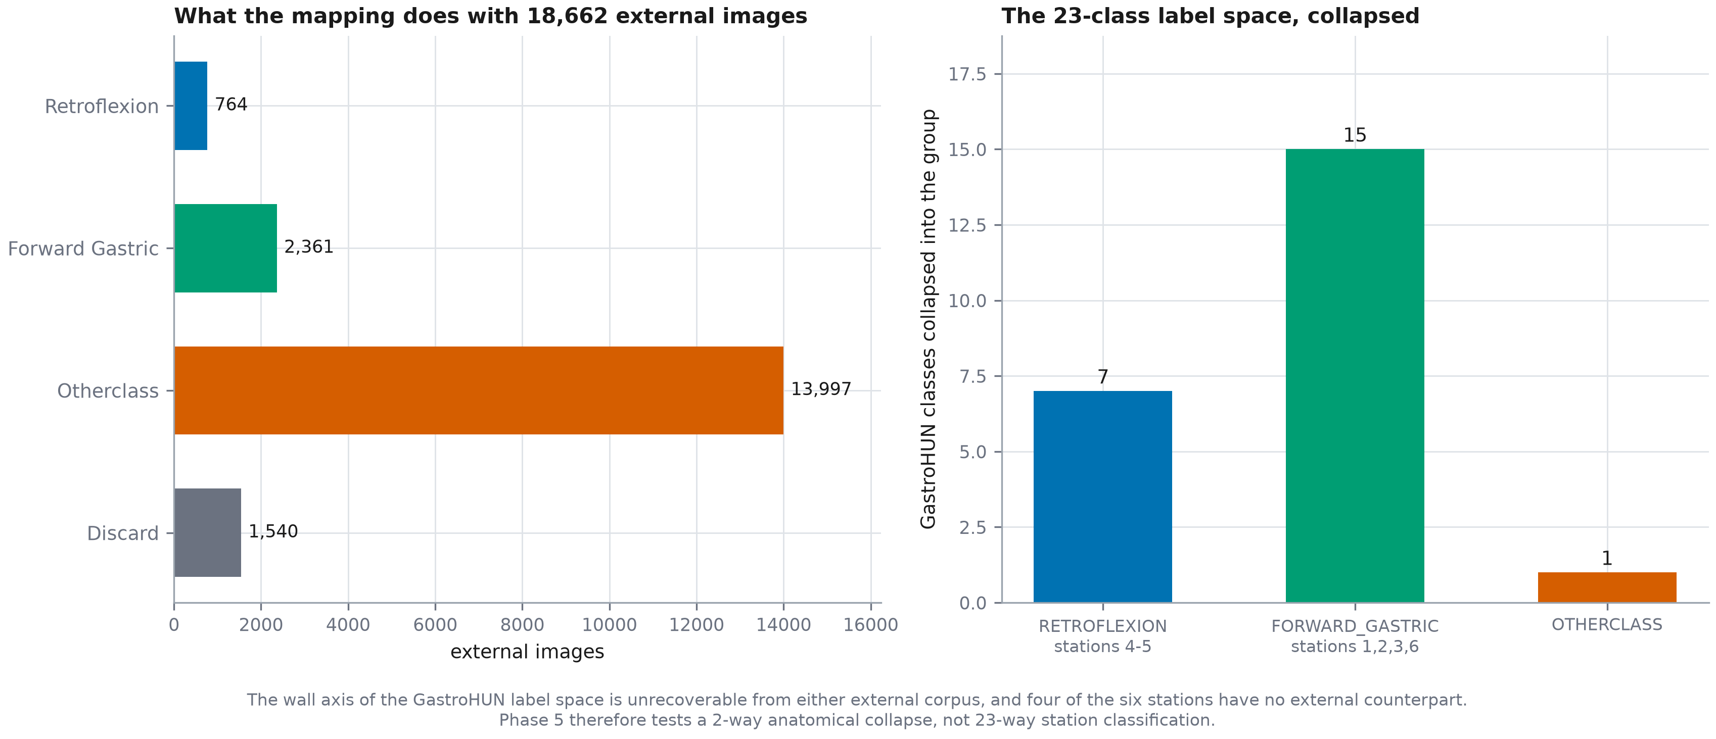
Figure 1. What the frozen mapping does with the external images, and how the 23-class GastroHUN label space collapses into the groups the external labels can express.
The wall axis of the GastroHUN label space is unrecoverable from either external corpus, and four of the six stations have no external counterpart. Phase 5 therefore tests a 2-way anatomical collapse and an out-of-protocol rejection endpoint. It does NOT and cannot test 23-way station classification externally. This is a property of the available public data, not of the model.

1.3 Research questions and pre-registered hypotheses
- P5-A: does the retroflexion-vs-forward distinction transfer to external centres?
- Endpoint: binary macro F1 over {RETROFLEXION, FORWARD_GASTRIC} on the 3,125 external gastric images. The model's 23-way argmax is collapsed through the frozen mapping; an OTHERCLASS prediction counts as INCORRECT for whichever class the image truly is, so the endpoint penalises both confusing the two views and failing to recognise a gastric view at all.
- Pre-registered expectation: a DROP is expected and is the publishable result (blueprint sec.4 PHASE 5). The pre-registered expectation is a drop of more than 10 points, because the external corpora are different centres, different vendors and different framing conventions, and because the retroflexion class is defined by endoscope orientation rather than by mucosal appearance.
- P5-B: given an image that is not a gastric SSS station at all, does the model route it to OTHERCLASS or confidently assert a station?
- Endpoint: out-of-protocol rejection rate: the fraction of the out-of-protocol images assigned OTHERCLASS
- Pre-registered expectation: the rejection rate will be LOW -- plausibly at or below the 4.3% chance rate of a 23-way head. GastroHUN contains almost no true out-of-protocol images and OTHERCLASS is a minority class its own annotators disagree about, so the model has had no opportunity to learn a rejection behaviour. This predicts confident misassignment, which is the deployment-relevant failure and the endpoint on which the external data is more informative than GastroHUN itself.
- P5-C: is the Phase 4 calibration ordering preserved under shift?
- Endpoint: Spearman rank correlation between the five arms' ECE ordering internally (Phase 4, pooled contested stratum) and externally (this phase, all evaluated images)
- Pre-registered expectation: the ordering is expected to be broadly preserved, because C3's low ECE is produced by a global confidence shift (Phase 4 sec.4.2) and a global shift is a property of the model rather than of the data it is shown. If the ordering does NOT survive, that is evidence the Phase 4 calibration result was dataset-specific, which would be the more important finding.

2. Methods

2.1 The external corpora
Table 2. The two external corpora, as acquired. Counts are realised from the extracted archives, not quoted from the papers.
Corpus | Images | Licence | Centre
HyperKvasir (labeled images) | 10,662 | CC BY 4.0 | Baerum Hospital, Vestre Viken Health Trust, Norway
GastroVision | 8,000 | CC BY-NC 4.0 | Baerum Hospital (Norway) and Karolinska University Hospital

Every external image was SHA-256 hashed against the 8,834-image GastroHUN inventory: 18,662 images checked exhaustively, 0 collisions. A collision would have meant the external test set was not external.
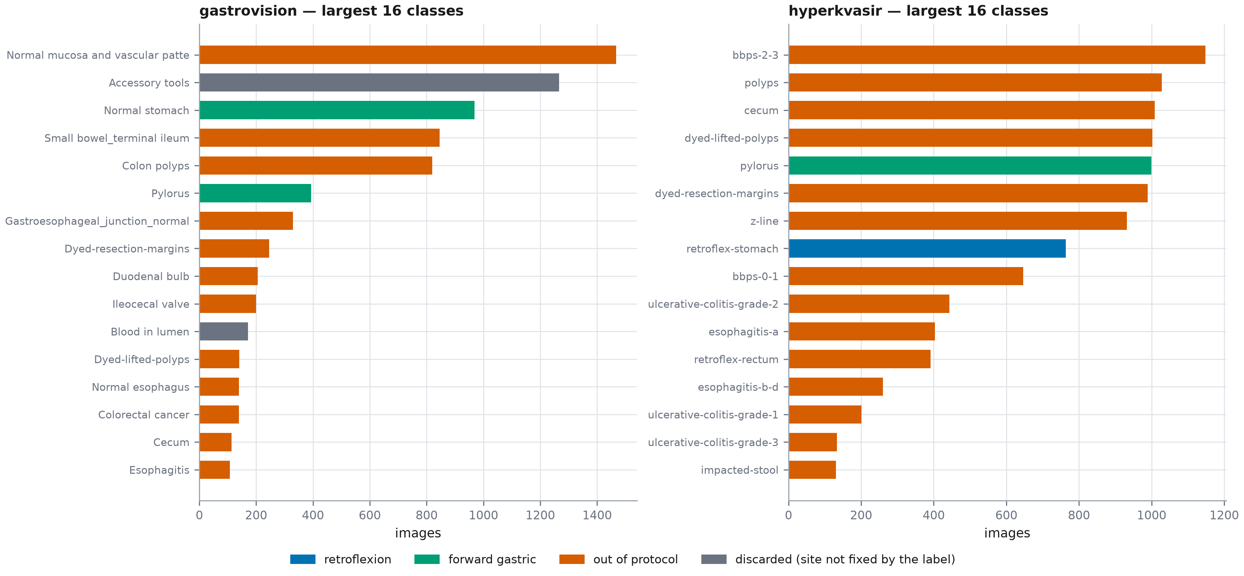
Figure 2. Class inventory of each corpus, coloured by the mapping decision.

2.2 The mapping table
Each of the 50 external class directories receives exactly one decision, and each decision carries a written anatomical rationale. Ambiguity is recorded per endpoint, because a label can be unambiguous on one axis and ambiguous on another: 'pylorus' is not an SSS station and so is ambiguous for station identity, but it is unambiguously a forward view and so is not ambiguous for P5-A, which asks only retroflexion versus forward.
Table 3. The frozen mapping, in totals. The per-class table with every rationale is Appendix A.
Decision | Images | Meaning
RETROFLEXION | 764 | GastroHUN stations 4-5
FORWARD_GASTRIC | 2,361 | GastroHUN stations 1, 2, 3, 6
OTHERCLASS | 13,997 | not a gastric SSS station at all
discard | 1,540 | the label does not fix the anatomical site

2.3 What is held fixed
Preprocessing is the Phase 2 path unchanged: PIL open -> convert('RGB') -> resize(224, LANCZOS) -> uint8; identical to phase2_cache.py and phase4_cache.py. Gate P5.3a re-decoded 400 GastroHUN images through the Phase 5 module and required them to come back bit-identical to the Phase 4 cache; 0 mismatched. Without that, a measured drop could be a preprocessing artefact rather than a domain effect.
Normalisation
Phase 2 TRAINING-SET statistics, applied at inference time by phase5_infer.py, NOT recomputed on the external corpora. Recomputing them on the external corpora would silently adapt the model to the target domain, which is precisely the adaptation this phase exists to measure the absence of.

no fine-tuning, no domain adaptation, no self-training, no threshold tuning and no post-hoc temperature scaling on external data. Phase 5 measures transfer, not transfer-after-adaptation. The Phase 5B self-training arm is a separate, later comparison against the numbers this pre-registration governs, and may not begin until they are committed.

2.4 Which arms were carried, and why all five
The blueprint status board records the Phase 4 guidance as 'carry the best-calibrated arm'. Applied literally that rule selects C3. C3 attains the lowest contested ECE (19.413 points) but is 6.446 points UNDER-confident on unanimous images, beyond the 5.0-point tolerance. Its calibration is therefore substantially a global confidence shift, not evidence that it knows which images are hard. Carrying it alone would carry an artefact into the external test.
A second reason is structural: the external half of RQ3 asks whether the uncertainty ranking is preserved outside the training distribution, and a ranking cannot be measured with one arm. Phase 5 is inference-only, so carrying all five costs fifteen forward passes. The decision was frozen in reports/phase5_carry_forward.json before any external image existed on disk.

2.5 Evaluation and the pre-registered precision target
reports/phase4_amendment.json records the absence of a pre-registered precision target as an outstanding Phase 4 defect: a NOT RESOLVED verdict there cannot be distinguished from an underpowered one. Phase 5 fixes a target in advance, so that a null is interpretable. The target is a 95% CI half-width of at most 3.0 points on the P5-A endpoint. if the realised half-width exceeds the target, the verdict is reported as UNDERPOWERED rather than as a null, and the report says how many images would have been needed.
Declared weakness: the clustering unit (P5-DEV-3)
Phases 0-4 clustered every interval by patient, because Phase 0 measured per-patient Fleiss kappa at 0.7459 +/- 0.1448 and images within a patient are not independent. Neither external corpus ships a usable grouping key: HyperKvasir's 'Video file' column has 10,662 distinct values over 10,662 images, one per image, and GastroVision ships none. Phase 5 intervals are therefore image-level and are OPTIMISTIC -- narrower than a correctly clustered interval would be. This is declared here rather than discovered later, and no Phase 5 interval may be compared directly against a Phase 0-4 interval.

Table 4. Gates on the 17,122-image external inference. P5.5c is the load-bearing one: 12 of 12 arm-seeds reproduced the Phase 4 internal probabilities bit-identically, so the external numbers and the internal comparator come from the same pipeline.
Inference gate | Pass
P5.5a_row_order_matches_index | True
P5.5b_argmax_equals_saved_pred | True
P5.5c_reproduces_phase4_internal_probs | True

3. Results

3.1 P5-A: does the retroflexion distinction transfer?
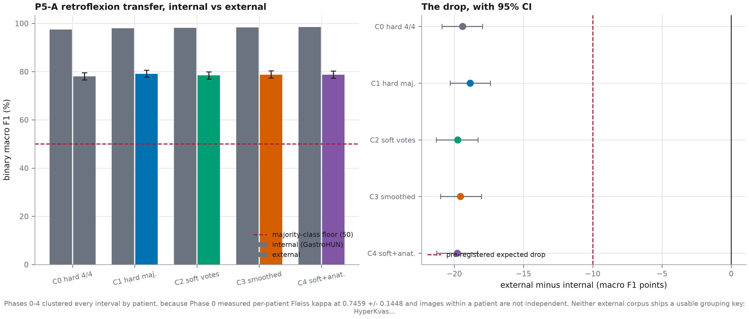
Figure 3. Left: binary macro F1 internally and externally, per arm, with the majority-class floor. Right: the drop, with its 95% CI.
Table 5. P5-A on 3,125 external gastric images (764 retroflexion, 2,361 forward) against 1,222 internal ones.
Configuration | Internal F1 | External F1 | External 95% CI | Drop | Half-width | Meets precision | Verdict
C0 hard label, 4/4 cohort (Phase 2 reference) | 97.43 | 78.03 | [76.55, 79.48] | -19.40 | 1.47 | True | TRANSFERS
C1 hard majority label, extended cohort | 97.95 | 79.09 | [77.67, 80.56] | -18.86 | 1.44 | True | TRANSFERS
C2 vote proportions | 98.17 | 78.41 | [76.87, 79.89] | -19.75 | 1.51 | True | TRANSFERS
C3 hard label + matched label smoothing (control) | 98.30 | 78.75 | [77.31, 80.27] | -19.55 | 1.48 | True | TRANSFERS
C4 vote proportions + anatomical penalty | 98.48 | 78.71 | [77.22, 80.19] | -19.78 | 1.48 | True | TRANSFERS
Note. An OTHERCLASS prediction counts as incorrect, so the endpoint penalises both confusing the two views and failing to recognise a gastric view at all.
Every arm transferred, and every arm met the pre-registered precision target, so these are powered verdicts rather than underpowered nulls. The pre-registered expectation was a drop of more than 10 points; the realised drop for C2 is -19.75 points [-21.29, -18.28]. A degradation of this size is the expected and publishable result, not a failure — but it is roughly twice what was predicted, and the report does not soften that.

3.2 P5-B: out-of-protocol rejection, and a falsified prediction
The pre-registered hypothesis was that rejection would sit at or below chance. The reasoning was concrete: the GastroHUN test split contains only 50 OTHERCLASS images in 1,353, so the model had almost no opportunity to learn a rejection behaviour.
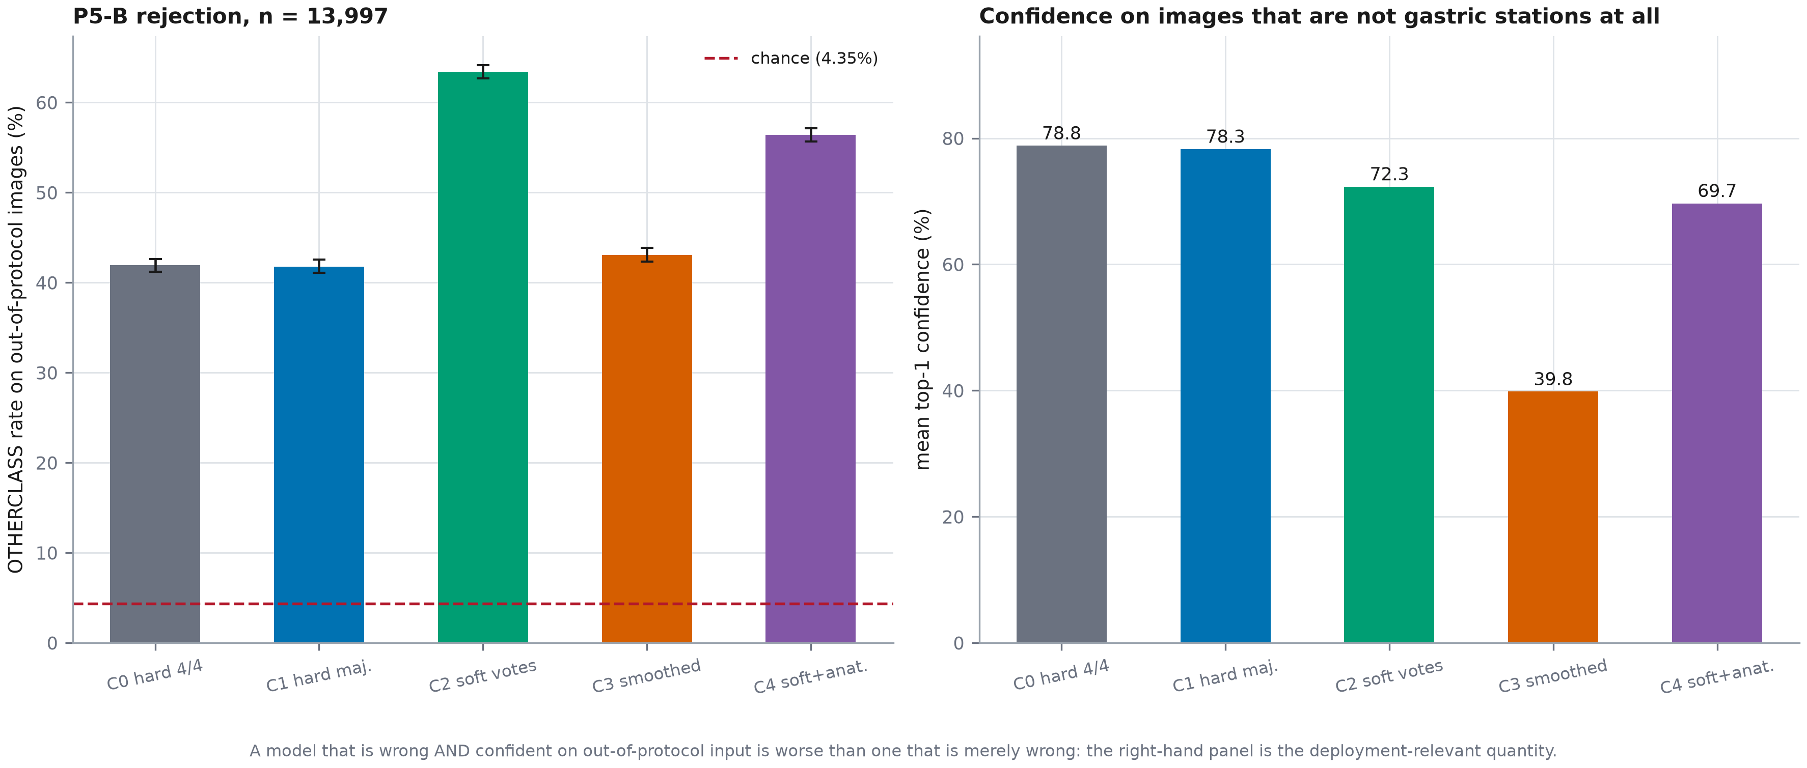
Figure 4. Left: OTHERCLASS rate on images that are not gastric stations at all, against the chance floor. Right: mean top-1 confidence on those same images.
Table 6. P5-B on 13,997 out-of-protocol images. Chance rate for a 23-way head is 4.35%.
Configuration | Rejection (%) | 95% CI | Mean top-1 conf (%) | Verdict
C0 hard label, 4/4 cohort (Phase 2 reference) | 41.92 | [41.22, 42.61] | 78.81 | REJECTS OUT-OF-PROTOCOL IMAGES
C1 hard majority label, extended cohort | 41.79 | [41.09, 42.55] | 78.28 | REJECTS OUT-OF-PROTOCOL IMAGES
C2 vote proportions | 63.40 | [62.69, 64.14] | 72.32 | REJECTS OUT-OF-PROTOCOL IMAGES
C3 hard label + matched label smoothing (control) | 43.06 | [42.34, 43.83] | 39.83 | REJECTS OUT-OF-PROTOCOL IMAGES
C4 vote proportions + anatomical penalty | 56.43 | [55.66, 57.15] | 69.67 | REJECTS OUT-OF-PROTOCOL IMAGES

The prediction was wrong by an order of magnitude, and the arms separate sharply: C2 rejects 63.4% of out-of-protocol images against C1's 41.8%. The separation runs in favour of the soft-target arms. This is a benefit GastroHUN's own test split is too thin in OTHERCLASS to have detected, and it is the clearest case in this thesis of external data answering a question the internal data could not.

3.3 P5-C: does the calibration ordering survive the shift?
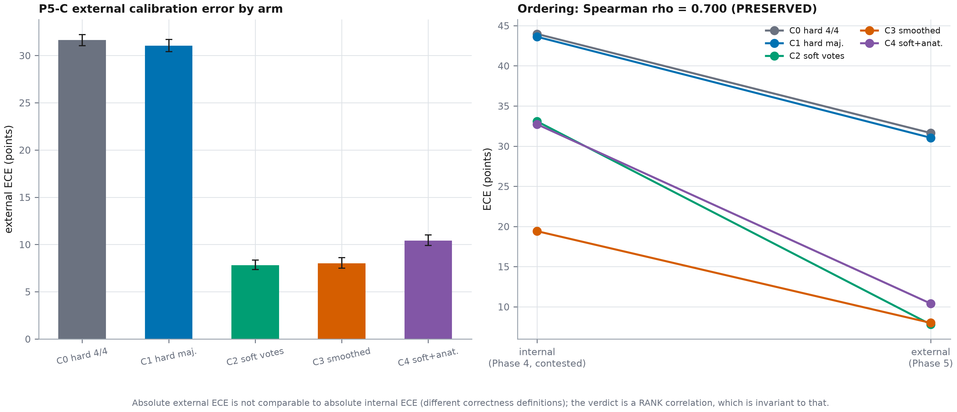
Figure 5. Left: external ECE by arm. Right: each arm's ECE internally and externally, showing which orderings survive.
Table 7. Calibration internally (Phase 4, pooled contested) and externally. A negative over/under-confidence value means the arm is UNDER-confident.
Configuration | Internal ECE | External ECE | External 95% CI | Over/under-confidence | External accuracy (%)
C0 hard label, 4/4 cohort (Phase 2 reference) | 43.97 | 31.63 | [31.03, 32.21] | 31.63 | 48.00
C1 hard majority label, extended cohort | 43.61 | 31.04 | [30.41, 31.71] | 31.04 | 48.46
C2 vote proportions | 33.08 | 7.80 | [7.36, 8.36] | 6.78 | 65.62
C3 hard label + matched label smoothing (control) | 19.41 | 8.00 | [7.50, 8.60] | -6.46 | 49.54
C4 vote proportions + anatomical penalty | 32.72 | 10.40 | [9.90, 11.00] | 10.15 | 60.18
Note. Phase 4 scored ECE against annotator-marginalised EXPECTED accuracy; the external corpora ship no per-annotator votes, so external correctness is plain 0/1 against the collapsed label.; confidence is the 23-way top-1 probability while correctness is judged at collapsed granularity, so mass split across members of the correct group reads as under-confidence. ECE on the collapsed group mass is reported alongside as the secondary definition.
The ordering is PRESERVED (Spearman rho = 0.700). Internally the order was C3 < C4 < C2 < C1 < C0; externally it is C2 < C3 < C4 < C1 < C0. The two best arms exchanged places: C3 was best internally and C2 is best externally.
The most direct confirmation of the Phase 4 mechanism claim is C3's under-confidence. Phase 4 measured it at -6.45 points on unanimous images and argued it was a global confidence shift — a property of the model, not of the data. Externally it is -6.46 points. It followed the model to two new centres essentially unchanged, which is what a global shift does, and it stops being an advantage there.

3.4 Sensitivity: the ambiguous mapping decisions, re-run
Table 8. Every mapping decision flagged ambiguous for an endpoint under test, re-run with the alternative frozen before scoring.
Mapping | n | P5-A F1 | P5-A verdict | P5-B rej. (%) | P5-B verdict
baseline | 3,125 | 78.41 | TRANSFERS | 63.40 | REJECTS OUT-OF-PROTOCOL IMAGES
flip gastrovision/Accessory tools | 15,263 | — | — | 64.39 | REJECTS OUT-OF-PROTOCOL IMAGES
flip gastrovision/Angiectasia | 14,014 | — | — | 63.37 | REJECTS OUT-OF-PROTOCOL IMAGES
flip gastrovision/Blood in lumen | 14,168 | — | — | 63.48 | REJECTS OUT-OF-PROTOCOL IMAGES
flip gastrovision/Erythema | 14,012 | — | — | 63.39 | REJECTS OUT-OF-PROTOCOL IMAGES
flip gastrovision/Normal stomach | 2,156 | 97.36 | TRANSFERS | — | —

Verdicts invariant to every single flip: True. The mapping's judgement calls do not carry the result.

4. Discussion

4.1 What the label-space finding means
The most consequential result of this phase is not a number. It is that the two most widely used public upper-GI corpora cannot express the question the thesis asks. GastroHUN labels wall and station; HyperKvasir and GastroVision label neither. Any paper claiming external validation of station-level gastric landmark classification on these corpora is either using a coarser endpoint than it appears to, or mapping labels that do not correspond. Stating that plainly is worth more than a station-level number would have been.

4.2 A 19-point drop, and what it is not
The drop of -19.75 points is roughly twice the pre-registered expectation. It is not evidence that the model is broken: it still transfers well clear of the majority-class floor on corpora from different centres, different vendors and different framing conventions, with no adaptation of any kind. But it does set the scale of the domain gap, and it should be quoted whenever an internal number from Phases 2 to 4 is quoted.

4.3 The result that changes the thesis's recommendation
Phase 4 concluded that calibration, not accuracy, was the headline deficiency, and that the matched control C3 was the best-calibrated arm. Phase 5 keeps the first half and overturns the second. Externally, C2 has the lowest ECE (7.80 against C3's 8.00), much higher accuracy (65.62% against 49.54%), and substantially better out-of-protocol rejection. C3's internal advantage was a global confidence shift that travelled intact and stopped helping.
Why five arms
Had Phase 5 carried only the arm the status board named best-calibrated, it would have carried C3, and none of this would be visible. The carry-forward decision was the single most consequential methodological choice in this phase.

4.4 Out-of-protocol rejection is the deployment-relevant endpoint
In a screening workflow the model does not receive a curated stream of gastric stations. It receives whatever the endoscope is pointed at. An arm that routes 63% of non-gastric frames to OTHERCLASS is categorically safer than one that routes 42% of them to a confidently asserted station, and the two arms are indistinguishable on GastroHUN. This endpoint should be primary, not secondary, in any future work.

4.5 Limitations specific to this phase
- Phases 0-4 clustered every interval by patient, because Phase 0 measured per-patient Fleiss kappa at 0.7459 +/- 0.1448 and images within a patient are not independent. Neither external corpus ships a usable grouping key: HyperKvasir's 'Video file' column has 10,662 distinct values over 10,662 images, one per image, and GastroVision ships none. Phase 5 intervals are therefore image-level and are OPTIMISTIC -- narrower than a correctly clustered interval would be. This is declared here rather than discovered later, and no Phase 5 interval may be compared directly against a Phase 0-4 interval.
- Neither corpus ships per-annotator labels, so there is no external agreement stratification and no external vote entropy. The within-stratum correlation that is RQ3's internal primary quantity has no external counterpart (deviation P5-DEV-2).
- All retroflexion images come from HyperKvasir, so P5-A rests on one corpus. GastroVision contributes the forward-view side and almost all of the out-of-protocol set.
- 1,540 images were discarded because their labels do not fix the anatomical site. They were scored anyway and re-included in the sensitivity analysis, which left every verdict unchanged.
- No adaptation of any kind was performed, by design. The Phase 5B self-training arm measures transfer-after-adaptation and is a separate comparison against the numbers frozen here.

4.6 Implications for Phases 6 and 7
- Phase 6's Grad-CAM work should target the retroflexion/forward boundary and the out-of-protocol failures, which are where the external errors concentrate.
- Phase 7 should quote the external number beside every internal one, and should present the C2-versus-C3 reversal as the phase's central result rather than as a footnote to Phase 4.
- Any deployment recommendation should name C2, and should cite out-of-protocol rejection rather than macro F1 as the reason.

5. Conclusion

5.1 Answers
- P5-A: TRANSFERS. 78.41 external against 98.17 internal, a drop of -19.75 points [-21.29, -18.28], with the pre-registered precision target met.
- P5-B: REJECTS OUT-OF-PROTOCOL IMAGES. The pre-registered hypothesis was falsified: rejection reached 63.4% against a 4.35% chance rate, and the soft-target arms rejected far more reliably than the hard-label ones.
- P5-C: PRESERVED, Spearman rho = 0.700, but with C3 and C2 exchanging places at the top.

5.2 Carry-forward decisions
- Carry C2 forward as the recommended configuration, on external calibration and out-of-protocol rejection rather than on internal accuracy.
- Retain C3 as a control in any future comparison, and treat a low ECE achieved alongside large under-confidence on easy cases as a warning sign rather than a result.
- Report out-of-protocol rejection as a primary endpoint in Phases 6 and 7. It separated the arms where every internal endpoint failed to.
- State the label-space limitation wherever external validation is claimed, in this thesis and in any paper drawn from it.
- Do not compare a Phase 5 interval against a Phase 0-4 interval: the clustering units differ and the Phase 5 ones are optimistic.

Appendices

Appendix A. The full mapping table
Table 9. Every external class directory, its decision and the anatomical reason for it.
Corpus | External class | n | Decision | Rationale
gastrovision | Accessory tools | 1,266 | discard | the frame is dominated by an instrument and the label says nothing about which tract is being viewed, so it can be neither a station nor a confident o
gastrovision | Angiectasia | 17 | discard | site not specified; angiectasia occurs in the stomach and the small bowel alike.
gastrovision | Barrett's esophagus | 95 | OTHERCLASS | oesophagus or the oesophago-gastric junction; proximal to the gastric protocol
gastrovision | Blood in lumen | 171 | discard | site not specified by the label; may be upper or lower GI.
gastrovision | Cecum | 113 | OTHERCLASS | lower gastrointestinal tract; not a gastric SSS station
gastrovision | Colon diverticula | 29 | OTHERCLASS | lower gastrointestinal tract; not a gastric SSS station
gastrovision | Colon polyps | 820 | OTHERCLASS | lower gastrointestinal tract; not a gastric SSS station
gastrovision | Colorectal cancer | 139 | OTHERCLASS | lower gastrointestinal tract; not a gastric SSS station
gastrovision | Duodenal bulb | 205 | OTHERCLASS | distal to the pylorus, outside the gastric protocol
gastrovision | Dyed-lifted-polyps | 141 | OTHERCLASS | therapeutic/interventional frame from the lower GI tract
gastrovision | Dyed-resection-margins | 246 | OTHERCLASS | therapeutic/interventional frame from the lower GI tract
gastrovision | Erythema | 15 | discard | site not specified by the label.
gastrovision | Esophageal varices | 7 | OTHERCLASS | oesophagus or the oesophago-gastric junction; proximal to the gastric protocol
gastrovision | Esophagitis | 107 | OTHERCLASS | oesophagus or the oesophago-gastric junction; proximal to the gastric protocol
gastrovision | Gastric polyps | 65 | discard | anatomically gastric, but the label is pathology-defined and the frame is centred on a lesion rather than on an SSS station, so neither the station no
gastrovision | Gastroesophageal_junction_normal z-line | 330 | OTHERCLASS | oesophagus or the oesophago-gastric junction; proximal to the gastric protocol
gastrovision | Ileocecal valve | 200 | OTHERCLASS | lower gastrointestinal tract; not a gastric SSS station
gastrovision | Mucosal inflammation large bowel | 29 | OTHERCLASS | lower gastrointestinal tract; not a gastric SSS station
gastrovision | Normal esophagus | 140 | OTHERCLASS | oesophagus or the oesophago-gastric junction; proximal to the gastric protocol
gastrovision | Normal mucosa and vascular pattern in the large bowel | 1,467 | OTHERCLASS | lower gastrointestinal tract; not a gastric SSS station
gastrovision | Normal stomach | 969 | FORWARD_GASTRIC | normal gastric mucosa. GastroVision has NO retroflex-stomach class, so retroflexed gastric frames in this corpus have nowhere else to be filed and may
gastrovision | Pylorus | 393 | FORWARD_GASTRIC | forward view of the pyloric ring; same reasoning as the HyperKvasir pylorus class.
gastrovision | Resected polyps | 92 | OTHERCLASS | therapeutic/interventional frame from the lower GI tract
gastrovision | Resection margins | 25 | OTHERCLASS | therapeutic/interventional frame from the lower GI tract
gastrovision | Retroflex rectum | 67 | OTHERCLASS | lower gastrointestinal tract; not a gastric SSS station. RECTAL retroflexion; must not be pooled with a gastric retroflexion.
gastrovision | Small bowel_terminal ileum | 846 | OTHERCLASS | lower gastrointestinal tract; not a gastric SSS station
gastrovision | Ulcer | 6 | discard | site not specified by the label; gastric and duodenal ulcers are both present in this class, so it cannot be assigned.
hyperkvasir | barretts | 41 | OTHERCLASS | oesophagus or the oesophago-gastric junction; proximal to the gastric protocol
hyperkvasir | barretts-short-segment | 53 | OTHERCLASS | oesophagus or the oesophago-gastric junction; proximal to the gastric protocol
hyperkvasir | bbps-0-1 | 646 | OTHERCLASS | bowel-preparation quality score from the lower GI tract
hyperkvasir | bbps-2-3 | 1,148 | OTHERCLASS | bowel-preparation quality score from the lower GI tract
hyperkvasir | cecum | 1,009 | OTHERCLASS | lower gastrointestinal tract; not a gastric SSS station
hyperkvasir | dyed-lifted-polyps | 1,002 | OTHERCLASS | therapeutic/interventional frame from the lower GI tract
hyperkvasir | dyed-resection-margins | 989 | OTHERCLASS | therapeutic/interventional frame from the lower GI tract
hyperkvasir | esophagitis-a | 403 | OTHERCLASS | oesophagus or the oesophago-gastric junction; proximal to the gastric protocol
hyperkvasir | esophagitis-b-d | 260 | OTHERCLASS | oesophagus or the oesophago-gastric junction; proximal to the gastric protocol
hyperkvasir | hemorrhoids | 6 | OTHERCLASS | lower gastrointestinal tract; not a gastric SSS station
hyperkvasir | ileum | 9 | OTHERCLASS | lower gastrointestinal tract; not a gastric SSS station
hyperkvasir | impacted-stool | 131 | OTHERCLASS | lower gastrointestinal tract; not a gastric SSS station
hyperkvasir | polyps | 1,028 | OTHERCLASS | lower gastrointestinal tract; not a gastric SSS station
hyperkvasir | pylorus | 999 | FORWARD_GASTRIC | forward view of the pyloric ring from the antrum. The pylorus is distal to the antrum and is NOT itself an SSS station, so this cannot be assigned a s
hyperkvasir | retroflex-rectum | 391 | OTHERCLASS | lower gastrointestinal tract; not a gastric SSS station. Note this is a RECTAL retroflexion, not a gastric one; it must not be pooled with retroflex-s
hyperkvasir | retroflex-stomach | 764 | RETROFLEXION | retroflexed view of the gastric cardia/fundus. This is the only class in either corpus that unambiguously denotes a stomach retroflexion, and P5-A res
hyperkvasir | ulcerative-colitis-grade-0-1 | 35 | OTHERCLASS | lower gastrointestinal tract; not a gastric SSS station
hyperkvasir | ulcerative-colitis-grade-1 | 201 | OTHERCLASS | lower gastrointestinal tract; not a gastric SSS station
hyperkvasir | ulcerative-colitis-grade-1-2 | 11 | OTHERCLASS | lower gastrointestinal tract; not a gastric SSS station
hyperkvasir | ulcerative-colitis-grade-2 | 443 | OTHERCLASS | lower gastrointestinal tract; not a gastric SSS station
hyperkvasir | ulcerative-colitis-grade-2-3 | 28 | OTHERCLASS | lower gastrointestinal tract; not a gastric SSS station
hyperkvasir | ulcerative-colitis-grade-3 | 133 | OTHERCLASS | lower gastrointestinal tract; not a gastric SSS station
hyperkvasir | z-line | 932 | OTHERCLASS | oesophagus or the oesophago-gastric junction; proximal to the gastric protocol. The Z-line is the squamocolumnar junction, outside the gastric protoco

Appendix B. Per-seed results
Table 10. P5-A per seed. The recognition column is the fraction of gastric images not routed to OTHERCLASS.
Config | Seed | External F1 | Internal F1 | Drop | Gastric recognition (%)
C0 | 1 | 78.96 | 97.55 | -18.59 | 93.1
C0 | 2 | 76.38 | 96.77 | -20.39 | 84.3
C0 | 3 | 78.75 | 97.98 | -19.23 | 93.0
C1 | 1 | 79.53 | 97.85 | -18.32 | 95.0
C1 | 2 | 79.21 | 97.85 | -18.64 | 95.4
C1 | 3 | 78.53 | 98.14 | -19.61 | 93.2
C2 | 1 | 78.66 | 98.08 | -19.43 | 91.2
C2 | 2 | 78.64 | 98.28 | -19.64 | 90.3
C2 | 3 | 77.95 | 98.13 | -20.18 | 89.3
C3 | 1 | 79.02 | 98.30 | -19.29 | 95.5
C3 | 2 | 79.08 | 98.33 | -19.25 | 95.8
C3 | 3 | 78.15 | 98.25 | -20.10 | 94.7
C4 | 1 | 78.50 | 98.54 | -20.04 | 91.6
C4 | 2 | 79.03 | 98.64 | -19.62 | 93.7
C4 | 3 | 78.60 | 98.28 | -19.68 | 92.4

Appendix C. Pre-registration record
Frozen at 2026-07-28 15:00:33, after the corpora, mapping and cache existed and before any external image was scored. The script that writes it refuses to overwrite an existing copy.
Pre-registration statement
This document fixes every decision that could otherwise be made after seeing the result. It is written after the corpora, the mapping table and the 224px cache exist -- so that endpoints are defined against realised counts rather than guesses -- and before any external image has been scored by any model. The script that writes it refuses to overwrite an existing copy.

Table 11. Declared deviations.
ID | Item | Adopted | Evidence | Impact
P5-DEV-1 | which arm is carried into external validation | all five arms x 3 seeds | C3 attains the lowest contested ECE (19.413 points) but is 6.446 points UNDER-confident on unanimous images, beyond the 5.0-point tolerance. Its calibration is therefore substantially a global confide | none adverse. Phase 5 is inference-only, so carrying five arms costs 15 forward passes; and RQ3's external half is a question about RANKING, which one arm cannot answer.
P5-DEV-2 | external agreement-stratified curve and external vote entropy | not computed; stated plainly instead, as that clause instructs | neither corpus ships per-annotator votes, so there is no external vote entropy and no external agreement stratification. The within-stratum rho that is RQ3's internal primary quantity has no external | RQ3's external half is tested as calibration-ordering preservation (P5-C) rather than as a reproduction of the entropy correlation.
P5-DEV-3 | interval clustering unit | image-level bootstrap, 1,000 resamples | no usable grouping key exists in either corpus; HyperKvasir's 'Video file' column is unique per image and GastroVision ships none. | Phase 5 intervals are optimistic relative to Phases 0-4 and may not be compared directly against them. The >=1,000 resample requirement is met.
P5-DEV-4 | granularity of the external endpoint | a 2-way anatomical collapse plus an out-of-protocol rejection endpoint, instead of any station-level metric | The wall axis of the GastroHUN label space is unrecoverable from either external corpus, and four of the six stations have no external counterpart. Phase 5 therefore tests a 2-way anatomical collapse | Phase 5 cannot and does not test 23-way station classification externally. This is a property of the available public data, not of the model, and it is reported as a finding in its own right.

P5-A is falsified as a transfer claim if the external binary macro F1 does not exceed the 50-point majority-class floor. P5-B's hypothesis is falsified if the model DOES reject out-of-protocol images above chance, which would be a better result than predicted and would have to be reported as such. P5-C is falsified if the calibration ordering does not survive the shift, which would downgrade the Phase 4 calibration finding to a dataset-specific one.

Appendix D. Script and artefact manifest
- python src/models/phase5_carry_forward.py # P5.0, frozen first
- python src/models/phase5_acquire.py --extract # P5.1, gates a-d
- python src/models/phase5_mapping.py # P5.2, gates a-c
- python src/models/phase5_cache.py # P5.3, gate P5.3a
- python src/models/phase5_cache_supplement.py # P5.3b
- python src/models/phase5_prereg.py # P5.4, FROZEN
- python src/models/phase5_infer.py # P5.5, gates a-c
- python src/models/phase5_infer_supplement.py # P5.5b
- python src/models/phase5_eval.py # P5.6 and P5.7
- python src/models/phase5_calibration.py # P5.8
- python src/models/phase5_sensitivity.py # P5.10
- python src/report/figures_phase5.py
- python src/report/build_phase5_docx.py
- python src/report/finalise_phase5.py

Appendix E. Analyses not executed, and what they would cost
- Phase 5B self-training on the external corpora. Approved and planned, gated on the numbers in this report being frozen and committed first; adapting before the clean transfer numbers exist would make the external validation circular.
- Station-level external evaluation. Not costed, because it is not possible: the external label spaces do not carry the station or wall axes.
- Case-clustered intervals. Would require case identifiers neither corpus publishes.
- A third external corpus. Kvasir-Capsule and the Nerthus set were considered and rejected as anatomically disjoint from the gastric SSS protocol.

