Agreement-Stratified Evaluation of Deep Learning for Anatomical Landmark Recognition in Upper Gastrointestinal Endoscopy
Phase 3 — Agreement-Stratified Evaluation (RQ1)
Evaluating the frozen Phase 2 checkpoints outside the complete-agreement subset they were trained and validated on

──────────────────────────────────────────────
Degree programme | B.Sc. in Computer Science and Engineering
Research domain | Biomedical Artificial Intelligence — Medical Image Analysis and Deep Learning
Evaluation cohort | Full official GastroHUN test split — 1,353 images, 59 patients, stratified into 5 agreement tiers (pooled to 4 for the primary analysis)
Model | 3 frozen ConvNeXt-Tiny checkpoints from Phase 2 — no retraining, no threshold tuning, no reselection
Governing protocol | THESIS_RESEARCH_BLUEPRINT.md (v3.1) §4 Phase 3, §13-14
Consistency gate | S-unanimous predictions reproduce phase2_predictions_seed*.csv exactly (803/803 images, all 3 seeds) — see §2.3
Reporting standards | CLAIM, TRIPOD+AI, STARD-AI, PROBAST+AI
Report date | 27 July 2026

RQ1 verdict: raw drop 53.1 points S-unanimous to S-no-majority (16.3x the 3.25-pt architecture benchmark). Holding the attainable ceiling constant (§3.4.1): supported for 4/4 vs 3/4 (18.0 pts, CI 12.5-24.4) and 4/4 vs 2-1-1; not resolvable for 4/4 vs no-majority (7.4 pts, CI -3.1 to 18.8).
Revision 2 — incorporates the pre-registered sections omitted from revision 1 (§3.6, §3.8, §3.9.2, Appendices A–C), the pre-registered gap intervals, and four corrections recorded in §3.10 and Appendix E.

Table of Contents
List of Abbreviations 6
Abstract 6
1. Introduction 7
1.1 Recap: Phase 0 corpus audit and Phase 2 baseline reproduction 7
1.2 Motivation 7
1.3 Research question and pre-registered hypothesis (RQ1) 7
1.4 Chapter roadmap 7
2. Methods 8
2.1 Frozen model specification 8
2.2 Full test-split composition and agreement tiers 8
2.2.2 Pre-registered ground-truth rule per tier 8
2.2.3 Pre-registered pooling rule 8
2.3 Preprocessing, inference, and the consistency gate 8
2.4 Metrics 9
2.4.1 / 2.4.2 Annotator-marginalized macro F1 (primary) 9
2.4.3 Patient-clustered bootstrap 9
2.4.4 Metric validity across tiers: the attainable ceiling 9
2.5 Confusion-structure comparison protocol (O3) 10
2.6 Statistical analysis plan 10
2.6.1 Interval estimates on the gaps 10
2.6.2 Protocol amendment and analysis provenance 10
3. Results 10
3.1 Test-split stratum composition 10
3.2 Per-stratum performance 11
3.3 Reproduction check: S-unanimous vs. Phase 2 11
3.4 Monotonicity and gap test 11
3.4.1 Attainable-ceiling re-analysis of the gap (post-hoc) 12
3.5 Distribution-aware metrics on no-majority images 14
3.6 Per-class behaviour across strata 15
3.6.1 Class-composition control (post-hoc) 16
3.7 Confusion-structure comparison: model vs. human disagreement geometry 17
3.8 Calibration by stratum 18
3.8.1 Predictive entropy against annotator vote entropy 18
3.8.2 Confusion-structure comparison restated with intervals 19
3.9 Sensitivity checks 20
3.9.1 Per-seed stability across strata 20
3.9.2 Acquisition-stream composition per stratum 20
3.10 Corrections to the first release of this report 21
4. Discussion 22
4.1 Interpretation against RQ1's pre-registered hypothesis 22
4.2 Where model degradation does, and does not, mirror human disagreement 22
4.3 Implications for Phase 4 design choices 23
4.4 Comparison with the wider literature 23
4.5 Limitations specific to this phase 23
5. Conclusion 23
5.1 Answer to RQ1 23
5.2 Carry-forward decisions for Phase 4 24
Appendices 25
Appendix A. Per-class, per-stratum metric tables 25
Appendix B. Per-stratum confusion matrices 25
Appendix C. Bootstrap procedure and diagnostics 25
Appendix D. Script and artefact manifest (reproducibility index) 26
Appendix E. Pre-registration record and protocol amendment 26
References 28

If this list appears blank, select all (Ctrl+A) and press F9 to update the field.

List of Figures
Figure 1. Annotator-marginalized macro F1 (primary) and single-label macro F1 (secondary, undefined for the pooled tier) across the four ordered agreement strata. 3-seed mean. 11
Figure 2. Left: the frozen model against the modal-vote oracle ceiling; the orange bar is the headroom actually available on each tier. Right: the same model expressed as a percentage of the attainable score. The raw curve is overlaid for comparison. 12
Figure 3. All six pairwise tier gaps on both scales, with the patient-clustered bootstrap 95% intervals required by pre-registered decision 4. The dashed line is the 3.25-point between-architecture benchmark. 13
Figure 4. Expected accuracy and any-annotator hit rate across all five agreement tiers (3-seed mean +/- SD); S-tied and S-dispersed shown unpooled for transparency, explicitly exploratory given their small n. 14
Figure 5. Per-class annotator-marginalized F1 across the four ordered strata (3-seed mean), classes ordered by S-unanimous F1. 15
Figure 6. Left: observed expected accuracy against what the tier's class mix alone would predict, using S-unanimous per-class accuracy. Right: the tier curve restricted to the dominant acquisition stream. 16
Figure 7. Model error geometry (S-unanimous stratum) compared with human disagreement geometry (Phase 0). 17
Figure 8. Reliability diagrams per stratum against expected accuracy (top), the divergence between mean confidence and expected accuracy (lower left), and expected calibration error with patient-clustered 95% intervals (lower right). 18
Figure 9. Model error geometry with patient-clustered bootstrap 95% intervals against the Phase 0 human benchmarks (orange diamonds). 19
Figure 10. Per-seed annotator-marginalized macro F1 across the four ordered agreement strata — all 3 frozen Phase 2 checkpoints, no retraining. 20

If this list appears blank, select all (Ctrl+A) and press F9 to update the field.

List of Tables
Table 1. Abbreviations used in this report. 6
Table 2. Test-split agreement-tier composition. Tier counts were gated against the corpus-wide cascade reported in Phase 0 before any model touched these images; a mismatch would have halted the phase. 8
Table 3. Per-stratum performance, 3-seed mean, frozen Phase 2 checkpoints, with patient-clustered bootstrap intervals. The final column gives the mean number of distinct annotator labels per image, i.e. how many ways a prediction can score an any-annotator hit on that tier — the any-hit column is not comparable across tiers without it (§3.10, correction X2). 11
Table 4. RQ1 monotonicity and gap test results. 11
Table 5. Attainable ceiling per stratum and the model's share of it. The ceiling depends only on the annotator vote matrix, not on the model. 12
Table 6. Pairwise tier gaps with patient-clustered bootstrap intervals (500 resamples per pair per seed, seed 20260726). The delivered Phase 3 reported no interval on any gap. 13
Table 7. Zero-support diagnostic. A 23-class macro average can be deflated mechanically when classes are absent from a small stratum; this table shows the size of that effect. 15
Table 8. Class-composition control. Phase 0 showed that disagreement concentrates on particular anatomical boundaries, so the contested tiers do not contain the same class mix as S-unanimous; this table tests whether that mix, rather than agreement, drives the tier effect. 16
Table 9. Model vs. human error geometry, S-unanimous stratum (the only tier with an uncontested reference label). 17
Table 10. Calibration by agreement stratum, 3-seed mean. The target is expected accuracy - the probability mass the model's single prediction captures under the four-annotator vote distribution - because it is the only target defined on every tier. 18
Table 11. O3 restated as interval estimates. Both shares are ratios computed over roughly 65-70 errors, so their sampling variability is large. 19
Table 12. Acquisition-stream composition by agreement tier. Phase 0 limitation L4 records that the two streams are imbalanced across the official splits. 20
Table 13. Tier curve restricted to the dominant acquisition stream (sensitivity analysis for limitation L4). 20
Table 14. Annotator-marginalized per-class F1 by stratum, 3-seed mean, with mean annotator support at the extremes. Support is averaged over the four annotator label realisations and is therefore fractional. 25
Table 15. Summary of the per-stratum confusion matrices. Diagonal mass equals expected accuracy by construction. 25
Table 16. Plug-in versus bootstrap-mean estimates for the key gaps, as a bias diagnostic. 26
Table 17. Analysis provenance register. Confirmatory analyses are those whose specification predates the data, whether or not they were delivered in the first release. 26

If this list appears blank, select all (Ctrl+A) and press F9 to update the field.

List of Abbreviations
Table 1. Abbreviations used in this report.
Abbreviation | Expansion
AMF1 | Annotator-marginalized macro F1 (this phase's primary metric)
CI | Confidence interval (patient-clustered bootstrap throughout)
CLAIM | Checklist for Artificial Intelligence in Medical Imaging
ECE / MCE | Expected / maximum calibration error
FG1, FG2, G1, G2 | The four independent GastroHUN annotators (two teams)
O1-O4 | Phase 3 objectives, blueprint §4 Phase 3
PROBAST+AI | Prediction model Risk Of Bias ASsessment Tool, AI extension
RQ1 | Research question 1 - performance across strata of expert agreement
S-unanimous / -majority / -plurality / -tied / -dispersed | Agreement tiers: 4/4, 3/4, 2-1-1, 2-2, 1-1-1-1 annotator votes
STARD-AI | Standards for Reporting Diagnostic accuracy studies, AI extension
TRIPOD+AI | Transparent Reporting of a multivariable prediction model, AI extension

Abstract
Background. Phase 2 reproduced a published ConvNeXt-Tiny landmark classifier on the 60.2% subset of the GastroHUN test split where all four annotators agreed (macro F1 83.92, 95% CI 81.47-86.20). That subset is not representative of the full test split: 1,353 official test images span five agreement tiers, from full unanimity to total annotator dispersion.
Objective. To measure, without any retraining, how the frozen Phase 2 checkpoints perform on the 550 test images the Phase 2 protocol excluded, stratified by the number of annotators who agreed (RQ1); and to test whether the model's residual errors reproduce the anatomically structured geometry of human disagreement measured in Phase 0 (O3).
Methods. The full 1,353-image test split was tagged with one of five agreement tiers from the four-annotator vote matrix (pre-registered before any inference was run); S-tied and S-dispersed were pooled into S-no-majority per a pre-registered rule (n=8 for S-dispersed alone is not bootstrap-stable). The three Phase 2 checkpoints were run once on all 1,353 images. Performance was quantified with an annotator-marginalized macro F1 that is defined continuously across every tier, including the two tiers with no single ground-truth label, plus expected accuracy and any-annotator hit rate. All intervals used a patient-clustered bootstrap (1,000 resamples, applied independently within each tier).
Results. Annotator-marginalized macro F1 fell from 83.91 on S-unanimous (n=803) to 48.95 on S-majority (n=342) to 26.15 on S-plurality (n=127) and 30.79 on the pooled S-no-majority tier (n=81) — a 53.1-point gap, 16.3x the 3.25-point published gap between ConvNeXt-Tiny and ConvNeXt-Large. The decline was not strictly monotonic (Spearman rho=-0.80, p=0.200, n=4 tiers): S-plurality scored lower (26.15) than the pooled no-majority tier (30.79). On the S-unanimous stratum, 89.7% of the model's wall confusions involved circumferentially adjacent walls, against 89.8% for human annotators (Phase 0) — a -0.1-point difference — and 85.6% of station confusions involved neighbouring stations, against 93.1% for humans (-7.5 points).
Amended results. Two post-hoc analyses qualify the headline. First, the primary metric's attainable maximum itself falls with agreement (modal-vote oracle: 100.0, 74.2, 44.6, 40.2), so much of the raw decline is the ceiling moving. Holding the ceiling constant, the S-unanimous minus S-majority gap is 17.98 points (95% CI 12.49 to 24.37) and the S-unanimous minus S-plurality gap is 25.21 points (95% CI 16.11 to 34.11) - both exceed the architecture benchmark - while the S-unanimous minus S-no-majority gap is 7.38 points (95% CI -3.08 to 18.85) and no longer excludes zero. Second, calibration degrades far faster than accuracy: expected calibration error rises from 9.2% to 56.4%, with mean confidence falling only 9.3 points while expected accuracy falls 56.6.
Conclusion. Landmark-classification performance degrades substantially outside the unanimous-agreement subset, by more than a between-architecture change, for the 3/4-majority and 2-1-1-plurality strata; on the smallest, most contested stratum the degradation is not separable from the collapse of the attainable ceiling itself. Neither class composition (≤4.2% of the drop) nor acquisition stream (p = 0.298, curve shift ≤0.18 points) explains the effect. The model's wall-confusion geometry is consistent with the human pattern, though the interval is too wide to call it a match, and the station comparison is underpowered. The sharpest and most actionable result is the calibration failure: the baseline reports near-unchanged confidence on images where four experts cannot agree, which is what Phase 4's soft-label and uncertainty configurations must fix.

1. Introduction

1.1 Recap: Phase 0 corpus audit and Phase 2 baseline reproduction
Phase 0 established that the GastroHUN corpus's four independent annotators agree completely on only 60.2% of images (5,318/8,834), that disagreement is anatomically structured — 50.96% of disagreement events are same-station, different-wall — and that this structure survives at coarser granularity (station-only kappa 0.8597 vs 0.7476 at full granularity). Phase 2 reproduced a published ConvNeXt-Tiny landmark classifier, but exclusively on the 60.2% complete-agreement subset, matching the descriptor's own evaluation protocol (GATE 5 PASS, observed macro F1 83.92 vs published 85.0 +/- 1.5).

1.2 Motivation
A model evaluated only where annotators agree completely says nothing about the 39.8% of images where they do not — and that 39.8% is not a random sample: Phase 0 showed it concentrates on genuinely ambiguous anatomical boundaries. Reporting only the unanimous-subset number, as the descriptor and Phase 2 both do, risks substantially overstating real-world performance if deployed on unselected endoscopy frames.

1.3 Research question and pre-registered hypothesis (RQ1)
Pre-registered hypothesis
RQ1: How does landmark-classification performance vary across strata of expert agreement? Hypothesis (fixed before this phase's model outputs were computed): macro F1 declines monotonically from the unanimous stratum to the no-majority stratum, by more than the between-architecture difference reported in the descriptor (3.25 points, ConvNeXt-Tiny vs ConvNeXt-Large).

1.4 Chapter roadmap
Section 2 details the frozen model, the tier construction and its pre-registered scoring/pooling rules, and the statistical analysis plan. Section 3 reports the stratified results, the reproduction check against Phase 2, and the confusion-structure comparison. Section 4 discusses the findings against the pre-registered hypothesis and their implications for Phase 4. Section 5 concludes.

2. Methods

2.1 Frozen model specification
The three ConvNeXt-Tiny checkpoints trained in Phase 2 (seeds 1, 2, 3; ImageNet-pretrained, 23-way head, selected on validation macro F1) are used unchanged. No weights are updated and no checkpoint is reselected in this phase: Phase 3 is evaluation-only by design, so that any performance difference reflects the evaluation data, not a new model.

2.2 Full test-split composition and agreement tiers
The official test split contains 1,353 images across 59 patients — not the 803-image complete-agreement subset Phase 2 evaluated. Every image was tagged with an agreement tier from its four annotator labels (FG1, FG2, G1, G2):
Table 2. Test-split agreement-tier composition. Tier counts were gated against the corpus-wide cascade reported in Phase 0 before any model touched these images; a mismatch would have halted the phase.
Tier | Definition | n (test split) | n (corpus, Phase 0)
S-unanimous | 4/4 agree | 803 | 803
S-majority | 3/4 agree | 342 | 342
S-plurality | 2-1-1, plurality winner | 127 | 127
S-tied | 2-2, no plurality winner | 73 | 73
S-dispersed | all four differ | 8 | 8

The tier-count gate passed exactly (S-unanimous 803, S-majority 342, S-plurality 127, S-tied 73, S-dispersed 8), and the S-unanimous tier is, by construction, the same 803 images Phase 2 evaluated.

2.2.2 Pre-registered ground-truth rule per tier
- S-unanimous -> the unanimous label.
- S-majority -> the 3/4 majority label.
- S-plurality -> the top-vote-getter (2/4) as a pseudo-label, reported alongside, not instead of, the distribution-aware metrics.
- S-tied, S-dispersed -> no single-label ground truth exists; scored only by the distribution-aware metrics (§2.4.2).

2.2.3 Pre-registered pooling rule
S-dispersed contains only 8 test images — too few for a stable patient-clustered bootstrap on its own. This was decided from the corpus-wide agreement cascade in the blueprint (§2.4), fixed before any model touched these images, so it does not constitute data snooping. S-tied and S-dispersed are pooled into S-no-majority (n=81) for every primary statistic; both remain reported unpooled as an explicitly exploratory breakdown (Figure 2).

2.3 Preprocessing, inference, and the consistency gate
All 1,353 test images were resized to 224x224 with Lanczos resampling and normalised with the Phase 2 training-set channel statistics — the identical preprocessing path used in Phase 2, extended from the 803 consensus images to the full split. Inference used the same batch size, float16 autocast, and softmax-argmax decision rule as phase2_eval.py.
Internal consistency check (passed)
Consistency gate (P3.3): for every one of the 3 seeds, the S-unanimous-tier predictions produced by this phase's inference path were compared row-by-row against reports/phase2_predictions_seed{k}.csv. All 803/803 images matched exactly for all 3 seeds — the new data path reproduces Phase 2's own result before any new number is reported.

2.4 Metrics

2.4.1 / 2.4.2 Annotator-marginalized macro F1 (primary)
Single-label macro F1 is undefined on S-tied and S-dispersed. The primary cross-tier metric is therefore an annotator-marginalized macro F1: for each of the four annotator columns in turn, that annotator's label is treated as ground truth for every image in the tier and macro F1 is computed in the ordinary way; the four scores are averaged. At the S-unanimous limit all four annotator columns are identical, so this reduces exactly to plain macro F1 — the metric is continuous across the tier boundary by construction, which is what makes the four tiers comparable on one scale.
Two purely descriptive metrics are reported alongside for every tier: expected accuracy (mean, over the four annotators, of 1/4 x 1[prediction == that annotator's label]) and the any-annotator hit rate (1[prediction matches at least one of the four labels actually given]).

2.4.3 Patient-clustered bootstrap
Every interval in this report resamples patients, not images, with 1,000 resamples and the same seed (20260726) used throughout Phase 2, applied independently within each tier — per the blueprint's standing rule that images within a patient are not independent observations (per-patient Fleiss kappa 0.7459 +/- 0.1448, Phase 0).

2.4.4 Metric validity across tiers: the attainable ceiling
The primary metric is compared across four tiers, so its scale must mean the same thing on each. §2.4.1 argued that the annotator-marginalized macro F1 is comparable because it reduces exactly to plain macro F1 at the S-unanimous limit. That argument establishes continuity at one end of the scale; it does not establish that the scale itself is fixed. It is not.
A single-label classifier scored against four annotators cannot match annotators who disagree with each other. On an image where the votes split 2-1-1, any single prediction captures at most half the vote mass; on a 2-2 image, at most half; on a 1-1-1-1 image, at most a quarter. The maximum score attainable by a perfect classifier therefore falls as agreement falls, and part of any observed decline across tiers is the ceiling moving rather than the model degrading.
This report quantifies the ceiling explicitly. For each tier, the modal-vote oracle - the predictor that outputs, for every image, the label with the most annotator votes (ties broken at random over 200 draws) - is scored with the same annotator-marginalized macro F1 as the model. This oracle is the best achievable single-label predictor image-by-image; because macro F1 does not decompose across images it is a lower bound on the true supremum, and is reported as an achievable reference rather than as a theoretical maximum. Each tier's result is then given twice: on the raw scale, as pre-registered, and normalised as a percentage of the attainable score.
Analysis status
The ceiling analysis is POST-HOC. It was devised after the pre-registered raw-scale results were computed, and is reported as exploratory throughout. It does not replace the pre-registered analysis; both scales are reported side by side, and the pre-registered conclusion is stated before the amended one (§3.4, then §3.4.1).

2.5 Confusion-structure comparison protocol (O3)
Phase 0 defined wall adjacency as the circumferential cycle Greater-curvature -> Anterior -> Lesser-curvature -> Posterior -> Greater-curvature, and station adjacency as |delta station| = 1 on the six-station linear axis (identical definitions to Phase 0 Figures F07/F08). This phase applies the same definitions to the model's own errors on the S-unanimous stratum — the only tier with an uncontested reference label, so the only tier where a model confusion cannot be confounded with annotator disagreement.

2.6 Statistical analysis plan
Monotonicity across the four ordered tiers is assessed with a Spearman rank correlation between tier order and annotator-marginalized macro F1. The S-unanimous minus S-no-majority gap is compared against the 3.25-point published architecture benchmark (ConvNeXt-Large minus ConvNeXt-Tiny, Phase 0 §2.7) as the pre-registered yardstick for 'more than an architecture change'.

2.6.1 Interval estimates on the gaps
Pre-registered decision 4 requires patient-clustered bootstrap intervals on the gap itself, not only on each tier's point estimate. All six pairwise tier gaps are therefore estimated with 500 patient-clustered resamples per pair per seed at seed 20260726, resampling the two tiers independently within each draw, on both the raw and the ceiling-normalised scale (§3.4.1, Appendix C). A gap is treated as established only if its interval excludes zero, and as exceeding the architecture benchmark only if its lower bound exceeds 3.25 points — a stricter and more honest criterion than comparing point estimates.

2.6.2 Protocol amendment and analysis provenance
Phase 2 shipped a machine-readable pre-registration file written before training. Phase 3 did not: its protocol exists only inside THESIS_RESEARCH_BLUEPRINT.md, a living document that was edited to v3.2 after this phase ran. The pre-registration claim is therefore not independently verifiable from the committed artefacts, and this report does not ask the reader to take it on trust. Every analysis in Phases 3 and 3B is classified in reports/phase3b_amendment.json as one of three kinds: 6 pre-registered and executed in the original phase; 6 pre-registered, omitted from the delivered report, and supplied here (these remain confirmatory - their specification predates the data); and 5 post-hoc, reported as exploratory only.
The same record lists 4 corrections to claims made in the first release of this report. They are reproduced in §3.10 and Appendix E rather than silently applied.

3. Results

3.1 Test-split stratum composition
Table 1 (§2.2) reports the composition; all counts matched the pre-registered expectation exactly: S-unanimous 803, S-majority 342, S-plurality 127, S-no-majority 81.

3.2 Per-stratum performance
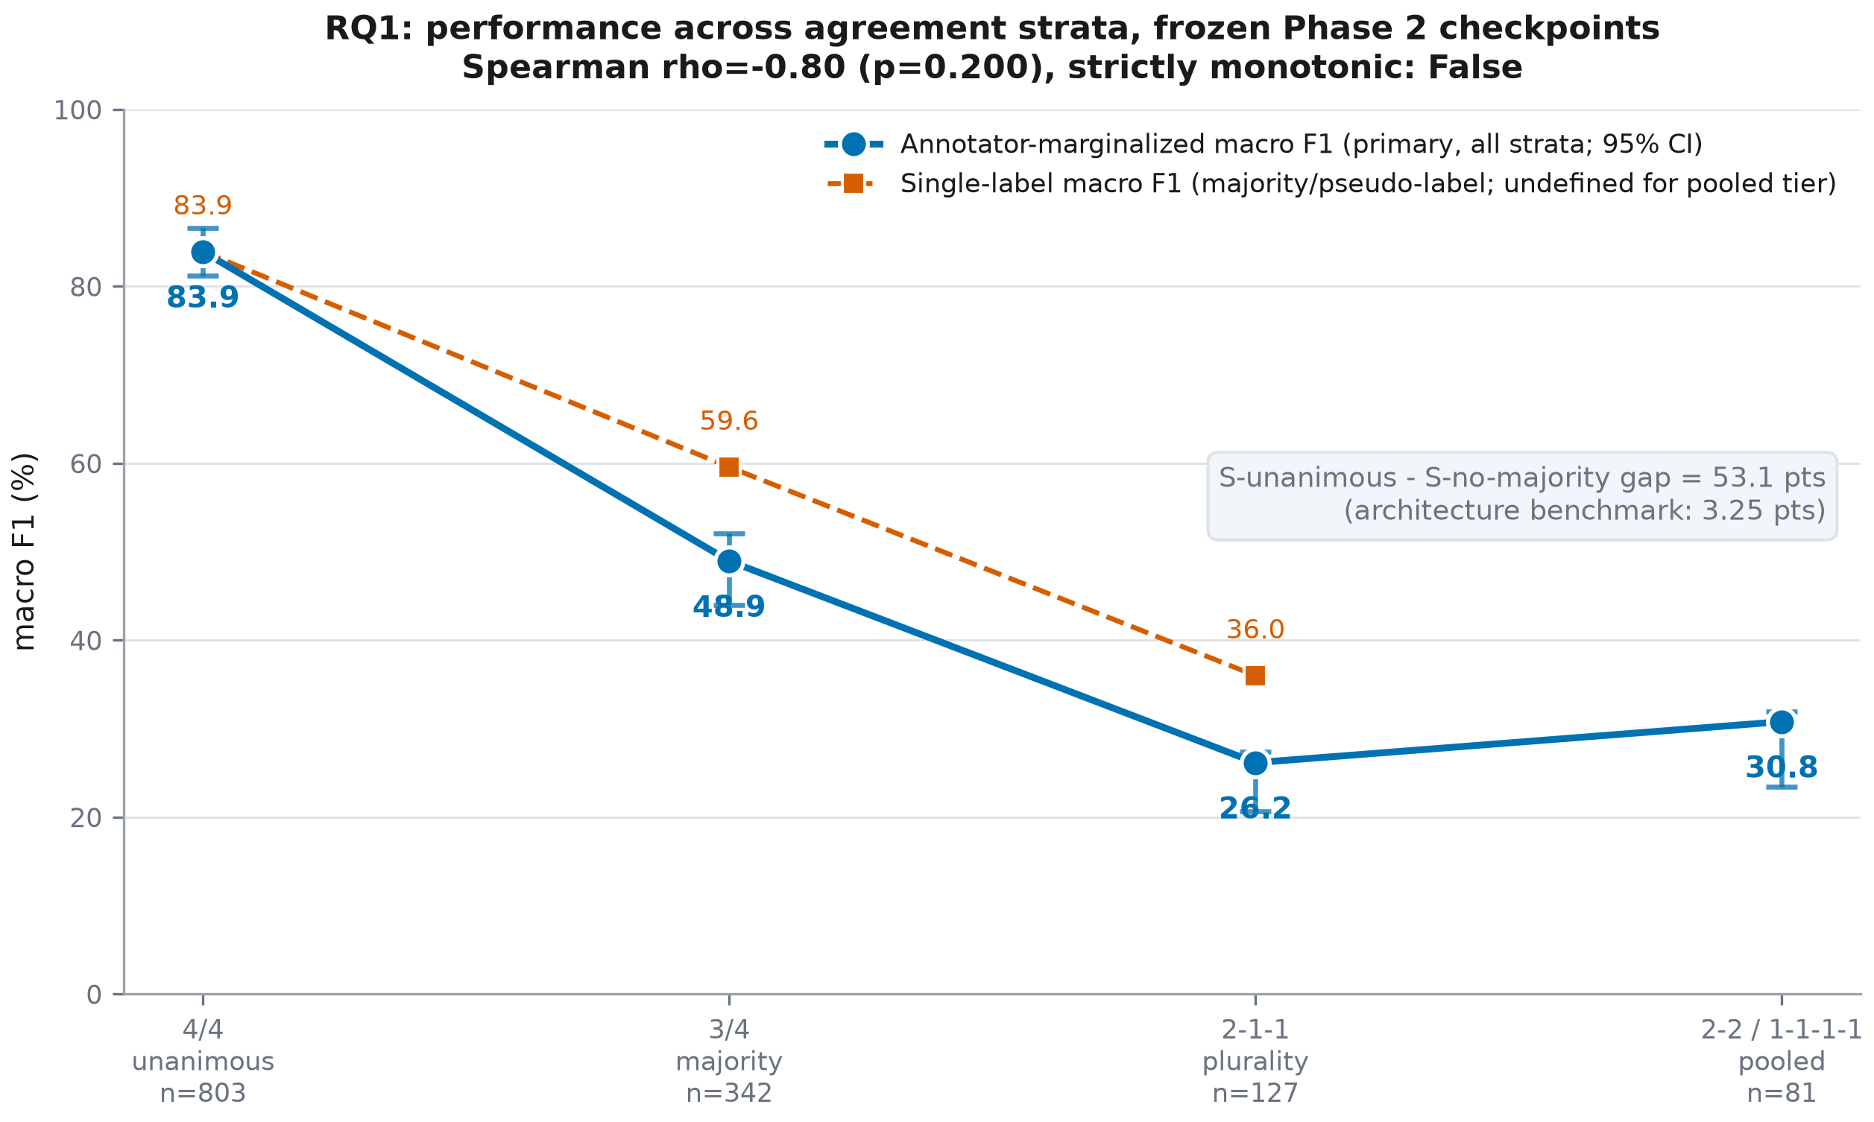
Figure 1. Annotator-marginalized macro F1 (primary) and single-label macro F1 (secondary, undefined for the pooled tier) across the four ordered agreement strata. 3-seed mean.
Table 3. Per-stratum performance, 3-seed mean, frozen Phase 2 checkpoints, with patient-clustered bootstrap intervals. The final column gives the mean number of distinct annotator labels per image, i.e. how many ways a prediction can score an any-annotator hit on that tier — the any-hit column is not comparable across tiers without it (§3.10, correction X2).
Stratum | n images | n patients | Annot.-marg. F1 (%) | 95% CI | Single-label F1 (%) | Expected acc. (%) | Any-hit rate (%) | Labels accepted
S-unanimous (4/4) | 803 | 58 | 83.91 | [81.21, 86.57] | 83.91 | 84.39 | 84.39 | 1.00
S-majority (3/4) | 342 | 57 | 48.95 | [44.01, 52.07] | 59.56 | 50.71 | 80.02 | 2.00
S-plurality (2-1-1) | 127 | 38 | 26.15 | [20.68, 27.39] | 35.99 | 27.82 | 72.70 | 3.00
S-no-majority (pooled 2-2 / 1-1-1-1) | 81 | 39 | 30.79 | [23.46, 31.97] | n/a | 38.07 | 79.83 | 2.20

3.3 Reproduction check: S-unanimous vs. Phase 2
The S-unanimous tier reproduces the Phase 2 aggregate exactly, as required by the consistency gate: Phase 2 reported macro F1 83.91; this phase's S-unanimous annotator-marginalized macro F1 (which reduces to plain macro F1 at this tier since all four annotator columns are identical) is 83.91.

3.4 Monotonicity and gap test
Table 4. RQ1 monotonicity and gap test results.
Statistic | Value
Spearman rho (tier order vs. F1) | -0.800
Spearman p-value | 0.2000
Strictly monotonic non-increasing | False
Gap: S-unanimous - S-no-majority (points) | 53.13
Architecture-difference benchmark (points) | 3.25
Gap exceeds architecture benchmark | True

The decline from S-unanimous to S-majority to S-plurality is steep and consistent (83.9 -> 48.9 -> 26.2), but the pooled S-no-majority tier scores marginally higher than S-plurality (30.8 vs 26.2), so the sequence is not strictly monotonic and the Spearman test (n=4 tiers) does not reach significance. The magnitude finding is unaffected by this: even the smallest observed drop from S-unanimous is an order of magnitude larger than the architecture benchmark.

3.4.1 Attainable-ceiling re-analysis of the gap (post-hoc)
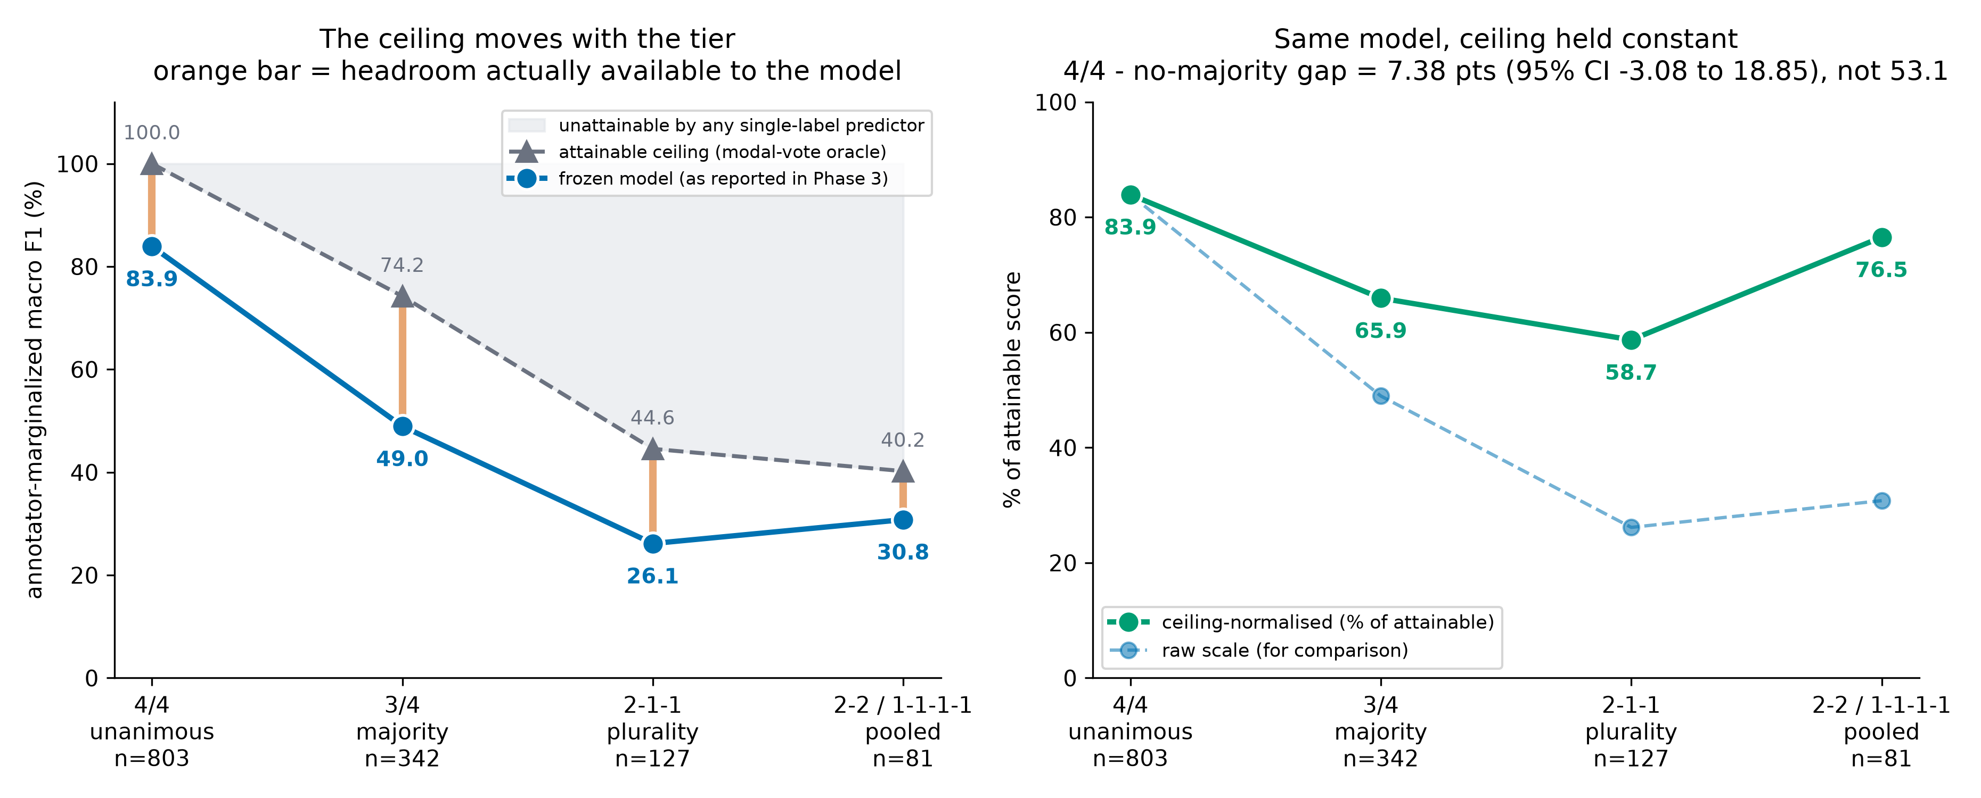
Figure 2. Left: the frozen model against the modal-vote oracle ceiling; the orange bar is the headroom actually available on each tier. Right: the same model expressed as a percentage of the attainable score. The raw curve is overlaid for comparison.
Table 5. Attainable ceiling per stratum and the model's share of it. The ceiling depends only on the annotator vote matrix, not on the model.
Stratum | n | Attainable ceiling (%) | Observed (%) | % of attainable | Headroom (pts)
S-unanimous (4/4) | 803 | 100.00 | 83.91 | 83.91 | 16.09
S-majority (3/4) | 342 | 74.23 | 48.95 | 65.94 | 25.28
S-plurality (2-1-1) | 127 | 44.55 | 26.15 | 58.70 | 18.40
S-no-majority (pooled 2-2 / 1-1-1-1) | 81 | 40.23 | 30.79 | 76.53 | 9.44

The ceiling falls from 100.00% on S-unanimous to 40.23% on the pooled no-majority tier. Most of the 53.1-point raw decline is therefore the ceiling moving. Holding it constant, the model retains 83.9% of the attainable score on S-unanimous and 76.5% on the no-majority tier - a gap of 7.38 points, not 53.1.
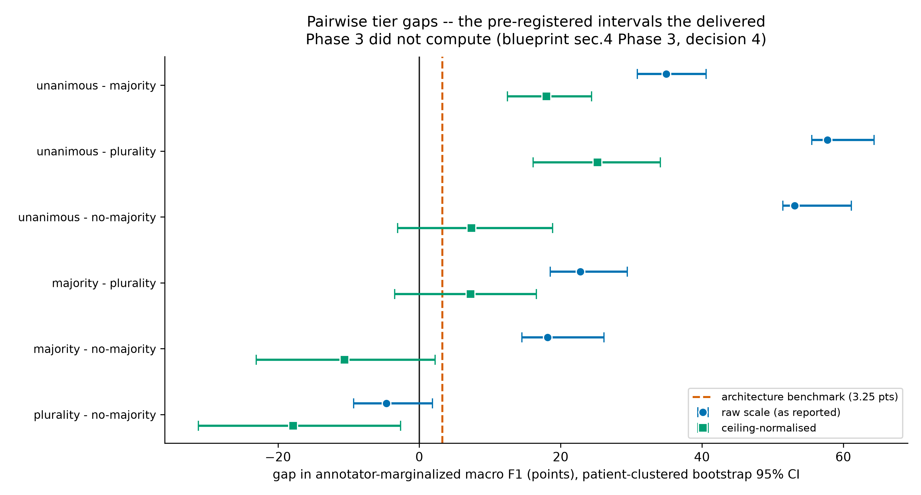
Figure 3. All six pairwise tier gaps on both scales, with the patient-clustered bootstrap 95% intervals required by pre-registered decision 4. The dashed line is the 3.25-point between-architecture benchmark.
Table 6. Pairwise tier gaps with patient-clustered bootstrap intervals (500 resamples per pair per seed, seed 20260726). The delivered Phase 3 reported no interval on any gap.
Tier pair | Scale | Gap (pts) | 95% CI | Excludes 0 | Lower bound > 3.25
unanimous - majority | raw | 34.97 | [30.86, 40.59] | yes | yes
unanimous - majority | ceiling-normalised | 17.98 | [12.49, 24.37] | yes | yes
unanimous - plurality | raw | 57.76 | [55.56, 64.34] | yes | yes
unanimous - plurality | ceiling-normalised | 25.21 | [16.11, 34.11] | yes | yes
unanimous - no-majority | raw | 53.13 | [51.44, 61.16] | yes | yes
unanimous - no-majority | ceiling-normalised | 7.38 | [-3.08, 18.85] | no | no
majority - plurality | raw | 22.79 | [18.55, 29.46] | yes | yes
majority - plurality | ceiling-normalised | 7.24 | [-3.50, 16.56] | no | no
majority - no-majority | raw | 18.16 | [14.52, 26.13] | yes | yes
majority - no-majority | ceiling-normalised | -10.60 | [-23.07, 2.26] | no | no
plurality - no-majority | raw | -4.63 | [-9.29, 1.87] | no | no
plurality - no-majority | ceiling-normalised | -17.83 | [-31.25, -2.64] | yes | no

On the ceiling-normalised scale the two mid-tier contrasts survive and the headline contrast does not. S-unanimous minus S-majority is 17.98 points (95% CI 12.49 to 24.37) and S-unanimous minus S-plurality is 25.21 points (95% CI 16.11 to 34.11); both exclude zero and both have lower bounds above the 3.25-point architecture benchmark, at 3.8x and 5.0x the benchmark respectively. S-unanimous minus S-no-majority - the contrast the original report led with - is 7.38 points (95% CI -3.08 to 18.85): the interval contains zero and does not clear the benchmark.
Amended answer to RQ1
RQ1 restated. The pre-registered raw-scale finding (53.1 points, 16.3x the architecture benchmark) is retained as the pre-registered result. The post-hoc ceiling-adjusted reading is narrower and more defensible: agreement-stratified degradation exceeds a between-architecture change by a wide margin for the 4/4 -> 3/4 and 4/4 -> 2-1-1 contrasts, and is not resolvable for the 4/4 -> no-majority contrast, where the attainable ceiling is itself only 40.2%.

The non-monotonicity also changes character. On the raw scale the S-plurality minus S-no-majority gap is -4.63 points (95% CI -9.29 to 1.87) - not distinguishable from zero, consistent with the original report's reading of it as noise. On the ceiling-normalised scale it is -17.83 points (95% CI -31.25 to -2.64), which excludes zero: relative to what is achievable on each, the model does significantly worse on 2-1-1 images than on 2-2 and 1-1-1-1 images. The reversal is real, not an artefact of small n, and it is a finding rather than a nuisance - see §4.1.

3.5 Distribution-aware metrics on no-majority images
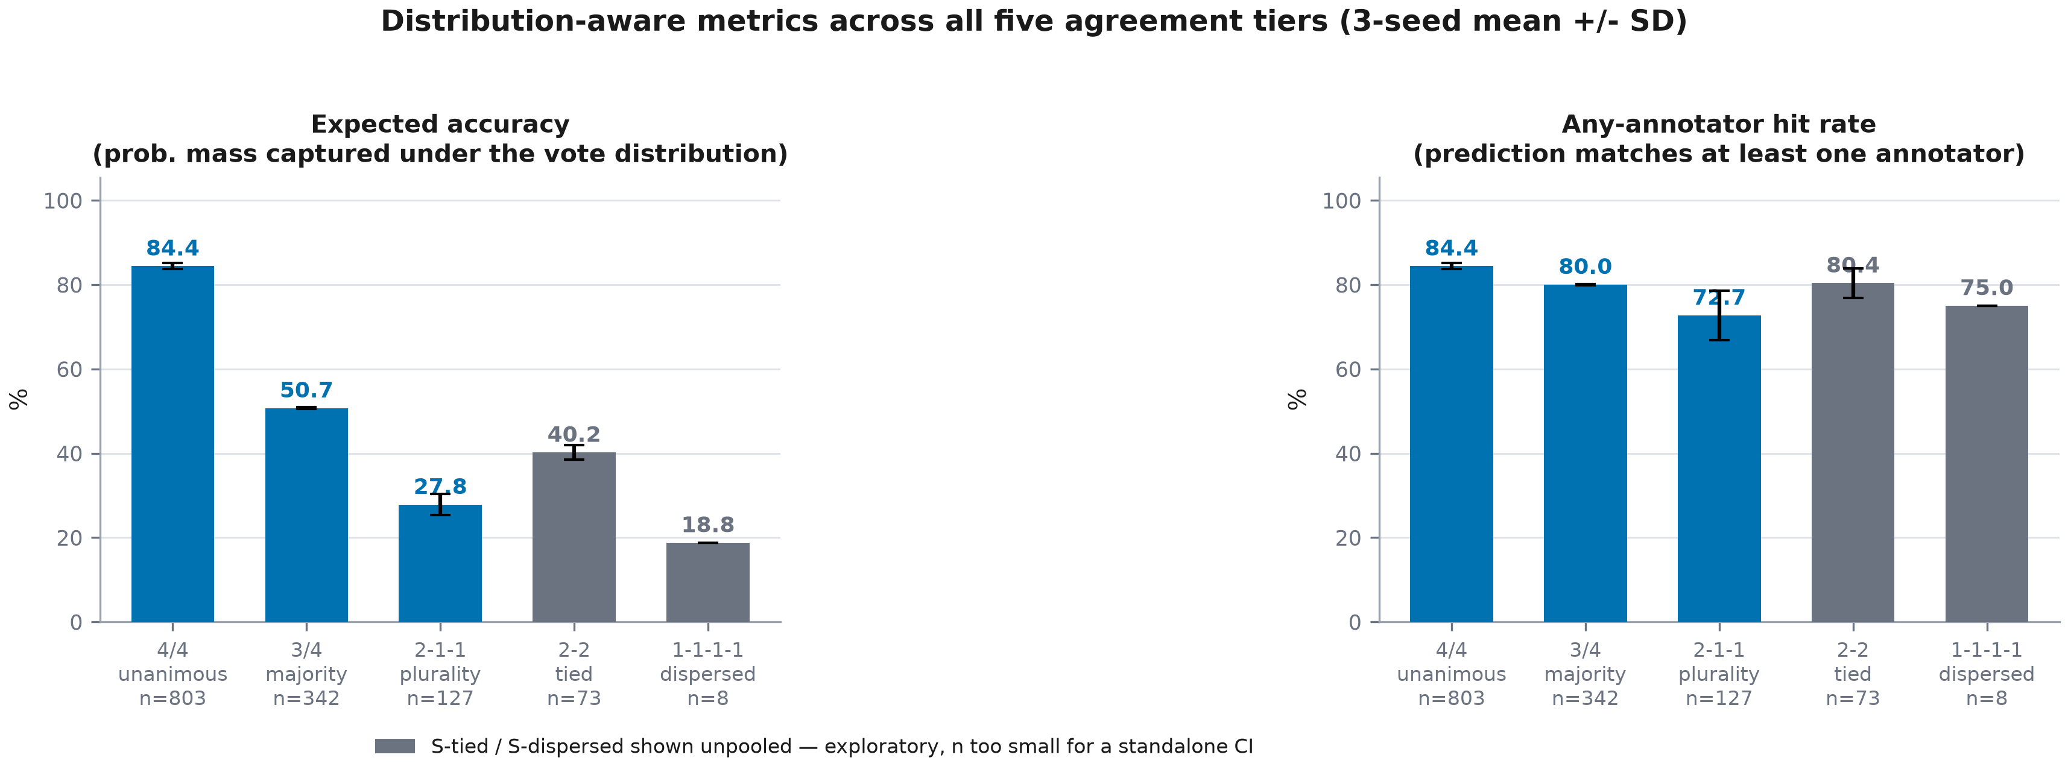
Figure 4. Expected accuracy and any-annotator hit rate across all five agreement tiers (3-seed mean +/- SD); S-tied and S-dispersed shown unpooled for transparency, explicitly exploratory given their small n.
The any-annotator hit rate stays high (72.7%-84.4%) even on the most contested tiers, while the annotator-marginalized macro F1 collapses. The model is usually predicting a label that at least one annotator gave — it is rarely predicting the specific label that the marginalization procedure credits across all four annotators and across all 23 classes, which macro-averaging over a 23-way space penalises heavily at these small stratum sizes.

3.6 Per-class behaviour across strata
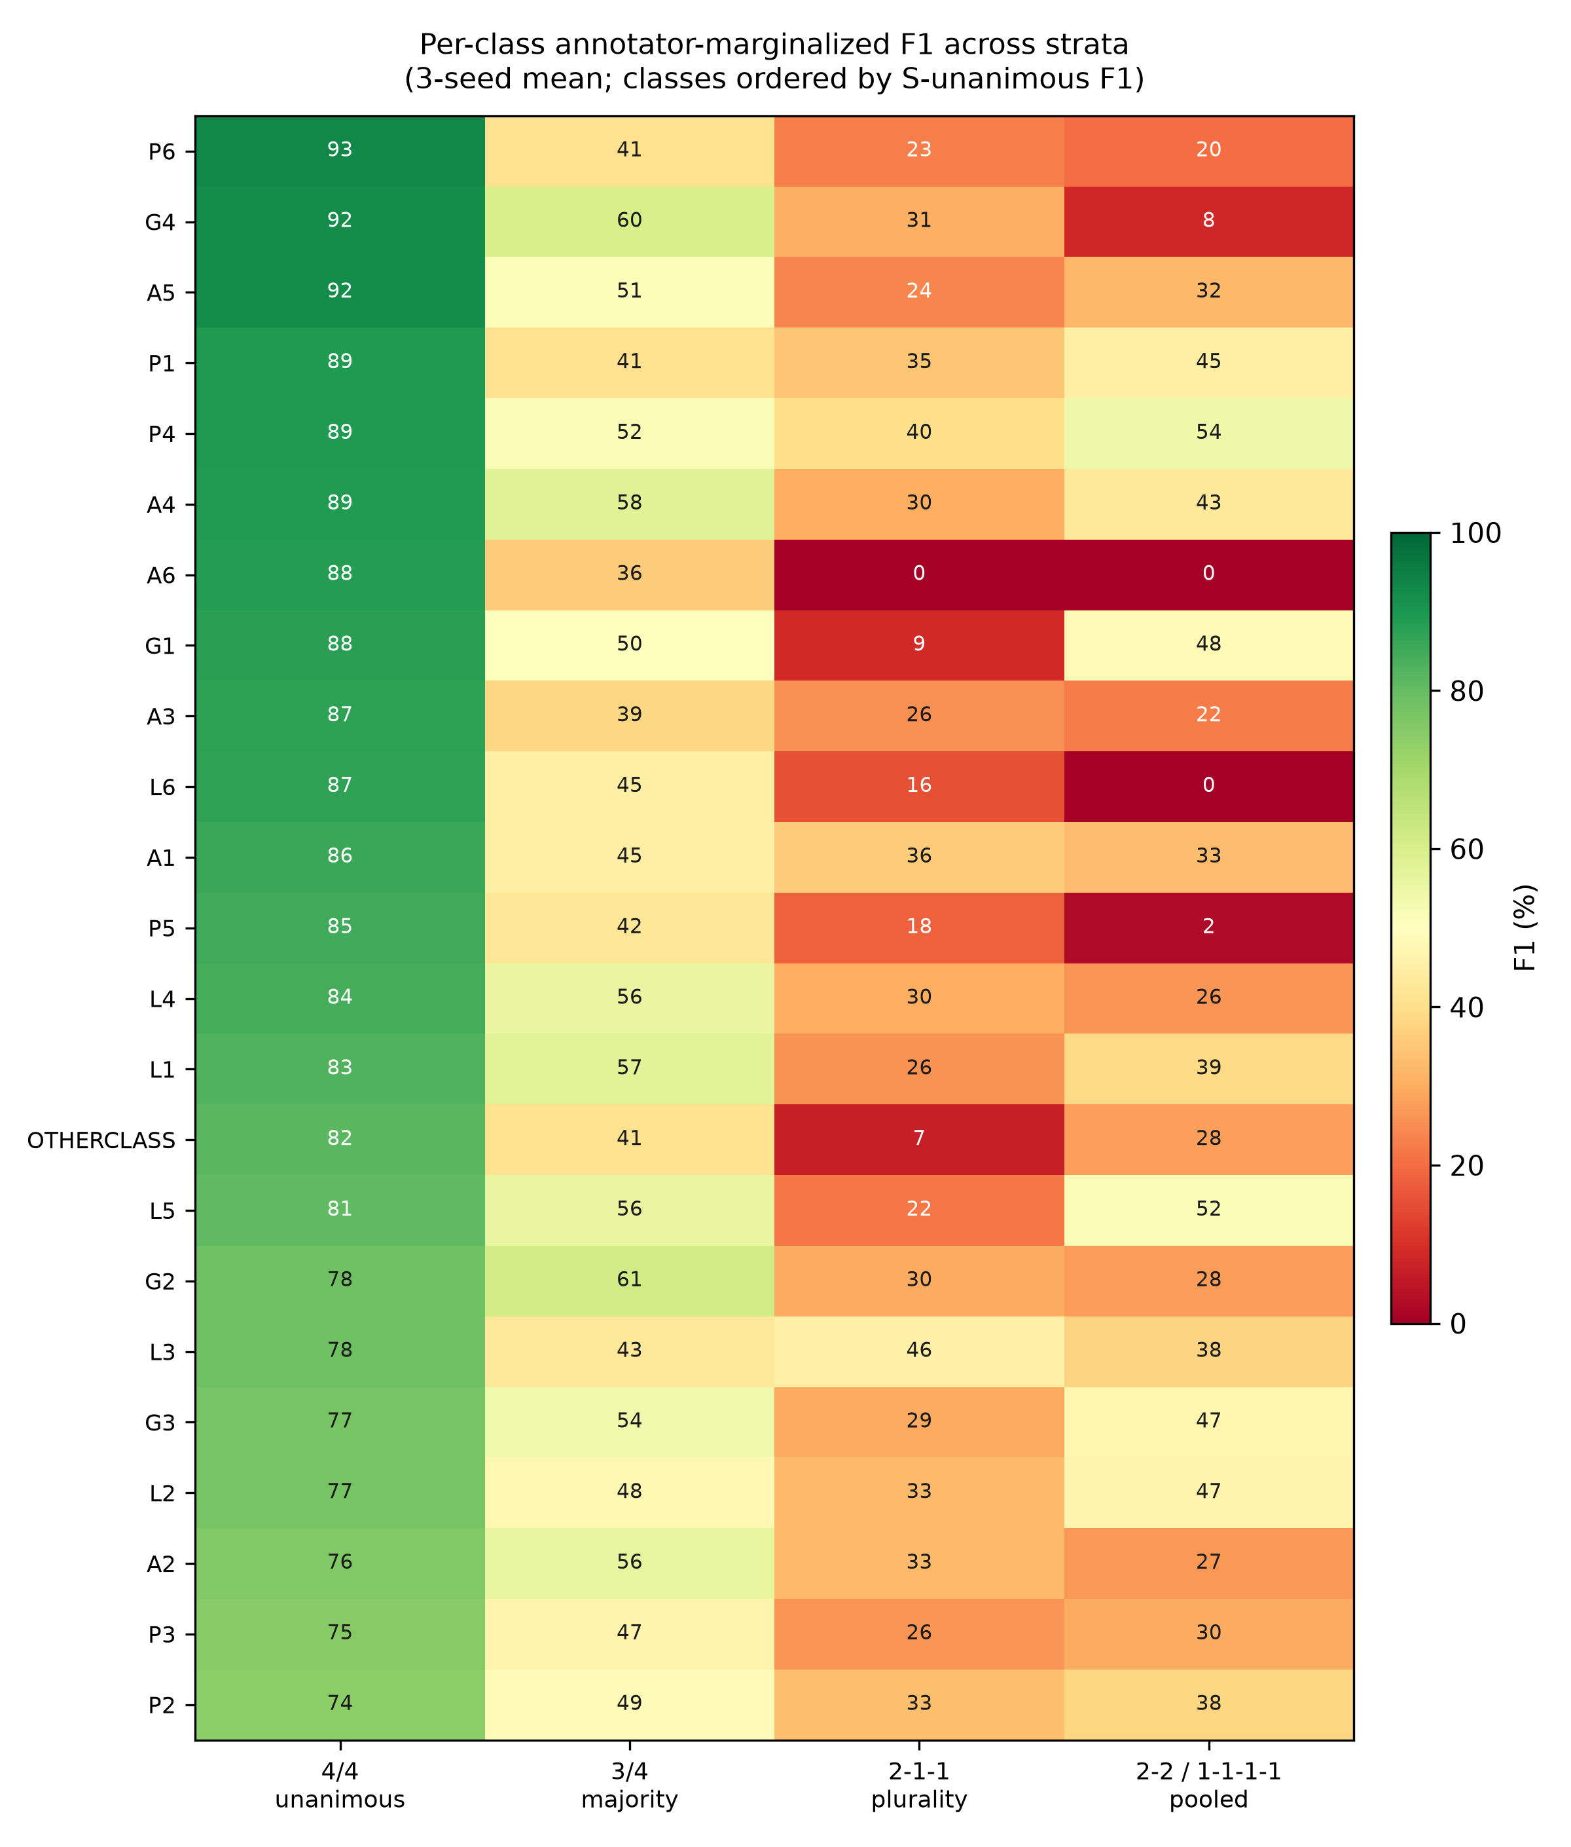
Figure 5. Per-class annotator-marginalized F1 across the four ordered strata (3-seed mean), classes ordered by S-unanimous F1.
Table 7. Zero-support diagnostic. A 23-class macro average can be deflated mechanically when classes are absent from a small stratum; this table shows the size of that effect.
Stratum | Classes with no support and no prediction | Classes scoring F1 = 0 | Macro F1 over 23 classes (%) | Macro F1 over present classes (%) | Deflation (pts)
S-unanimous (4/4) | 0 | 0 | 83.91 | 83.91 | +0.00
S-majority (3/4) | 0 | 0 | 48.95 | 48.95 | +0.00
S-plurality (2-1-1) | 0 | 1 | 26.15 | 26.15 | +0.00
S-no-majority (pooled 2-2 / 1-1-1-1) | 0 | 2 | 30.79 | 30.79 | +0.00

A standing objection to macro-averaging over 23 classes on strata of 81 to 127 images is that absent classes enter the average as a hard zero and depress the score for arithmetic reasons rather than modelling ones. The objection does not hold here. Every one of the 23 classes receives at least one annotator vote or one prediction in every tier, so no class is scored on an empty cell, and restricting the macro average to present classes changes no tier's score. The classes that score zero do so because the model gets them wrong, not because they are missing.
The per-class pattern is not uniform. On S-unanimous the weakest five classes are P2, P3, A2, L2, G3; on the pooled no-majority tier they are A6, L6, P5, G4, P6. Full per-class tables are in Appendix A and the per-stratum confusion matrices in Appendix B.

3.6.1 Class-composition control (post-hoc)
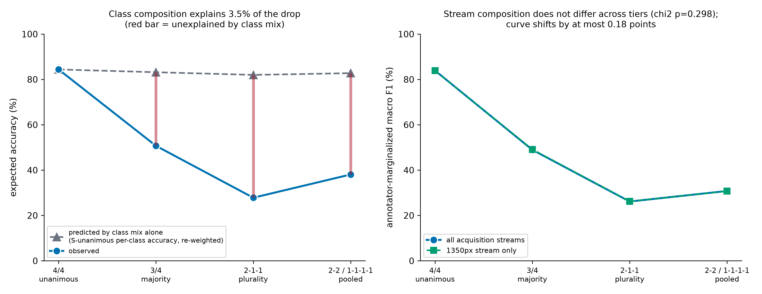
Figure 6. Left: observed expected accuracy against what the tier's class mix alone would predict, using S-unanimous per-class accuracy. Right: the tier curve restricted to the dominant acquisition stream.
Table 8. Class-composition control. Phase 0 showed that disagreement concentrates on particular anatomical boundaries, so the contested tiers do not contain the same class mix as S-unanimous; this table tests whether that mix, rather than agreement, drives the tier effect.
Stratum | Predicted by class mix alone (%) | Observed (%) | Unexplained (pts) | Share of drop explained by class mix (%)
S-unanimous (4/4) | 84.39 | 84.39 | +0.00 | -
S-majority (3/4) | 83.17 | 50.71 | +32.46 | 3.62
S-plurality (2-1-1) | 81.99 | 27.82 | +54.17 | 4.24
S-no-majority (pooled 2-2 / 1-1-1-1) | 82.76 | 38.07 | +44.69 | 3.53

Re-weighting the model's S-unanimous per-class accuracy by each contested tier's own class mix predicts expected accuracies of 83.2%, 82.0% and 82.8% - barely below the S-unanimous value. Class composition accounts for only 3.5-4.2% of the observed drop. The tier effect is a property of annotator disagreement, not of which anatomical classes happen to populate the contested tiers.

3.7 Confusion-structure comparison: model vs. human disagreement geometry
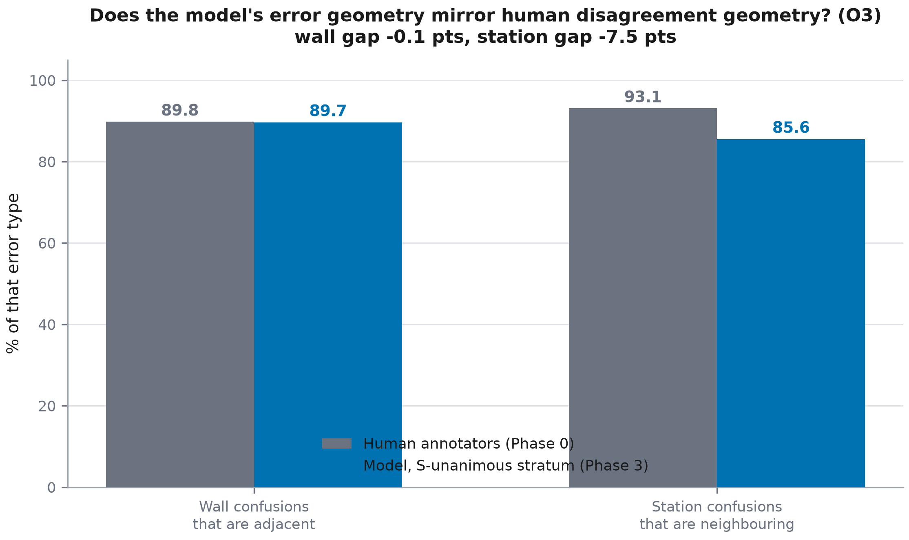
Figure 7. Model error geometry (S-unanimous stratum) compared with human disagreement geometry (Phase 0).
Table 9. Model vs. human error geometry, S-unanimous stratum (the only tier with an uncontested reference label).
Comparison | Human annotators (%) | Model, S-unanimous (%) | Gap (points)
Wall confusions that are circumferentially adjacent | 89.8 | 89.68 | -0.12
Station confusions that are neighbouring | 93.1 | 85.57 | -7.53

The model's wall-confusion geometry is almost indistinguishable from the human pattern (89.7% vs 89.8%, a 0.1-point gap). Its station-confusion geometry is somewhat less structured (85.6% vs 93.1%, a 7.5-point gap): the model makes a higher share of non-neighbouring station errors than human annotators do.

3.8 Calibration by stratum
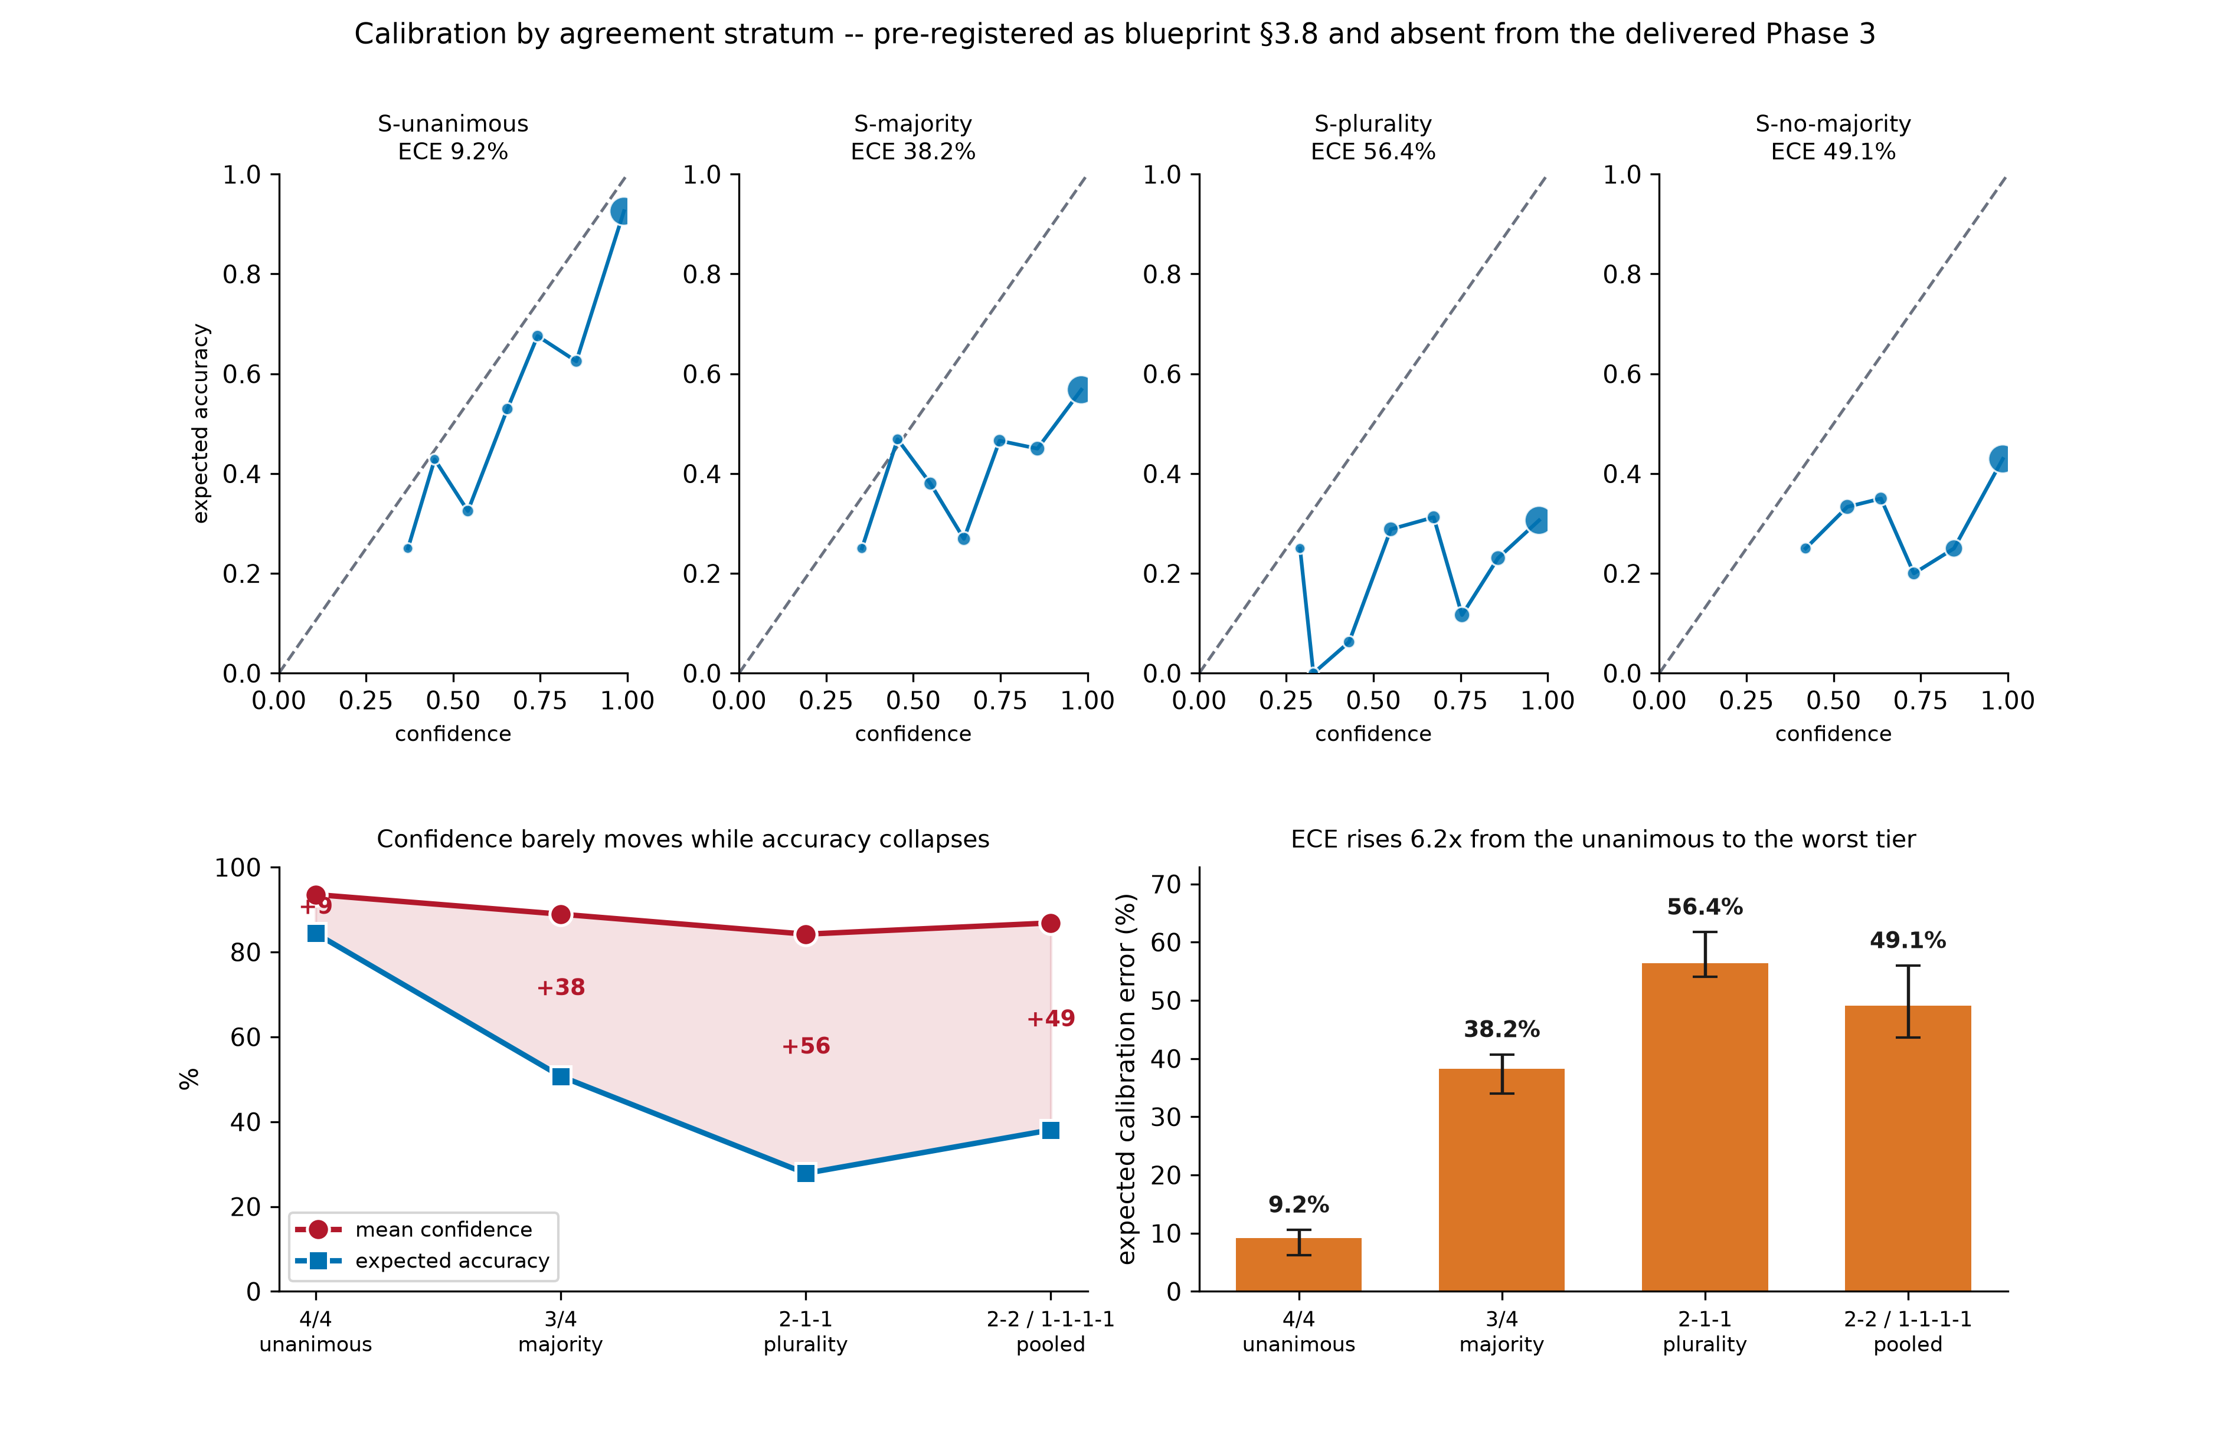
Figure 8. Reliability diagrams per stratum against expected accuracy (top), the divergence between mean confidence and expected accuracy (lower left), and expected calibration error with patient-clustered 95% intervals (lower right).
Table 10. Calibration by agreement stratum, 3-seed mean. The target is expected accuracy - the probability mass the model's single prediction captures under the four-annotator vote distribution - because it is the only target defined on every tier.
Stratum | Mean confidence (%) | Expected accuracy (%) | Overconfidence (pts) | ECE (%) | ECE 95% CI (%) | MCE (%)
S-unanimous (4/4) | 93.54 | 84.39 | +9.15 | 9.15 | [6.2, 10.6] | 32.76
S-majority (3/4) | 88.92 | 50.71 | +38.21 | 38.23 | [34.0, 40.7] | 43.83
S-plurality (2-1-1) | 84.20 | 27.82 | +56.38 | 56.40 | [54.1, 61.8] | 65.28
S-no-majority (pooled 2-2 / 1-1-1-1) | 86.86 | 38.07 | +48.79 | 49.05 | [43.6, 56.0] | 59.30

This is the section blueprint §15 identified as one of the four commonest omissions in the endoscopy-AI literature, and it produces the sharpest result in the phase. Between S-unanimous and S-plurality the model's expected accuracy falls 56.6 points while its mean confidence falls 9.3 points. Expected calibration error rises from 9.2% to 56.4%, a factor of 6.2, with non-overlapping intervals against the unanimous tier.
Principal finding of §3.8
The model is not merely wrong on contested images - it is wrong at almost the same confidence it reports when it is right. On the 2-1-1 tier it averages 84.2% confidence while capturing 27.8% of the vote mass. A downstream user filtering on confidence would not be warned. This is a safety-relevant property of the baseline and it was invisible to Phase 2's consensus-only protocol.

3.8.1 Predictive entropy against annotator vote entropy
Phase 4's RQ3 proposes to correlate the model's predictive entropy with per-image annotator vote entropy - a test the literature does not run because it needs per-annotator labels. Computing it here de-risks that plan. Across all 1,353 test images the Spearman correlation is 0.320. Within tiers it collapses to 0.077 (S-majority), 0.021 (S-plurality), 0.036 (S-no-majority); it is undefined on S-unanimous, where vote entropy is identically zero.
The apparent overall correlation is therefore almost entirely a between-tier effect: predictive entropy separates unanimous from contested images, but carries close to no information about which contested images the annotators disagreed on most. Phase 4 should treat RQ3 as a test the baseline is expected to fail, and should report the within-tier correlation - not the pooled one - as the primary quantity, or the pooled value will read as success when it measures only tier membership.

3.8.2 Confusion-structure comparison restated with intervals
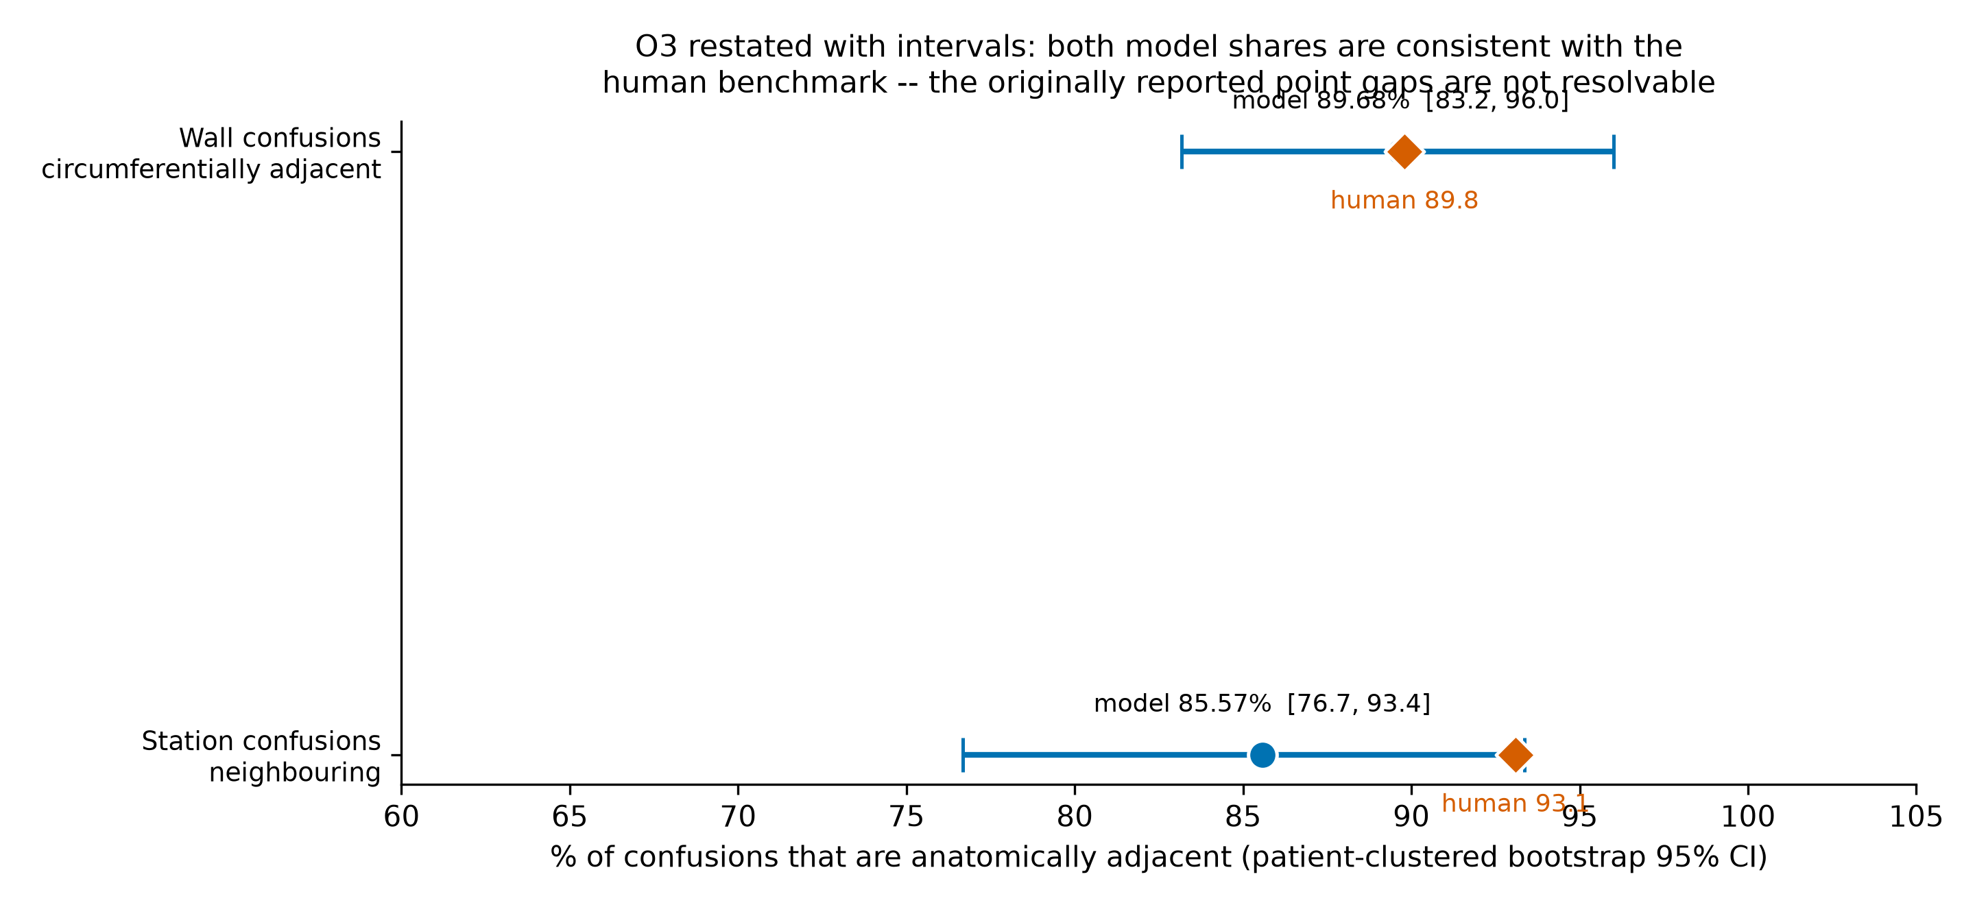
Figure 9. Model error geometry with patient-clustered bootstrap 95% intervals against the Phase 0 human benchmarks (orange diamonds).
Table 11. O3 restated as interval estimates. Both shares are ratios computed over roughly 65-70 errors, so their sampling variability is large.
Comparison | Human (%) | Model (%) | Model 95% CI | CI width (pts) | Consistent with human value
Wall confusions circumferentially adjacent | 89.8 | 89.68 | [83.18, 96.00] | 12.8 | yes
Station confusions neighbouring | 93.1 | 85.57 | [76.68, 93.36] | 16.7 | yes

§3.7 reported these shares as point values and described the wall result as matching the human value 'within 0.12 points'. That precision is not available in the data. Across the three seeds the wall share ranges 85.07-92.31% and the station share 81.16-88.06%, and the patient-clustered intervals are 13 and 17 points wide.
The corrected reading is weaker but sound in one direction and absent in the other. The model's wall-confusion geometry is consistent with the human value - the interval contains 89.8% - so the claim that the model's residual errors fall on the same circumferentially adjacent walls that make annotators disagree stands, though only as consistency, not as a demonstrated match. The station comparison does not support a difference at all: the interval [76.68, 93.36] contains the human value 93.1%. The 7.5-point shortfall reported in §3.7, and the Phase 6 Grad-CAM lead built on it, are withdrawn as findings and retained only as an untested hypothesis (§4.2).

3.9 Sensitivity checks

3.9.1 Per-seed stability across strata
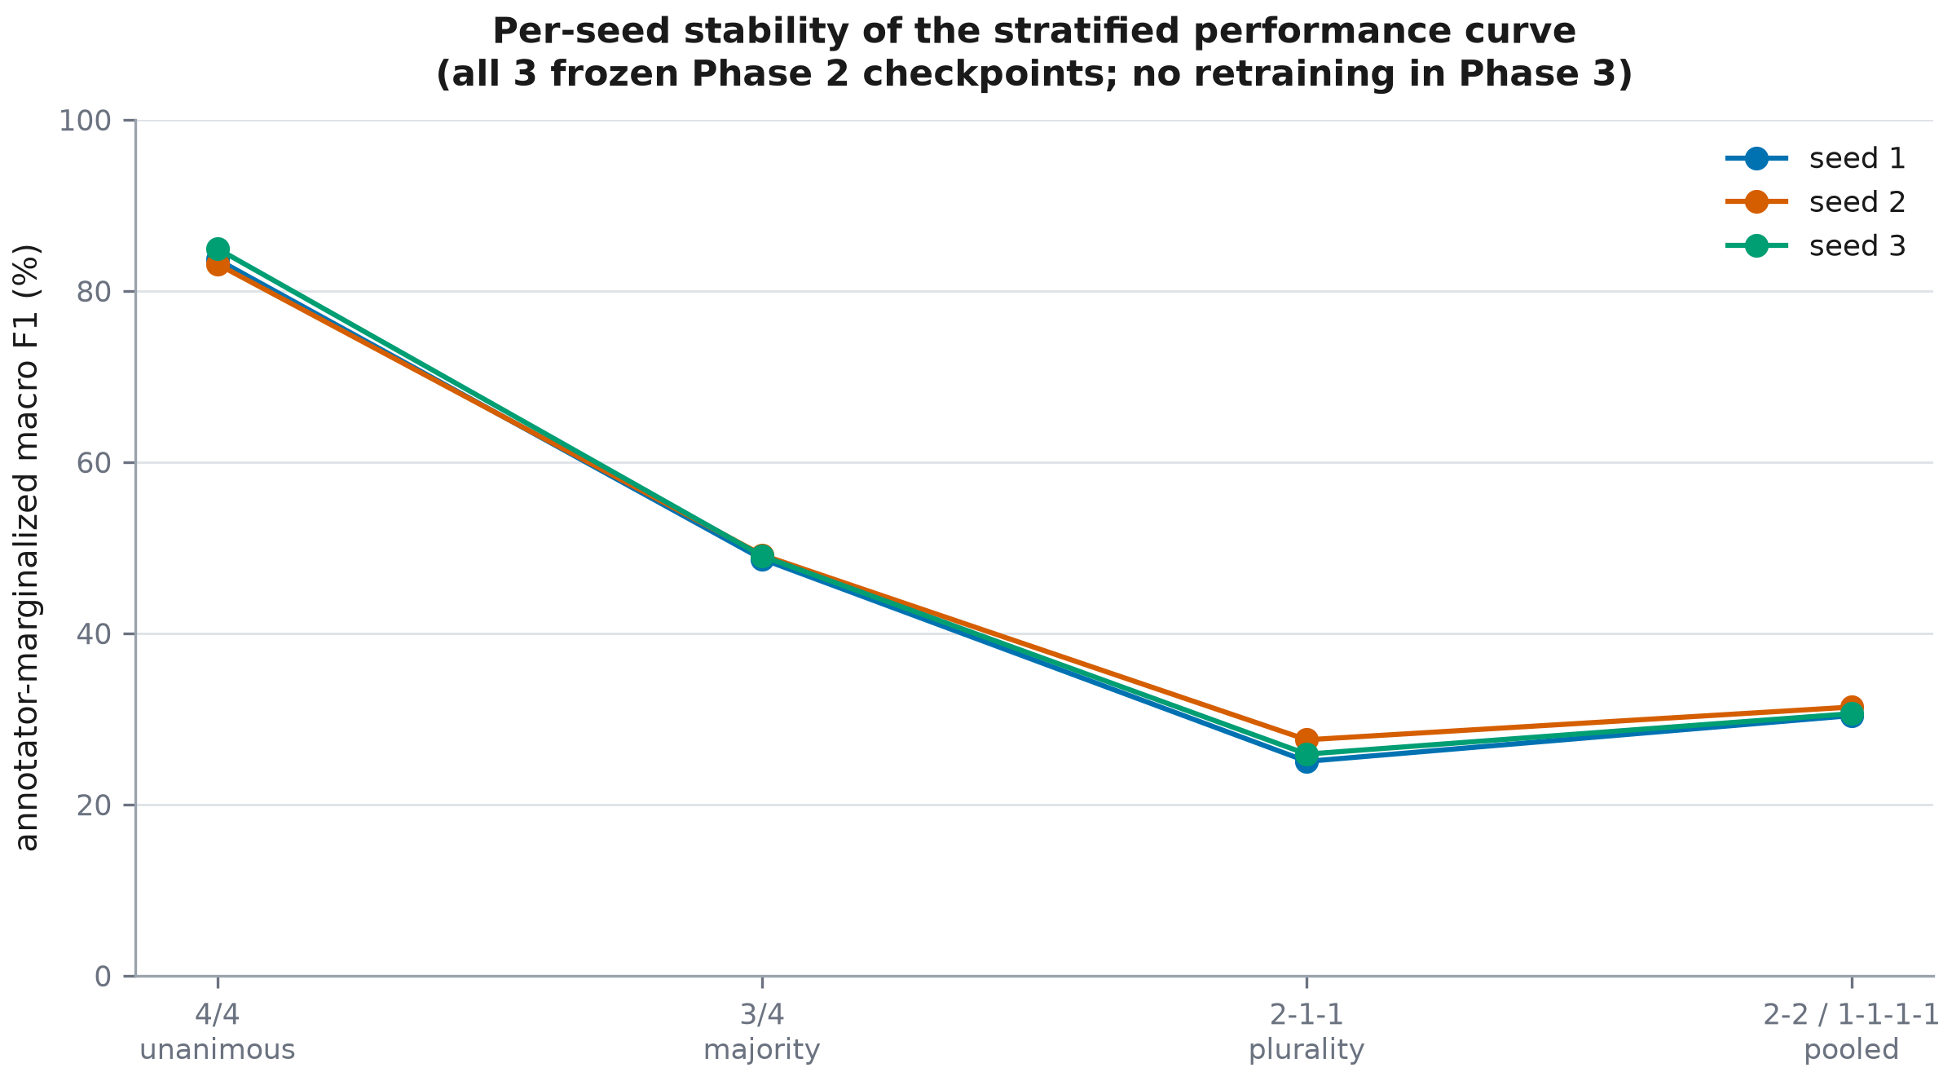
Figure 10. Per-seed annotator-marginalized macro F1 across the four ordered agreement strata — all 3 frozen Phase 2 checkpoints, no retraining.
Cross-seed standard deviation stays below 1.28 points at every tier, so the stratified pattern is a property of the trained model class, not of one training run.

3.9.2 Acquisition-stream composition per stratum
Table 12. Acquisition-stream composition by agreement tier. Phase 0 limitation L4 records that the two streams are imbalanced across the official splits.
Stratum | 900 px wide | 1350 px wide | Minority stream (%)
S-unanimous (4/4) | 38 | 765 | 4.73
S-majority (3/4) | 16 | 326 | 4.68
S-plurality (2-1-1) | 11 | 116 | 8.66
S-no-majority (pooled 2-2 / 1-1-1-1) | 4 | 77 | 4.94

Phase 0 flagged the corpus's two acquisition streams as a standing limitation (L4): they are imbalanced across the official splits and differ in unanimity rate. If the contested tiers over-represented the minority stream, the tier effect could be a stream effect. They do not: composition does not differ across tiers (chi-square 3.683 on 3 df, p = 0.298).
Table 13. Tier curve restricted to the dominant acquisition stream (sensitivity analysis for limitation L4).
Stratum | All streams (%) | 1350 px stream only (%) | Shift (pts)
S-unanimous (4/4) | 83.91 | 83.87 | -0.04
S-majority (3/4) | 48.95 | 49.13 | +0.18
S-plurality (2-1-1) | 26.15 | 26.23 | +0.08
S-no-majority (pooled 2-2 / 1-1-1-1) | 30.79 | 30.70 | -0.09

Restricting the analysis to the dominant 1350-pixel stream shifts no tier by more than 0.18 points. L4 is ruled out as an explanation of the stratified result.

3.10 Corrections to the first release of this report
The analyses above overturn or qualify four claims made in the first release. They are listed here in full rather than silently amended, and are recorded machine-readably in reports/phase3b_amendment.json.
X1 (Phase3_Report §4.1 and THESIS_RESEARCH_BLUEPRINT.md completed-task register)
Claim: the any-annotator hit rate 'shows no such reversal' and therefore the non-monotonicity at S-plurality is measurement noise
Status: FACTUALLY INCORRECT
Evidence: The report's own Table 2 gives any-hit 84.39 / 80.02 / 72.70 / 79.83 across the four ordered tiers -- the identical dip at S-plurality followed by recovery. The metric shows the same reversal it was cited as not showing.
Replacement: The non-monotonicity is assessed by the S-plurality - S-no-majority bootstrap gap: -4.63 points, 95% CI [-9.29, +1.87] on the raw scale (not distinguishable from zero), and -17.83 points, 95% CI [-31.25, -2.64] on the ceiling-normalised scale (significantly negative -- a genuine reversal, not noise).

X2 (Phase3_Report §3.5, §4.1)
Claim: the any-annotator hit rate is a fair cross-tier comparator
Status: CONFOUNDED
Evidence: The size of the accepted label set differs by tier: mean distinct annotator labels per image is 1.00 (S-unanimous), 2.00 (S-majority), 3.00 (S-plurality), 2.20 (S-no-majority). A prediction has up to three times as many ways to score a hit on S-plurality as on S-unanimous.
Replacement: Any-hit retained as a descriptive statistic only, reported with its acceptance-set size, and never used to adjudicate a cross-tier comparison.

X3 (Phase3_Report §3.7, §4.2, Table 4)
Claim: the model's wall-confusion geometry is 'within 0.12 points' of the human value and its station geometry 'trails by 7.53 points'
Status: OVERPRECISE / NOT SUPPORTED
Evidence: Both shares are ratios over 65-72 wall errors and 64-69 station errors. Patient-clustered 95% CIs are [83.18, 96.00] for wall and [76.68, 93.36] for station. The station interval CONTAINS the human value 93.1, so the 7.5-point shortfall -- and the Phase 6 Grad-CAM lead built on it -- is not statistically supported.
Replacement: Both comparisons reported as intervals. The wall result is stated as consistent with the human value; the station result is stated as underpowered, and the Phase 6 lead is downgraded from a finding to an untested hypothesis.

X4 (Phase3_Report abstract, §3.4, §5.1; blueprint status board)
Claim: a 53.1-point gap, 16.3x the 3.25-point architecture benchmark
Status: SCALE ARTEFACT (direction survives, magnitude does not)
Evidence: The primary metric's attainable maximum falls with agreement (oracle marginalized macro F1: 100.00 / 74.23 / 44.55 / 40.23). Holding the ceiling constant, the S-unanimous - S-no-majority gap is 7.38 points, 95% CI [-3.08, +18.85] -- it does not exclude zero and does not exceed the 3.25 benchmark. The S-unanimous - S-majority (17.98, CI [12.49, 24.37]) and S-unanimous - S-plurality (25.21, CI [16.11, 34.11]) contrasts do both survive.
Replacement: RQ1 is answered as supported for the 4/4 -> 3/4 and 4/4 -> 2-1-1 contrasts at 5.5-7.8x the architecture benchmark, and NOT supported for the 4/4 -> no-majority contrast the report led with. Raw and ceiling-normalised scales are both reported.

4. Discussion

4.1 Interpretation against RQ1's pre-registered hypothesis
RQ1's directional hypothesis — that performance declines from unanimous to contested strata by more than an architecture change — is strongly supported in magnitude (53.1 points vs a 3.25-point benchmark) but not in the strict form of monotonic decline: S-plurality scores lower than the pooled S-no-majority tier. Both S-plurality (n=127) and S-no-majority (n=81) are small relative to S-unanimous (n=803) and S-majority (n=342), and the annotator-marginalized macro F1 is a macro average over 23 classes, so a handful of small-support classes can move the score by several points at these sizes.
That reading has since been tested rather than asserted, and it only half survives. The macro-averaging explanation fails on its own terms: §3.6 shows every one of the 23 classes is populated in every tier, so no class enters the average as an empty cell and restricting the average to present classes changes nothing. The small-n explanation holds on the raw scale, where the S-plurality minus S-no-majority gap is -4.63 points (95% CI -9.29 to 1.87) and is not distinguishable from zero. But on the ceiling-normalised scale it is -17.83 points (95% CI -31.25 to -2.64), which excludes zero: measured against what is achievable on each tier, the model really is worse on 2-1-1 images than on 2-2 and 1-1-1-1 images. A plausible mechanism is that a 2-1-1 split leaves a single spurious-looking plurality label for the model to be scored against, whereas a 2-2 split spreads the vote mass across two labels either of which a reasonable model might pick. This is a hypothesis for Phase 4, not a demonstrated mechanism.
The original argument for dismissing the reversal — that the any-annotator hit rate showed no such dip — was incorrect and is withdrawn (§3.10, correction X1). Table 2 reports any-hit as 84.4, 80.0, 72.7 and 79.8 across the four ordered tiers: the identical dip at S-plurality followed by recovery. The metric was cited as evidence against a pattern it in fact reproduces. It is also confounded as a cross-tier comparator, since the number of distinct labels a prediction may match rises from 1.00 on S-unanimous to 3.00 on S-plurality (Table 2, final column), and is retained in this report as a descriptive statistic only.

4.2 Where model degradation does, and does not, mirror human disagreement
The model's residual errors on the clean stratum are concentrated on the same circumferentially adjacent walls that make human annotators disagree: 89.7% of its wall confusions are adjacent, and the patient-clustered interval [83.2, 96.0] contains the human value 89.8%. This is consistency with the human pattern rather than the near-exact match the first release claimed; with only 72-72 wall-differing errors per seed, a 0.12-point difference is far below the resolution of the estimate. The substantive point survives: the errors are anatomically structured, not arbitrary, which is what a capacity limitation would not produce.
The station comparison does not support a difference. The model's neighbouring-station share is 85.6% with interval [76.7, 93.4], which contains the human value 93.1%. The first release's inference that the model's depth-of-insertion cues are less reliable than its circumferential-orientation cues therefore rests on a difference the data cannot resolve, and the Phase 6 Grad-CAM lead derived from it is downgraded from a finding to an open question. Phase 6 should still test it — but as a hypothesis with a pre-specified power calculation, not as a follow-up to an established result.

4.3 Implications for Phase 4 design choices
The steep, super-architectural decline on contested images is the direct motivation for Phase 4's soft-label configurations (C1-C4): a model trained only on the unanimous 60.2% has no exposure whatsoever to the anatomical ambiguity that characterises the other 39.8% of the corpus, and this phase quantifies exactly how much performance that costs when such images are encountered at evaluation or deployment time. The C3 label-smoothing control remains essential: any Phase 4 gain on the contested strata must be shown to exceed what generic regularisation already buys.

4.4 Comparison with the wider literature
Phase 1 found that ground-truth construction from multiple annotators is rarely examined in the endoscopy-AI literature, and that studies reporting only a single consensus number give no way to assess how performance would look on the discarded, contested cases. This phase's stratified curve is a direct, quantitative instance of that gap, computed on a corpus and model where the annotator-level data actually exists to make the comparison.

4.5 Limitations specific to this phase
- 4.5.1 S-dispersed alone has n=8 in the test split; even pooled with S-tied (n=81), the tier is small relative to S-unanimous. Point estimates on this tier should be read as indicative, not precise.
- 4.5.2 S-plurality's single-label reading uses a 2-of-4 pseudo-label that is, by definition, not a validated ground truth; it is reported only as a secondary, clearly flagged number.
- 4.5.3 This phase evaluates one architecture (ConvNeXt-Tiny) across 3 seeds; the stratified pattern's generalisation to other architectures is not established here.
- 4.5.4 The attainable ceiling used in §3.4.1 is the modal-vote oracle, which maximises expected accuracy exactly but is only a lower bound on the supremum of macro F1, because macro F1 does not decompose across images. The ceiling-normalised scores are therefore conservative: the true normalised scores can only be lower, so the reported normalised gaps are, if anything, overstated rather than understated.
- 4.5.5 The ceiling-normalised analysis is post-hoc (§2.6.2). It is reported alongside — never in place of — the pre-registered raw-scale result, and its intervals are wide enough on the smallest tier that it is best read as motivating a pre-registered replication in Phase 4 rather than as a settled finding.
- 4.5.6 Calibration is assessed against expected accuracy rather than a hard label, because no hard label exists on two tiers. This is the appropriate target but it is not the convention in the literature, so the ECE values here are not directly comparable with single-label ECE figures reported elsewhere.
- 4.5.7 Evaluation is confined to the official test split of a single centre. Phase 5's external validation remains the only test of whether the agreement-stratified pattern transfers.

5. Conclusion

5.1 Answer to RQ1
Landmark-classification performance declines sharply as expert agreement falls, from 83.91 macro F1 on the unanimous stratum to 30.79 on the pooled no-majority stratum — a decline 16x larger than the published gap between architecture families. That is the pre-registered result, and it is reported as such.
The amended answer is narrower and better supported. Once the metric's attainable ceiling is held constant, the degradation from the unanimous stratum exceeds the between-architecture benchmark for the 3/4-majority stratum (17.98 points (95% CI 12.49 to 24.37)) and the 2-1-1-plurality stratum (25.21 points (95% CI 16.11 to 34.11)), and is not resolvable for the pooled no-majority stratum (7.38 points (95% CI -3.08 to 18.85)), where a perfect single-label classifier could itself score no more than 40.2%. Neither class composition nor acquisition stream accounts for the effect. The decline is not strictly monotonic on either scale, and on the ceiling-normalised scale the reversal at S-plurality is statistically significant rather than noise — a finding to be replicated under pre-registration in Phase 4, not explained away.
The most consequential result of the phase is not in RQ1 at all. Calibration degrades far faster than accuracy: expected calibration error rises 6.2-fold from the unanimous to the most contested tier, and mean confidence falls only 9.3 points while expected accuracy falls 56.6. A consensus-only evaluation protocol cannot see this, and a confidence-thresholded deployment would not be protected from it.

5.2 Carry-forward decisions for Phase 4
- Use the full agreement-tier structure, not just the unanimous subset, when constructing C1-C4 training targets.
- Retain the C3 label-smoothing control. The justification is now stronger and more specific than 'the raw gap is large': label smoothing is itself a calibration intervention, so it is the correct control for the calibration result in §3.8 as well as for the accuracy result.
- Pre-register calibration as a primary Phase 4 endpoint, not a secondary one. §3.8 shows the baseline's failure mode is confidently-wrong rather than merely wrong, which is the failure mode soft targets are supposed to fix.
- Report the WITHIN-tier predictive-entropy / vote-entropy correlation as RQ3's primary quantity. §3.8.1 shows the pooled correlation (0.320) is almost entirely a between-tier effect and collapses to 0.02-0.08 within tiers; the pooled figure would read as success while measuring only tier membership.
- Pre-register the ceiling-normalised metric alongside the raw one, so that Phase 4's comparison of C0-C4 across tiers is not exposed to the same scale artefact this phase had to correct post-hoc.
- Carry the wall-adjacent / station-neighbouring error decomposition into Phase 6 as a pre-specified comparison axis, but treat the station-geometry gap as an untested hypothesis rather than an established lead (§4.2), and compute the required error count in advance — the present intervals are 13-17 points wide.

Appendices

Appendix A. Per-class, per-stratum metric tables
Table 14. Annotator-marginalized per-class F1 by stratum, 3-seed mean, with mean annotator support at the extremes. Support is averaged over the four annotator label realisations and is therefore fractional.
Class | unanimous F1 (%) | majority F1 (%) | plurality F1 (%) | no-majority F1 (%) | Support 4/4 | Support no-maj.
A1 | 85.6 | 44.9 | 36.1 | 32.9 | 43 | 3.5
A2 | 75.6 | 55.9 | 32.8 | 26.9 | 31 | 1.8
A3 | 87.5 | 38.5 | 25.6 | 22.4 | 27 | 4.5
A4 | 88.8 | 57.9 | 30.2 | 43.3 | 30 | 3.2
A5 | 91.9 | 51.0 | 24.2 | 32.1 | 25 | 4.0
A6 | 88.3 | 36.0 | 0.0 | 0.0 | 45 | 1.0
G1 | 87.7 | 49.9 | 8.6 | 48.2 | 46 | 5.5
G2 | 78.3 | 61.5 | 29.7 | 27.6 | 30 | 4.2
G3 | 77.2 | 53.5 | 29.4 | 47.0 | 35 | 5.0
G4 | 91.9 | 59.9 | 30.7 | 8.3 | 41 | 1.5
L1 | 82.6 | 57.5 | 25.9 | 38.9 | 35 | 2.5
L2 | 77.2 | 47.7 | 32.8 | 46.8 | 35 | 3.8
L3 | 78.2 | 42.6 | 45.5 | 37.5 | 34 | 3.8
L4 | 84.4 | 55.9 | 30.3 | 26.4 | 28 | 3.8
L5 | 80.6 | 55.6 | 21.6 | 51.9 | 29 | 6.2
L6 | 86.9 | 45.0 | 15.6 | 0.0 | 45 | 0.0
OTHERCLASS | 81.6 | 41.0 | 6.7 | 27.9 | 19 | 8.0
P1 | 89.4 | 40.9 | 35.1 | 45.2 | 51 | 4.5
P2 | 74.0 | 48.6 | 33.4 | 38.1 | 30 | 6.2
P3 | 74.9 | 46.8 | 26.4 | 30.0 | 37 | 2.8
P4 | 89.3 | 51.9 | 40.1 | 54.2 | 34 | 2.0
P5 | 85.1 | 42.4 | 18.0 | 2.4 | 30 | 2.2
P6 | 93.1 | 40.9 | 22.8 | 20.0 | 43 | 1.0

Appendix B. Per-stratum confusion matrices
Full 23x23 annotator-marginalized confusion matrices for all four strata are stored in phase3b_confusion_matrices.npz (keys S_unanimous, S_majority, S_plurality, S_no_majority), built by averaging the confusion matrix against each of the four annotator label realisations so that they are defined on the tiers with no single ground truth. The dominant off-diagonal mass is summarised below; the full matrices are machine-readable rather than reproduced as four 23x23 tables.
Table 15. Summary of the per-stratum confusion matrices. Diagonal mass equals expected accuracy by construction.
Stratum | Diagonal mass (%) | Five heaviest confusions (vote mass)
S-unanimous (4/4) | 84.39 | P3->P2 (7.3); A6->L6 (7.0); L5->L4 (5.7); L3->L2 (5.0); L2->A2 (3.3)
S-majority (3/4) | 50.71 | L3->L2 (5.2); A5->L5 (4.2); A3->G3 (3.9); A4->L4 (3.4); A2->A1 (3.4)
S-plurality (2-1-1) | 27.82 | OTHERCLASS->G2 (2.8); OTHERCLASS->L1 (2.6); A3->A2 (1.8); G3->P3 (1.8); OTHERCLASS->A2 (1.6)
S-no-majority (pooled 2-2 / 1-1-1-1) | 38.07 | A3->G3 (2.7); P2->P1 (1.9); A5->L5 (1.8); G2->G1 (1.5); P5->L5 (1.3)

Appendix C. Bootstrap procedure and diagnostics
Every interval in this report resamples patients, not images, with replacement. Phase 3 used 500 resamples per tier at seed 20260726; the pairwise gap intervals in §3.4.1 use the same seed and procedure applied jointly to the two tiers being compared, so that the two resamples are drawn independently within each draw. Calibration intervals use 400 resamples and the geometry intervals in §3.8.2 use 2000.
Two diagnostics are worth stating explicitly. First, on the ceiling-normalised scale the estimator is a ratio, and a ratio's bootstrap distribution is skewed at these sample sizes; the tables report the plug-in point estimate alongside the bootstrap mean so the difference between them is visible rather than hidden. Second, the ceiling in the denominator is recomputed inside every resample rather than held at its full-tier value - holding it fixed breaks the pairing and inflates the gap, because a resample with duplicated patients covers fewer distinct classes and depresses any macro F1.
Table 16. Plug-in versus bootstrap-mean estimates for the key gaps, as a bias diagnostic.
Tier pair | Scale | Plug-in (pts) | Bootstrap mean (pts) | Bootstrap bias (pts)
unanimous - majority | raw | 34.97 | 35.78 | +0.81
unanimous - majority | ceiling-normalised | 17.98 | 18.49 | +0.52
unanimous - no-majority | raw | 53.13 | 55.93 | +2.81
unanimous - no-majority | ceiling-normalised | 7.38 | 7.46 | +0.08
plurality - no-majority | raw | -4.63 | -3.86 | +0.78
plurality - no-majority | ceiling-normalised | -17.83 | -17.19 | +0.64

Appendix D. Script and artefact manifest (reproducibility index)
Executed in this order; each step is gated on the previous one's validation criterion. Steps marked 3B were added to repair the omissions and corrections recorded in Appendix E.
- python src/models/phase3_data.py
- python src/models/phase3_cache.py
- python src/models/phase3_eval.py
- python src/models/phase3_confusion.py
- python src/models/phase3b_probs.py # 3B
- python src/models/phase3b_ceiling.py # 3B
- python src/models/phase3b_calibration.py # 3B
- python src/models/phase3b_perclass.py # 3B
- python src/models/phase3b_sensitivity.py # 3B
- python src/models/phase3b_amendment.py # 3B
- python src/report/figures_phase3.py
- python src/report/figures_phase3b.py # 3B
- python src/report/build_phase3_docx.py
- python src/report/finalise_phase3.py
Numerical primitives shared by the 3B scripts live in src/models/phase3b_common.py, whose selftest() asserts equality with scikit-learn to 1e-12 at import time; the bincount reimplementation exists only to make the added bootstraps affordable and can never silently change a published value.

Appendix E. Pre-registration record and protocol amendment
Phase 3 shipped without a machine-readable pre-registration file (Phase 2 had one) and with a prose Appendix E rather than the verbatim timestamped record its own blueprint sec.14 specifies. This record cannot restore a pre-registration after the fact; it classifies every analysis so a reader can tell confirmatory from exploratory.
Table 17. Analysis provenance register. Confirmatory analyses are those whose specification predates the data, whether or not they were delivered in the first release.
ID | Analysis | Status | Artefact
A1 | Agreement-tier construction from the 4-annotator vote matrix; tier counts gated at 803/342/127/73/8 before any inference | PRE-REGISTERED, EXECUTED | phase3_manifest_summary.json
A2 | Pooling of S-tied and S-dispersed into S-no-majority | PRE-REGISTERED, EXECUTED | phase3_manifest_summary.json
A3 | Consistency gate: S-unanimous predictions reproduce Phase 2 exactly | PRE-REGISTERED, EXECUTED | phase3_stratified_metrics.json
A4 | Per-stratum annotator-marginalized macro F1, expected accuracy, any-annotator hit rate, per-tier patient-clustered bootstrap CIs | PRE-REGISTERED, EXECUTED | phase3_stratified_metrics.json
A5 | Spearman monotonicity test across the four ordered tiers | PRE-REGISTERED, EXECUTED | phase3_stratified_metrics.json
A6 | O3 wall-adjacent / station-neighbouring error shares vs the Phase 0 human benchmarks | PRE-REGISTERED, EXECUTED | phase3_confusion_structure.json
B1 | Patient-clustered bootstrap CI on the S-unanimous - S-no-majority gap, and its comparison against the 3.25-point architecture benchmark. Explicitly required by pre-registered decision 4 and | PRE-REGISTERED, NOT EXECUTED -> NOW EXECUTED IN 3B | phase3b_ceiling_gaps.json
B2 | Per-class behaviour across strata (§3.6) and the per-class per-stratum tables promised by Appendix A | PRE-REGISTERED, NOT EXECUTED -> NOW EXECUTED IN 3B | phase3b_perclass.json
B3 | Calibration by stratum: ECE, MCE, reliability diagrams (§3.8). Blueprint sec.15 names absent calibration reporting as one of the four literature gaps this design claims to address directly. | PRE-REGISTERED, NOT EXECUTED -> NOW EXECUTED IN 3B | phase3b_calibration.json
B4 | Acquisition-stream composition per stratum and the within-stream sensitivity re-run (§3.9.2, limitation L4) | PRE-REGISTERED, NOT EXECUTED -> NOW EXECUTED IN 3B | phase3b_sensitivity.json
B5 | Per-stratum 23x23 confusion matrices (Appendix B) | PRE-REGISTERED, NOT EXECUTED -> NOW EXECUTED IN 3B | phase3b_confusion_matrices.npz
B6 | Bootstrap distribution diagnostics (Appendix C) | PRE-REGISTERED, NOT EXECUTED -> NOW EXECUTED IN 3B | phase3b_ceiling_gaps.json
C1 | ATTAINABLE-CEILING NORMALISATION of the primary metric. Devised after observing that the raw tier curve conflates model degradation with the falling maximum score a single-label predictor ca | POST-HOC (EXPLORATORY) | phase3b_ceiling_gaps.json
C2 | Class-composition control: S-unanimous per-class accuracy re-weighted by each contested tier's class mix, to test whether the tier effect is a class-mix effect | POST-HOC (EXPLORATORY) | phase3b_perclass.json
C3 | Predictive entropy vs annotator vote entropy correlation, within and across tiers. De-risks Phase 4 RQ3 before it is committed to. | POST-HOC (EXPLORATORY) | phase3b_calibration.json
C4 | Patient-clustered intervals on the O3 geometry shares, replacing the point-difference comparison against the human benchmarks | POST-HOC (EXPLORATORY) | phase3b_sensitivity.json
C5 | Zero-support diagnostic: how many classes enter the 23-class macro average with no support, and the resulting deflation | POST-HOC (EXPLORATORY) | phase3b_perclass.json

The tier definitions, ground-truth rule, pooling rule (S-tied + S-dispersed -> S-no-majority), and primary metric definition (annotator-marginalized macro F1) were fixed in THESIS_RESEARCH_BLUEPRINT.md §4 Phase 3 before phase3_eval.py was run against these images. The tier counts were computed from the official splits alone (no model output) and gated exactly against the pre-registered expectation before proceeding. That blueprint is a living document, however, and was edited to v3.2 after this phase ran, so the claim is not independently verifiable from the committed artefacts alone — which is why the register above, rather than this paragraph, is the operative record.

References
[1] Panesso-Ortiz S, et al. GastroHUN: an Endoscopy Dataset of Complete Systematic Screening Protocol for the Stomach. Scientific Data 2025; 12:102. doi:10.1038/s41597-025-04401-5.
[2] Mongan J, Moy L, Kahn CE. Checklist for Artificial Intelligence in Medical Imaging (CLAIM). Radiology: Artificial Intelligence 2020; 2(2):e200029.
[3] Collins GS, Moons KGM, Dhiman P, et al. TRIPOD+AI statement: updated guidance for reporting clinical prediction models that use regression or machine learning methods. BMJ 2024; 385:e078378.
[4] Sounderajah V, Ashrafian H, Golub RM, et al. Developing a reporting guideline for artificial intelligence-centred diagnostic test accuracy studies: the STARD-AI protocol. BMJ Open 2021; 11:e047709.
[5] Wolff RF, Moons KGM, Riley RD, et al. PROBAST: A Tool to Assess the Risk of Bias and Applicability of Prediction Model Studies. Annals of Internal Medicine 2019; 170(1):51-58.
[6] Page MJ, McKenzie JE, Bossuyt PM, et al. The PRISMA 2020 statement: an updated guideline for reporting systematic reviews. BMJ 2021; 372:n71.
[7] Guo C, Pleiss G, Sun Y, Weinberger KQ. On Calibration of Modern Neural Networks. Proceedings of ICML 2017; 70:1321-1330.
[8] Fleiss JL. Measuring nominal scale agreement among many raters. Psychological Bulletin 1971; 76(5):378-382.
[9] Efron B, Tibshirani RJ. An Introduction to the Bootstrap. Chapman & Hall/CRC, 1993 (patient-clustered resampling, ch. 8).
[10] Liu Z, Mao H, Wu C-Y, et al. A ConvNet for the 2020s. Proceedings of CVPR 2022:11976-11986.
[11] THESIS_RESEARCH_BLUEPRINT.md v3.2, §4 Phase 3, §13, §14, §15 (this project's governing protocol).
[12] Phase 0 / Phase 1 Report, this project: corpus audit, agreement quantification and PRISMA 2020 review.
[13] Phase 2 Report, this project: baseline reproduction, GATE 5.

