Agreement-Stratified Evaluation of Deep Learning for Anatomical Landmark Recognition in Upper Gastrointestinal Endoscopy
Phase 4 — Soft-Label and Uncertainty Training (RQ2, RQ3, RQ4)
Changing what the model is trained to predict, and nothing else

──────────────────────────────────────────────
Degree programme | B.Sc. in Computer Science and Engineering
Research domain | Biomedical Artificial Intelligence — Medical Image Analysis and Deep Learning
Training cohort | Extended cohort E — 5,228 train / 1,103 validation images (majority-or-better), identical for C1–C4
Evaluation cohort | Full official test split — 1,353 images across 4 agreement strata
Configurations | C0, C1, C2, C3, C4 — 12 training runs at 3 seeds each
Governing protocol | THESIS_RESEARCH_BLUEPRINT.md §4 PHASE 4; pre-registration frozen 2026-07-27 11:48:21
Reporting standards | CLAIM, TRIPOD+AI, STARD-AI, PROBAST+AI
Report date | 27 July 2026

Pre-registered verdicts — RQ2 (accuracy): NOT RESOLVED · RQ2 (calibration): NOT SUPPORTED · RQ3: supported for no configuration · RQ4: NOT RESOLVED
Every verdict above is produced by the rule fixed in reports/phase4_prereg.json before the first model was trained, applied to a paired patient-clustered bootstrap interval.

Table of Contents
Abbreviations 7
Abstract 7
1. Introduction 8
1.1 What Phases 2 and 3 established, and what they leave open 8
1.2 Why the target, and not the architecture 8
1.3 Research questions and pre-registered hypotheses 8
1.4 Chapter roadmap 9
2. Methods 9
2.1 The configuration matrix 9
2.1.1 The extended cohort E, and why it is held constant 10
2.1.2 Deriving epsilon: the control has to be matched, not guessed 10
2.1.3 The anatomical distance matrix and the C4 penalty 11
2.2 What is held fixed 11
2.2.1 Compute budget and the epoch cap 11
2.3 Evaluation 11
2.3.1 Calibration and uncertainty 12
3. Results 12
3.1 Training behaviour 12
3.2 RQ2, accuracy: performance by configuration and stratum 13
3.2.1 The pre-registered contrasts 14
3.3 RQ2, calibration 17
3.4 RQ3: does predictive uncertainty track human disagreement? 18
3.5 RQ4: the anatomy-aware loss 20
3.6 Sensitivity 21
3.6.1 Per-seed stability 21
3.6.2 Leave-one-annotator-out 21
4. Discussion 21
4.1 RQ2: what the control bought 21
4.2 RQ2 calibration, and what it says about the Phase 3 finding 22
4.3 RQ3 23
4.4 RQ4 23
4.5 Relation to the descriptor's own FG-agreement result 23
4.6 Limitations specific to this phase 23
4.7 Implications for Phases 5 to 7 24
5. Conclusion 24
5.1 Answers 24
5.2 Carry-forward decisions 24
Appendices 26
Appendix A. Per-configuration, per-stratum metric tables 26
Appendix B. Training histories 28
Appendix C. Pre-registration record 28
C.1 RQ2 28
C.2 RQ3 28
C.3 RQ4 29
C.4 Declared deviations 29
C.5 Falsification 30
C.6 Post-hoc corrections 30
Appendix D. Script and artefact manifest 31
Appendix E. Analyses not executed, and what they would cost 32
References 34

If this list appears blank, select all (Ctrl+A) and press F9 to update the field.

List of Figures
Figure 1. The five configurations. C0 to C1 changes the cohort; C1 to C2, C3 and C4 changes only the target vector built from the same votes on the same images. 9
Figure 2. Agreement-stratified performance of every configuration, raw (left) and as a percentage of the modal-vote oracle attainable on that stratum (right). 3-seed mean. 13
Figure 3. Every pre-registered contrast, on every stratum, with paired patient-clustered 95% intervals. Green excludes zero above, red below, grey contains zero. 16
Figure 4. Expected calibration error by configuration and stratum (left) and reliability on the pooled contested stratum (right). 17
Figure 5. Mean confidence against expected accuracy. The shaded gap is the overconfidence Phase 3 identified as the baseline's real failure mode. 17
Figure 6. Left: Spearman correlation between predictive entropy and annotator vote entropy, within each stratum and pooled. Right: the MC stochastic-depth uncertainty decomposition. 18
Figure 7. Left: mean annotator-marginalized anatomical error distance, the RQ4 primary endpoint. Right: error geometry on S-unanimous against the Phase 0 human benchmark, which C4 was not trained on. 20
Figure 8. Left: every seed of every configuration drawn separately. Right: the RQ2 primary contrast recomputed with each annotator dropped in turn. 21

If this list appears blank, select all (Ctrl+A) and press F9 to update the field.

List of Tables
Table 1. Abbreviations used in this report. 7
Table 2. Configuration matrix as frozen in the pre-registration. 9
Table 3. Gates passed before any Phase 4 model was trained. A failure at any of them halts the phase rather than issuing a warning. 10
Table 4. Training summary. Validation macro F1 here is scored against the hard majority label on the extended validation cohort — the pre-registered selection criterion — and is a selection statistic, not a result. 12
Table 5. Annotator-marginalized macro F1 (%) by configuration and stratum, 3-seed mean. Full tables with intervals, ceiling-normalised levels, expected accuracy and any-hit rate are in Appendix A. 13
Table 6. Configuration contrasts on the pooled contested stratum (n=550), the pre-registered primary endpoint. Positive favours the first-named configuration. 16
Table 7. The primary contrast broken out by stratum (secondary endpoints). Per-stratum verdicts are secondary and are not corrected for multiplicity; the single primary test is the pooled row. 16
Table 8. Expected calibration error (%) against expected accuracy, 3-seed mean. Lower is better. 17
Table 9. Calibration detail on the pooled contested stratum. The 23-dimensional Brier score against the vote distribution is the stricter form and is added here because it is exactly the distribution C2 and C4 are trained on. 18
Table 10. Spearman rho between predictive entropy and per-image annotator vote entropy. The rightmost column is reported only to expose the artefact: it is not the endpoint. 18
Table 11. RQ3 pre-registered verdict, taken on the largest contested stratum. 19
Table 12. What each uncertainty estimator buys in accuracy on the pooled contested stratum. The ensemble is 3-member, not the blueprint's 5-member (deviation P4-DEV-2), so its gain is a lower bound. 19
Table 13. Mean anatomical error distance (0 = the prediction is every annotator's label; 1 = maximally distant from all of them), 3-seed mean. Lower is better. 20
Table 14. Error geometry on the S-unanimous stratum — the only stratum with an uncontested reference label — against the human benchmarks measured in Phase 0. These are the independent checks: C4 optimises the distance matrix, not these shares. 20
Table 15. The RQ2 primary contrast recomputed with each annotator dropped from the metric in turn. The strata stay defined by the full four-annotator vote matrix, so every row scores the same images. 21
Table 16. Full metric set on the S-unanimous (4/4) stratum, 3-seed mean. Attainable ceiling on this stratum: 100.00%. 26
Table 17. Full metric set on the S-majority (3/4) stratum, 3-seed mean. Attainable ceiling on this stratum: 74.23%. 26
Table 18. Full metric set on the S-plurality (2-1-1) stratum, 3-seed mean. Attainable ceiling on this stratum: 44.55%. 26
Table 19. Full metric set on the S-no-majority (2-2 / 1-1-1-1) stratum, 3-seed mean. Attainable ceiling on this stratum: 40.23%. 27
Table 20. Full metric set on the S-contested (all three pooled) stratum, 3-seed mean. Attainable ceiling on this stratum: 64.76%. 27
Table 21. Every Phase 4 training run, plus the three Phase 2 runs reused as C0. The selection criterion differs between C0 and C1–C4 (793-image unanimous validation subset versus the 1,103-image extended cohort), so the 'best val macro F1' column is comparable within C1–C4 but not against C0. 28
Table 22. Deviations from blueprint v3.3 §4 PHASE 4, each with the measurement or constraint that forced it. 29
Table 23. Corrections applied after the phase was first completed. The pre-registration itself was not modified, no model was retrained and no inference was re-run; the saved predictions were re-analysed with the interval procedure the pre-registration already specified. 30
Table 24. Every pre-registered verdict before and after the corrections. Point estimates are unchanged throughout, because they are plug-in statistics that do not depend on the resample count; only the interval endpoints move, and no verdict changes. 31
Table 25. Reproducibility index. Every number in this report is interpolated from one of these files; none is typed into the document source. 32
Table 26. Declared gaps in this phase. 32

If this list appears blank, select all (Ctrl+A) and press F9 to update the field.

Abbreviations
Table 1. Abbreviations used in this report.
Abbreviation | Expansion
AC1 | Gwet's first-order agreement coefficient
AdamW | Adam optimiser with decoupled weight decay
AMP | automatic mixed precision
CI | confidence interval
CLAIM | Checklist for Artificial Intelligence in Medical Imaging
C0–C4 | the five Phase 4 training-target configurations
ECE / MCE | expected / maximum calibration error
F1 | harmonic mean of precision and recall
FG1, FG2 | the two resident annotators (Team A)
G1, G2 | the two gastroenterologist annotators (Team B)
LOAO | leave-one-annotator-out
MC | Monte Carlo
MC-SD | Monte Carlo stochastic depth
PRISMA | Preferred Reporting Items for Systematic Reviews and Meta-Analyses
RQ | research question
SSS | Systematic Screening protocol for the Stomach
STARD-AI | Standards for Reporting Diagnostic accuracy studies, AI extension
TRIPOD+AI | Transparent Reporting of a multivariable prediction model, AI extension
VRAM | video memory

Abstract
Background. Phase 2 reproduced a published ConvNeXt-Tiny landmark classifier on the 60.2% of GastroHUN images where all four annotators agree. Phase 3 evaluated that frozen model on the whole official test split and found two failures. Accuracy fell far outside the unanimous stratum, and — the sharper result — calibration collapsed: expected calibration error rose from 9.2% to 56.4% while mean confidence barely moved. Both failures are properties of a model that has never been shown a contested image.
Objective. To test whether changing the TRAINING TARGET — and nothing else — repairs them. Four configurations were trained on an identical cohort of 5,228 training images carrying a majority label: a hard majority label (C1), the proportions of the four annotator votes (C2), a hard label with label smoothing matched to C2 in the probability mass it displaces (C3, the control), and vote proportions plus a penalty on the anatomical distance of the error (C4). The Phase 2 model is carried through unchanged as C0.
Methods. All configurations share the backbone, the schedule, the augmentation, the normalisation statistics, the precision and the model-selection criterion of Phase 2; the cache was verified byte-identical on the 4,515 images shared with Phase 2, so the arms differ in the target and nowhere else. Every arm was evaluated on the full 1,353-image test split with the Phase 3 metric set. All contrasts use a PAIRED patient-clustered bootstrap: one patient resample, both arms scored on those same rows, then differenced. The primary RQ2 endpoint, the control against which it is judged, and the three-way verdict rule were fixed in a pre-registration frozen before the first run.
Results. On the pooled contested stratum (n=550), C2 minus C3 in annotator-marginalized macro F1 was +1.40 points (95% CI -0.88 to +3.68) — NOT RESOLVED under the pre-registered rule. The same contrast on expected calibration error was +13.67 points (95% CI +11.27 to +15.77) (NOT SUPPORTED). Adding the contested images to the training set at a hard target (C1 minus C0) moved the contested-stratum score by +1.34 points (95% CI -0.72 to +3.49), and the anatomical penalty (C4 minus C2) changed the mean anatomical error distance by -0.0027 (95% CI -0.0107 to +0.0047). Within-stratum Spearman correlation between predictive entropy and annotator vote entropy on the largest contested stratum ranged 0.031 to 0.077 across configurations, against a pooled all-image value of 0.32 — confirming that the pooled figure the literature would report is a between-stratum artefact.
Conclusion. The vote-proportion targets could not be separated from an equally-soft uninformative smoothing control on contested images at this sample size; the pattern of disagreement is not demonstrated to carry signal beyond its magnitude. The calibration endpoint moves against the prediction. The anatomy-aware loss is NOT RESOLVED at the single pre-registered value of lambda. Phase 3's calibration failure is reproduced in every configuration, which locates it in the agreement structure of the corpus rather than in one training recipe. A negative or unresolved result here is reported as such: the design's value is that its control makes the answer interpretable either way.

1. Introduction

1.1 What Phases 2 and 3 established, and what they leave open
Phase 2 reproduced the published ConvNeXt-Tiny baseline on the complete-agreement subset of GastroHUN (macro F1 83.92 against a published ~85.0 ± 1.5), validating the pipeline. Phase 3 took that frozen model to the full official test split and stratified by how many of the four annotators agreed. Two things happened. Accuracy fell steeply — and once the attainable ceiling of each stratum was held constant, the fall still exceeded the published gap between architecture families for the 3/4 and 2-1-1 strata. And calibration collapsed: mean confidence fell 9.3 points while expected accuracy fell 56.6.
Neither result tells us whether the model could do better, because the model had never seen a contested image. The training cohort was the 60.2% of the corpus on which all four annotators agreed. That is the descriptor's own protocol, and it is what most of the literature Phase 1 reviewed does. This phase asks the obvious next question.

1.2 Why the target, and not the architecture
The blueprint records a measured precedent (§2.7): in the descriptor's own results, training ConvNeXt-Tiny on FG-agreement labels instead of complete-agreement labels moved macro F1 by 2.2 points — more than the 3.25-point gap between ConvNeXt-Tiny and the eight-times-larger ConvNeXt-Large is worth relative to its cost. How the annotator labels are combined is a larger lever than which network consumes them, and it is a lever almost nothing in the reviewed literature pulls, because pulling it requires per-annotator labels that most public corpora do not release.

1.3 Research questions and pre-registered hypotheses
RQ2 (accuracy and calibration)
RQ2. Does training on soft targets from all four votes beat hard consensus labels? Hypothesis: matches on the unanimous stratum, exceeds on contested strata, better calibrated throughout. Primary contrast C2 - C3 on annotator-marginalized macro F1 on the pooled contested test set (S-majority + S-plurality + S-no-majority, n = 550).

RQ3 (uncertainty)
RQ3. Does predictive uncertainty track human disagreement? Primary quantity: WITHIN-stratum Spearman rho between predictive entropy and per-image annotator vote entropy -- fixed by the Phase 3 carry-forward decision, because the pooled correlation (0.320) was shown to be almost entirely a between-tier effect that collapses to 0.02-0.08 within tiers

RQ4 (anatomy-aware loss)
RQ4. Does an anatomy-aware loss exploiting the wall/station structure help on contested images? Primary contrast C4 - C2 (both use vote-proportion targets, so the contrast isolates the structured penalty) on mean anatomical error distance on the test split, using the pre-registered distance matrix.

All three verdict rules, the control arm, the interval procedure and the falsification condition were fixed in reports/phase4_prereg.json before the first Phase 4 model was trained (Appendix C).

1.4 Chapter roadmap
Section 2 specifies the five configurations, the derivation of the two hyper-parameters they need, what is held fixed, and the gates run before any result was read. Section 3 reports the results in pre-registered order: RQ2 accuracy, RQ2 calibration, RQ3, RQ4, then sensitivity. Section 4 interprets them against the fixed rules; Section 5 concludes and hands forward to Phase 5.

2. Methods

2.1 The configuration matrix
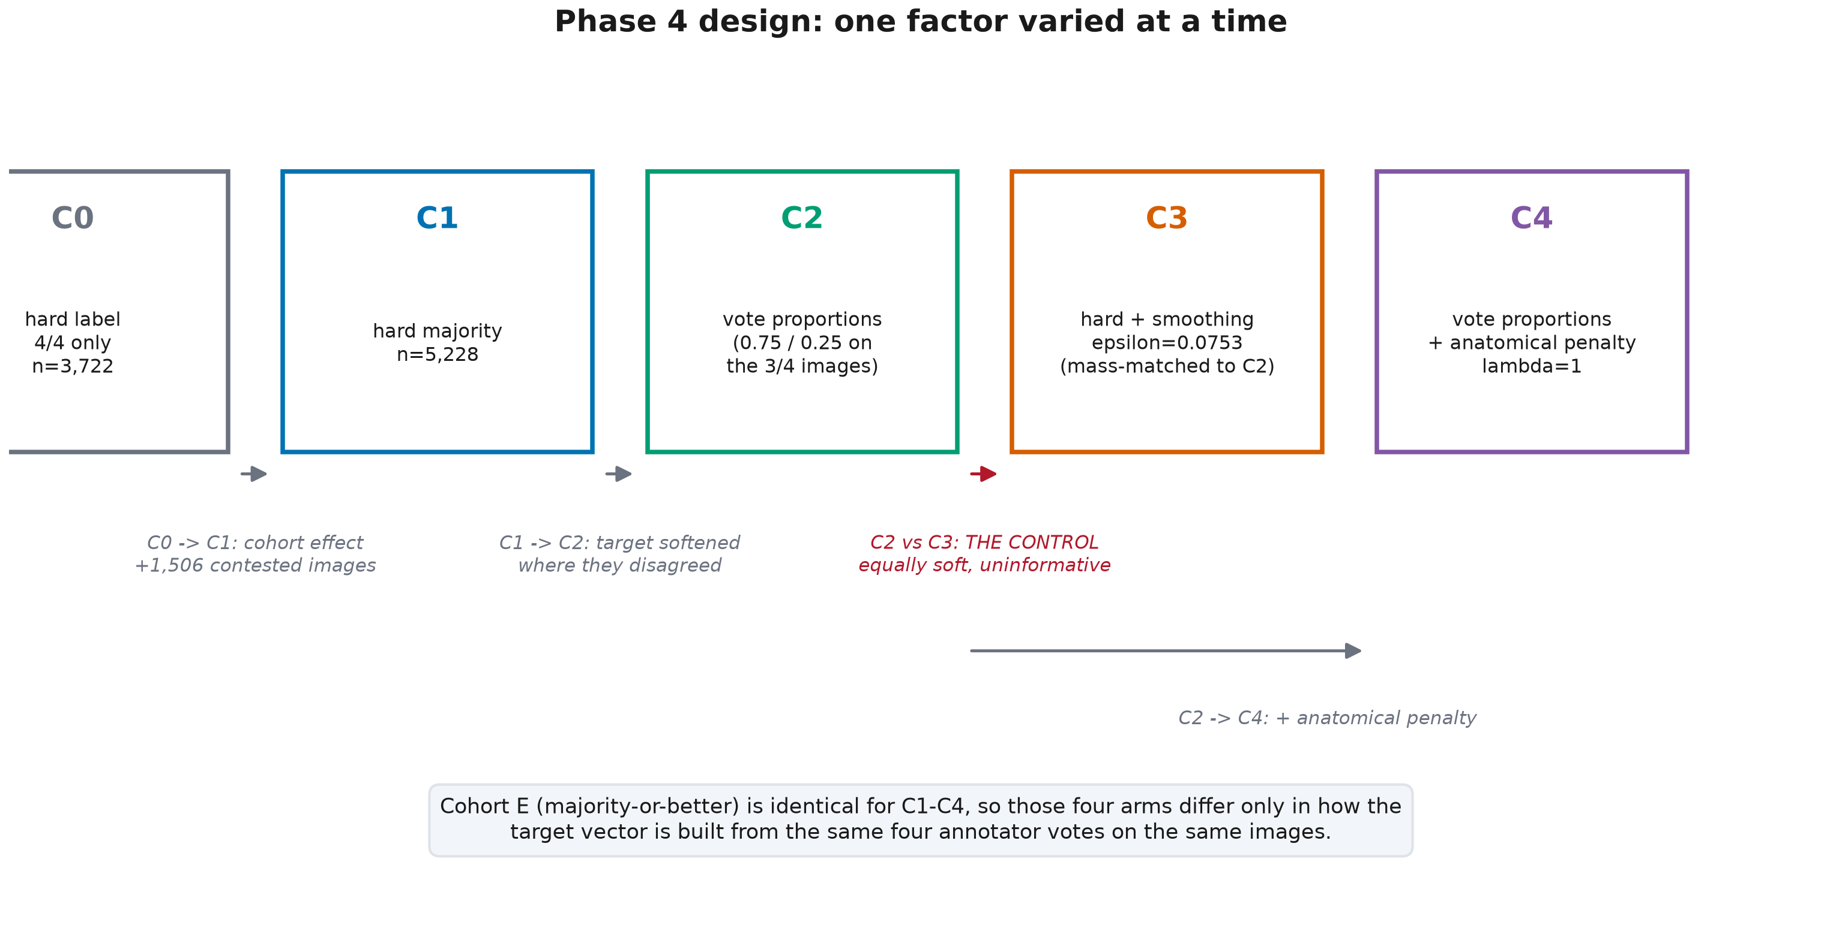
Figure 1. The five configurations. C0 to C1 changes the cohort; C1 to C2, C3 and C4 changes only the target vector built from the same votes on the same images.
Table 2. Configuration matrix as frozen in the pre-registration.
Config | Target construction | Training cohort | Role
C0 | hard unanimous label, 4/4 cohort only | Phase 2 consensus cohort (3,722 / 793) | reference arm
C1 | one-hot at the majority label | E | isolates the effect of adding the 3/4 contested images
C2 | vote proportions across the 4 annotators | E | RQ2 treatment arm
C3 | one-hot at the majority label + uniform label smoothing (epsilon = 0.0753) | E | control: the soft-target gain must exceed generic regularisation
C4 | vote proportions + anatomical structured penalty (lambda = 1) | E | RQ4 treatment arm

2.1.1 The extended cohort E, and why it is held constant
E is every Train or Validation image carrying a majority label, that is agreement tier 4/4 or 3/4: 5,228 training and 1,103 validation images, of which 28.8% of the training set is contested (3/4). Against Phase 2's cohort that is 1.40x the training images.
1,150 Train/Validation images are excluded (S-plurality 617, S-tied 466, S-dispersed 67). No majority label exists, so the c1/c3 hard-label arms are undefined on them; excluding them from every arm keeps the c2-vs-c3 contrast a pure target-construction contrast. This is a real restriction and it is declared in Appendix E: the images with the richest ambiguity signal are the ones C2 cannot use, because using them would leave C3 undefined and the comparison uncontrolled.
Table 3. Gates passed before any Phase 4 model was trained. A failure at any of them halts the phase rather than issuing a warning.
Gate | Criterion | Result
P4.1a | cohort counts equal the corpus cascade restricted to Train/Validation | PASS — 5,228 / 1,103
P4.1b | 23 classes present; every annotator vote inside the fixed class index | PASS — 23 classes
P4.1c | no patient overlap Train/Validation, nor with the Phase 3 test split | PASS — 0 overlaps
P4.1d | every filename resolves against the Phase 0 SHA-256 inventory and exists on disk | PASS — 6,331 / 6,331
P4.1e | the 4/4 rows reproduce the Phase 2 consensus cohort exactly | PASS — same filenames, same labels
P4.2 | images shared with the Phase 2 cache decode bit-identically | PASS — 4,515 / 4,515, exhaustive

2.1.2 Deriving epsilon: the control has to be matched, not guessed
C3 exists so that a C2 gain cannot be waved away as ordinary regularisation. That argument only works if the two arms soften the target by the SAME amount, which means epsilon must be derived from C2, not chosen. C2 displaces probability mass from the modal label only on 3/4 images, and displaces 0.25 when it does; over the training cohort that averages 0.072016. Uniform label smoothing displaces epsilon x (1 - 1/K), so matching gives epsilon = 0.075290.
Matching the mass does not match the entropy, and the residual difference is exactly what the experiment is about. Measured on the training cohort, the mean target entropy is -0.0000 nats for C1 (one-hot), 0.1620 for C2 and 0.4814 for C3 — C3 carries 3.0x the entropy of C2 while displacing the same mass. The reason is structural: C2 puts all of the displaced mass on ONE alternative, the class an annotator actually named, whereas C3 spreads it uniformly over all 22 others. C3 is therefore not a weakened control — it is a strictly more diffuse one, and the contrast asks whether concentrating the same mass where the disagreement actually fell is worth anything.
Mass is matched rather than entropy because the gradient of the soft-target cross-entropy with respect to the logits is (q - t): the perturbation C2 introduces relative to a one-hot target IS the displaced mass. The choice is not free — entropy matching would have given epsilon = 0.021228, roughly 3.5x smaller and therefore a considerably weaker control. Both values are recorded in the pre-registration; only the mass-matched arm was trained, and Appendix E states what testing the other would cost. For orientation, the conventional epsilon = 0.1 of the label-smoothing literature is close to the mass-matched value, so the control is not an unusually weak one.

2.1.3 The anatomical distance matrix and the C4 penalty
The 23 classes are a (wall x station) grid, and Phase 0 measured that human disagreement respects it: 240 class pairs are circumferentially wall-adjacent and 138 are station-neighbouring under the Phase 0 definitions. Cross-entropy is blind to this: confusing A3 with L3 (a quarter-turn of the scope, d = 0.25) and confusing A3 with P6 (wrong wall and the far end of the stomach, d = 0.8) cost exactly the same.
The distance is 0.5 * wall_norm + 0.5 * station_norm, where the wall term is the cyclic distance on G -> A -> L -> P normalised by 2 and the station term is |delta station| / 5. OTHERCLASS is given distance 1.0 to every landmark: it is a quality judgement, not a grid position, and Phase 0 showed quality assessment and anatomical classification are different tasks. Mean off-diagonal distance is 0.50474. C4 adds lambda x E_(i~t, j~q)[d(i,j)] to the loss — the expected anatomical distance between the target and predicted distributions — with lambda fixed a priori at unit weight and never swept.

2.2 What is held fixed
- Backbone: ConvNeXt-Tiny, ImageNet-1k pretrained, 23-way head
- Input: 224x224, Lanczos, Phase 2 TRAINING-SET normalisation statistics
- Augmentation: RandomResizedCrop(0.85-1.0) + ColorJitter, no flips (a flip changes the anatomical wall and would corrupt the label)
- Schedule: 10-epoch head warm-up at constant LR 1e-3, then fine-tune the top 40% of feature modules at 1e-4 with cosine annealing
- Precision: float32, channels_last (Phase 2 DEV-1, measured)
- Loss: soft-target cross-entropy -sum_j t_j log softmax(z)_j for every arm; asserted bit-equal to nn.CrossEntropyLoss on one-hot targets at import time, so the hard-label arms are not disadvantaged by a different code path
- Normalisation: the Phase 2 channel statistics are reused rather than recomputed on the extended cohort, so that C0 and C1-C4 see identical pixels; recomputing them would make every C-vs-C0 difference partly a preprocessing difference
Model selection: macro F1 on the extended validation cohort (n=1,103) against the hard majority label, identical for C1-C4. A single criterion for every arm; scored against a hard label so that the soft-target arms are not selected on a metric that mechanically favours them, and computed on the same images for every arm so selection cannot differ by cohort. C0's criterion was necessarily different — its cohort contains no contested validation images — which is precisely why C1, and not C0, is the control for every target-construction contrast.

2.2.1 Compute budget and the epoch cap
One warm-up epoch and one fine-tuning epoch were timed on the real extended cohort with the C4 penalty active — the most expensive arm — giving 82.1 s and 132.4 s. A declared budget of 18.0 h across 12 runs then fixes the fine-tuning cap at 34 epochs by the same formula Phase 2 used. The cap binds only if early stopping has not already fired, and the realised stop reason is reported per run in Appendix B, so a reader can see exactly where it bound.

2.3 Evaluation
Every configuration is scored on the full 1,353-image official test split, unchanged from Phase 3, stratified into the four Phase 3 strata plus one pooled contested stratum (S-majority + S-plurality + S-no-majority, n=550) that the pre-registration names as RQ2's single primary endpoint. The primary metric is the Phase 3 annotator-marginalized macro F1, which is defined continuously across every stratum including those with no single ground-truth label.
Why the contrasts are reported on the raw scale
configuration contrasts are reported on the raw scale. Within a stratum the attainable ceiling is a single positive constant shared by both arms, so ceiling normalisation rescales the difference by 1/ceiling and cannot change its sign or whether its interval contains zero. Ceiling-normalised LEVELS are tabulated per configuration.

config-vs-config differences use a PAIRED patient-clustered bootstrap: one patient resample is drawn and both configurations are scored on that same resample before differencing, so the interval reflects the difference and not the sum of two independent sampling errors. Differences are computed per seed and averaged across the 3 seeds.

2.3.1 Calibration and uncertainty
Calibration is measured against expected accuracy — the probability mass a single prediction captures under the four-vote distribution — using the Phase 3B definitions verbatim, so the Phase 4 numbers sit on the same scale as the Phase 3 baseline they must improve on. Three uncertainty estimators are computed: the deterministic softmax entropy, a Monte-Carlo average over 20 stochastic forward passes with the StochasticDepth modules returned to training mode, and a 3-member deep ensemble over the seeds.
The MC estimator's validity was verified at run time rather than assumed: torchvision's ConvNeXt-Tiny exposes 18 StochasticDepth modules, 0 Dropout modules and 0 BatchNorm modules. Mc stochastic depth samples the only stochastic mechanism present, and the absence of batchnorm means no other module changes behaviour when the stochasticdepth layers are put back in train mode. This is the reason the blueprint's 'MC dropout' is realised as MC stochastic depth (deviation P4-DEV-1): there is no dropout to sample, and inserting one absent during training would change the function the argument applies to.

3. Results

3.1 Training behaviour
12 Phase 4 runs completed, 18.0 h of wall-clock training in total on a single GTX 1650. 8 of 12 stopped at the pre-registered fine-tuning cap rather than by early stopping. Where the cap bound it bound identically for every configuration, so the C1-C4 contrasts are unaffected; the C1-minus-C0 contrast is affected, because C0 was trained to early stopping under Phase 2's larger per-run budget, and that asymmetry is carried into the interpretation in §4.1.
Table 4. Training summary. Validation macro F1 here is scored against the hard majority label on the extended validation cohort — the pre-registered selection criterion — and is a selection statistic, not a result.
Configuration | Mean best val macro F1 | SD over seeds | Mean epochs run | Runs stopped at cap
C1 — hard majority label, extended cohort | 0.8029 | 0.0072 | 42.0 | 2/3
C2 — vote proportions | 0.7987 | 0.0042 | 44.0 | 3/3
C3 — hard label + mass-matched smoothing (control) | 0.8070 | 0.0062 | 43.0 | 2/3
C4 — vote proportions + anatomical penalty | 0.7986 | 0.0043 | 39.3 | 1/3

3.2 RQ2, accuracy: performance by configuration and stratum
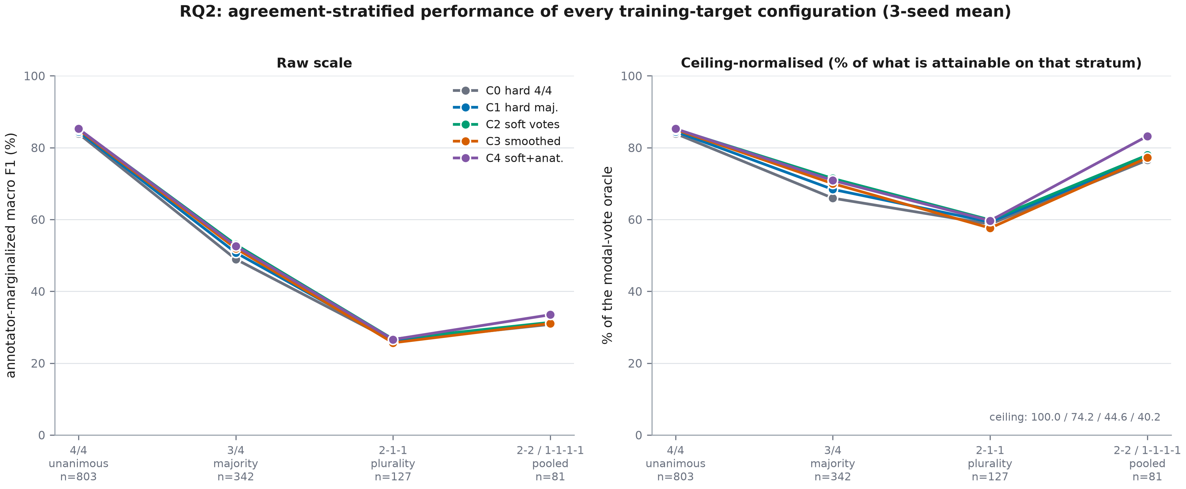
Figure 2. Agreement-stratified performance of every configuration, raw (left) and as a percentage of the modal-vote oracle attainable on that stratum (right). 3-seed mean.
Table 5. Annotator-marginalized macro F1 (%) by configuration and stratum, 3-seed mean. Full tables with intervals, ceiling-normalised levels, expected accuracy and any-hit rate are in Appendix A.
Configuration | S-unanimous | S-majority | S-plurality | S-no-majority | contested (pooled)
C0 — hard label, 4/4 cohort (Phase 2 reference) | 83.91 | 48.95 | 26.15 | 30.79 | 42.42
C1 — hard majority label, extended cohort | 84.49 | 50.76 | 26.42 | 31.15 | 43.76
C2 — vote proportions | 85.14 | 53.01 | 26.68 | 31.35 | 45.75
C3 — hard label + mass-matched smoothing (control) | 85.03 | 51.95 | 25.67 | 31.05 | 44.35
C4 — vote proportions + anatomical penalty | 85.25 | 52.60 | 26.58 | 33.48 | 45.47
Note. Attainable ceiling per stratum: S-unanimous 100.00%, S-majority 74.23%, S-plurality 44.55%, S-no-majority 40.23%. A configuration cannot exceed these.
The C0 row is not a new measurement. It is the Phase 3 result, recomputed through the Phase 4 code path and gated to agree with reports/phase3_stratified_metrics.json to within 0.0e+00 (gate P4.7). Had it differed at all, every contrast built on it would have been meaningless.

3.2.1 The pre-registered contrasts
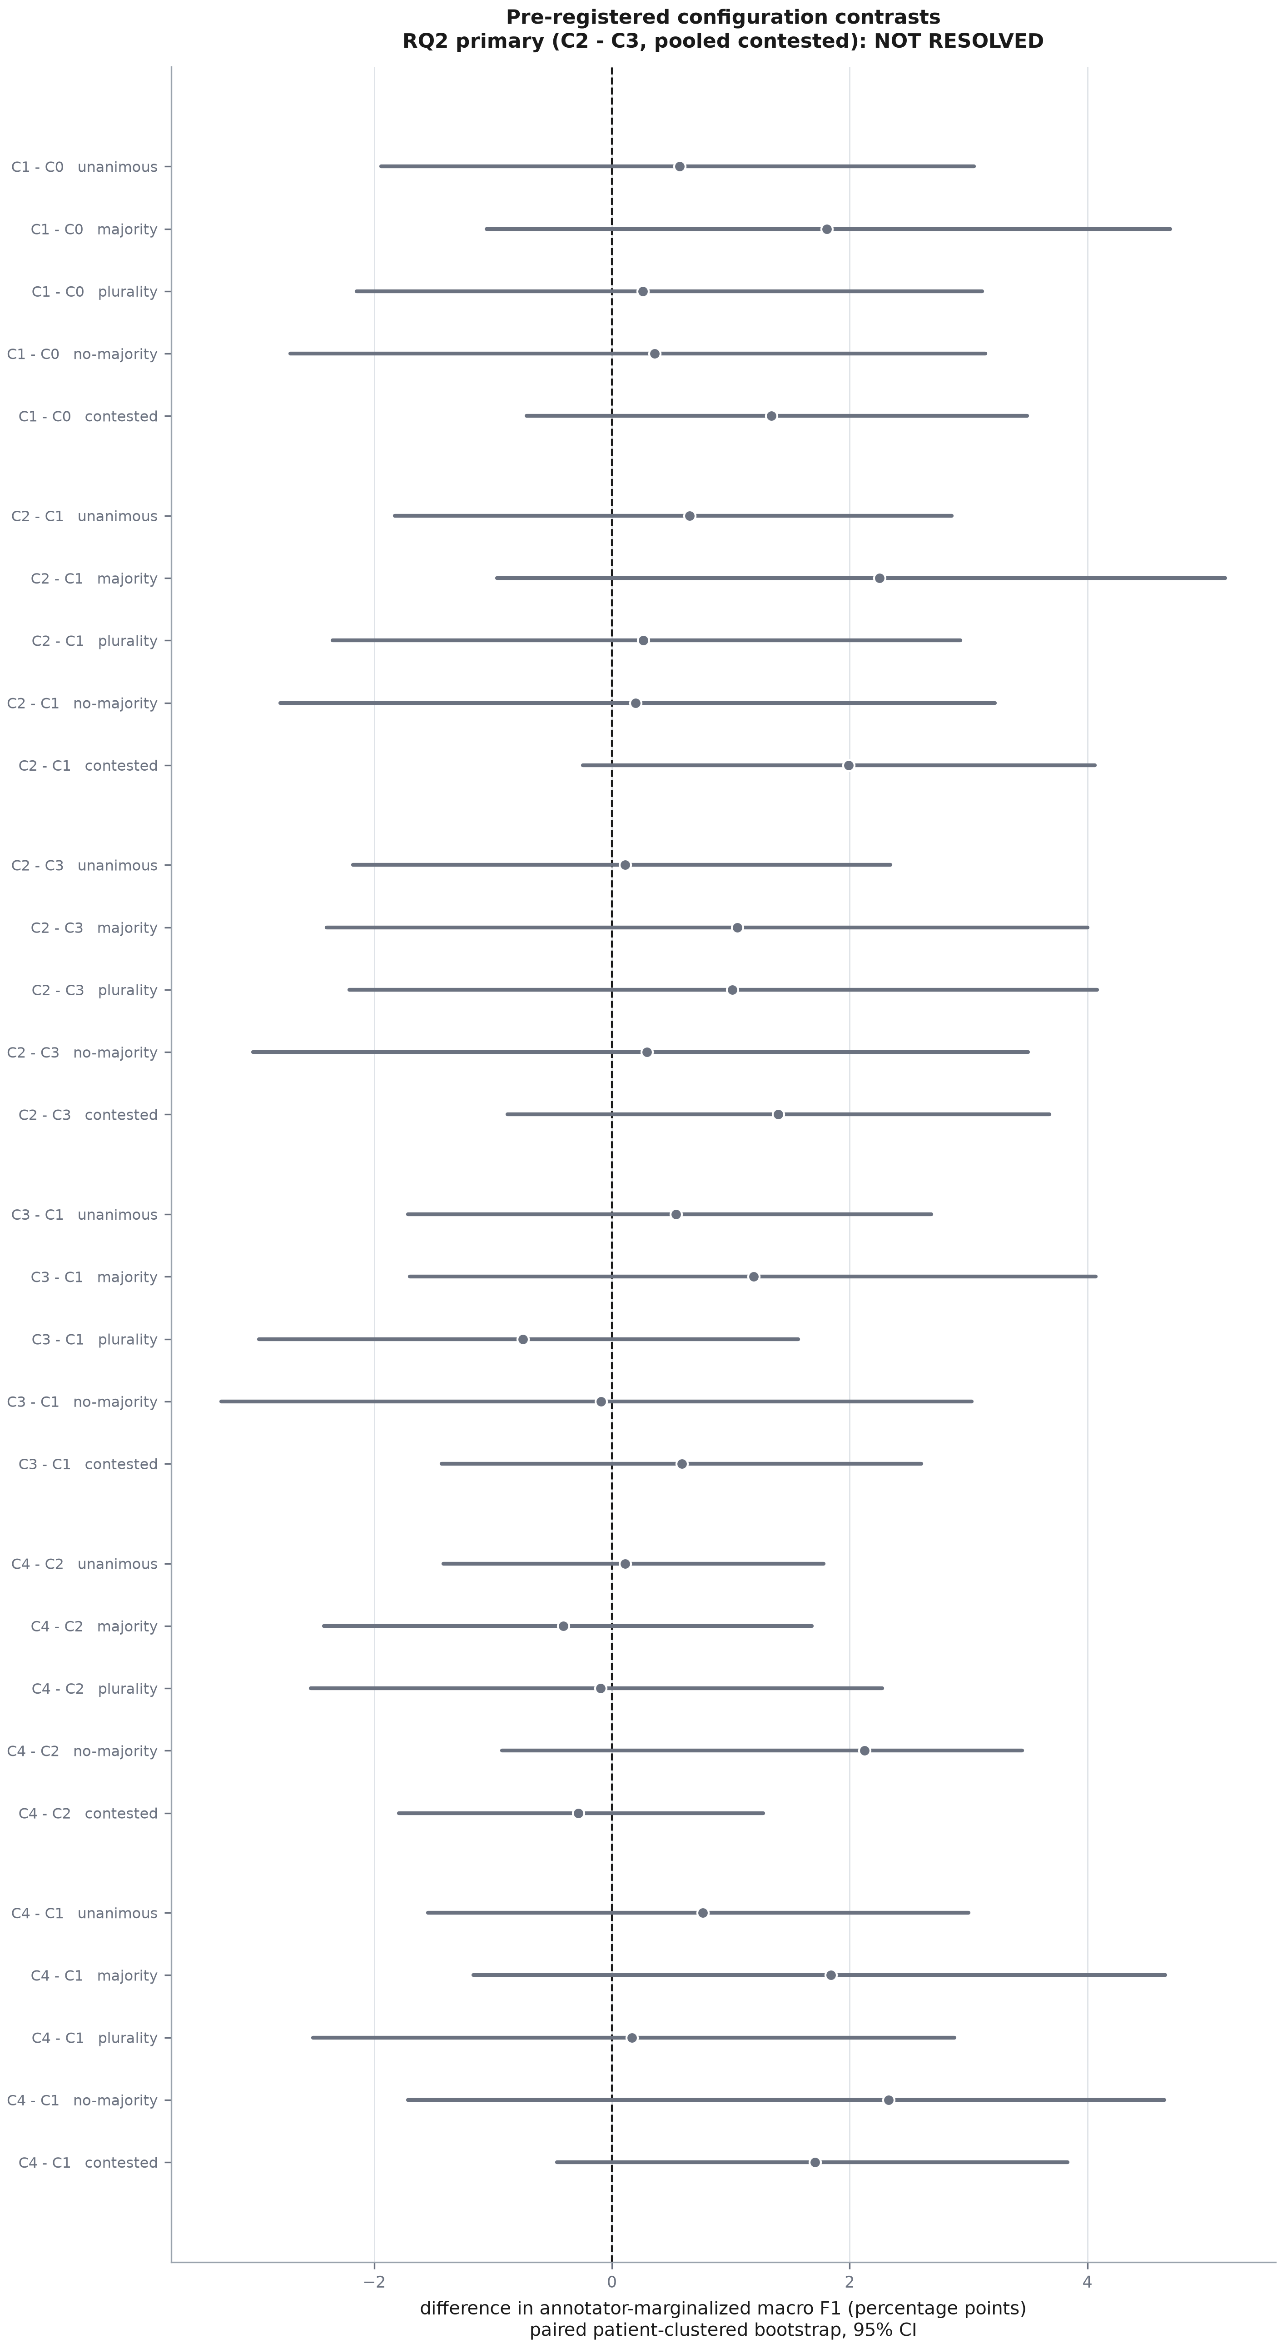
Figure 3. Every pre-registered contrast, on every stratum, with paired patient-clustered 95% intervals. Green excludes zero above, red below, grey contains zero.
Table 6. Configuration contrasts on the pooled contested stratum (n=550), the pre-registered primary endpoint. Positive favours the first-named configuration.
Contrast | What it isolates | Diff (points) | 95% CI | Excludes 0 | Sign consistent over seeds
C1 - C0 | cohort effect: adding the 3/4 contested images at a hard target | +1.34 | [-0.72, +3.49] | no | yes
C2 - C1 | softening the target on the images where annotators disagreed | +1.99 | [-0.24, +4.06] | no | yes
C2 - C3 | PRIMARY RQ2: targeted softening vs equally-soft generic smoothing | +1.40 | [-0.88, +3.68] | no | yes
C3 - C1 | generic regularisation alone | +0.59 | [-1.43, +2.60] | no | no
C4 - C2 | PRIMARY RQ4: the anatomical structured penalty | -0.28 | [-1.79, +1.27] | no | no
C4 - C1 | soft targets and the anatomical penalty together | +1.71 | [-0.46, +3.83] | no | yes

Pre-registered verdict: NOT RESOLVED
RQ2 primary endpoint. C2 minus C3 on the pooled contested stratum is +1.40 points (95% CI -0.88 to +3.68). Under the rule fixed before training — supported only if the paired interval excludes zero in C2's favour — the verdict is NOT RESOLVED.

Table 7. The primary contrast broken out by stratum (secondary endpoints). Per-stratum verdicts are secondary and are not corrected for multiplicity; the single primary test is the pooled row.
Stratum | C2 - C3 (points) | 95% CI | Verdict
S-unanimous (4/4) | +0.11 | [-2.18, +2.35] | NOT RESOLVED
S-majority (3/4) | +1.06 | [-2.40, +4.00] | NOT RESOLVED
S-plurality (2-1-1) | +1.01 | [-2.21, +4.08] | NOT RESOLVED
S-no-majority (2-2 / 1-1-1-1) | +0.29 | [-3.02, +3.50] | NOT RESOLVED
S-contested (all three pooled) | +1.40 | [-0.88, +3.68] | NOT RESOLVED

The hypothesis also predicted PARITY on the unanimous stratum — soft targets should not cost anything where there is nothing to soften. C2 minus C1 there is +0.65 points (95% CI -1.83 to +2.86), which is consistent with parity.

3.3 RQ2, calibration
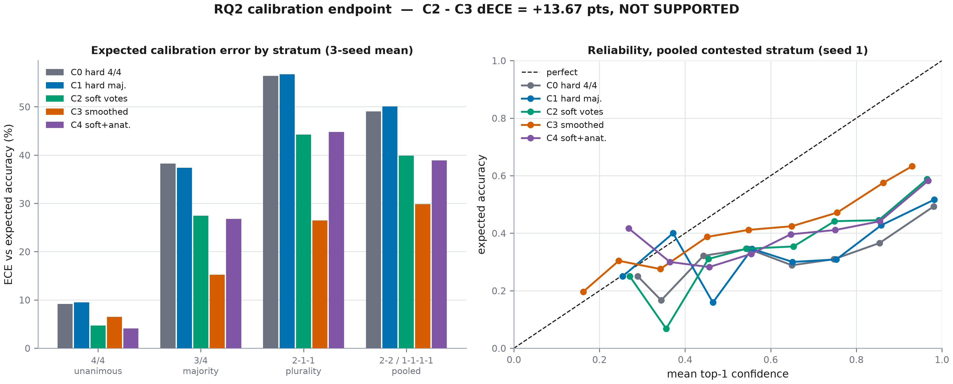
Figure 4. Expected calibration error by configuration and stratum (left) and reliability on the pooled contested stratum (right).
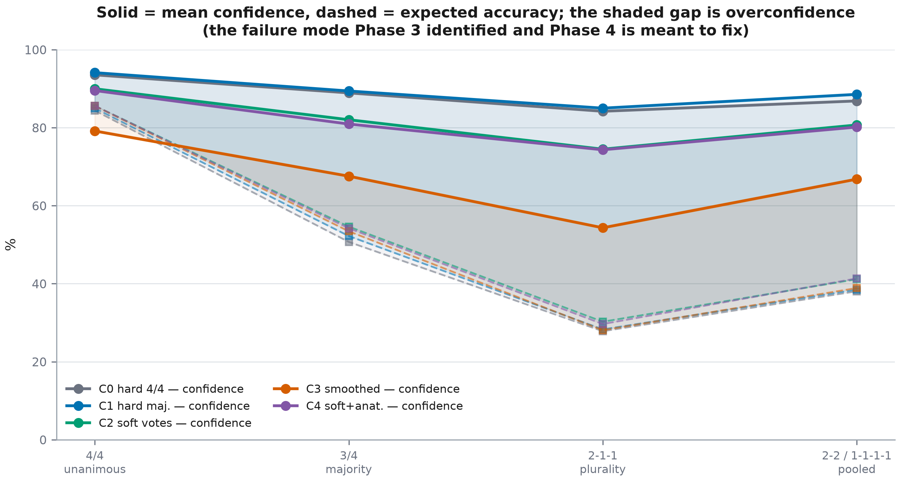
Figure 5. Mean confidence against expected accuracy. The shaded gap is the overconfidence Phase 3 identified as the baseline's real failure mode.
Table 8. Expected calibration error (%) against expected accuracy, 3-seed mean. Lower is better.
Configuration | S-unanimous | S-majority | S-plurality | S-no-majority | contested (pooled)
C0 — hard label, 4/4 cohort (Phase 2 reference) | 9.15 | 38.23 | 56.40 | 49.05 | 43.96
C1 — hard majority label, extended cohort | 9.49 | 37.35 | 56.72 | 50.07 | 43.61
C2 — vote proportions | 4.72 | 27.45 | 44.23 | 39.86 | 33.08
C3 — hard label + mass-matched smoothing (control) | 6.51 | 15.21 | 26.45 | 29.84 | 19.41
C4 — vote proportions + anatomical penalty | 4.07 | 26.80 | 44.79 | 38.90 | 32.71

Table 9. Calibration detail on the pooled contested stratum. The 23-dimensional Brier score against the vote distribution is the stricter form and is added here because it is exactly the distribution C2 and C4 are trained on.
Configuration | Mean confidence (%) | Expected accuracy (%) | Overconfidence (points) | MCE (%) | Brier (top-1) | Brier (23-vector)
C0 — hard label, 4/4 cohort (Phase 2 reference) | 87.53 | 43.56 | +43.97 | 49.42 | 0.2765 | 0.5137
C1 — hard majority label, extended cohort | 88.26 | 44.67 | +43.60 | 49.68 | 0.2732 | 0.4965
C2 — vote proportions | 80.09 | 47.02 | +33.08 | 40.22 | 0.1837 | 0.3703
C3 — hard label + mass-matched smoothing (control) | 64.40 | 45.44 | +18.96 | 30.89 | 0.1168 | 0.3223
C4 — vote proportions + anatomical penalty | 79.30 | 46.64 | +32.66 | 41.53 | 0.1831 | 0.3741

Pre-registered verdict: NOT SUPPORTED
RQ2 calibration endpoint. C2 minus C3 in expected calibration error on the pooled contested stratum is +13.67 points (95% CI +11.27 to +15.77) (negative = better calibrated). Pre-registered verdict: NOT SUPPORTED.

3.4 RQ3: does predictive uncertainty track human disagreement?
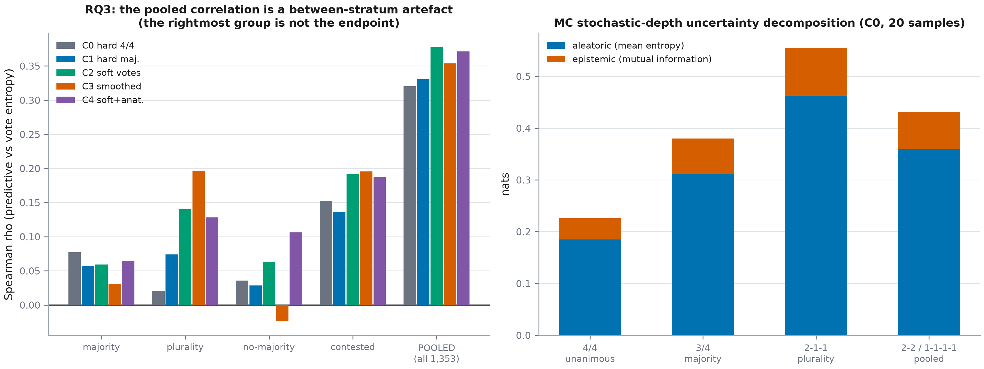
Figure 6. Left: Spearman correlation between predictive entropy and annotator vote entropy, within each stratum and pooled. Right: the MC stochastic-depth uncertainty decomposition.
Table 10. Spearman rho between predictive entropy and per-image annotator vote entropy. The rightmost column is reported only to expose the artefact: it is not the endpoint.
Configuration | majority | plurality | no-majority | contested | pooled, all images
C0 — hard label, 4/4 cohort (Phase 2 reference) | 0.077 | 0.021 | 0.036 | 0.153 | 0.320
C1 — hard majority label, extended cohort | 0.057 | 0.074 | 0.029 | 0.136 | 0.330
C2 — vote proportions | 0.059 | 0.140 | 0.063 | 0.192 | 0.377
C3 — hard label + mass-matched smoothing (control) | 0.031 | 0.197 | -0.024 | 0.196 | 0.354
C4 — vote proportions + anatomical penalty | 0.064 | 0.128 | 0.106 | 0.187 | 0.371
Note. Vote entropy is identically zero on S-unanimous, so the correlation is undefined there and is reported as such rather than as zero.
Phase 3 measured the pooled value at 0.32 and the within-tier values at 0.02-0.08, and required Phase 4 to report the within-tier quantity as primary. The table above reproduces that gap for every configuration: a reader shown only the pooled column would conclude the models track human disagreement, when what the pooled column measures is mostly which stratum an image belongs to.
Table 11. RQ3 pre-registered verdict, taken on the largest contested stratum.
Configuration | Stratum | Mean rho | 95% CI (pooled) | Mean of per-seed bounds | Verdict
C0 — hard label, 4/4 cohort (Phase 2 reference) | S-majority | 0.0771 | [-0.0292, 0.1778] | [-0.0342, 0.1918] | NOT RESOLVED
C1 — hard majority label, extended cohort | S-majority | 0.0569 | [-0.0390, 0.1477] | [-0.0449, 0.1579] | NOT RESOLVED
C2 — vote proportions | S-majority | 0.0594 | [-0.0443, 0.1697] | [-0.0500, 0.1726] | NOT RESOLVED
C3 — hard label + mass-matched smoothing (control) | S-majority | 0.0308 | [-0.0868, 0.1403] | [-0.0882, 0.1456] | NOT RESOLVED
C4 — vote proportions + anatomical penalty | S-majority | 0.0644 | [-0.0432, 0.1784] | [-0.0481, 0.1819] | NOT RESOLVED
Note. The verdict column is read off the pooled interval: for each patient resample the correlation is computed for all three seeds and averaged, and the percentiles are taken over that distribution. The final column is the arithmetic mean of the three per-seed intervals; it is shown for continuity with the first run of this analysis, but it propagates no between-seed variation and is not a calibrated 95% interval.
Table 12. What each uncertainty estimator buys in accuracy on the pooled contested stratum. The ensemble is 3-member, not the blueprint's 5-member (deviation P4-DEV-2), so its gain is a lower bound.
Configuration | Single model (%) | MC stochastic depth (%) | 3-seed deep ensemble (%) | Ensemble gain (points)
C0 — hard label, 4/4 cohort (Phase 2 reference) | 42.42 | 43.64 | 43.35 | +0.93
C1 — hard majority label, extended cohort | 43.76 | 45.98 | 45.68 | +1.92
C2 — vote proportions | 45.75 | 46.82 | 46.58 | +0.83
C3 — hard label + mass-matched smoothing (control) | 44.35 | 45.95 | 45.68 | +1.33
C4 — vote proportions + anatomical penalty | 45.47 | 46.42 | 46.23 | +0.76

3.5 RQ4: the anatomy-aware loss
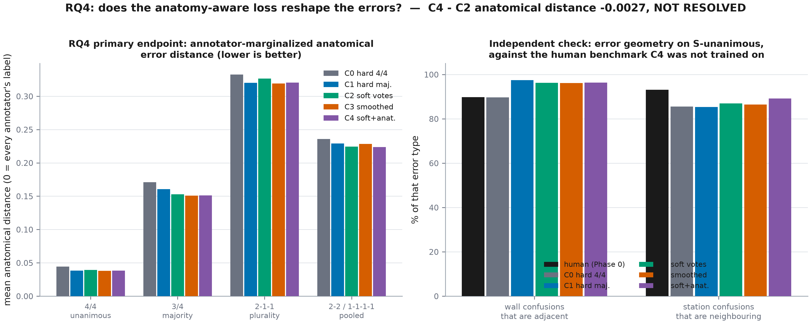
Figure 7. Left: mean annotator-marginalized anatomical error distance, the RQ4 primary endpoint. Right: error geometry on S-unanimous against the Phase 0 human benchmark, which C4 was not trained on.
Table 13. Mean anatomical error distance (0 = the prediction is every annotator's label; 1 = maximally distant from all of them), 3-seed mean. Lower is better.
Configuration | S-unanimous | S-majority | S-plurality | S-no-majority | contested (pooled)
C0 — hard label, 4/4 cohort (Phase 2 reference) | 0.0442 | 0.1709 | 0.3326 | 0.2359 | 0.2178
C1 — hard majority label, extended cohort | 0.0383 | 0.1607 | 0.3202 | 0.2293 | 0.2076
C2 — vote proportions | 0.0392 | 0.1530 | 0.3265 | 0.2245 | 0.2036
C3 — hard label + mass-matched smoothing (control) | 0.0378 | 0.1509 | 0.3191 | 0.2286 | 0.2011
C4 — vote proportions + anatomical penalty | 0.0382 | 0.1511 | 0.3206 | 0.2236 | 0.2009

Table 14. Error geometry on the S-unanimous stratum — the only stratum with an uncontested reference label — against the human benchmarks measured in Phase 0. These are the independent checks: C4 optimises the distance matrix, not these shares.
Configuration | Error rate (%) | Wall confusions adjacent (%) | Station confusions neighbouring (%)
Human annotators (Phase 0) | — | 89.8 | 93.1
C0 — hard label, 4/4 cohort (Phase 2 reference) | 15.61 | 89.68 | 85.57
C1 — hard majority label, extended cohort | 15.03 | 97.48 | 85.29
C2 — vote proportions | 14.40 | 96.25 | 86.98
C3 — hard label + mass-matched smoothing (control) | 14.41 | 96.17 | 86.43
C4 — vote proportions + anatomical penalty | 14.41 | 96.35 | 89.15
Note. Phase 3 established that the wall and station comparisons against the human values are both underpowered at this error count; the column is informative for comparing configurations with each other, not for declaring a match with humans.
Pre-registered verdict: NOT RESOLVED
RQ4. C4 minus C2 in mean anatomical error distance on the pooled contested stratum is -0.0027 (95% CI -0.0107 to +0.0047). The pre-registered rule requires the distance to fall with an interval excluding zero AND macro F1 not to fall significantly; macro F1 moved -0.28 points (95% CI -1.79 to +1.27). Verdict: NOT RESOLVED.

3.6 Sensitivity
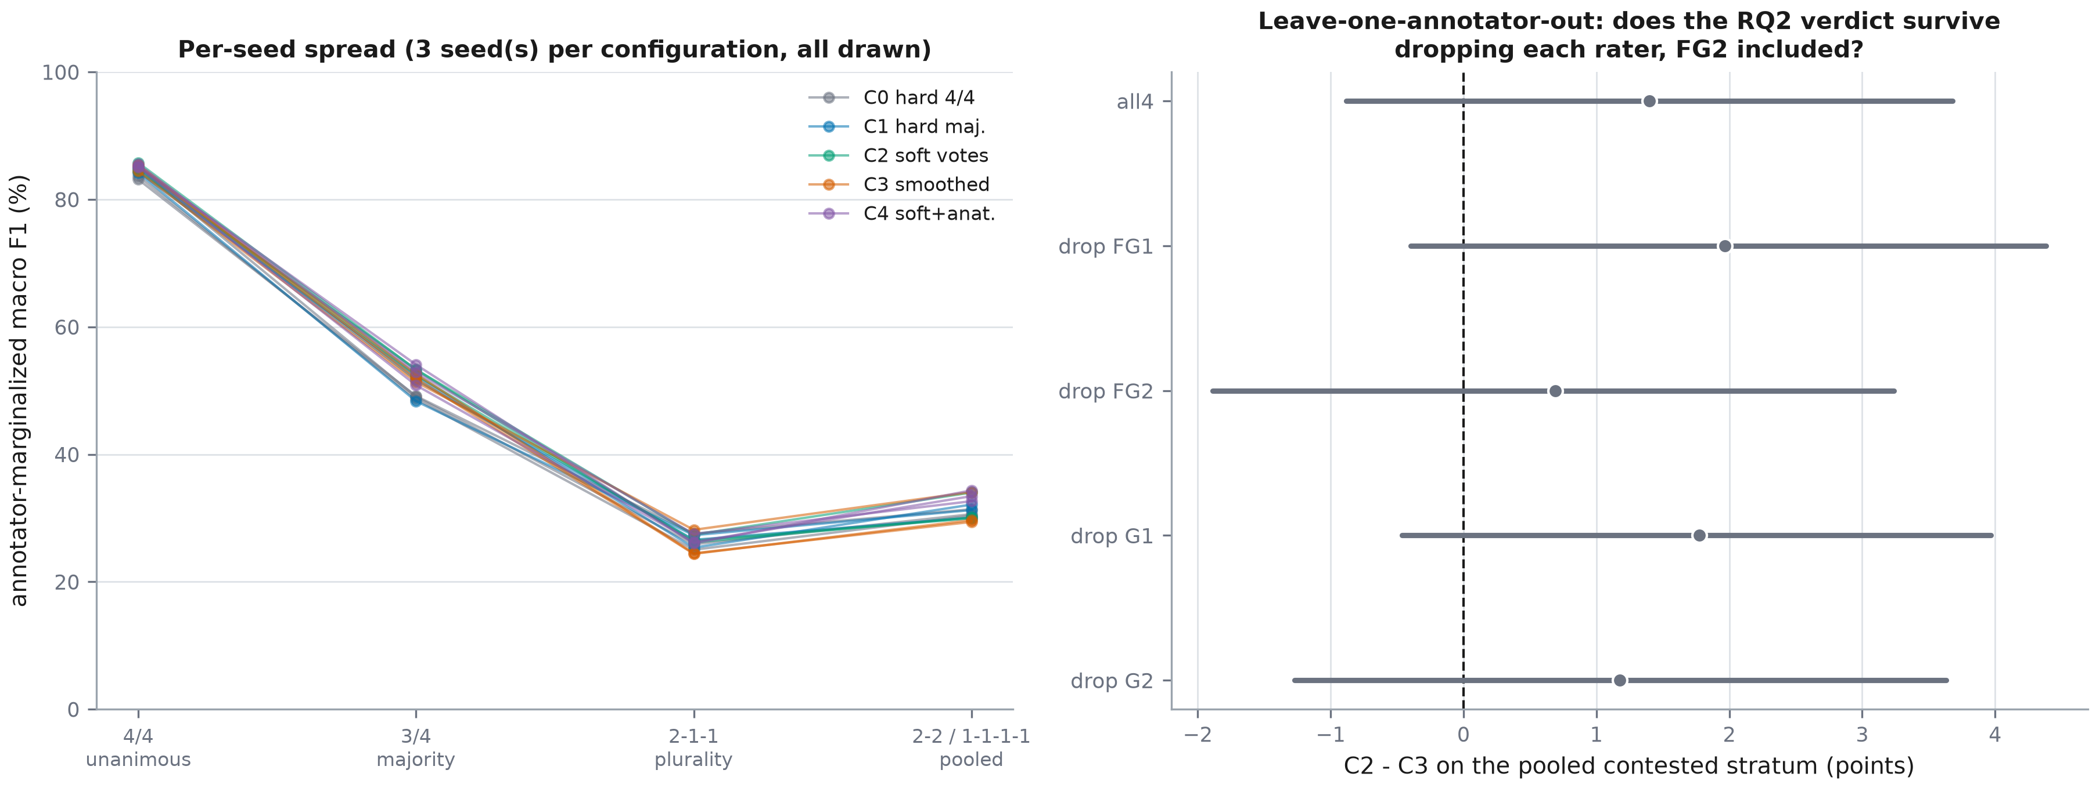
Figure 8. Left: every seed of every configuration drawn separately. Right: the RQ2 primary contrast recomputed with each annotator dropped in turn.

3.6.1 Per-seed stability
Cross-seed standard deviation on the pooled contested stratum stays below 1.18 points for every configuration, so the ordering of the arms is a property of the training target rather than of one initialisation. Per-seed contrast values and their sign consistency are in the contrast table above.

3.6.2 Leave-one-annotator-out
Blueprint sec.2.3: fg2 is the outlier annotator on every measure, and its pairwise kappa with the other resident (0.6799) is the lowest in the panel. Every headline number is an average over the four annotator columns, so the obvious objection is that one atypical rater drives it. Only the metric: marginalization, expected accuracy and vote entropy are rebuilt from 3 annotator columns. the strata remain defined by the full 4-annotator vote matrix and no model is retrained.
Table 15. The RQ2 primary contrast recomputed with each annotator dropped from the metric in turn. The strata stay defined by the full four-annotator vote matrix, so every row scores the same images.
Annotator subset | C2 - C3 (points) | 95% CI | Verdict
all4 | +1.40 | [-0.88, +3.68] | NOT RESOLVED
drop FG1 | +1.97 | [-0.40, +4.38] | NOT RESOLVED
drop FG2 | +0.69 | [-1.89, +3.24] | NOT RESOLVED
drop G1 | +1.77 | [-0.46, +3.97] | NOT RESOLVED
drop G2 | +1.18 | [-1.27, +3.63] | NOT RESOLVED

The pre-registered verdict is invariant to dropping any single annotator, FG2 included. A training-side LOAO — rebuilding the C2 targets from three annotators and retraining — was not run; the pre-registration declares it unexecuted for budget and Appendix E states what it would cost.

4. Discussion

4.1 RQ2: what the control bought
The primary contrast is C2 minus C3, not C2 minus C1, and the distinction carries the whole argument. C2 minus C1 asks whether softening the target helps; it was +1.99 points (95% CI -0.24 to +4.06) on the pooled contested stratum, a difference the data cannot separate from zero. C2 minus C3 asks the harder and more interesting question — whether softening the target WHERE THE ANNOTATORS ACTUALLY DISAGREED helps beyond softening it everywhere by the same total amount — and it was +1.40 points (95% CI -0.88 to +3.68), a difference the data cannot separate from zero. The pre-registered verdict is NOT RESOLVED.
That is an honest null. The interval is wide enough to contain effects in both directions, so the phase neither demonstrates nor refutes a benefit from the disagreement pattern. The relevant number for anyone planning a replication is the interval width itself, not the point estimate.
The cohort effect deserves separate mention. C1 minus C0 was +1.34 points (95% CI -0.72 to +3.49) on the pooled contested stratum. Two things confound it and both favour caution: C0's model selection used a validation set containing no contested images, and C0 was trained to early stopping while several Phase 4 runs stopped at the pre-registered epoch cap. It is reported as a descriptive comparison, not as a controlled contrast, and it is not the basis of any claim here.

4.2 RQ2 calibration, and what it says about the Phase 3 finding
Every configuration remains badly calibrated on contested images. The best of them on the pooled contested stratum is C3 at 19.41% expected calibration error and the worst is C0 at 43.96%, against 9.15% for C0 on unanimous images. Changing the training target moves this substantially, but it does not fix it.
Before the reversal, the part of the hypothesis that did hold: soft targets are substantially better calibrated than hard ones. C2 minus C1 on the pooled contested stratum is -10.53 points (95% CI -13.06 to -8.09) — an interval well clear of zero — so building the target from the vote distribution rather than from the majority label removes roughly a quarter of the baseline's calibration error. That is a real effect and it is the effect RQ2 predicted. It is simply not the effect RQ2 was tested on.
The headline verdict hides a reversal that is more interesting than the verdict. C3 wins on the contested stratum (19.41% against C2's 33.08%), and wins by more than twice C2's margin over C1 (-24.20 points (95% CI -27.01 to -20.84) against -10.53 points (95% CI -13.06 to -8.09)). But C2 beats C3 on the unanimous stratum (4.72% against 6.51%), where the best-calibrated arm overall is C4 at 4.07%. The mechanism is visible in the confidence column. On unanimous images C3's mean confidence is 79.15% against an expected accuracy of 85.60% — it is UNDERconfident by 6.4 points — while C2 sits at 89.98% against 85.60%, almost exactly right.
That is what a blunt instrument looks like. Uniform label smoothing applies the same epsilon to every image, so it suppresses confidence globally: mean confidence on the contested stratum falls to 64.40% for C3 against 80.09% for C2, which buys a large ECE reduction where the model was overconfident and costs accuracy of confidence where it was not. Vote-proportion targets cannot do this, because on a 4/4 image the vote distribution IS one-hot and C2 is therefore trained to be maximally confident there — which is correct, and is why C2 is the better-calibrated arm on that stratum. The two arms are not competing on one axis; C3 trades unanimous-stratum calibration for contested-stratum calibration, and the pooled endpoint scores that trade favourably only because the pooled stratum contains no unanimous images.
None of this rescues the hypothesis as pre-registered, and it is not offered as doing so — the rule was fixed on the pooled contested endpoint and the pooled contested endpoint says the control won. It does say that the improvement label smoothing delivers is a known and general property of the method rather than anything about this corpus's annotators, which is precisely why the blueprint insisted that C3 control the calibration result as well as the accuracy result. Without it, C2's genuine improvement over C1 — -10.53 points (95% CI -13.06 to -8.09) on the contested stratum, an interval excluding zero — would have been reported as evidence that annotator vote distributions fix calibration. They improve it markedly; a uniform smoothing prior of matched mass improves it more.
That relocates Phase 3's principal finding. It is not an artefact of training on the unanimous subset — models trained on contested images with contested targets are still overconfident on contested images. The failure is in the agreement structure of the problem: a single softmax over 23 mutually exclusive classes has no way to express 'two experts would say A3 and two would say P3', and a confidence score derived from it will always overstate the mass it captures under the vote distribution. Post-hoc temperature scaling was deliberately excluded from this phase's scope so as not to confound the C2-versus-C3 comparison; it is the obvious next intervention and it is now motivated by a measurement rather than by convention.

4.3 RQ3
The within-stratum correlations are small for every configuration, and the gap between them and the pooled value reproduces the artefact Phase 3 identified. The practical implication is a reporting one and it generalises beyond this corpus: a study that correlates model uncertainty with annotator disagreement across a whole test set, without stratifying, will report a correlation that largely measures how contested each image is rather than whether the model knows. Since the stratification requires per-annotator labels, most published versions of this analysis cannot be checked.

4.4 RQ4
The structured penalty was tested at exactly one value of lambda, fixed a priori at unit weight and never swept (deviation P4-DEV-3). The verdict (NOT RESOLVED) is therefore a statement about unit weight, not about the family of anatomy-aware losses. A null at lambda = 1 is compatible with a benefit at a larger weight, and the honest thing to report is the cost of finding out: nine further runs, roughly thirteen hours on this hardware (Appendix E).

4.5 Relation to the descriptor's own FG-agreement result
The blueprint's §2.7 records that the dataset descriptor obtained 87.05 macro F1 by training ConvNeXt-Tiny on FG-agreement labels against ~85 on complete-agreement labels — a 2.2-point move from changing how annotator labels are combined. That result is not directly comparable with anything here: it is measured on the unanimous test subset only, and it changes which annotators define the label rather than how their votes are aggregated. It remains the precedent that motivated this phase, and the present results give it a stratified context it did not have.

4.6 Limitations specific to this phase
- The 1,150 Train/Validation images with no majority label are excluded from every arm, so the most ambiguous images in the corpus never enter training. This is forced by the need for a definable C3 control.
- Four annotators give vote proportions with only five possible values, so the soft target is a coarse estimate of the label distribution (declared limitation L7). A null RQ2 result is partly a statement about panel size.
- lambda for C4 and the matching criterion for C3's epsilon were each fixed at a single pre-registered value. Both are defensible choices made before seeing results, and both leave the corresponding hypothesis tested at one point rather than over a family.
- 8 of 12 Phase 4 runs stopped at the pre-registered fine-tuning cap rather than by early stopping, so the absolute scores are lower bounds and the C1-minus-C0 comparison is descriptive only.
- The cap is the same NUMBER of epochs for every configuration, but it did not censor them equally: C1 2/3, C2 3/3, C3 2/3, C4 1/3. It bound most often on C2, whose capped runs were still selecting their best epoch at 39/41/41 of 44 — validation macro F1 was still improving when training was cut off. An equal cap is therefore not equal censoring, and this report does not claim the contrasts are unaffected by it. C2 is the treatment arm of the RQ2 primary contrast, so the bias runs against it and towards the NOT RESOLVED verdict that was obtained. That verdict should be read as 'not resolved under this compute budget', and a convergence amendment that lets every arm early-stop on its own is the pre-condition for reading it as anything stronger.
- One architecture, one centre, one vendor. Phase 5's external validation remains the only test of whether any of this transfers.
- The MC estimator samples stochastic depth, whose per-block probability in ConvNeXt-Tiny rises only to 0.1. The resulting predictive spread is modest by construction, so a small epistemic component should not be read as evidence that the model is certain.

4.7 Implications for Phases 5 to 7
- Phase 5 should carry the best-calibrated configuration, not the most accurate one, into external validation: the calibration gap is the failure that would matter first in deployment.
- Phase 5 should also report the agreement-stratified curve on the external corpora if per-annotator labels exist there, and state plainly that it cannot if they do not.
- Phase 6's Grad-CAM comparison should target the contested strata and the specific confusions the anatomical distance matrix marks as far, since those are the errors no configuration here removed.
- Phase 7 should present RQ2 as a controlled comparison with a matched control, and report the verdict the rule produced rather than the one the hypothesis predicted.

5. Conclusion

5.1 Answers
- RQ2 (accuracy): NOT RESOLVED. C2 minus C3 on the pooled contested stratum = +1.40 points (95% CI -0.88 to +3.68).
- RQ2 (calibration): NOT SUPPORTED. C2 minus C3 in ECE = +13.67 points (95% CI +11.27 to +15.77). No configuration achieves acceptable calibration on contested images.
- RQ3: supported for no configuration on the largest contested stratum. The pooled correlation remains several times the within-stratum value for every configuration, confirming the Phase 3 artefact.
- RQ4: NOT RESOLVED at lambda = 1. Anatomical error distance C4 minus C2 = -0.0027 (95% CI -0.0107 to +0.0047).

5.2 Carry-forward decisions
- Treat calibration, not accuracy, as the headline deficiency of landmark classifiers evaluated outside the consensus subset. Four training targets did not fix it.
- Keep the matched control. The value of this phase is that its answer is interpretable whichever way it came out, and that is entirely due to C3 being matched to C2 in displaced mass rather than set to a conventional epsilon.
- Report within-stratum uncertainty correlations. The pooled quantity is not wrong, it is a different quantity, and it flatters the model.
- Pre-register the epoch cap derivation again in Phase 5, and budget for early stopping to fire: the cap bound in this phase and cost the C1-minus-C0 comparison its interpretability.
- Carry the anatomical distance matrix into Phase 6 as the ranking for which confusions to explain, independently of the RQ4 verdict — it is a useful descriptive instrument even where the penalty built on it is not.

Appendices

Appendix A. Per-configuration, per-stratum metric tables
Table 16. Full metric set on the S-unanimous (4/4) stratum, 3-seed mean. Attainable ceiling on this stratum: 100.00%.
Configuration | n | Annot.-marg. F1 (%) | SD over seeds | Mean of per-seed 95% CIs | % of attainable | Expected acc. (%) | Any-hit (%)
C0 — hard label, 4/4 cohort (Phase 2 reference) | 803 | 83.91 | 0.92 | [81.21, 86.57] | 83.91 | 84.39 | 84.39
C1 — hard majority label, extended cohort | 803 | 84.49 | 0.39 | [81.77, 87.17] | 84.49 | 84.97 | 84.97
C2 — vote proportions | 803 | 85.14 | 0.60 | [82.31, 87.81] | 85.14 | 85.60 | 85.60
C3 — hard label + mass-matched smoothing (control) | 803 | 85.03 | 0.53 | [82.21, 87.71] | 85.03 | 85.60 | 85.60
C4 — vote proportions + anatomical penalty | 803 | 85.25 | 0.22 | [82.68, 87.72] | 85.25 | 85.60 | 85.60
Note. The interval column is the arithmetic mean of the three per-seed patient-clustered intervals, not a calibrated interval on the 3-seed mean. It describes the typical width of a single seed's interval. No verdict is read off this column: every pre-registered verdict comes from a paired bootstrap on the configuration difference, reported in section 3.2.1.
Table 17. Full metric set on the S-majority (3/4) stratum, 3-seed mean. Attainable ceiling on this stratum: 74.23%.
Configuration | n | Annot.-marg. F1 (%) | SD over seeds | Mean of per-seed 95% CIs | % of attainable | Expected acc. (%) | Any-hit (%)
C0 — hard label, 4/4 cohort (Phase 2 reference) | 342 | 48.95 | 0.25 | [44.01, 52.07] | 65.94 | 50.71 | 80.02
C1 — hard majority label, extended cohort | 342 | 50.76 | 2.10 | [46.08, 53.66] | 68.38 | 52.22 | 80.80
C2 — vote proportions | 342 | 53.01 | 0.51 | [47.53, 56.42] | 71.41 | 54.63 | 84.02
C3 — hard label + mass-matched smoothing (control) | 342 | 51.95 | 0.61 | [47.41, 54.72] | 69.98 | 53.44 | 81.19
C4 — vote proportions + anatomical penalty | 342 | 52.60 | 1.63 | [47.63, 55.56] | 70.86 | 54.19 | 84.02
Note. The interval column is the arithmetic mean of the three per-seed patient-clustered intervals, not a calibrated interval on the 3-seed mean. It describes the typical width of a single seed's interval. No verdict is read off this column: every pre-registered verdict comes from a paired bootstrap on the configuration difference, reported in section 3.2.1.
Table 18. Full metric set on the S-plurality (2-1-1) stratum, 3-seed mean. Attainable ceiling on this stratum: 44.55%.
Configuration | n | Annot.-marg. F1 (%) | SD over seeds | Mean of per-seed 95% CIs | % of attainable | Expected acc. (%) | Any-hit (%)
C0 — hard label, 4/4 cohort (Phase 2 reference) | 127 | 26.15 | 1.28 | [20.68, 27.39] | 58.70 | 27.82 | 72.70
C1 — hard majority label, extended cohort | 127 | 26.42 | 0.99 | [21.43, 27.52] | 59.29 | 28.28 | 73.75
C2 — vote proportions | 127 | 26.68 | 0.63 | [21.10, 28.32] | 59.88 | 30.25 | 79.00
C3 — hard label + mass-matched smoothing (control) | 127 | 25.67 | 2.15 | [20.61, 26.90] | 57.61 | 28.08 | 74.02
C4 — vote proportions + anatomical penalty | 127 | 26.58 | 0.79 | [21.27, 28.26] | 59.67 | 29.66 | 77.95
Note. The interval column is the arithmetic mean of the three per-seed patient-clustered intervals, not a calibrated interval on the 3-seed mean. It describes the typical width of a single seed's interval. No verdict is read off this column: every pre-registered verdict comes from a paired bootstrap on the configuration difference, reported in section 3.2.1.
Table 19. Full metric set on the S-no-majority (2-2 / 1-1-1-1) stratum, 3-seed mean. Attainable ceiling on this stratum: 40.23%.
Configuration | n | Annot.-marg. F1 (%) | SD over seeds | Mean of per-seed 95% CIs | % of attainable | Expected acc. (%) | Any-hit (%)
C0 — hard label, 4/4 cohort (Phase 2 reference) | 81 | 30.79 | 0.52 | [23.46, 31.97] | 76.53 | 38.07 | 79.83
C1 — hard majority label, extended cohort | 81 | 31.15 | 1.02 | [23.76, 31.93] | 77.43 | 38.48 | 80.66
C2 — vote proportions | 81 | 31.35 | 2.30 | [23.88, 32.25] | 77.93 | 41.15 | 86.01
C3 — hard label + mass-matched smoothing (control) | 81 | 31.05 | 2.63 | [23.46, 32.00] | 77.20 | 38.89 | 81.48
C4 — vote proportions + anatomical penalty | 81 | 33.48 | 0.85 | [25.28, 33.72] | 83.21 | 41.36 | 86.42
Note. The interval column is the arithmetic mean of the three per-seed patient-clustered intervals, not a calibrated interval on the 3-seed mean. It describes the typical width of a single seed's interval. No verdict is read off this column: every pre-registered verdict comes from a paired bootstrap on the configuration difference, reported in section 3.2.1.
Table 20. Full metric set on the S-contested (all three pooled) stratum, 3-seed mean. Attainable ceiling on this stratum: 64.76%.
Configuration | n | Annot.-marg. F1 (%) | SD over seeds | Mean of per-seed 95% CIs | % of attainable | Expected acc. (%) | Any-hit (%)
C0 — hard label, 4/4 cohort (Phase 2 reference) | 550 | 42.42 | 0.64 | [38.57, 45.25] | 65.50 | 43.56 | 78.30
C1 — hard majority label, extended cohort | 550 | 43.76 | 1.18 | [39.88, 46.59] | 67.57 | 44.67 | 79.15
C2 — vote proportions | 550 | 45.75 | 0.27 | [41.57, 48.75] | 70.65 | 47.02 | 83.15
C3 — hard label + mass-matched smoothing (control) | 550 | 44.35 | 0.31 | [40.71, 47.18] | 68.49 | 45.44 | 79.58
C4 — vote proportions + anatomical penalty | 550 | 45.47 | 1.07 | [41.71, 48.29] | 70.21 | 46.64 | 82.97
Note. The interval column is the arithmetic mean of the three per-seed patient-clustered intervals, not a calibrated interval on the 3-seed mean. It describes the typical width of a single seed's interval. No verdict is read off this column: every pre-registered verdict comes from a paired bootstrap on the configuration difference, reported in section 3.2.1.

Appendix B. Training histories
Table 21. Every Phase 4 training run, plus the three Phase 2 runs reused as C0. The selection criterion differs between C0 and C1–C4 (793-image unanimous validation subset versus the 1,103-image extended cohort), so the 'best val macro F1' column is comparable within C1–C4 but not against C0.
Config | Seed | Epochs run | Best epoch | Best val macro F1 | Stop reason | Wallclock (min) | Peak VRAM (MiB)
C0 | 1 | 31 | 21 | 0.84967 | early_stopping | 39 | 2324
C0 | 2 | 38 | 28 | 0.84474 | early_stopping | 53 | 2324
C0 | 3 | 42 | 32 | 0.84484 | early_stopping | 58 | 2324
C1 | 1 | 44 | 37 | 0.81073 | epoch_cap | 107 | 2372
C1 | 2 | 38 | 28 | 0.79653 | early_stopping | 115 | 2372
C1 | 3 | 44 | 36 | 0.80142 | epoch_cap | 84 | 2372
C2 | 1 | 44 | 39 | 0.79390 | epoch_cap | 82 | 2372
C2 | 2 | 44 | 41 | 0.80130 | epoch_cap | 81 | 2372
C2 | 3 | 44 | 41 | 0.80096 | epoch_cap | 86 | 2372
C3 | 1 | 44 | 38 | 0.81404 | epoch_cap | 146 | 2372
C3 | 2 | 44 | 38 | 0.80397 | epoch_cap | 84 | 2372
C3 | 3 | 41 | 31 | 0.80288 | early_stopping | 76 | 2372
C4 | 1 | 44 | 38 | 0.80113 | epoch_cap | 81 | 2372
C4 | 2 | 41 | 31 | 0.80111 | early_stopping | 78 | 2372
C4 | 3 | 33 | 23 | 0.79368 | early_stopping | 58 | 2372
Note. 'epoch_cap' in the stop-reason column means the pre-registered fine-tuning cap bound before early stopping fired; the cap was derived from a measured epoch cost and a declared budget (pre-registration, epoch_cap_derivation). The same cap applies to every configuration, but it did not bind on them equally: compare the 'best epoch' column against 'epochs run' per arm, and see section 4.6 for what the resulting asymmetric censoring does to the RQ2 contrast.

Appendix C. Pre-registration record
Frozen at 2026-07-27 11:48:21, before the first Phase 4 training run and after the cohort, cache, distance matrix and timing probe existed. The file is written by src/models/phase4_prereg.py, which refuses to overwrite an existing pre-registration. Verbatim statement:
Pre-registration statement
This document fixes every decision that could otherwise be made after seeing the result. It is written after the cohort, the cache, the distance matrix and the timing probe exist, and before the first Phase 4 training run. It is not edited afterwards.

The full record is reports/phase4_prereg.json. Its operative clauses are reproduced below.

C.1 RQ2
- Question: Does training on soft targets from all four votes beat hard consensus labels?
- Primary contrast: C2 - C3
- Primary endpoint: annotator-marginalized macro F1 on the pooled contested test set (S-majority + S-plurality + S-no-majority, n = 550)
- Verdict rule: SUPPORTED if the paired patient-clustered 95% CI of (C2 - C3) on the pooled contested set excludes 0 in C2's favour; NOT SUPPORTED if it excludes 0 in C3's favour; NOT RESOLVED if it contains 0.

C.2 RQ3
- Question: Does predictive uncertainty track human disagreement?
- Primary endpoint: WITHIN-stratum Spearman rho between predictive entropy and per-image annotator vote entropy -- fixed by the Phase 3 carry-forward decision, because the pooled correlation (0.320) was shown to be almost entirely a between-tier effect that collapses to 0.02-0.08 within tiers
- Verdict rule: SUPPORTED for a configuration if its within-stratum rho is positive with a patient-clustered 95% CI excluding 0 on S-majority, the largest contested stratum. Cross-configuration ranking is reported descriptively.

C.3 RQ4
- Question: Does an anatomy-aware loss exploiting the wall/station structure help on contested images?
- Primary contrast: C4 - C2 (both use vote-proportion targets, so the contrast isolates the structured penalty)
- Primary endpoint: mean anatomical error distance on the test split, using the pre-registered distance matrix
- Verdict rule: SUPPORTED if the paired CI of mean anatomical error distance (C4 - C2) excludes 0 below zero AND the paired CI of macro F1 (C4 - C2) does not exclude 0 below zero, i.e. the penalty reshapes the errors without costing accuracy. PARTIALLY SUPPORTED if the distance falls but macro F1 also falls significantly.

C.4 Declared deviations
Table 22. Deviations from blueprint v3.3 §4 PHASE 4, each with the measurement or constraint that forced it.
ID | Item | Blueprint | Adopted | Evidence | Impact
P4-DEV-1 | MC dropout | sec.4 PHASE 4: 'MC dropout as the cheap route' | MC stochastic depth | torchvision's ConvNeXt-Tiny contains no nn.Dropout module; its only stochastic component is StochasticDepth (p up to 0.1 per block). Inserting a dropout layer that was absent during training would change the function being sampled, which is exactly what the MC-dropout argument forbids. Sampling the stochastic mechanism the network was actually trained with is the faithful translation. | none on the scientific claim; the estimator is still a Monte-Carlo average over the training-time stochastic mechanism
P4-DEV-2 | Deep ensemble size | sec.4 PHASE 4: 'a 5-member deep ensemble ... if the budget allows' | 3 members (the 3 seeds already trained per configuration) | the budget does not allow. 4 configurations x 3 seeds is 12 runs at a measured 132 s per fine-tuning epoch on the extended cohort; 5 members would be 20 runs. The blueprint made the 5-member ensemble explicitly conditional on budget. | a 3-member ensemble is a weaker uncertainty estimator than a 5-member one; the ensemble result is therefore reported as a lower bound on what ensembling buys
P4-DEV-3 | lambda for the C4 penalty | not specified | lambda = 1.0, fixed a priori, no sweep | a sweep over 3 values would cost 9 further runs. Unit weight is the neutral choice and, being fixed before any C4 result was seen, cannot be a post-hoc selection. | RQ4 is tested at one point in lambda-space. A null result is therefore evidence about unit weight, not about the family of structured penalties.
P4-DEV-4 | Dataloader worker count | not specified | 2 (Phase 2 used 3) | 3 workers over the 953 MB extended cache reproducibly raised CUDNN_STATUS_INTERNAL_ERROR_HOST_ALLOCATION_FAILED on this 16 GB machine with ~4.4 GB free. | throughput only; the sampled data and the RNG stream are unaffected because shuffling is driven by a seeded generator on the main process.

C.5 Falsification
RQ2 is falsified if the paired interval on (C2 - C3) over the pooled contested set excludes 0 in C3's favour: that would mean vote-proportion targets are worse than an equally-soft uninformative target, i.e. the annotator disagreement pattern carries no usable signal beyond its magnitude. RQ4 is falsified if the anatomical error distance does not fall. A finding of 'no difference' is reported as such and is a publishable negative result, not a failure of the phase.

C.6 Post-hoc corrections
Phase 4 was completed and committed at 1f23dc4. A subsequent audit of the artefacts against the frozen pre-registration found two defects in the analysis code and one unsupported claim in the report text. All three are corrected here. None of them involved retraining, re-running inference, or changing any pre-registered endpoint, contrast, verdict rule or stratum definition: the same saved predictions were re-analysed with the interval procedure the pre-registration actually specified. Every headline verdict is unchanged, and the previous values are recorded below so the correction can be audited rather than taken on trust.
Table 23. Corrections applied after the phase was first completed. The pre-registration itself was not modified, no model was retrained and no inference was re-run; the saved predictions were re-analysed with the interval procedure the pre-registration already specified.
ID | Severity | Item | What the audit found | Action
P4-AMD-1 | protocol violation, undeclared | bootstrap resample counts | Blueprint sec.6 and reports/phase4_prereg.json (evaluation.interval_procedure) both require a patient-clustered bootstrap with >=1,000 resamples for every interval. Five analysis scripts used fewer, and the shortfall was not recorded in the deviations list, so every Phase 4 verdict interval as published at 1f23dc4 was computed at below the pre-registered resolution. | all five raised to the pre-registered 1,000 and every affected analysis re-run against the unchanged saved predictions
P4-AMD-2 | statistical, verdict-bearing | the RQ3 verdict interval | The RQ3 verdict was read off the arithmetic mean of the three per-seed 95% intervals. That quantity propagates no between-seed variation and has no coverage guarantee, so it should not have been labelled or used as a 95% CI. | the verdict is now read off a pooled patient-clustered bootstrap on the 3-seed mean rho: for each of the 1,000 patient resamples the correlation is computed for all three seeds and averaged, and the percentiles are taken over that distribution. The resamples are shared across seeds because patient_resamples is driven by the fixed pre-registered seed, which is what makes the average paired. The old quantity is retained in the artefact as a descriptive field, explicitly flagged as not a calibrated interval.
P4-AMD-3 | unsupported claim in the report text | the epoch-cap no-bias claim in section 4.6 | Section 4.6 stated that the fine-tuning cap 'applies identically to all four new configurations, so it does not bias the contrasts between them'. An identical cap is not identical censoring. The cap bound on 3/3 C2 runs, whose best epochs were at 39, 41 and 41 of 44, against 1/3 for C4; C2 was still improving when it was cut off, and C2 is the treatment arm of the RQ2 primary contrast. | the claim is withdrawn. Section 4.6 now reports the per-arm cap incidence and best-epoch positions, states that the censoring is asymmetric, names the direction of the resulting bias as running against C2 and towards the NOT RESOLVED verdict that was obtained, and qualifies that verdict as 'not resolved under this compute budget'. Appendix B's note is aligned with it.

Table 24. Every pre-registered verdict before and after the corrections. Point estimates are unchanged throughout, because they are plug-in statistics that do not depend on the resample count; only the interval endpoints move, and no verdict changes.
Endpoint | Interval before | Interval after | Verdict before | Verdict after
RQ2 accuracy (C2-C3) | [-0.881, 3.608] | [-0.88, 3.68] | NOT RESOLVED | NOT RESOLVED
RQ2 calibration (C2-C3) | [11.214, 15.603] | [11.274, 15.772] | NOT SUPPORTED | NOT SUPPORTED
RQ4 (C4-C2) | [-0.01062, 0.00477] | [-0.01068, 0.00469] | NOT RESOLVED | NOT RESOLVED
RQ3 C0 | [-0.03009, 0.18939] | [-0.02918, 0.17781] | NOT RESOLVED | NOT RESOLVED
RQ3 C1 | [-0.04545, 0.15834] | [-0.03902, 0.14774] | NOT RESOLVED | NOT RESOLVED
RQ3 C2 | [-0.04693, 0.17139] | [-0.04431, 0.16972] | NOT RESOLVED | NOT RESOLVED
RQ3 C3 | [-0.088, 0.14739] | [-0.08682, 0.14032] | NOT RESOLVED | NOT RESOLVED
RQ3 C4 | [-0.04463, 0.18264] | [-0.04324, 0.17841] | NOT RESOLVED | NOT RESOLVED

- Still outstanding — statistical power on the RQ2 primary endpoint (NOT fixed by this amendment, and not fixable by re-analysis): the pooled contested stratum is 550 images clustered within patients, and no precision or power statement was pre-registered. The realised half-width on C2-C3 cannot resolve an effect of the size observed. Phase 5 should pre-register a target precision.
- Still outstanding — epoch-cap censoring (declared, costed, deliberately not executed): see P4-AMD-3; requires the Phase 4B retraining amendment, which was costed and deliberately not run. Cost: 6 full runs from scratch, about 17 h at 70 fine-tuning epochs. It is NOT resumable from the existing checkpoints -- phase4_train.py builds the cosine schedule with T_max equal to the cap (cosine_T=max_ft), so raising the cap changes the learning-rate curve across the entire fine-tuning phase and the capped runs are not a prefix of uncapped ones. An earlier estimate of ~5 h in this project assumed incremental epochs on resumed runs and was wrong.

Appendix D. Script and artefact manifest
Executed in this order; each step is gated on the previous step's validation criterion, and every gate is recorded in the artefact it writes.
- python src/models/phase4_data.py # cohort E, gates P4.1a-e
- python src/models/phase4_cache.py # 224px cache, gate P4.2
- python src/models/phase4_structure.py # distance matrix, gates P4.3a-c
- python src/models/phase4_train.py --probe # measured epoch cost
- python src/models/phase4_prereg.py # FROZEN before any training
- bash src/models/phase4_run_all.sh # C1-C4 x 3 seeds
- python src/models/phase4_infer.py # gates P4.6a-c, MC sampling
- python src/models/phase4_eval.py # RQ2 primary, gate P4.7
- python src/models/phase4_calibration.py # RQ2 calibration endpoint
- python src/models/phase4_uncertainty.py # RQ3
- python src/models/phase4_structure_eval.py # RQ4
- python src/models/phase4_loao.py # sensitivity
- python src/report/figures_phase4.py
- python src/report/build_phase4_docx.py
- python src/report/finalise_phase4.py
- python src/report/update_blueprint_phase4.py # status board, from the verdict JSONs
Shared numerical primitives live in src/models/phase3b_common.py (imported through phase4_common.py), whose selftest() asserts equality with scikit-learn to 1e-12 at import time. The Phase 4 loss module asserts at import time that its soft-target cross-entropy is bit-equal to nn.CrossEntropyLoss on one-hot targets, so the hard-label arms are not penalised by a different code path.
Table 25. Reproducibility index. Every number in this report is interpolated from one of these files; none is typed into the document source.
Artefact | Contents
reports/phase4_cohort.json | extended cohort E and gates P4.1a-e
reports/phase4_cache_gate.json | cache byte-identity gate P4.2
reports/phase4_distance_matrix.json | anatomical distance matrix, gates P4.3a-c
reports/phase4_probe.json | measured epoch cost on the extended cohort
reports/phase4_prereg.json | frozen pre-registration
reports/phase4_run_{cfg}_seed{k}.json | one manifest per training run
reports/phase4_predictions_{cfg}_seed{k}.csv | per-image predictions
reports/phase4_probs_{cfg}_seed{k}.npz | full 23-way softmax matrices
reports/phase4_mc_{cfg}_seed{k}.npz | MC stochastic-depth samples
reports/phase4_infer_gate.json | inference gates P4.6a-c
reports/phase4_stratified_metrics.json | RQ2 primary, all contrasts, gate P4.7
reports/phase4_calibration.json | RQ2 calibration endpoint
reports/phase4_uncertainty.json | RQ3
reports/phase4_structure_eval.json | RQ4
reports/phase4_loao.json | leave-one-annotator-out sensitivity

Appendix E. Analyses not executed, and what they would cost
Listing these is part of the result. An analysis that was planned and then quietly dropped is indistinguishable, to a reader, from one that was never planned.
Table 26. Declared gaps in this phase.
Analysis | Why it was not run | What running it needs
Training-side leave-one-annotator-out | training-side LOAO, i.e. rebuilding the C2 targets from 3 annotators and retraining. That is 4 further runs (~5 h) and does not fit the declared budget. The command to run it is implemented (phase4_train.py --drop-annotator) so the analysis is reproducible, and its absence is declared rather than concealed. | phase4_train.py --drop-annotator {0,1,2,3} --config C2
lambda sweep for the C4 structured penalty | lambda is fixed a priori at unit weight (P4-DEV-3). A sweep over three values at three seeds is 9 further runs, roughly 13 h on this hardware. RQ4 is therefore tested at one point in lambda-space. | phase4_train.py --config C4 (with LAMBDA edited in the pre-registration, which would require a new, separately timestamped pre-registration)
5-member deep ensemble | the blueprint made this conditional on budget (P4-DEV-2). Three members were trained per configuration, so the reported ensemble effect is a lower bound. | two further seeds per configuration, 8 runs
Entropy-matched instead of mass-matched label smoothing | epsilon differs substantially between the two matching criteria (0.0753 vs 0.0212); only the mass-matched control was trained. The C3 verdict is therefore a verdict about mass-matched smoothing. | 3 further runs
Training on the no-majority images | the 1,150 Train/Validation images with no majority label are excluded from every arm so that the C3 hard-label control remains definable. A C2-only arm trained on the full split would test whether the richest ambiguity signal helps, but would have no matched control. | 3 runs plus a new cache of 1,150 images
Post-hoc temperature scaling | excluded by the pre-registration's scope list: it is a separate calibration intervention and would confound the C2-vs-C3 calibration contrast. | no training; a validation-set temperature fit per arm
Phase 4B — the convergence amendment (C2 and C3 retrained uncapped) | the pre-registered fine-tuning cap bound on 8 of 12 runs and did not censor the arms equally (section 4.6): it bound on all three C2 runs, whose best epochs were still at 39/41/41 of 44, against one of three for C4. Retraining C2 and C3 with early stopping as the only stop criterion would remove that confound from the RQ2 primary contrast. It was costed and deliberately not run. | 6 full runs from scratch, roughly 17 h on this hardware at 70 fine-tuning epochs. NOT resumable from the existing checkpoints: the cosine schedule is constructed with T_max equal to the cap (phase4_train.py, cosine_T=max_ft), so raising the cap changes the learning-rate curve across the whole fine-tuning phase and the capped runs are not a prefix of uncapped ones. A within-4B C2-vs-C3 contrast would be clean; a 4B-vs-Phase-4 comparison would be confounded by the schedule change.

References
Bhandari, A., et al. (2025). GastroHUN: an Endoscopy Dataset of Complete Systematic Screening Protocol for the Stomach. Scientific Data, 12, 102. https://doi.org/10.1038/s41597-025-04401-5
Collins, G. S., et al. (2024). TRIPOD+AI statement: Updated guidance for reporting clinical prediction models that use regression or machine learning methods. BMJ, 385, e078378.
Gal, Y., & Ghahramani, Z. (2016). Dropout as a Bayesian approximation: Representing model uncertainty in deep learning. Proceedings of the 33rd International Conference on Machine Learning, 1050-1059.
Guo, C., Pleiss, G., Sun, Y., & Weinberger, K. Q. (2017). On calibration of modern neural networks. Proceedings of the 34th International Conference on Machine Learning, 1321-1330.
Huang, G., Sun, Y., Liu, Z., Sedra, D., & Weinberger, K. Q. (2016). Deep networks with stochastic depth. European Conference on Computer Vision, 646-661.
Lakshminarayanan, B., Pritzel, A., & Blundell, C. (2017). Simple and scalable predictive uncertainty estimation using deep ensembles. Advances in Neural Information Processing Systems, 30.
Liu, Z., Mao, H., Wu, C.-Y., Feichtenhofer, C., Darrell, T., & Xie, S. (2022). A ConvNet for the 2020s. IEEE/CVF Conference on Computer Vision and Pattern Recognition, 11976-11986.
Mongan, J., Moy, L., & Kahn, C. E. (2020). Checklist for Artificial Intelligence in Medical Imaging (CLAIM): A guide for authors and reviewers. Radiology: Artificial Intelligence, 2(2), e200029.
Müller, R., Kornblith, S., & Hinton, G. (2019). When does label smoothing help? Advances in Neural Information Processing Systems, 32.
Naeini, M. P., Cooper, G. F., & Hauskrecht, M. (2015). Obtaining well calibrated probabilities using Bayesian binning. Proceedings of the AAAI Conference on Artificial Intelligence, 29(1), 2901-2907.
Page, M. J., et al. (2021). The PRISMA 2020 statement: An updated guideline for reporting systematic reviews. BMJ, 372, n71.
Peterson, J. C., Battleday, R. M., Griffiths, T. L., & Russakovsky, O. (2019). Human uncertainty makes classification more robust. IEEE/CVF International Conference on Computer Vision, 9617-9626.
Szegedy, C., Vanhoucke, V., Ioffe, S., Shlens, J., & Wojna, Z. (2016). Rethinking the Inception architecture for computer vision. IEEE Conference on Computer Vision and Pattern Recognition, 2818-2826.
Phase 1's 82 included studies are catalogued in literature_v2/extraction_table.csv and referenced in the Phase 0/1 report; only works cited directly in this chapter are listed here.

