download-removebg-preview.png

PROJECT REPORT TEMPLATE

INTRODUCTION

**Overview**

**The designing engaging social media posts for college fest using canva project focuses on creating eye catching and appealing social media posts to promote and generate excitement for acollege fest social media platforms are powerful tools for reaching a large audience and utilizing a user friendly graphic design tool like canava can enchance the visual appeal and effectiveness**

# Purpose

* Small and Convenient
* Affordable Advertisement
* Give A visual aid to Remember your business
* Business cards are a vital networking tool
* Business Cards Create and professinal Image credible

# Problem Definition & Design Thinking

* 1. **Empathy Map**

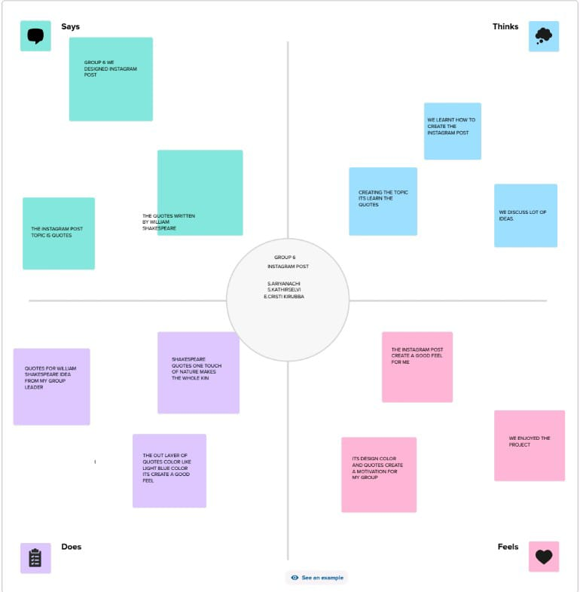

# Ideation & Brainstorming Map

# brstm.jpeg

**RESULT**



# ADVANTAGES & DISADVANTAGES Advantages

* Canva is very simple to use and user friendly
* Canva provides social media templates
* Canva offers a professional look
* Team access
* As well as million of image

# Disadvandage

* The free version is limited
* Unique elements cannot be created
* limited export setting s
* Alignment concerns
* Unable to move one design to another design

# APPLICATIONS

* We create a canva account
* Choose our design type
* And we used business card template
* we uploaded our backround image
* we used uploading photos, and adding text, and used to editing elements ,and change fonts
* Added to the women icon , flower design of corner.
* we created to business card
* Finally we downloaded a design

# CONCLUSION

People in our team worked together to make a business card on the topic " Designing professional business card " through this , a company's advertisement can be brought to the door of the card . canva is an essential tool for most business .It is easy to use offers a wide range of templates, its affordable, customizable and helps business with their branding. Graphic designing can be learned through this project.