https://github.com/472950043/JYBdeJKXY

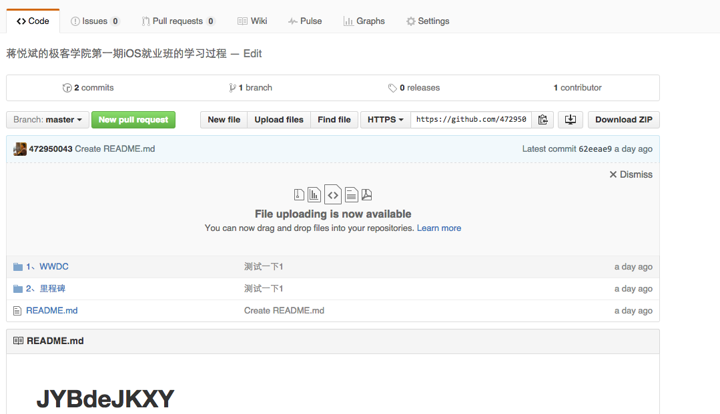

http://www.cocoachina.com/bbs/u.php?tid=155383

