LSU规格说明书

- Composition/构成
- Optical system/光学系统
- fθ lenses 2, Collimating lenses, Polygonal mirror, Cylindrical lenses
- Laser diode and LD driving circuit, Horizontal synchronizing circuit
- Scanning motor, Motor driving circuit

- 使用条件规范：
- 装置摆放：Horizontal 0±10 °

- 操作温度：0 ~ +60 ℃

- 操作湿度：20% ~ 85% RH

- 储存温度：-20℃～+60 ℃

- 储存湿度：20% ~ 85% RH

- Dust Proof/防尘：There are some clearance between LD/BD Circuit Board, motor connector, cover glass, top cover and LSU Housing. So please confirm the dust proof performance on your set condition.

- Optical System/光学系统
- Line length/有效走步距离：297 mm
- Focal length/对焦距离：246 mm
- Fθcharacteristic/ｆθ特性：y=246θ, Δy=±0.9%

- Scanning Motor/扫描马达
- Motor Type/型式：Brush less PLL controlled/DC无刷马达
- Direction of motor rotation/回转方向：CW
- Number of facet/镜面数量：6
- Motor speed：21259.84 rpm ±0.1%
- Motor starting time without jitter stable time (≦ about 0.5sec)
- Starting Current/启动电流：≦2.0 A
- Rated Load Current/定格负荷电流：≦0.6 A

- Laser Diode/激光二极管
- Spot wavelength/点波长：775 ~ 800 nm (at +25℃)
- Spot power：Less Than 0.5mW±10％
- Spot power variation：≦20% Calculated by:(1-Minimum/Maximum)×100[%]
- Spot Power Difference between LD1 and LD2：≦10%
- Distance Between Beams at Image Plane：Scan Direction(290μm)
Process Direction 42.3μm ± (10μｍ)
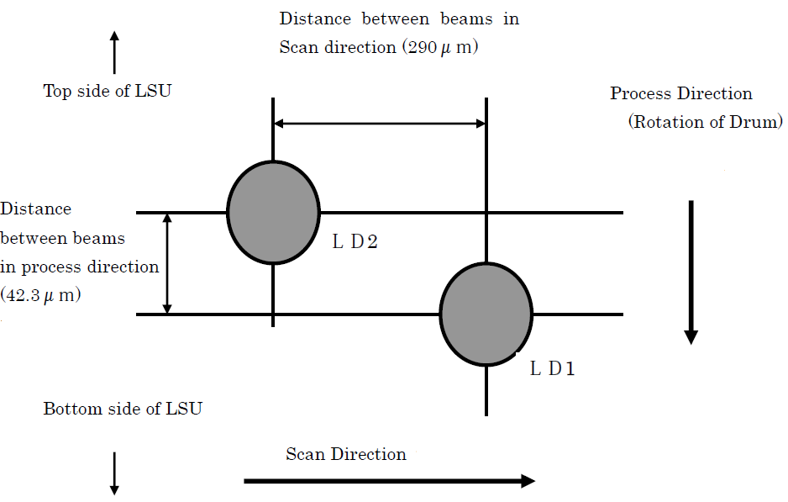

- Scanning constant
- Time for 1 scan：470.37 μsec
- Dot number for 1 scan：12170.58 dot
- Time for 1 dot：38.65 ns
- Scan length for 1 scan：515.221 mm

- Power supply/额定电压
- Scanning Motor/扫描仪马达：+24±2.4V
- Laser diode driving and horizontal synchronizing circuit：+5±0.25V

- Scanning position
- Usable line length：297±1.0 mm
- Start of scan position error：±0.5 mm
- Scan location error in the process direction：±1.0 mm
- Skew of the scan line：±0.5 mm
- Scan bow：±0.5 mm

- Spot size (at 13.5% of the peak intensity)：
- Spot size (scan direction)：75±20 μｍ（13.5％）
- Spot size variation (scan direction)：≦20μm
- Spot size (process direction)：80 ± 20 μｍ（13.5％）
- Spot size variation (process direction)：≦20μm

- Jitter
- Process jitter (between adjacent scans)：≦6μm
- Process jitter (over any 6 adjacent scans)：≦12μm
- Scan jitter (high frequency)：≦0.015 %
- Scan jitter (low frequency)：≦0.026 %

- Scanning Motor Life/马达寿命
- Continuous operation/连续操作：≧3,000 h
- Intermittent operation/间断操作：≧30,0000 cycles (On 10sec/Off 15sec)

- LD driving circuit/LD驱动电路
- Power supply voltage/使用电压：+5V±5% (Ripple;≦50mVp-p)
- Power requirements/消耗电流：≦400mA

- Horizontal synchronizing circuit(BD)/水平同步电路
- Power supply voltage/使用电压：+5V±5% (Ripple;≦50mVp-p)
- Power requirements/消耗电流：≦ 30mA

- Pin Assignment：
- Scanning Motor
Pin No. | Signal | I/O
1 | CLOCK | I
2 | /READY | O
3 | /START | I
4 | GND | -
5 | 24V | -

- LD driving circuit
Pin No. | Signal | I/O
1 | /APC1 | I
2 | /ENABLE | I
3 | /APC2 | I
4 | GND | -
5 | VIDEO1+ | I
6 | VIDEO2+ | I
7 | VIDEO1- | I
8 | VIDEO2- | I
9 | VCONT1 | I
10 | VCONT2 | I
11 | 5V | -
12 | GND | -
13 | 5V | -
14 | GND | -

- Horizontal synchronizing circuit
Pin NO. | Signal | I/O
1 | /HSYNC | O
2 | GND | I
3 | 5V | -
4 | GND | -

- 储存环境：
- 储存温度:-20 ~ 60摄氏度
- 储存湿度:20% ~ 85% 相对湿度
- 保装需完善，避免外力碰撞到此组件
- 避免灰尘渗入，以免污染关键组件

- 包装及运输：
请参考机台包装需求

- 外观尺寸图：
