**VirtIO-GPU**

**变更记录**

|  |  |  |  |
| --- | --- | --- | --- |
| 版本 | 修改者 | 日期 | 描述 |
| V0.1 |  |  |  |
|  |  |  |  |

**相关背景**

[VirtIO GPU](https://xiaomi.f.mioffice.cn/wiki/wikk4bBlbuYmGg9HLD9k1eTuvfh)

**在QEMU上的使用**

**环境搭建**

[Vela平台QEMU应用说明](https://xiaomi.f.mioffice.cn/wiki/wikk4PUNSbb7UabbJccuMQWwjcd)

**使用说明**

**编译**

|  |
| --- |
| Shell #编译armv8a版本 ./build.sh vendor/qemu/boards/vela/configs/qemu-arm64-v8a-ap -j8 #编译armv7a版本 ./build.sh vendor/qemu/boards/vela/configs/qemu-armeabi-v7a-ap -j8 |

**关键Kconfig配置项**

|  |
| --- |
| Makefile CONFIG_DRIVERS_VIRTIO_GPU=y #使能Virtio GPU相关驱动 CONFIG_VIDEO_FB=y #使能framebuffer设备驱动 CONFIG_DRIVERS_VIDEO=y #被CONFIG_VIDEO_FB所依赖 #以下为可选项 CONFIG_EXAMPLES_FB=y #使能fb测试程序 CONFIG_EXAMPLES_LVGLDEMO=y #使能LVGL测试程序，需要开启LVGL相关配置，详见goldfish-arm64-v8a/defconfig |

**qemu启动参数**

-device virtio-gpu-device,xres=width,yres=height,bus=virtio-mmio-bus.N

其中width、height为该显示设备对应的宽、高，N为未被占用的MMIO总线设备号，目前Vela上最多支持4个MMIO设备(N=0..3)。启动后可以在/dev下看到fbX节点，可以用fb /dev/fbX命令进行测试。lvgldemo默认使用/dev/fb0，可以通过menuconfig修改CONFIG_LV_FBDEV_INTERFACE_DEFAULT_DEVICEPATH在编译时指定使用的fb设备。

以armv8a版本为例（armv7a使用qemu-system-arm）:

|  |
| --- |
| Shell qemu-system-aarch64 -cpu cortex-a53 \  -machine virt,virtualization=on,gic-version=3 \  -chardev stdio,id=con,mux=on -serial chardev:con \  -global virtio-mmio.force-legacy=false \  -netdev user,id=u1,hostfwd=tcp:127.0.0.1:10023-10.0.2.15:23,hostfwd=tcp:127.0.0.1:15001-10.0.2.15:5001 \  -device virtio-net-device,netdev=u1,bus=virtio-mmio-bus.0 \  -device virtio-gpu-device,xres=1280,yres=720,bus=virtio-mmio-bus.1 \  -device virtio-gpu-device,xres=480,yres=480,bus=virtio-mmio-bus.2 \  -device virtio-gpu-device,xres=360,yres=280,bus=virtio-mmio-bus.3 \  -mon chardev=con,mode=readline \  -kernel ./nuttx/nuttx [42949668.120000] [ 4] [ INFO] [ap] NuttX 12.0.0-vela 7056e4e3d7 Jul 4 2023 15:45:59 arm64 ap kvdbd [6:100] servicemanager [7:100] telnetd [11:100]  NuttShell (NSH) NuttX-12.0.0-vela qemu-armv8a-ap> [42949668.120000] [ 6] [ INFO] [ap] nsh_child: BG kvdbd nsh: kvdbd: command not found [42949668.130000] [ 6] [ INFO] [ap] nsh_child: BG kvdbd complete  qemu-armv8a-ap> ls /dev /dev:  binder  console  fb0  fb1  fb2  log  null  ram0  telnet  ttyS0  zero qemu-armv8a-ap> fb /dev/fb1 VideoInfo:  fmt: 13  xres: 480  yres: 480  nplanes: 1 PlaneInfo (plane 0):  fbmem: 0x4091a060  fblen: 921600  stride: 1920  display: 1  bpp: 32 Mapped FB: 0x4091a060  0: ( 0, 0) (480,480)  1: ( 43, 43) (394,394)  2: ( 86, 86) (308,308)  3: (129,129) (222,222)  4: (172,172) (136,136)  5: (215,215) ( 50, 50) Test finished qemu-armv8a-ap> fb /dev/fb2 VideoInfo:  fmt: 13  xres: 360  yres: 280  nplanes: 1 PlaneInfo (plane 0):  fbmem: 0x40a07060  fblen: 403200  stride: 1440  display: 2  bpp: 32 Mapped FB: 0x40a07060  0: ( 0, 0) (360,280)  1: ( 32, 25) (296,230)  2: ( 64, 50) (232,180)  3: ( 96, 75) (168,130)  4: (128,100) (104, 80)  5: (160,125) ( 40, 30) Test finished qemu-armv8a-ap> lvgldemo widgets & lvgldemo [21:100] qemu-armv8a-ap> [42949697.410000] [21] [ INFO] [ap] [LVGL] [Warn] (24.450, +10) fbdev_try_init_fbmem2: fbmem2 is incorrect (in lv_fbdev_interface.c line #457) [42949697.450000] [21] [ INFO] [ap] [LVGL] [Warn] (24.490, +40) lv_demo_widgets: LV_FONT_MONTSERRAT_24 is not enabled for the widgets demo. Using LV_FONT_DEFAULT instead. (in lv_demo_widgets.c line #112) |

以上是在fb1和fb2上使用fb测试，并在fb0上使用lvgldemo进行测试的过程，结果如下：

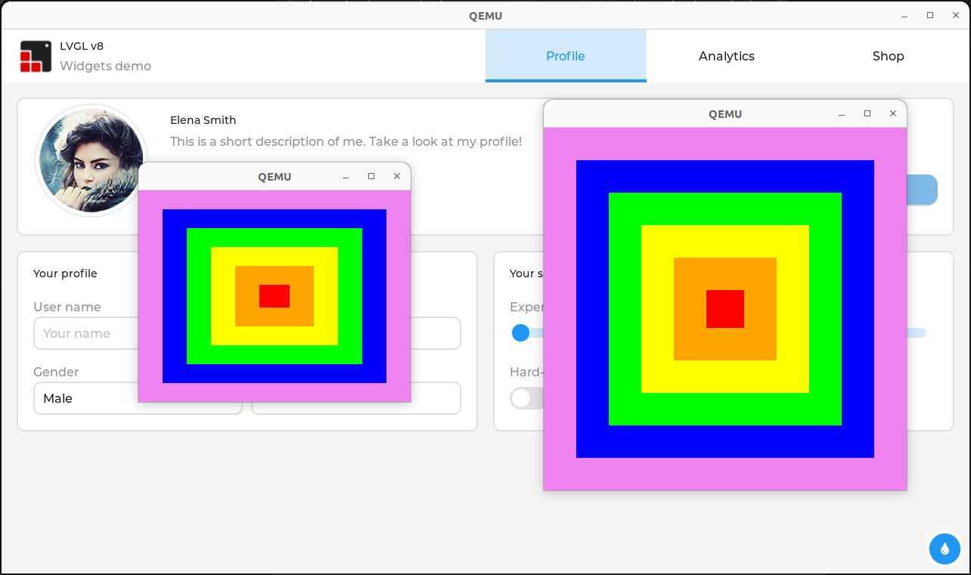

**在Goldfish上的使用**

由于Goldfish默认的VirtIO-GPU后端实现不完整，目前暂时用goldfish_fb作为替代，参考[Goldfish-FB](https://xiaomi.f.mioffice.cn/wiki/wikk4Y2VvRjxiDI1xfRqMh0juTW)。