Reliability and Safety Analysis

Year: 2022 Semester: Spring Team: 2 Project: VRm

Creation Date: March 30, 2022 Last Modified: April 1, 2022

Author: Emma Clary Email: clarye@purdue.edu

Assignment Evaluation:

| **Item** | **Score (0-5)** | **Weight** | **Points** | **Notes** |
| --- | --- | --- | --- | --- |
| **Assignment-Specific Items** | | | | |
| **Reliability Analysis** |  | x2 |  |  |
| **MTTF Tables** |  | x3 |  |  |
| **FMECA Analysis** |  | x2 |  |  |
| **Schematic of Functional Blocks (Appendix A)** |  | x2 |  |  |
| **FMECA Worksheet (Appendix B)** |  | x3 |  |  |
| **Writing-Specific Items** | | | | |
| **Spelling and Grammar** |  | x2 |  |  |
| **Formatting and Citations** |  | x1 |  |  |
| **Figures and Graphs** |  | x2 |  |  |
| **Technical Writing Style** |  | x3 |  |  |
| **Total Score** |  | | |  |

5: Excellent 4: Good 3: Acceptable 2: Poor 1: Very Poor 0: Not attempted

Comments:

1. Reliability Analysis

Components in this design selected to be most likely to fail are the R-78E3.3-0.5 DC to DC converter, STM32F091 Microcontroller, FMMTA06TA BJT, and the 16 bus Servo Driver. The R-78E3.3-0.5 DC to DC converter was selected because it runs hot and must be able to switch very rapidly to produce the 3.3V power supply with a 7.5 V input. The BJT was selected since transistors are known to age and wear out. The microcontroller was selected since it is a high complexity component and should be considered in such an analysis.

**STM32F091:**

I used the model of digital CMOS IC microprocessor model for this microcontroller. 𝝀𝑷 = (C1 · πt + C2· πe) · πl · πq [1]. The MTTF and 𝝀𝑷 are in the expected range. A failure of this microcontroller would not directly cause harm to the users.

| Parameter name | Description | Value | *Comments* |
| --- | --- | --- | --- |
| C1 | Die complexity | 0.56 | *32-bit CMOS* |
| πT | Temperature factor | 0.98 | CMOS, Tj = 25 C |
| C2 | Package failure rate | 0.0398 | 52-pin |
| πE | Environmental factor | 5.0 | Gm |
| πQ | Quality Factor | 2.0 | Class B-1 |
| πl | Learning factor | 1.0 | >= 2years |
|  |  |  |  |
| Entire design: |  |  |  |
| λp |  | 1.1374 |  |
| MTTF |  | 0.879 |  |

**FMMTA06TA BJT:**

I used the model of digital CMOS IC microprocessor model for this microcontroller. 𝝀p = πb*πt*πr*πs* πq*πe [1]. The MTTF and 𝝀𝑷 are in the expected range. A failure of this component would not directly cause harm to the users.

| Parameter name | Description | Value | *Comments regarding choice of parameter value, especially if you had to make assumptions.* |
| --- | --- | --- | --- |
| λb | Base Rate Failure | 0.18 | *Bipolar* |
| πT | Temperature Factor | 0.98 | Tj = 25 C |
| πr | Power Rating Factor | 0.55 | Pr = 0.2W |
| πQ | Quality Factor | 5.0 | Lower |
| πE | Environmental Factor | 5.0 | Gm |
| πs | Voltage Stress Factor | 1.0 | Vs = VCE/VCEO = 1 |
| Entire design: |  |  |  |
| λp |  | 2.4255 |  |
| MTTF |  | 0.412 |  |

**Switching Regulator:**

The failure per 10^6 hours is calculated by 𝝀p = πb*πt*πs*πc* πq*πe [1]. The model of Voltage regulator is used. The MTTF and 𝜆𝑃 is in the expected range. A failure of this regulator would not directly cause harm to the users.

| Parameter name | Description | Value | *Comments regarding choice of parameter value, especially if you had to make assumptions.* |
| --- | --- | --- | --- |
| λb | Base Rate Failure | 0.002 | Voltage Regulator |
| πT | Temperature Factor | 0.98 | Tj = 25 C |
| πs | Stress Factor | 1.0 | Vs = 1.0 |
| πc | Contact Construction | 1.0 | Metallurgically bonded |
| πe | Environmental Factor | 2.0 | Gm |
| πq | Quality Factor | 8.0 | plastic |
| Entire design: |  |  |  |
| λp |  | 0.0316 |  |
| MTTF |  | 31.88776 |  |

1. Failure Mode, Effects, and Criticality Analysis (FMECA)

I labeled the following failure modes as low, medium, and high to indicate the level of severity of each failure. Low means that the system will shut down but the user is not harmed in any way. Medium means that there is a small probability of injury to the user. High means that the user could be severely injured by fire or toxic gas. As for observing these issues, it is mostly listed as “observation” since the failure will be blantant when the system is shut down or continually resetting. All it would take to notice all of these is a quick check of the robot arms position or the buzzer indicator on the board.

3.0 Sources Cited:

[1] “Military Handbook Reliability Prediction of Electronic Equipment” Department of Defense. Washington DC. MIL-HDBK-217F, Dec. 2, 1991.

Appendix A: Schematic Functional Blocks

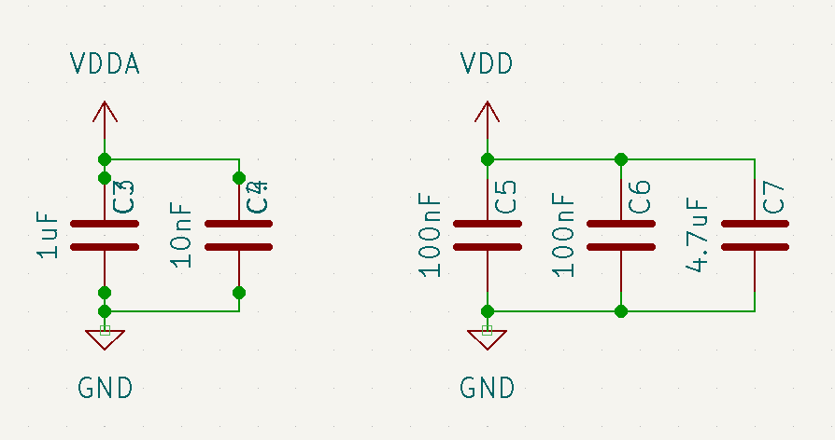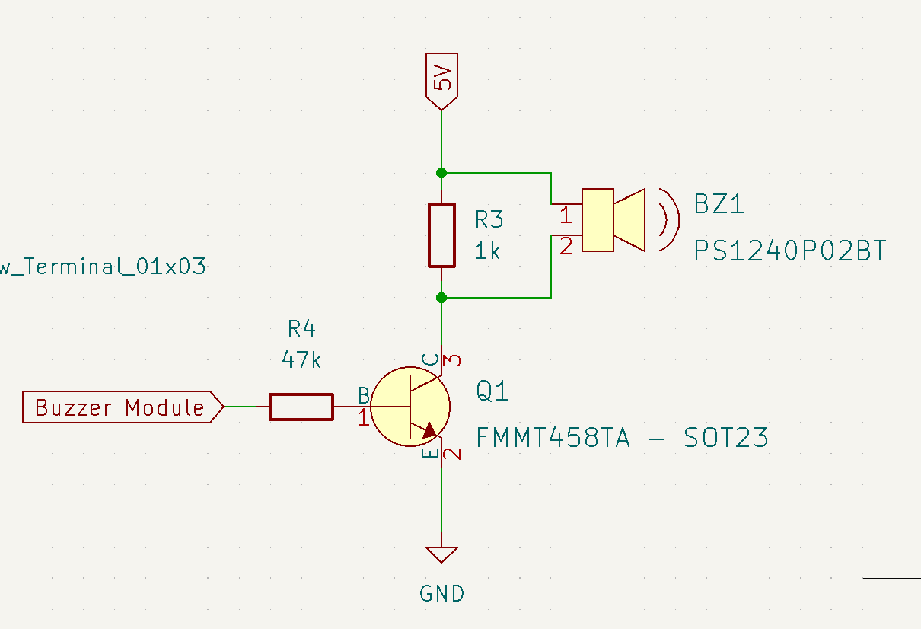

Figure 1 Figure 2

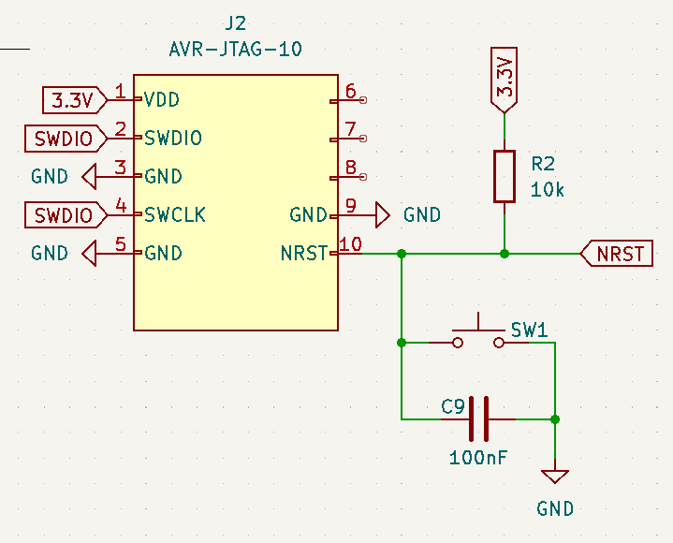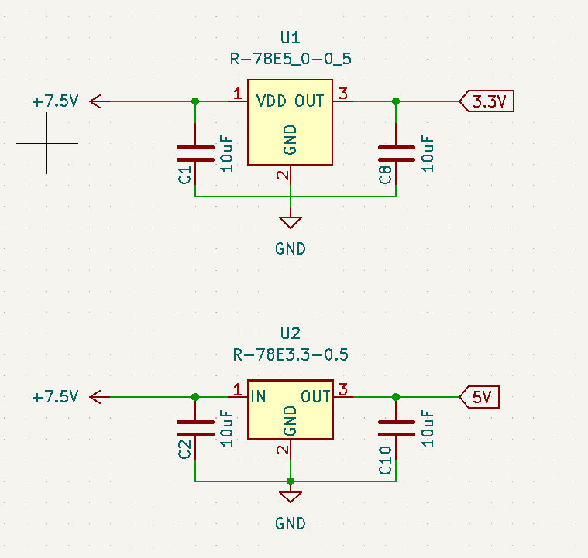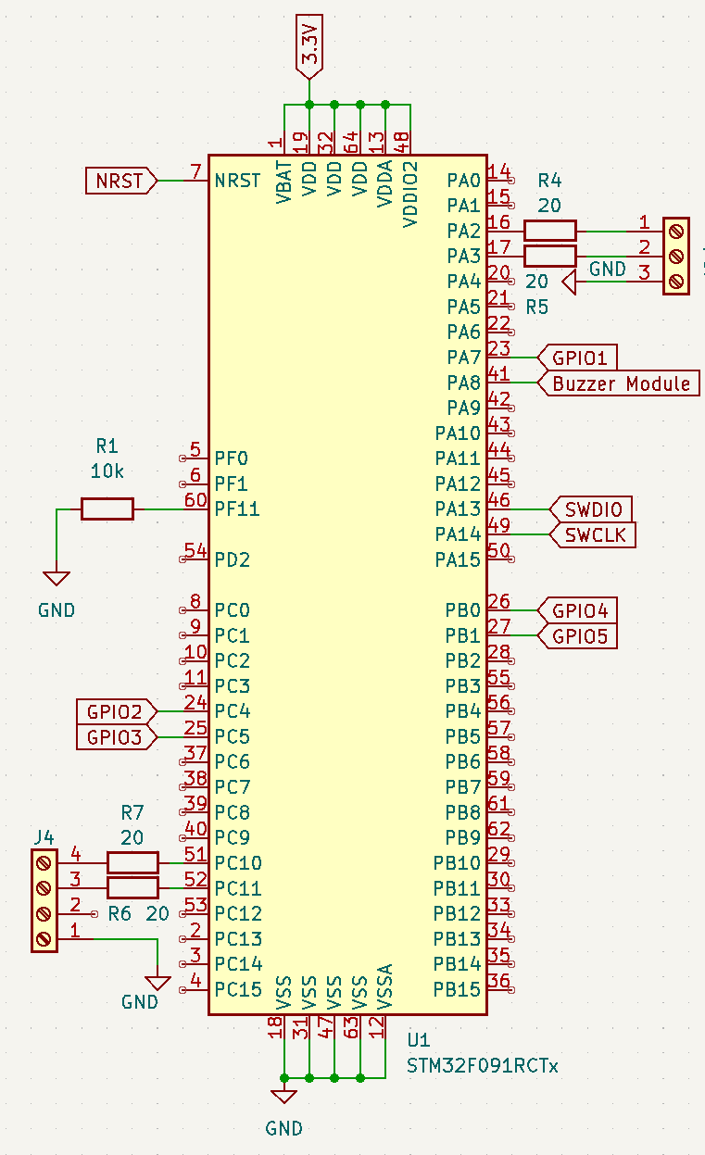

Figure 3 Figure 4 Figure 5

Appendix B: FMECA Worksheet

| **Failure No.** | **Failure Mode** | **Possible Causes** | **Failure Effects** | **Method of Detection** | **Criticality** | **Remarks** |
| --- | --- | --- | --- | --- | --- | --- |
| 1 | Voltage regulator falls short | Overheat, damage to IC | Damage of all IC and micro | Observation | Med |  |
| 2 | Voltage Drop | capacitor failure | Error in computations | Observe Robot angles | Low |  |
| 3 | Voltage regulator output too high | Damaged IC | Damage all IC and micro | Observe (smoke) | Low |  |
| 4 | Buzzer output not audible | Input voltage incorrect, BJT issues | User is unaware that server discon. | Observation | Low |  |
| 5 | Reset Signal is always high | Damaged pushbutton | Can’t restart the system | Observation | Low |  |
| 6 | Reset signal is always low | Shorted capacitor | System keeps resetting | Observation | Low |  |
| 7 | Can’t receive data from the program header | Damaged cable or RJ11 connector | Can’t program the micro | Observation | Med |  |
| 8 | The micro stops executing instructions | Software, resistor issues, input voltage incorrect | Entire system is frozen | Observation | Low |  |