Ethical and Environmental Analysis

Year: 2022 Semester: Spring Team: 2 Project: Vrms

Creation Date: April 6, 2022 Last Modified: April 8, 2022

Author: Matthew Wen Email: wen101@purdue.edu

Assignment Evaluation:

| **Item** | **Score (0-5)** | **Weight** | **Points** | **Notes** |
| --- | --- | --- | --- | --- |
| **Assignment-Specific Items** | | | | |
| **Environmental Impact** |  | x6 |  |  |
| **Ethical Challenges** |  | x6 |  |  |
| **Writing-Specific Items** | | | | |
| **Spelling and Grammar** |  | x2 |  |  |
| **Formatting and Citations** |  | x1 |  |  |
| **Figures and Graphs** |  | x2 |  |  |
| **Technical Writing Style** |  | x3 |  |  |
| **Total Score** |  | | |  |

5: Excellent 4: Good 3: Acceptable 2: Poor 1: Very Poor 0: Not attempted

Comments:

*Comments from the grader will be inserted here.*

1. Environmental Impact Analysis

Manufacturer:

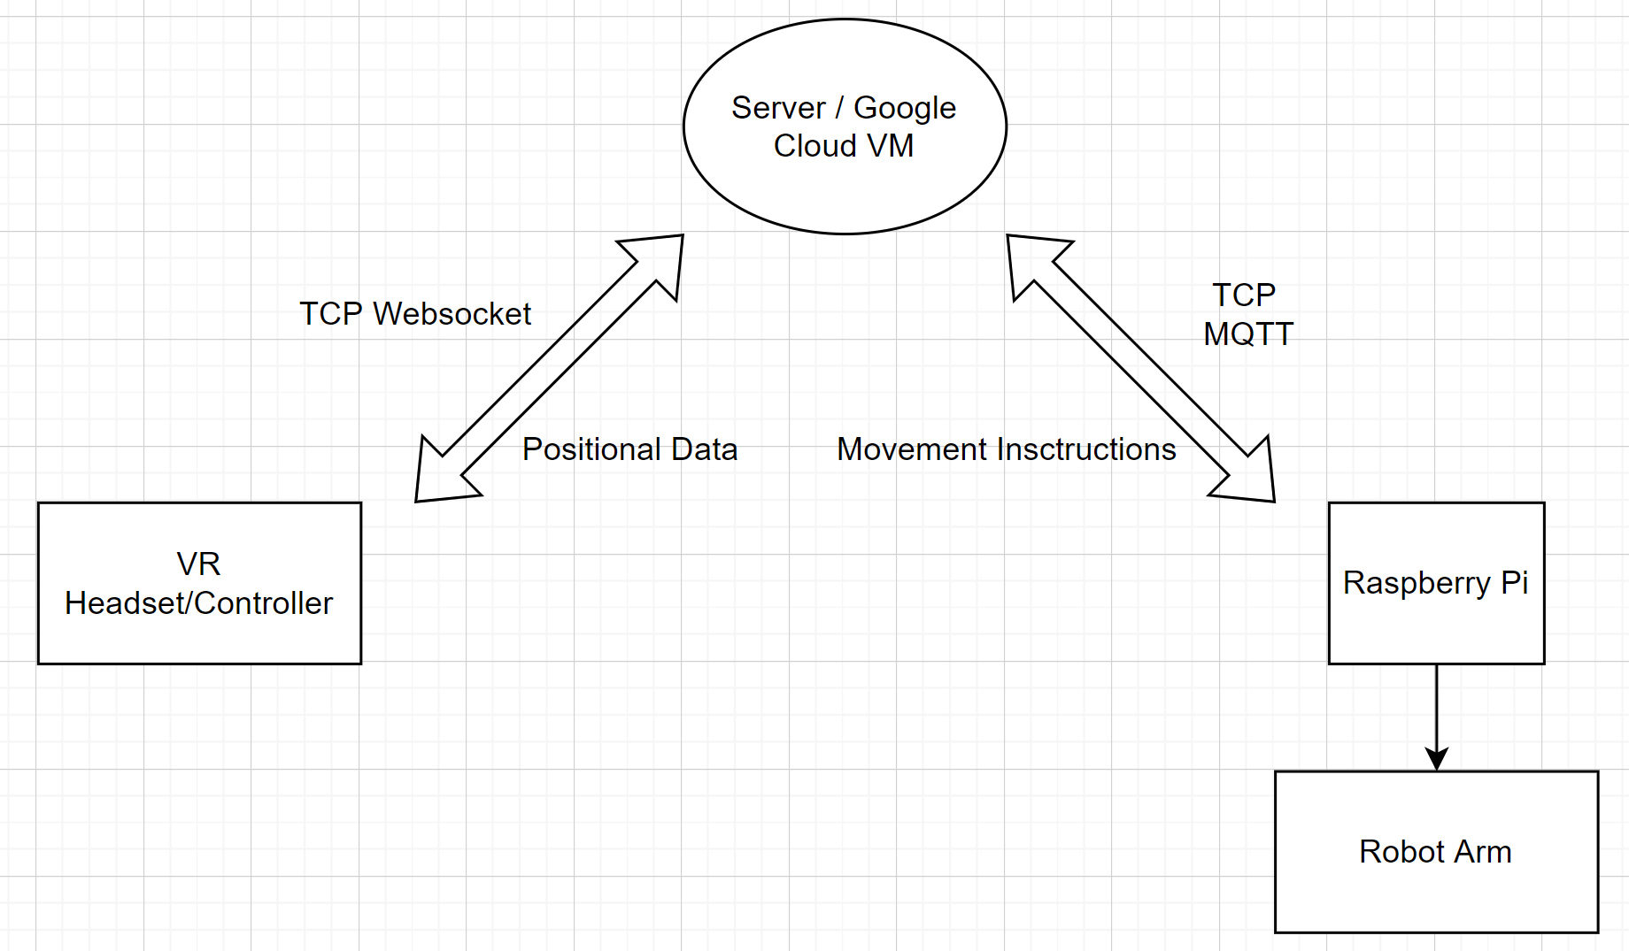

Here is a simple figure that shows the three major components to worry about. The VR headset, the server, and the robotic arm and raspberry pi itself.

We have three major components for our product. The first component is the device to control the robotic arm from the user end. Second is the server to connect the device connected to use to the robotic arm and back. The third component is our product, the robotic arm. This will become the main focus when talking about the environmental impact of our prototype because it contains the Printed Circuit Board (PCB) made by the team, the computer (in this case the raspberry pi) that connects to the server and the virtual reality headset, and the arm.

An issue with our component is that there are three major parts, and there are a lot of moving components. We are worried if the manufacturer would have to create that device for the user to control the robotic arm. In addition, does the manufacturer have to worry about that device working, in other words, being able to get streaming data, in addition to being able to control the robotic arm.

In addition to the server, there is a lot of money that you would have to invest to be able to scale and produce servers that interact with both products. The servers have to be able to take TCP packets for the robotic arm data. In addition, it has to be able to obtain UDP packets for streaming video. According to Amazon Web Servers[1], the cost for the manufacturer to be able to obtain servers just to obtain parts to run these servers can get very expensive, especially that means swapping hardware parts when they lose performance. This is a large demand from the manufacturing end.

One of the manufactures main goals for us is to create our PCB. For this project, we are only using one PCB board. However, developing a PCB board does have a negative impact on the environment in terms of causing more waste water [2]. In addition to getting the PCB, being able to solder all the components, and then the components' environmental impact. These are things we have to consider when producing our product.

* Normal Use

For normal use of the device using the robotic arm, the most important thing that came to our mind is what would happen if something goes wrong with that device? Does that require us to take the product back, repair it and try to link it up again to your devices, and send it back? This is an issue we thought about when trying to narrow down what to focus on the most for our project.

For the server, we were mostly concerned about using an on-premise solution. Because if we use an on-premise solution, it would be hard for a group of four members to retain if something goes wrong with the server. In addition, if the server goes down, then all components of the project fail.

For the robotic arm, the most important thing about environmental use is the amount of power our robotic arm is going to use. We decided to not use a battery because we want to make the most out of the arm's ability to move, in addition to the computing power to connect to a wifi network and being able to control and stream video through it. We thought as a team that being able to connect to wifi and being able to stream more data is an important factor of our project because the end goal of the project is to be able to control the robotic arm from afar, not up close. As a result, using a resource like BLE, which uses less power, would be nice in a sense that it would use less power. However, it would render the product useless if the person is already right next to the arm, and can just use their normal arm to do the task.

* Disposal / Recycling

For normal use of the device using the robotic arm, the most important thing that came to our mind is how applicable that hardware device to other products. In other words, can it be used for something else, or recyclable. In this sense, if it breaks or the product is rendered useless, what happens to that device that controls the robotic arm?

For the server, we can dispose of the server and potentially use it for another project, or sell the server components back. However, this would require changing the entire computer, or just leave a computer / server hanging with nothing to do. It is not a good idea to throw out a ton of servers once the project becomes not useful anymore.

Lastly, for the robotic arm. If one were to dispose of the robotic arm if it runs into an accident, we have to make sure that all the components are being recycled correctly, and none of the metal or computer products go to waste.

* How We Address the Problem

We tackled the issue with the device used to control the robotic arm by using a Virtual Reality Headset. The reason why the team decided to use a well known Virtual Reality headset manufacturer instead of an in-house version to control the arms is that if we build a custom control for our project, it will only serve as a device that allows the team to control the robotic arm. Using a Virtual Headset from Meta builds an extension to an already defined community. As a result, if the customer has no use of our project, the virtual reality headset can be used for a different purpose; it doesn't need to be scrapped and destroyed. The main issue with this situation is that we have to be able to keep up with Meta's continuous software updates. As a result, we used unity to make sure that unity compilation will be able to make our software automatically compatible with each new software update from Meta, in addition to new Virtual Reality Headsets.

For the server, we made sure that the software is portable, and that if we do not need a server anymore, it is as simple as clicking a button from Google saying to destroy our Virtual Machine. What is really nice about using a third party provider like Google Cloud is that they will reuse that virtual machine for somebody else's project. In addition to being able to destroy and stop the program on the server, it is just as easy as to start the software. We used docker images that stores the version of all the packages that we use now, so it would be easy to spin up another computer without the need to obtain the other computer. Just if that one computer contained the only working code, we do not need to resort to that computer because docker images help us retain previous working code.

As for the arm, we made minimal connections between all components of our project. The reason why we did this was the less hardware it needed, the better for the environment.

1. Ethical Challenges
   * Ethical Challenges We Faced

When we are talking about using a robotic arm remotely, it is important to know that the arm is not being abused, and is being used as expected. As a result, we applied safety measures to the product. For example, while testing the product, there were many instances where there is a motor lock where it is being programmed to an arm placement that is not possible. In addition, we do not want the arm to be used too rigorously where it is being moved too fast. Lastly, we don't want the arm to perform an action that will cause it to self-destruct.

* + Fixing Ethical Challenges

We perform safety measures to ensure nothing like this happens. If for example the arm is requested to perform fast movement, then it would just perform them slowly; we set a speed limit to how fast the motors can move, as a result, it will work like it is lagging even though it is not lagging. We will also indicate on the Virtual Reality Headset that the movement is too fast.

In addition, we also noticed that and was recommended to us that if there is a failure, there is no need for the arm to move back to its original position. The best thing for the arm to do is just sit there and not move. However, it is still a good indication that a failure has happened if there is someone around the arm; at a certain distance away of course. As a result, we placed a beeping sound on our device. According to Tesla, this is what happens when they are able to detect people sleeping as they were using their autopilot, it will make a beeping sound indicating to either wake up, or it will shut the car down. According to Tesla again, they thought it would be better if the car did not move than to continue driving. That is the ideology we used for our project [3]. This device will indicate if it lost connection to the hardware device, or just fail in general. As a result, if someone hears that button, it means that the arm will become deactivated and that it needs to be pulled out of whatever it is doing at that moment.

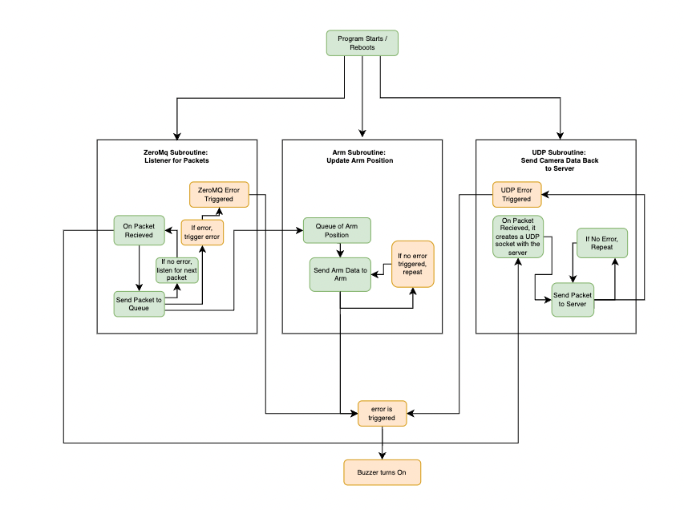

This figure right here is the pipeline on how that buzzer gets activated. If there is a failure at any of the yellow components, it will cause a buzzer to occur. There will also be errors if it is not getting any movement data because the arm has to be somewhat moving, and not just idling.

3.0 Sources Cited

[1] Engdahl, Sylvia. “Blogs.” *Amazon*, Greenhaven Press/Gale, 2008, https://aws.amazon.com/blogs/storage/comparing-your-on-premises-storage-patterns-with-aws-storage-services/.

[2] Gerić M;Gajski G;Oreščanin V;Domijan AM;Kollar R;Garaj-Vrhovac V; “Environmental Risk Assessment of Wastewaters from Printed Circuit Board Production: A Multibiomarker Approach Using Human Cells.” *Chemosphere*, U.S. National Library of Medicine, https://pubmed.ncbi.nlm.nih.gov/27829507/.

[3] “Autopilot and Full Self-Driving Capability.” *Tesla*, 9 Apr. 2022, https://www.tesla.com/support/autopilot.