User Manual

Year: 2022 Semester: Spring Team: 2 Project: VRm

Creation Date: April 11, 2022 Last Modified: April 14, 2022

Author: Brian Latimer Email: blatimer@purdue.edu

Assignment Evaluation:

| **Item** | **Score (0-5)** | **Weight** | **Points** | **Notes** |
| --- | --- | --- | --- | --- |
| **Assignment-Specific Items** | | | | |
| **Product Description** |  | x1 |  |  |
| **Product Illustration** |  | x2 |  |  |
| **Setup Instructions** |  | x3 |  |  |
| **Usage Instructions** |  | x3 |  |  |
| **Troubleshooting Instructions** |  | x3 |  |  |
| **Writing-Specific Items** | | | | |
| **Spelling and Grammar** |  | x2 |  |  |
| **Formatting and Citations** |  | x1 |  |  |
| **Figures and Graphs** |  | x2 |  |  |
| **Technical Writing Style** |  | x3 |  |  |
| **Total Score** |  | | |  |

5: Excellent 4: Good 3: Acceptable 2: Poor 1: Very Poor 0: Not attempted

Comments:

1. Product Description

VRm is a Virtual Reality project that allows a user to control a physical robot arm via a VR simulation. The VR user will control the movement of the robot arm by manipulating a target with the controller, and the simulated arm will try to reach that target's position and rotation. Our solution allows for greater control of the robot arm compared to similar projects due to the increased range of motion. VRm will allow users to complete tasks naturally in an environment that is unsafe and unsuitable for direct human interaction.

1. Product Illustrations

**VR controllers**

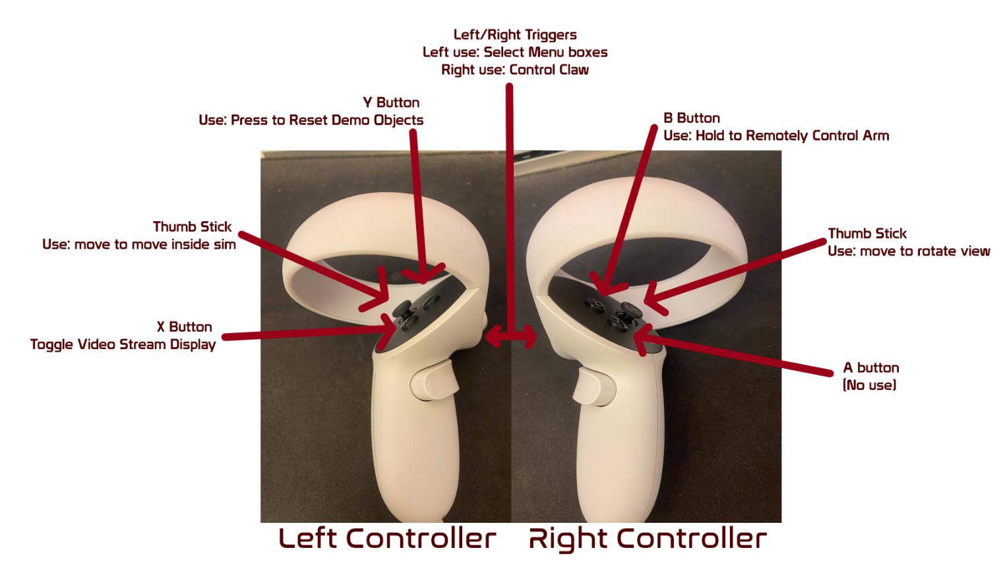

**VR Application**

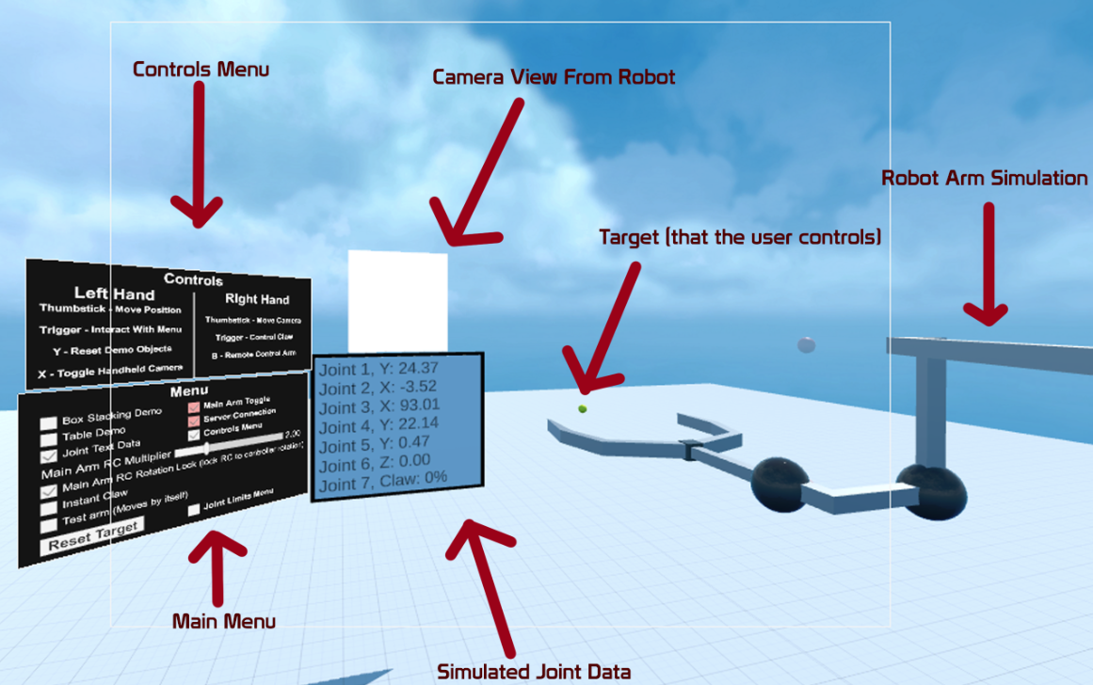

**Robotic Arm**

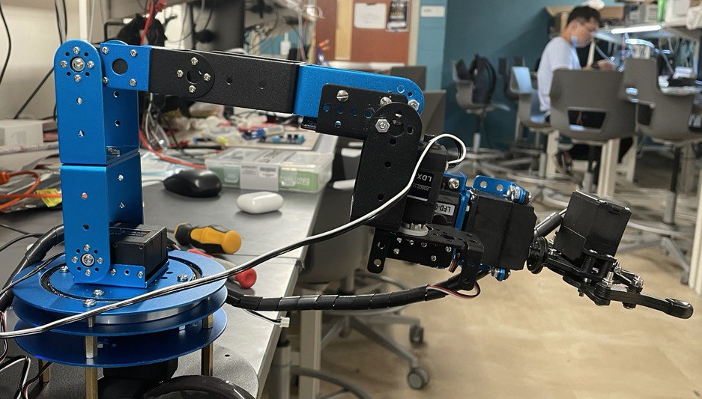

**Servo Driver**

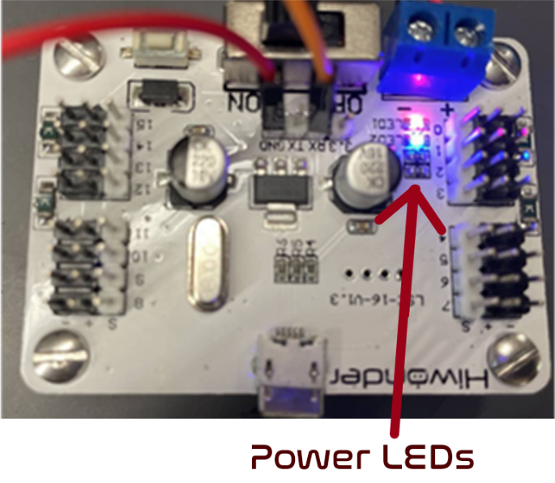

1. Setup Instructions

**Launching the Application**

1. Ensure that the VR device is connected to the internet.
2. Launch the application on the VR device.

**Turning on The Arm**

1. Ensure that the arm is plugged into a power source. (Wall outlet for example)
2. Ensure that the servo board power is on. (Blinking blue and solid red led)
3. Ensure that the Raspberry Pi is connected to the internet.
4. Usage Instructions

**Launching the application**

1. Put on a VR headset.
2. Navigate to the list of applications in the VR headset.
3. Press the VRm application to launch it.

**Using the Application**

1. After launching, the application should automatically be usable with the robotic arm.
2. To move the arm, hold the B button and the simulated arm will track your hand movements and rotation. Let go of the button to stop tracking. The claw of the arm is controlled by the Right Trigger.
3. To toggle the camera to hover above your left controller, press the X button.
4. To interact with the menus, hover the pointer (coming from the left controller) over the button you want to press, then press the Left Trigger.
5. The other controls can be found in the controls diagram either in this document or from the controls menu inside of the simulation.
6. Troubleshooting Instructions

| **Problem** | **Potential Solutions** |
| --- | --- |
| Simulation stops communicating with the robot arm. | * Did the internet stop working? Ensure the devices are still connected to the internet.. * Still not working? Close and restart simulation. * If none of the above solves the problem, please contact VRm support below. |
| Video stream from arm appears frozen in simulation | * Is the internet working? Wait for the simulation to attempt to reconnect to the video stream. * Did the internet stop working? Ensure the devices are still connected to the internet. * Still not working? Close and restart simulation. * If none of the above solves the problem, please contact VRm support below. |
| Something occurred in the simulation preventing normal use of the simulated arm | * Can this be fixed by resetting the arm’s position? Press the “Reset Target” button in the menu. * Still not working? Close and restart simulation. * If this problem is happening constantly, please contact VRm support below. |

We are sorry you are having issues with your VRm or VRm simulation program!

27/7 Customer Support: 1-234-567-8910, Support@Vrm.com.