Legal and Regulatory Analysis

Year: 2022 Semester: Spring Team: 2 Project: VRm

Creation Date: March 25, 2022 Last Modified: March 25, 2022

Author: James Donnelly Email: donnell9@purdue.edu

Assignment Evaluation:

| **Item** | **Score (0-5)** | **Weight** | **Points** | **Notes** |
| --- | --- | --- | --- | --- |
| **Assignment-Specific Items** | | | | |
| **Regulatory Analysis** |  | x3 |  |  |
| **Analysis of Patent 1** |  | x3 |  |  |
| **Analysis of Patent 2** |  | x3 |  |  |
| **Analysis of Patent 3** |  | x3 |  |  |
| **Writing-Specific Items** | | | | |
| **Spelling and Grammar** |  | x2 |  |  |
| **Formatting and Citations** |  | x1 |  |  |
| **Figures and Graphs** |  | x2 |  |  |
| **Technical Writing Style** |  | x3 |  |  |
| **Total Score** |  | | |  |

5: Excellent 4: Good 3: Acceptable 2: Poor 1: Very Poor 0: Not attempted

Comments:

*Comments from the grader will be inserted here.*

1.0 Regulatory Analysis

As we expect our product to be marketable in a number of industries, including laboratory, factory, and outdoor settings with an emphasis on remote operation, we expect that we will need to gain FCC and UL certifications. The FCC certification is necessary as the remote communication aspect of our project renders it as an unintentional radiator. The UL certification comes into play as our product may be used in the workplace, so it must follow OSHA regulations. We believe that having these certifications will be enough to justify putting our product into our intended market.

Our relevance to FCC regulations largely fall under internet use, as our wireless communications will be done through the internet. These regulations are specified in Title 47 of the Code of Federal Regulations. Chapter 1, Subchapter A, Part 8 specified rules for internet freedom.. Since internet use is something that is available to the public, the main requirement that must be followed is internet transparency. All information regarding network management practices, performance characteristics, and commercial terms of the internet access must be made available to the customer so that they can make an informed decision about what the use of the product will mean for them. This wouldn’t be an issue for us, as we can post all of our information regarding our internet use publicly on our website. The section also requires that our network use is necessary to the functionality of our product. This is currently satisfied, as we don’t use the internet for any purposes that aren’t critical to functionality. For official verification, we would need to apply online and have our product tested in an FCC recognized lab [1].

Getting a UL certification will involve many aspects of our product. Our product uses video communication through the camera and VR headset, so it must be compliant with all Audio/Video equipment safety requirements. As we are using network communications, our product must also be compliant with the ANSI/CAN/UL standards for software cybersecurity for network connectable products. Moving onto the physical aspect of our project, it must be compliant with any of the requirements involving the materials that we used. This includes standards for plastic materials, standards for wires and cables, as well as PCB, motor, and power management requirements. Meeting all of these requirements may involve upgrading our materials used as well as making some design changes. Similarly to the FCC, we will need to apply and test our product in a recognized lab [2].

2.0 Legal Liability Analysis

2.1 Analysis of Patent 1: Robot Arm by Extended Robotics

This product [3] is a robot arm that allows people to operate it in VR, much like our project. The product has many similarities to our project, like the cloud control feature, where you can control the arm via the internet. Some differences from this robot is the way you can view the world using it, where it attempts to recreate the world in VR using camera tracking, while our project would use the cameras to view the world. This product also is very slow moving. The product is in very early stages, so it doesn’t have much documentation available for us to look at, and there is no indication of any pending or issued patents on this product. We believe that our fundamentally differing methods of viewing the world in VR will be enough to avoid any issues between this product and ours. However, we do think that as this product evolves we should keep up to date on its documentation and potential patents to ensure that we don’t run into any future conflicts while designing our own product.

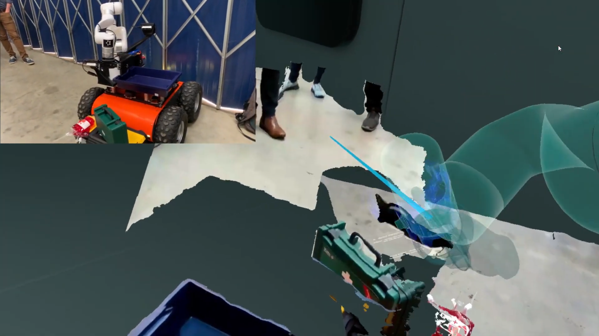

2.2 Analysis of Patent 2: myCobot Pro 6 DOF Robot Arm by Elephant Robotics

This commercial product [4] is a 6 degree of freedom arm, allowing for more control than the usual 5 DOF robot arms. Our product would be somewhat similar, but with an extra motor on the end to allow for rotation like a wrist, which this product doesn’t have. The way this arm is controlled is by using an app, where you can control it manually or create scripts to automate it. There is no way to use VR or teleoperation like our project, however. Similarly to the first product, there is no indication of pending or issued patents. Since the main features of our product are VR capabilities and remote operation, we believe our product to be unique enough to avoid any infringement issues. However, should our VR or remote operation not work causing us to fall back on a more simpler project, we would then need to ensure that there is enough unique about our project to avoid any legal issues.

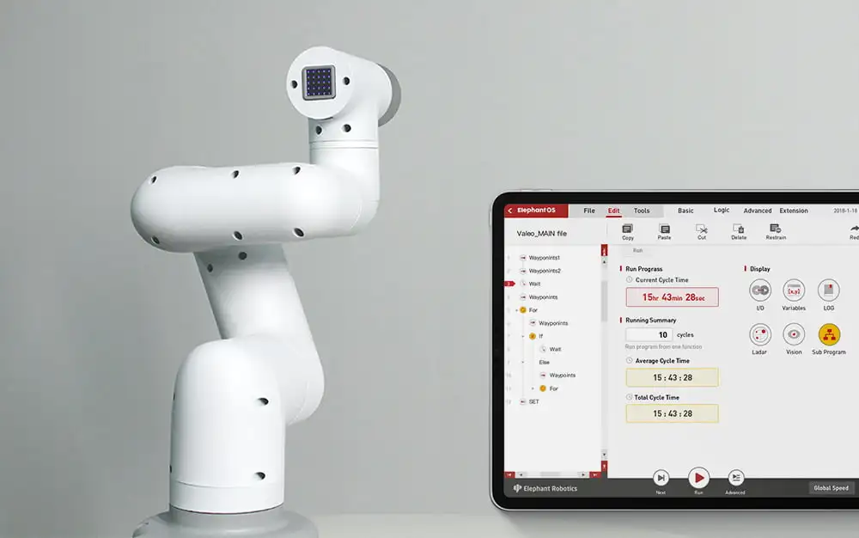

2.3 Analysis of Patent 3: Teleoperating of robots with tasks by mapping to human operator pose

Patent Number: US9579799B2

Patent Holder: Nimble Robotics Inc

Patent Filing Date: 02/16/2021

This patent [5] Allows for human control of a robot based on cameras that track the human. They track the human using cameras to recreate a skeleton in software, to then track the arm. This patent would use kinematics to then be able to translate the skeleton to robot arm positions. The main difference from this patent to our product is the method of tracking the arm. Our solution is by using a VR controller in Unity to move/rotate a target for the robot arm to follow, while this patent uses cameras. Due to this critical difference, we do not believe there is a concern for infringement. However, should we choose to change our design in the future to utilize camera tracking, this would be something that we would need to be aware of.

3.0 Sources Cited:

[1] “Title 47 of the CFR.” *Code of Federal Regulations*, 2022, <https://www.ecfr.gov/current/title-47>

[2] “UL.” *Underwriters Laboratories*, 2022, <https://www.ul.com/>

[3] “Robotic Teleoperation: Robotic Arm Software: United Kingdom.” *Extend Robotics*, 2019, <https://www.extendrobotics.com/>.

[4] “MyCobot Pro Black- 1kg Payload Commercial 6DOF Collaborative Robot Arm.” Oz Robotics, 2020, <https://ozrobotics.com/shop/mycobot-pro-1kg-payload-commercial-6dof-collaborative-robot-arm>

[5] “US10919152B1 - Teleoperating of Robots with Tasks by Mapping to Human Operator Pose.” *Google Patents*, Google, 2018, <https://patents.google.com/patent/US10919152B1/en>.