**Checking whether I can access the web server through my browser:**

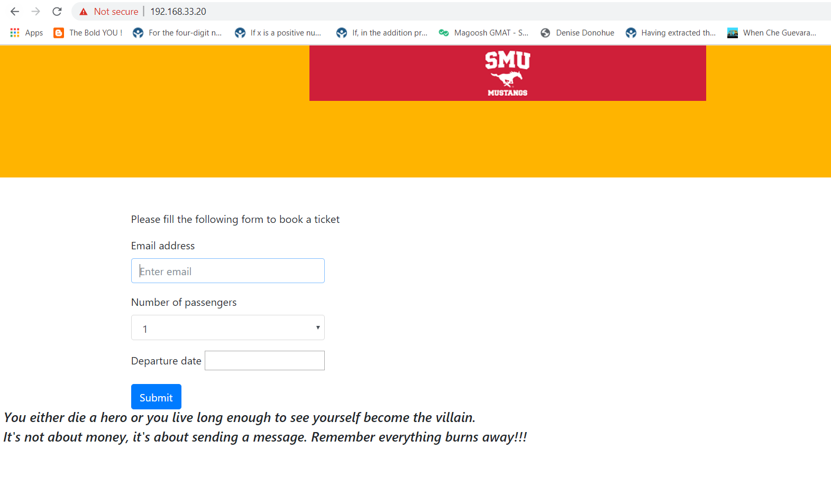

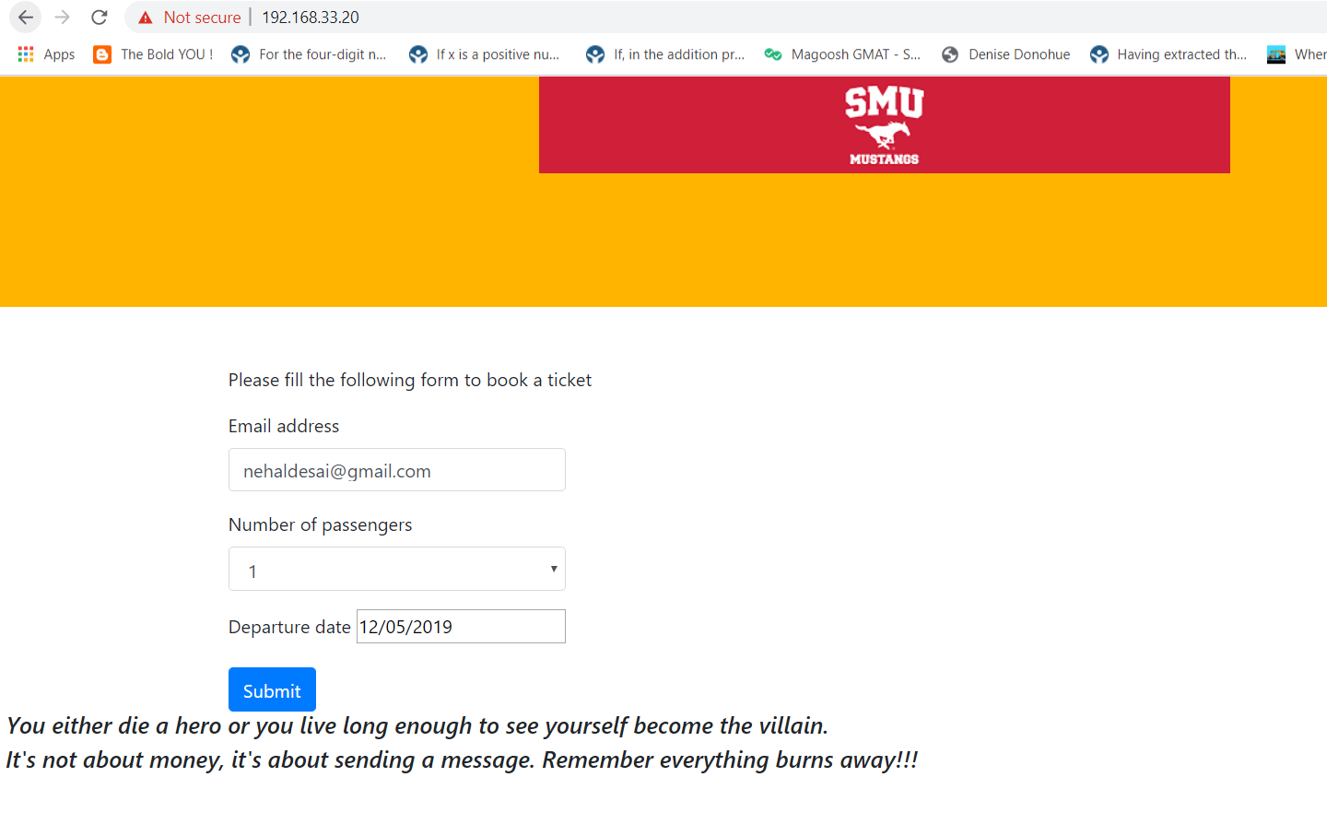

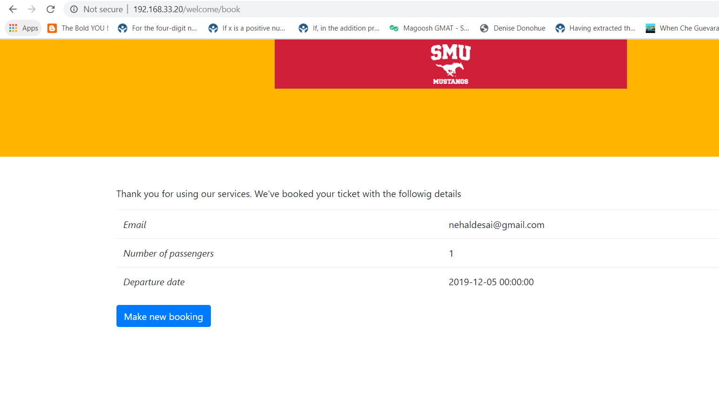

**Questionnaire**

1. **What did you do in this lab?**
2. First, I created a vagrant file to create three virtual machines on my host. Then, I made one virtual machine as ansible controller and second one as ansible web server and last one as database server. The main objective is to create a web server on one node and data base server on another one from ansible controller machine itself with the help of playbooks. The task of webserver is to take details from the users to book airline reservation and store it in database.
3. **What problems did you encounter?**
4. the problem that I encountered in this lab is that I was not able to ssh into the webserver and database server from the ansible control machine. I tried it so many times, but it took a while for me to access ssh into both webserver and database server from the ansible control machine.
5. **How did you solve this problem?**
6. The reason I was not able to ssh into ansible nodes is that I copied the wrong key into the ansible nodes from ansible controller. I used ssh copy-id command to rectify the problem which I got.
7. **What aspects of the lab were unclear?**
8. I am still finding little bit difficult why we use ansible roles if we have ansible playbooks and then I didn’t understand how to write ansible playbooks to do some particular tasks on the ansible nodes.