COSC2753 Assignment 2

Task 4 Fashion Visual Search Brief
  - A concise research and implementation guide for the four-member team

Recommended direction
Treat Task 4 as an image retrieval problem. The leading final candidate is a compact Siamese CNN trained from scratch with triplet loss to produce 128-dimensional normalized embeddings. Compare it against raw pixels, PCA, an autoencoder and the Task 1 CNN embedding before declaring an ultimate judgement.
Why this choice matters. Classification models learn class boundaries. Visual search must learn a distance: visually related products should be close, and confusing products should be separated. Triplet loss trains that distance directly [2][3].
Critical limit. If two products have identical pixels at the supplied resolution, an image-only model cannot know that their product IDs, materials or seasons differ. The system should group duplicates, use available metadata for re-ranking, or return a tie. Claiming that a more complex CNN can always separate identical inputs would be incorrect.

Team decisions required before coding
1. Resolve the current repository mismatch: main no longer contains src, although the README and task branches still import it.
2. Confirm Task 3's real final model. The team description says MLP, while the inspected Task 3 branch currently contains CNN, Logistic Regression and Random Forest work.
3. Freeze one duplicate-aware train, gallery and query split for Task 4 before comparing methods.
4. Agree that the Siamese model is a candidate until retrieval metrics and qualitative Top K grids support the final judgement.

1 Assignment requirements before Task 4
The assignment asks for an end-to-end Fashion Intelligence System with three classification tasks and one advanced visual search task. The brief below converts the marking language into checks the team can act on. This internal document is not the final report; the submitted report remains limited to five pages plus two appendix pages [1].
Requirement | What the team must show | Task 4 evidence
At least four final models | One model for each task; each task must submit a different model. | A separately trained Task 4 encoder and search artifacts.
Train your own algorithms | The final model cannot rely on weights trained on outside data. | Train the compact encoder from scratch. A pretrained model may appear only as a comparison.
Investigate alternatives | Compare methods rather than report one score. | Raw pixels, PCA, autoencoder, Task 1 features and triplet embedding.
Analyse data status | Explain how imbalance, missing data, duplicates and image quality change results. | Duplicate-aware splits, label audit, repair log and failure examples.
Ultimate judgement | Define what best means and justify the final choice beyond one metric. | Retrieval quality, speed, memory, reliability and usability.
Independent evaluation | Compare with literature and, where possible, data outside the original evaluation. | External fashion images or a small team-labelled query set, reported separately.
Real-world use | Provide a GUI or web interface that calls the model through an API. | Upload image, return Top K cards, show score and optional filters.
Reproducibility | Standard machine setup, saved models, scripts, predictions and README. | Deterministic split, config, saved IDs, embeddings and reload smoke test.

Minimum readiness checks
- Define similarity before training. Use strict relevance for the same articleType and lenient relevance for the same subCategory; add human judgement for visual quality.
- Exclude the query image and every exact duplicate of that query from metric calculations unless duplicate retrieval is the explicit test.
- Keep the hidden test set out of training and tuning. Build validation queries only from labelled training data.
- Record seeds, image size, normalization, augmentation, split IDs, package versions and model configuration.
- Do not use colour jitter as the default augmentation because colour is part of fashion similarity. Test any augmentation as an ablation.

2 Dataset facts that change the approach
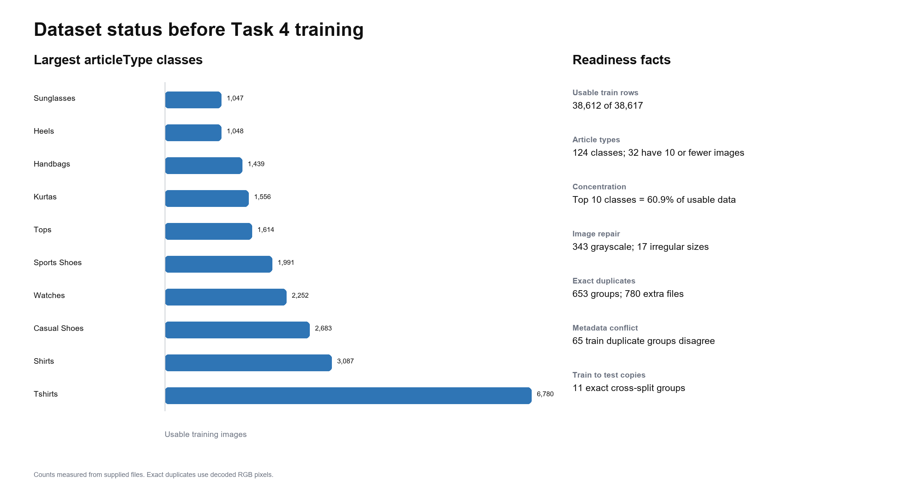
Figure 1 Measured dataset status before Task 4 training
The supplied data contains 38,617 metadata rows and 38,612 rows with matching training images. The 124 articleType classes are strongly imbalanced: 32 have ten or fewer usable examples, while the ten largest classes contain 60.9% of the data. Random triplet sampling would therefore over-represent common classes and often generate negatives that are too easy.
Exact decoded pixels form 653 duplicate groups across train and test, representing 780 extra files. 65 duplicate groups within training disagree on at least one metadata field. A random image-level split can place the same pixels in training and validation, inflate retrieval scores and teach contradictory labels.

Preprocessing policy
Observed issue | Required action | Why it matters
5 metadata rows without an image | Inner join metadata IDs to image filenames and log dropped IDs. | Avoid missing-file failures and preserve auditability.
343 grayscale and 17 irregular train images | Convert to RGB and resize consistently to 60 x 80. | The encoder requires a fixed three-channel input.
653 exact duplicate groups | Hash decoded pixels and assign the whole group to one split. | Prevents leakage and misleading Top K results.
65 duplicate groups with metadata disagreement | Flag or exclude conflicting pairs from positive sampling. | Triplet supervision must not send the same pixels to opposite labels.
32 classes with at most 10 images | Use class-aware sampling; keep singletons out of query evaluation. | Some classes cannot form valid anchor-positive pairs.
21 rows contain fragments in extra CSV columns | Drop only verified junk columns and retain an audit count. | Silent parsing errors can shift or corrupt metadata.

3 What Tasks 1 to 3 contribute
The earlier tasks provide context and possible comparison features, but Task 4 still needs its own retrieval objective. The repository findings below distinguish the team plan from code that is currently visible.
Task | Current direction | Useful contribution to Task 4 | Main limitation
Task 1 articleType | Team plan and branch: CNN. Branch also includes HOG with Logistic Regression and Linear SVM baselines. | The CNN's penultimate layer is a strong supervised embedding comparison. | Cross-entropy separates classes; it does not guarantee useful within-class visual ranking.
Task 2 season | Team plan and branch: Random Forest on HOG and colour histograms. | Colour histograms are useful for an optional re-ranking signal. | Season is partly a catalogue label and may be weakly visible in the image.
Task 3 gender and usage | Team plan says MLP. The inspected branch instead contains CNN, Logistic Regression, Random Forest and a multi-task CNN. | Predicted gender or usage can become optional customer filters. | The model mismatch must be resolved before integration or report comparison.

Repository blocker to fix first
The current main branch contains task README files but no src directory, while task branches still import src.data, src.models and src.evaluate. This is an integration problem, not a Task 4 modelling problem. The team should restore or replace the agreed shared API on an integration branch, run all task smoke tests there, and merge to main only after review.

Model comparison for Task 4
Method | Pros | Cons | Role
Raw pixels | Very simple; establishes a floor. | Sensitive to position and background; high dimension. | Baseline
PCA | Fast, reproducible and compact. | Linear features miss complex shape and texture. | Classical baseline
Convolutional autoencoder | Learns from images without labels. | Reconstruction may preserve background more than product meaning. | Unsupervised comparison
Task 1 CNN embedding | Uses articleType supervision already available. | May conflict with the different-model rule if reused as the final model; not trained for ranking. | Strong comparison
Siamese CNN with triplet loss | Directly learns a retrieval distance and supports hard negatives. | Triplet construction and mining add complexity; labels are an imperfect proxy for visual similarity. | Leading final candidate

Decision rule. Select the final model only after the same duplicate-aware query set is used for every method. Prefer the smallest model that wins on mean Average Precision, Precision at 5, qualitative relevance and query latency without relying on forbidden pretrained weights.

4 Recommended Task 4 model

Compact Siamese CNN with triplet loss
Siamese describes weight sharing, not two independent models. The same encoder processes an anchor image, a positive image and a negative image. Because all three pass through identical weights, their output vectors can be compared in one embedding space [2][3].
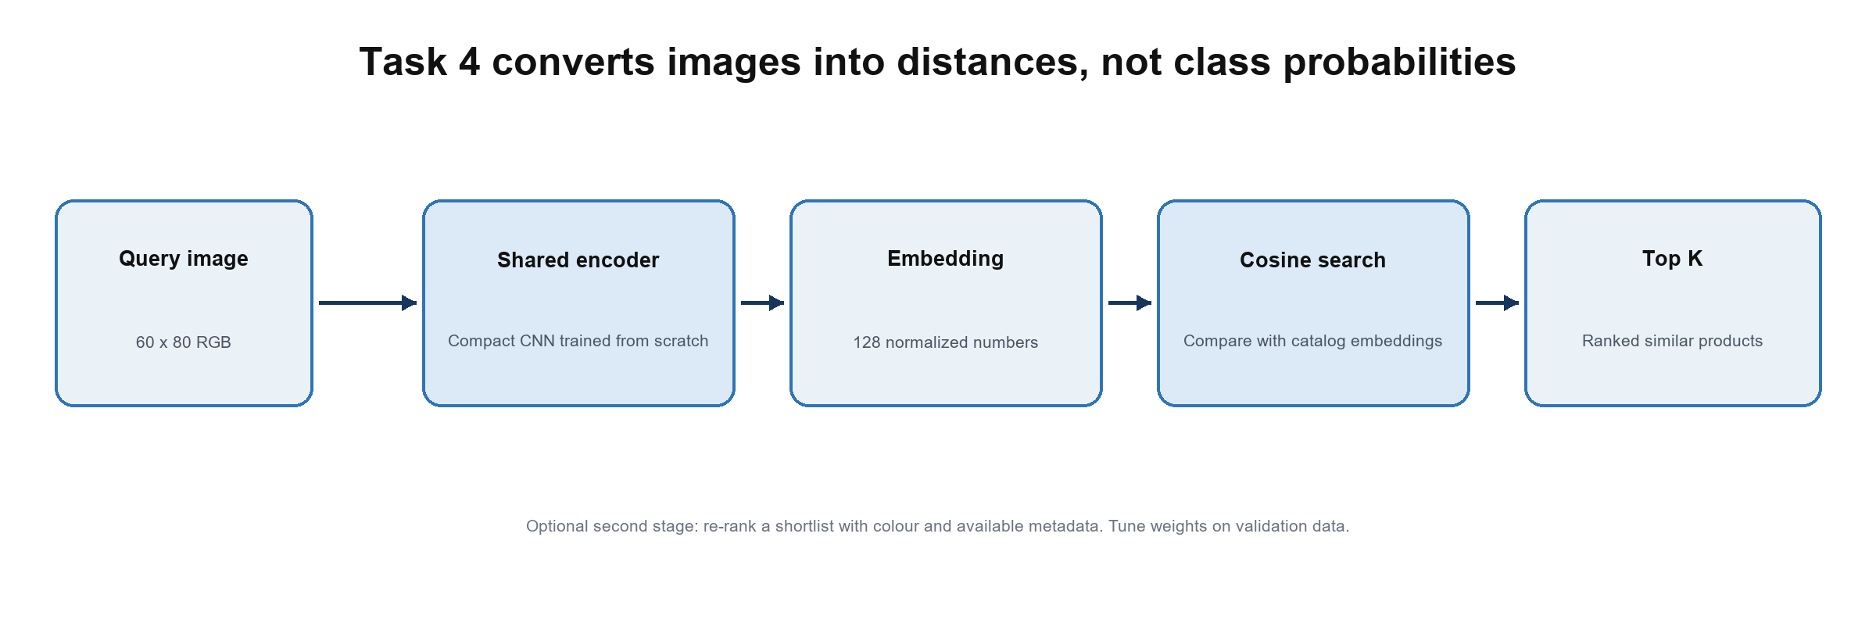
Figure 2 Recommended retrieval pipeline

How one training example works
1. Anchor: a black running shoe.
2. Positive: another running shoe with a different view or style.
3. Easy negative: a handbag. This becomes uninformative once the model learns basic categories.
4. Hard negative: a black casual shoe or sandal. It looks plausible but should rank below the true running-shoe match.
Triplet loss reduces the anchor-positive distance and increases the anchor-negative distance by at least a margin. In simple notation: loss = max(d(anchor, positive) - d(anchor, negative) + margin, 0). A zero loss means the ordering already satisfies the margin; it does not mean every pair is visually identical.

Practical starting architecture
Component | Starting choice | Reason
Input | 60 x 80 RGB | Matches the supplied files and keeps training feasible on standard machines.
Encoder | 3 convolution blocks with batch normalization, ReLU and pooling | Learns colour, edges, texture and silhouette without a pretrained backbone.
Pooling | Global average pooling | Reduces parameters compared with flattening a large feature map.
Embedding | Dense 128 then L2 normalization | Compact enough for all catalog items; cosine search becomes a dot product.
Loss | Triplet margin loss | Optimizes relative ranking directly.
Sampling | Balanced anchor classes plus semi-hard negatives | Stops common classes and easy negatives from dominating.

Starting values such as a 128-dimensional embedding, margin 0.2, batch size 64 and Adam learning rate 0.001 are hypotheses, not final settings. Tune them on retrieval metrics and record every experiment.

5 How Top K filtering works
After training, the encoder runs once over every catalog image. The resulting matrix E has one normalized embedding per product. A new query becomes vector q. Cosine similarity computes how closely each catalog vector points in the same direction as q: cos(q, x) = (q dot x) / (norm(q) norm(x)). The system sorts scores from highest to lowest and returns the first K IDs [5][6].
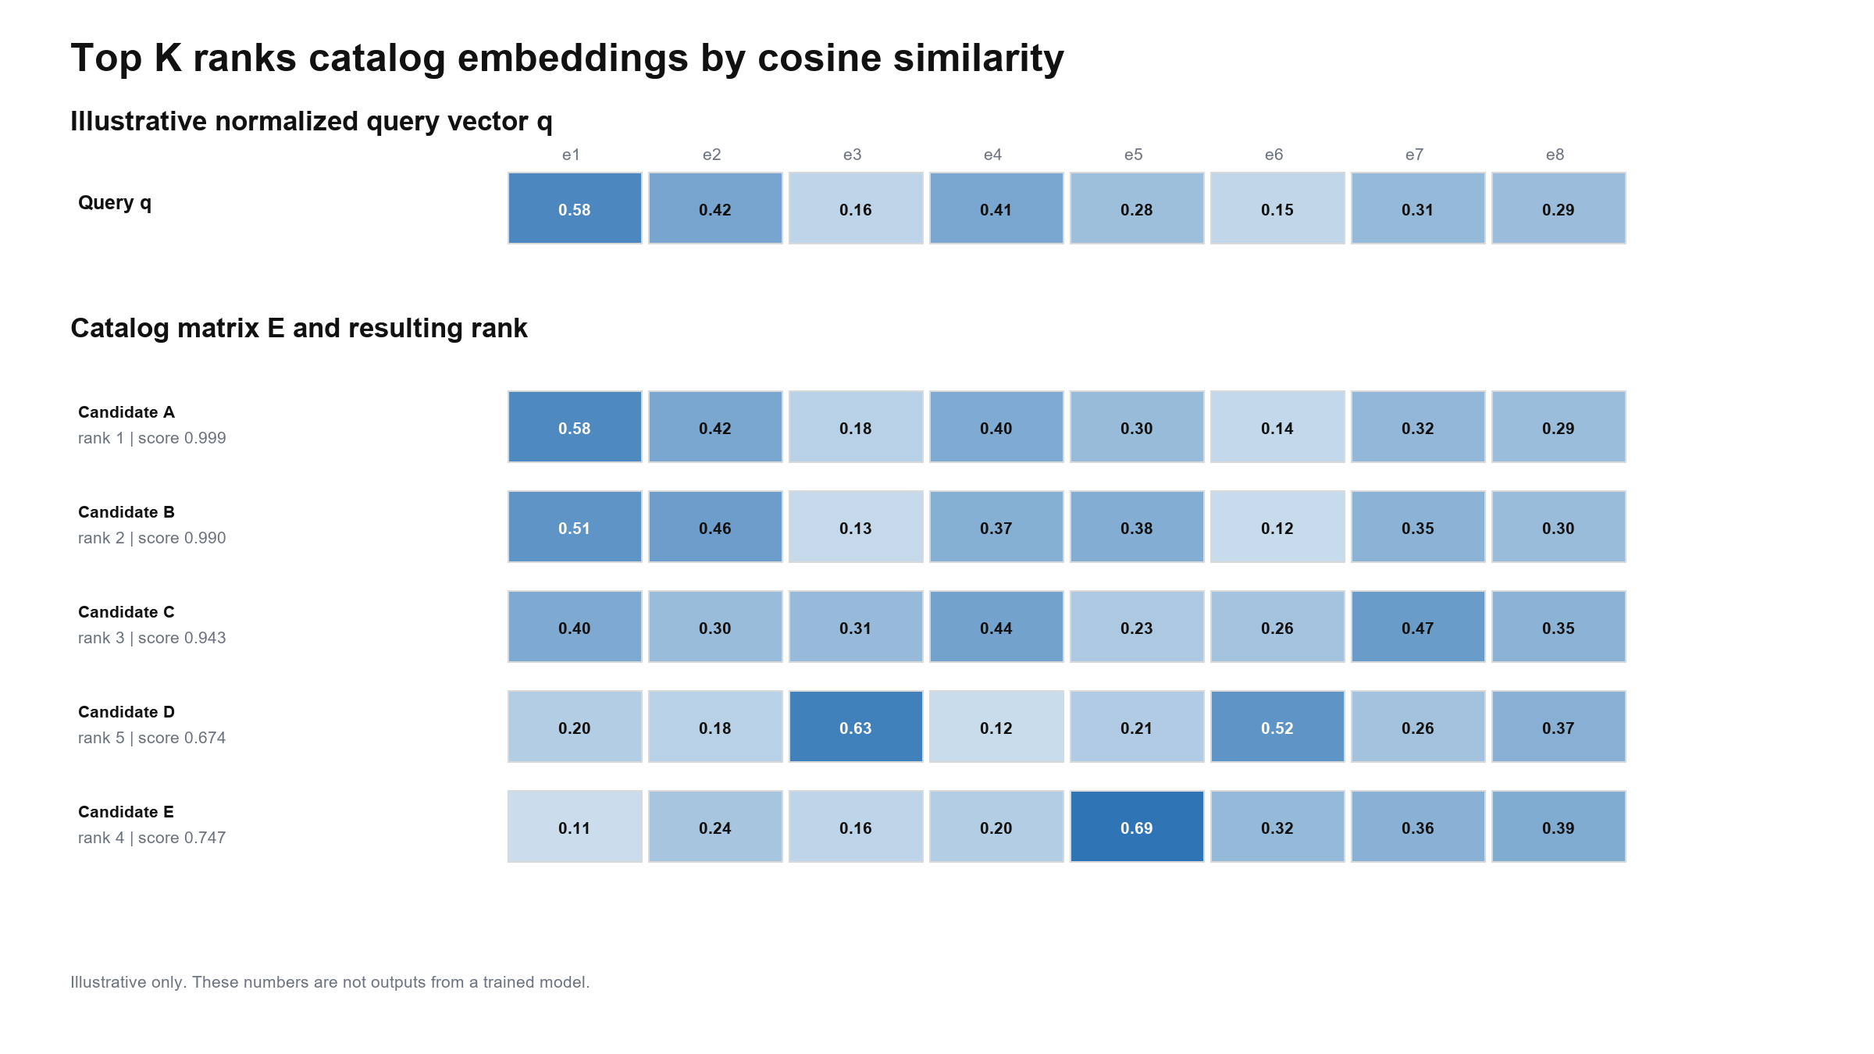
Figure 3 Illustrative embedding matrix and ranking, not trained output

Recommended two-stage ranking
1. Stage 1 retrieves a shortlist, for example the best 30 candidates, using only embedding cosine similarity.
2. Stage 2 optionally re-ranks that shortlist using colour similarity and metadata that is actually available at query time.
3. The application removes the query itself and handles duplicate groups before displaying the final Top K.
An example validation formula is 0.70 visual embedding + 0.20 colour + 0.10 metadata compatibility. Do not copy these weights into the final system without tuning. For an uploaded external image, true articleType, gender or usage is unknown; metadata can be used only when the customer supplies a filter or another model predicts it. Using hidden ground-truth query metadata would leak information.

6 Products that look 99 percent similar
The phrase 99 percent similar hides three different cases. Each needs a different response.
Case | What the model can observe | Correct handling
Exact duplicate pixels | No visual difference at all. | Group by decoded-pixel hash, keep the group in one split and avoid counting duplicates as separate proof of quality.
Same appearance, different catalog facts | The pixels may be identical even when product ID, material, season or name differs. | Return a tie or use available metadata. An image-only model cannot infer information absent from the pixels.
Small visible differences | Logo, stitching, collar, texture, pattern, colour shade or silhouette may differ by a few pixels. | Use hard negatives from the same subCategory, preserve colour, and consider a second-stage local-detail or colour re-ranker.
Different crop or viewpoint | The same product can move or scale in the frame. | Use mild translation, zoom and horizontal flip; avoid augmentations that destroy colour or shape.
Label says different but humans see similar | articleType is only a proxy for visual relevance. | Report strict and lenient metrics and add a small human-labelled relevance set.

Hard-negative strategy
- Warm-up with random negatives for a few epochs so the encoder learns broad categories.
- Then select semi-hard negatives: different articleType but the same subCategory, or the closest incorrect candidate in the current batch.
- Exclude exact duplicate conflicts from triplets. Otherwise identical pixels can be both positive and negative, making the objective contradictory.
- Inspect retrieval grids for near-neighbour failures. Metrics based only on articleType will miss wrong colours, patterns and style details.

Signals for second-stage re-ranking
Signal | Helps with | Risk
HSV colour histogram | Same shape but clearly different colour. | Can overvalue background colour.
Local texture or centre crop | Small logos, fabric patterns and stitching. | Low-resolution images may not contain enough detail.
Predicted articleType | Keeping visually plausible categories near the top. | Classification errors can wrongly suppress good matches.
User filters | Explicit gender, colour or usage preferences. | Must remain optional; filtering changes the search question.
Product metadata | Ties between visually identical catalog entries. | Unavailable for external queries unless supplied or predicted.

7 How train.py should work
train.py should coordinate the experiment from configuration to saved artifacts. It should not become a single 600-line file containing data loading, model classes, evaluation, plotting and search. Keep reusable Task 4 logic beside it so the training script remains readable and testable.
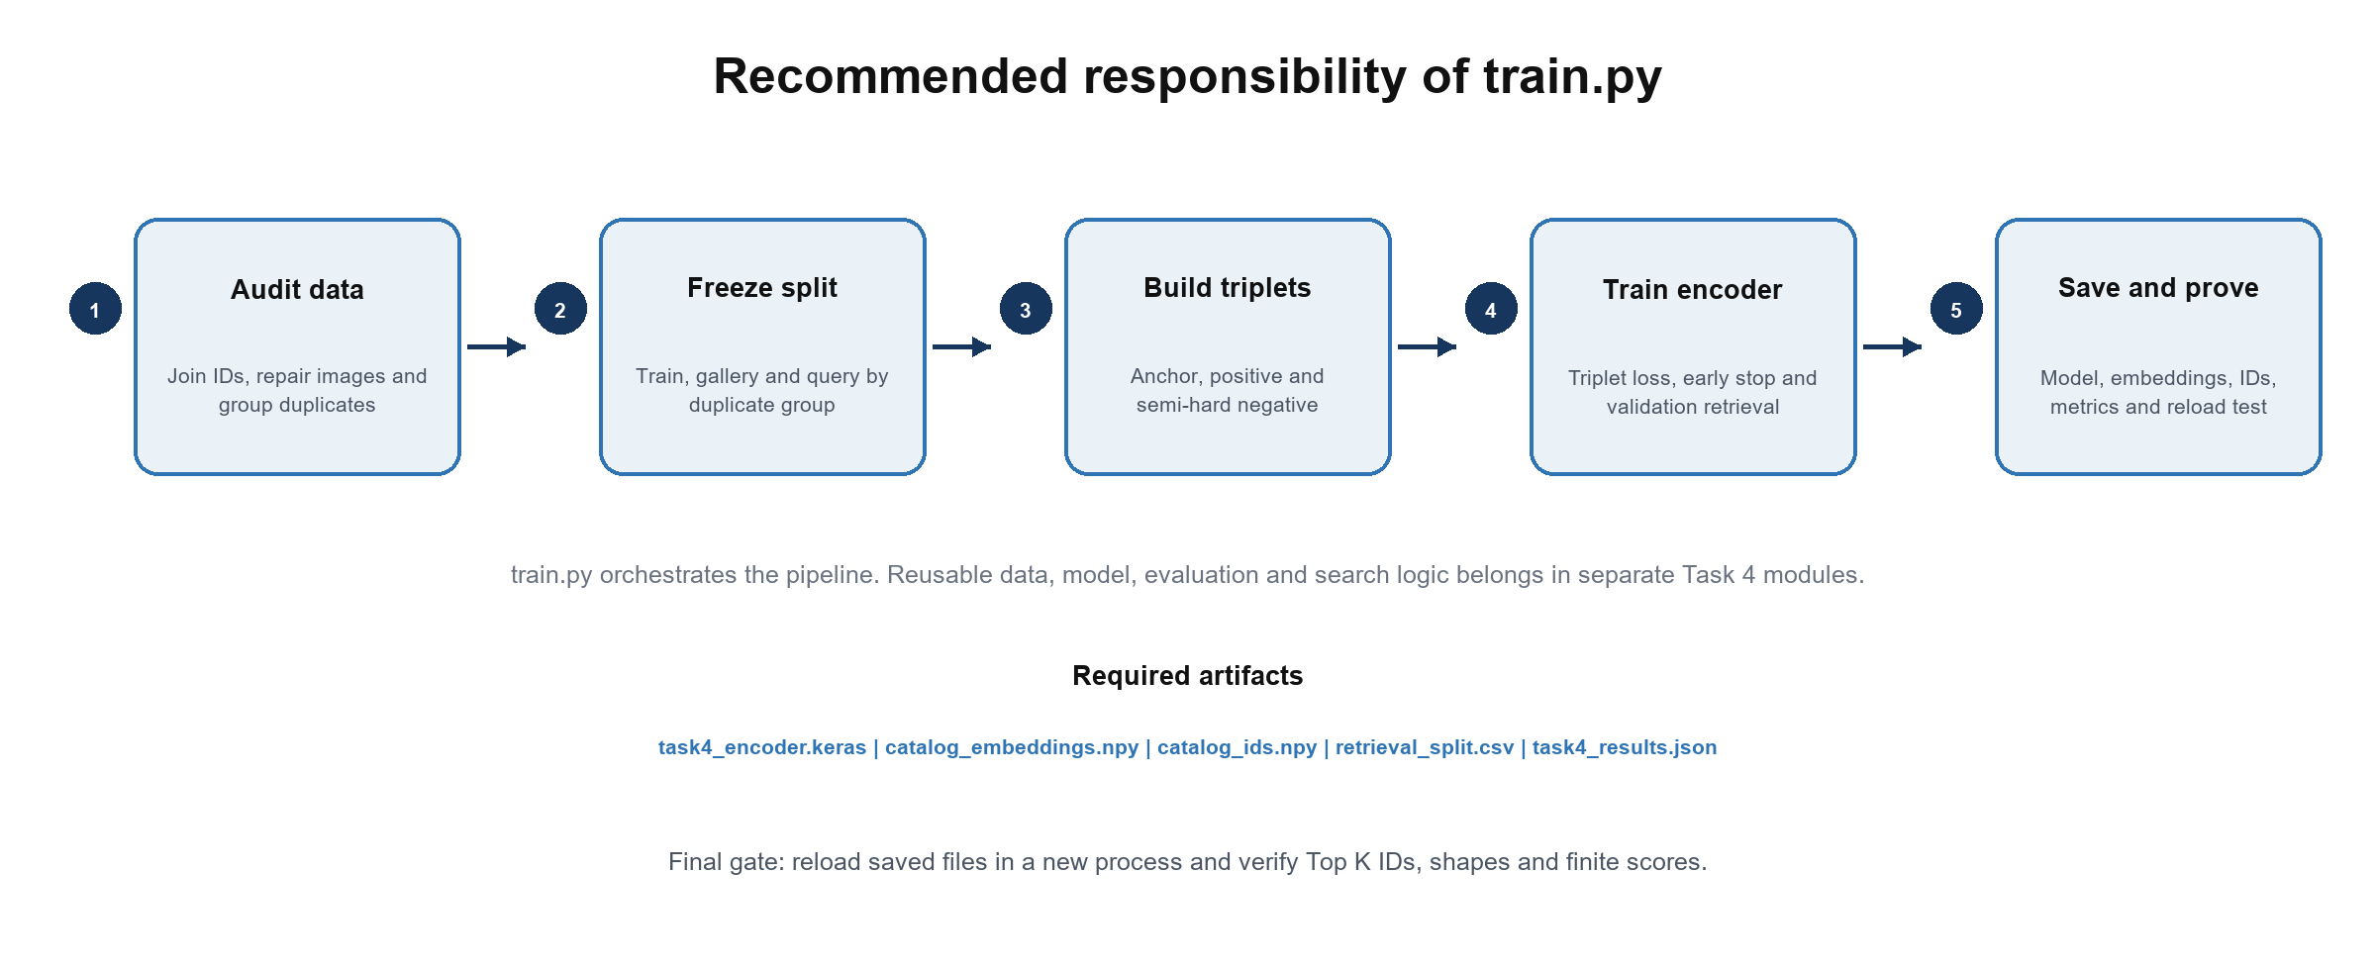
Figure 4 Recommended train.py responsibility and outputs

Suggested module ownership
File | Responsibility
tasks/task4_visual_search/train.py | Parse arguments, set seeds, call each stage, log config, select checkpoint and run the final smoke test.
data.py | Load images and metadata, repair channels and sizes, compute duplicate groups, create split IDs and sample triplets.
model.py | Build the compact encoder and the triplet-training model; register custom serializable objects.
evaluate.py | Compute Precision at K, Recall at K, mAP at K, nDCG at K, latency and qualitative retrieval grids.
search.py | Load saved artifacts, encode a query, perform cosine search, remove self or duplicates and return ranked product IDs.
README.md | Environment, dataset placement, training command, search command, expected outputs and troubleshooting.

Integration rule. Task 4 files should stay inside the Task 4 folder until the team agrees on shared interfaces. Do not modify main directly. Create a dedicated feature branch, keep commits limited to Task 4, and merge through review after the shared src decision is resolved.

8 train.py method sequence
Method | Input and action | Output or assertion
parse_args | Read paths, seed, image size, embedding dimension, margin, batch size, epochs and experiment name. | A serializable configuration object.
set_reproducibility | Seed Python, NumPy and Keras; enable deterministic behaviour where available. | Repeated split IDs and comparable runs.
load_and_audit_data | Join IDs to files, validate required fields, convert RGB, resize and report missing or malformed records. | Clean index plus an audit JSON.
build_duplicate_groups | Hash decoded RGB pixels and group identical images. | A duplicate_group_id for every image.
make_retrieval_split | Split by duplicate group into train, gallery and query; preserve class coverage where possible. | Frozen CSV of IDs and roles.
build_triplet_dataset | Create balanced anchors, valid positives and scheduled random or semi-hard negatives. | Batched tf.data triplets.
build_encoder | Create the compact CNN, Dense 128 layer and L2 normalization. | One reusable embedding model.
fit_triplet_model | Optimize triplet loss with early stopping and checkpointing. | Best validation checkpoint and history.
encode_catalogue | Run the encoder over gallery images in batches. | Embeddings aligned with catalog IDs.
evaluate_retrieval | Search each validation query, exclude self and duplicates, compute metrics and grids. | Comparable results JSON and figures.
save_artifacts | Save encoder, embeddings, IDs, split, config and results. | A complete inference package.
smoke_test_reload | Open saved files in a fresh process and search a few queries. | Finite scores, valid Top K IDs and matching shapes.

Training loop checks
- Stop on a retrieval metric such as validation mAP at 10 when practical, not training loss alone.
- Log the fraction of active triplets. If almost every triplet has zero loss, negative mining is too easy.
- Fail early on NaN embeddings, empty positive pools, query IDs inside the training role, or a mismatch between embeddings and ID counts.
- Save the best checkpoint and a last checkpoint separately. The best checkpoint supports the final comparison; the last supports debugging.

9 Evaluation and team handoff

Metrics that answer different questions
Metric | Question answered | Report use
Precision at 5 | How many of the first five results are relevant? | Customer-facing quality at the visible result count.
Recall at 5 | How much of the relevant gallery appears in the first five? | Useful when many alternatives exist.
mAP at 10 | Are relevant products consistently ranked near the top across queries? | Recommended primary retrieval metric.
nDCG at 10 | Does the order reflect graded relevance such as same type versus same subCategory? | Supports strict and lenient relevance.
Query latency | How long does embedding plus search take? | Real-world viability on a standard machine.
Retrieval grid | Are colour, texture and silhouette subjectively plausible? | Qualitative error analysis and report figures.

Acceptance checklist before merging
- All compared methods use the same frozen gallery and query IDs.
- Exact duplicates cannot cross train, gallery and query roles, and self-matches are removed.
- No pretrained weights are used in the final candidate; any pretrained reference is clearly labelled comparison only.
- The saved encoder reloads without the training script's in-memory state.
- Top K output contains product IDs, scores and metadata rows in the correct order.
- README instructions work from a clean environment and use paths relative to the repository root.
- A small web or GUI demo calls the same search function or API used in testing.
- The team records failed cases and limitations instead of claiming that identical images can always be separated.

Immediate team sequence
1. Resolve the src and Task 3 branch discrepancies.
2. Approve the Task 4 relevance definition and duplicate-aware split.
3. Implement baselines and evaluation before the triplet model.
4. Train and tune the compact Siamese candidate.
5. Choose the ultimate model from evidence, then connect it to the demo API and interface.

References
[1] RMIT University. COSC2753 3013 Machine Learning Assignment 2 2026B. Provided assignment PDF
[2] Schroff F, Kalenichenko D, Philbin J. FaceNet A Unified Embedding for Face Recognition and Clustering. CVPR 2015. Open source
[3] Keras. Image similarity estimation using a Siamese Network with a triplet loss. Open source
[4] Liu Z, Luo P, Qiu S, Wang X, Tang X. DeepFashion Powering Robust Clothes Recognition and Retrieval With Rich Annotations. CVPR 2016. Open source
[5] scikit-learn. NearestNeighbors documentation. Open source
[6] scikit-learn. cosine_similarity documentation. Open source
[7] TensorFlow. Save serialize and export Keras models. Open source

