**PROJECT TITLE**

**Terra Map Adventure**

An adventure & resource management game played on a real world map using NASA's land cover database for realism.

**MOTIVATION**

Developing a fun, entertaining and educating game to raise the philanthropy mindset and spirit by prioritizing collaboration and barter mechanism for mutual prosperity.

**HOW TO PLAY?**

* Each player decide which location s/he want to manage the resources among the 16 lands.
* Arriving at the designated land, the player start to look for collaboration or barter if there is any human(s).
* If the player(s) can find the human(s) to partner with, s/he will join with him/her/them to harvest vegetation (wood, food, leaves, grass, etc.) and/or collect existing natural resources (sand, soil, animals, minerals, oxygen, water, etc.).
* If the player(s) find no humans exist, s/he will seek energy and/or animal(s) to help him/her harvest vegetation (wood, food, leaves, grass, etc.) and/or collect existing natural resources (sand, soil, minerals, oxygen, water, etc.).
* The harvesting aim to provide the player a shelter to live, and food to eat.

Challenge: as many gold/etc as possible in n turns

save during turn, but can't end turn until kosher

donate to charity to get perks

collaborative work

ENF: 2 wood, 1 leaf

EBF: 1 wood, 2 leaf

DNF: 1 leaf

DBF: 1 leaf

sand

wood, leaf, sand, person, food, water, magic, energy

energy = robot needs to move around

person = guards your land; help you harvest more

roads = move thru tile faster

food to feed people

horse to transport things (or other animals) to transport resources

(simulation game)

management game

limit things in tile

spoilage and salting -- transport not in the original game

gold = something you mine

philanthropy = helps other people, improve quality of life

no water crossing = bridge

**CODE STYLE**

?

**SCREENSHOTS**

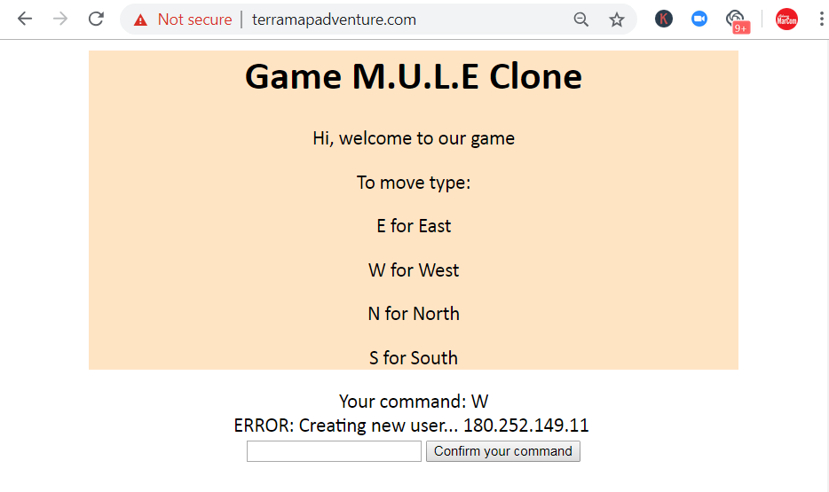

**TECH/FRAMEWORK USED**

Front End Development

HTML5, CSS3, Vanilla JavaScript

Back End Development

Pearl

Database

?

Web framework

< Dropwizard > ?

Dependency Management

< Maven > ?

Generate RSS Feeds

< ROME > ?

**FEATURES**

The first game in the software development using real world map NASA's land cover database and Google Maps database.

**CODE EXAMPLE**

?

**INSTALLATION**

?

**API REFERENCE**

?

**RUNNING THE TESTS**

?

**TEAM**

Initiator & Project Manager: Barry Carter

Front End Engineer: ?

Back End Engineer: Barry Carter

Researcher & Documentation: Eri Hariono

**CREDITS**

NASA

Google Maps

**RESOURCES**

* NASA (and others) classify lands into 16 different categories: https://eoimages.gsfc.nasa.gov/images/imagerecords/61000/61004/lcc_key.jpg
* Maps: https://visibleearth.nasa.gov/view.php?id=61004
* Google Maps: http://test.barrycarter.info/bc-image-overlay-nokml.pl?url=lcc.png
* Lists of other types of map: https://visibleearth.nasa.gov/

**TECHNICAL REMARKS**

* World map 43200x21600 image representing earth land types, cylindrical projection
* Pixel to latitude/longitude translation
* x pixels go from 0 to 43199 (for 43200 pixels total)
* y pixels go from 0 to 21599 (for 21600 pixels total)
* each pixel is 1/120 degree wide and 1/120 degree high
* x pixel to lon: (2x-43199)/240 [center of pixel]
* lon to x pixel: (43199+240x)/2
* y pixel to lat: (21599-2x)/240
* lat to y pixel: (21599-240x)/2

**SUPPORT**

Reach out to Barry Carter at one of the following places!

* Website at http://terramapadventure.com/
* Twitter at ?
* Discord at ?
* Repository at https://github.com/barrycarter/YAMC
* Insert more social links here?

**ACKNOWLEDGMENTS**

* Hat tip to anyone whose code was used ?
* Inspiration

https://www.facebook.com/FarmVille/

https://en.wikipedia.org/wiki/M.U.L.E.

https://civilization.com/

**NOTES**

This README serve as a living document.