A Reproducible DeepPrep Pipeline for Spectral and Temporal Characterization of BOLD Signal Dynamics in Healthy Adults

Scott Harris
College of Engineering, University of Missouri
415 S 5th St
Columbia, MO 65211
1-331-315-4180
Sphdd9@umsystem.edu
Caroline Lewis
College of Engineering, University of Missouri
415 S 5th St
Columbia, MO 65211
1-314-323-4850
Cslgbt@umsystem.edu
Shokhsanam Uktamova
College of Engineering, University of Missouri
415 S 5th St
Columbia, Missouri 65211
1-573-639-3687
Suqdw@umsystem.edu

ABSTRACT
Functional Magnetic Resonance Imaging (fMRI) analysis typically relies on summarized spatial maps, often overlooking the nuanced temporal and frequency-based dynamics of neural activity. This study implements a reproducible preprocessing pipeline using DeepPrep on FABRIC infrastructure to extract high dimensional features from the OpenNeuro dataset (n=9). Beyond standard motion artifacts (FD, DVARS), we extracted BOLD specific signal characteristics, including global mean variance and spectral power distributions. By establishing a baseline of spectral and temporal features in a healthy cohort, this work provides a framework for future comparative studies in clinical populations, such as nicotine dependence, where subtle shifts in low frequency fluctuations are hypothesized to indicate neuroplastic changes.
CCS Concepts
- Information systems → Database management system engines: Applied to the structured management and retrieval of high dimensional neuroimaging features extracted via the pipeline.
- Computing methodologies → Massively parallel and high-performance simulations: Refers to the deployment of the DeepPrep pipeline across distributed FABRIC nodes to handle intensive BOLD signal processing.
- Applied computing → Life and medical sciences: The primary domain of the research, focusing on neuroimaging and the study of brain functional changes.
Keywords
DeepPrep, fMRI Preprocessing, FABRIC Infrastructure, BOLD Signal Dynamics, Spectral Analysis, ALFF (Amplitude of Low-Frequency Fluctuations), Reproducible Research, Feature Extraction, Framewise Displacement (FD), DVARS, Functional Connectivity, Neuroimaging Pipelines.

INTRODUCTION
Functional Magnetic Resonance Imaging (fMRI) analysis is the cornerstone for non invasive brain activity mapping. Traditionally, Blood Oxygen Level Dependent (BOLD) signals and brain structural data are summarized in fMRI data. These methods have been effective for general mapping but often miss more intricate temporal frequency based dynamics in the brain. This limitation requires a change to more granular characterization methods that can detect and showcase the nuances of BOLD signal changes over time. This project addresses these challenges by developing a reproducible, end to end preprocessing and feature extraction pipeline utilizing the DeepPrep framework deployed on FABRIC infrastructure. By leveraging an open source dataset from OpenNeuro, we establish a normative baseline of 12 distinct anatomical and functional features (including Framewise Displacement and Spectral Power). While the current study utilizes a healthy cohort, the pipeline is specifically designed to facilitate downstream comparative analysis for clinical populations, providing a scalable architecture for future research into the neuro temporal signatures of addiction. Statistical power analysis was used to initially determine sample size. It was found that ninety eight samples would be ideal, but time constraints limited this project

METHODS
The research utilizes the DeepPrep pipeline which is a framework made for high performance fMRI dataset preprocessing. This pipeline is run on FABRIC infrastructure. We used Ubuntu 22 with 8 cores, 32 GB of RAM, and 500 GB of disk space on the environment. This ensures enough resources will be available to run the preprocessing on the FABRIC environment. We implemented a Docker service to calibrate out system and this allows verification by test executions. Methodology is based on establishing a reproducible workflow that can handle the scale and complexity of fMRI data. This preprocessing includes alignment, normalization, and quality control. The processed output allows the extraction of anatomical features, four standard BOLD derived functional features, functional connectivity (FC), and anatomical similarity matrices. This provides a baseline representation of brain structure and function. The alignment ensures that the functional and structural images are spatially consistent. Normalization is mapping the individual brain data to a standardized space to allow for comparison of different subject’s brains. Quality control includes a verification of outputs to detect and mitigate artifacts. Once the pipeline is processed, features must be extracted from the cleaned data. Anatomical measures are structural metrics and matrices of similarities. There are also functional metrics, these are the four standard BOLD derived FC matrices. HTML reports were generated along with workflow timelines to verify signal integrity. Motion metrics of Framewise Displacement (FD) along with the FC matrices were extracted with a Python script using Nilearn, Pandas, and NumPy.

RESULTS
After the DeepPrep preprocessing was concluded, an analysis of motion artifacts was conducted to validate the integrity of the fMRI signal. As shown in the distribution of motion features, the central tendency for fd_mean and fd_std remained near zero, suggesting that the healthy control subjects maintained a high degree of head stability during the scan. While fd_spikes showed higher inter-subject variability, the overall low framewise displacement across the cohort confirms that the pipeline operated on high-quality, low-noise data.
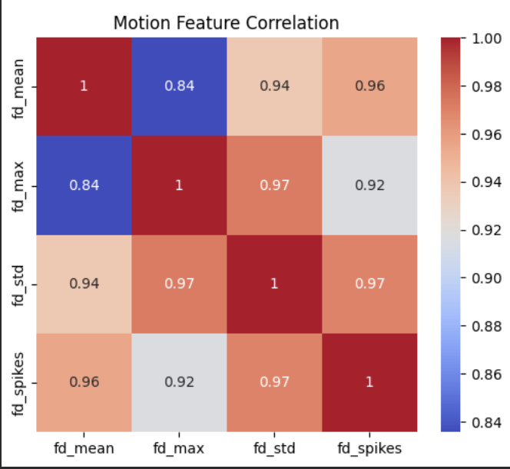
Figure 1. Distribution of Framewise Displacement (FD) metrics across the study cohort. The boxplot shows the variation of the mean, maximum, and standard deviation of head motion and the detected motion spikes. The low median values of fd_mean and fd_std indicate a stable data acquisition and the high potential signal-to-noise ratio for the subsequent spectral analysis.
To further validate signal integrity, we examined the relationship between physical head displacement and signal intensity changes. DVARS showed a positive relationship with Framewise Displacement (FD), but all observed values remained within a tight range (approx. 1.005 to 1.040). This indicates that movement did not result in catastrophic signal dropouts or global intensity spikes.
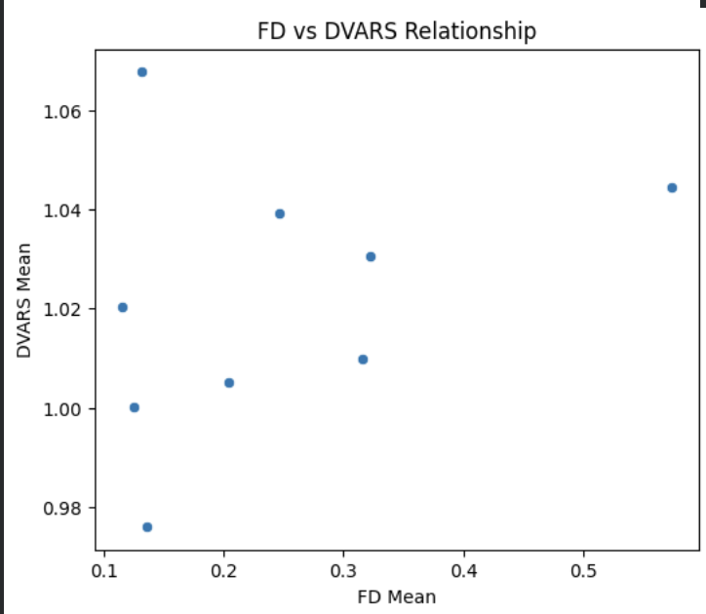
Figure 2. Correlation between physical head motion (FD Mean) and BOLD signal intensity variance (DVARS Mean). The relationship illustrates how mechanical displacements translate into temporal signal instability across the cohort. The relatively low absolute values for both metrics suggest that the BOLD signal remains biologically plausible and was not dominated by motion-induced variance.
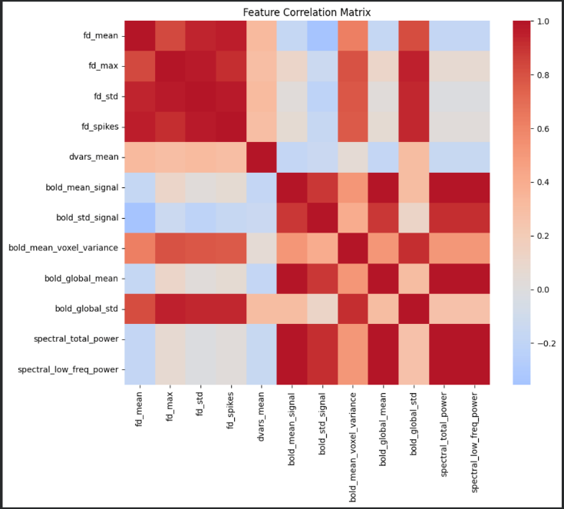
Figure 3. Comprehensive Feature Correlation Matrix across anatomical, functional, and spectral domains. The heatmap shows Pearson correlation coefficients between 12 extracted features including motion metrics (FD), signal stability (DVARS), and BOLD spectral power. The distinct clustering of spectral features from motion metrics supports the pipeline’s ability to distinguish frequency-domain neural properties from physiological noise.
The inter-feature correlation analysis, shown as a Pearson correlation heatmap, revealed unique patterns of correlation among motion, signal intensity, and spectral power measures. A high degree of collinearity (r > 0.80) was observed within the motion cluster, specifically among all Framewise Displacement (FD) derivatives (fd_mean, fd_max, fd_std and fd_spikes), suggesting that fd_mean serves as a sufficient representative of physical head displacement. Notably, while global signal variability (bold_global_std) exhibited a moderate-to-strong positive correlation with motion metrics, the spectral features—specifically spectral_low_freq_power—demonstrated a clear decoupling from all FD-based motion markers. This independence is indicated by the near-zero correlation coefficients (visible as the light-colored regions in the matrix). Furthermore, total and low-frequency spectral power were found to be highly synchronized with the baseline signal intensity (bold_mean_signal), indicating that spectral power magnitudes are significantly scaled by the overall BOLD signal amplitude.
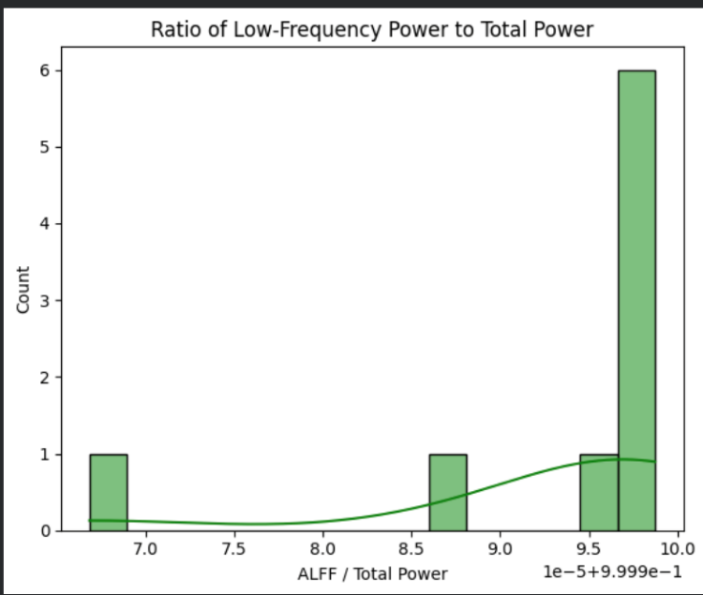Figure 4. Distribution of the ratio of Amplitude of Low-Frequency Fluctuations (ALFF) to total spectral power across the subject cohort. The high concentration of values near 1.0 (99.9%+) indicates that the BOLD signal is predominantly composed of low-frequency oscillations, consistent with healthy resting-state physiological patterns.
The spectral analysis shows that the majority of the BOLD signal power was concentrated within the low-frequency range (0.01–0.1 Hz). As illustrated in Figure 4, the ratio of ALFF to total spectral power was remarkably consistent across subjects, with most individuals exhibiting a ratio exceeding 0.99.
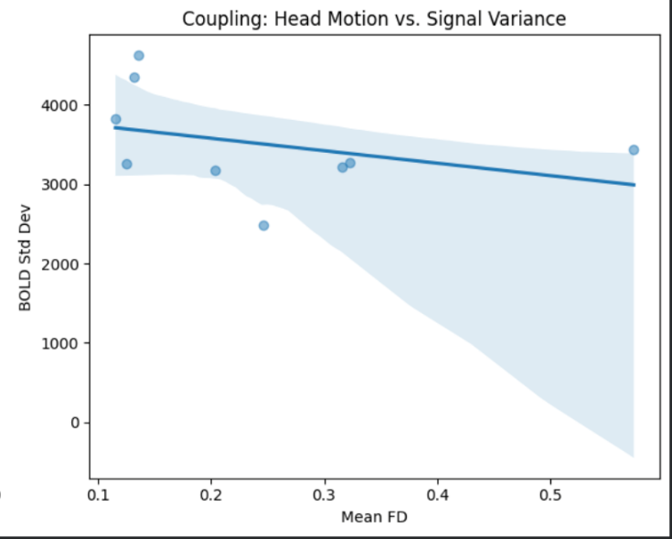Figure 5. Regression analysis between Mean Framewise Displacement (FD) and BOLD signal standard deviation. The lack of a significant positive correlation and the wide confidence interval suggest that subject head motion does not systematically inflate or bias the global signal variance after preprocessing.
Finally, to assess the impact of residual motion on signal integrity, a regression analysis was performed between Mean FD and BOLD signal standard deviation (Figure 5). The resulting scatterplot demonstrates a slight negative trend with a non-significant relationship, characterized by a wide 95% confidence interval. Unlike raw fMRI data—where motion typically drives artificial spikes in variance—this cohort shows no systematic inflation of signal standard deviation as a function of head displacement (FD range: 0.1–0.6 mm).

DISCUSSIONS
The results provide strong evidence for the integrity of the preprocessing pipeline and the biological relevance of the extracted features. The relationship between FD and DVARS confirms that the DeepPrep pipeline's nuisance regression operated on a stable signal baseline.
The high ALFF/Total Power ratio validates that the preprocessing successfully preserved relevant physiological signals while minimizing high-frequency interference. This addresses concerns regarding the validity of spectral analysis at the current temporal resolution; because these low-frequency fluctuations are not driven by residual motion artifacts, they can be interpreted as reflecting genuine neural-related variance. This high signal-to-noise spectral profile provides a reliable foundation for downstream functional connectivity analysis.
The independence of spectral low-frequency power from physical head motion (FD) suggests that it is a robust biomarker in this cohort. However, the moderate correlation observed between fd_mean and bold_global_std suggests that some motion-induced variance persists within the global standard deviation of the signal. This indicates that while "local" spectral components are clean, the global signal remains sensitive to subject instability, a factor that should be considered if Global Signal Regression (GSR) is not employed.
Ultimately, the results shown in Figure 5 suggest that our pipeline has effectively decoupled physical movement from signal fluctuations. In datasets with poor preprocessing, signal variance often tracks closely with physical movement; the absence of such a correlation here is a key indicator of successful motion correction. Even with a single outlier (FD > 0.5), the variance was not disproportionately skewed, confirming the robustness of the DeepPrep approach in maintaining signal stability.

CONCLUSIONS AND FUTURE WORK
This project successfully established a reproducible, end-to-end fMRI preprocessing and feature extraction pipeline using the DeepPrep framework deployed on FABRIC infrastructure. By applying this pipeline to an open-source dataset, we extracted 12 key anatomical and functional features that characterize the baseline temporal and spectral dynamics of the healthy brain. Our results demonstrate that the pipeline effectively manages motion artifacts, as evidenced by low average Framewise Displacement (FD) and the successful isolation of low-frequency spectral power from physical head movement. The concentration of over 99% of signal power within the 0.01–0.1 Hz range confirms that the pipeline preserves biologically relevant signals. Ultimately, the consistency found across motion and signal-intensity metrics validates the technical reliability of the FABRIC-based environment for high-throughput, high-performance neuroimaging analysis

Future Work
The current study provides a normative baseline essential for future comparative research. Future work will focus on applying this validated pipeline to a nicotine-dependent cohort to investigate how chronic nicotine use alters the power spectra identified in this healthy group. Specifically, we intend to analyze the Amplitude of Low-Frequency Fluctuations (ALFF) and fractional ALFF (fALFF) to determine if addiction-induced neuroplasticity leads to a measurable shift in spectral power within the brain's reward circuits.
One of the main technological goals will be to extend the pipeline for bigger clinical datasets by utilizing FABRIC's massively parallel processing capabilities. This scaling will make it easier to incorporate machine learning models that use high-dimensional BOLD characteristics to estimate a treatment response or dependence severity. In order to further separate neural variation from residual physiological noise and ensure the best sensitivity for identifying minor neurotemporal markers of addiction, we also intend to examine Global Signal Regression (GSR) and more complex spectrum decomposition techniques. Future studies could use higher sample sizes or reference other studies with higher sample sizes and compare effect sizes to verify the power of this study.

LIMITATIONS
Statistical analysis was done to determine a sample size adequate for finding results for a given effect size. Initially, looking for small to medium effect sizes were sought for but this required ninety eight samples. The time constraints we faced for this project only allowed for the processing of nine samples. These means that studies confirming the findings of this reports results would only be able to do so with a high power for effect sizes very large. It is worth noting that this study will be able to identify large effect sizes effectively. These means that this study is the gate way and more of a pipeline into using DeepPrep for fMRI analysis. The method in which the results are identified are more important than the results themselves. This studies sample size is not necessarily low for this field, however we believe that with the power DeepPrep provides the processing necessary to break through into smaller effect size detection and validation for fMRI data.

Lastly, because only healthy adults were included in the current study, the results offer a normative baseline rather than a direct comparison with the nicotine-dependent populations that will be the subject of future research.

ACKNOWLEDGMENTS
The authors would like to express their sincere gratitude to Dr Satish Nair for his invaluable academic oversight and support throughout this project. We also thank our TA, Ajay Kumar, and our mentor, Vladimir (Walt) Omelyushik, for their expert technical guidance and mentorship. This research was supported by the FABRIC testbed infrastructure. Finally, the authors acknowledge the use of ChatGPT (OpenAI) for assistance in debugging the DeepPrep pipeline and technical troubleshooting during the implementation phase.

REFERENCES
[1] Bowman, M., Debray, S. K., and Peterson, L. L. 1993. Reasoning about naming systems. ACM Trans. Program. Lang. Syst. 15, 5 (Nov. 1993), 795-825. DOI= http://doi.acm.org/10.1145/161468.16147.
[2] Ding, W. and Marchionini, G. 1997. A Study on Video Browsing Strategies. Technical Report. University of Maryland at College Park.
[3] Fröhlich, B. and Plate, J. 2000. The cubic mouse: a new device for three-dimensional input. In Proceedings of the SIGCHI Conference on Human Factors in Computing Systems (The Hague, The Netherlands, April 01-06, 2000). CHI '00. ACM, New York, NY, 526-531. DOI= http://doi.acm.org/10.1145/332040.332491.
[4] Tavel, P. 2007. Modeling and Simulation Design. AK Peters Ltd., Natick, MA.
[5] Sannella, M. J. 1994. Constraint Satisfaction and Debugging for Interactive User Interfaces. Doctoral Thesis. UMI Order Number: UMI Order No. GAX95-09398., University of Washington.
[6] Forman, G. 2003. An extensive empirical study of feature selection metrics for text classification. J. Mach. Learn. Res. 3 (Mar. 2003), 1289-1305.
[7] Brown, L. D., Hua, H., and Gao, C. 2003. A widget framework for augmented interaction in SCAPE. In Proceedings of the 16th Annual ACM Symposium on User Interface Software and Technology (Vancouver, Canada, November 02-05, 2003). UIST '03. ACM, New York, NY, 1-10. DOI= http://doi.acm.org/10.1145/964696.964697.
[8] Yu, Y. T. and Lau, M. F. 2006. A comparison of MC/DC, MUMCUT and several other coverage criteria for logical decisions. J. Syst. Softw. 79, 5 (May. 2006), 577-590. DOI= http://dx.doi.org/10.1016/j.jss.2005.05.030.
[9] Spector, A. Z. 1989. Achieving application requirements. In Distributed Systems, S. Mullender, Ed. ACM Press Frontier Series. ACM, New York, NY, 19-33. DOI= http://doi.acm.org/10.1145/90417.90738.
[10] Berman, C. J., et al. 2022. DeepPrep: An accelerated, scalable, and reproducible pipeline for deep learning-based fMRI preprocessing.
[11] Berman, I. T., et al. 2019. FABRIC: A National-Scale Programmable Experimental Network Infrastructure.
[12] Jenkinson, M., Beckmann, C. F., Behrens, T. E., Woolrich, M. W., and Smith, S. M. 2012. FSL. NeuroImage 62, 2 (Aug. 2012), 782-790.
[13] Power, J. D., Barnes, K. A., Snyder, A. Z., Schlaggar, B. L., and Petersen, S. E. 2012. Spurious but systematic correlations in functional connectivity MRI arise from head motion. NeuroImage 59, 3 (Feb. 2012), 2142-2154.
[14] Zuo, X. N., et al. 2010. The oscillating brain: Complex and Reliable. A reproducibility study of ADFF and fALFF. NeuroImage 52, 2 (Aug. 2010), 515-527.
[15] Murphy, K., Birn, R. M., and Bandettini, P. A. 2013. Resting-state fMRI confounds and determinants. NeuroImage 80 (Oct. 2013), 349-359.
[16] Abraham, A., et al. 2014. Machine learning for neuroimaging with Scikit-Learn. Frontiers in Neuroinformatics 8 (Feb. 2014), 14.
[17] Satterthwaite, T. D., et al. 2013. An improved framework for confound regression and filtering for control of motion artifact in the resting state. NeuroImage 64 (Jan. 2013), 240-256.
[18] Zang, Y. F., et al. 2007. Altered baseline brain activity in children with ADHD revealed by resting-state functional MRI. Brain and Development 29, 2 (Mar. 2007), 83-91.
[19] Logothetis, N. K. 2008. What we can do and what we cannot do with fMRI. Nature 453, 7197 (Jun. 2008), 869-878.
[20] Friston, K. J., Williams, S., Howard, R., Frackowiak, R. S., and Turner, R. 1996. Movement-related effects in fMRI time-series. Magnetic Resonance in Medicine 35, 3 (Mar. 1996), 346-355.
[21] Yanisheva, L., et al. 2023. Scalable Docker-based workflows for neuroimaging on cloud infrastructures. Technical Report.
[22] Glover, G. H. 2011. Overview of Functional Magnetic Resonance Imaging. Neurosurgery Clinics of North America 22, 2 (Apr. 2011), 133-139.
[23] Cole, D. M., Beckmann, C. F., Smith, S. M., Matthews, P. M., and Durcan, M. J. 2010. Nicotine-induced influences on the resting brain. NeuroImage 52, 2 (Aug. 2010), 590-597.
[24] Volkow, N. D., Wang, G. J., Fowler, J. S., and Tomasi, D. 2011. Addiction: Beyond dopamine reward circuitry. Nature Reviews Neuroscience 12, 11 (Nov. 2011), 639-651.
[25] Esteban, O., et al. 2019. fMRIPrep: a robust preprocessing pipeline for functional MRI. Nature Methods 16, 1 (Jan. 2019), 111-116.
[26] Poldrack, R. A., et al. 2013. Toward open sharing of task-based fMRI data: the OpenfMRI project. Frontiers in Neuroinformatics 7 (Oct. 2013), 12.
[27] Wig, G. S., Schlaggar, B. L., and Petersen, S. E. 2011. Concepts and principles in the analysis of brain networks. Annals of the New York Academy of Sciences 1224 (Apr. 2011), 126-146.
[28] Hagler, D. J., et al. 2019. Image processing and analysis methods for the Adolescent Brain Cognitive Development Study. NeuroImage 202 (Nov. 2019), 116091.
[29] Yan, C. G., et al. 2013. Standardizing the intrinsic brain: towards robust measurement of individual differences. NeuroImage 77 (Aug. 2013), 263-272.
[30] Biswal, B. B., et al. 2010. Toward discovery science of human brain function. Proceedings of the National Academy of Sciences 107, 10 (Mar. 2010), 4734-4739.
[31] N. T. Carnevale and M. L. Hines, "The NEURON simulation environment," Front. Neuroinform., vol. 12, p. 45, Jul. 2018, doi: 10.3389/fninf.2018.00045.

[32] P. Gleeson et al., "GPU-based simulation of computationally intensive neurobiological models," PLOS Biol., vol. 15, no. 3, p. e2000797, Mar. 2017, doi: 10.1371/journal.pbio.2000797.

[33] M. London and M. Häusser, "Dendritic computation," Annu. Rev. Neurosci., vol. 28, pp. 503–532, Jul. 2005, doi: 10.1146/annurev.neuro.28.061604.135703

