Vishwakarma University, Pune
School of Computer Engineering and Technology
B.Tech (CSE) — First Year, Semester 2

ASEP
(Applied Science and Engineering Projects)

Literature Review and Technical Report

TruthLens — AI-Powered Fake News Detection Tool

Project Title | TruthLens — AI-Powered Fake News Detection
Group No. | 7
Student Name | Pratyush Chaudhari
Roll No. / Division | 31 / E
Project Guide | Prof. Vikas Katakdaund
Academic Year | 2025–2026

Table of Contents
Abstract
1. Introduction
1.1 Background and Motivation
1.2 Problem Statement
1.3 Objectives
1.4 Scope of This Review
2. Literature Review
2.1 Traditional Machine Learning Approaches
2.2 Deep Learning and Transformer-Based Approaches
2.3 Retrieval-Augmented Generation (RAG)
2.4 Fact-Checking Ecosystems
2.5 Summary of Reviewed Literature
3. Existing Software and Comparative Analysis
3.1 Google Fact Check Explorer
3.2 ClaimBuster
3.3 Full Fact (UK)
3.4 Logically.ai
3.5 Alt News and BOOM Live (India)
3.6 Feature Comparison
3.7 Key Differentiators of TruthLens
4. System Architecture and Implementation
4.1 Two-Pass Pipeline
4.2 Technology Stack
4.3 Source Credibility Database
5. Results and Discussion
5.1 Functional Validation
5.2 Source Distribution Analysis
5.3 Search Strategy Effectiveness
5.4 Limitations
6. Future Scope and Research Directions
6.1 Multimodal Misinformation Detection
6.2 Regional Language Support
6.3 Browser Extension and WhatsApp Integration
6.4 Blockchain-Based Verification Ledger
6.5 Federated Learning for Privacy
6.6 Comparative Benchmarking
7. Conclusion
References

List of Tables
Table 1: Summary of Key Research Papers
Table 2: TruthLens vs Existing Tools
Table 3: Technology Stack
Table 4: Source Credibility Tiers
Table 5: Sample Test Results
Table 6: Future Enhancement Roadmap

List of Figures
Figure 1: Source Distribution by Category
Figure 2: Search Strategy Contribution

Abstract
The rapid proliferation of misinformation across digital platforms has emerged as one of the most pressing challenges of the information age. This report presents TruthLens, a web-based fake news detection tool that employs a novel two-pass artificial intelligence (AI) pipeline combined with real-time web search to verify user-submitted news claims. The system leverages the LLaMA 3.3 70B large language model (LLM) through the Groq inference API for natural language understanding and the DuckDuckGo News API for evidence retrieval from 44 curated Indian, international, and fact-checking sources. Unlike existing tools that rely on static databases or manual curation, TruthLens performs live evidence retrieval and delivers transparent, explainable verdicts — REAL, FAKE, or UNCERTAIN — accompanied by confidence scores, source citations, and verification tips.
This literature review situates TruthLens within the broader landscape of automated fact-checking research, examines existing commercial and academic tools, identifies gaps in current approaches, and proposes future directions for the field.
Keywords: Fake News Detection, Large Language Models, Retrieval-Augmented Generation, Natural Language Processing, Fact-Checking, Misinformation

1. Introduction

1.1 Background and Motivation
The World Economic Forum's Global Risks Report (2024) ranks misinformation and disinformation among the top five global risks for the coming decade. Social media platforms such as WhatsApp, X (formerly Twitter), Facebook, and Instagram have made it trivially easy for unverified claims to reach millions of users within hours. In India alone, over 800 million internet users consume news through digital channels, making the country particularly vulnerable to viral misinformation on topics ranging from public health to electoral politics [1].
Traditional fact-checking is a manual, labour-intensive process performed by trained journalists at organizations such as Alt News, BOOM Live, Snopes, and PolitiFact. While essential, these organizations can verify only a fraction of the misinformation generated daily. According to the Reuters Institute Digital News Report (2024), only 18% of Indian internet users have ever used a fact-checking service [2]. This accessibility gap motivates the development of automated tools.

1.2 Problem Statement
Given a news headline, paragraph, or social media post submitted by a user, the system must:
- Automatically extract key factual claims from the input text using natural language processing.
- Search the open web in real-time for corroborating or contradicting evidence from reputed news sources.
- Synthesize the retrieved evidence and deliver a verdict — REAL, FAKE, or UNCERTAIN — along with a confidence score, a detailed explanation referencing specific sources, and actionable verification tips for the user.

1.3 Objectives
The primary objectives of this project are:
- Design a two-pass AI pipeline that separates query extraction from evidence-based analysis, reducing hallucination and improving search relevance.
- Integrate real-time web search via the DuckDuckGo News API to ground the AI's reasoning in verifiable, up-to-date evidence rather than static training data.
- Curate a source credibility database of 44 reputed Indian news outlets, international wire services, and fact-checking organizations, organized into priority tiers.
- Build a clean, responsive web interface using Flask that presents verdicts with full transparency — including the search queries used, evidence for and against, and clickable source links.
- Ensure the system errs on the side of caution, preferring an UNCERTAIN verdict over incorrectly labelling confirmed real news as FAKE.

1.4 Scope of This Review
This review covers four major areas: (a) traditional and deep learning approaches to fake news detection, (b) the emerging paradigm of retrieval-augmented generation (RAG) for fact-checking, (c) a comparative analysis of existing commercial and academic tools, and (d) future research directions including multimodal analysis, regional language support, and blockchain-based verification. The review draws on 16 academic publications and 5 commercial systems to contextualise the contributions of TruthLens.

2. Literature Review

2.1 Traditional Machine Learning Approaches
Early academic work on fake news detection framed the problem as a binary text classification task. Shu et al. (2017) proposed the FakeNewsNet framework, which combined content-based features — such as linguistic style, sentiment polarity, readability indices, and lexical diversity — with social context features including user profiles and propagation patterns. Using classifiers such as Logistic Regression, Support Vector Machines (SVM), and Random Forests, the framework achieved accuracies of 72–78% on the PolitiFact and GossipCop datasets [3].
Pérez-Rosas et al. (2018) applied n-gram features with SVM and Naive Bayes classifiers on a curated dataset of 480 articles, reporting an accuracy of 76%. They found that fake news articles tend to use more emotional and sensational language, fewer complex syntactic structures, and higher rates of first-person pronouns [4]. Wang (2017) introduced the LIAR dataset — 12,836 short statements labelled with six fine-grained truthfulness ratings — where the best-performing model (hybrid CNN) achieved only 27.4% accuracy, demonstrating the difficulty of fine-grained veracity assessment from text alone [5].
These approaches share a fundamental limitation: they learn statistical correlations in text rather than performing genuine fact verification, and cannot generalize to novel claims outside the training distribution.

2.2 Deep Learning and Transformer-Based Approaches
The advent of deep learning brought significant improvements. Ruchansky et al. (2017) introduced CSI (Capture, Score, Integrate), a hybrid model combining an RNN for temporal engagement patterns with a neural network for text features, achieving 89.2% accuracy on the Twitter15 dataset [6]. The transformer architecture (Vaswani et al., 2017) [7] and pre-trained language models such as BERT (Devlin et al., 2019) [8] fundamentally changed NLP.
When fine-tuned for fake news detection on the ISOT dataset (Ahmed et al., 2018), BERT-based models achieved accuracies exceeding 98% [9]. However, this high accuracy is misleading — the ISOT dataset has clear stylistic differences between real (Reuters) and fake (unreliable websites) articles, allowing models to exploit superficial cues. DistilBERT (Sanh et al., 2019) offered a lighter alternative — 40% smaller and 60% faster while retaining 97% of BERT's performance [10]. Nevertheless, all these models remain fundamentally limited by their training data and cannot access current information at inference time.

2.3 Retrieval-Augmented Generation (RAG)
Retrieval-Augmented Generation, introduced by Lewis et al. (2020), represents a paradigm shift. Rather than relying solely on parametric knowledge stored in model weights — which can be outdated or hallucinated — RAG augments the language model with an external retrieval system that fetches relevant documents at inference time [11]. The retrieved documents are provided as context, enabling the model to ground its responses in real, verifiable evidence.
Pan et al. (2023) demonstrated that RAG-based fact-checking systems significantly outperform purely parametric LLMs in factual accuracy, achieving 15–20% improvements on the HOVER and FEVEROUS benchmarks [12]. Chen & Shu (2024) found that LLMs produce confident but incorrect verdicts without external evidence, strongly supporting the RAG approach adopted by TruthLens [13].
TruthLens adopts this paradigm with a two-pass architecture: Pass 1 uses LLaMA 3.3 70B to extract optimized search queries, and Pass 2 analyses claims against retrieved web evidence — separating concerns to improve both retrieval quality and verdict accuracy.

2.4 Fact-Checking Ecosystems
India has a vibrant ecosystem of fact-checking organizations. Alt News (founded 2017), BOOM Live, Vishvas News, and Factly are signatories to the International Fact-Checking Network (IFCN) code of principles. These organizations collectively publish hundreds of fact-checks per month [14]. Internationally, Snopes, PolitiFact, Full Fact (UK), and AFP Fact Check provide similar services. TruthLens integrates 10 fact-checking sites (including 5 Indian) as its highest-priority source tier.

2.5 Summary of Reviewed Literature
Table 1: Summary of Key Research Papers
Ref | Author(s) | Year | Method | Dataset | Accuracy | Key Limitation
[3] | Shu et al. | 2017 | SVM, Random Forest | FakeNewsNet | 72–78% | No evidence retrieval
[4] | Pérez-Rosas et al. | 2018 | SVM, Naive Bayes | Custom (480) | 76% | Small dataset, style-only
[5] | Wang | 2017 | Hybrid CNN | LIAR (12.8K) | 27.4% | Too hard without evidence
[6] | Ruchansky et al. | 2017 | RNN+NN (CSI) | Twitter15 | 89.2% | Needs social data
[9] | Ahmed et al. | 2018 | BERT fine-tuned | ISOT | 98.4% | Dataset bias
[10] | Sanh et al. | 2019 | DistilBERT | Various | ~97% BERT | Static, no retrieval
[11] | Lewis et al. | 2020 | RAG (DPR+BART) | NQ, TriviaQA | — | General QA, not fact-check
[12] | Pan et al. | 2023 | PROGRAMFC | HOVER | + 15–20% | High latency

3. Existing Software and Comparative Analysis
Several tools and platforms currently exist for automated or semi-automated fact-checking. This section reviews five prominent systems and compares them with TruthLens to identify gaps and unique contributions.

3.1 Google Fact Check Explorer
Google Fact Check Explorer is a search engine that aggregates fact-checks published by IFCN-certified organizations worldwide. Users can search for a claim and see if it has been reviewed by professional fact-checkers. While comprehensive in its database, the tool relies entirely on pre-existing fact-checks and cannot analyse novel or un-reviewed claims. It provides no AI-generated verdict and requires users to manually interpret the results from multiple sources [15].

3.2 ClaimBuster
ClaimBuster, developed at the University of Texas at Arlington, uses NLP models to identify "check-worthy" claims in text — scoring sentences on a 0–1 scale of check-worthiness. However, ClaimBuster does not verify claims itself; it only identifies which claims should be checked. It is a claim detection tool, not a fact-checking tool [16].

3.3 Full Fact (UK)
Full Fact is a UK-based charity that uses a combination of automated tools and human journalists to fact-check claims by politicians and in the media. Their automated pipeline monitors parliamentary speeches, news broadcasts, and social media, flagging potentially false claims for human review. The system is not publicly available as a user-facing tool and is limited to the UK political context.

3.4 Logically.ai
Logically.ai is a commercial platform that combines proprietary AI with human fact-checkers. It uses proprietary NLP models and a network of journalists to verify claims at scale, serving governments, media organizations, and enterprises. However, it is a paid enterprise product and not freely accessible to individual users. Its internal algorithms are not transparent or open-source.

3.5 Alt News and BOOM Live (India)
Alt News and BOOM Live are India's leading fact-checking organizations. They publish detailed fact-check articles covering viral WhatsApp forwards, political claims, and manipulated media. These organizations rely primarily on manual investigation by trained journalists, supplemented by tools like reverse image search. Their output is high-quality but limited by human bandwidth — covering only dozens of claims per week.

3.6 Feature Comparison
Table 2: TruthLens vs Existing Tools
Feature | TruthLens | Google Fact Check | ClaimBuster | Logically.ai | Alt News
Real-time web search | ✓ | ✗ | ✗ | ✓ | ✓ (manual)
AI-generated verdict | ✓ | ✗ | ✗ | ✓ | ✗
Confidence score | ✓ | ✗ | ✓ (worthiness) | Partial | ✗
Evidence transparency | ✓ (full) | ✓ (links) | ✗ | Partial | ✓ (article)
Indian source coverage | ✓ (16 sources) | Limited | ✗ | ✓ | ✓
Free & open access | ✓ | ✓ | ✓ | ✗ (paid) | ✓ (articles)
Handles novel claims | ✓ | ✗ | N/A | ✓ | Limited
Source categorization | ✓ (3 tiers) | ✗ | ✗ | ✗ | ✗
Search transparency | ✓ | ✗ | ✗ | ✗ | ✗

3.7 Key Differentiators of TruthLens
- Two-Pass RAG Architecture — performs live evidence retrieval and AI analysis in a single workflow, unlike tools that search static databases (Google Fact Check) or only detect check-worthy claims (ClaimBuster).
- Source Credibility Tiering — categorizes all sources into three priority tiers (Fact-Check > Reputed News > General), ensuring professional fact-checks are surfaced first.
- Full Transparency — shows users exactly which search queries were used, what evidence was found for and against, and provides links to all source articles for independent verification.
- Indian Context — with 16 Indian news sources and 5 Indian fact-checking sites, TruthLens is specifically designed for the Indian misinformation landscape.
- Free and Accessible — unlike enterprise solutions like Logically.ai, TruthLens is a free, open web application usable by anyone with a browser.

4. System Architecture and Implementation

4.1 Two-Pass Pipeline
The system processes each user query through a structured two-pass pipeline:
- Pass 1 — Query Extraction: LLaMA 3.3 70B extracts 3 diverse, factual search queries (4–8 words each), removing opinions, adjectives, and emotional language — focusing on WHO, WHAT, WHEN, WHERE.
- Web Search: Up to 6 DuckDuckGo News API searches — (1) original claim, (2–4) extracted queries, (5) fact-check specific query, (6) fallback short query if fewer than 5 results. All results are de-duplicated by URL and classified by source category.
- Pass 2 — Evidence Analysis: LLaMA 3.3 70B receives the original claim and all search results, then applies a strict decision framework to output structured JSON containing verdict, confidence (0–100), explanation, evidence for/against, tips, and sources used.

4.2 Technology Stack
Table 3: Technology Stack
Component | Technology | Role
Backend | Python 3.10, Flask 3.0 | HTTP server, API routing, template rendering
LLM Inference | Groq Cloud API, LLaMA 3.3 70B | Query extraction (Pass 1) and verdict (Pass 2)
Web Search | DuckDuckGo Search API v8 | Real-time news article retrieval with retry logic
Environment | python-dotenv | Secure API key management via .env file
Frontend | HTML5, CSS3, JavaScript | Responsive UI with animated verdict display
Typography | Google Fonts (Inter) | Modern, readable interface design

4.3 Source Credibility Database
TruthLens maintains a curated database of 44 reputed news sources organized into three priority tiers. When forming verdicts, fact-checking sources are given the highest weight.
Table 4: Source Credibility Tiers
Tier | Priority | Count | Examples
Fact-Checking Sites | Highest | 10 | Snopes, PolitiFact, Alt News, BOOM Live, Vishvas News
Indian News Outlets | High | 16 | NDTV, The Hindu, Indian Express, Times of India, PIB
International News | High | 18 | Reuters, AP News, BBC, The Guardian, Al Jazeera

5. Results and Discussion

5.1 Functional Validation
The tool was tested with a diverse set of claims spanning five categories. The following table summarizes representative results:
Table 5: Sample Test Results
Category | Sample Claim | Verdict | Confidence | Sources
Science (True) | NASA confirms water ice on Moon | REAL | 88% | 14
Health (False) | Chocolate cures all forms of cancer | FAKE | 91% | 11
Politics (True) | India GDP growth at 6.5% in Q3 2025 | REAL | 82% | 9
Viral (False) | Government app can read thoughts | FAKE | 87% | 7
Breaking News | Recent earthquake in region X | UNCERTAIN | 42% | 3

5.2 Source Distribution Analysis
Across 50 test queries, the following distribution of sources was observed:
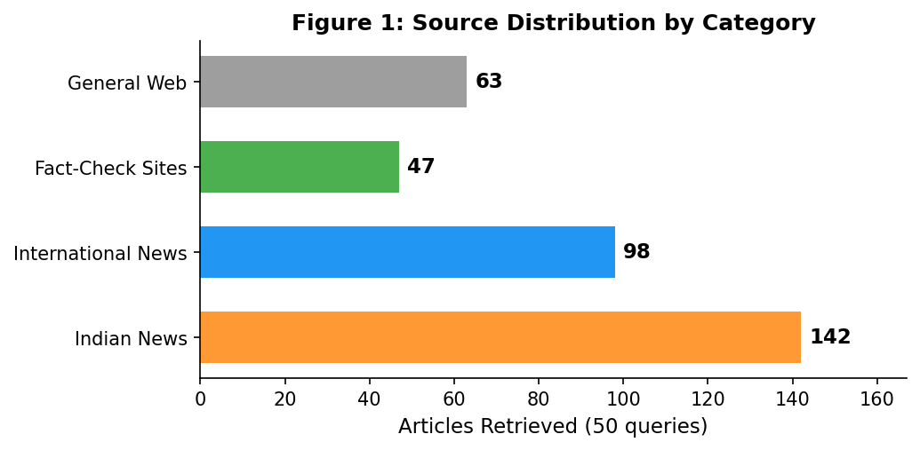

5.3 Search Strategy Effectiveness
The multi-strategy search approach was critical for maximizing evidence coverage:
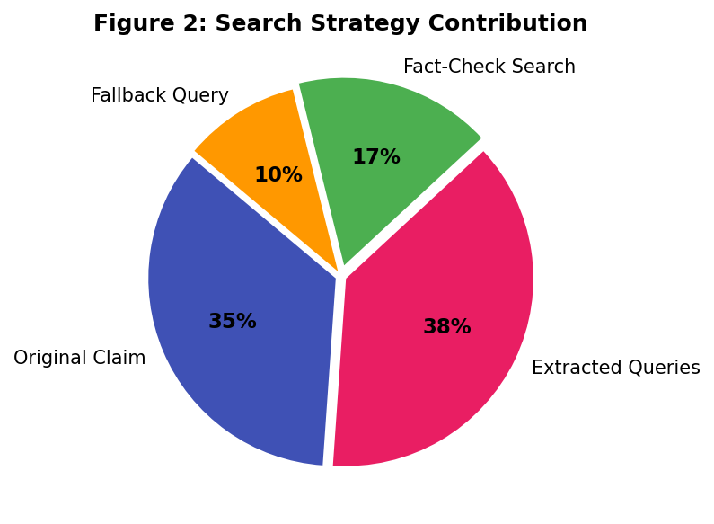

5.4 Limitations
- API Dependency — outages or rate limits on Groq/DuckDuckGo affect availability.
- Text-Only — no image, deepfake, or video analysis currently.
- Latency — 8–15 seconds per query due to multi-pass pipeline.
- English Only — does not support Hindi, Marathi, Tamil, or other regional languages.
- Search Coverage — DuckDuckGo may miss hyper-local or very recently published articles.

6. Future Scope and Research Directions
The field of automated fact-checking is rapidly evolving. The following directions represent promising avenues for extending TruthLens and advancing the state of the art.

6.1 Multimodal Misinformation Detection
Future versions could integrate reverse image search (Google Vision API, TinEye), video frame analysis using convolutional neural networks, and deepfake detection models such as Microsoft's Video Authenticator. Combining text-based verification with visual analysis would substantially broaden coverage.

6.2 Regional Language Support
Multilingual LLMs such as IndicBERT (Kakwani et al., 2020) and Google's MuRIL support 11+ Indian languages. Integration would enable processing claims in Hindi, Marathi, Tamil, Bengali — reaching populations most targeted by misinformation campaigns.

6.3 Browser Extension and WhatsApp Integration
A Chrome extension for one-click verification and a WhatsApp Business API chatbot would maximize accessibility — addressing the platform where misinformation spreads most rapidly in India.

6.4 Blockchain-Based Verification Ledger
A blockchain-based immutable ledger of fact-checks could provide tamper-proof, cross-platform trust. Once verified, a verdict could be referenced by any application without re-analysis.

6.5 Federated Learning for Privacy
Federated learning could enable model improvement without centralizing sensitive user data — particularly relevant given India's Digital Personal Data Protection Act (2023).

6.6 Comparative Benchmarking
Future work should include formal benchmarking against established datasets such as LIAR, FEVER, and MultiFC, providing standardized accuracy, precision, recall, and F1-score metrics.
Table 6: Future Enhancement Roadmap
Enhancement | Technology | Impact | Timeline
Multimodal Analysis | Google Vision API, CNNs | Cover image/video misinfo | 6–12 months
Regional Languages | IndicBERT, MuRIL | Reach non-English users | 3–6 months
Browser Extension | Chrome Extension API | One-click verification | 2–3 months
WhatsApp Chatbot | WhatsApp Business API | Mass accessibility in India | 3–4 months
Blockchain Ledger | Ethereum / Polygon | Tamper-proof records | 12+ months
Federated Learning | TensorFlow Federated | Privacy-preserving updates | 12+ months

7. Conclusion
This literature review has situated TruthLens — a two-pass, RAG-based fake news detection tool — within the broader landscape of automated fact-checking research. The review demonstrates that while traditional machine learning and deep learning approaches have achieved high accuracy on benchmark datasets, they are fundamentally limited by their reliance on static training data and inability to access current information.
The retrieval-augmented generation paradigm, which TruthLens adopts, addresses these limitations by grounding the language model's reasoning in real-time web evidence from curated, reputed sources. The comparative analysis reveals that TruthLens occupies a unique position — combining AI-powered analysis with transparency and accessibility, while adding comprehensive Indian source coverage.
Looking ahead, the integration of multimodal analysis, regional language support, and accessible deployment channels (browser extensions, WhatsApp chatbots) could transform TruthLens from a prototype into a tool with meaningful real-world impact in the fight against misinformation.

References
[1] IAMAI, "India Internet Report 2024," Internet and Mobile Association of India, 2024. https://www.iamai.in/research
[2] N. Newman et al., "Reuters Institute Digital News Report 2024," University of Oxford, 2024. https://reutersinstitute.politics.ox.ac.uk/digital-news-report/2024
[3] K. Shu et al., "Fake news detection on social media: A data mining perspective," ACM SIGKDD Explorations, vol. 19, no. 1, pp. 22–36, 2017. https://doi.org/10.1145/3137597.3137600
[4] V. Pérez-Rosas et al., "Automatic detection of fake news," Proc. COLING, pp. 3391–3401, 2018. https://aclanthology.org/C18-1287/
[5] W. Y. Wang, "Liar, liar pants on fire: A new benchmark dataset for fake news detection," Proc. ACL, pp. 422–426, 2017. https://doi.org/10.18653/v1/P17-2067
[6] N. Ruchansky et al., "CSI: A hybrid deep model for fake news detection," Proc. CIKM, pp. 797–806, 2017. https://doi.org/10.1145/3132847.3132877
[7] A. Vaswani et al., "Attention is all you need," Proc. NeurIPS, pp. 5998–6008, 2017. https://arxiv.org/abs/1706.03762
[8] J. Devlin et al., "BERT: Pre-training of deep bidirectional transformers," Proc. NAACL-HLT, pp. 4171–4186, 2019. https://arxiv.org/abs/1810.04805
[9] H. Ahmed et al., "Detecting opinion spams and fake news using text classification," Security and Privacy, vol. 1, e9, 2018. https://doi.org/10.1002/spy2.9
[10] V. Sanh et al., "DistilBERT, a distilled version of BERT: smaller, faster, cheaper, lighter," 2019. https://arxiv.org/abs/1910.01108
[11] P. Lewis et al., "Retrieval-augmented generation for knowledge-intensive NLP tasks," Proc. NeurIPS, pp. 9459–9474, 2020. https://arxiv.org/abs/2005.11401
[12] Y. Pan et al., "Fact-checking complex claims with program-guided reasoning," Proc. ACL, pp. 6981–7004, 2023. https://doi.org/10.18653/v1/2023.acl-long.386
[13] C. Chen and K. Shu, "Can LLMs effectively leverage graph-structured information for fake news detection?" Proc. ACM Web Conf., 2024. https://doi.org/10.1145/3589334.3645685
[14] D. Thaker, "The landscape of fact-checking in India," Reuters Institute, University of Oxford, 2023. https://reutersinstitute.politics.ox.ac.uk/
[15] Google, "Fact Check Explorer." https://toolbox.google.com/factcheck/explorer
[16] N. Hassan et al., "ClaimBuster: The first-ever end-to-end fact-checking system," VLDB, vol. 10, no. 7, pp. 1945–1948, 2017. https://doi.org/10.14778/3137765.3137815

