UNLOCKING INSIGHTS INTO THE GLOBAL AIR TRANSPORTATION NETWORK WITH TABLEAU

INTRODUCTION:
Unlocking Insights into the Global Air Transporttion Network with Tableau
Creating Dashboard,Story using Tablueau and analyzing Glonal Air Transportation.

PROJECT DESCRIPTION:
Air Transportation is the transportation of passengers and goods via aircrafts. The global air transportation market is expected to witness significant growth in the forecast period owing to the increasing air passenger traffic, growing number of airport expansion projects, and rising demand for air freight servicesPromote the development and growth of international air transportation. Promote and guarantee collaboration between the different international air transport companies. Strengthen safety within all areas of air transportation. Creation of international air traffic rules and regulationsAir transport is an important enabler to achieving economic growth and development. Air transport facilitates integration into the global economy and provides vital connectivity on a national, regional, and international scale. It helps generate trade, promote tourism, and create employment opportunities.

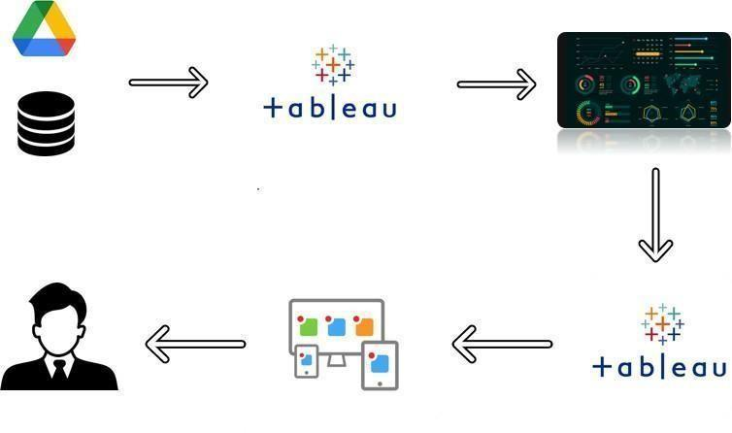

OVERVIEW:
Air Transportation is the transportation of passengers and goods via aircrafts. The global air transportation market is expected to witness significant growth in the forecast period owing to the increasing air passenger traffic, growing number of airport expansion projects, and rising demand for air freight services.

PROPOSE:
The importance of air transport lies in its ability as an economic engine to generate and support jobs, strengthen trade and connectivity between people and countries, promote tourism, and connect remote communities.

PROBLEM STATEMENT AND DESIGN THINGING:
Over recent decades, it has become crucial to develop and refine skills that allow us to understand and act on rapid changes in our environment. The world has become increasingly interconnected and complex, with increased expectations and a lot of unknowns. Design thinking offers a means to grapple with all this change in a human-centric way.
Analytics is an essential component of organizations’ success and is being applied to business and big data to describe, predict, and improve business performance. While there are mature and innovative frameworks for the concepts of business intelligence (BI) and analytics, this article will explore how using a design thinking framework, can enable BI & analytics to contribute more towards creating organization and shareholder value.
First, let’s look at what design thinking is.
Brief Intro to Design Thinking
Design thinking is a design methodology that provides a solution-based approach to solving problems. It’s extremely useful in tackling complex problems that are ill-defined or unknown by understanding the human needs involved, re-framing the problem in human-centric ways, brainstorming many ideas, and adopting a hands-on approach in prototyping and testing.
Design thinking is a process for creative problem-solving that has a human-centered core.

EMPATHY MAP :
DASHBOARDS AND STORY:

