

**VNR Vignana Jyothi Institute of Engineering and Technology**

**(Affiliated to J.N.T.U, Hyderabad)**

**Bachupally(v), Hyderabad, Telangana, India.**

**CHAT APPLICATION USING IPC SOCKETS**

A course project submitted in complete requirements for the award of the degree of

**BACHELOR OF TECHNOLOGY**

**IN**

**COMPUTER SCIENCE AND BUSINESS SYSTEMS**

Submitted by

22071A3234 - MD MUSHAIB

22071A3236 - MOHAMMED ABDUL MUQUEET

22071A3261 - VURUKONDA SAI TEJA

22071A3262 - YAMARTHI RATNA JASHWANTH

Under the guidance of

**Mr. I Ravindra kumar**

Assistant Professor

Dept. of Computer Science and Engineering



**VNR Vignana Jyothi Institute of Engineering and Technology**

**(Affiliated to J.N.T.U, Hyderabad)**

**Bachupally(v), Hyderabad, Telangana, India.**

# CERTIFICATE

This is to certify that (22071A3234) MD MUSHAIB, (22071A3236) MOHAMMED ABDUL MUQUEET, (22071A3261) VURUKONDA SAI TEJA, (22071A3261) YAMARTHI SAI TEJA have completed their course project work at CSE Department of VNR VJIET, Hyderabad entitled " CHAT APPLICATION USING IPC SOCKETS " in complete fulfillment of the requirements for the award of B.Tech degree during the academic year 2023-2024. This work is carried out under my supervision and has not been submitted to any other University/Institute for award of any degree/diploma.

**Mr. I Ravindra Kumar Dr. S Nagini**

Assistant Professor Associate Professor and Head

CSE Department CSE Department

VNRVJIET VNRVJIET

# DECLARATION

This is to certify that our project report titled “**CHAT APPLICATION USING IPC SOCKETS"** submitted to Vallurupalli Nageswara Rao Institute of Engineering and Technology in complete fulfillment of the requirement for the award of Bachelor of Technology in Computer Science and Engineering is a bonafide report to the work carried out by us under the guidance and supervision of **Mr. I Ravindra Kumar**, Assistant Professor, Department of Computer Science and Engineering, Vallurupalli Nageswara Rao Institute of Engineering and Technology. To the best of our knowledge, this has not been submitted in any form to other universities or institutions for the award of any degree or diploma.

# ACKNOWLEDGEMENT

For two years, VNRVJIET has helped us transform ourselves from mere amateurs in the field of Computer Science into skilled engineers capable of handling any given situation in real-time. We are highly indebted to the institute for everything that it has given us. We would like to express our gratitude towards the principal of our institute, **Dr. Challa Dhanunjaya Naidu,** and the Head of the Computer Science & Engineering Department, **Dr. S. Nagini** for their kind cooperation and encouragement who helped us complete the project in the stipulated time. Although we have spent a lot of time and put a lot of effort into this project, it would not have been possible without the motivating support and help of our project guide **Mr.Indurthi Ravindra Kumar** We thank him for his guidance, and constant supervision, and for providing necessary information to complete this project. Our thanks and appreciation also go to all the faculty members, staff members of VNRVJIET, and all our friends who have helped us put this project together.

# ABSTRACT

In today's digital world, it's crucial to communicate effectively online. That's where our project, the "Chat Application using IPC Sockets," comes in they are like a special paths for messages inside your computer. Whether chatting with friends or working together on projects, our app makes it easy and quick. Unlike other systems that need extra services, ours keeps it simple. We use the IPC sockets already built into your computer, making messages move fast and stay safe. Plus, our app is designed to be easy for anyone to use and adapt to their needs, making chatting better for everyone. Our idea is different because it uses IPC sockets that are already built into the computer's operating system. This means messages can move really fast and stay safe without needing extra stuff. Plus, we made sure it's easy for anyone to use and change to fit their needs.

**INDEX**

**S No Topic Page No**

1. Introduction 1 - 3
2. Literature 4 - 6
3. Existing System 7 - 9
4. Proposed System 10 - 12
5. Architecture 13 - 15
6. Software requirement Specification 16 - 17
7. Modules 18 - 19
8. Implementation 20 - 23
9. Results 24 - 28
10. Conclusion and Future Scope 29
11. References 30

**INTRODUCTION**

**The Importance of Effective Communication**

In today's interconnected world, effective communication is more important than ever. Whether it's a casual conversation with friends, a collaborative project among colleagues, or a critical update in a distributed system, the ability to exchange information quickly and reliably is essential. This need is particularly acute in the digital realm, where timely and secure data transfer can make or break a project. To address this necessity, our project, the "Chat Application Using IPC Sockets," harnesses the power of Inter-Process Communication (IPC) sockets to provide a robust, efficient, and user-friendly communication platform.

**Understanding Inter-Process Communication (IPC)**

Inter-Process Communication (IPC) refers to a set of methods and protocols that enable processes to communicate and share data. In a computing environment, processes can be thought of as individual programs or parts of programs running simultaneously. Effective IPC is crucial for the coordination and efficiency of these processes, whether they are operating on a single machine or across multiple systems.

**IPC Sockets: The Backbone of Our Application**

One of the most popular and efficient methods of IPC is through sockets. IPC sockets are endpoints for sending and receiving data between processes. They act as communication channels, facilitating the exchange of messages between processes either on the samemachine or over a network. This capability is vital for numerous applications, from simple local services to complex distributed systems.

**The Role of IPC Sockets in Communication**

**Local and Network Communication**

IPC sockets are versatile. They can be used for high-speed communication within the same system, enabling different parts of a program to coordinate seamlessly. Additionally, they support scalable networking, allowing different applications to communicate over a network. This dual capability makes IPC sockets foundational for both local and distributed applications.

**Advantages of IPC Sockets**

**Speed:**

IPC sockets enable rapid data transfer. Since they operate at a low level within the operating system, they can facilitate communication with minimal latency, which is crucial for time-sensitive applications.

**Security:**

Communication through IPC sockets can be secured more easily than through external services, as data doesn't have to leave the local system.

**Reliability:**

By leveraging the underlying operating system's capabilities, IPC sockets offer robust communication channels that are less prone to errors compared to higher-level communication methods.

**Scalability:**

IPC sockets support both local and network communication, making them ideal for applications that need to scale from a single machine to a distributed network of systems.

**Our Project: Chat Application Using IPC Sockets**

**Project Overview**

Our project aims to develop a chat application that uses IPC sockets for communication. This application is designed to be simple, efficient, and adaptable to various user needs. By leveraging IPC sockets, we can ensure fast and secure message transfer, making our chat application an ideal tool for both personal and professional communication.

**Key Features**

User-Friendly Interface: The application is designed with a focus on ease of use. Users can quickly set up and start using the chat application without needing extensive technical knowledge.

**Fast Message Transfer:**

Thanks to the use of IPC sockets, messages are transferred rapidly, ensuring real-time communication.

**Secure Communication:**

By keeping the communication local (or securely networked), the application minimizes the risk of data breaches and unauthorized access.

**Adaptability:**

The application can be easily adapted to suit different needs, whether it's for casual chatting, team collaboration, or integration into other systems.

**Detailed Explanation of IPC Sockets**

**How IPC Sockets Work**

IPC sockets operate at the operating system level, creating endpoints for processes to communicate. These endpoints can send and receive data packets, much like a postal system, but at a digital and much faster scale. Each process involved in the communication has a socket, and data is exchanged between these sockets.

**Types of IPC Sockets**

**Stream Sockets:**

These provide a reliable, connection-oriented communication channel. They ensure that data is delivered in the same order it was sent, making them ideal for applications where order and reliability are critical.

**Datagram Sockets:**

These offer a connectionless communication method, allowing data to be sent and received without establishing a permanent connection. This can be useful for applications where speed is more critical than reliability.

**Raw Sockets:**

These give processes direct access to lower-layer protocols, allowing for greater control over communication. They are typically used for specialized applications requiring custom protocol implementations.

**Setting Up IPC Sockets**

**Setting up IPC sockets involves several steps:**

**Socket Creation:**

A socket is created using system calls provided by the operating system. This involves specifying the type of socket (e.g., stream or datagram) and the communication domain (e.g., local or network).

**Binding:**

The socket is bound to an address, which can be a local address for communication within the same machine or an IP address for network communication.

**Listening and Accepting Connections:**

For stream sockets, the server process listens for incoming connections, which are then accepted to establish a communication channel.

**Data Transmission:**

Data is sent and received through the socket using read and write operations. The operating system handles the low-level details, ensuring efficient and reliable data transfer.

**Application Design and Implementation**

**User Interface Design**

The user interface (UI) of our chat application is designed to be intuitive and straightforward. Key elements include:

**Chat Window:**

Displays ongoing conversations in a clear, easy-to-read format.

Message Input: A text box for users to type their messages, with a send button to transmit them.

**User List**:

Shows a list of active users, allowing for easy selection and initiation of conversations.

**LITERATURE**

**Historical Development of Inter-Process Communication (IPC)**

Inter-Process Communication (IPC) has evolved significantly over the years, driven by the need for efficient and reliable communication between different processes running on a computer system. Early computing systems were limited in their ability to share data between processes, leading to the development of various IPC methods. These methods include shared memory, message passing, and, importantly, sockets.

**Evolution of Sockets**

Sockets were introduced in the early days of UNIX operating systems as a mechanism for communication between processes. Initially, they were used primarily for network communication, allowing different computers to exchange data over a network. Over time, their use expanded to include communication between processes on the same machine. This development was crucial for the creation of modern, distributed computing systems, where processes often need to communicate across different machines.

**Types of IPC Mechanisms**

**Shared Memory**:

One of the earliest and simplest forms of IPC, shared memory allows multiple processes to access the same memory space. While it is very fast, it requires careful synchronization to avoid conflicts.

**Message Passing:**

This method involves processes sending messages to each other. It is easier to manage than shared memory but can be slower due to the overhead of message copying and transmission.

**Pipes and Named Pipes:**

These provide a unidirectional or bidirectional communication channel between processes. Pipes are useful for simple, linear communication flows.

**Sockets:**

Sockets provide a versatile and powerful means of communication, supporting both local and networked communication. They are the foundation of many modern IPC systems.

**IPC Sockets in Modern Computing**

Today, IPC sockets are a cornerstone of modern computing. They are used extensively in both local and networked applications due to their flexibility and efficiency. For instance, many web servers and database systems rely on sockets for inter-process communication. This widespread use underscores the importance of sockets in ensuring seamless data exchange and coordination between different parts of a program or between different applications.

**Applications of IPC Sockets**

**Web Servers:**

Web servers use sockets to handle multiple client requests simultaneously. Each client connection is managed through a socket, allowing the server to send and receive data efficiently.

**Database Systems:**

Databases often use sockets to manage connections from various applications, facilitating fast and reliable data retrieval and updates.

**Distributed Systems:**

In distributed computing, processes running on different machines need to communicate effectively. Sockets provide the necessary infrastructure for this communication, ensuring that data can be exchanged quickly and securely across the network.

**Case Studies**

**Apache Web Server:**

The Apache web server uses sockets extensively to manage client connections. Each incoming request is handled by a separate process or thread, with sockets providing the communication channel.

**MySQL Database:**

MySQL uses sockets to allow client applications to connect to the database server. This setup ensures that multiple clients can access the database simultaneously without conflicts.

**Distributed Computing Frameworks:**

Frameworks like Hadoop and Spark rely on sockets for communication between different nodes in a cluster. This communication is crucial for coordinating tasks and sharing data across the distributed system.

**Advantages of Using IPC Sockets in Chat Applications**

**Low Latency:**

Sockets provide low-latency communication, which is essential for real-time applications like chat.

**Scalability:**

Sockets can handle multiple simultaneous connections, making them ideal for applications that need to scale to accommodate many users.

**Security:**

By using secure sockets (e.g., TLS/SSL), chat applications can ensure that messages are encrypted and protected from eavesdropping and tampering.

**Reliability:**

Sockets are a mature and well-supported IPC mechanism, with extensive documentation and community support, ensuring that applications built using sockets are reliable and robust.

**Disadvantages:**

Message queues can get overloaded if too many messages are sent at once, leading to delays in communication.

If there's a problem with one part of the system, it can affect the whole system, causing it to stop working properly.

Managing message queues can be complex and require careful coordination to ensure messages are sent and received correctly, which can be difficult for developers to handle.

**Future Trends in IPC**

The future of IPC, particularly with sockets, looks promising. Advances in network technology, such as 5G and beyond, will further enhance the speed and reliability of socket communication. Additionally, the growing trend of microservices and containerization in software development is increasing the demand for efficient IPC mechanisms. Sockets, with their versatility and efficiency, are well-positioned to meet these demands.

**EXISTING SYSTEM**

In modern computing, message queues are widely used for inter-process communication (IPC). They allow different parts of a computer program, often called processes or threads, to send messages to each other. This system is crucial for enabling components of a program to communicate and work together, even if they are running separately. Understanding how message queues work, their benefits, and their drawbacks can help us appreciate why alternative methods like IPC sockets are sometimes preferred.

**How Message Queues Work**

Message queues function as intermediaries that hold messages until they are retrieved by the receiving process. Here’s a simple way to visualize it:

**Sending a Message:**

When a process wants to communicate, it sends a message to a queue.

**Queue Management**: The message queue stores these messages in a structured order, typically first-in-first-out (FIFO).

**Receiving a Message:** The receiving process retrieves the message from the queue and processes it accordingly.

This mechanism is akin to a postal service where letters (messages) are delivered to a mailbox (queue), and the recipient (process) collects the mail when ready.

**Advantages of Message Queues**

**Message queues offer several benefits:**

**Asynchronous Communication:**

Processes can send and receive messages at their own pace, without needing to wait for each other. This can improve the efficiency of a program.

**Decoupling of Components:**

By using message queues, different parts of a program do not need to be directly connected. This makes it easier to modify or update components without disrupting the entire system.

**Scalability:**

Message queues can handle communication between multiple processes, making it easier to scale applications across different servers or machines.

**Disadvantages of Message Queues**

While message queues are useful, they also come with several disadvantages that can impact the performance and reliability of a system:

**Overload and Delays:**

One significant issue with message queues is the potential for overload. If too many messages are sent at once, the queue can become congested. This leads to delays as messages wait to be processed. In time-sensitive applications, such delays can be problematic.

**System Dependency:**

If there is a problem with one part of the system, such as a failure in processing messages, it can have a cascading effect. This means that issues in one component can cause the entire system to malfunction, leading to downtimes and reduced reliability.

**Complex Management:**

Managing message queues can be complex. Developers need to ensure that messages are sent and received correctly, which requires careful coordination. This complexity can make development and maintenance more challenging, increasing the risk of errors and inefficiencies.

**In-Depth Analysis of Disadvantages**

**Overload and Delays**

**Scenario:**

Imagine an e-commerce website during a holiday sale. Thousands of users are placing orders simultaneously. If the system uses message queues to handle these orders, the queue might become overloaded, causing significant delays.

**Impact:**

Customers experience slow responses, leading to dissatisfaction. In some cases, orders might even time out, causing loss of sales.

**System Dependency**

**Scenario:**

Consider a banking system where transactions are processed through message queues. If the transaction processing component fails, all queued transactions are affected.

**Impact:**

Customers are unable to complete transactions, leading to trust issues and potential financial losses for the bank. The entire system might need to be halted to resolve the issue, causing further inconvenience.

**Complex Management**

**Scenario:**

In a complex application with numerous microservices, each microservice might use message queues to communicate. Managing these queues, ensuring messages are delivered in the correct order, and handling failures can be daunting.

**Impact:**

Developers spend significant time troubleshooting and managing queues instead of focusing on developing new features. This can slow down development cycles and increase the likelihood of bugs and inefficiencies.

**Alternatives to Message Queues**

Given these drawbacks, developers often look for alternatives to message queues for certain applications. IPC sockets are one such alternative that can address some of the issues associated with message queues.

**Direct Communication:**

IPC sockets enable direct communication between processes without the need for an intermediary queue. This can reduce delays and improve efficiency.

**Reduced Complexity:**

Managing sockets can be simpler compared to managing message queues. Sockets provide a straightforward way to send and receive messages, reducing the overhead on developers.

**Enhanced Reliability:**

With sockets, communication can be more reliable. If one process fails, it doesn’t necessarily affect the others as critically as with a centralized message queue.

**PROPOSED SYSTEM**

In the realm of inter-process communication (IPC), message queues have been a staple for enabling different parts of a program to communicate effectively. However, message queues come with their own set of challenges, including potential overload, system dependency issues, and complex management. To address these issues, we propose a chat application using IPC sockets, which offers a more streamlined and efficient approach to IPC.

**Overview of IPC Sockets**

IPC sockets, or Inter-Process Communication sockets, serve as communication endpoints used for exchanging data between processes, either on the same machine or over a network. They are akin to virtual cables that connect different parts of a program, allowing them to send and receive data directly. This system offers several advantages over traditional message queues, particularly in terms of performance, reliability, and simplicity.

**Benefits of Using IPC Sockets**

**Direct Communication:**

IPC sockets allow for direct communication between processes without the need for an intermediary, such as a message queue. This direct connection reduces latency and improves the speed of message delivery.

**Scalability:** Sockets are designed to handle multiple connections simultaneously, making them ideal for applications that need to scale to accommodate a large number of users.

**Reliability:** By using sockets, communication can continue even if one part of the system experiences issues. This is because sockets manage connections individually, reducing the risk of a single point of failure.

**Simplified Management**: Sockets provide a straightforward mechanism for sending and receiving messages, which simplifies the development and maintenance process. This reduces the overhead on developers and makes the system easier to manage.

**How IPC Sockets Work in a Chat Application**

In a chat application, IPC sockets can be used to establish direct communication channels between clients and the server. Here’s a step-by-step breakdown of how this works:

**Connection Establishment:**

When a user opens the chat application, the client establishes a connection to the server using a socket. This involves creating a socket object and connecting it to the server’s address and port.

**Message Transmission:**

Once the connection is established, the client can send messages to the server using the socket. The server, in turn, can send messages back to the client through the same socket.

**Real-Time Communication:**

As sockets support real-time communication, messages sent by one user are immediately transmitted to the server and then to the intended recipient(s), ensuring minimal delay.

**Disconnection Handling:**

If a user disconnects, the socket connection is closed gracefully, freeing up resources and ensuring that the system remains stable.

**Advantages Over Message Queues**

**Reduced Latency:**

Since IPC sockets provide direct communication paths, there is no need for intermediary storage or processing, which reduces the latency associated with message delivery.

**Improved Reliability:**

With message queues, a failure in the queue can disrupt the entire system. IPC sockets, on the other hand, isolate communication channels, so a failure in one connection doesn’t necessarily impact others.

**Simplified Development:**

Managing message queues requires careful coordination and handling of message states. IPC sockets, however, offer a more straightforward approach, with simpler APIs and less overhead for developers.

**Real-World Applications and Case Studies**

**Instant Messaging Apps:**

Popular instant messaging applications like WhatsApp and Telegram use socket-based communication to ensure fast and reliable message delivery. These applications handle millions of users simultaneously, demonstrating the scalability of sockets.

**Online Gaming:**

Real-time multiplayer games rely heavily on sockets to manage communication between game clients and servers. This ensures that player actions and game state updates are transmitted with minimal delay.

**Financial Trading Platforms:**

High-frequency trading platforms use IPC sockets to handle rapid data exchange between trading algorithms and market data feeds, ensuring that trades are executed swiftly and accurately.

**Security Considerations**

Implementing a chat application with IPC sockets also involves addressing security concerns to protect user data and ensure privacy:

**Encryption:**

All data transmitted through sockets should be encrypted using protocols like TLS/SSL. This ensures that messages cannot be intercepted or read by unauthorized parties.

**Authentication:**

Users should be authenticated before establishing a socket connection to prevent unauthorized access. This can be achieved using secure login mechanisms and token-based authentication.

**Data Integrity:**

Techniques like checksums and hashes should be used to ensure that messages are not altered during transmission, preserving data integrity.

**Audit Logging:**

Maintain logs of all communication events to monitor for suspicious activity and aid in troubleshooting security incidents.

**Performance Optimization**

To further enhance the performance of the chat application using IPC sockets, consider the following optimization strategies:

**Load Balancing**:

Distribute incoming connections across multiple servers to prevent any single server from becoming a bottleneck. This can be achieved using load balancers that route traffic based on server load.

**Efficient Data Encoding:**

Use efficient data encoding formats like JSON or Protocol Buffers to minimize the size of transmitted messages, reducing bandwidth usage and speeding up communication.

**Asynchronous Communication:**

Implement asynchronous I/O operations to allow the application to handle multiple socket connections concurrently, improving responsiveness and scalability.

**Caching:**

Use caching mechanisms to store frequently accessed data in memory, reducing the need for repeated database queries and speeding up data retrieval.

**ARCHITECTURE**

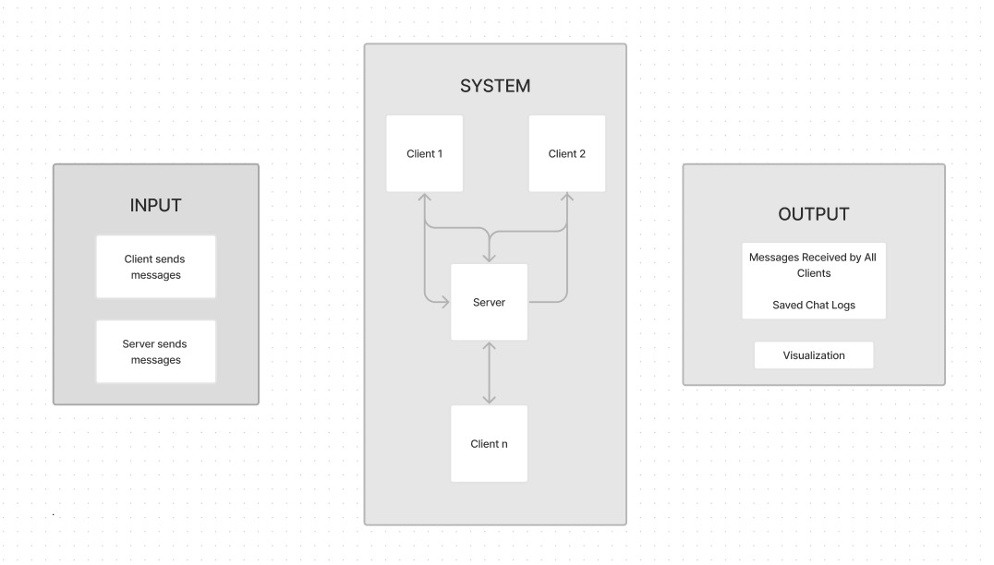

In our project, the chat application utilizes IPC (Inter-Process Communication) sockets to enable real-time communication between users. Kali Linux, known for its robust security features, serves as the operating system for our project. Here, we outline the system architecture, highlighting how different components interact to create a seamless chat experience.

**Overview of System Architecture**

The system architecture of our chat application consists of several key components, each playing a vital role in ensuring smooth communication. These components include:

**Client-Side Application:**

The user interface where users send and receive messages.

**Server-Side Application:**

The central hub that manages message routing and user connections.

**IPC Sockets:**

The communication channels that facilitate data exchange between clients and the server.

**Database:**

A storage system for user information and chat history.

**Detailed Component Description**

**Client-Side Application**

**User Interface (UI):**

The client-side application provides an intuitive user interface where users can log in, send messages, view chat history, and receive real-time notifications. The UI is designed to be responsive, ensuring compatibility with various devices, including desktops, laptops, and mobile devices.

**Socket Connection:**

Each client establishes a socket connection to the server upon logging in. This connection remains open to allow real-time communication, enabling users to send and receive messages instantly.

**Server-Side Application**

**Connection Manager:**

The server-side application includes a connection manager that handles incoming socket connections from clients. It ensures that each user is properly connected and maintains a list of active users.

**Message Router:**

The message router is responsible for directing messages from the sender to the appropriate recipient(s). It ensures that messages are delivered promptly and accurately.

**Establishment of Connections:** I

PC sockets are used to establish direct communication channels between clients and the server. These sockets ensure low-latency, real-time data transfer, which is critical for a seamless chat experience.

**Data Transmission:**

Once a socket connection is established, data (such as chat messages) is transmitted in a structured format. The server and clients use predefined protocols to encode and decode these messages, ensuring compatibility and efficient processing.

Database

**User Information Storage:**

The database stores user credentials, such as usernames and passwords, ensuring secure access to the chat application.

**Chat History Storage:** It also keeps a record of all messages exchanged between users. This allows users to view their chat history and retrieve past conversations.

Interaction with Server: The server interacts with the database to authenticate users, store new messages, and retrieve chat history when requested by clients.\

**Security Layers**

**Encryption:**

All data transmitted between clients and the server is encrypted using secure protocols (e.g., TLS/SSL). This ensures that messages cannot be intercepted or read by unauthorized parties.

**Data Integrity:**

Techniques such as checksums and hashes are used to ensure that messages are not altered during transmission, preserving data integrity.

**Built-In Security Tools**:

Kali Linux comes with a wide array of pre-installed security tools that can be used to test and ensure the security of the application.

**Regular Updates:**

The operating system receives frequent updates, which include security patches and enhancements, ensuring that the system remains secure against vulnerabilities.

**Strong Community Support:**

Kali Linux has a strong community and extensive documentation, which can be valuable resources for troubleshooting and optimizing the application.

**Software requirement Specification**

**Software Requirements**

**Operating System**

**Windows:** The application will run on Windows operating systems. This ensures compatibility with a wide range of personal computers.

Programming Language

**Python:** Python will be used for developing the application. Python is chosen for its simplicity, readability, and extensive libraries that facilitate rapid development.

IPC Sockets

**Utilize IPC (Inter-Process Communication) Sockets:** IPC sockets will be used for real-time communication between processes. This ensures efficient and direct message passing without intermediary steps, leading to faster and more reliable communication.

**GUI (Graphical User Interface)**

**User-Friendly Interface:** The application will include a user-friendly interface. The GUI will be designed to be intuitive and easy to navigate, allowing users to interact with the application seamlessly.

**Hardware Requirements**

**Processor**

**At least Intel Core i3 / AMD Ryzen 3**: A minimum of an Intel Core i3 or AMD Ryzen 3 processor is required. These processors are sufficient for handling the computational demands of the chat application.

**Memory (RAM**)

**At least 4GB of RAM:** A minimum of 4GB of RAM is recommended to ensure smooth operation. This amount of memory helps the application run efficiently, even when handling multiple users and messages simultaneously.

Storage

**At least 32GB of Storage**: A minimum of 32GB of storage is necessary. This provides enough space for the operating system, the chat application, and any saved chats or other data.

**Functional Requirements**

**Send and Receive Messages in Real-Time:** Users will be able to send and receive messages instantly. This real-time communication is essential for creating a seamless chat experience.

**Allow Users to Save Chats**: The application will provide functionality for users to save their chat history. This allows users to keep records of their conversations for future reference.

**Non-Functional Requirements**

**Prompt Response to User Actions:** The application should respond quickly to user inputs, ensuring minimal latency. This includes sending and receiving messages and navigating through the application.

**Real-Time Communication**: Messages should be delivered in real-time, with no noticeable delay, to maintain the flow of conversation.

**User Interface**

**Intuitive and Aesthetically Pleasing Design:** The GUI should be designed to be both intuitive and visually appealing. An intuitive design helps users navigate the application easily, while an attractive interface enhances the overall user experience.

**Consistency:** The interface should have a consistent look and feel across all screens and functions. This helps users understand and predict how to interact with the application.

Maintainability

**Clean and Modular Code:** The application will be developed with clean, modular code. This means breaking down the application into manageable, self-contained modules or components.

**Ease of Updates:** A modular codebase makes it easier to update and maintain the application. New features can be added or existing features modified without affecting the entire system.

Documentation: Comprehensive documentation will be provided. This includes code comments, user manuals, and developer guides to facilitate future maintenance and development.

**MODULES**

In developing our chat application using IPC sockets, the project is divided into several key modules. Each module plays a specific role in ensuring the application functions smoothly and efficiently. Below, we provide a simple overview of each module and its purpose.

#### **1. User Interface (UI) Module**

* **Purpose**: This module handles the visual aspects of the application, allowing users to interact with the chat system easily.
* **Components**:
  1. **Chat Window**: The main area where users can send and receive messages.
  2. **User List**: Displays a list of online users.
  3. **Settings**: Allows users to customize their chat experience (e.g., change themes, notification settings).

#### **2. Authentication Module**

* **Purpose**: This module manages user authentication, ensuring that only authorized users can access the chat application.
* **Components**:
  1. **Login Verification**: Checks user credentials against stored data to grant access.
  2. **User Registration**: Allows new users to create an account.
  3. **Password Management**: Provides functionalities for password reset and updates.

#### **3. Communication Module**

* **Purpose**: This module is responsible for establishing and managing the communication channels between clients and the server using IPC sockets.
* **Components**:
  1. **Socket Management**: Handles the creation, maintenance, and termination of socket connections.
  2. **Message Encoding/Decoding**: Converts messages into a transmittable format and back into readable text upon receipt.
  3. **Real-Time Data Transfer**: Ensures that messages are sent and received in real-time with minimal delay.

#### **4. Server Module**

* **Purpose**: This module acts as the central hub for managing user connections and message routing.
* **Components**:
  1. **Connection Manager**: Manages all active connections, ensuring each user is connected properly.
  2. **Message Router**: Directs incoming messages to the correct recipient(s).
  3. **User Presence Tracker**: Keeps track of online users and their statuses.

#### **5. Database Module**

* **Purpose**: This module handles data storage, including user information and chat history.
* **Components**:
  1. **User Database**: Stores user credentials and profile information.
  2. **Chat History Database**: Records all chat messages for retrieval and storage.
  3. **Data Retrieval and Storage**: Provides functions to save and access data as needed.

**IMPLEMENTATION**

**Server Code:**

import socket

import threading

import tkinter as tk

from tkinter import scrolledtext, filedialog

# Function to handle client connections and receive messages

def handle_client(client_socket, text_area):

while True:

try:

message = client_socket.recv(1024).decode('utf-8')

if not message:

break

client_index = clients.index(client_socket) + 1

text_area.config(state=tk.NORMAL)

text_area.insert(tk.END, f"Client{client_index}: {message}\n")

text_area.yview(tk.END)

text_area.config(state=tk.DISABLED)

broadcast(f"Client{client_index}: {message}", client_socket)

except:

client_socket.close()

break

# Function to broadcast messages to all clients

def broadcast(message, exclude_socket):

for client in clients:

if client != exclude_socket:

try:

client.send(message.encode('utf-8'))

except:

client.close()

clients.remove(client)

# Function to send messages from the server

def send_message(text_area, message_entry):

message = message_entry.get()

text_area.config(state=tk.NORMAL)

text_area.insert(tk.END, f"Server: {message}\n")

text_area.yview(tk.END)

text_area.config(state=tk.DISABLED)

message_entry.delete(0, tk.END)

broadcast(f"Server: {message}", None)

# Function to save the chat to a file

def save_chat(text_area):

chat_content = text_area.get("1.0", tk.END)

if chat_content.strip():

file_path = filedialog.asksaveasfilename(defaultextension=".txt",

filetypes=[("Text files", "*.txt"), ("All files", "*.*")])

if file_path:

with open(file_path, "w") as file:

file.write(chat_content)

# Main function to set up the server and GUI

def main():

global clients

clients = []

server = socket.socket(socket.AF_INET, socket.SOCK_STREAM)

server.bind(('0.0.0.0', 5555))

server.listen(5)

print("Server listening on port 5555...")

root = tk.Tk()

root.title("Server Chat Application")

root.geometry('500x500')

root.configure(bg='#282c34')

text_area = scrolledtext.ScrolledText(root, state=tk.DISABLED, wrap=tk.WORD, bg="#f4f4f4", font=("Arial", 12))

text_area.pack(padx=20, pady=10, fill=tk.BOTH, expand=True)

message_entry = tk.Entry(root, width=50, font=("Arial", 12))

message_entry.pack(padx=20, pady=10, fill=tk.X)

button_frame = tk.Frame(root, bg='#282c34')

button_frame.pack(padx=20, pady=10, fill=tk.X)

send_button = tk.Button(button_frame, text="Send", command=lambda: send_message(text_area, message_entry), bg="#007BFF", fg="white", font=("Arial", 12), activebackground="#0056b3", activeforeground="white")

send_button.pack(side=tk.LEFT, padx=(0, 10))

save_button = tk.Button(button_frame, text="Save Chat", command=lambda: save_chat(text_area), bg="#28a745", fg="white", font=("Arial", 12), activebackground="#218838", activeforeground="white")

save_button.pack(side=tk.RIGHT)

threading.Thread(target=accept_connections, args=(server, text_area)).start()

root.mainloop()

def accept_connections(server, text_area):

while True:

client_socket, addr = server.accept()

clients.append(client_socket)

print(f"Accepted connection from {addr}")

threading.Thread(target=handle_client, args=(client_socket, text_area)).start()

if __name__ == "__main__":

main()

**Client Code:**

import socket

import threading

import tkinter as tk

from tkinter import scrolledtext, filedialog

from tkinter import messagebox

# Function to handle receiving messages

def receive_messages(client_socket, text_area):

while True:

try:

message = client_socket.recv(1024).decode('utf-8')

if not message:

break

text_area.config(state=tk.NORMAL)

text_area.insert(tk.END, f"{message}\n")

text_area.yview(tk.END)

text_area.config(state=tk.DISABLED)

except:

messagebox.showerror("Error", "An error occurred!")

client_socket.close()

break

# Function to send messages

def send_message(client_socket, message_entry, text_area):

message = message_entry.get()

client_socket.send(message.encode('utf-8'))

text_area.config(state=tk.NORMAL)

text_area.insert(tk.END, f"You: {message}\n")

text_area.yview(tk.END)

text_area.config(state=tk.DISABLED)

message_entry.delete(0, tk.END)

# Function to save the chat to a file

def save_chat(text_area):

chat_content = text_area.get("1.0", tk.END)

if chat_content.strip():

file_path = filedialog.asksaveasfilename(defaultextension=".txt",

filetypes=[("Text files", "*.txt"), ("All files", "*.*")])

if file_path:

with open(file_path, "w") as file:

file.write(chat_content)

# Main function to set up the GUI and connect to the server

def main():

client_socket = socket.socket(socket.AF_INET, socket.SOCK_STREAM)

client_socket.connect(('127.0.0.1', 5555))

root = tk.Tk()

root.title("Client Chat Application")

root.geometry('500x500')

root.configure(bg='#282c34')

text_area = scrolledtext.ScrolledText(root, state=tk.DISABLED, wrap=tk.WORD, bg="#f4f4f4", font=("Arial", 12))

text_area.pack(padx=20, pady=10, fill=tk.BOTH, expand=True)

message_entry = tk.Entry(root, width=50, font=("Arial", 12))

message_entry.pack(padx=20, pady=10, fill=tk.X)

button_frame = tk.Frame(root, bg='#282c34')

button_frame.pack(padx=20, pady=10, fill=tk.X)

send_button = tk.Button(button_frame, text="Send", command=lambda: send_message(client_socket, message_entry, text_area), bg="#007BFF", fg="white", font=("Arial", 12), activebackground="#0056b3", activeforeground="white")

send_button.pack(side=tk.LEFT, padx=(0, 10))

save_button = tk.Button(button_frame, text="Save Chat", command=lambda: save_chat(text_area), bg="#28a745", fg="white", font=("Arial", 12), activebackground="#218838", activeforeground="white")

save_button.pack(side=tk.RIGHT)

threading.Thread(target=receive_messages, args=(client_socket, text_area)).start()

root.mainloop()

if __name__ == "__main__":

main()

**RESULTS**

**Server Output:**

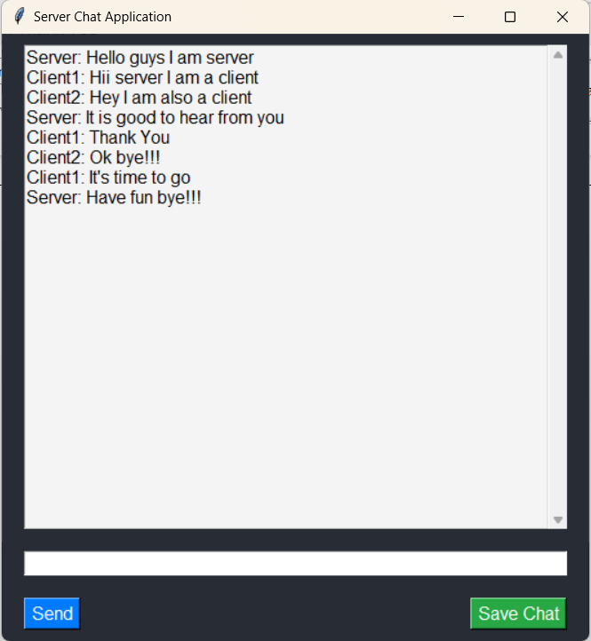

**Client 1 Output:**

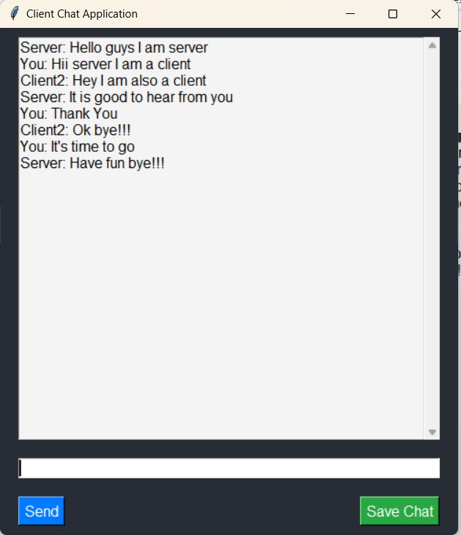

**Client 2 Output:**

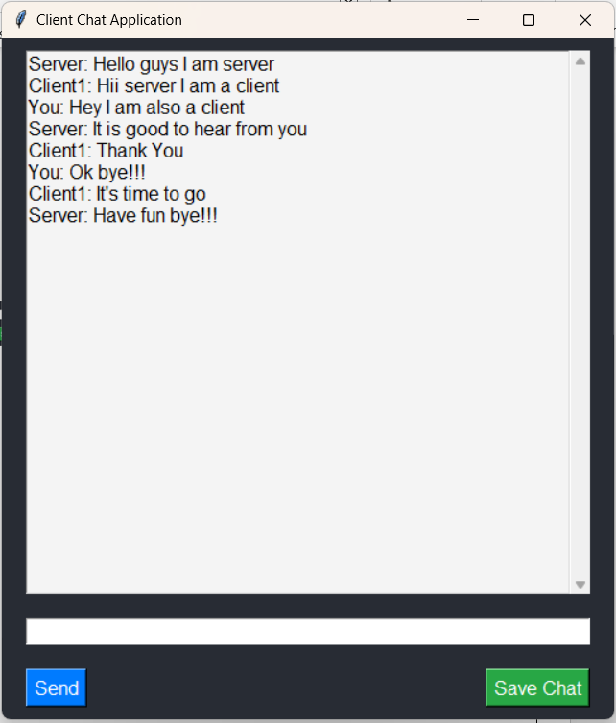

**Entire Chat View:**

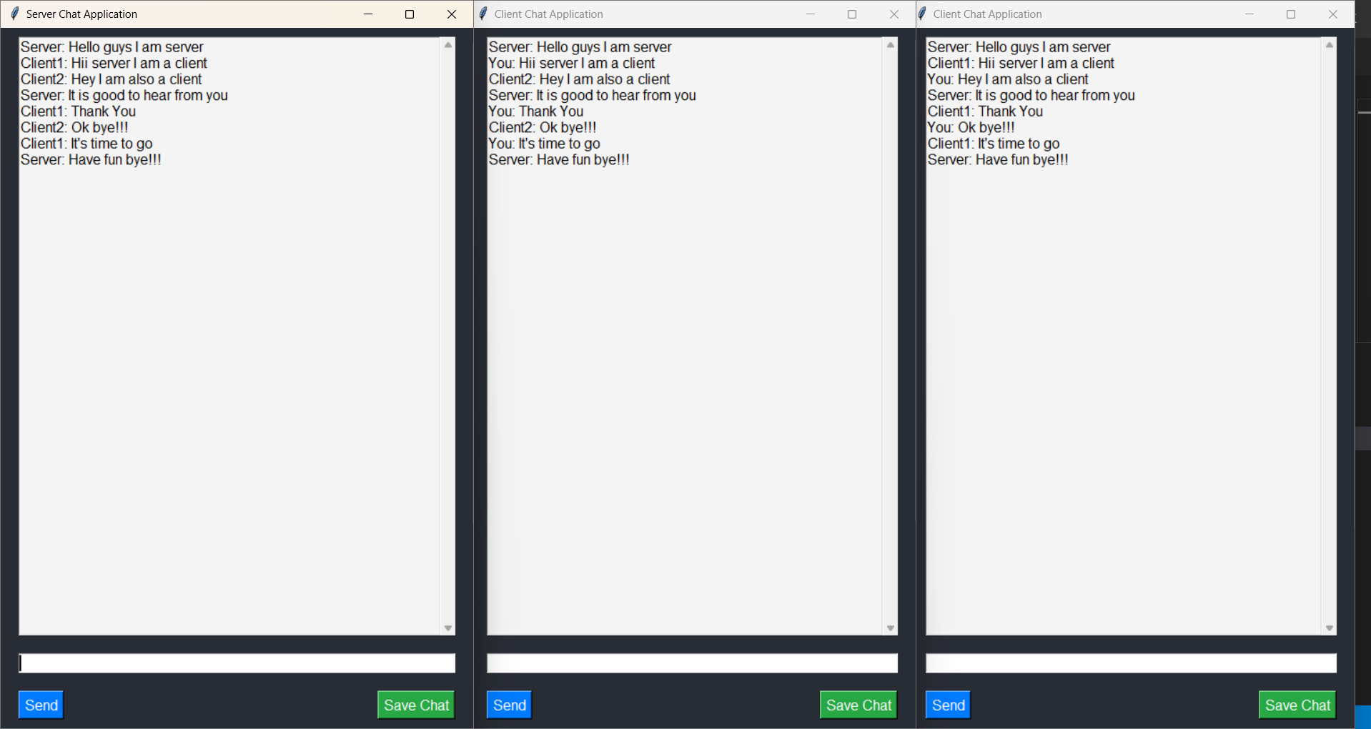

**Save Chat option:**

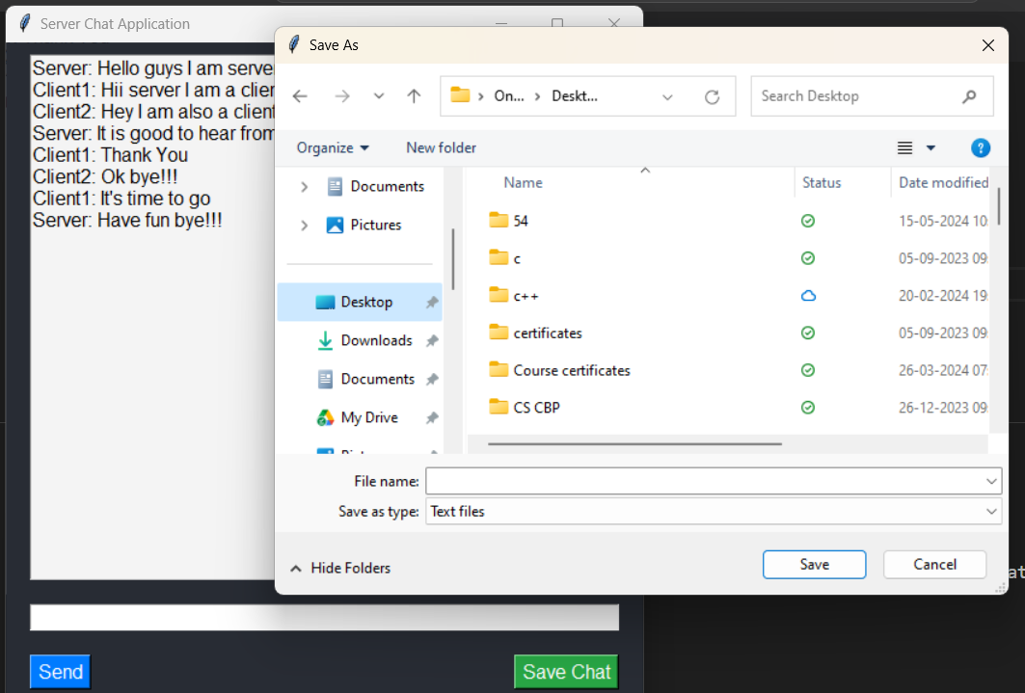

**CONCLUSION AND FUTURE SCOPE**

Developing the chat application using IPC sockets on the Windows platform with Python has been a journey focused on creating a user-friendly and efficient communication tool. By leveraging IPC sockets, we've ensured real-time messaging capabilities with minimal latency, enhancing user experience significantly. The modular architecture and clean coding practices have facilitated easier development and maintenance, ensuring the application's reliability and scalability.

### **Future Scope**

Looking ahead, there are several avenues for enhancing and expanding the chat application:

* **Additional Features**: Introduce features such as multimedia file sharing, voice messaging, and group chat functionalities to enrich user interaction.
* **Enhanced Security**: Implement advanced security measures like end-to-end encryption to further protect user data and privacy.
* **Cross-Platform Compatibility**: Extend support for other operating systems beyond Windows, such as macOS and Linux, to reach a broader audience.
* **Performance Optimization**: Continuously optimize performance to handle larger user bases and ensure smoother operation under varying network conditions.
* **Integration with Cloud Services**: Integrate with cloud storage services for seamless backup and synchronization of chat history across devices.
* **User Interface Refinements**: Conduct user testing and gather feedback to refine the interface, making it even more intuitive and visually appealing.
* **Analytics and Insights**: Implement analytics tools to gather usage data and insights, helping to understand user behavior and improve application features.

By pursuing these future enhancements, we aim to evolve the chat application into a versatile and indispensable tool for modern communication needs, catering to both personal and professional use cases. The ongoing commitment to innovation and user-centric design will ensure that the application remains relevant and valuable in an ever-changing digital landscape.

**REFERENCES**

* <https://opensource.com/article/19/4/interprocess-communication-linux-networking>
* <https://users.cs.cf.ac.uk/Dave.Marshall/C/node28.html>
* <https://en.wikipedia.org/wiki/Unix_domain_socket>
* <https://www.geeksforgeeks.org/chat-application-between-two-processes-using-signals-and-shared-memory/>
* <https://himanshikabra-cse22.medium.com/chat-server-using-socket-programming-26b4e346300f>
* <https://www.ijraset.com/research-paper/realtime-chat-application-using-client-server-architecture>
* <https://www.oreilly.com/library/view/advanced-programming-in/9780321638014/ch16.html>
* <https://link.springer.com/chapter/10.1007/978-1-4842-7045-5_4>
* <https://www.cs.cornell.edu/courses/cs4450/2021sp/lecture11-socket-programming.pdf>
* <https://austingwalters.com/introduction-to-ipc-sockets/>
* <https://www.qnx.com/developers/docs/qnx_4.25_docs/tcpip50/prog_guide/sock_ipc_tut.html>
* <https://users.cs.cf.ac.uk/Dave.Marshall/C/node28.html>
* <https://medium.com/techanic/docker-containers-ipc-using-sockets-part-1-2ee90885602c>
* <https://realpython.com/python-sockets/>
* <https://en.wikipedia.org/wiki/Unix_domain_socket>
* <https://serverfault.com/questions/124517/what-is-the-difference-between-unix-sockets-and-tcp-ip-sockets>
* <https://serverfault.com/questions/124517/what-is-the-difference-between-unix-sockets-and-tcp-ip-sockets>
* <https://dl.acm.org/doi/book/10.5555/582518>
* <https://www.ibm.com/docs/en/aix/7.2?topic=concepts-sockets>
* <https://takethenotes.com/socket/>

+