Investigating Gaze-Assisted Object Selection in Virtual Reality
COMP3180 Research Proposal
Name: Viet Phi Long Le
Student ID: 48027480
Topic Category: VR Eyes Gaze-assisted Object Selection project

Introduction
Virtual reality (VR) interaction design increasingly depends on how users select and manipulate objects in 3D space, and eye tracking is becoming a standard hardware feature in modern headsets such as the Vive Focus Vision. This creates industry interest in gaze-based input as a complement to, or replacement for, traditional handheld controllers. However, gaze data reflects visual attention rather than deliberate intent, a limitation widely known in HCI research as the “Midas Touch” problem: if every look becomes a selection, users trigger unwanted interactions constantly. This project investigates a specific, research-informed alternative: gaze-assisted target selection, where eye gaze determines the target of interest and a controller trigger provides deliberate confirmation. The project compares this hybrid technique against conventional controller-ray pointing across selection time, accuracy, and perceived usability, and additionally examines how target size affects each technique’s performance. Rather than assuming gaze-based selection is inherently superior, the project treats interaction method as an empirical question, consistent with recent literature showing context-dependent trade-offs between eye- and controller-based input. For the games industry, where VR titles must support fast, comfortable and error-tolerant interaction to remain commercially viable, evidence about when gaze-assisted selection helps or hinders provides practical, transferable guidance for interaction designers working with next-generation, eye-tracking-enabled hardware.

Literature Review

Adhanom, I. B., MacNeilage, P., & Folmer, E. (2023). Eye Tracking in Virtual Reality: A Broad Review of Applications and Challenges. Virtual Reality, 27, 1481–1505.
This is a broad survey reviewing the range of applications and open challenges for eye tracking across VR research.
This review situates the current project's technique within the broader landscape of VR eye-tracking research, surveying use cases such as foveated rendering, avatar gaze and attention analysis alongside gaze-based interaction, and cataloguing recurring technical and human-factors challenges. What is most relevant to this project is its framing of gaze-based selection as only one of many competing uses for eye-tracking data in VR, and its discussion of hardware-level limitations — tracking accuracy, calibration drift, and individual differences in gaze behaviour — that any gaze-interaction system must design around. It also reinforces that gaze naturally reflects exploratory visual attention rather than deliberate action, motivating confirmation-based designs rather than raw gaze-driven selection. This broad framing helped move my project away from an initial gaze-only concept toward a gaze-plus-confirmation design early in the research process.
Usefulness: establishes the technical and conceptual landscape that justifies why this project pairs gaze with a controller confirmation mechanism rather than treating gaze as a stand-alone input channel.

Hou, W.-J., & Chen, X.-L. (2021). Comparison of Eye-Based and Controller-Based Selection in Virtual Reality. International Journal of Human–Computer Interaction, 37(5), 484–495.
This is an empirical study directly comparing eye-based and controller-based object selection performance in VR.
Because this paper directly compares the two input modalities examined in this project, it is the closest existing analogue to the planned experiment. Its central relevance is evidence that controller-based selection can be highly accurate and efficient, cautioning against the assumption that gaze-based methods are automatically faster or more usable simply because they align with natural visual attention. This directly informed the framing of the research question as an investigation of trade-offs rather than an attempt to demonstrate gaze superiority, and reinforced the decision to measure both conditions on equal terms rather than treating controller pointing as merely a weaker baseline.
Usefulness: provides the closest direct empirical precedent for the project’s central comparison and guards against overclaiming gaze superiority.

Ryu, K., Lee, J.-J., & Park, J.-M. (2019). GG Interaction: A Gaze–Grasp Pose Interaction for 3D Virtual Object Selection. Journal on Multimodal User Interfaces, 13, 383–393.
This paper proposes and evaluates a multimodal technique combining gaze with a hand-grasp pose to select 3D virtual objects.
This paper explores combining gaze with a second, deliberate input to select 3D objects, following the same general design philosophy underlying the gaze-plus-trigger technique used in this project: gaze narrows down the target while a separate physical action confirms intent. Although it uses hand-grasp gestures rather than a controller trigger, it demonstrates that multimodal gaze-based selection is an established design pattern with prior empirical support rather than an idea invented for this project. It also provides a useful point of comparison for the final evaluation — a controller trigger may be faster to learn and more precise to trigger deliberately than a hand pose, at the cost of requiring a handheld device, and this trade-off is worth discussing when interpreting my own results.
Usefulness: confirms that pairing gaze targeting with a distinct confirmation action is an established, validated interaction pattern, and contextualises the specific confirmation modality chosen for this project.

Fernandes, A. S., Schütz, I., Murdison, T. S., & Proulx, M. J. (2025a). Gaze Inputs for Targeting: The Eyes Have It, Not With a Cursor. International Journal of Human–Computer Interaction, 41(19), 12251–12269.
This is an empirical study examining how feedback design — specifically, whether a visible cursor indicates the current gaze target — affects gaze-based targeting.
This study's relevance to this project lies in flagging feedback as a confound: differences observed between gaze and controller conditions in an experiment could stem from feedback design choices as much as from the input modality itself. This raises a methodological concern that must be addressed in the prototype: whatever visual feedback is given for a gaze-hovered target (for example, a highlight outline) needs to be deliberately designed and applied consistently across trials, since inconsistent feedback could confound the comparison between conditions rather than reflect a genuine difference between interaction techniques. This paper therefore shaped the experiment protocol as much as the interaction design itself.
Usefulness: highlights feedback design as a methodological variable that must be controlled for so that observed differences in the experiment can be attributed to the interaction technique itself.

Fernandes, A. S., Murdison, T. S., & Proulx, M. J. (2025b). Looking in Depth: Targeting by Eye and Controller Input for Multi-Depth Target Placement. International Journal of Human–Computer Interaction, 41(13), 7952–7967.
This is an empirical study comparing eye- and controller-based targeting for objects placed at multiple depths in a VR scene.
This is the most directly relevant empirical source for shaping the project’s evaluation design. It examines eye- versus controller-based targeting specifically in multi-depth 3D layouts, finding a context-dependent trade-off: in their multi-depth condition, eye targeting achieved higher reported information throughput (2.86 bits/s versus 2.56 bits/s for the controller) but also a higher miss rate (21% versus 9%). This is important because it directly contradicts a simple “gaze is faster and better” narrative, instead showing speed and accuracy pulling in opposite directions depending on technique. It motivated the decision to measure both selection time and accuracy/miss rate as co-equal dependent variables, and supports including target size as a variable that may interact with interaction technique.
Usefulness: provides the strongest direct precedent and a verified quantitative benchmark for expecting a speed–accuracy trade-off between the two techniques this project compares.

Mohan, P., Goh, W. B., Fu, C. W., & Yeung, S. K. (2018). DualGaze: Addressing the Midas Touch Problem in Gaze Mediated VR Interaction. 2018 IEEE International Symposium on Mixed and Augmented Reality (ISMAR-Adjunct), 79–84.
This paper proposes and evaluates the DualGaze technique, which uses a secondary confirmation signal to prevent unintended selection in gaze-driven VR interaction.
This paper directly targets the core problem this project is designed around: gaze alone triggers unintended selections because visual attention does not equal intent. DualGaze’s proposed solution via a secondary confirmation signal parallels this project’s own gaze-plus-controller-trigger design, reinforcing that the Midas Touch problem is a well-recognised, actively researched limitation rather than a minor implementation detail. It provided the strongest early justification for abandoning the project’s initial gaze-only concept in favour of deliberate confirmation, and it usefully names competing confirmation strategies in the literature, which will help in discussing, in the final evaluation, why a controller trigger was chosen over dwell-time or secondary-gaze confirmation specifically. Early in development I in fact attempted a blink/wink-based secondary-gaze confirmation as an alternative to the controller trigger; time and reliability constraints meant it was set aside before completion, but the attempt, documented in the Development Diary, grounds this trade-off discussion in first-hand experience rather than the literature alone.
Usefulness: directly evidences the Midas Touch problem that motivated the shift from a gaze-only design to the gaze-plus-controller-confirmation technique this project evaluates.

Summary of the Literature
Across these six sources, a consistent pattern emerges: eye tracking is a mature and industry-relevant VR interaction channel, but gaze data alone is an unreliable proxy for user intent, and multiple independent research groups have converged on pairing gaze with a secondary, deliberate confirmation signal (Ryu et al., 2019; Mohan et al., 2018). At the same time, direct performance comparisons (Hou & Chen, 2021; Fernandes et al., 2025b) show that outcomes are highly context-dependent, with gaze-based techniques sometimes trading accuracy for speed rather than outperforming controllers outright, and methodological choices such as feedback design can themselves shape results (Fernandes et al., 2025a). This reveals a live and current gap: while the gaze-plus-confirmation pattern is well established, its specific performance trade-offs against traditional controller pointing are not fixed findings but vary by task, depth, and target properties. This project addresses that gap by implementing and evaluating a controlled gaze-plus-trigger technique against controller pointing on a current, commercially available headset (Vive Focus Vision), directly measuring selection time, accuracy, and perceived usability across two target sizes.

Project Proposal

Learning Goals
My primary motivation for this project is to build practical, industry-relevant VR development skills as a step toward a long-term career in immersive technology — including eventually building narrative-driven VR experiences, and gaining the kind of demonstrated technical experience valued by employers building VR/XR platforms, such as Meta. The following learning goals are structured across Bloom’s taxonomy so that each is specific and measurable:
- Understand: explain the Midas Touch problem and the key trade-offs identified in current eye-tracking-in-VR literature — evaluated by my ability to justify design decisions when questioned.
- Apply: implement a working eye-tracking pipeline in Unity using the Vive Focus Vision via OpenXR, and a controller-ray interaction system, meeting a measurable target of both techniques reliably registering selections in at least 95% of attempts during pilot testing.
- Analyse: analyse quantitative experiment data (selection time, accuracy) and qualitative usability feedback to identify patterns in how interaction technique and target size affect performance, evaluated by the presence of clear, data-supported findings in the evaluation report.
- Evaluate: critically evaluate the gaze-plus-controller design against the controller-only baseline and against designs described in the literature, judged by whether the final reflection accurately identifies genuine limitations rather than only strengths.
- Create: produce a functional, portfolio-ready VR prototype and a short demonstration video suitable for presenting my technical ability to prospective employers in the VR/XR industry.
These goals are directly relevant to industry roles in VR interaction design and technical UX research, both because eye-tracking hardware is becoming standard in commercial headsets and because employers in this space explicitly value demonstrated experience building and evaluating novel input techniques, not only shipping polished game content.

Scoping Evidence
The primary research question guiding this project is: How does gaze-assisted target selection with controller confirmation compare with traditional controller pointing in VR in terms of selection time, accuracy, and perceived usability?
To answer this, I have designed a controlled, two-condition VR prototype rather than a full game, allowing the interaction method to be isolated as the primary independent variable. Condition A uses traditional controller-ray pointing (point and press trigger); Condition B uses gaze-assisted selection (look at target, press controller trigger to confirm). Following further scoping of the literature, I will additionally vary target size (small vs. large) as a second factor, since prior work (Fernandes et al., 2025b) suggests interaction-technique effects are not uniform across target and layout conditions. Primary dependent variables are selection time (from target presentation to confirmed selection), accuracy (miss rate / incorrect-target selection), and perceived usability, gathered via a short post-condition questionnaire (adapted from the System Usability Scale) and brief structured interview questions.
Technical feasibility work already completed: I have created a Unity 6 project using the VR Core template with the XR Interaction Toolkit, Input System, Cinemachine, and Unity UI (UGUI) packages, and implemented and compiled a working target-selection script that enforces the gaze-targets/controller-confirms interaction pattern, using Unity’s built-in XR Simple Interactable and hover-event system. This script began as an adaptation of a published Unity gaze-interaction reference project built for an older editor (Unity 2021.2.10f1 / 2022.3.25f1); migrating it onto the lab’s Unity 6000.3.7f1 install surfaced several breaking API changes, notably Cinemachine’s namespace change and a knock-on assembly/entry-point resolution error, both logged in full in the Development Diary. I have also planned the OpenXR-based integration route for Vive Focus Vision eye tracking (VIVE OpenXR plugin, Eye Gaze Interaction Profile, and a Tracked Pose Driver feeding an XR Gaze Interactor), which avoids dependency on a closed, Vive-proprietary SDK and satisfies the unit’s requirement that a free/open access route is used. Remaining feasibility work is to confirm on-device that real gaze pose data streams correctly through this pipeline, which I plan to test in the VR lab in the coming weeks. User testing will be conducted with 4–5 classmates/students with their informed consent, consistent with unit guidance that formal ethics approval is not required provided the Code of Ethics is followed.
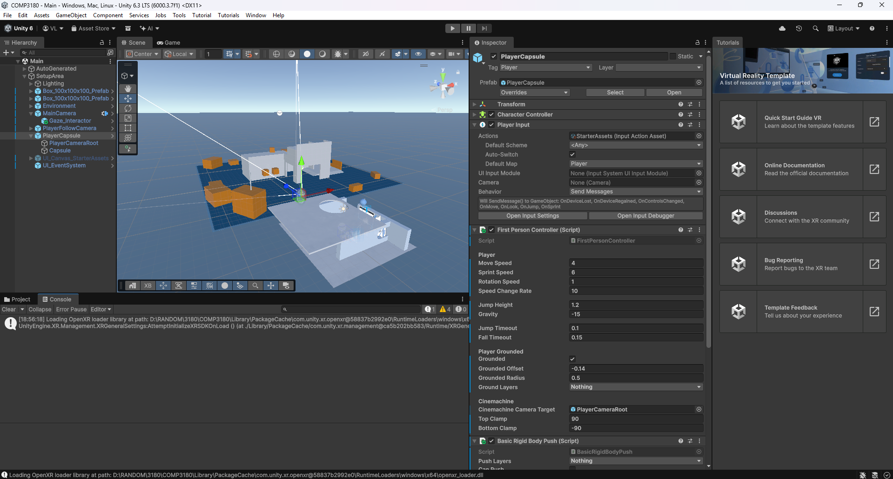
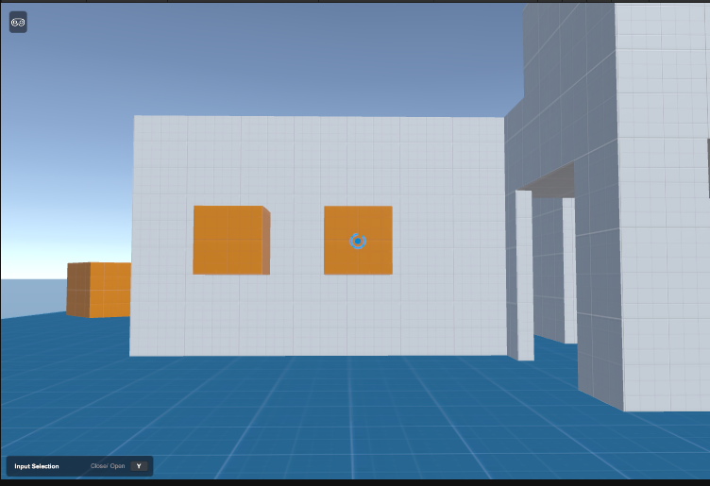
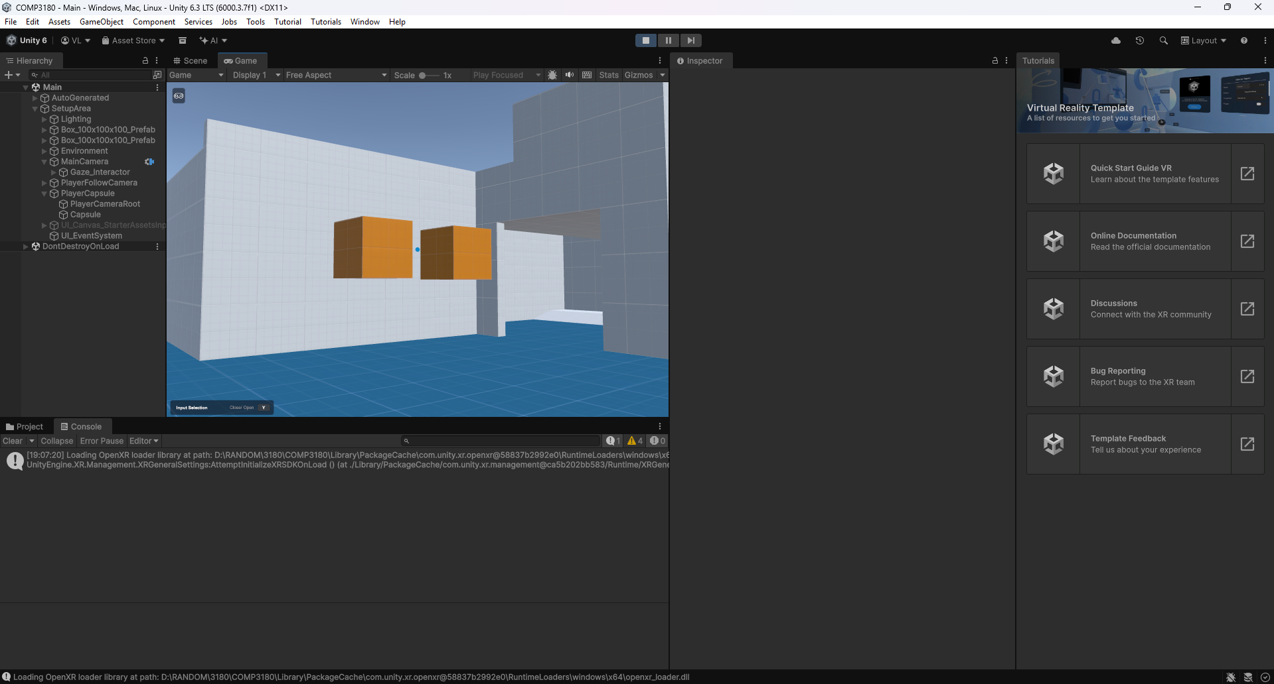
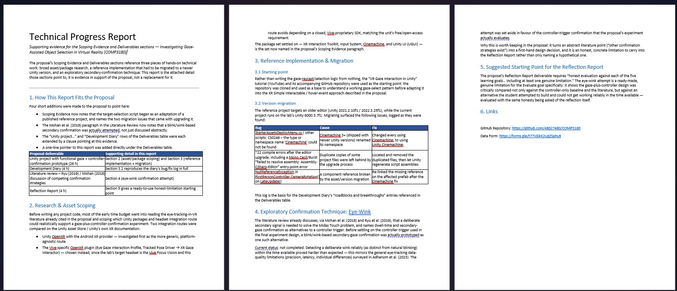

Deliverables
The table below lists the proposed deliverables, how the success of each will be measured, and the estimated hours allocated to each, totalling the required 65 hours (50 hours outside class time plus 15 hours of lab time in the second half of semester).
Deliverable / Success Measure | Detail | Hours
Unity project with functional gaze + controller-confirmation selection prototype in GitHub, built on a migrated and adapted third-party reference implementation. Success: both interaction techniques function reliably across both target sizes, confirmed via internal pilot testing before formal evaluation. | Main prototype | 26
Three-minute demonstration video of the prototype for portfolio. Success: clearly demonstrates both interaction conditions, exported in a format suitable for a public portfolio. | Portfolio video | 4
Evaluation Report. Success: clearly presents method, results and analysis addressing the research question, written for an HCI/games-industry audience. | Evaluation report | 7
Experiment protocol and instrument design (consent form, task instructions, usability questionnaire). | Evaluation artefact | 4
Recruitment and data collection with 4–5 participants across both conditions and two target sizes. | Evaluation artefact | 8
Document collating and analysing quantitative (time/accuracy) and qualitative (usability) data. | Evaluation artefact | 8
Development Diary. Success: consistent weekly entries covering progress, roadblocks and breakthroughs across the session, including the Unity-version migration process and the exploratory blink-confirmation attempt. | Diary | 4
Reflection Report. Success: honest evaluation against each of the five learning goals above, including at least one genuine limitation. | Reflection | 4
Total |  | 65
Full supporting detail on the Unity Asset Store research process, the reference-implementation migration, and the parked eye-wink confirmation experiment is provided in the attached Technical Progress Report.

References
Adhanom, I. B., MacNeilage, P., & Folmer, E. (2023). Eye tracking in virtual reality: A broad review of applications and challenges. Virtual Reality, 27, 1481–1505. https://doi.org/10.1007/s10055-022-00738-z
Fernandes, A. S., Murdison, T. S., & Proulx, M. J. (2025b). Looking in depth: Targeting by eye and controller input for multi-depth target placement. International Journal of Human–Computer Interaction, 41(13), 7952–7967. https://doi.org/10.1080/10447318.2024.2401657
Fernandes, A. S., Schütz, I., Murdison, T. S., & Proulx, M. J. (2025a). Gaze inputs for targeting: The eyes have it, not with a cursor. International Journal of Human–Computer Interaction, 41(19), 12251–12269. https://doi.org/10.1080/10447318.2025.2453966
Hou, W.-J., & Chen, X.-L. (2021). Comparison of eye-based and controller-based selection in virtual reality. International Journal of Human–Computer Interaction, 37(5), 484–495. https://doi.org/10.1080/10447318.2020.1826190
Mohan, P., Goh, W. B., Fu, C. W., & Yeung, S. K. (2018). DualGaze: Addressing the Midas Touch problem in gaze mediated VR interaction. 2018 IEEE International Symposium on Mixed and Augmented Reality (ISMAR-Adjunct), 79–84.
Ryu, K., Lee, J.-J., & Park, J.-M. (2019). GG Interaction: A gaze–grasp pose interaction for 3D virtual object selection. Journal on Multimodal User Interfaces, 13, 383–393. https://doi.org/10.1007/s12193-019-00305-y
Used Gemini to fix bugs in the project:

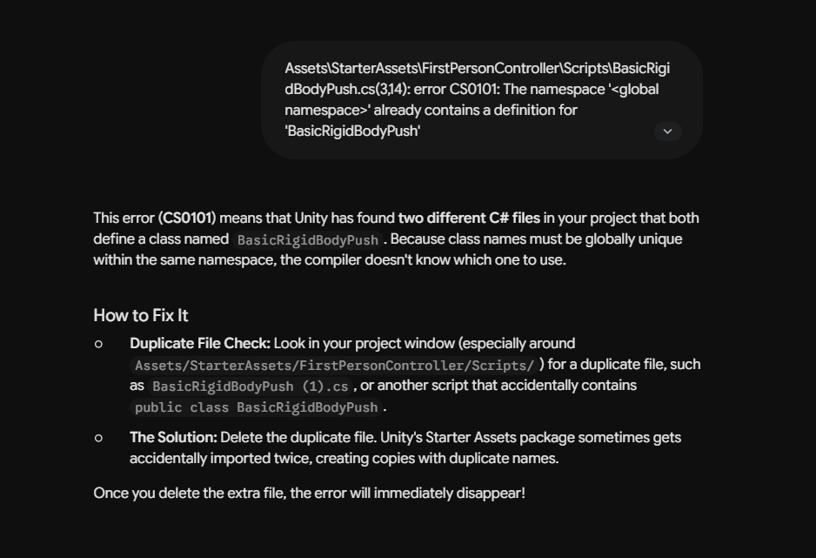
https://share.gemini.google/x7e0YgzXWJg8
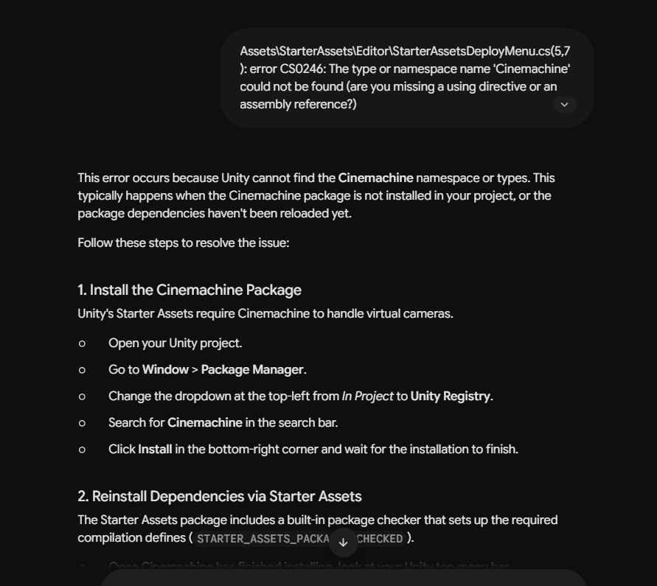
https://share.gemini.google/0pJudHsx4Jdm

Used Claude to check spelling, gramma
https://claude.ai/share/c28d7e59-b0bb-416d-9502-64a2aea0d3ac

