COMP3180 – Final Project Report
  - Name: Viet Phi Long Le
  - Student ID: 48027480
  - GitHub Username: 48027480

Table of Contents
1 Project Deliverables 2
2 Development Diary Summary 2
2.1 Up to Week 8 2
2.2 Mid-session break 3
2.3 Week 9 3
2.4 Week 10 3
2.5 Week 11 3
2.6 Week 12 3
2.7 Week 13 3
3 Evaluation 4
3.1 Target Audience 5
3.2 Method 5
3.3 Results and Discussion 5
4 Learning Reflection 8
5 Industry Relevance and Future Work 9
6 Appendices 9
6.1 Hours log since the research proposal 9
6.2 Commit history 10
6.3 R&D iteration log 11
6.4 Raw shooter results (Save/TestResult1.csv) 11
6.5 Questionnaire instrument and responses 12
6.6 The ten playgrounds 12
6.7 Gaze log format 12
7 Statement on Generative AI use 13
7.1 ChatGPT (OpenAI) 13
7.2 Gemini (Google) 13
7.3 Claude chat (Anthropic) 13
7.4 Claude Code (Anthropic): project development 13
7.5 Claude Code (Anthropic, Claude Opus 5.5): this report 14
8 References 14

Project Deliverables
The project set out to compare gaze-assisted selection (look at a target, press the trigger to confirm) with controller pointing on the HTC VIVE Focus Vision. Eye data never reached Unity from the headset, so the main deliverable became a gaze testbed that runs on head gaze today and switches to the eye tracker by itself once eye data is available.
Deliverable | Description | Link
VR Gaze Playground (main deliverable) | Unity 6 project (URP, OpenXR, XR Interaction Toolkit 3.5.1; Unity Technologies, 2026). A room where objects are aimed at with gaze and grabbed with a button, a shooter prototype with three timed areas and seven gaze test playgrounds. One aim ray uses the eye tracker when found, otherwise the head. Every test saves CSV results tagged with the aim source. | https://github.com/48027480/COMP3180
Portfolio video | Demonstration of the playground, the shooter areas and the gaze playgrounds running, hosted on Echo360. | [ECHO360 VIDEO LINK]
Controller vs gaze study scene | Two-condition trial (controller ray vs gaze plus trigger) with counterbalanced blocks and targets sized in degrees of visual angle. | https://github.com/48027480/COMP3180/blob/main/Assets/Scenes/ExperimentalScene.unity
Eye-gaze-assist and wink input | Hands-free mode where winks grab, drop, press buttons or fire. Checked with simulated eye values only. | https://github.com/48027480/COMP3180/blob/main/Assets/GazeStudy/Scripts/WinkInput.cs
Editor scene builders | Menu tools that build the playground, shooter prototype and gaze wings from code. | https://github.com/48027480/COMP3180/tree/main/Assets/GazeStudy
Documentation | Setup, controls, logic, playground specifications, CSV formats and known limits. | https://github.com/48027480/COMP3180/blob/main/Assets/README_VREyeGaze.md
Evaluation and development records | Questionnaire, raw results, hours log, commit history and R&D iteration log. | Appendices

Changes from the proposal: the formal controller vs gaze study with 4 to 5 participants was replaced by a smaller head-gaze evaluation, because its gaze condition could not run on eye data. The shooter prototype, the seven gaze playgrounds and the scene builders were added, and the parked wink confirmation was completed as eye-gaze-assist. Section 7 separates my own work from the work of AI tools.

Development Diary Summary
Each problem, action, result and decision is logged in the R&D iteration log (Appendix 6.3), with hours and commits in Appendices 6.1 and 6.2. Most iterations were technical debugging; user-centred iteration was limited to one test session (Section 3).

Up to Week 8
I created the Unity 6 project and adapted a gaze-confirm script from an older reference project. The migration broke on Cinemachine's namespace change and an assembly resolution error, both fixed. A blink-based confirmation was set aside because of time and reliability problems. I reviewed the literature and wrote the research proposal.

Mid-session break
I finished the Unity 6 migration settings, set up the first OpenXR settings and wired the first scene hierarchy.

Week 9
Roadblock: in the VR lab I enabled the OpenXR Eye Gaze Interaction profile and the VIVE OpenXR features (HTC Corporation, 2026) and streamed the Focus Vision over VIVE Streaming. Head and controllers tracked, but Unity found no eye gaze device.

Week 10
More attempts with different OpenXR feature combinations, still without eye data. HTC's documentation lists its eye tracker data as beta and recommends OpenXR 1.12.1, while the project uses 1.17.1. This remains my strongest lead.

Week 11
Further attempts, still without eye data. I did not log each attempt separately, so the exact combinations tried in Weeks 9 to 11 cannot be reported; I reflect on this in Section 4.

Week 12
Roadblock: the editor crashed and left only a recovery scene. Breakthrough: I moved scene construction into editor scripts so scenes could be rebuilt from code. I also configured the VIVE Focus features in OpenXR.

Week 13
Breakthrough: GazePickupSelector now picks its ray source every frame (eye tracker, head, controller or desktop camera) and logs it, so the project could be tested on head gaze. On 2 November I built the study scene, the pickup playground and the shooter prototype, and embedded the VIVE plugin so lab PCs needed no download. I revived the blink idea as wink input, with thresholds that ignore normal blinks, as a new deliverable.
Roadblock: checking the aim source of the first results showed they were head gaze, not eye gaze. I documented this in the README and changed the plan: the formal study was dropped and I designed seven gaze playgrounds, ready for when eye data works. By 10 November all seven were built on a shared base class with a 20 Hz gaze log; I played each one through and an automated run checked that each runs and logs.
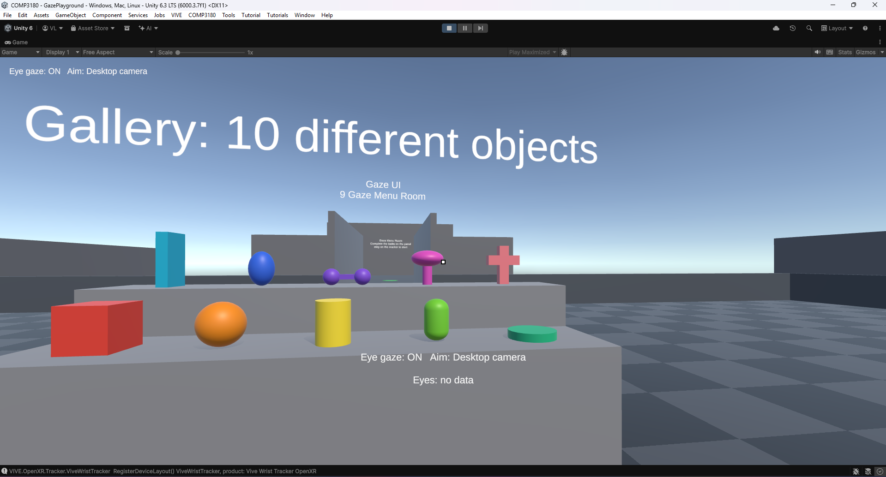
Figure 1a. The single aim ray before use

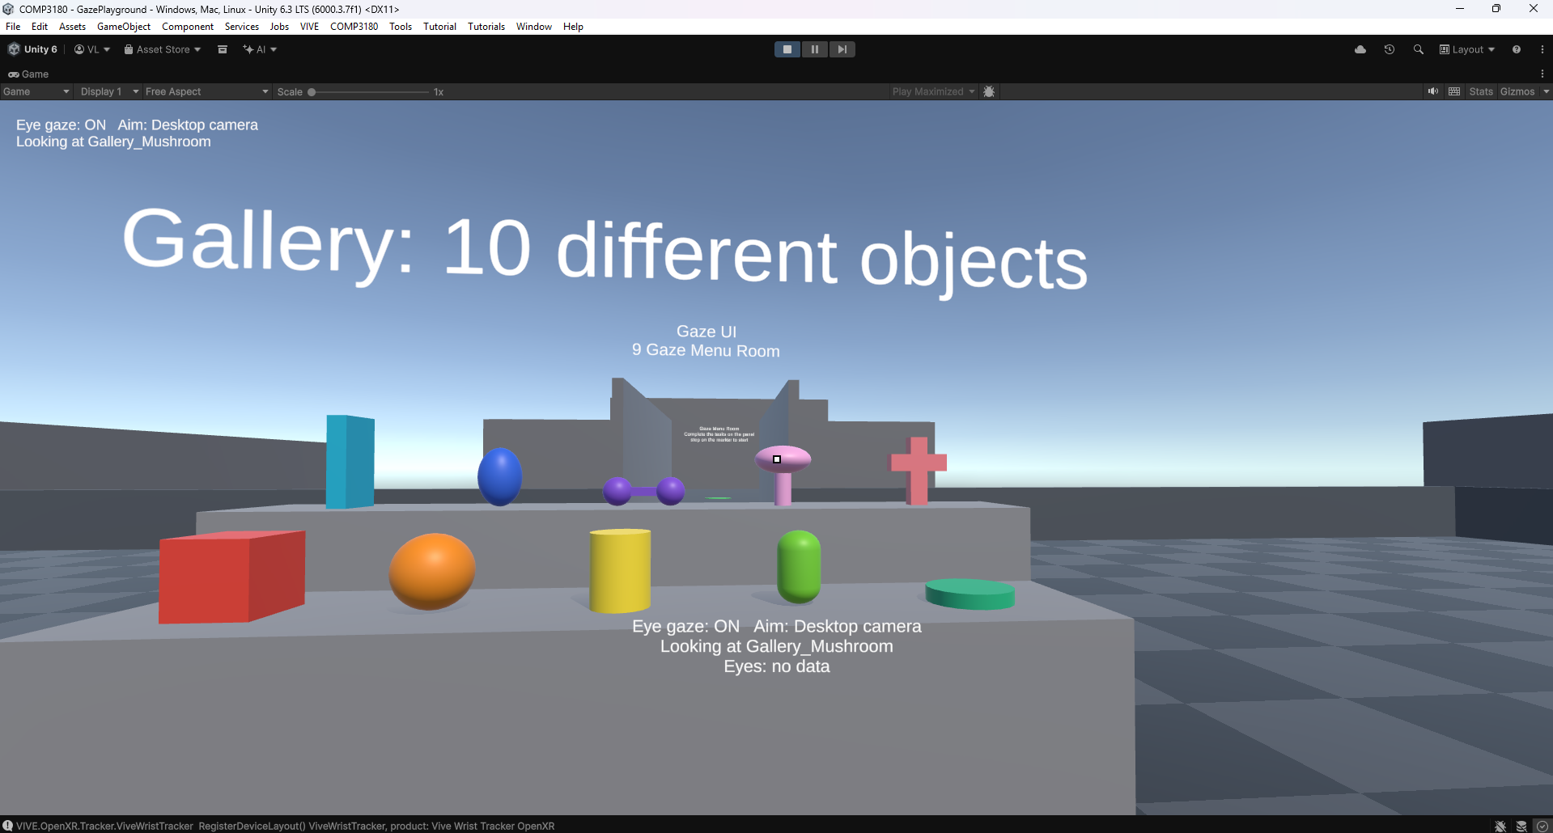
Figure 1b. The single aim ray in use: the reticle marks where the head is pointing and the object under it highlights before any button is pressed.

Evaluation
Original research question: how does gaze-assisted target selection with controller confirmation compare with traditional controller pointing in VR in terms of selection time, accuracy and perceived usability?
This question could not be answered. Without eye data the gaze condition falls back to the head, there was no controller baseline, and selection time was not logged. The completed study addresses a narrower question: how does head-gaze aiming with trigger confirmation perform across stationary and moving VR targets, in terms of accuracy and perceived usability? A separate check asked whether the seven gaze playgrounds run and log correctly.

Target Audience
The main deliverable is a testbed for VR interaction designers and developers adding gaze input to games for eye-tracking headsets. They need to know where gaze selection helps or fails, and a way to measure it, before committing to it in a shipped game.

Method
Activity | Who | Valid records | Used for
Shooter areas, head gaze, headset (2 Nov) | One tester (the log does not identify who) | 1 session, 3 areas | Accuracy
Questionnaire after the shooter areas | Two testers | 2 responses | Perceived usability
Playgrounds 4 to 10 played through | Me (developer) | Not analysed | Basic function only
Automated desktop run of 4 to 10 | No person | 7 logs written | Execution check only

Table 1. Activities, testers and records.
- Procedure: in the headset over VIVE Streaming, aim source "Head (no eye device)". Three areas of 30 seconds each, in fixed order: rising spheres, walking NPCs, still spheres. Aim with the head, fire with the trigger. Reticle and hover highlight were the same in every area, to avoid the feedback confound described by Fernandes et al. (2025a).
- Instruments: the automatic CSV log, and a questionnaire with experience items, intuitiveness (1 to 5), accuracy in responding to intent (1 to 5) and discomfort (Appendix 6.5). Only closed items are analysed.
- Wording problem: the two usability items asked about "eye-gazing" assist and tracking, but testers experienced head gaze. The answers are read as ratings of the head-gaze aiming they experienced, with caution, and are not eye-gaze results.
- Respondents: ages 21 and 53; one VR beginner, one advanced VR user; both proficient with controllers.

Results and Discussion
Area (order played) | Shots | Hits | Accuracy | Target
Floating Targets (1st) | 42 | 26 | 61.9% | Rising, 0.5 to 1.5 m
NPC Range (2nd) | 40 | 20 | 50.0% | Walking NPCs
Aim Trainer (3rd) | 40 | 27 | 67.5% | Still, 0.3 to 1.4 m
Total | 122 | 73 | 59.8%

Table 2. Head-gaze shooter results from one session, 30 s per area (raw data in Appendix 6.4).
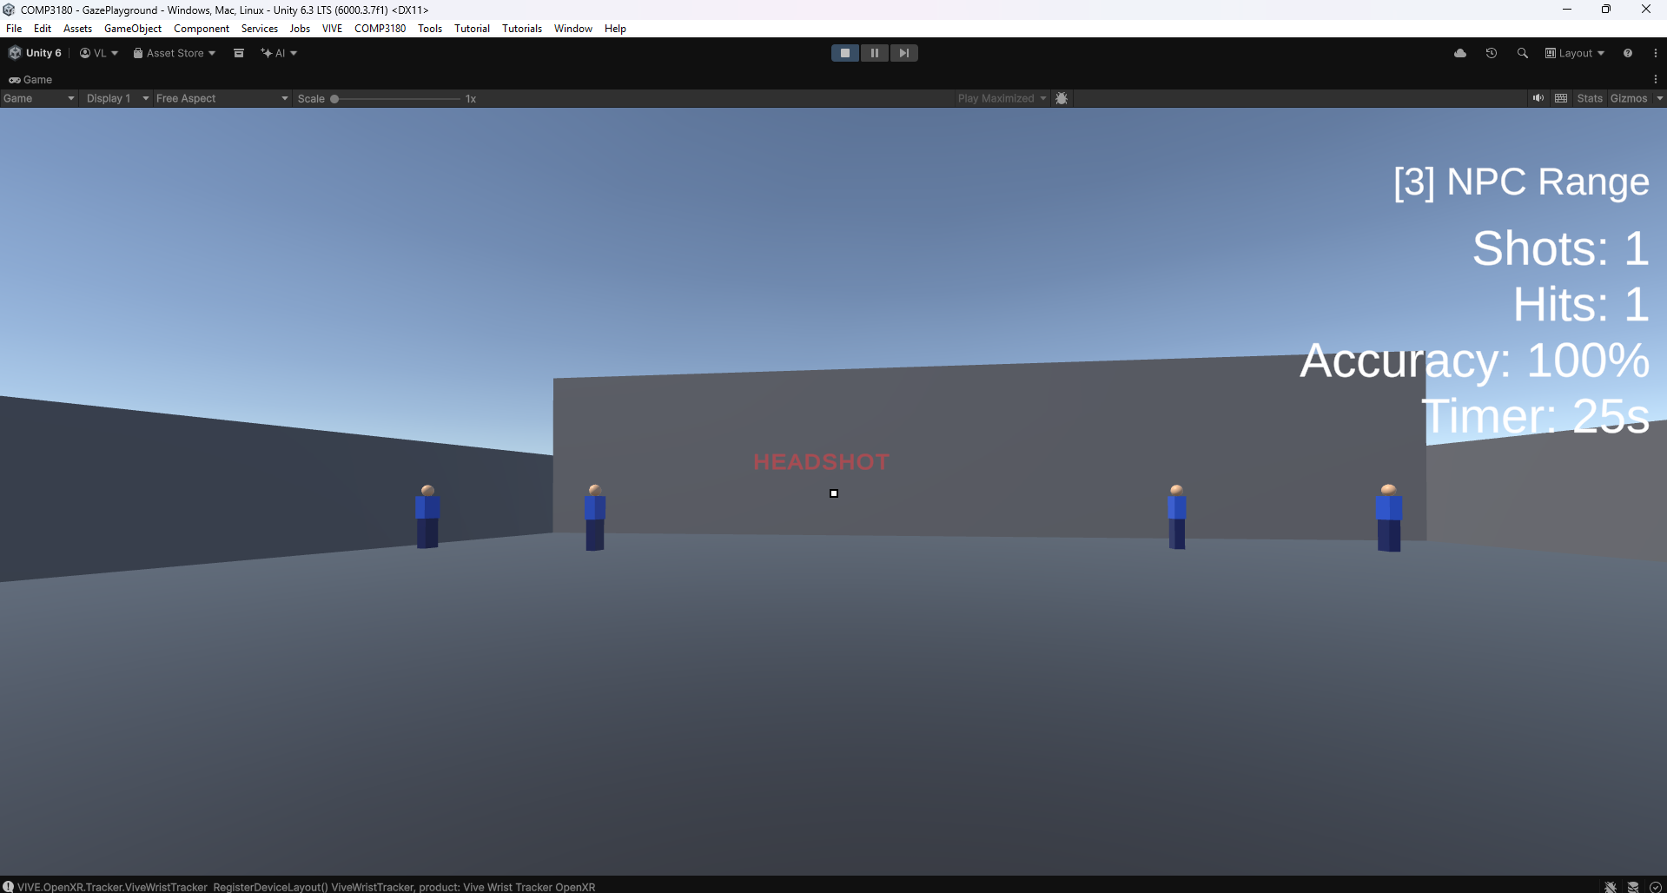
Figure 2. The NPC Range under head gaze: walking NPCs with head, body and leg hit zones, and the HUD counting shots, hits and accuracy that are saved to CSV.
The fire rate was steady at about 1.3 to 1.4 shots per second in every area. Accuracy was highest on still targets (67.5%) and lower in the two areas with moving targets (61.9% and 50.0%). This is a descriptive pattern from one 30-second session per area. The areas also differ in target size, speed, shape and spawn rules, the order was fixed, and the Aim Trainer was played last, so practice may explain part of its lead. The design cannot show that target motion caused the difference.
Questionnaire item | Response 1 | Response 2
Intuitiveness of "eye-gazing" assist (1 to 5) | 3 | 2
Accuracy in responding to intent (1 to 5) | 3 | 3
Physical discomfort | Moderate | Mild

Table 3. Closed questionnaire responses (n = 2).
Both respondents gave middling ratings and reported some discomfort. Two responses cannot show why the ratings were similar or whether a larger group would agree.
Within these limits, the observations agree with the literature. Trigger confirmation acted as the deliberate second signal recommended against the Midas touch problem (Jacob, 1990; Ryu et al., 2019; Mohan et al., 2018): selections happened only on a press. The lower accuracy on moving targets fits head gaze being a slow, heavy pointer. Fernandes et al. (2025b) reported miss rates of 21% for eye and 9% for controller targeting; the head-gaze miss rates here (32.5% to 50%) are higher, but the tasks differ, so this is only indicative. Hou and Chen (2021) likewise warn against assuming gaze-style input is easier than a controller.
For the target audience, the testbed is the more useful result. Ten areas share one aim ray, test flow and log format, and every row records its aim source, so head and eye data cannot be mixed. The gaze playgrounds log saccade latency, pursuit gain, false triggers, scan paths, peripheral detection and selection time per input method (Appendix 6.6). The Gaze Menu Room rotates between dwell, gaze plus click and the controller ray at two button sizes, so the original comparison can run there once eye data arrives. The automated run and my own play-through show these tests run and log; only testing with other people can show whether they are usable.
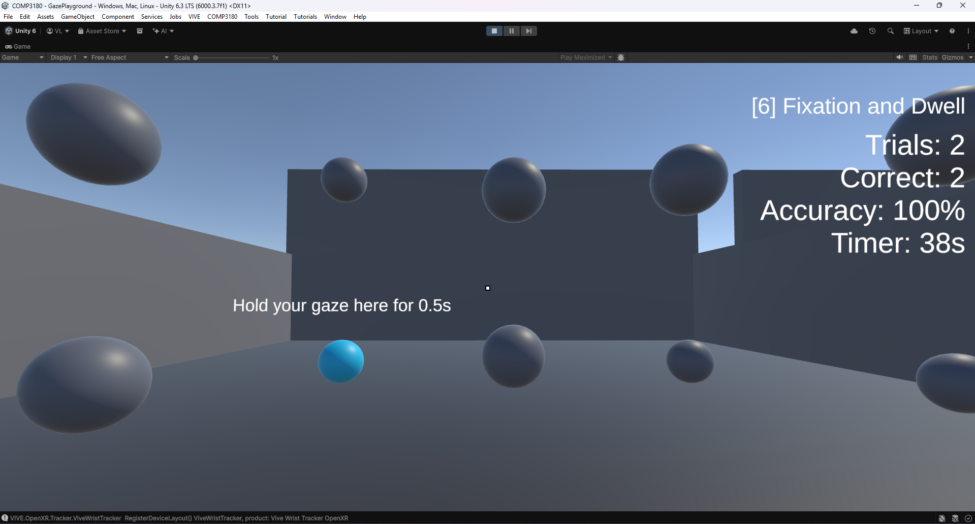
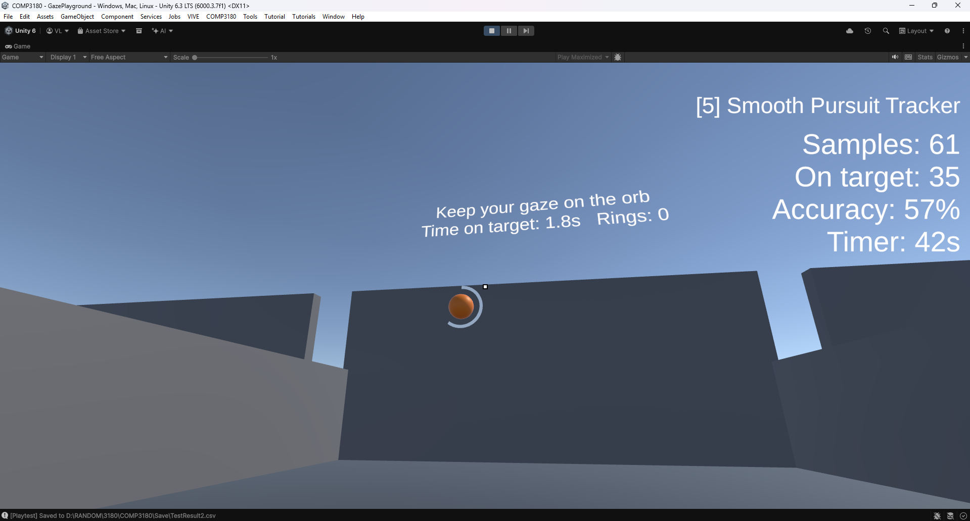
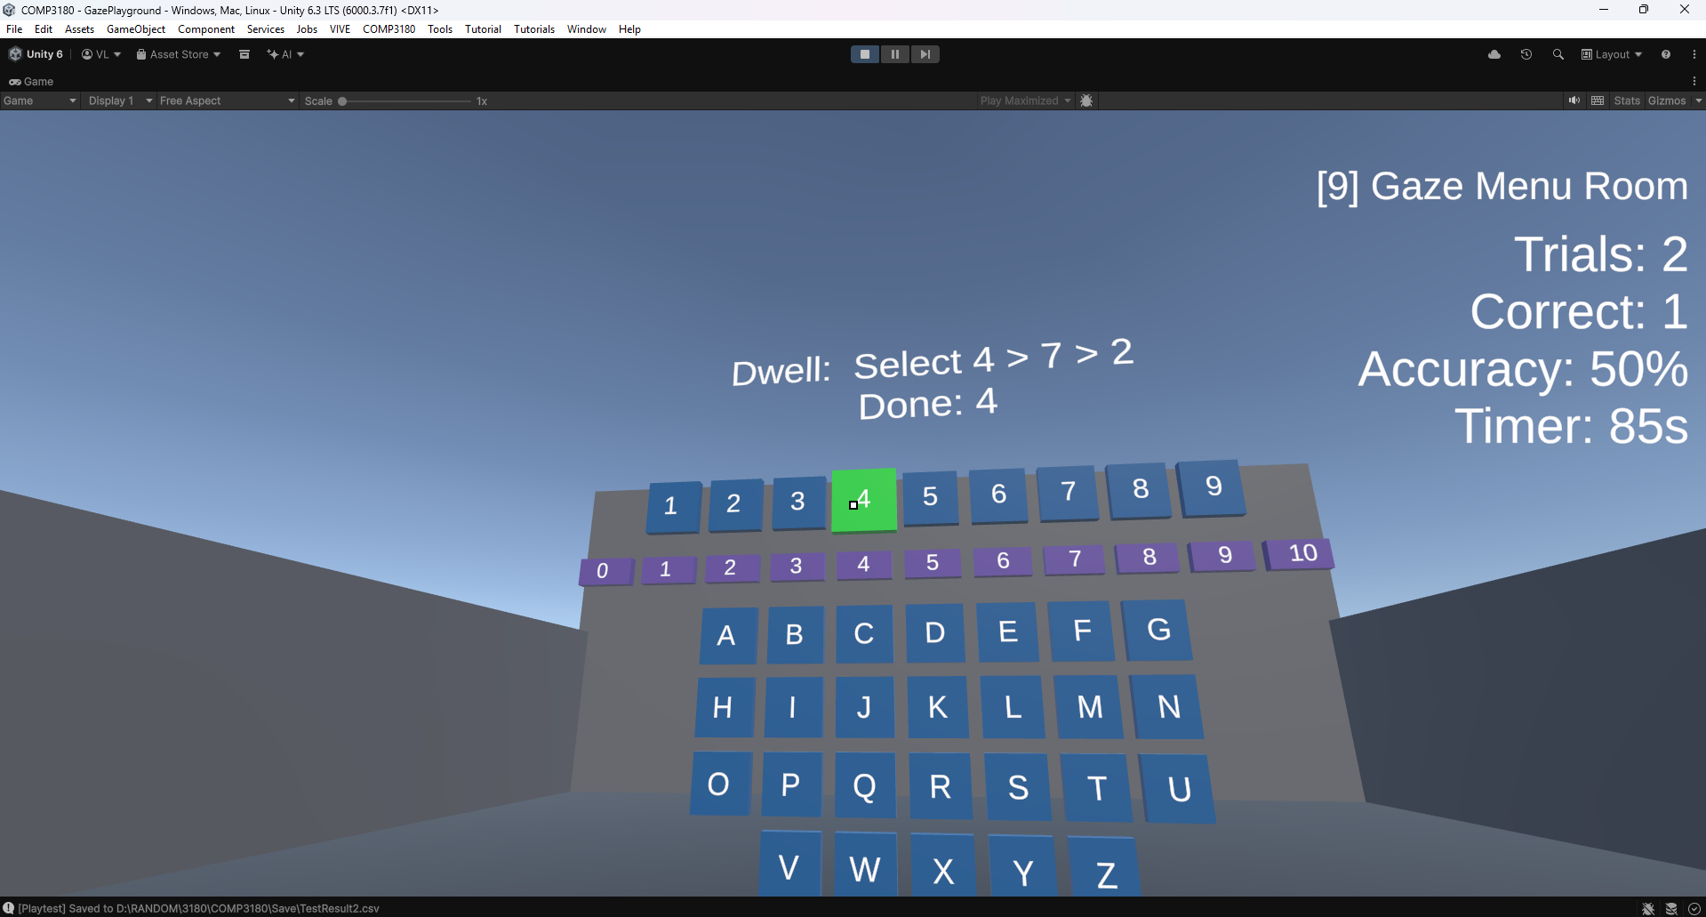
Figure 3. Three of the gaze playgrounds built for eye data: the saccade grid (gaze jumps), the smooth pursuit orb (tracking a moving target) and the gaze menu (dwell vs click vs controller).
Limitations: no eye data; no controller baseline; no selection time; one session of 30 s per area; fixed order; target types that differ in several ways; two questionnaire responses with mislabelled items instead of the planned SUS (Brooke, 1996); and no human usability testing of playgrounds 4 to 10.
Answer: the original question remains open. For the narrower question, testing showed that head-gaze aiming with trigger confirmation avoided accidental selections, that accuracy in this session was lower on moving targets, and that the two respondents rated it as moderately intuitive and accurate. These results are a pilot baseline, not a general finding.

Learning Reflection
Learning goals from my research proposal, framed with Bloom's taxonomy (Anderson & Krathwohl, 2001):
- Understand: explain the Midas touch problem and the trade-offs in the literature.
- Apply: implement an OpenXR eye-tracking pipeline and a controller-ray system, with 95% of selections registering.
- Analyse: find data-supported patterns in time, accuracy and usability.
- Evaluate: identify genuine limitations, not only strengths.
- Create: a portfolio-ready prototype and video.

Understand: met. I used the Midas touch problem to justify the trigger confirmation, the dwell timer in the gaze tests and the wink rules that ignore normal blinks, and I designed playground 6 to measure false triggers.
Apply: partly met. The controller ray, head gaze and OpenXR setup work and the eye-gaze code path exists, but no eye data reached Unity and I did not measure the 95% target. I still built the skills I aimed for: OpenXR features and interaction profiles, embedding a vendor plugin as a local package, XR Interaction Toolkit 3.5, the Input System, and editor tools that build scenes from code.
Analyse: partly met. I designed structured logging, with one row per event, gaze samples at 20 Hz and the settings stored in every row. I found one descriptive pattern, but the data set is too small for the analysis I planned, and I learned that questionnaire wording must match the condition actually tested.
Evaluate: met best, because the project forced it. Realising my results were head gaze, not eye gaze, and saying so at the top of the README taught me more about research integrity than a smooth study would have.
Create: largely met. The playground, ten test areas and documentation are in a state I can show employers, together with the portfolio video in Section 1.
Self-directed learning: research and experimentation worked well when I could test quickly, as with the wink thresholds and the ray fallback. It worked badly with the eye tracker, where I spent three weeks trying configurations without a clear diagnostic strategy or a record of each attempt. In future I will test the riskiest hardware dependency in the first week, log each attempt and its result, and ask HTC's developer forums or unit staff after a week without progress. I also learned to use AI coding tools in a controlled way: I designed the tests, reviewed every change and verified it in Unity and the headset.

Industry Relevance and Future Work
Eye tracking is available in selected current headsets, including the PlayStation VR2 (Sony Interactive Entertainment, n.d.) and VIVE Focus Vision (HTC Corporation, n.d.), and Apple's visionOS guidelines treat the eyes as a primary input (Apple, n.d.). This project maps to two roles: VR interaction programmer and technical UX researcher at a VR studio.
Professional competency | Project evidence
VR hardware and input integration | OpenXR eye gaze and VIVE feature setup; local VIVE plugin package
Interaction-system implementation | One aim ray for grab, buttons, weapon and all tests
Robustness and compatibility | Runtime fallback from eye tracker to head, controller or desktop
Instrumentation and data collection | CSV logs with aim source, settings and 20 Hz gaze samples
UX research and evaluation | Ten test playgrounds; evaluation with its limits stated
Tooling and workflow automation | Editor scene builders

Future work: get eye data working (OpenXR 1.12.1 and a wired connection first), correct the questionnaire wording, then run the controller vs eye gaze study with at least 12 participants and the SUS, and playtest playgrounds 4 to 10 with other people. Tracking accuracy and calibration drift (Adhanom et al., 2023) suggest adding gaze smoothing and a hit tolerance.

Appendices

Hours log since the research proposal
When | Work | Hours | Evidence (commit)
Break (24 to 26 Sep) | Unity 6 migration settings, first OpenXR settings, scene hierarchy | 3 | 98dfda0, fc3f72f, 4ac96c5
Week 9 | VR lab: OpenXR Eye Gaze Interaction profile, VIVE OpenXR features, VIVE Streaming | 3 | Not committed
Week 10 | VR lab: further OpenXR feature combinations, HTC documentation | 3 | Not committed
Week 11 | VR lab: further eye tracking configuration attempts | 2 | Not committed
Week 12 (1 Nov) | Editor crash and scene recovery, OpenXR and VIVE Focus feature setup | 5 | 278fcff, d2991b7
Week 13 (2 Nov) | Controller vs gaze study scene: TrialManager, TargetRing, DataLogger, SelectionRaySource, GazeProbe | 4 | d5a8ecf
Week 13 (2 Nov) | Pickup playground: GazePickupSelector, PickupObject, PlayerBody | 2 | 47ff31c
Week 13 (2 Nov) | Shooter prototype: three areas, NPC hit zones, weapon, HUD, test flow, CSV, tutorials, builder | 3 | 675b91e, 28dd028
Week 13 (2 Nov) | Control remapping, UI fixes, wink system, eye-gaze-assist, VIVE plugin embedded, first README | 3 | 10f984d, f7f9367, 0f3775c, e33eede, 5be6477
Week 13 (2 Nov) | Head-gaze test session and questionnaire | 1 | 4108723
Week 13 to 10 Nov | Seven gaze playgrounds: GazeTestArea, GazeTarget, GazeLogCsv, seven area scripts, GazeTestsBuilder, wing layouts | 16 | d0fcba9
Week 13 to 10 Nov | Eye data debugging: aim source and live eye values in the status text | 3 | d0fcba9
10 Nov | Automated desktop run of playgrounds 4 to 10, README rewrite | 2 | d0fcba9
10 Nov | Questionnaire and results analysis | 1 | Appendix 6.5
10 Nov onwards | Final project report | 6 | This document
10 Nov onwards | Portfolio video planning, recording and editing | 4 | Echo360 video
 | Total | 61

Commit history
Repository: https://github.com/48027480/COMP3180 (branch main).
Date | Commits | Content
2026-08-31 | 929f9b7, 8bc019d, 0664a54 | Initial commit, create project, create folders
2026-09-14 | d4bbd29, 688792d, 37d5064 | Cinemachine and XR packages, first gaze script
2026-09-24 | 98dfda0 | Gaze confirm script and OpenXR settings
2026-09-26 | fc3f72f, 4ac96c5 | Unity 6 migration settings, scene hierarchy
2026-11-01 | 278fcff, d2991b7 | Recovery scene after editor crash, OpenXR feature setup
2026-11-02 | d5a8ecf | Controller vs gaze study scene and scripts
2026-11-02 | 47ff31c | Gaze pickup playground
2026-11-02 | 675b91e, 28dd028 | Shooter prototype, NPCs, HUD, test flow, CSV, tutorials
2026-11-02 | 10f984d, f7f9367 | Controller remapping, help board, wink system
2026-11-02 | 0f3775c | VIVE OpenXR 2.5.1 copied into the project
2026-11-02 | e33eede, 5be6477, 4108723 | Eye-gaze-assist, test length, first README, first results CSV
2026-11-10 | d0fcba9 | Playgrounds 4 to 10, gaze log, README rewrite

R&D iteration log
Each row records a problem, what I did, what happened and what I decided, with the supporting evidence. Rows 1 to 9 are technical iterations; row 10 is the only user-centred iteration. The Weeks 9 to 11 attempts were not logged individually, so row 3 summarises them.
# | Problem | Action | Result | Decision | Evidence
1 | Reference gaze script failed in Unity 6 (to Week 8) | Fixed Cinemachine namespace and assembly errors | Script compiled | Keep the gaze-confirm pattern | Proposal; 37d5064, 98dfda0
2 | Need a confirm action without a button (to Week 8) | Prototyped blink confirmation | Unreliable in the time available | Park it; use the trigger | Proposal
3 | Unity found no eye gaze device (Weeks 9 to 11) | OpenXR Eye Gaze Interaction profile, VIVE OpenXR features, VIVE Streaming, in several combinations | No eye data in any attempt | Follow HTC lead: eye data is beta, OpenXR 1.12.1 recommended | OpenXR settings history
4 | Could not tell which part failed | Added GazeProbe checks and status text showing aim source and eye values | Shows "Eyes: no data" | Keep as a permanent diagnostic | d5a8ecf, d0fcba9
5 | Editor crash lost the scene (Week 12) | Recovered the scene by hand | Slow and error-prone | Build scenes from code with editor builders | 278fcff, 28dd028
6 | No eye data blocked all testing (Week 13) | Ray source chosen every frame, logged as AimSource | Project runs on head gaze | Build all tests on this ray | 47ff31c, d0fcba9
7 | Normal blinks would trigger winks | Closed below 0.25, open above 0.6, 0.1 s hold, both eyes reopen | Correct with simulated values | Keep; thresholds marked as starting guesses | f7f9367, e33eede
8 | First results looked like eye-gaze data | Checked the recorded aim source | Head (no eye device) | Report as head gaze; README warning; drop the formal study | 4108723, 5be6477
9 | Tests needed for when eye data works | Designed and built playgrounds 4 to 10 on a shared base class | Automated run and my play-through: all run and log | Ready for eye data; human testing still needed | d0fcba9
10 | Is head-gaze aiming usable? (user-centred) | Shooter session and questionnaire | Middling ratings; items worded as "eye-gazing" | Correct the wording before the next study | Appendices 6.4, 6.5

Raw shooter results (Save/TestResult1.csv)
DateTime,Area,Shots,Hits,AccuracyPercent,DurationSeconds,Completed
2026-11-02 17:27:31,"Floating Targets",42,26,61.9,30,True
2026-11-02 17:28:32,"NPC Range",40,20,50,30,True
2026-11-02 17:29:35,"Aim Trainer",40,27,67.5,30,True

Questionnaire instrument and responses
Instrument (Google Form): https://docs.google.com/forms/d/e/1FAIpQLSd40pD0uiUowxd7kzQHZvHPNfoWw2cc6ieHGL7cBT7_zTRW8g/viewform
Raw closed responses. Both respondents confirmed consent for their anonymised data and feedback to be used for the project. Open-text questions (what was liked most, frustrations, suggestions) are not analysed in this report.
Question | Response 1 | Response 2
Age | 21 | 53
Experience with VR | Beginner | Advanced
Experience with XR / AR / MR | None | Intermediate
Mouse and keyboard experience | Power user / Gamer | Power user / Gamer
Game controller experience | Proficient / Regular user | Proficient / Regular user
How intuitive did the eye-gazing assist feature feel to use? (1 to 5) | 3 | 2
Physical discomfort (eye strain, dizziness, nausea, headache) | Moderate | Mild
How accurate was the eye-gazing tracking in responding to your intent? (1 to 5) | 3 | 3

The ten playgrounds
Playground | What it tests | Length
1 Aim Trainer | Still targets 0.3 to 1.4 m wide | 30 s
2 Floating Targets | Targets rising at 2 to 6 m/s | 30 s
3 NPC Range | Walking NPCs with head, body and leg zones | 30 s
4 Saccade Jump Grid | Latency, landing error and overshoot of gaze jumps | 45 s
5 Smooth Pursuit Tracker | Following a moving orb, pursuit gain | 45 s
6 Fixation and Dwell | Dwell selection and false triggers (Midas touch) | 45 s
7 Visual Search | Search time and scan path | 60 s
8 Peripheral Awareness | Detection by angle while fixating the centre | 60 s
9 Gaze Menu Room | Dwell vs gaze plus click vs controller ray, two button sizes | 90 s
10 Memory and Attention | Gaze sequence recall and guard watching | 90 s

Gaze log format
Each gaze test writes Save/GazeLog{number}.csv with one row per event and one gaze sample every 0.05 s. Columns: Timestamp, TestSeconds, Area, Event, AimSource, GazeOrigin X/Y/Z, GazeDir X/Y/Z, TargetId, Target X/Y/Z, Hit, ReactionTimeSeconds, AngularErrorDeg, Difficulty, Measures. AimSource is Eye tracker, Head (no eye device), Controller or Desktop camera, so head-gaze and eye-gaze data can always be separated.

Statement on Generative AI use
I used generative AI tools to discuss ideas, write and debug code, write documentation and draft this report. I checked all code and written text before accepting and submitting it. The table below separates my own work from the work of each tool; the evidence for each tool follows.
Area | My work | AI tool's work
Research question and literature review | Chose the question, found and read the sources, wrote the proposal | Claude: spelling and grammar check of the proposal
Early ideas | Selected which ideas to pursue | ChatGPT: drafted and discussed ideas
Interaction technique and gaze playground design | Designed the gaze-plus-trigger technique and playgrounds 4 to 10 (tests, rules, sizes, timings) | None
C# implementation and scene builders | Specified what to build, reviewed and accepted each change, integrated it in the scene | Claude Code: wrote and edited the scripts and editor builders
Headset setup and debugging | OpenXR and VIVE setup, all headset testing in the lab, reporting errors | Claude Code: diagnosed compile and runtime errors; Gemini: bug fixes before the proposal
Testing and evaluation | Ran the shooter session and questionnaire, played playgrounds 4 to 10, decided to report head gaze | Claude Code: automated desktop run of playgrounds 4 to 10
README and this report | Supplied the facts, corrected errors (including participant counts), reviewed and edited | Claude Code: drafted the text and fitted it to the template

ChatGPT (OpenAI)
Used to draft and discuss early project ideas (OpenAI, 2026). Evidence: https://chatgpt.com/share/6af30794-e78c-83ec-b3a1-dbfbc0ac4163

Gemini (Google)
Used to help fix bugs during the Unity 6 migration, before the research proposal (Google, 2026). Evidence: https://share.gemini.google/x7e0YgzXWJg8 and https://share.gemini.google/0pJudHsx4Jdm

Claude chat (Anthropic)
Used to check spelling and grammar in the research proposal (Anthropic, 2026). Evidence: https://claude.ai/share/c28d7e59-b0bb-416d-9502-64a2aea0d3ac

Claude Code (Anthropic): project development
Used to build the project (Anthropic, 2026): writing and editing C# scripts (playground, shooter prototype, wink input, eye-gaze-assist, gaze playgrounds 4 to 10 and the editor scene builders), debugging compile and runtime errors, running the automated desktop check of playgrounds 4 to 10, and writing the README. Evidence: the commit history in Appendix 6.2 and prompt: “The gazed object should be able to pick up, drag around. VR controller will be any free button to hold, mouse will be holding left-click. Create a botton (could be 3D object and place it on the ground) if player step on it, refresh the area, all object return to default place. Inside the scene "GazePlayground", at wall_west create the T junction led to another area, this is the prototype areas. follow the MD files that I provide. The new prototype area still be the testing feature for the eye-gazed project. player should pick up a gun laying on the ground to enter and playtest this area, without the gun can only interact with the default area only If you have anything unclear, feel free to ask me before doing anything. If you need my confirmation at any step, tell me immediately. Do not guess and do anything you unsure”. Output: ShooterPrototypeBuilder.cs, GazePickupSelector.cs, GrabInput.cs and ResetPad.cs. Note: prompt comes with UnityShooterPrototype_Spec.md placed in Docs folder of GitHub repository.

Claude Code (Anthropic, Claude Opus 5.5): this report
Used to draft this report from the README, the research proposal, the questionnaire results and the git history, to fit it to the report template, to revise it after marking feedback, and to draft the portfolio video plan. References not in my proposal (Jacob, 1990; Brooke, 1996; Anderson & Krathwohl, 2001; the Apple, Sony and HTC product pages) were suggested during drafting; Claude Code checked that the Sony and HTC pages state eye tracking. I reviewed and edited the draft before submission. Evidence: 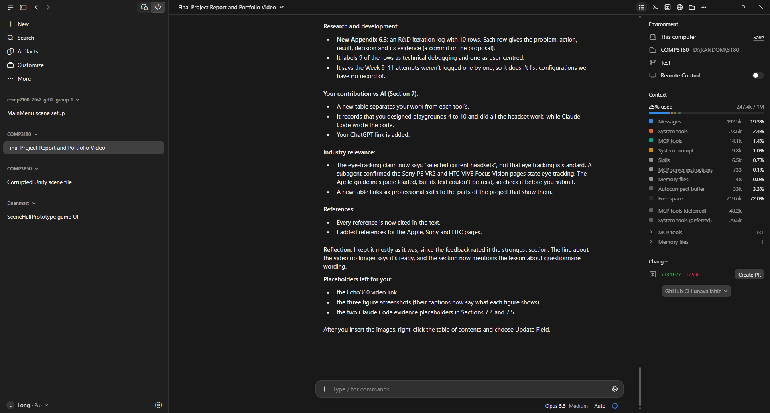

References
Adhanom, I. B., MacNeilage, P., & Folmer, E. (2023). Eye tracking in virtual reality: A broad review of applications and challenges. Virtual Reality, 27, 1481–1505. https://doi.org/10.1007/s10055-022-00738-z
Anderson, L. W., & Krathwohl, D. R. (Eds.). (2001). A taxonomy for learning, teaching, and assessing: A revision of Bloom's taxonomy of educational objectives. Longman.
Anthropic. (2026). Claude and Claude Code [Large language model and coding tool]. https://www.anthropic.com/claude
Apple. (n.d.). Eyes. Human Interface Guidelines. Retrieved November 10, 2026, from https://developer.apple.com/design/human-interface-guidelines/eyes
Brooke, J. (1996). SUS: A "quick and dirty" usability scale. In P. W. Jordan, B. Thomas, B. A. Weerdmeester, & I. L. McClelland (Eds.), Usability evaluation in industry (pp. 189–194). Taylor & Francis.
Fernandes, A. S., Murdison, T. S., & Proulx, M. J. (2025b). Looking in depth: Targeting by eye and controller input for multi-depth target placement. International Journal of Human–Computer Interaction, 41(13), 7952–7967. https://doi.org/10.1080/10447318.2024.2401657
Fernandes, A. S., Schütz, I., Murdison, T. S., & Proulx, M. J. (2025a). Gaze inputs for targeting: The eyes have it, not with a cursor. International Journal of Human–Computer Interaction, 41(19), 12251–12269. https://doi.org/10.1080/10447318.2025.2453966
Google. (2026). Gemini [Large language model]. https://gemini.google.com
Hou, W.-J., & Chen, X.-L. (2021). Comparison of eye-based and controller-based selection in virtual reality. International Journal of Human–Computer Interaction, 37(5), 484–495. https://doi.org/10.1080/10447318.2020.1826190
HTC Corporation. (n.d.). VIVE Focus Vision. Retrieved November 10, 2026, from https://www.vive.com/us/product/vive-focus-vision/overview/
HTC Corporation. (2026). VIVE OpenXR plugin for Unity (Version 2.5.1) [Software]. https://github.com/ViveSoftware/VIVE-OpenXR
Jacob, R. J. K. (1990). What you look at is what you get: Eye movement-based interaction techniques. In Proceedings of the SIGCHI Conference on Human Factors in Computing Systems (pp. 11–18). ACM. https://doi.org/10.1145/97243.97246
Mohan, P., Goh, W. B., Fu, C. W., & Yeung, S. K. (2018). DualGaze: Addressing the Midas touch problem in gaze mediated VR interaction. In 2018 IEEE International Symposium on Mixed and Augmented Reality Adjunct (ISMAR-Adjunct) (pp. 79–84). IEEE.
OpenAI. (2026). ChatGPT [Large language model]. https://chatgpt.com
Ryu, K., Lee, J.-J., & Park, J.-M. (2019). GG Interaction: A gaze–grasp pose interaction for 3D virtual object selection. Journal on Multimodal User Interfaces, 13, 383–393. https://doi.org/10.1007/s12193-019-00305-y
Sony Interactive Entertainment. (n.d.). PlayStation VR2. Retrieved November 10, 2026, from https://www.playstation.com/en-us/ps-vr2/
Unity Technologies. (2026). XR Interaction Toolkit (Version 3.5.1) [Software]. https://docs.unity3d.com/Packages/com.unity.xr.interaction.toolkit@3.5/manual/index.html

