

Project manager

Single Page Application On Project Manager



May 22, 2019

IIHT - Cognizant

Skill Based Assessment (SBA)

Setup Document Version 1.0

Table of Contents

**Type chapter title (level 1)1**

Type chapter title (level 2)2

Type chapter title (level 3)3

**Type chapter title (level 1)4**

Type chapter title (level 2)5

Type chapter title (level 3)6

|  |  |  |  |  |
| --- | --- | --- | --- | --- |
| **Revision History** | | | | |
| **Sl. No.** | **Description** | **Author** | **Date** | **Version** |
| 1 | Initial draft | Sayon Roy | 22-May-2019 | 1.0 |
|  |  |  |  |  |
|  |  |  |  |  |
|  |  |  |  |  |
|  |  |  |  |  |
|  |  |  |  |  |
|  |  |  |  |  |

# Introduction

This document is used to do the initial setup of the application “**Project Manager**” in local machine for development and debugging purpose. Once the setup is done, developer can scale, customize, debug, build & run the application according to the requirement.

# Software Requirements and Technology details

## Required Software

The below software are required to debug/develop and run the application:

1. Visual Studio 2017
2. Visual Studio Code (preferable latest version)
3. SQL Server Management Studio 2017
4. Google Chrome
5. Node JS v 8.12.0
6. GIT BASH and GIT UI (for connecting to the repository)

## Technology Details

The below technologies are used to build the application:

1. Angular 4 (UI)
2. HTML (UI)
3. CSS3 and BOOTSTRAP (UI)
4. .NET Framework
5. Web API 2.0 (C#)
6. Entity Framework (C#)
7. SQL (C#)

# Setting up the application

## Taking checkout

1. Open URL <https://github.com/480448/FSE_SBA_FINAL.git> where the codes are checked in.

2. Click on the “**Clone or download**” button.

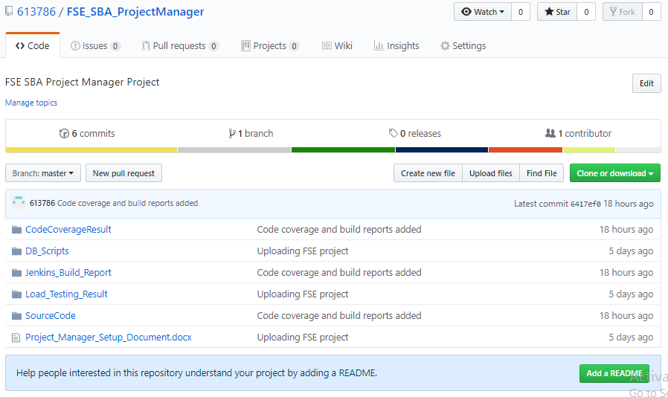

1. On clicking “Close or download” button, a small pop-up opens up, click on “**Download** **ZIP**” button to download the code in your local system.

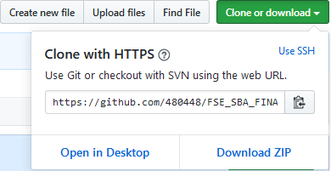

1. Unzip file and extract the code to your required path on the system.

## Folder Structure

In the main folder **ProjectManagerSln** there are two folders.

1. **Client_App**: This folder contains the Angular code.
2. **Server_App**: This folder contains the C# part (Service – WebAPI) code.

### Client

1. Go to the path where you can see the file ***angular.json*** file.
2. Open command prompt
3. Copy the path from Step No. 1
4. Traverse to the path of Step 1 in the command prompt
5. Once you are in this path, run this command “npm install –g -f @angular/cli”
6. After this installation is done, run this command “npm install -f”
7. Let all the npm packages install in the project
8. Once the installation is done you will be able to see a folder “*node_modules*” in your system
9. Don’t close the command window yet

### Server

1. Open the folder **/Server_App**/**projectManager**
2. Open the file “**projectManager.sln**” in Visual Studio 2017
3. Build the application
4. Don’t close the Visual Studio 2017 yet

### Database

1. Open the SQL Server Management Studio
2. Run the script “**Project_Manager_Create_Database.sql**”
3. Run the script “**Project_Manager_Create_Table.sql**”

# Running the application

Once the build is succeeded:

1. Open the command prompt and run the command “npm start”
2. Open the visual studio 2017 and select the “**projectManager**” project as startup project and press “**Start**” to run the application
3. Once the node modules are built after the step 1, open Google Chrome and enter the URL “**localhost:4200**”