A multi-page PDF test file

Here, have a cat:

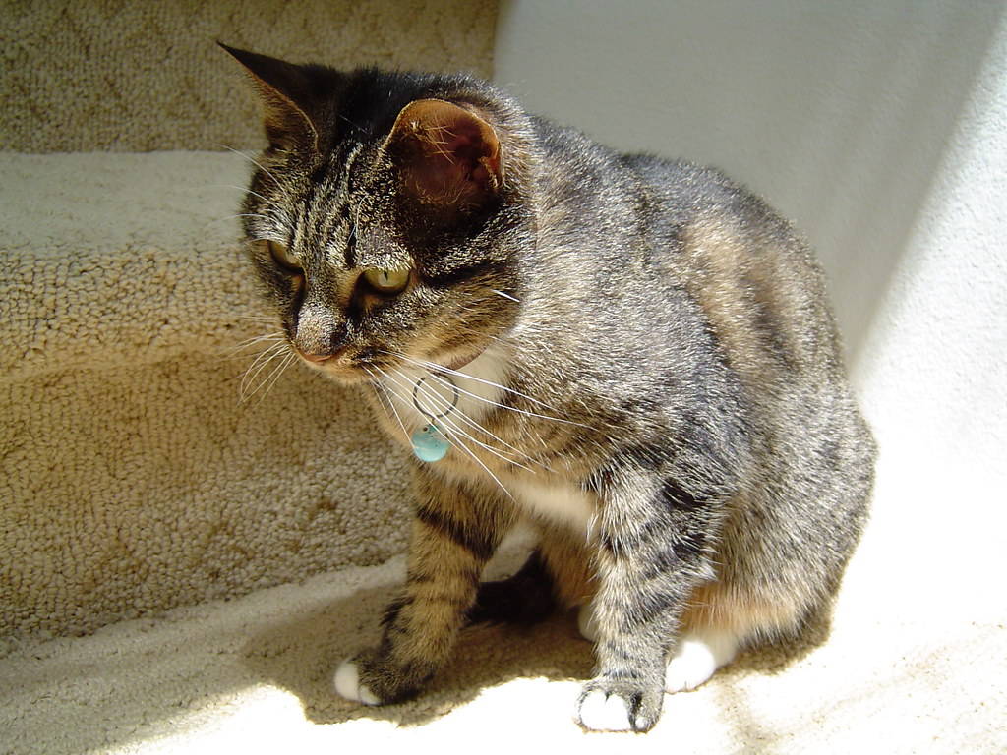

[*"Cat - DSC00705"*](https://www.flickr.com/photos/38021965@N00/8109351)*by [yuankuei](https://www.flickr.com/photos/38021965@N00) is licensed under*[*CC BY-NC-ND 2.0*](https://creativecommons.org/licenses/by-nc-nd/2.0/?ref=ccsearch&atype=rich)

Second Page

There’s nothing here.