# Mechanical System

## Manufacturer’s Information

MEP Engineer: CJL Engineering

AHU Supplier: Berner

HVAC/Plumbing Contractor: SSM Industries

Sprinkler Contractor: S.A. Comunale

(Reference: CSL_technical_report_1)

## Installation Date

Rough-In work of mechanical system starts from 08/15/2011 to 11/17/2011, lasting 69 days.

(Reference: CSL_technical_report_2)

## System Description – Passive Design

### Natural Ventilation

Unconditioned space, such as the large atrium, remains entirely heated and cooled naturally through passive design. Two diagrams depicting the air flow in the passively design spaces are pictured below.

 

Figures – Provided by The Design Alliance Architects, images depict the natural ventilation of the passively designed spaces

## System Description – Active Design

The majority of the building is heated and cooled by one variable air volume AHU supplying a maximum of 12,400 CFM. A geothermal ground source heat pump and enthalpy wheel was installed in order to further reduce the energy load imposed by the AHU. Housed on the north side of the first floor, the mechanical room supplies the AHU with preconditioned refrigerant from the closed loop geothermal system and air pressure to the dry pipe fire suppression system. In addition, other unique design features include a raised floor system for the distribution of supply air, thermal radiant floor heating to provide supplementary heat, and a green roof for increased thermal mass to stabilize the heating and cooling loads.

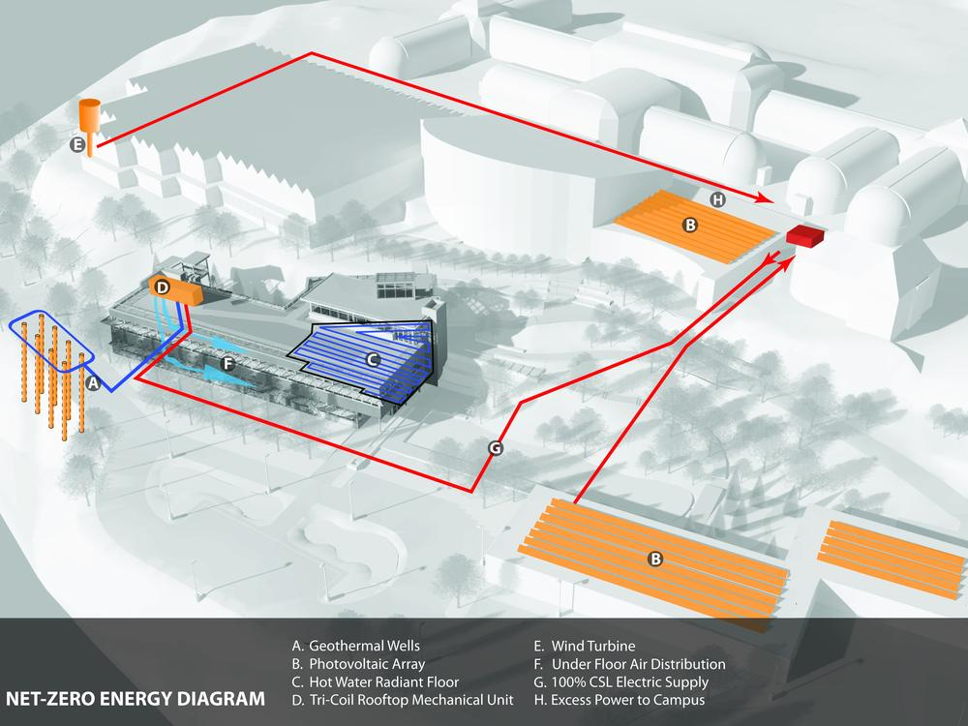

Figure 1. Geothermal Wells (A), Hot Water Radiant Floor (C), Tri-Coil Rooftop Mechanical Unit (D)

### Geothermal Heating and Cooling

A geothermal well system has also been installed as part of the energy conservation measures. The wells are 510 feet deep and twenty feet on center from well to well. These wells feed water cooled compressors for both heating and cooling loads by providing tempered water to the AHU in the winter and cool water during the summer. All HVAC equipment is controlled via a direct digital control (DDC) building automation system (BAS), and all metering pertaining to HVAC work records data in conjunction with the BAS.

### Under-Floor Distribution System

Mechanically, the building is primarily served by an under-floor air distribution (UFAD) system. UFAD was selected because of its efficiency and low energy consumption relative to comparable systems. The UFAD provides optimum comfort control while at the same time preventing over ventilation by reducing ventilation to unoccupied air volumes. The UFAD system introduced ventilation air directly into the breathing zone and allows heat from internal loads to stratify above the occupants. When outside air conditions permit, the building is cooled by natural ventilation through motorized operable windows and full economizing cycle on the rooftop unit. The atrium is not mechanically conditioned. HEPEX Tubing for a future radiant hydronic heating system is installed to temper the space in the heating season (if this proves to be necessary), and no cooling is provided to the atrium in the cooling season. Instead, the atrium relies totally on natural ventilation.

### Tri-coil energy-recovery System

The entire system is served by a roof top air handling unit (AHU‐1). One dedicated rooftop unit serves the under-floor system for the entire building. The unit consists of a filter module (MERV 9 pre‐filters and MERV 13 final filters), recirculation/mixing box module, exhaust fan with VFD, enthalpy wheel module, tri-coil module, supply fan with VFD and water cooled compressors. The unit provides approximate 12,000 cfm supply air with the ability to go to a full economizer cycle when outdoor air conditions allow. The unit responds to CO2 demand control ventilation. The tri‐coil design includes a DX coil sandwiched in between a glycol run around loop. The run around loop and associated fractional horsepower pump provides pre‐cooling and reheating to increase dehumidification capacity. The desiccant coated total enthalpy recovery wheel provides free heating, cooling, dehumidification and/or humidification depending on the season. The system capacity is based on loads and ventilation requirements as calculated using Trane Trace 700 software program. All occupied spaces are ventilated with outdoor air (OA) in accordance with ASHRAE 62.1‐2004 with the intent of meeting LEED Indoor Environmental Quality Prerequisite 1, Minimum IAQ Performance and Credit 2, Increased Ventilation. Thermal comfort conditions comply with ASHRAE Standard 55‐2004 within all mechanically ventilated spaces.

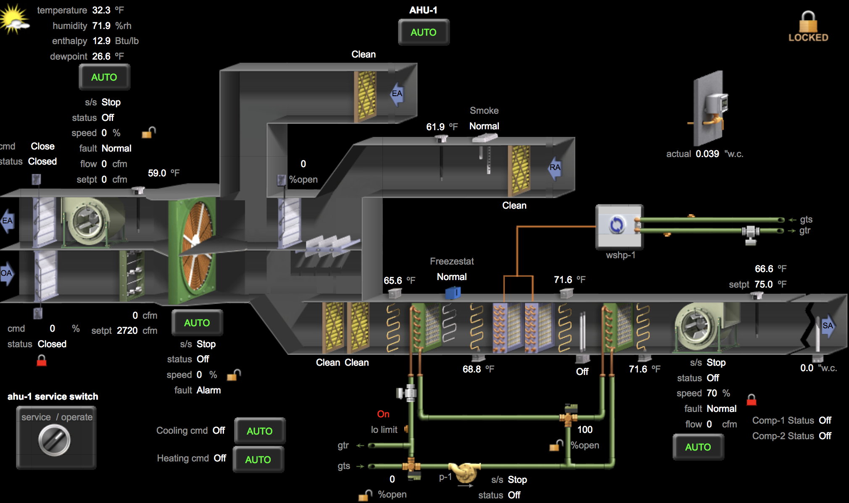

# Sustainable Features

## Net Zero Energy



The CSL design utilizes passive-first strategies to connect occupants to the natural world – a strategy which has proven beneficial to occupant comfort and building performance. Efforts to maximize natural daylight, supplemented by occupancy sensors and daylight dimming controls, have resulted in a lighting power density of 0.57 W/sf without adjustment for controls. Daylight autonomy in most space is approximately 80%; total projected energy savings to 90.1-2004 baseline is 77%. These strategies couple with renewable energy generation and reuse of water to yield a total Energy Utilization Index (EUI) modeled at 19 kBTU/sf/yr post-occupancy. In its 2015 operational year, the CSL achieved an actual total EUI of 18 kBTU/sf/yr, with a net EUI of -3 kBTU/sf/yr, producing more electricity onsite through photovoltaic and wind generation than the building used. This represents a 73.8% reduction (68.7 kBtu/sf/yr median EUI per EPA’s Target Finder vs. 18 kBtu/sf/yr for CSL EUI), meeting the AIA’s 2030 commitment. Each year, the surplus from renewable energy resources has grown, from 5,082 kWh in 2013 to 11,185 kWh in 2014 to 18,724 in 2015. Having a net-zero building powered by onsite renewable energy eliminates fossil fuel use and the greenhouse gasses associated with carbon-intensive energy production

Metrics:

**Total pEUI:**19 kBtu/sf/yr

**Total EUI actual:**18 kBtu/sf/yr

**Net pEUI:**-2 kBtu/sf/yr

**Net EUI actual:**-3 kBtu/sf/yr

**Percent Reduction from National Median EUI for Building Type (predicted):**72%

**Percent reduction actual:**73.80%

**Lighting Power Density:**0.57 watts/sf

## Net Zero Water

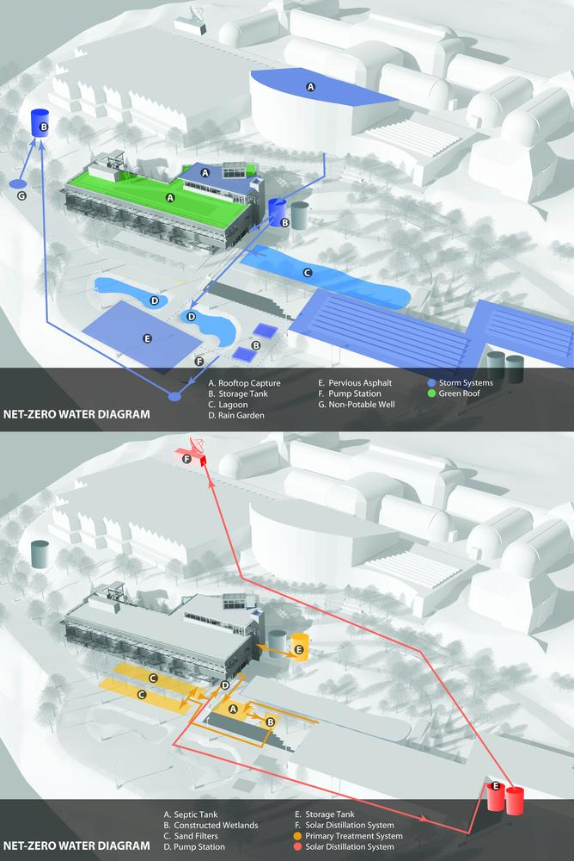

The 2.9-acre CSL site is net-zero water, managing all rainfall and treating all sanitary waste on site. The CSL can manage a 10-year storm event within the site boundaries (3.3” of rain in 24 hours) through soil- and vegetation-based systems like green roofs, rain gardens, bioswales, lagoon, pervious asphalt, and high performance native landscapes. No potable water was used for irrigation after the landscape’s establishment period. The CSL also harvests ½ acre of rooftop runoff from adjacent buildings outside the site boundary. Annually, approximately 500,000 gallons of rooftop runoff are harvested in an underground 60,000-gallon rain tank. The harvested water will be reused to offset daily irrigation demand in Phipps’ conservatory spaces, significantly reducing the campus’ need for municipal water supply and the energy required to treat and deliver it to Phipps. All of the building’s wastewater is treated on site using settling tanks, constructed wetlands, sand filters, and UV filters prior to reuse as flush water for all the building’s restrooms.

Metrics:

**Percent reduction of regulated potable water:**93%

**Is potable water used for irrigation:**No

**Percent of rainwater from maximum anticipated 24 hour, 2-year storm event that can be managed onsite:**100%