Nerves of steel

-Sneha Baidya



“Would you be able to hold this match? If you aren’t sure then we can replace you, are you sure you can at least make a draw?” my team leader asked me. My years of preparation and hard work would be determined by this one game of mine. I stared straight into her eyes and replied, “I will try my level best”. Yes, I am a chess player. Clash of minds as people say, for me chess has always been my escape route from sanity. My years of practice was going to be tested today, and this was the most important game of my chess career, I knew it.

Chess is nothing less than magic for me. I find it astonishing, how just two simple colors, black and white, can make marvelous motifs of creativity. Once a person explores the beauty of chess, they can’t unsee it, they got to fall in love with chess. For me chess can either give me the joy of world victory, or the desire to burn down everything, there’s no in-between. You got to have a heart of stone and nerves of steel to conquer this ultimate gymnasium of two minds.

That day, I was going to play against a much higher rated opponent. For those who aren’t familiar with chess, “rating” is a way of representing a player’s standard. So in simple words, my opponent was much stronger in chess than me. I was brutally scared, to be honest, representing my institution and my team in this crucial match, my back was already against the wall, and I knew there’s no way back now.

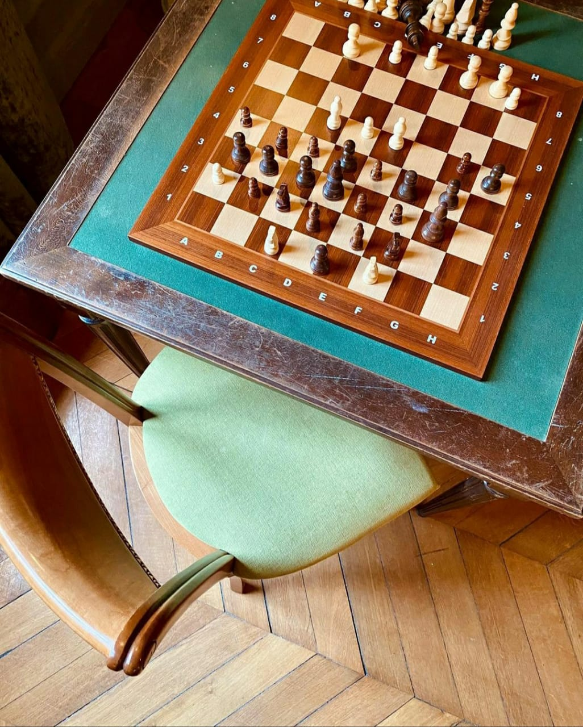

With clumsy steps, I reached the playing hall. I saw my opponent, already at the playing board, adjusting her king, queen, and pawns. Adrenalin rushed through my veins, so I decided to visit the restroom for my pre-match self-talk. When I faced the mirror and gazed through my butterfly brown eyes, a memory flashed across my eyes. A flashback of my childhood summer, my earliest memory of playing chess, when my only motivation to get up early in the morning was the excitement of playing chess on the computer. All my chess coaching lessons seemed to be concentrated on this one day, this one huge match of mine. I summoned my old self, the fearless young girl, frolicking her way through the chess boards. I cleared all my dark clouds of doubts and gave way to my sunshine, the sun of hope. I returned back to the chessboard gathering all my courage, knowledge, and strength. I knew there was going to be a war on the board today with blood baths, and I had to be strong.

The game started, I was playing black. My opponent played an opening with which I was familiar, so my opening part of the game went fine. Everything was normal until my opponent tricked me to lose a pawn. Pawns are the soul of chess, as said by Philidor, I knew that this wasn’t an easy game now. Meanwhile, I noticed that two of my teammates have won their respective games and one of them had lost. That meant that I needed to win or draw my own game in order to secure the team victory. The responsibility of the whole team was now on my shoulders, I knew that loss wasn’t an option now. I fueled my tactics and scrambled hard to squeeze a draw out of that dead loss position. I could feel my heart throbbing, during the final moment of the match, when we stopped the clock and shook hands.

So the most memorable match of my entire chess career is a hard-fought draw, not a win. Because no win in this world will be as big as my level of satisfaction after making my team and my institution proud of me. The amount of passion I poured into that one game is the pride of my chess career. That one game gave me a spectrum of emotions, which I will keep cherishing till the last day of my life.

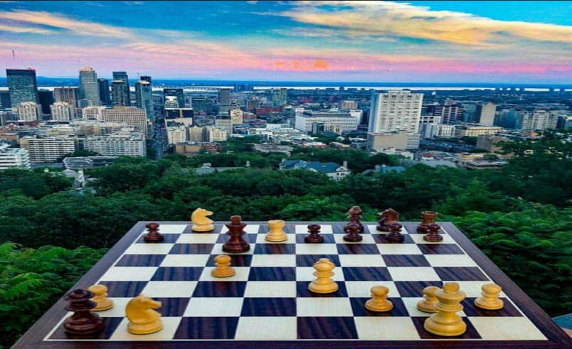

(source of all images: Instagram)

(This article is my submission for RGVTUAN article writing competition. This has already been used once. This is just a sample of my work.)