**Project Two Proposal – UNC Raleigh Data Class (May 2019)**

**Alex Jose, Davis Trinh, Jing Duan, Carlos Moreno, Kent Bryant**

**Project repository stored in https://github.com/4890A/bitcoin-media**

**A project to answer the question: Does media (and social media) sentiment about Bitcoin reflect its price fluctuations, and could an investor base decisions on current sentiment?**

We’ll analyze the fluctuation of Bitcoin value since 2012, compared with the US Dow Jones, and gold, and heatmap Google searches about Bitcoin in different countries.

This project will be a combination webscraping, Leaflet, and more. The user will be able to display the Bitcoin price over time, and overlay that with stock market, and gold prices, as well as media participation (with hoverable article headlines).

Datasets to evaluate the public sentiment about Bitcoin (using tools such as TextBlob):

* Subreddit forum on the Bitcoin market
* Scraped data from NYTimes articles about Bitcoin
* Data scraped from Twitter

Including other datasets:

* Bitcoin price from coinpaprika API
* Dow Jones Industrial Average
* Google Trends data on Bitcoin:

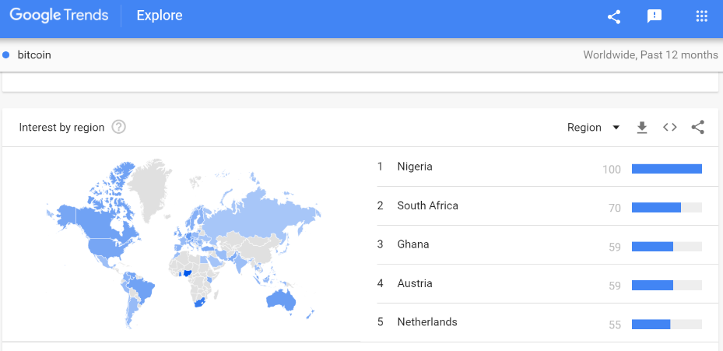

One visualization:

