FriendZone Timeline Canva DocumentPhoto groups for Canva
Use these groups as image options beside each timeline stage. The captions match the files in the img folder.

Week 1 Starting point
We began with a broad question: how can we help people make friends in a new space?
Outcome: Initial direction: support people entering a new location, life stage, hobby, or community.
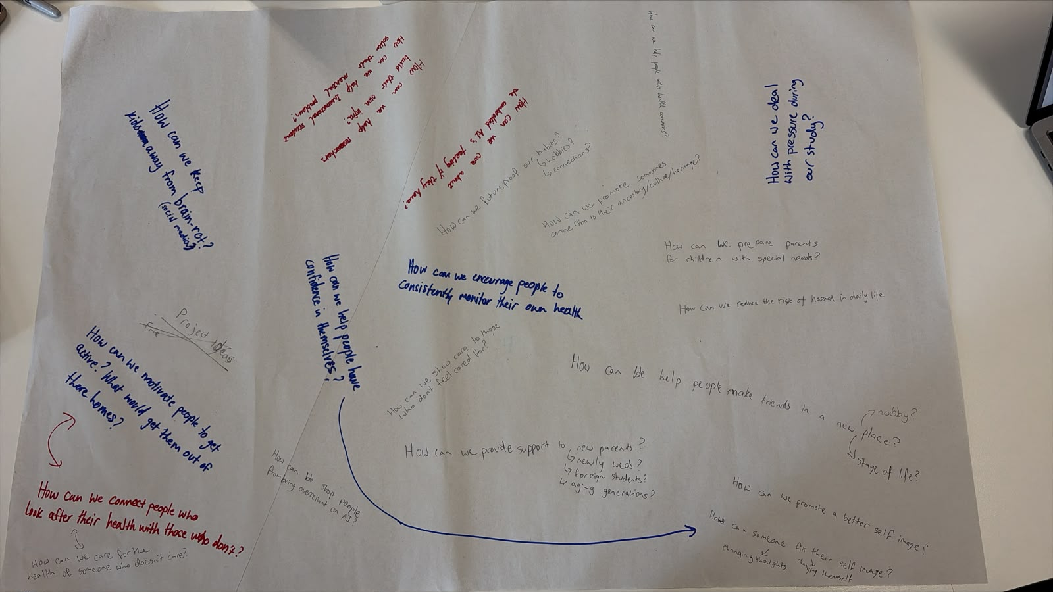  1.jpeg | 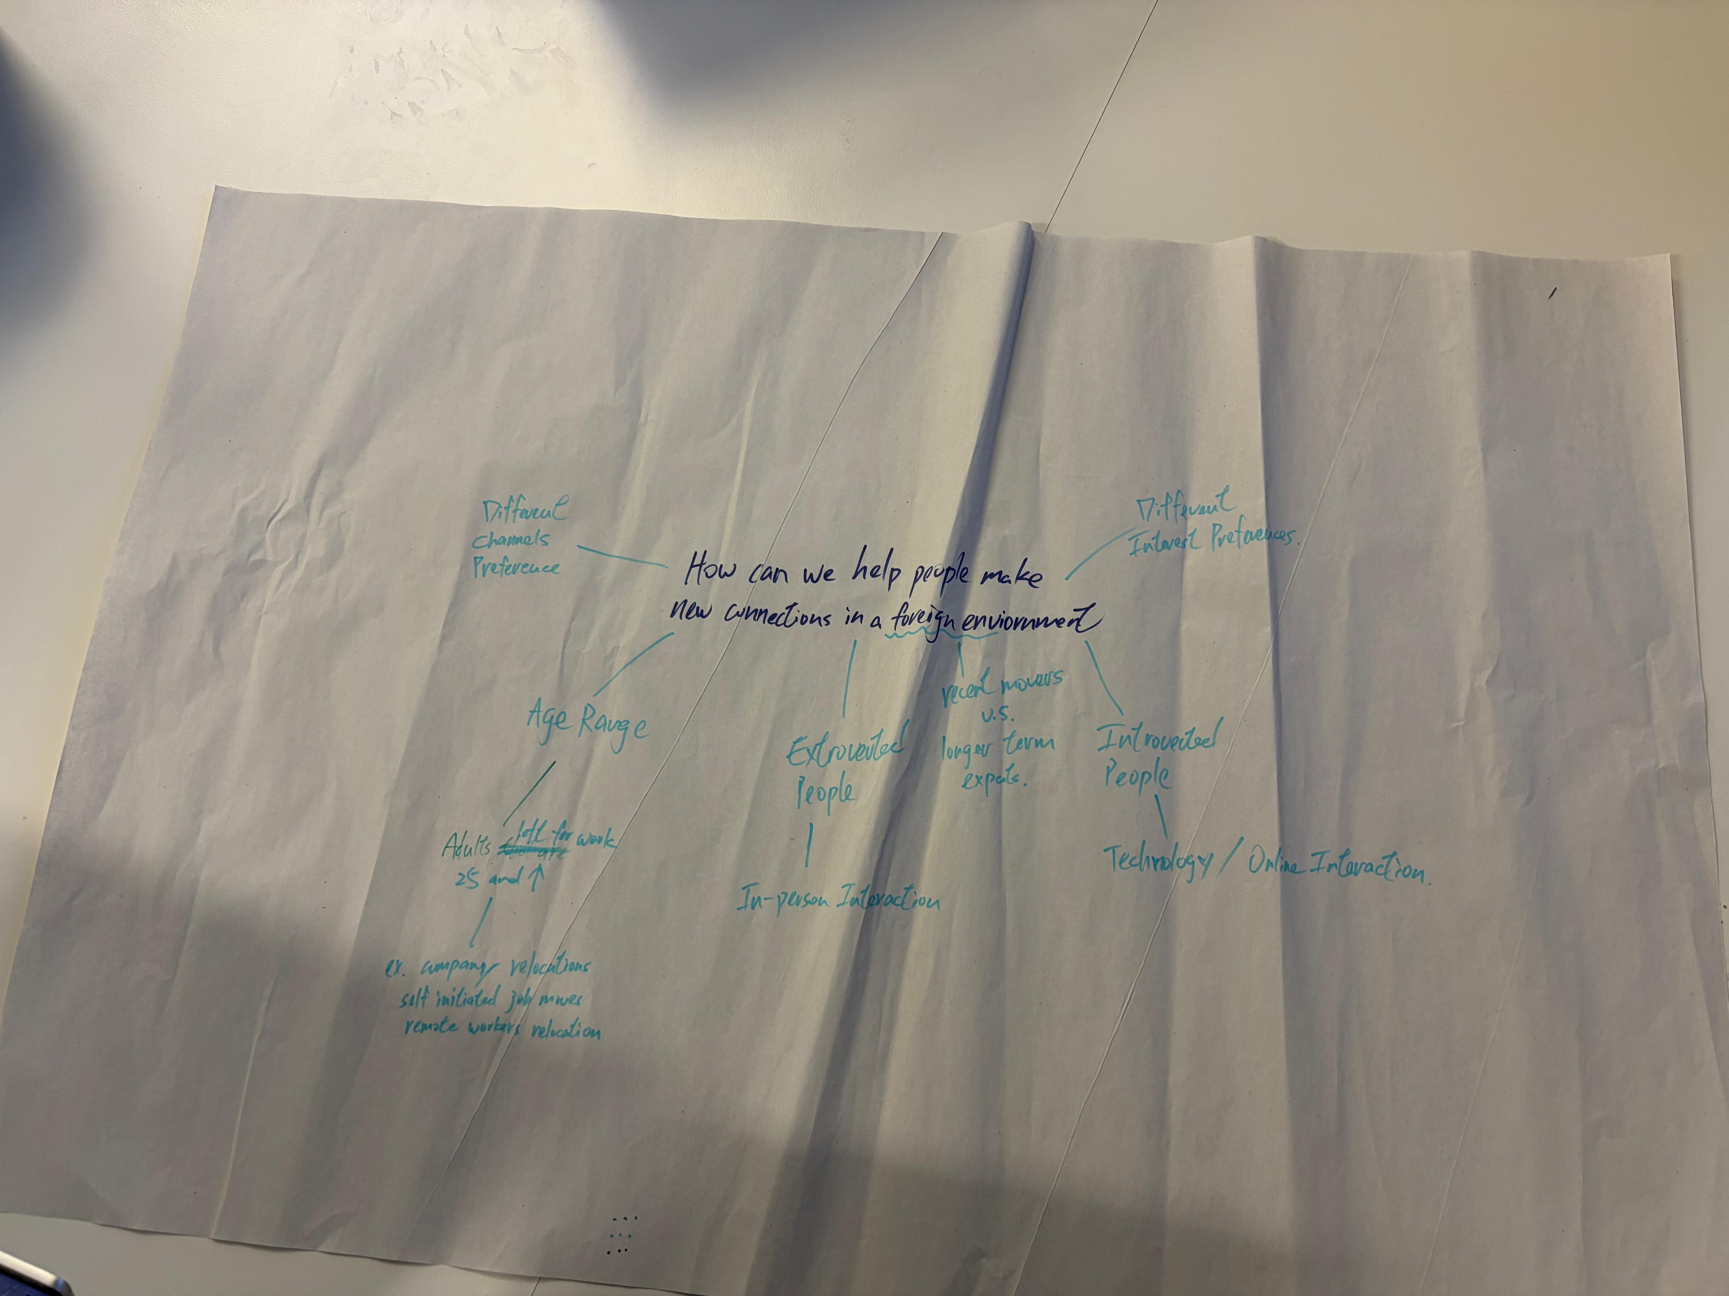  2.jpeg

Week 2 Research planning
We moved from brainstorming to interview planning and agreed to speak with people connected to social or community groups.
Outcome: Interview questions and shared Google Drive files were prepared.
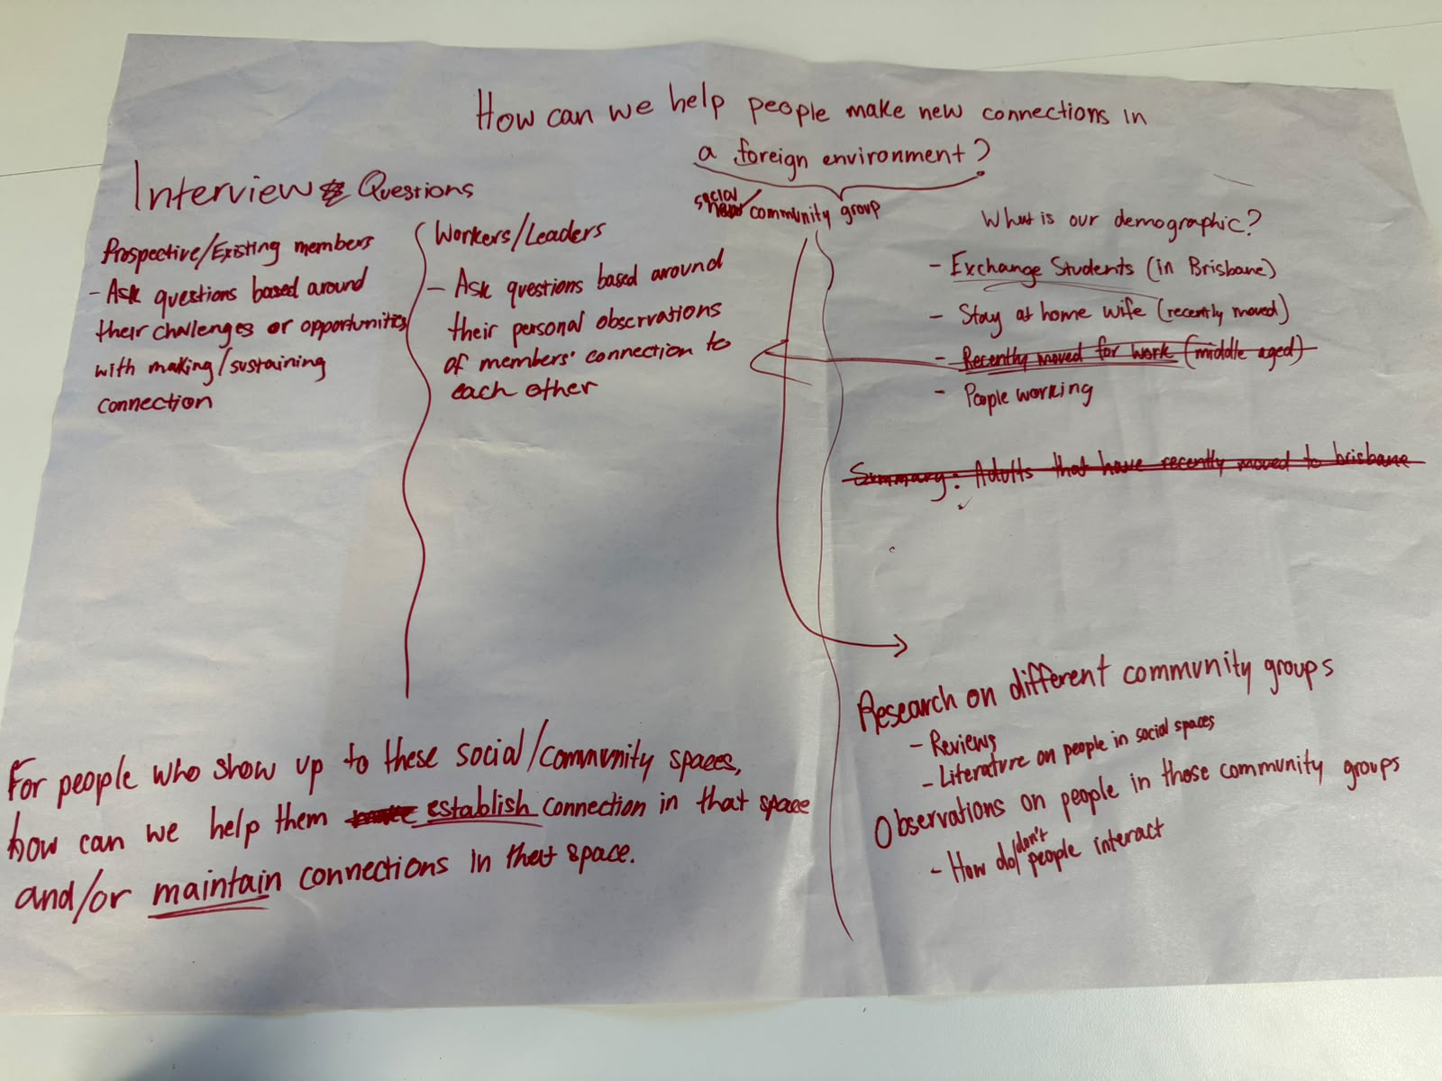  3.jpeg | 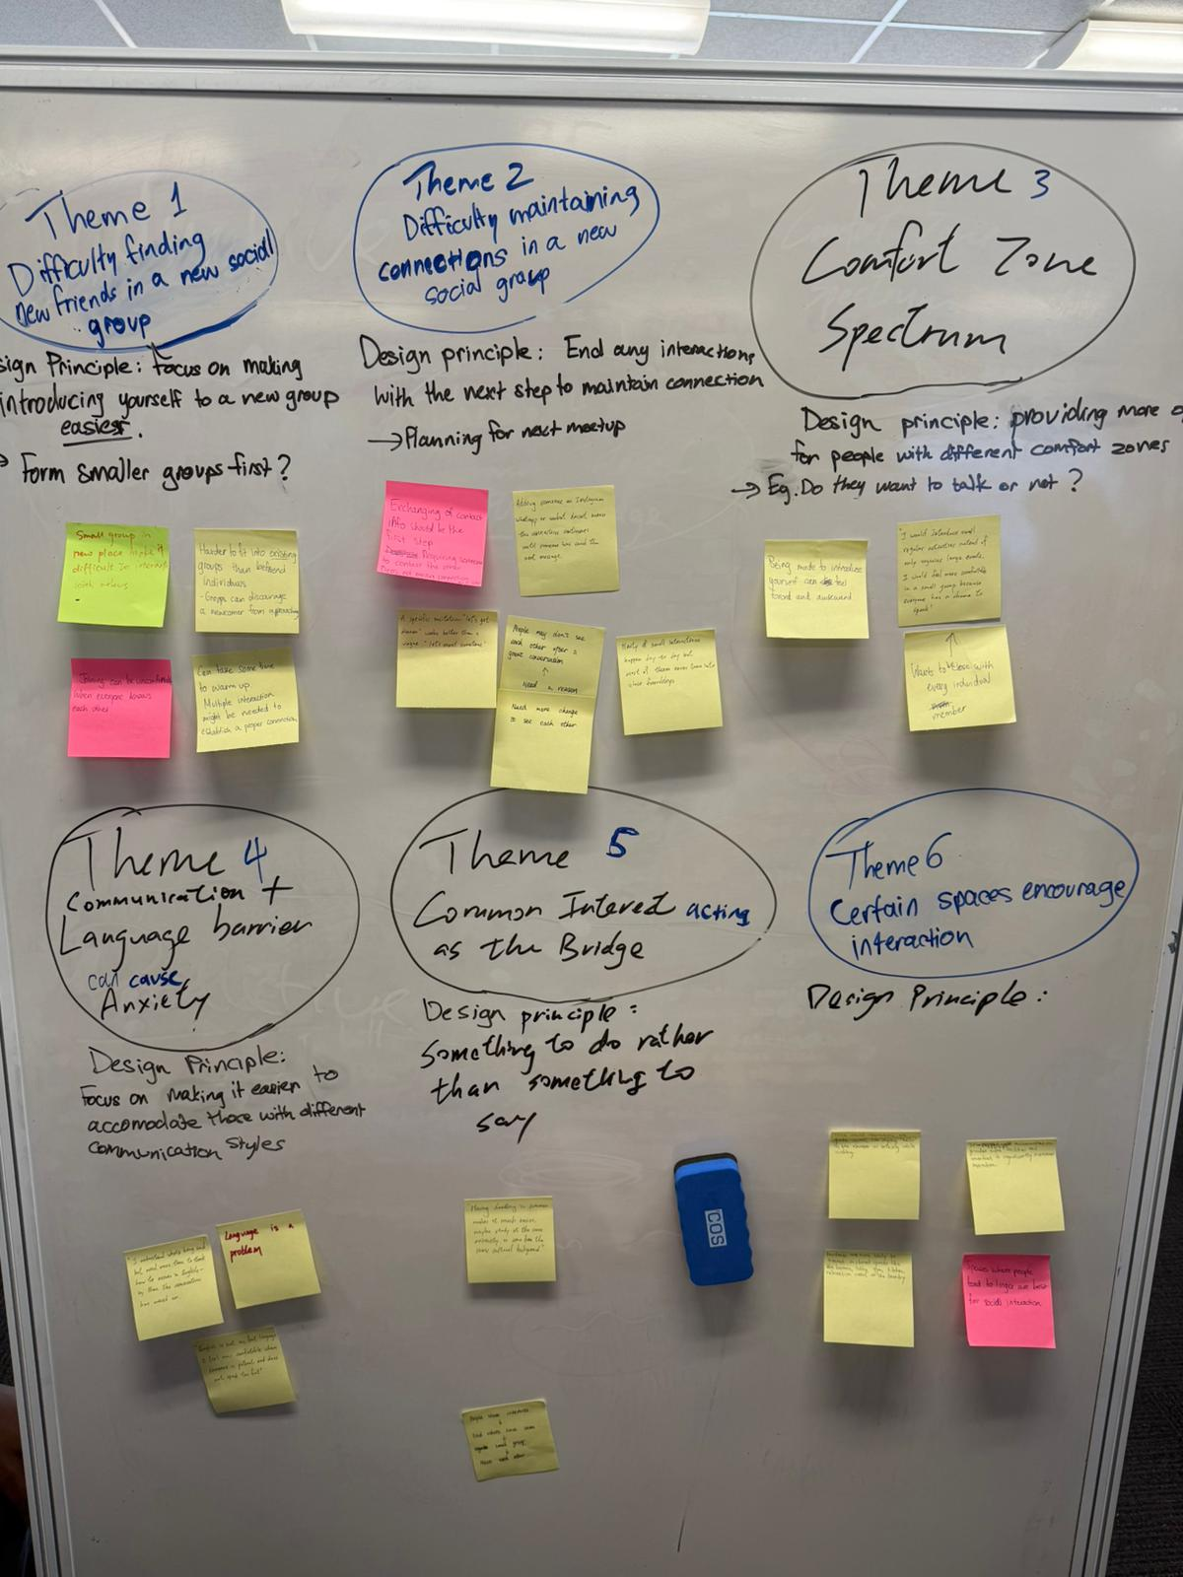  4.jpeg

Week 3 Interview insights
The interviews showed that the problem was not only finding events. People often lacked a reason to start speaking.
Outcome: Key barriers: starting without context, fear of awkwardness, and losing contact after the first meeting.
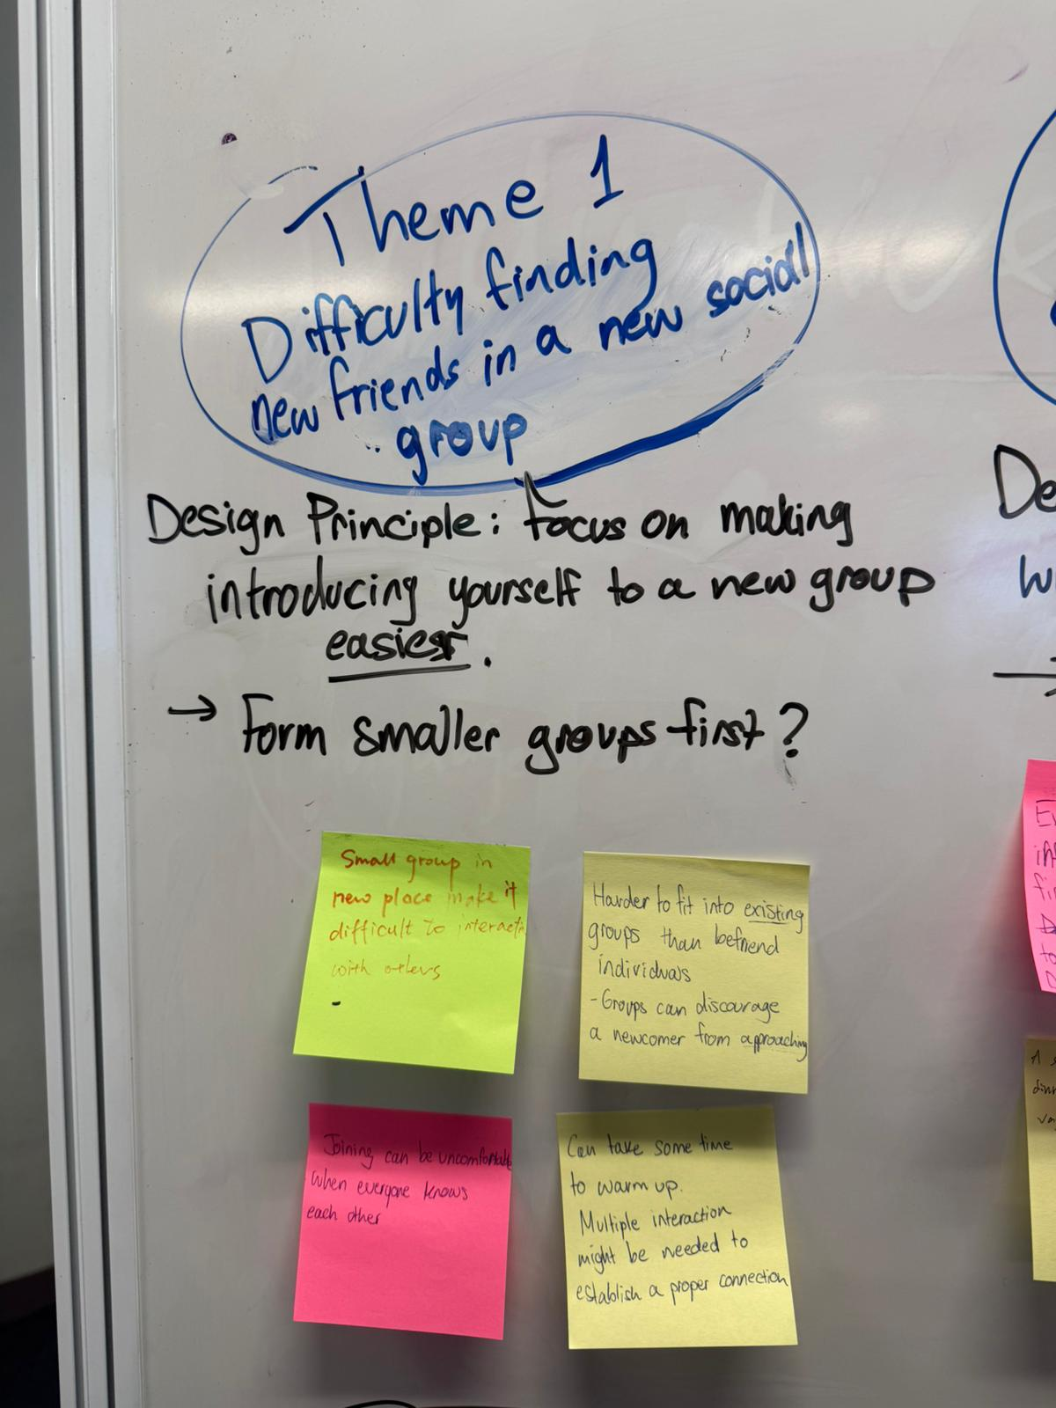  5.jpeg | 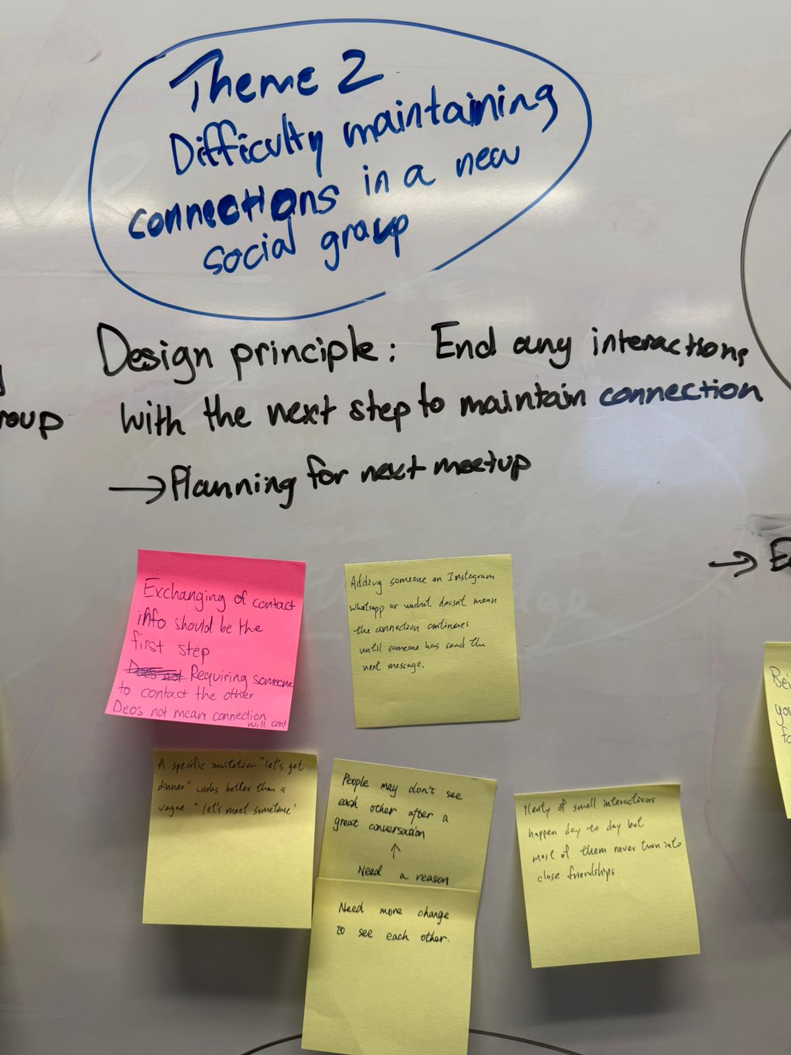  6.jpeg | 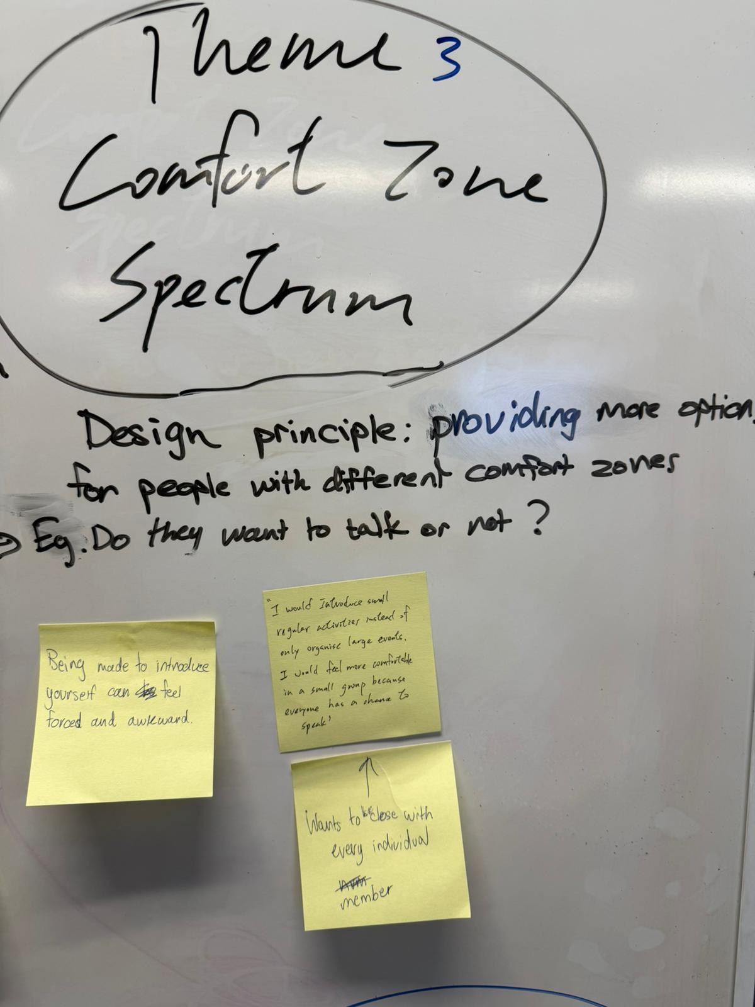  7.jpeg
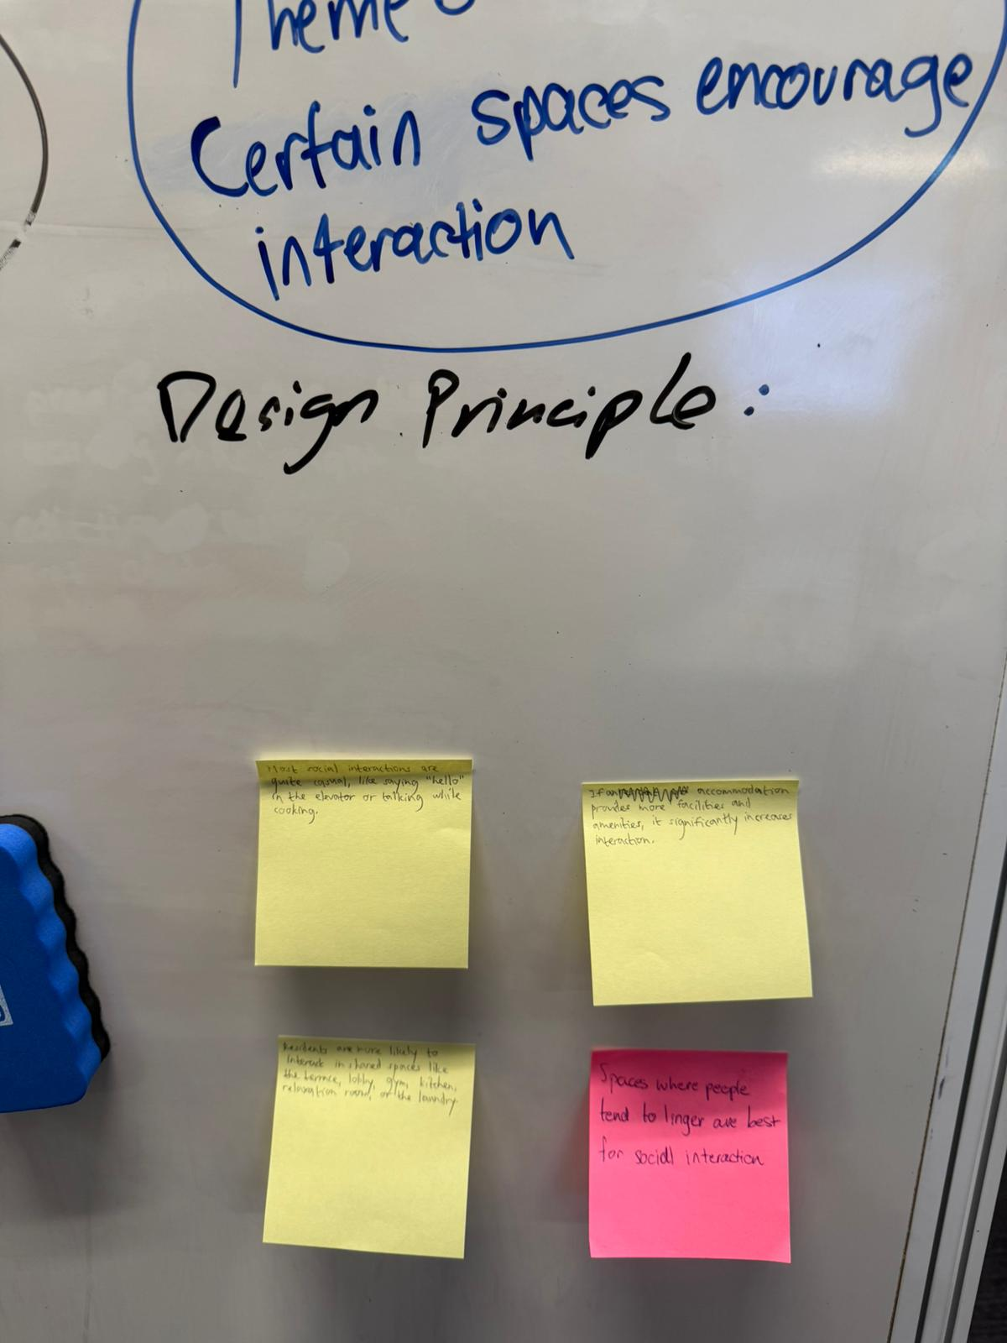 | 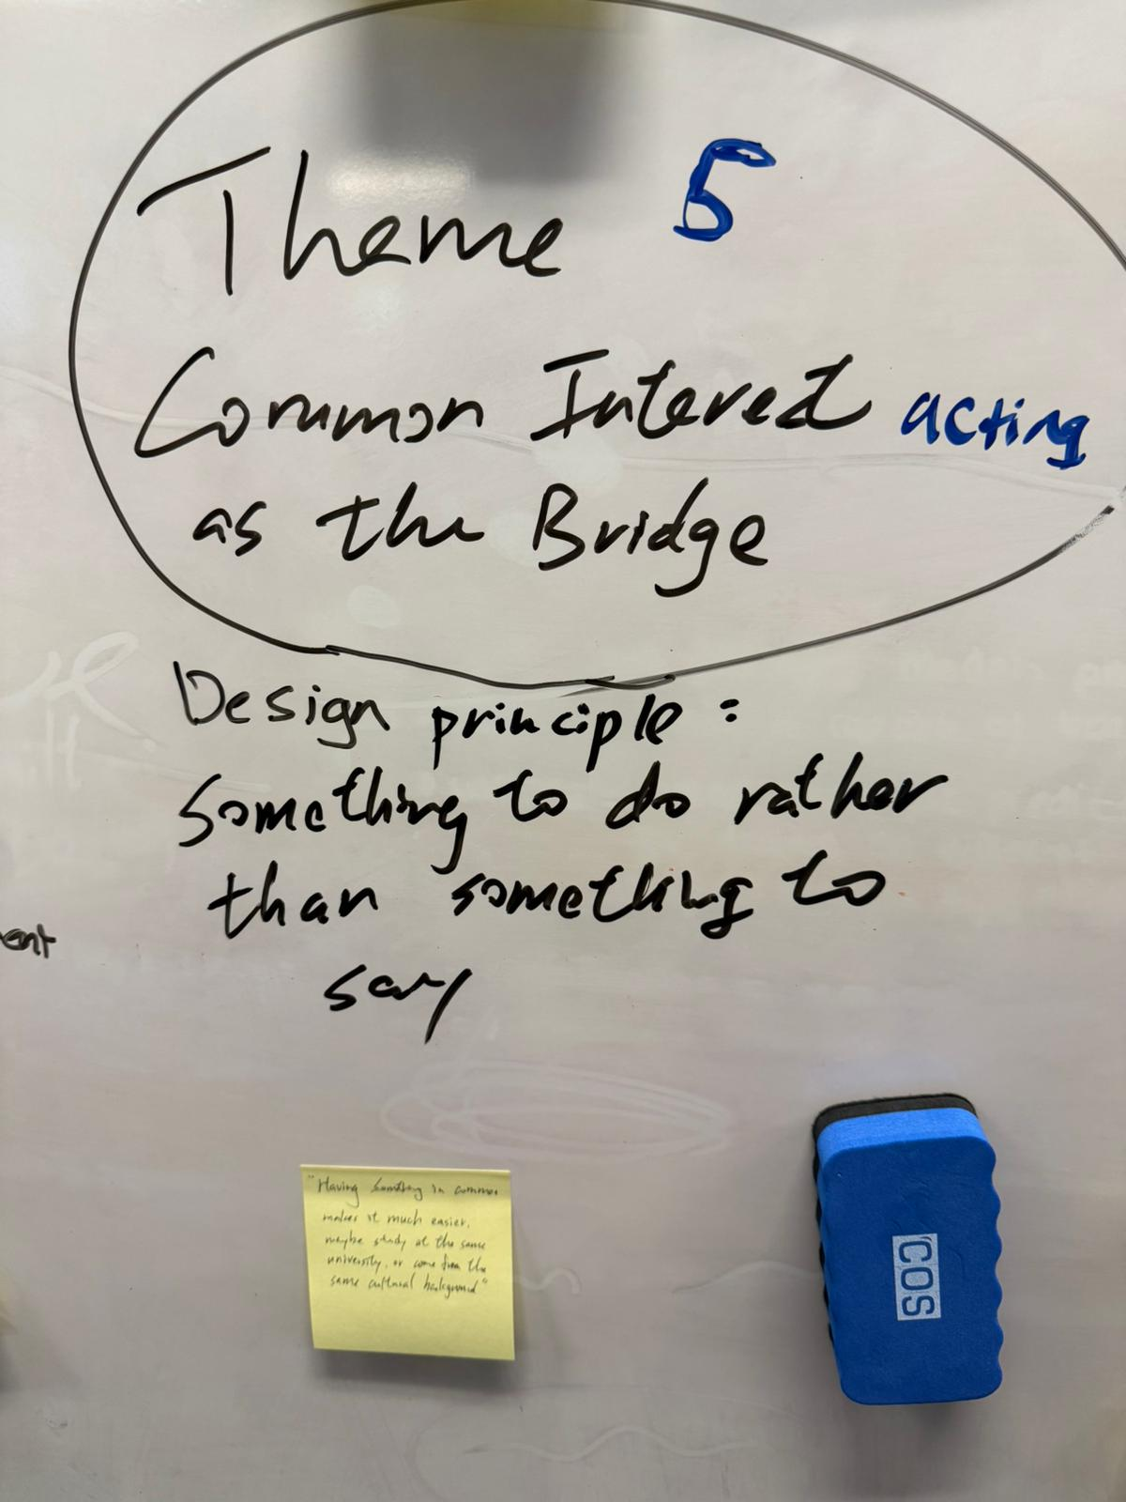 | 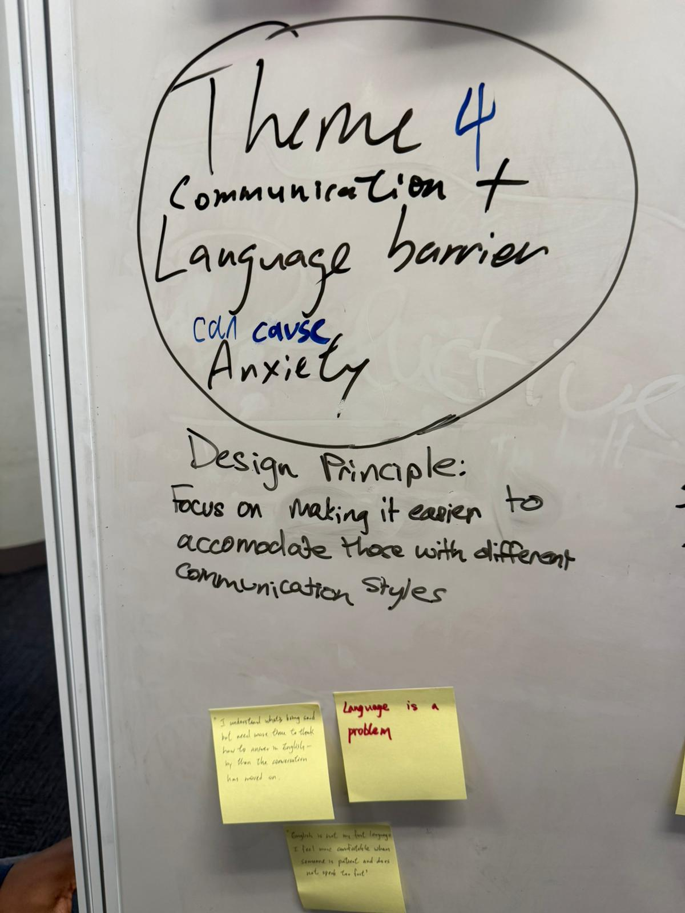

Week 5 Prototype concept
We built a storyboard around a person entering a new city and using FriendZone to join small activities.
Outcome: Core journey: new environment, loneliness, shared activity, safe meeting, mutual follow-up, repeated connection.
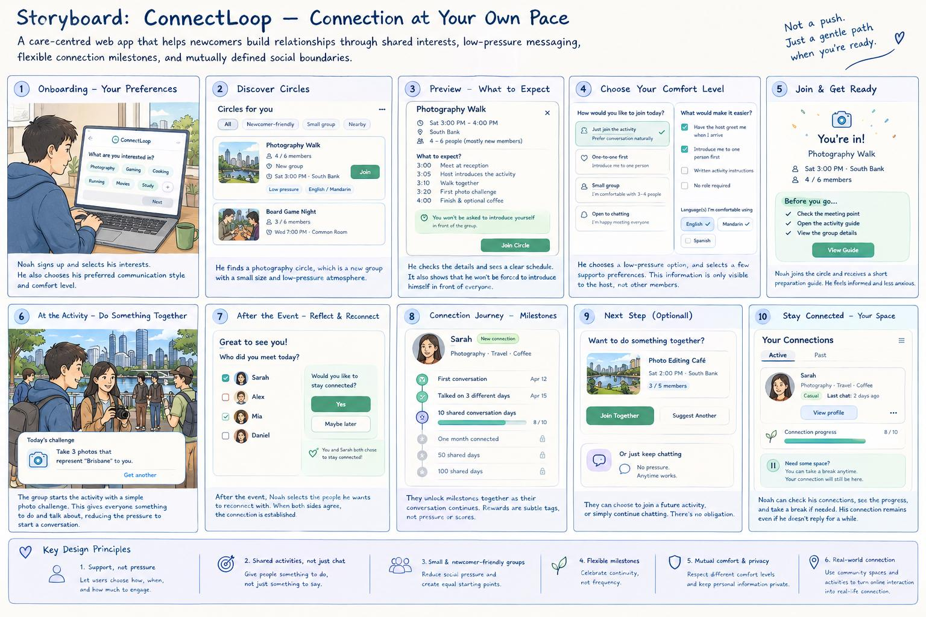  11.jpeg | 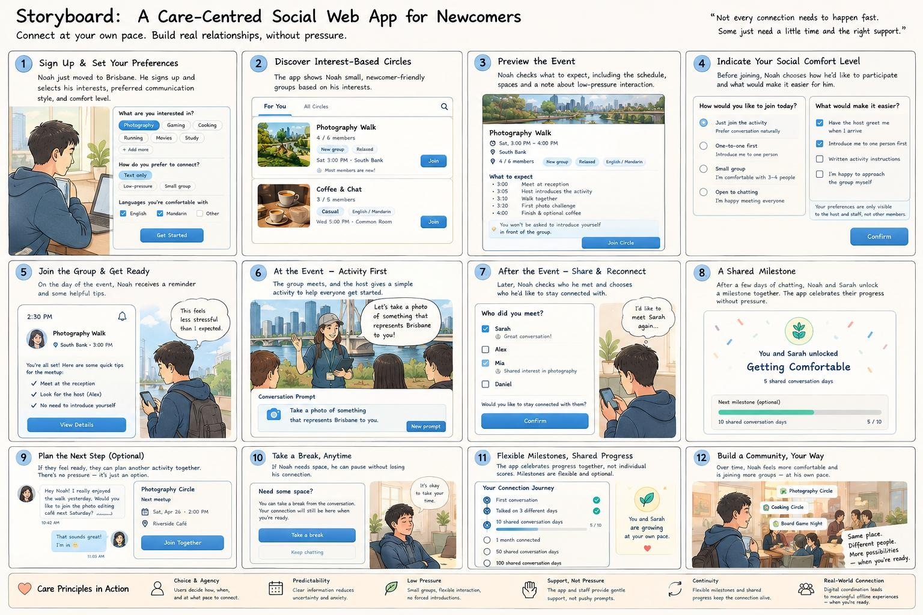  12.jpeg

Week 6 Refinement
After feedback, we researched loneliness, technology-supported face-to-face interaction, preference settings, and app reward risks.
Outcome: Research helped justify the key interaction and refine how rewards should work.
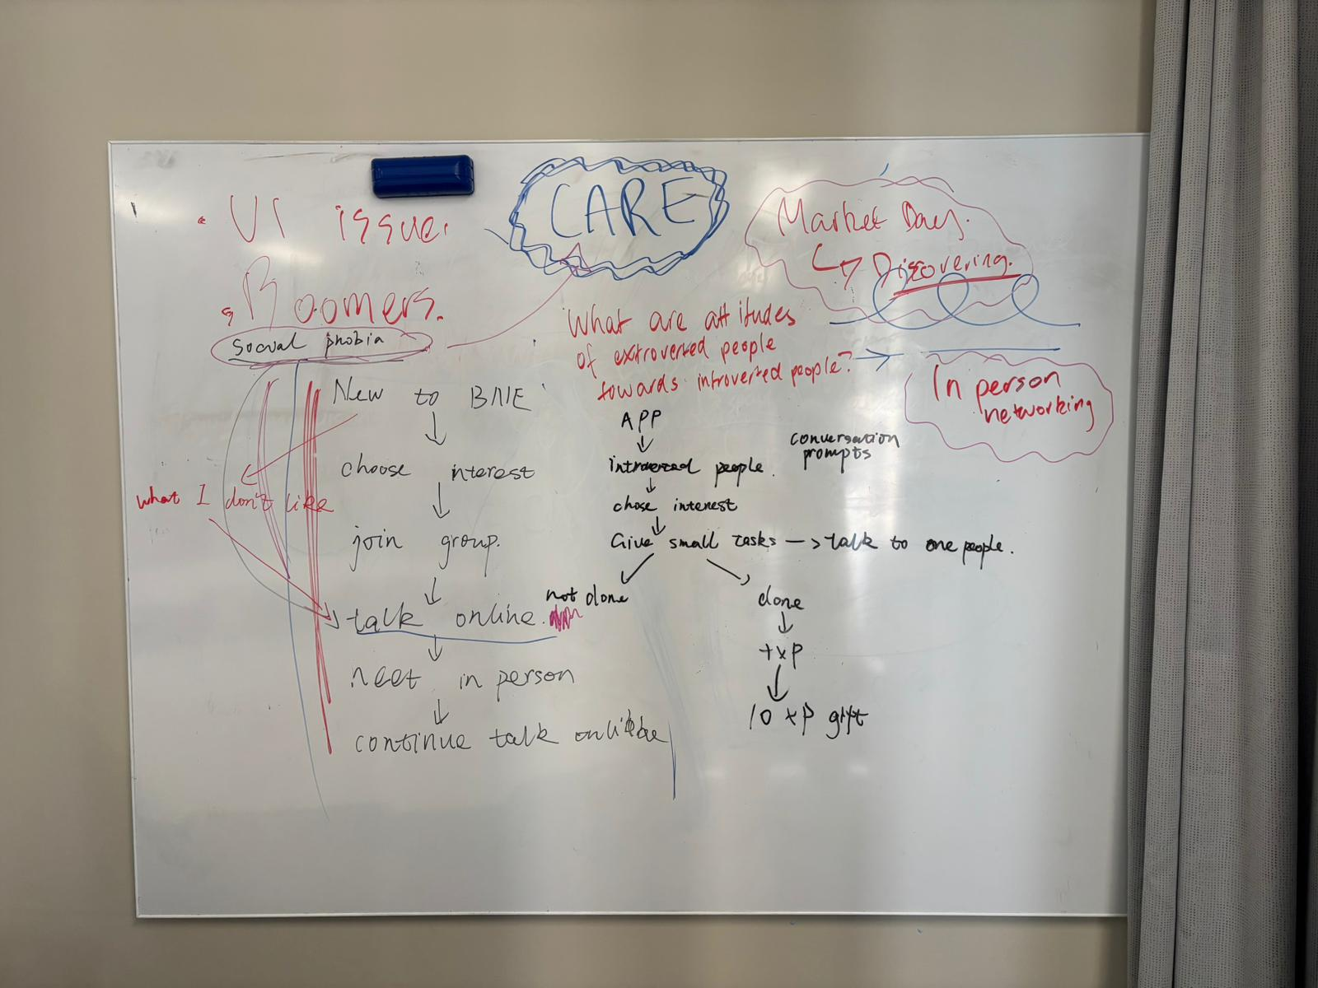  13.jpeg | 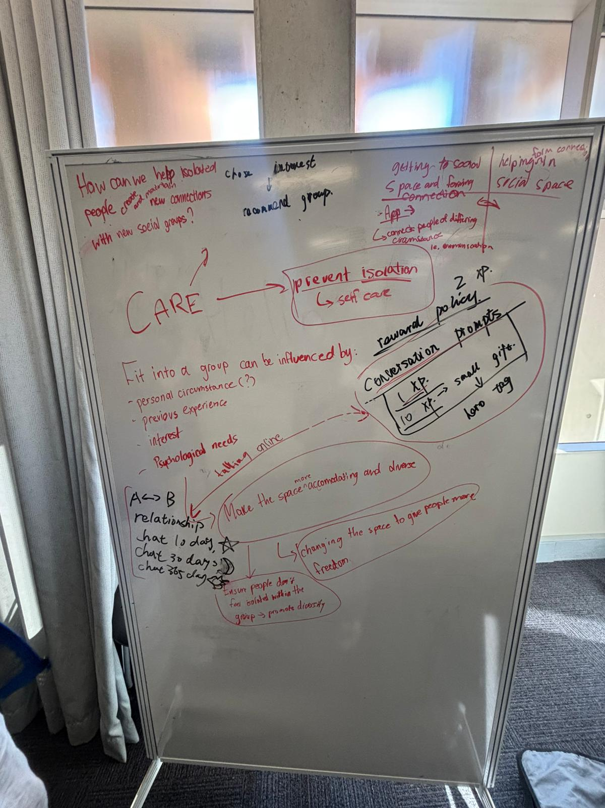  14.jpeg

Week 7 Final direction
We finalised FriendZone around one key interaction: a prompt card that gives users something to say.
Outcome: Final design position: online prompts move people toward meeting; in-person prompts support conversation without keeping users on screen.
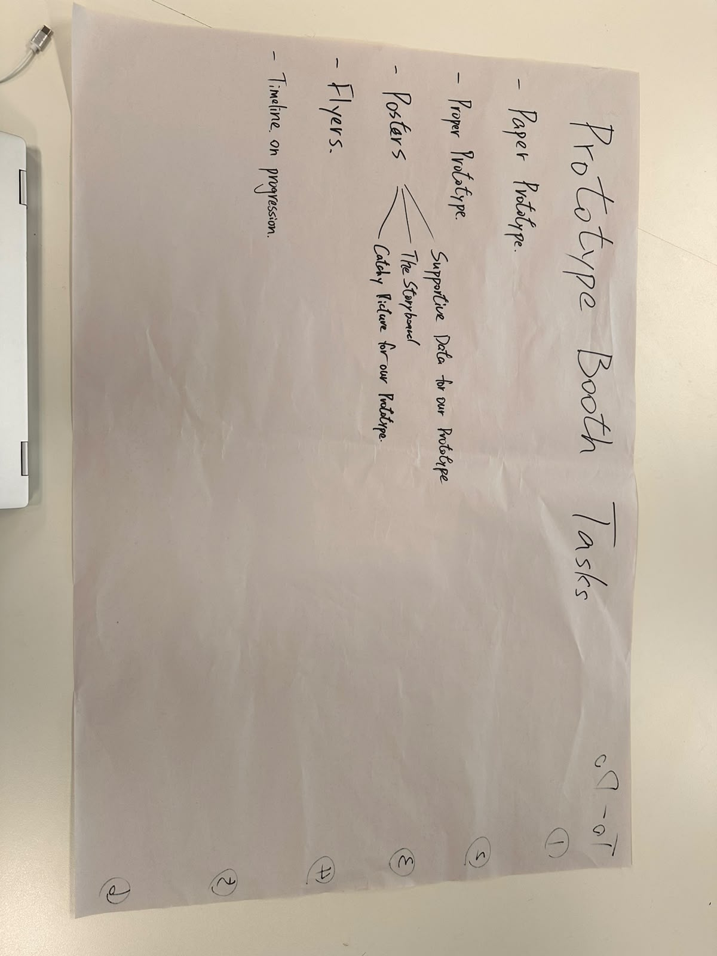  15.jpeg | 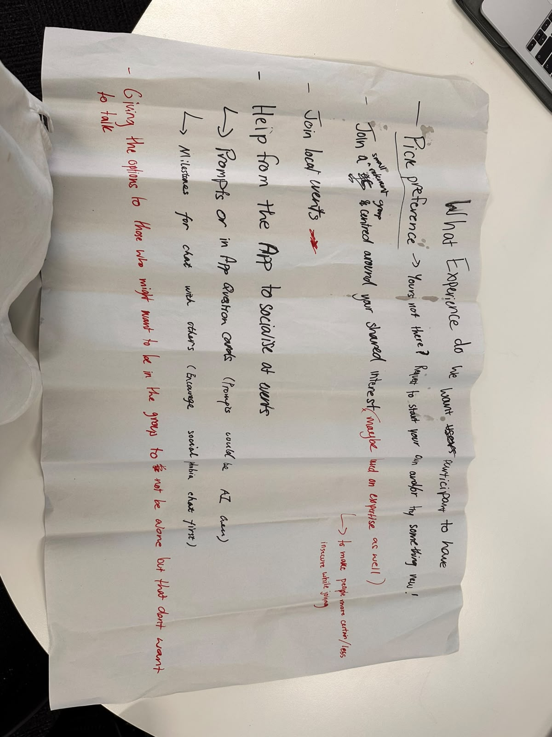  16.jpeg | 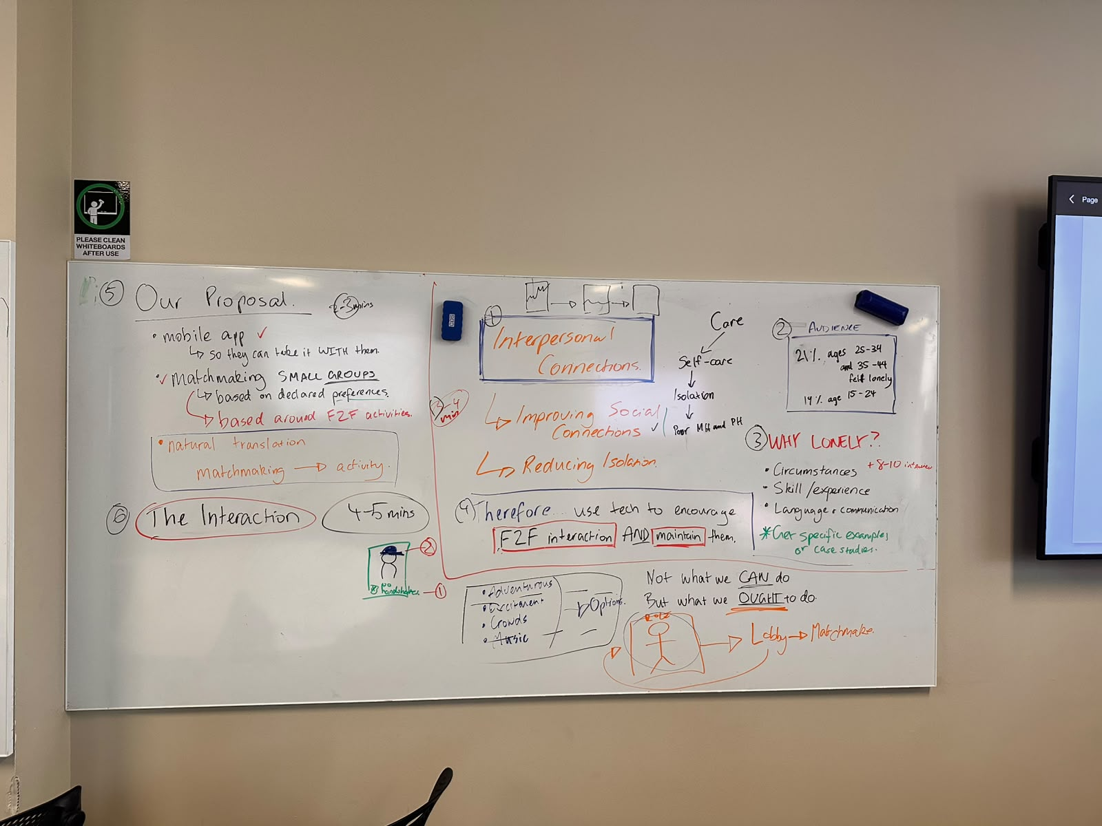  17.jpeg

Final summary
Our design developed from a broad question about making friends in new environments into a focused interaction that gives users a reason to speak. Through interviews and research, we realised that people often struggle not only to find others, but also to feel comfortable starting and maintaining new relationships.
The final FriendZone concept focuses on small private circles, shared interests, gradual prompt cards, light online encouragement, and no in-person rewards. The app helps users move from online preparation into real face-to-face connection, then supports follow-up without turning the relationship into another screen-based task.

