Submission Template for
INFS2200/INFS7903 Assignment 2
Semester 2, 2026

Submission of Screenshot for Assignment 2

Submitted by:
Student Name | Student ID | Practical Session | Tutor Name
Yuyang Gong | 49079984 | Friday 9:00–10:00 | Mr. Li, Jiayun

About AI Usage:
Did you use AI in this assignment? | Yes
The purpose of AI used in this assignment? | To help draft and debug SQL, interpret PostgreSQL output, and complete and format the report.
To what extend that AI is used in this submitted work? | AI assisted with substantial SQL and explanatory text, checked outputs using an isolated local replay, and supplemented incomplete captures. The original interactive screenshots and hand-drawn graph were supplied by the student.
Did you discuss your AI usage with the tutor during the “Show to Tutor” Lab sessions? | No. A2 has not yet been shown to the tutor, and this AI use has not yet been discussed.

Screenshot Q1.1 (1) | Marks: /1
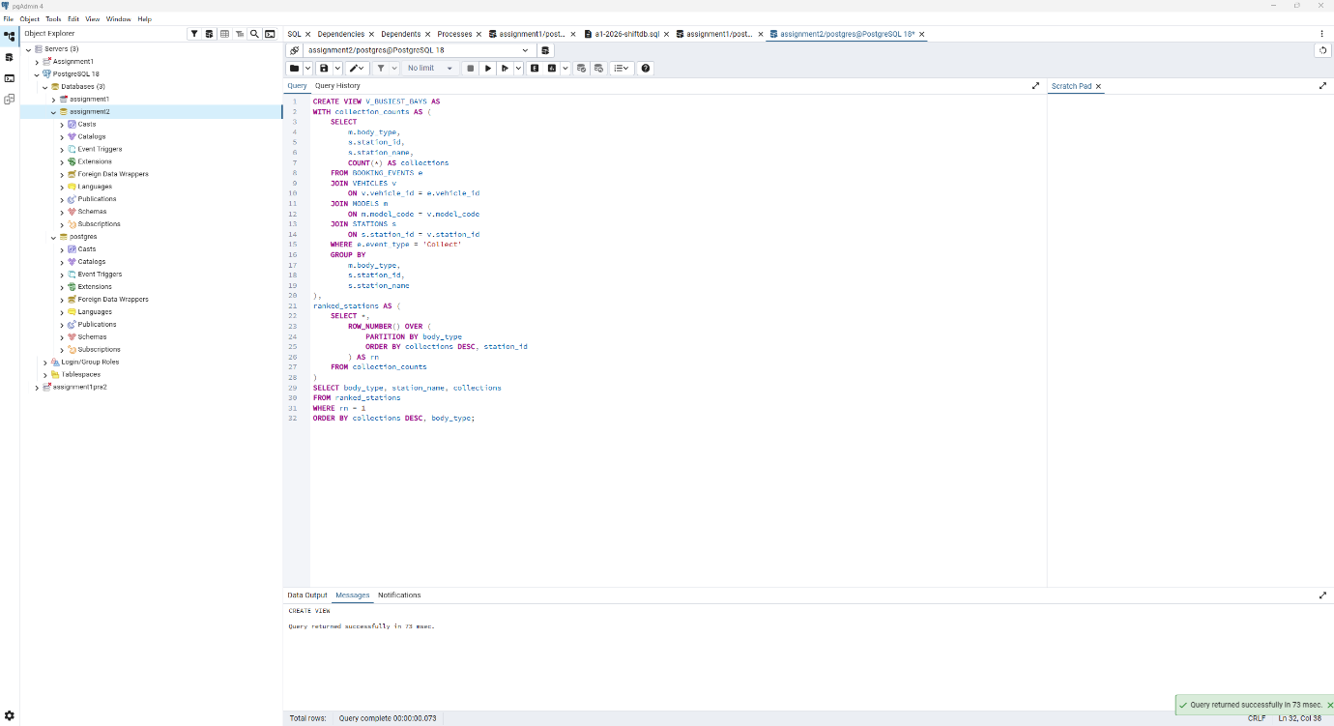
Explanation
The first CTE counts Collect events for each body type and station. ROW_NUMBER partitions those counts by body type and picks the largest count; station_id resolves ties deterministically so exactly one station is returned per represented body type. The final ORDER BY puts the largest winner first.
The schema records a station on VEHICLES, rather than on BOOKING_EVENTS. The station reported is therefore the vehicle's recorded station, which is the location available in the supplied schema.
Comments:

Screenshot Q1.1(2) | Marks: /0.5
Evidence note: the newly supplied native pgAdmin captures are used in Q1.1.2, Q1.3.2, Q2.1.2 and Q3.1.1. Other plans labelled as replay output come from the previously validated clean PostgreSQL 18.6 replay. A separately labelled complete replay plan supplements Query A in Q1.3.2 because its native capture clips two long conditions. Measurements belong to their labelled runs; captures from different stages are not a controlled timing experiment. Original Q3.2 and Q4 interactive evidence is retained.
SQL
SELECT * FROM V_BUSIEST_BAYS;
EXPLAIN (ANALYZE, BUFFERS)
SELECT * FROM V_BUSIEST_BAYS;
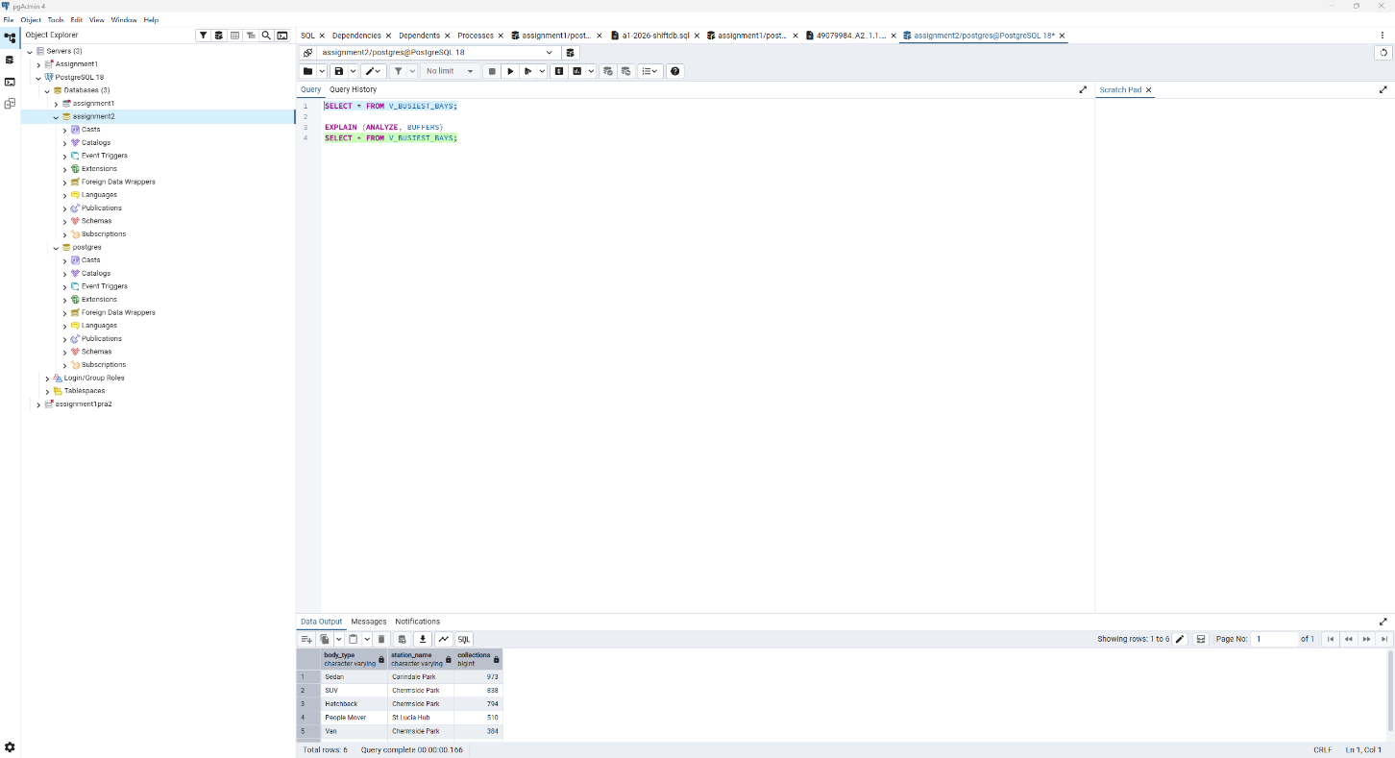
Execution plan without IDX_EVENT_TYPE_TIME, native pgAdmin, lines 1 to 34
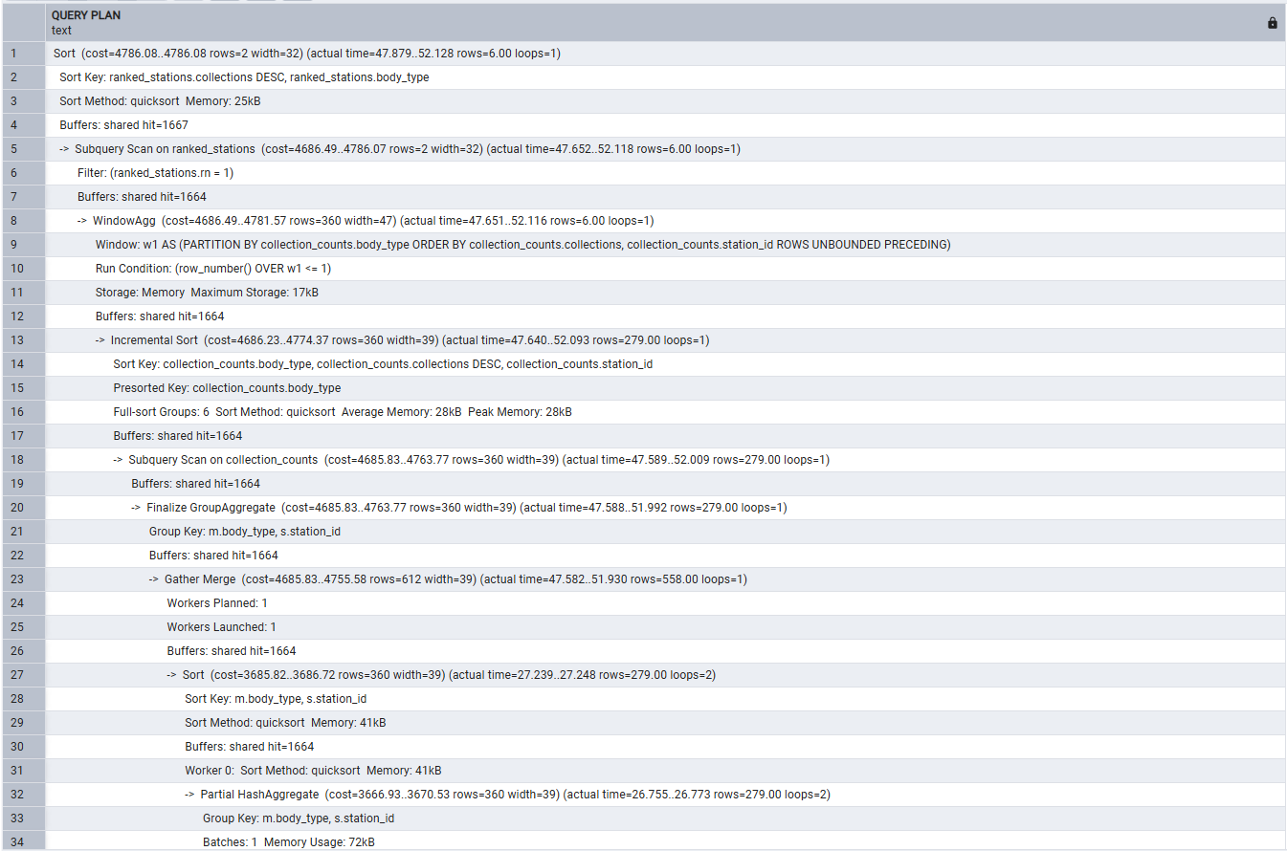
Execution plan without IDX_EVENT_TYPE_TIME, native pgAdmin, lines 35 to 68
Explanation
The view returns six rows. Sedan at Carindale Park leads with 973 collections, followed by SUV 838, Hatchback 794, People Mover 510, Van 384 and Ute 333. In the native repeat measurement without IDX_EVENT_TYPE_TIME, the top node estimates 2 rows and returns 6, with cost 4786.08..4786.08. Planning takes 7.797 ms and execution takes 52.686 ms.
A Parallel Seq Scan filters BOOKING_EVENTS to Collect events. Its 29,769.5 actual rows per loop across two loops represent 59,539 collections. Hash joins attach vehicle, model and station attributes. Partial aggregation and Finalize GroupAggregate produce 279 body-type/station groups in this captured run; incremental sorting and WindowAgg select one winner per body type, and the final sort orders the six winners. The small final result does not avoid processing the underlying event log.
Comments:

Screenshot Q1.2 | Marks: /1.5
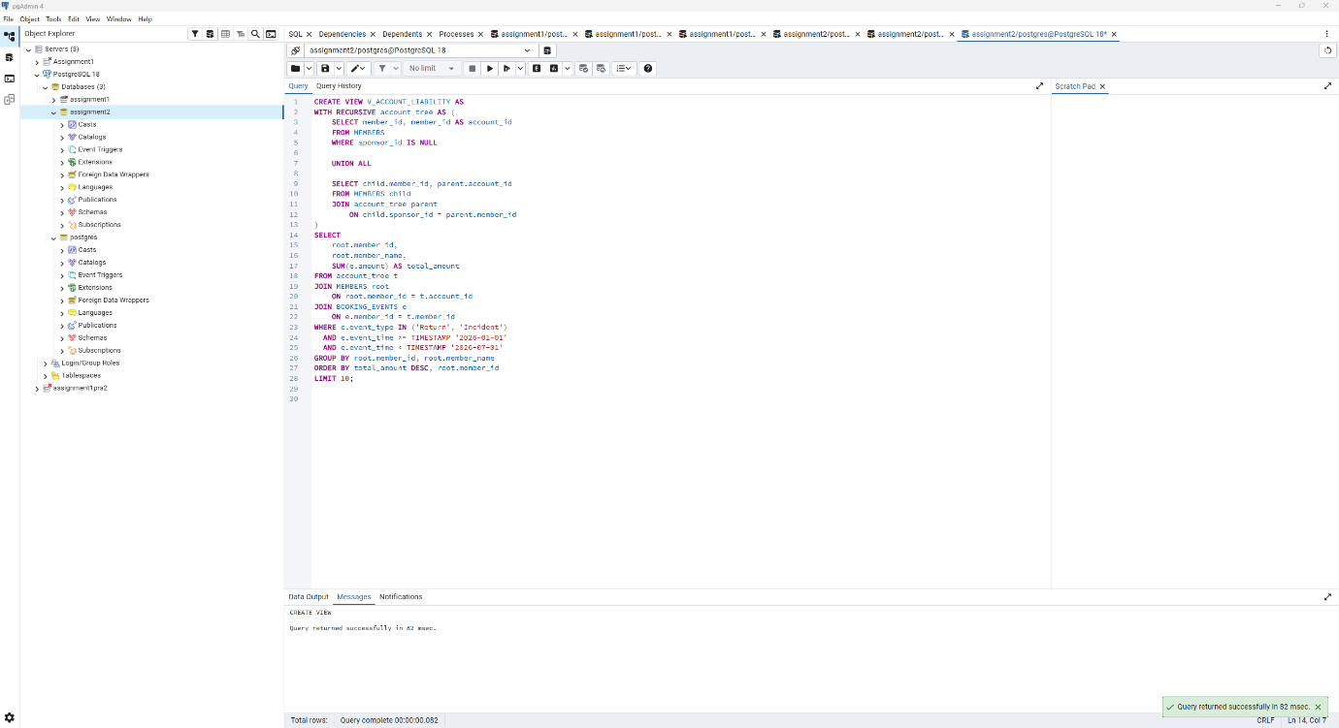
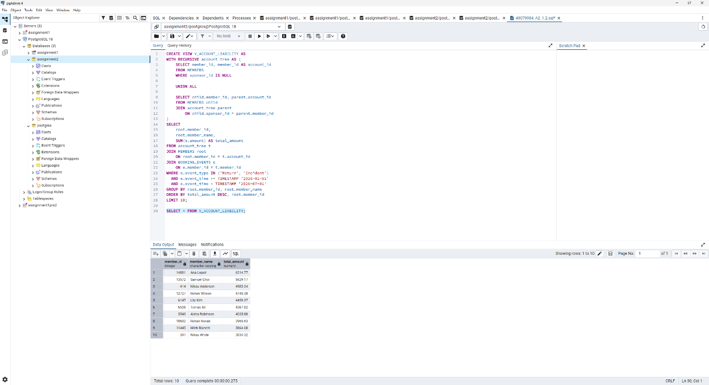
Explanation
The recursive seed maps each unsponsored account to itself. Each recursive step maps a sponsored child to the same root account as its parent, so every member in the supplied sponsorship forest maps to exactly one ultimately liable account. Joining charges to this mapping bills personal charges and every level of sponsored charges to the root, without counting an event at several intermediate accounts.
Only Return fares and Incident damage charges are included. The half-open timestamp range from 2026-01-01 up to, but excluding, 2026-07-01 includes all of 30 June. Totals are sorted descending, with member_id as a deterministic tie-breaker, and limited to ten accounts. The result is shown in Q1.3 Query A. An independent upward traversal produced the same ten rows.
Comments:

Screenshot Q1.3 (2) | Marks: /0.5
Q1.3 part 1 materialized view definition
CREATE MATERIALIZED VIEW MV_ACCOUNT_LIABILITY AS
WITH RECURSIVE account_tree AS (
SELECT member_id, member_id AS account_id
FROM MEMBERS
WHERE sponsor_id IS NULL
UNION ALL
SELECT child.member_id, parent.account_id
FROM MEMBERS child
JOIN account_tree parent
ON child.sponsor_id = parent.member_id
)
SELECT
root.member_id,
root.member_name,
SUM(e.amount) AS total_amount
FROM account_tree t
JOIN MEMBERS root
ON root.member_id = t.account_id
JOIN BOOKING_EVENTS e
ON e.member_id = t.member_id
WHERE e.event_type IN ('Return', 'Incident')
AND e.event_time >= TIMESTAMP '2026-01-01'
AND e.event_time < TIMESTAMP '2026-07-01'
GROUP BY root.member_id, root.member_name
ORDER BY total_amount DESC, root.member_id
LIMIT 10;
Q1.3 part 2 SQL
-- Query A: retrieve the ordinary view results.
SELECT * FROM V_ACCOUNT_LIABILITY;
-- Query A: report the ordinary view execution plan.
EXPLAIN (ANALYZE, BUFFERS)
SELECT * FROM V_ACCOUNT_LIABILITY;
-- Query B: retrieve the materialized view results.
SELECT * FROM MV_ACCOUNT_LIABILITY;
-- Query B: report the materialized view execution plan.
EXPLAIN (ANALYZE, BUFFERS)
SELECT * FROM MV_ACCOUNT_LIABILITY;
Query A original result
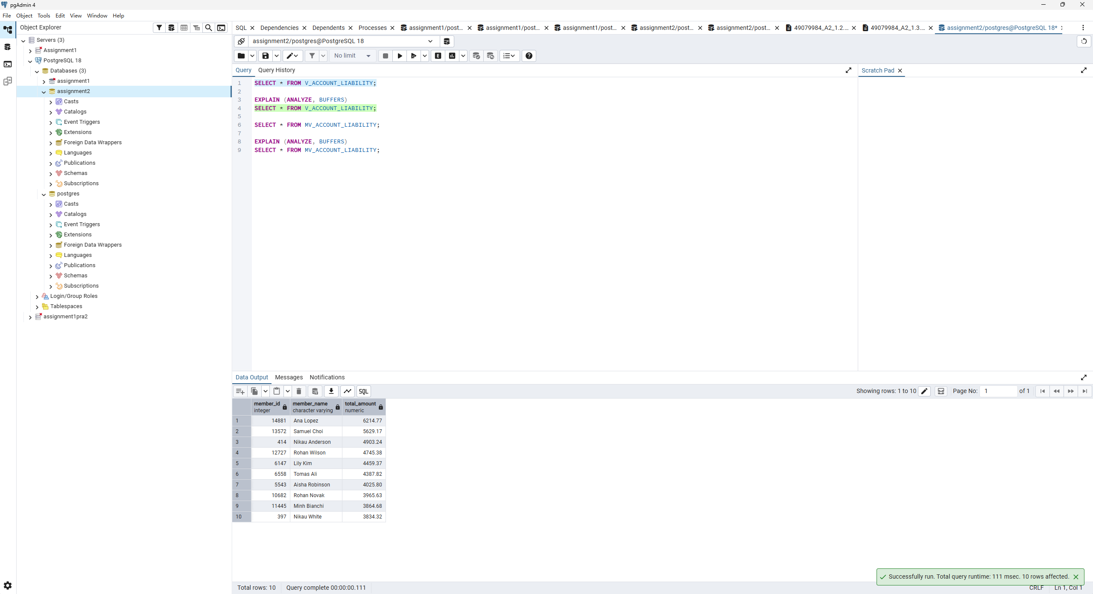
Query A ordinary view, native pgAdmin, lines 1 to 34
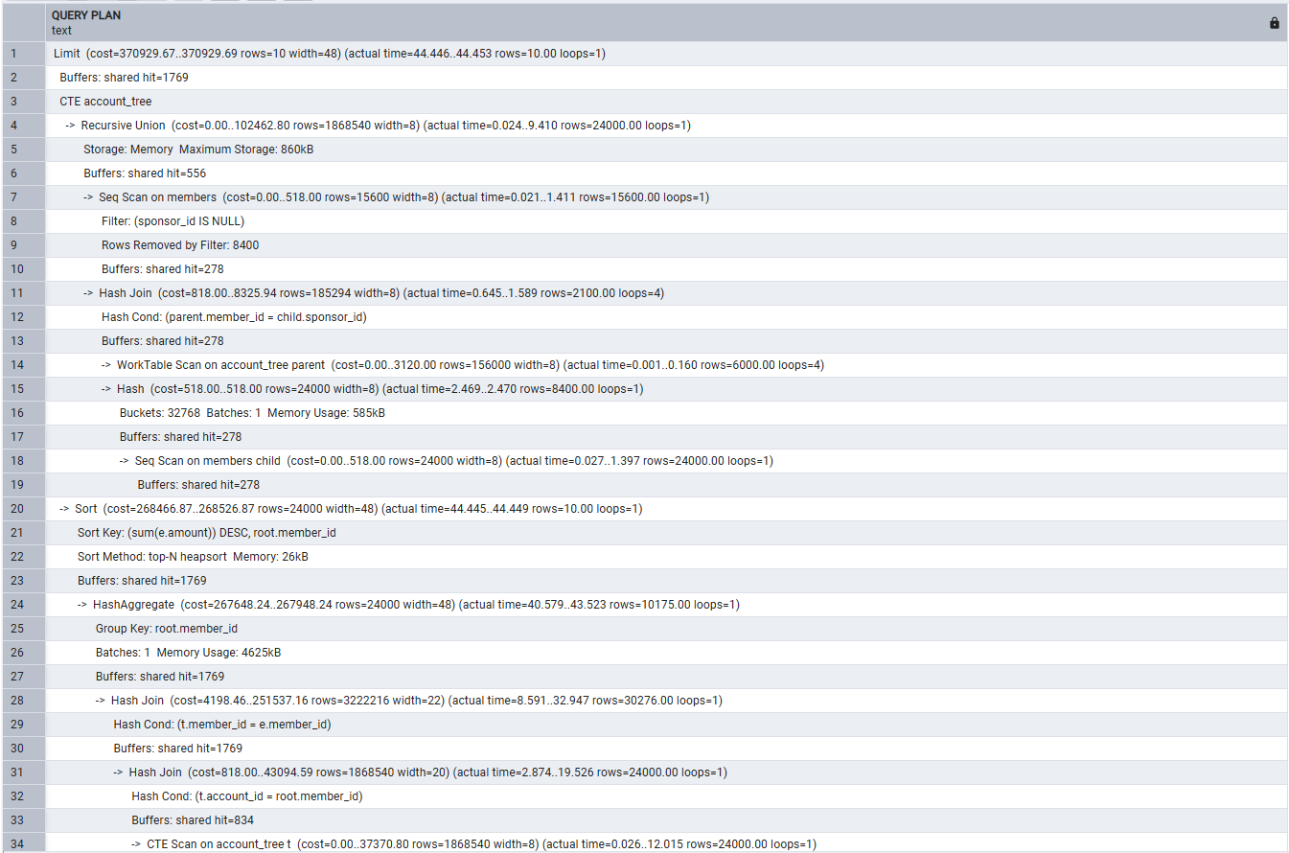
Query A ordinary view, native pgAdmin, lines 21 to 54; overlap retained
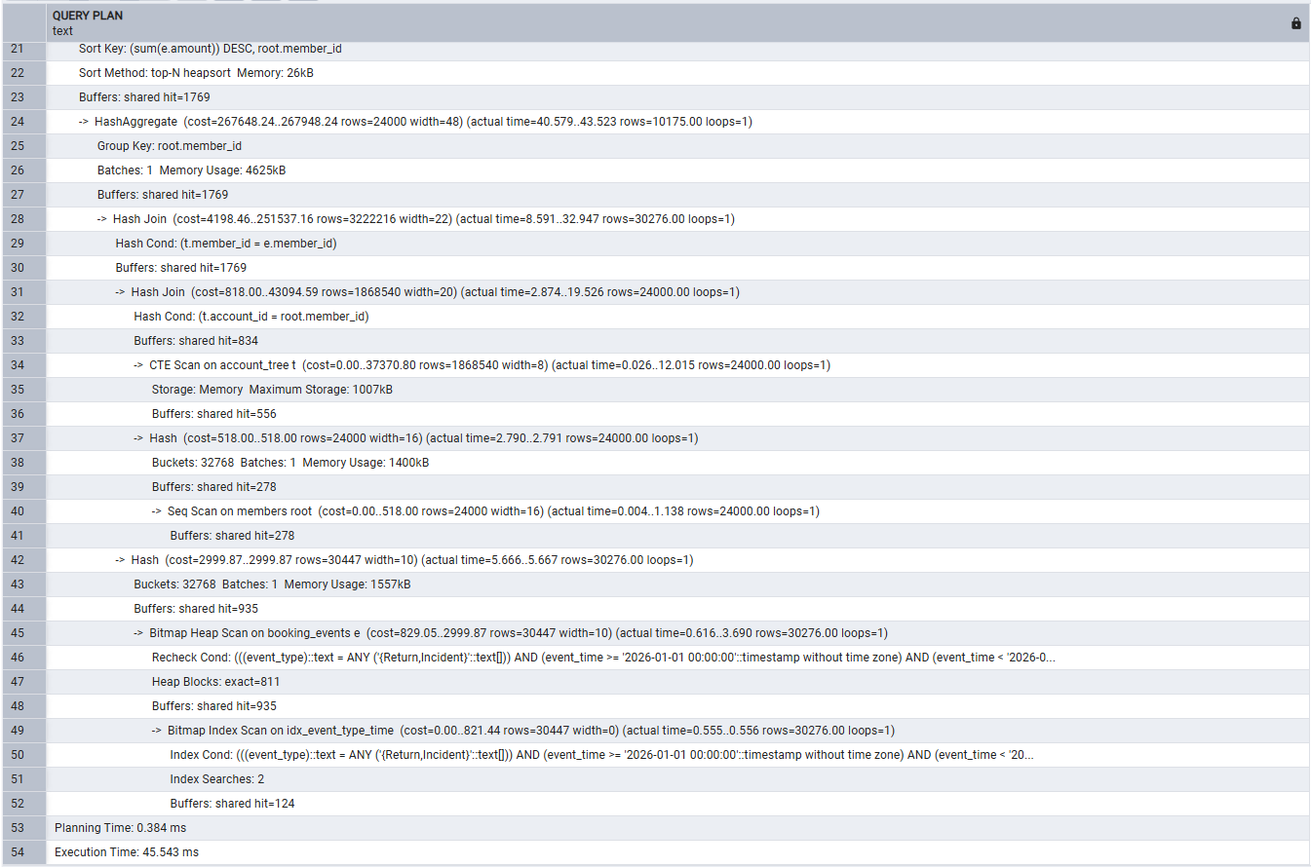
The native screenshots above clip the ends of two long filter conditions. The following complete plan is retained as supplementary evidence from the earlier replay. It is a separate run with its own estimates, access path and timing; it does not fill in unseen native output. Its execution time is 61.402 ms.
Supplementary complete ordinary-view plan from the earlier replay, part 1 of 2
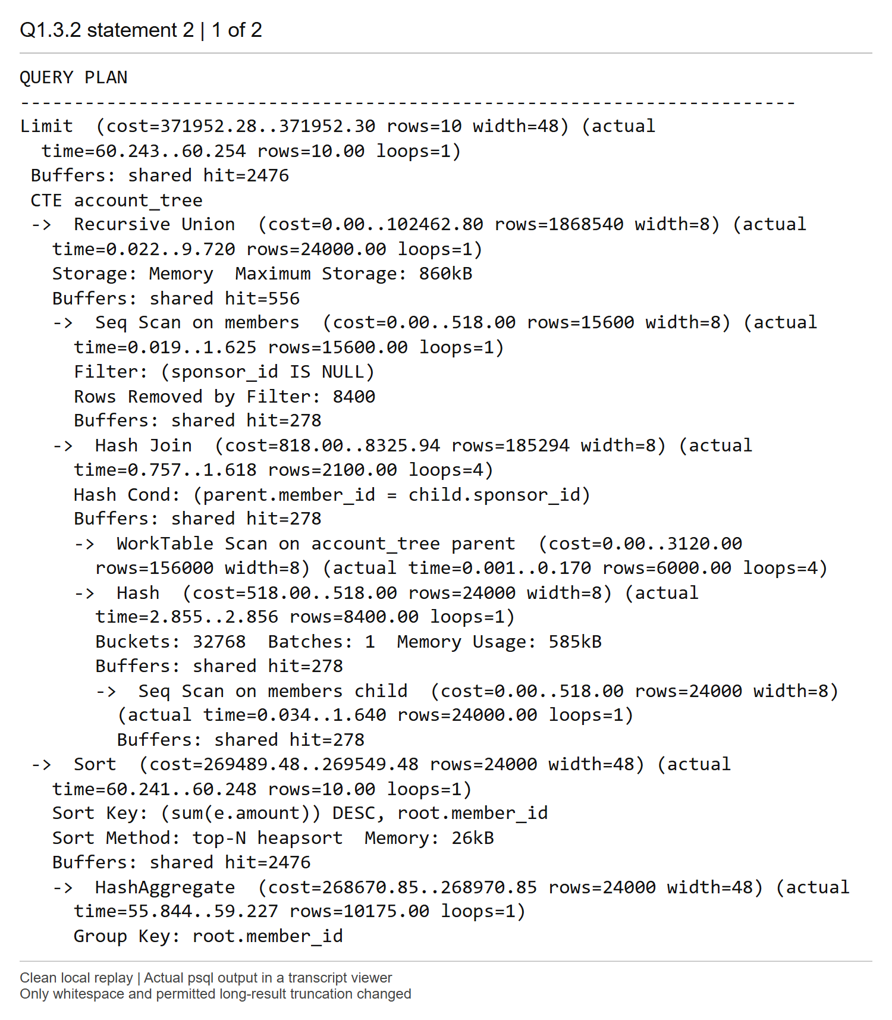
Supplementary complete ordinary-view replay plan, part 2 of 2
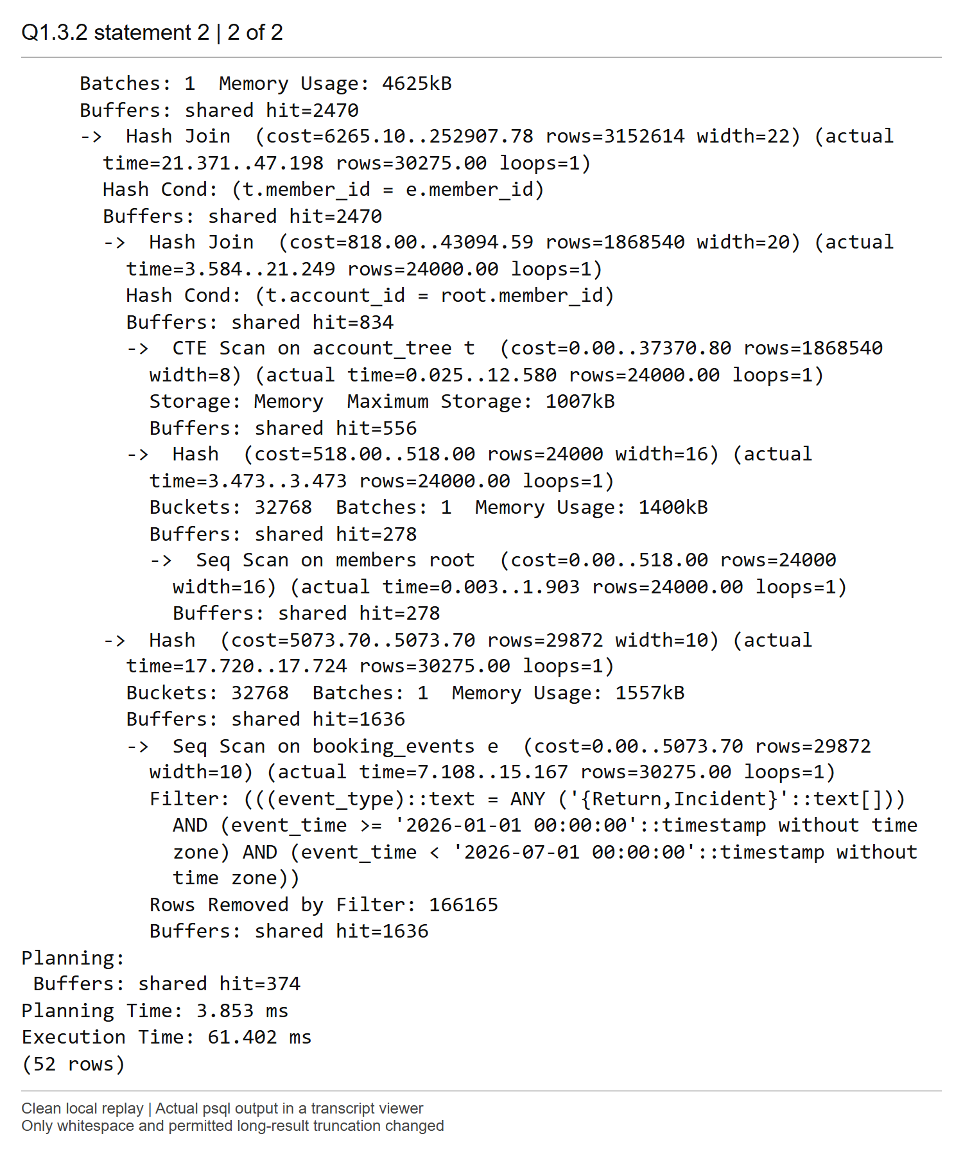
Query B original result
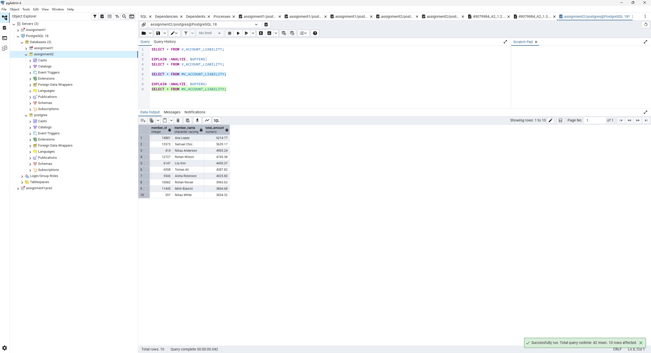
Query B materialized view, native pgAdmin execution plan
Native plan transcription
Seq Scan on mv_account_liability
(cost=0.00..18.50 rows=850 width=68)
(actual time=0.223..0.224 rows=10.00 loops=1)
Buffers: shared hit=1
Planning:
Buffers: shared hit=16
Planning Time: 1.373 ms
Execution Time: 0.236 ms
Explanation
Both original results initially show the same ten accounts, led by Ana Lopez (14881), 6,214.77. The new Query A plan builds the 24,000-member account mapping, filters 30,276 eligible events using Bitmap Index Scan and Bitmap Heap Scan, then performs joins, HashAggregate and a top-N sort. Its top cost is 370929.67..370929.69, planning takes 0.384 ms and execution takes 45.543 ms. This later run is distinct from the initial results and supplementary replay.
Query B scans the stored ten-row result: cost 0.00..18.50, planning 1.373 ms, execution 0.236 ms and one shared-buffer hit. Its estimate of 850 rows differs from the actual 10; it does not mean 850 rows are stored. Materialization avoids repeating recursion, joins and aggregation. Separate runs and database stages do not establish a controlled speed ratio. Use an explicit ORDER BY when output order matters.
Comments:

Screenshot Q1.3 (3) | Marks: /0.5
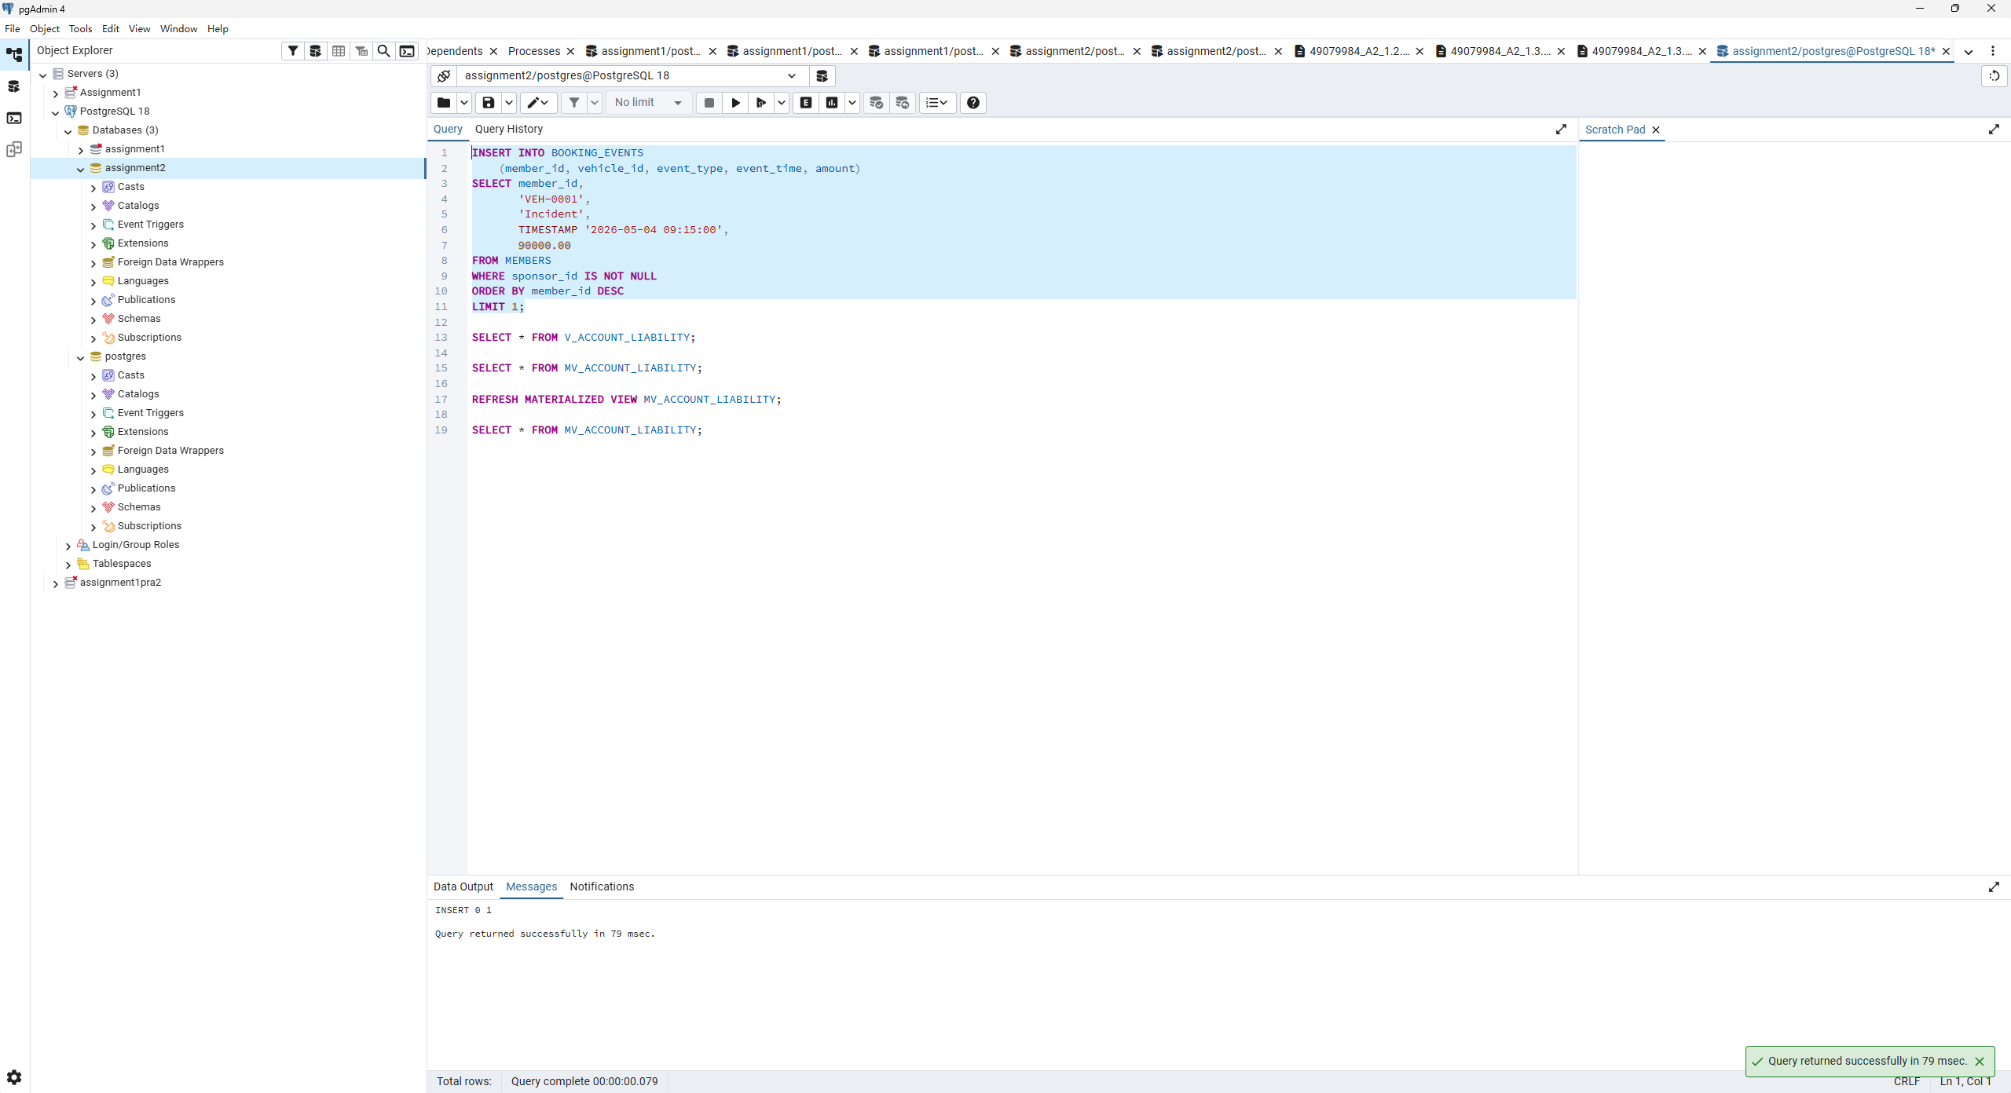
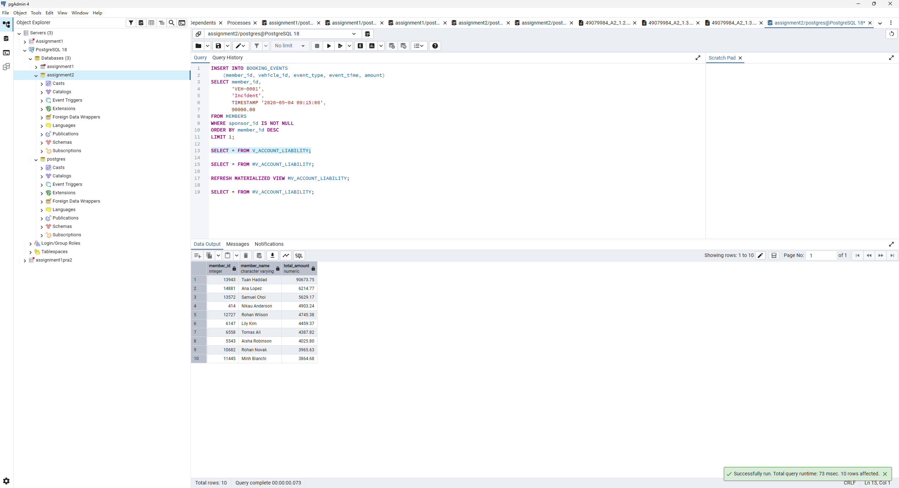
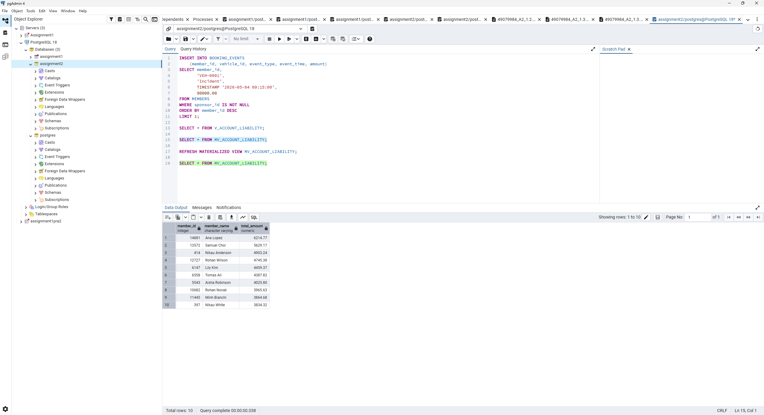
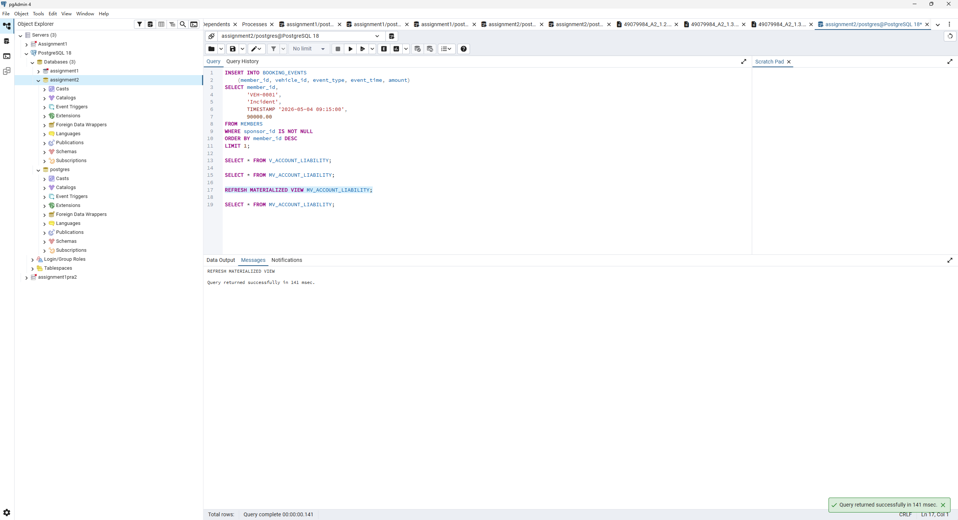
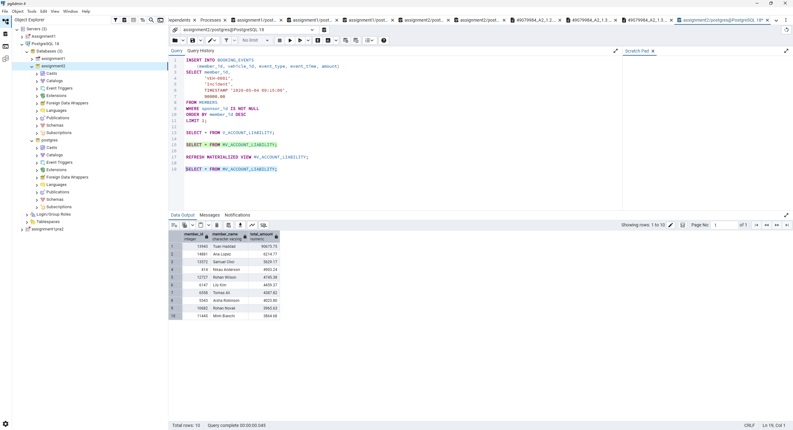
Explanation
The supplied INSERT chooses member 24000. Its sponsorship chain is 24000 -> 22086 -> 18148 -> 13943, so the additional 90,000.00 is billed to Tuan Haddad (13943). Query A immediately puts that account first at 90,673.75. Query B still shows the earlier top ten, led by Ana Lopez, and does not include Tuan Haddad. After REFRESH, Query B shows the same updated ten rows as Query A; account 397 drops out of the top ten.
A materialized view trades faster reads for extra storage, refresh work and potentially stale answers between refreshes. An ordinary view computes an answer from the data visible to each query.
Comments:

Screenshot Q2.1 (1) | Marks: /0.5
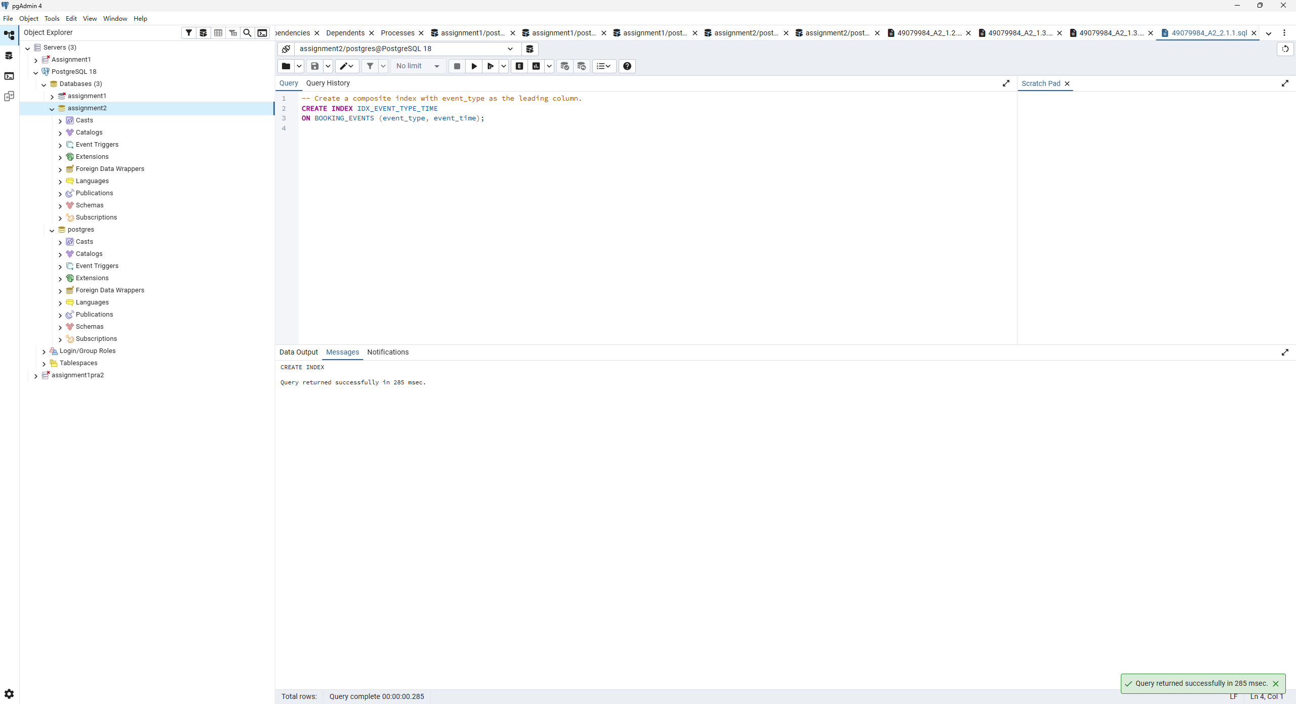
Explanation
This B-tree index has event_type as its first key and event_time as its second key, in the required order. It orders timestamps within each event type.
Comments:

Screenshot Q2.1 (2) | Marks: /1.5
SQL
-- Retrieve the busiest station for each body type after creating the index.
SELECT * FROM V_BUSIEST_BAYS;
-- Compare this plan with the plan recorded in Q1.1 before creating the index.
EXPLAIN (ANALYZE, BUFFERS)
SELECT * FROM V_BUSIEST_BAYS;
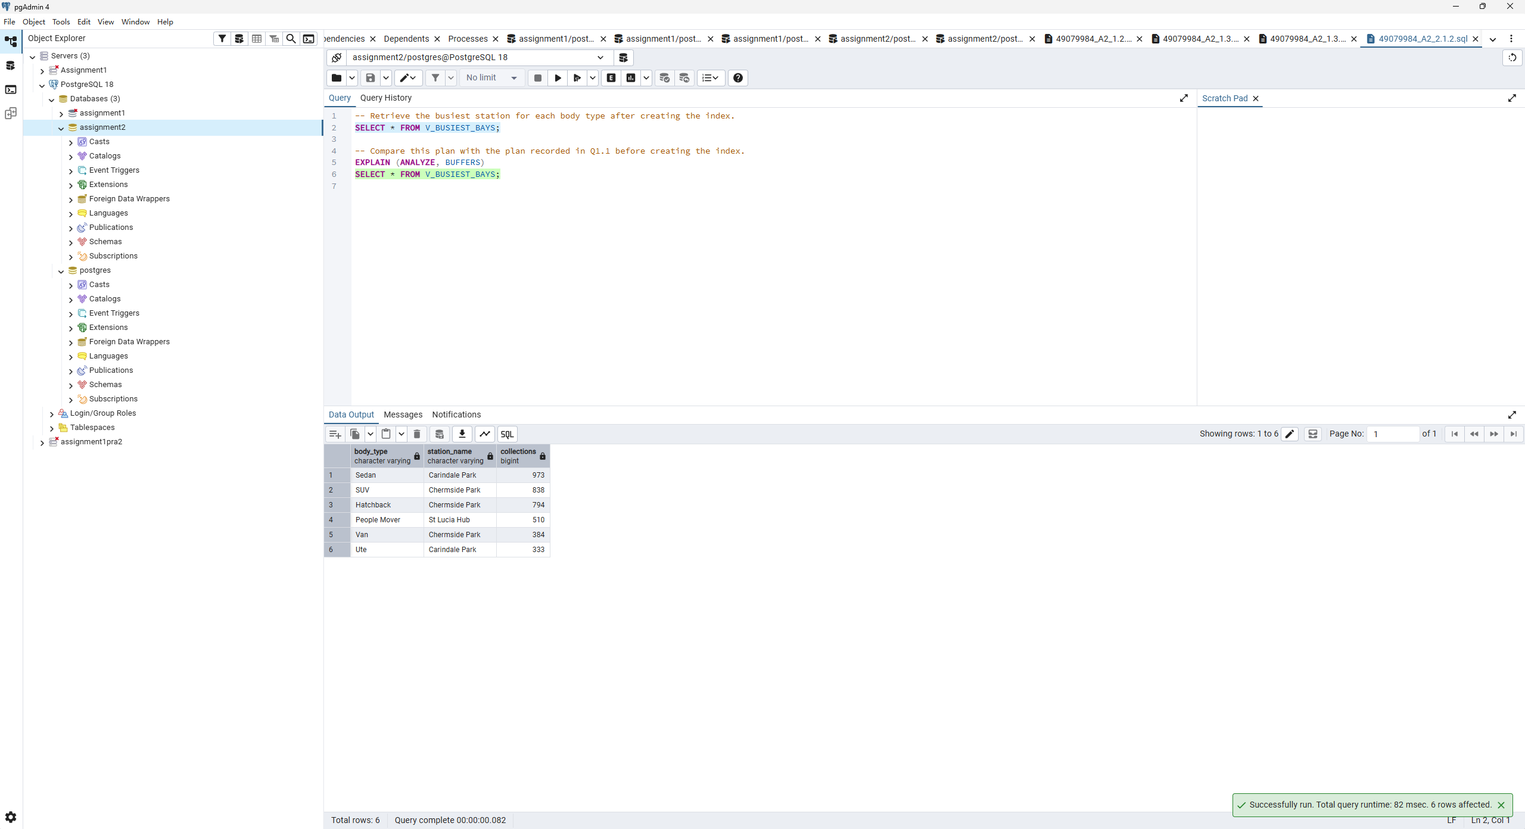
Execution plan after the index-restoration step, native pgAdmin, lines 1 to 34
Execution plan after the index-restoration step, native pgAdmin, lines 35 to 68
Explanation
The six result rows are unchanged. The native plan remains a Parallel Seq Scan of the event log followed by hash joins, aggregation, ranking and sorting; IDX_EVENT_TYPE_TIME is not used by this query. Its top cost is 4786.08..4786.08, the same as the native plan without the index. Planning takes 1.633 ms and execution takes 40.538 ms, compared with 7.797 ms and 52.686 ms respectively in Q1.1.2. A faster single run with an unchanged access path can reflect caching and run-to-run variation; it is not evidence of an index benefit.
The scan returns 59,539 Collect events distributed throughout the heap. The query also needs vehicle_id, which this index does not contain. An index path would traverse many index entries and fetch many heap pages, whereas a parallel sequential scan reads the table efficiently. There is no timestamp condition, so the second index column does not narrow this query. Adding an index gives the planner another option; it does not require its use.
Comments:

Screenshot Q2.1 (3) | Marks: /1
SQL
-- Count incidents and sum their charges for March 2026.
SELECT COUNT(*), SUM(amount)
FROM BOOKING_EVENTS
WHERE event_type = 'Incident'
AND event_time >= TIMESTAMP '2026-03-01'
AND event_time < TIMESTAMP '2026-04-01';
-- Report the execution plan for the March incidents query.
EXPLAIN (ANALYZE, BUFFERS)
SELECT COUNT(*), SUM(amount)
FROM BOOKING_EVENTS
WHERE event_type = 'Incident'
AND event_time >= TIMESTAMP '2026-03-01'
AND event_time < TIMESTAMP '2026-04-01';
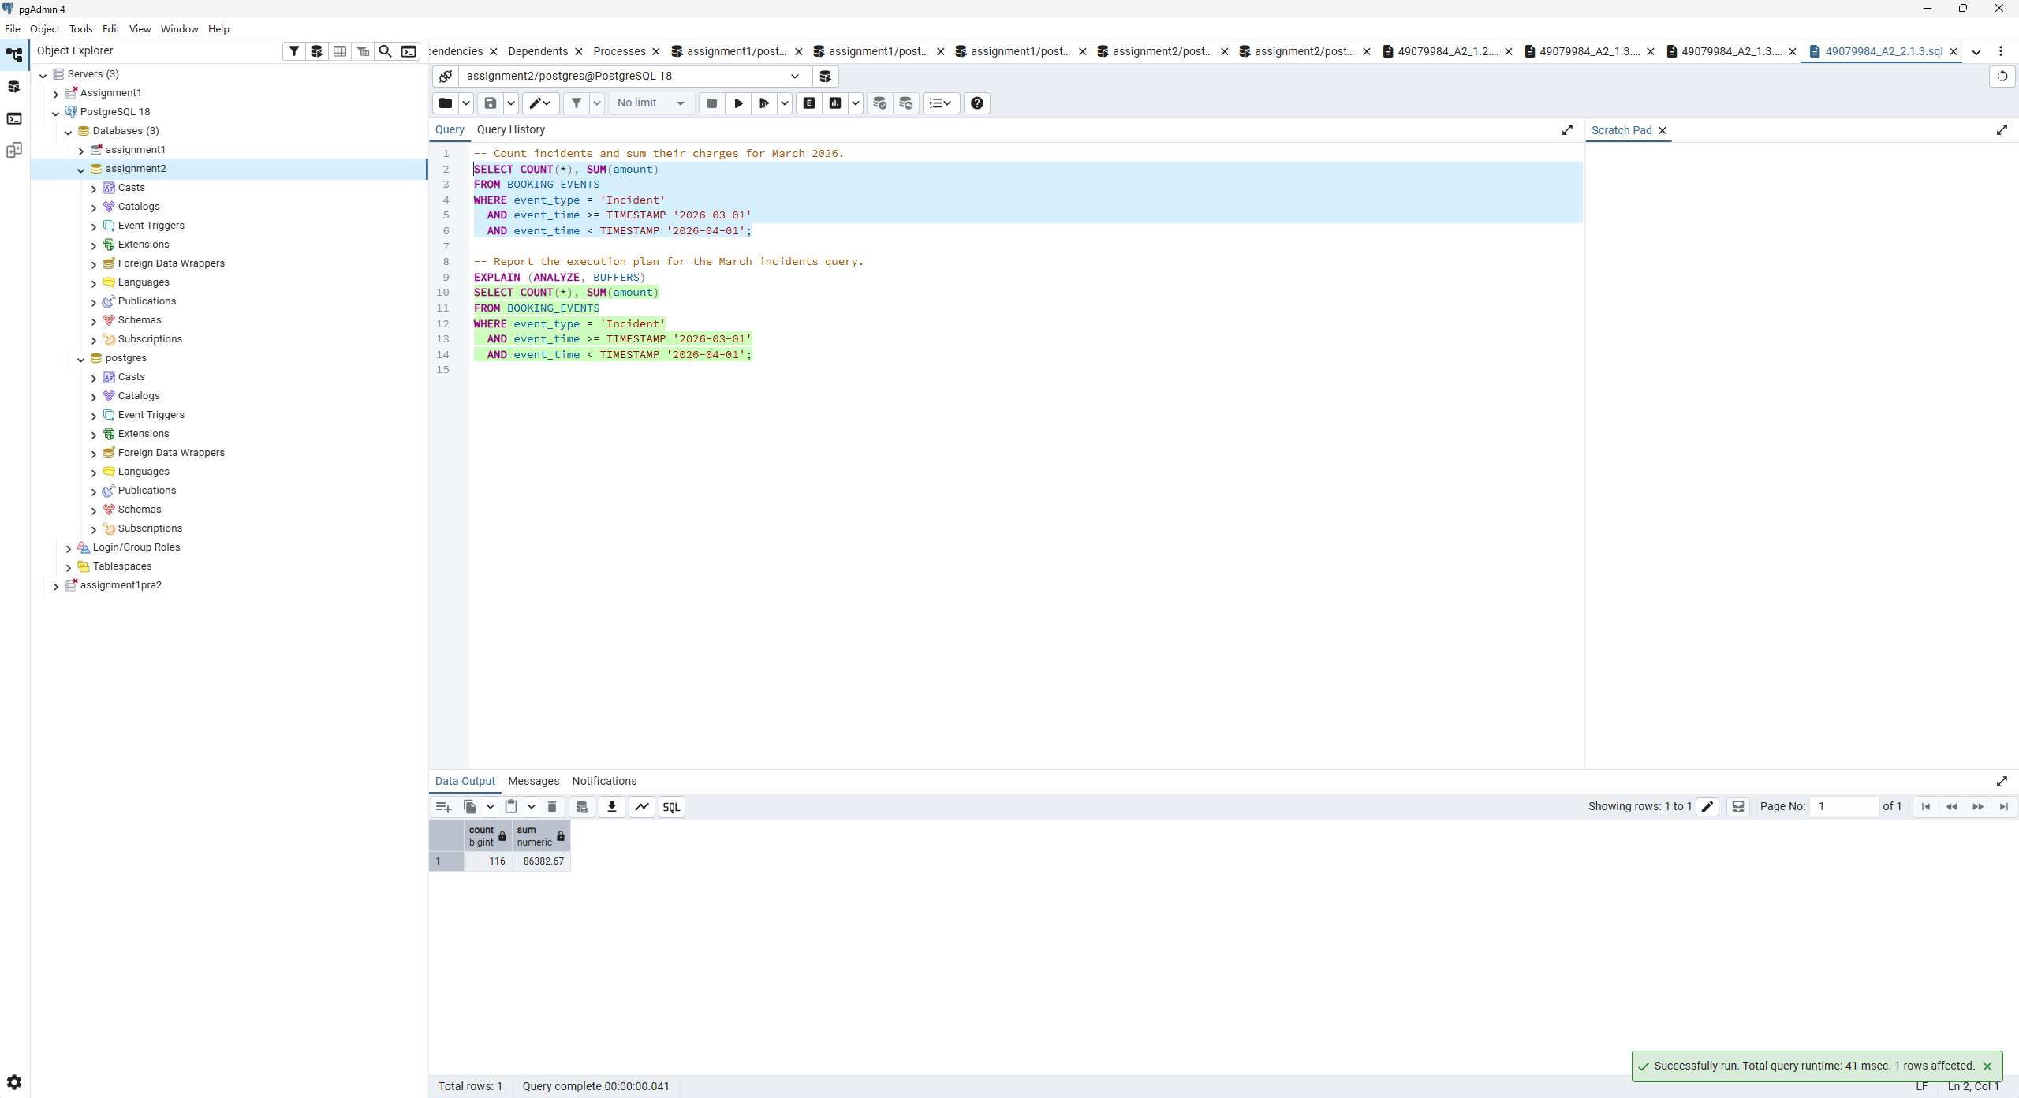
Q2.1.3 March incidents plan — complete replay output
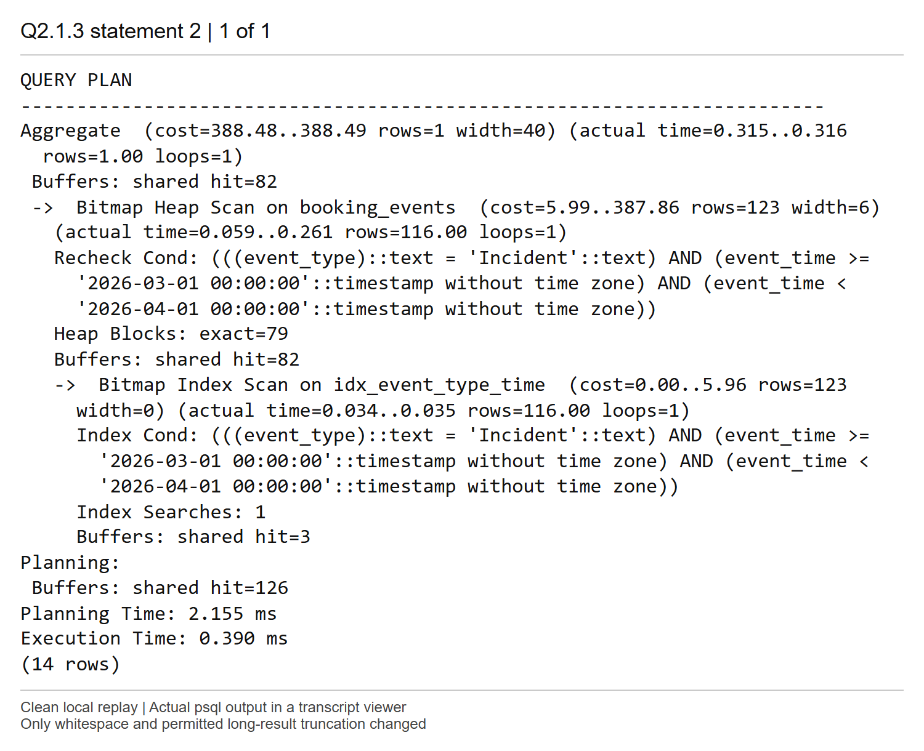
Explanation
The query returns count 116 and sum 86,382.67. The aggregate estimates and returns one result row, with cost 388.48..388.49 and execution time 0.390 ms. Its child Bitmap Index Scan finds 116 matching entries, versus 123 estimated, and Bitmap Heap Scan visits 79 exact heap blocks before computing the aggregate.
Incident equality fixes the leading key, and the lower and upper March timestamp bounds restrict the second key to a short contiguous range within Incident entries. These 116 events are about 0.059 percent of the table, so the bitmap index path avoids most rows and pages. The plan needs heap access for amount, which is not stored in the index. This is much more selective than the all-time Collect query in Q2.1 part 2.
Comments:

Screenshot Q2.2(1) | Marks: /1
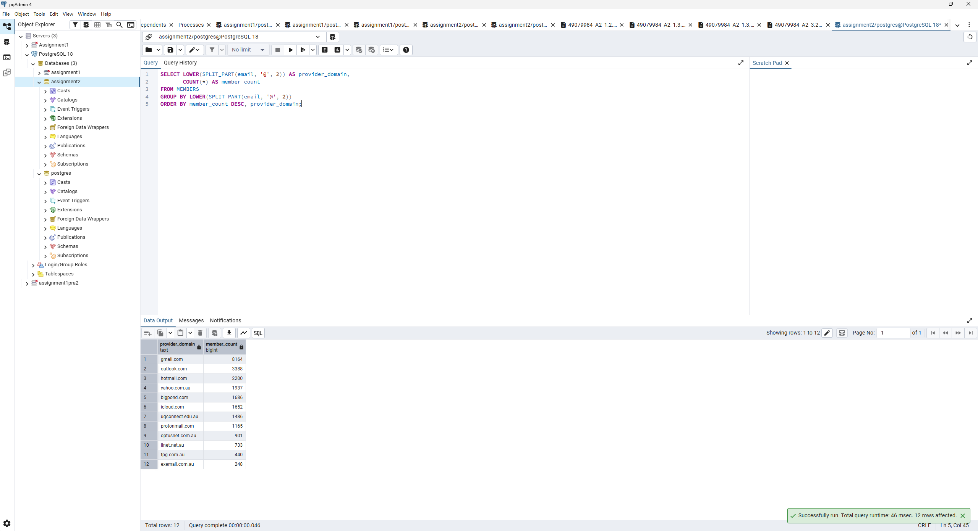
Explanation
LOWER(SPLIT_PART(email, '@', 2)) extracts the part after @ and normalizes its case before grouping. The query reports 12 domains accounting for all 24,000 members, with gmail.com first at 8,164 members. exemail.com.au has 248 members. The secondary alphabetical ordering makes equal counts reproducible.
Comments:

Screenshot Q2.2 (2) | Marks: /1
SQL
-- Report the domain-count query plan before creating the expression index.
EXPLAIN (ANALYZE, BUFFERS)
SELECT LOWER(SPLIT_PART(email, '@', 2)) AS provider_domain,
COUNT(*) AS member_count
FROM MEMBERS
GROUP BY LOWER(SPLIT_PART(email, '@', 2))
ORDER BY member_count DESC, provider_domain;
Q2.2.2 domain counts before indexing — complete replay output
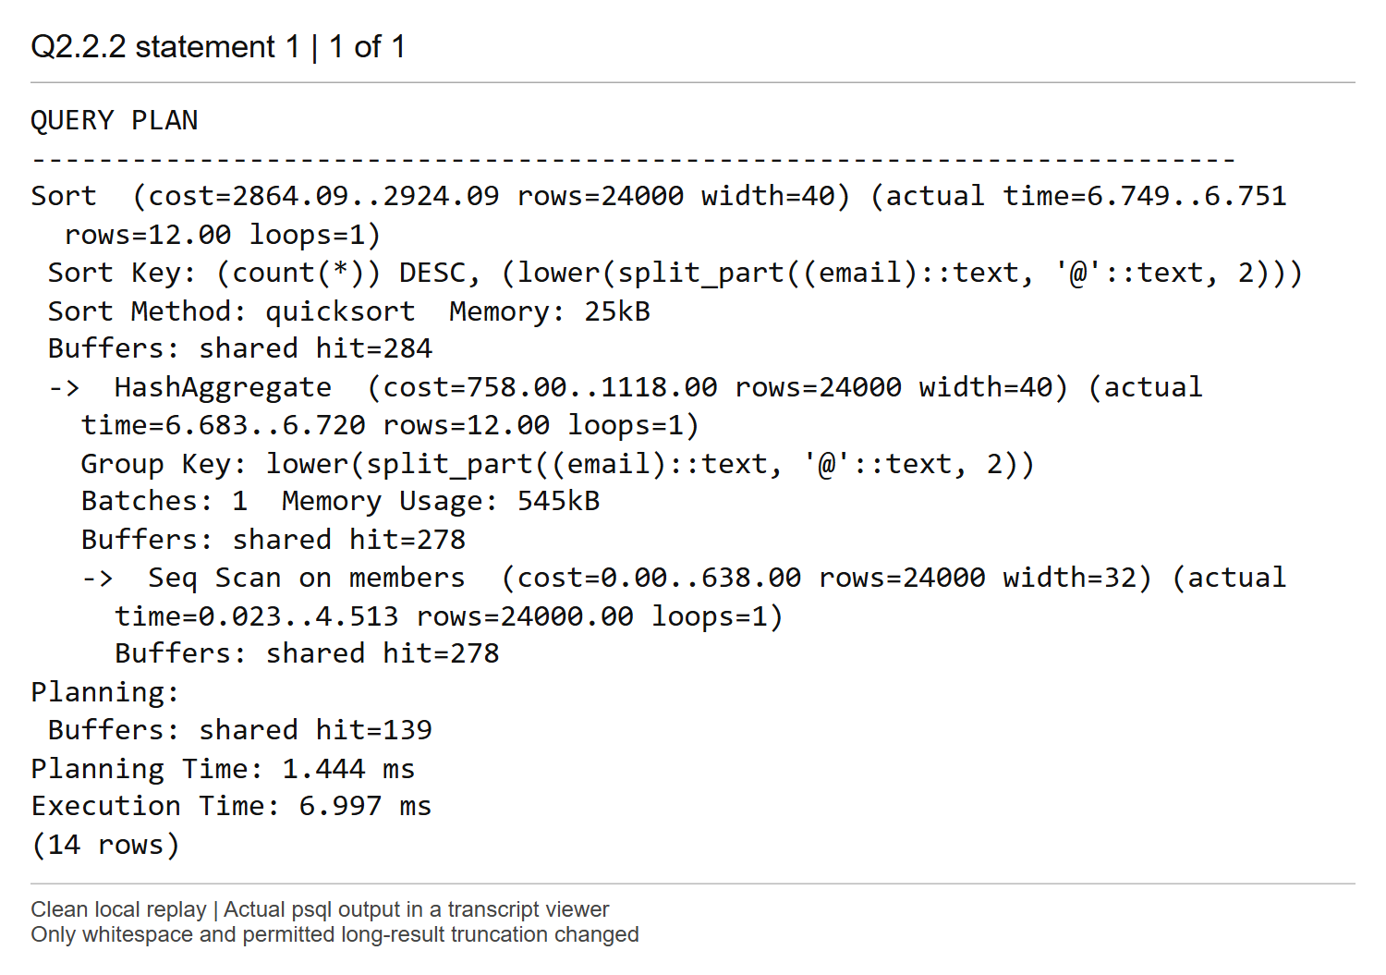
Explanation
The plan performs a Seq Scan of all 24,000 MEMBERS rows, computes the normalized domain, uses HashAggregate for the counts, and sorts the resulting 12 groups by count descending. The top cost is 2864.09..2924.09 and execution time is 6.997 ms. It estimates 24,000 groups but actually returns only 12, reflecting the lack of statistics for this derived expression at this point.
Every member contributes to the requested whole-population counts, so a complete scan is appropriate. Hash aggregation has a single batch and the final quicksort uses only 25 kB; neither step spills to disk in this run.
Comments:

Screenshot Q2.2 (3) | Marks: /1
The UNIQUE index on email orders complete email addresses, so members with the same provider domain are not necessarily adjacent. It does not index the normalized domain expression, so it cannot directly locate a domain or avoid processing every address for the domain-count query.
Comments:

Screenshot Q2.2 (4) | Marks: /0.5
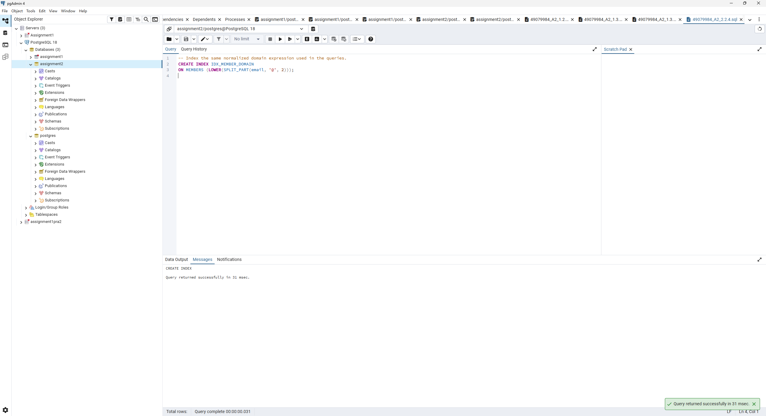
Explanation
The expression in IDX_MEMBER_DOMAIN exactly matches LOWER(SPLIT_PART(email, '@', 2)) in the queries, including the case folding. PostgreSQL can therefore look up a normalized domain directly in this index.
Comments:

Screenshot Q2.2 (5) | Marks: /1.5
SQL
-- Report the domain-count query plan after creating the expression index.
EXPLAIN (ANALYZE, BUFFERS)
SELECT LOWER(SPLIT_PART(email, '@', 2)) AS provider_domain,
COUNT(*) AS member_count
FROM MEMBERS
GROUP BY LOWER(SPLIT_PART(email, '@', 2))
ORDER BY member_count DESC, provider_domain;
-- Report the selective lookup plan for a rare provider domain.
EXPLAIN (ANALYZE, BUFFERS)
SELECT member_id, member_name, email
FROM MEMBERS
WHERE LOWER(SPLIT_PART(email, '@', 2)) = 'exemail.com.au';
Q2.2.5 domain counts after indexing — complete replay output
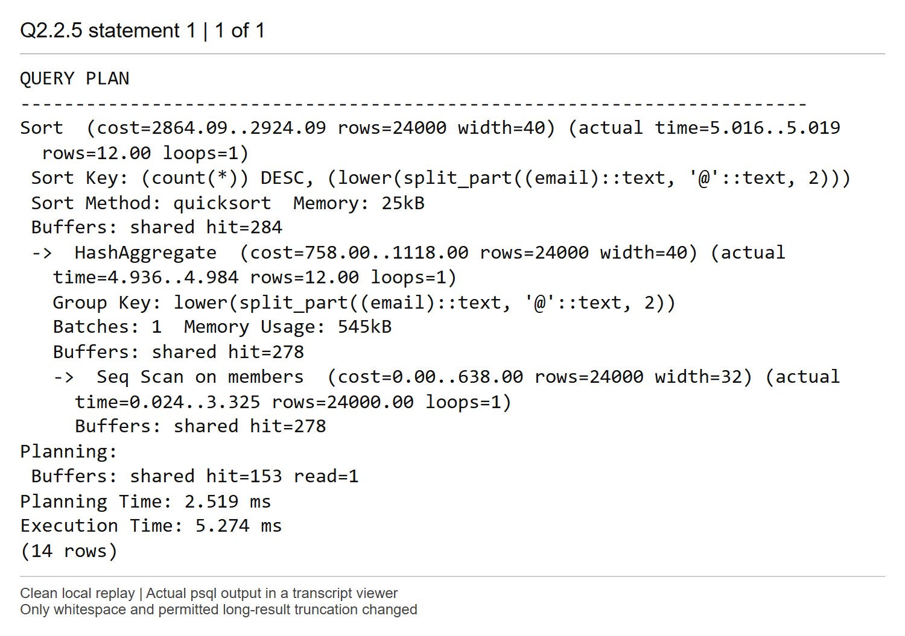
Q2.2.5 rare provider lookup — complete replay output
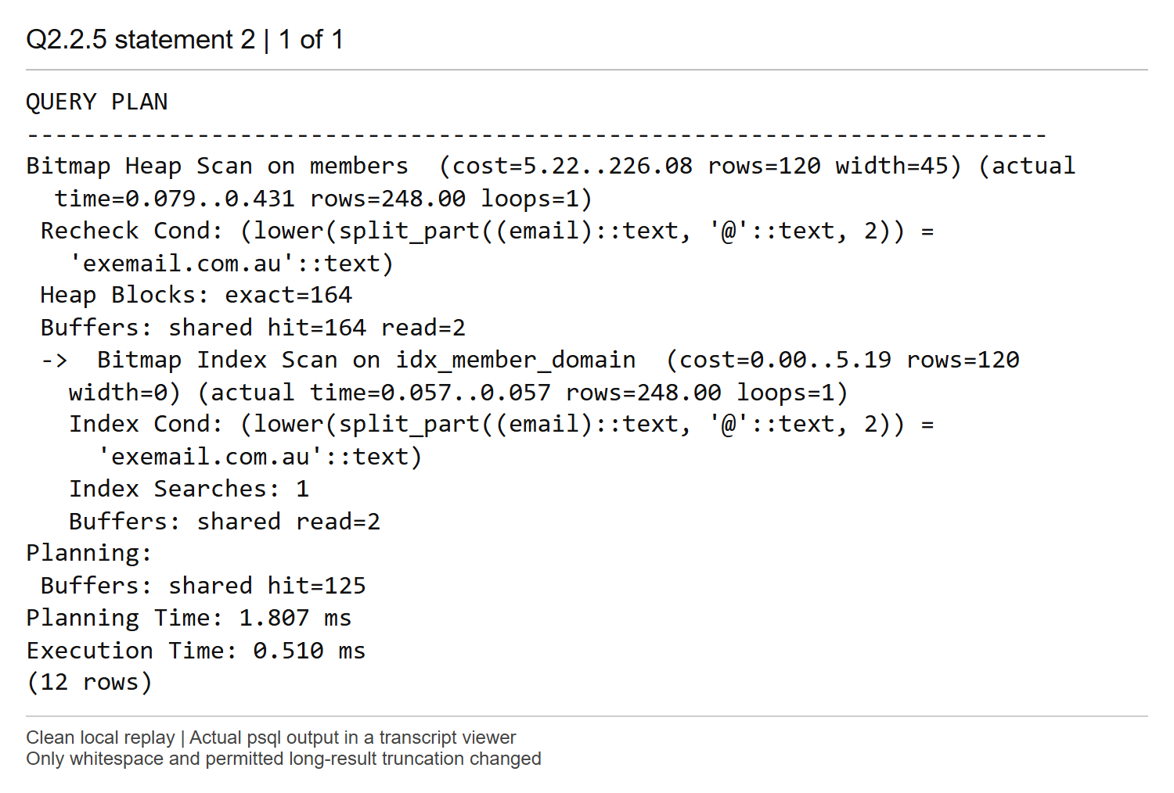
Explanation
The domain-count query keeps its Seq Scan -> HashAggregate -> Sort plan, estimates 24,000 groups and returns 12. Its top cost stays 2864.09..2924.09; execution is 5.274 ms compared with 6.997 ms before the index. All 24,000 members still have to contribute to the counts, and an index ordered by domain cannot directly satisfy ORDER BY COUNT(*) DESC.
The rare-provider lookup instead uses Bitmap Index Scan on IDX_MEMBER_DOMAIN followed by Bitmap Heap Scan. It returns 248 members, about 1.03 percent of MEMBERS, versus 120 estimated, with cost 5.22..226.08 and execution time 0.510 ms. The bitmap batches access to 164 exact heap blocks; heap access is needed for member_id, member_name and email. The index avoids evaluating the domain predicate on every member. Its advantage is selective access, rather than speeding every query that mentions the expression.
Comments:

Screenshot Q3.1 (1) | Marks: /1.5
SQL
-- Statement A: find vehicles with no Collect event using NOT EXISTS.
SELECT v.vehicle_id
FROM VEHICLES v
WHERE NOT EXISTS (
SELECT 1
FROM BOOKING_EVENTS e
WHERE e.vehicle_id = v.vehicle_id
AND e.event_type = 'Collect'
)
ORDER BY v.vehicle_id;
-- Statement B: find the same vehicles using a left join and a NULL check.
SELECT v.vehicle_id
FROM VEHICLES v
LEFT JOIN BOOKING_EVENTS e
ON e.vehicle_id = v.vehicle_id
AND e.event_type = 'Collect'
WHERE e.vehicle_id IS NULL
ORDER BY v.vehicle_id;
Statement A native pgAdmin result, first ten and last ten rows
Left: rows 1 to 10. Right: rows 66 to 75. The 55 intermediate rows are omitted.
Statement B native pgAdmin result, first ten and last ten rows
Left: rows 1 to 10. Right: rows 66 to 75. The 55 intermediate rows are omitted.
Explanation
Both statements return the same 75 vehicle IDs, ordered by vehicle_id. Statement A uses a correlated NOT EXISTS test. Statement B places the Collect predicate in the LEFT JOIN condition and keeps rows with no matching event vehicle_id. The matched-side vehicle_id is NOT NULL in the schema, so NULL identifies an unmatched vehicle unambiguously.
Putting event_type in WHERE instead of ON would remove the unmatched rows and break the outer-join solution. Independent EXCEPT ALL checks in both directions previously found no differences. The native result captures show the same first ten and last ten IDs and a total of 75 rows. They are placed in the supplied Statement A then Statement B order alongside the SQL above; the captured result panes themselves do not display the SQL text.
Comments:

Screenshot Q3.1 (2) | Marks: /1.5
SQL
-- Report the execution plan for Statement A.
EXPLAIN (ANALYZE, BUFFERS)
SELECT v.vehicle_id
FROM VEHICLES v
WHERE NOT EXISTS (
SELECT 1
FROM BOOKING_EVENTS e
WHERE e.vehicle_id = v.vehicle_id
AND e.event_type = 'Collect'
)
ORDER BY v.vehicle_id;
-- Report the execution plan for Statement B.
EXPLAIN (ANALYZE, BUFFERS)
SELECT v.vehicle_id
FROM VEHICLES v
LEFT JOIN BOOKING_EVENTS e
ON e.vehicle_id = v.vehicle_id
AND e.event_type = 'Collect'
WHERE e.vehicle_id IS NULL
ORDER BY v.vehicle_id;
Statement A execution plan — complete replay output
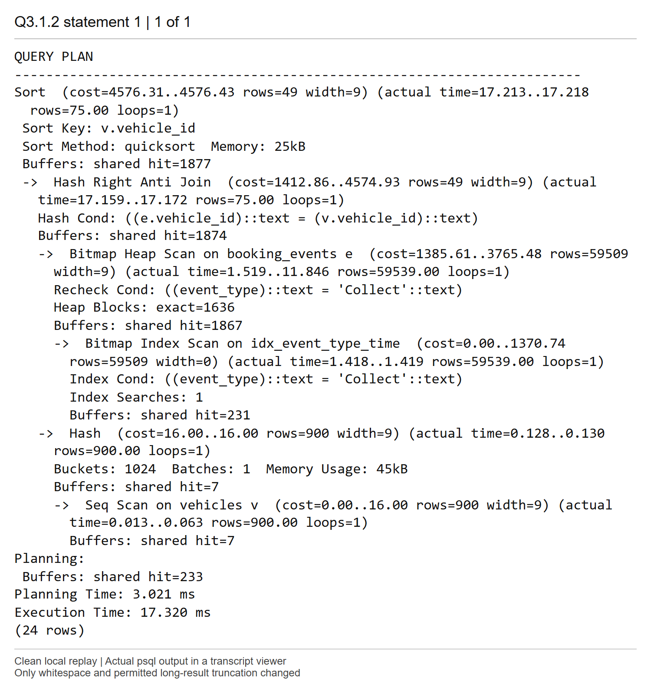
Statement B execution plan — complete replay output
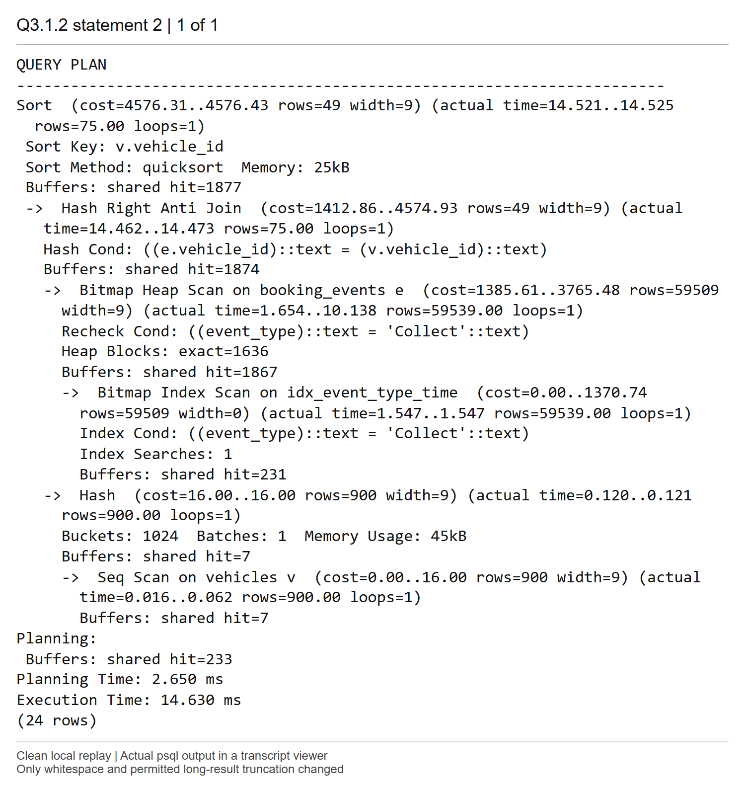
Explanation
The two plans have the same operator structure and cost 4576.31..4576.43. Both return 75 rows, versus 49 estimated, using Hash Right Anti Join and a final vehicle_id sort. Statement A takes 17.320 ms and Statement B 14.630 ms in these runs.
PostgreSQL decorrelates NOT EXISTS and recognizes the outer-join NULL filter as the same anti-join operation. It hashes the small set of 900 vehicles and scans 59,539 Collect events through a bitmap index/heap path, keeping the vehicle rows without any match. The Right direction describes the physical join inputs chosen by the optimizer; it preserves the intended vehicle-side anti-join semantics. Neither syntax forces a separate full event scan for each vehicle. The minor time difference does not establish a consistent performance difference.
Comments:

Screenshot Q3.2 (1) | Marks: /2
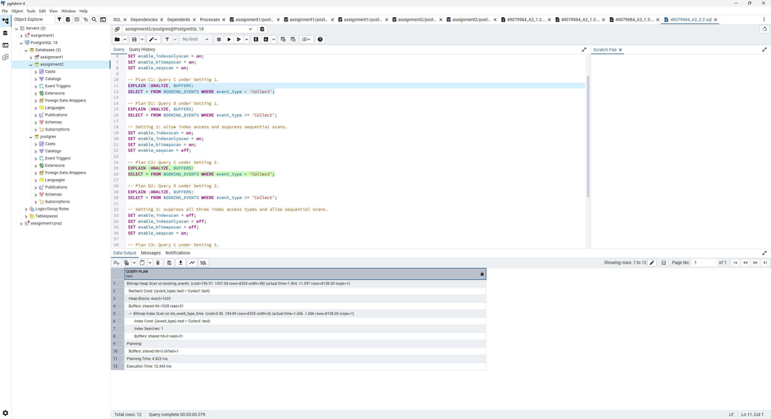
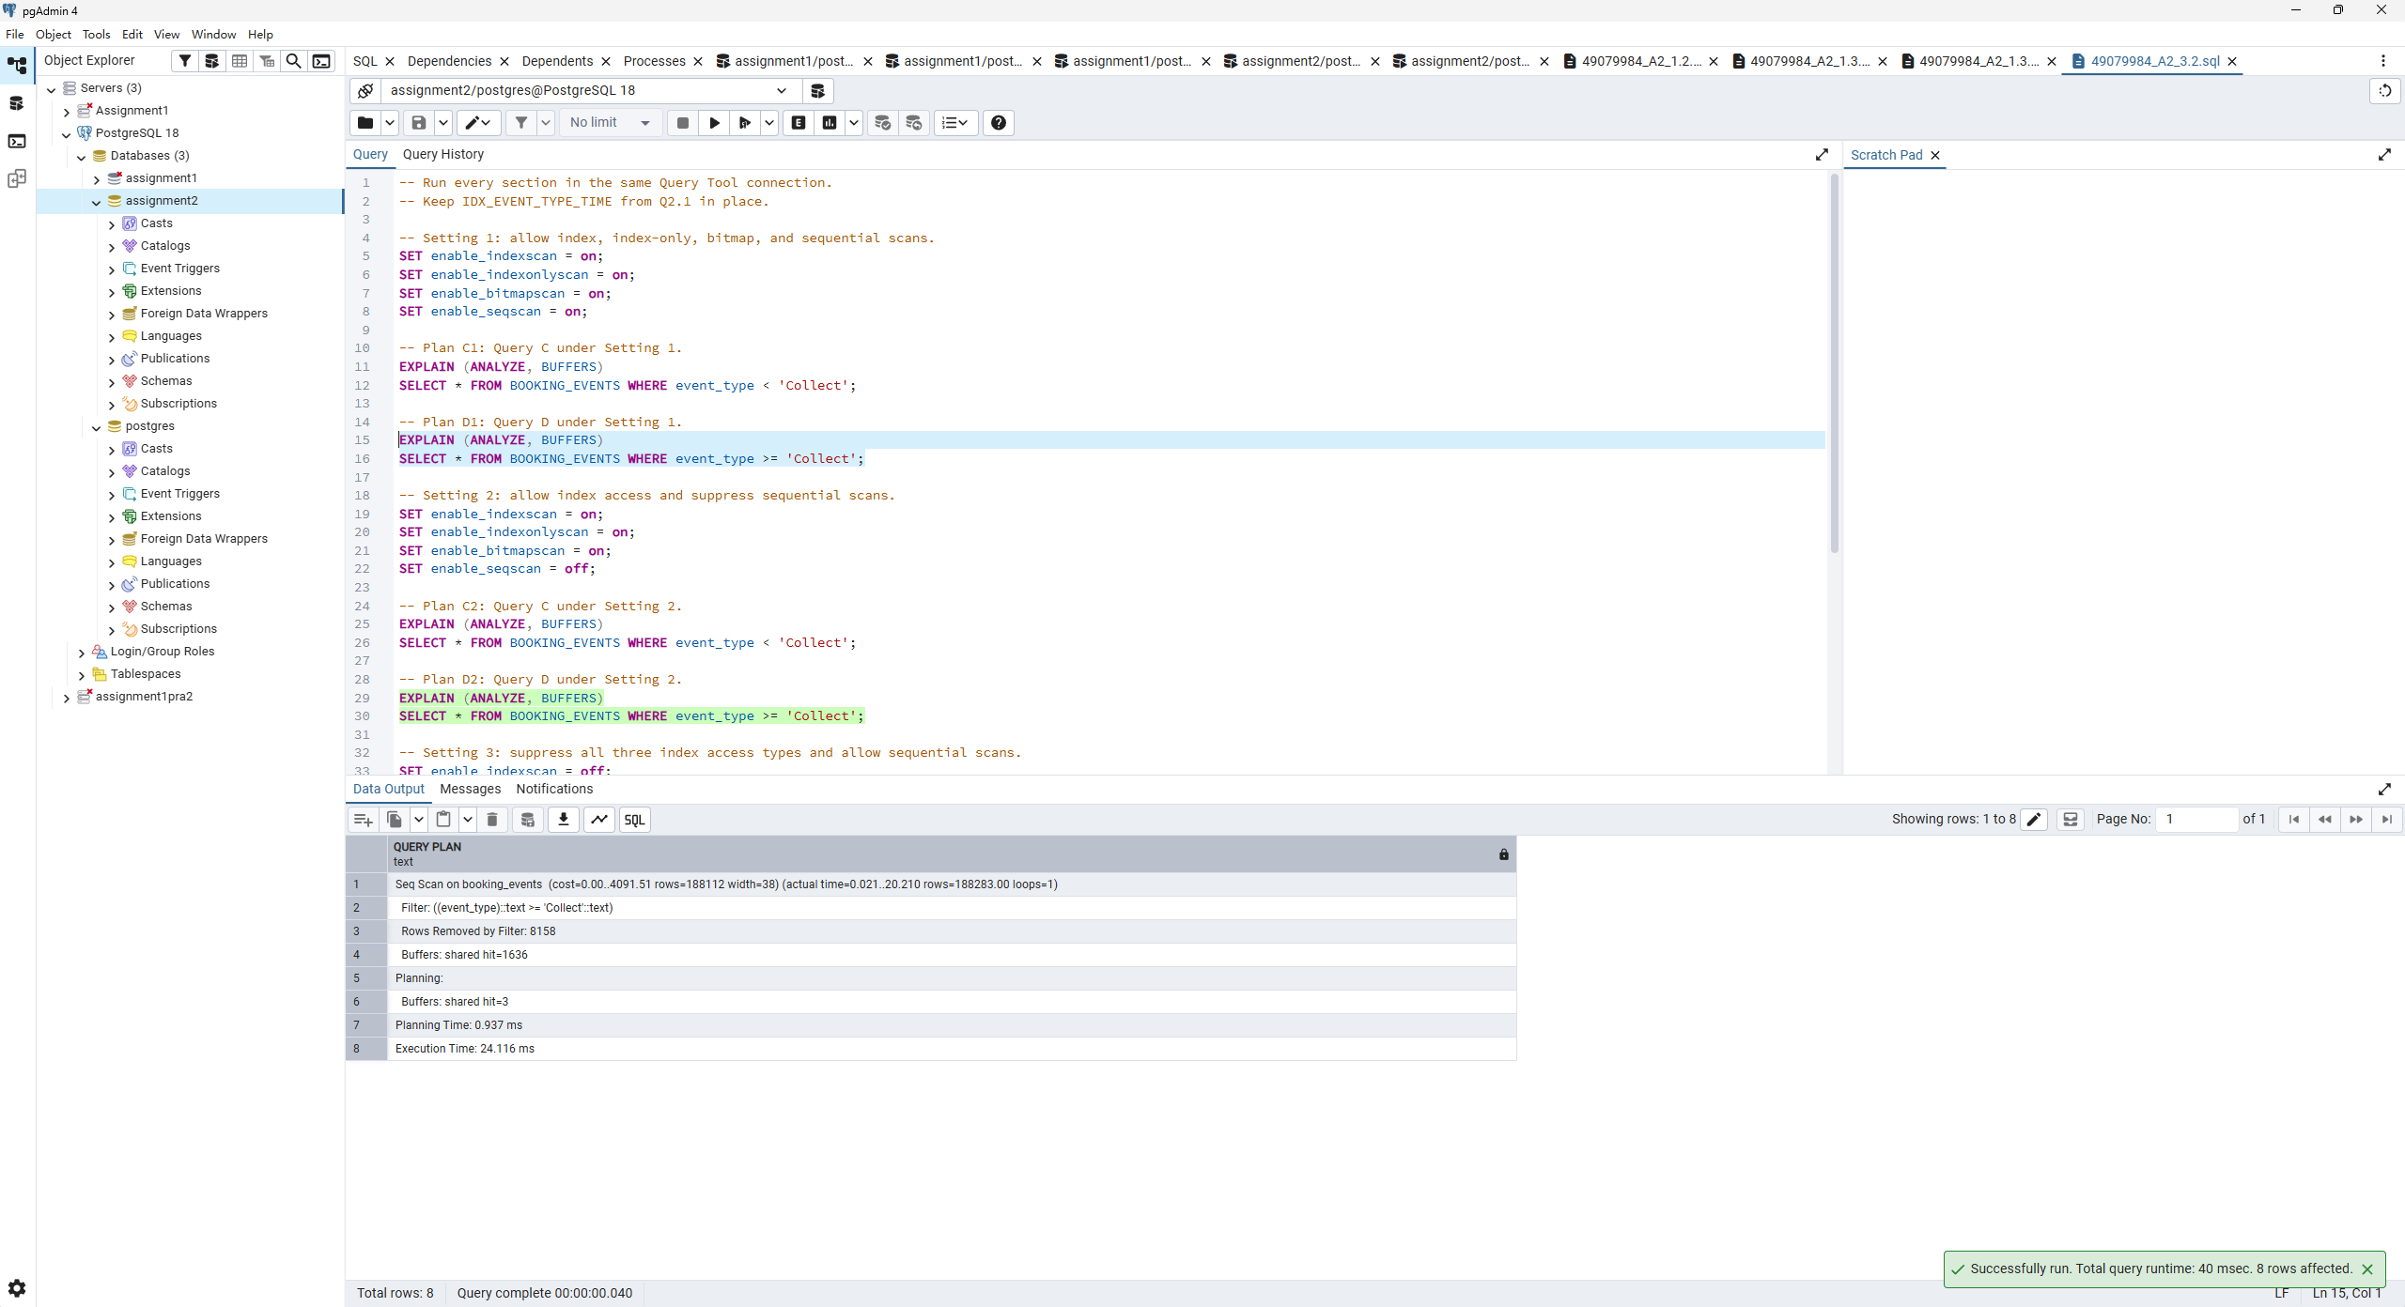
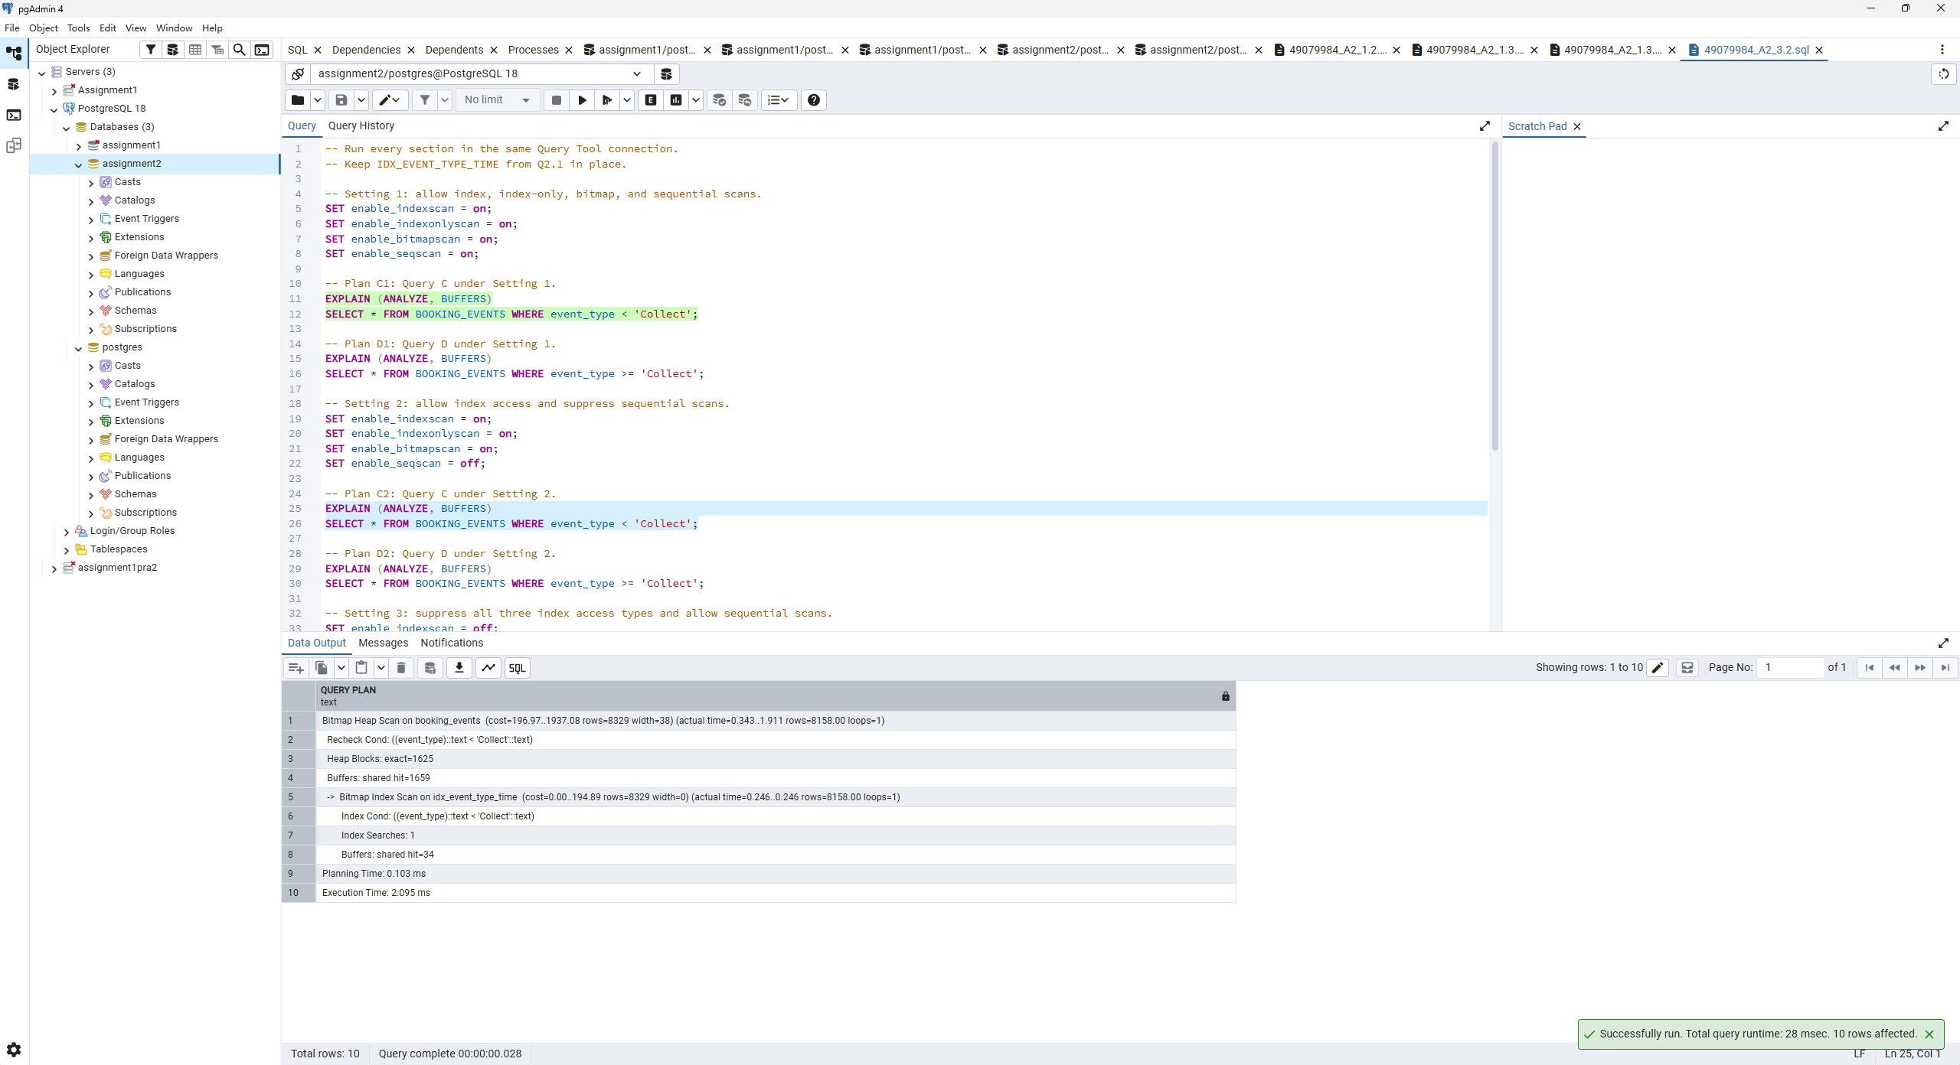
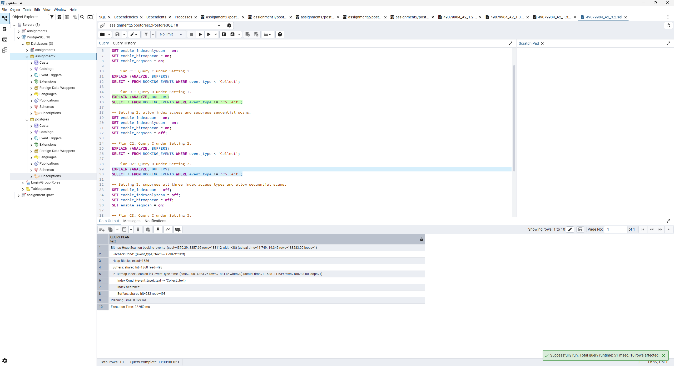
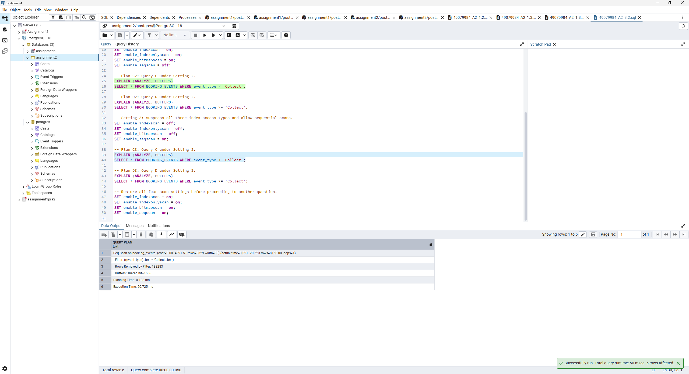
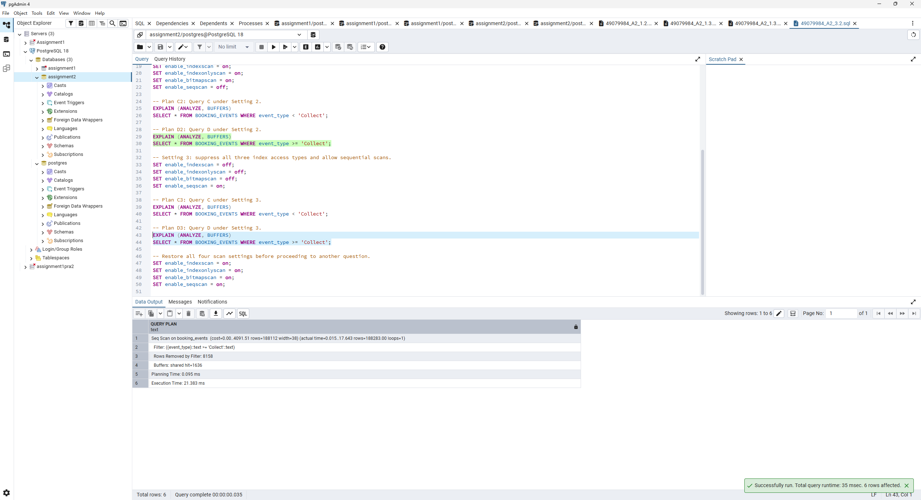
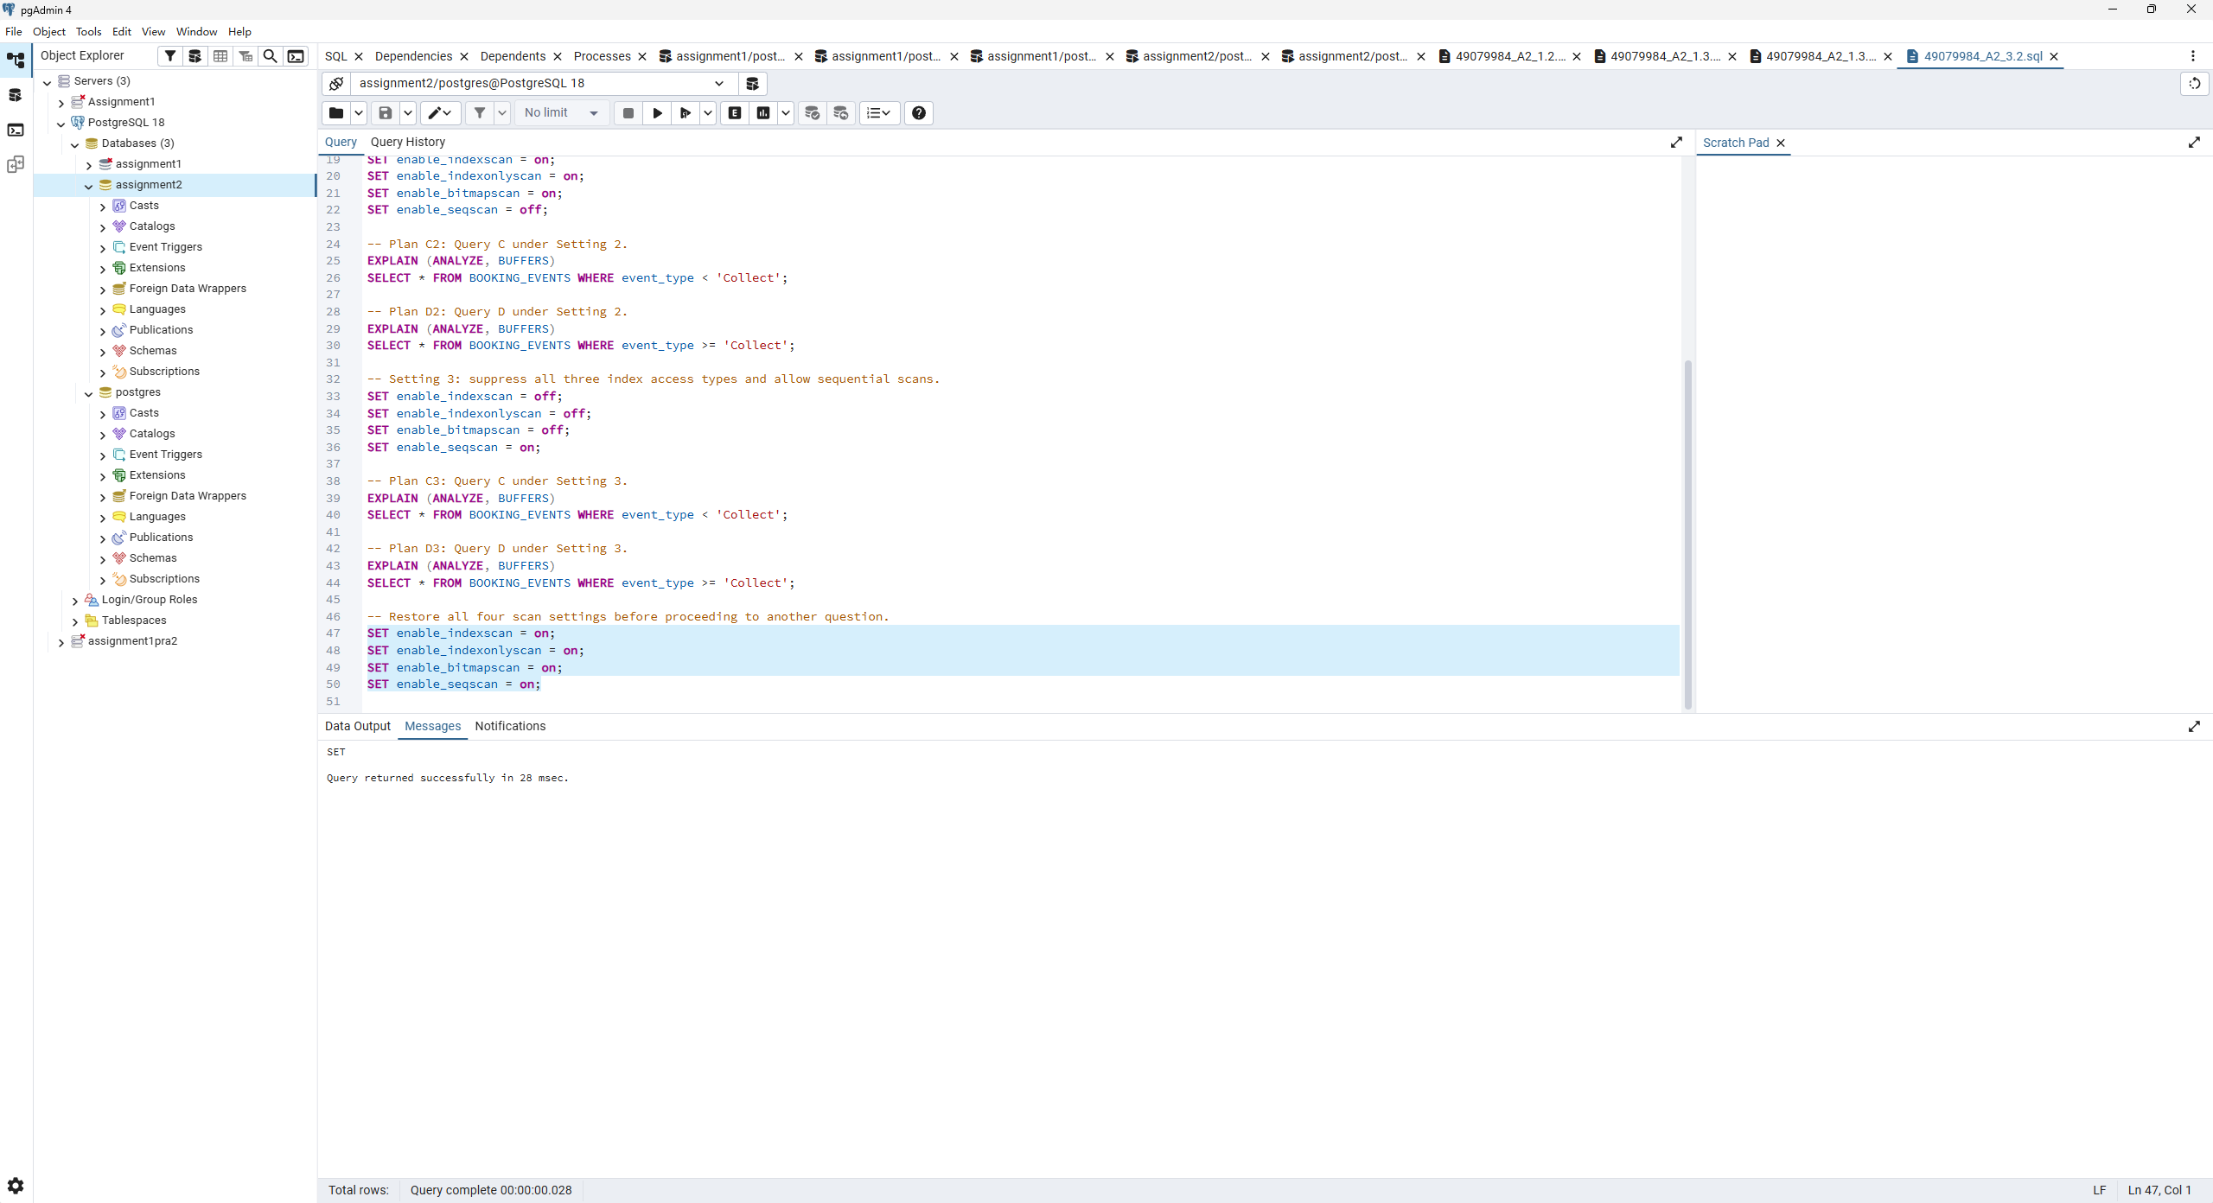
Full text of the recorded plans
These are transcriptions of the original interactive pgAdmin plans above, with unchanged values. They belong to the recorded run, rather than the clean replay used to supplement Q1–Q3.1.
C1
Bitmap Heap Scan on booking_events (cost=196.97..1937.08 rows=8329 width=38)
(actual time=1.964..11.097 rows=8158.00 loops=1)
Recheck Cond: ((event_type)::text < 'Collect'::text)
Heap Blocks: exact=1625
Buffers: shared hit=1628 read=31
-> Bitmap Index Scan on idx_event_type_time (cost=0.00..194.89 rows=8329
width=0) (actual time=1.606..1.606 rows=8158.00 loops=1)
Index Cond: ((event_type)::text < 'Collect'::text)
Index Searches: 1
Buffers: shared hit=3 read=31
Planning:
Buffers: shared hit=3 dirtied=1
Planning Time: 4.423 ms
Execution Time: 12.443 ms
D1
Seq Scan on booking_events (cost=0.00..4091.51 rows=188112 width=38) (actual
time=0.021..20.210 rows=188283.00 loops=1)
Filter: ((event_type)::text >= 'Collect'::text)
Rows Removed by Filter: 8158
Buffers: shared hit=1636
Planning:
Buffers: shared hit=3
Planning Time: 0.937 ms
Execution Time: 24.116 ms
C2
Bitmap Heap Scan on booking_events (cost=196.97..1937.08 rows=8329 width=38)
(actual time=0.343..1.911 rows=8158.00 loops=1)
Recheck Cond: ((event_type)::text < 'Collect'::text)
Heap Blocks: exact=1625
Buffers: shared hit=1659
-> Bitmap Index Scan on idx_event_type_time (cost=0.00..194.89 rows=8329
width=0) (actual time=0.246..0.246 rows=8158.00 loops=1)
Index Cond: ((event_type)::text < 'Collect'::text)
Index Searches: 1
Buffers: shared hit=34
Planning Time: 0.103 ms
Execution Time: 2.095 ms
D2
Bitmap Heap Scan on booking_events (cost=4370.29..8357.69 rows=188112
width=38) (actual time=11.749..19.345 rows=188283.00 loops=1)
Recheck Cond: ((event_type)::text >= 'Collect'::text)
Heap Blocks: exact=1636
Buffers: shared hit=1868 read=493
-> Bitmap Index Scan on idx_event_type_time (cost=0.00..4323.26 rows=188112
width=0) (actual time=11.638..11.639 rows=188283.00 loops=1)
Index Cond: ((event_type)::text >= 'Collect'::text)
Index Searches: 1
Buffers: shared hit=232 read=493
Planning Time: 0.099 ms
Execution Time: 22.959 ms
C3
Seq Scan on booking_events (cost=0.00..4091.51 rows=8329 width=38) (actual
time=0.021..20.523 rows=8158.00 loops=1)
Filter: ((event_type)::text < 'Collect'::text)
Rows Removed by Filter: 188283
Buffers: shared hit=1636
Planning Time: 0.108 ms
Execution Time: 20.725 ms
D3
Seq Scan on booking_events (cost=0.00..4091.51 rows=188112 width=38) (actual
time=0.015..17.643 rows=188283.00 loops=1)
Filter: ((event_type)::text >= 'Collect'::text)
Rows Removed by Filter: 8158
Buffers: shared hit=1636
Planning Time: 0.095 ms
Execution Time: 21.383 ms
Comments:

Screenshot Q3.2 (2) | Marks: /2
Queries C and D partition 196,441 events at this stage. C returns 8,158 rows (4.15 percent), while D returns 188,283 (95.85 percent). The opposite inequalities on the same indexed column therefore have very different selectivity.
C1 uses Bitmap Index Scan on IDX_EVENT_TYPE_TIME followed by Bitmap Heap Scan. Its cost is 196. 97..1937.08, with 8,329 rows estimated and 8,158 returned. Planning takes 4.423 ms and execution 12.443 ms. It visits 1,625 exact heap blocks; total buffers are 1,628 shared hits and 31 reads. Selective index access costs less than scanning and filtering the whole event log, even though the matching events are spread across many heap pages.
D1 uses Seq Scan, with cost 0. 00..4091.51, 188,112 estimated rows and 188,283 actual rows. Planning takes 0.937 ms and execution 24.116 ms. It reads the heap through 1,636 shared buffer hits and removes 8,158 nonmatching rows. Returning almost the whole table makes a sequential pass cheaper in the cost model than traversing many index entries and then visiting almost every heap page.
C2 retains the bitmap plan and the same cost and row estimates when sequential scans are suppressed. Planning takes 0.103 ms and execution 2.095 ms. All 1,659 buffer accesses are hits, including 34 for the index. The change from C1 includes a warmer cache; suppressing a scan type did not change the chosen access method, so the faster time cannot be attributed to a new plan.
D2 uses Bitmap Index Scan plus Bitmap Heap Scan because sequential scans are suppressed. Its cost rises to 4370. 29..8357.69. It still returns 188,283 rows versus 188,112 estimated and visits all 1,636 heap blocks, with 1,868 shared hits and 493 reads overall. Planning takes 0.099 ms and execution 22.959 ms. This is slightly faster than D1 in this single run despite the higher estimated cost. It does not establish that bitmap access is generally better for this broad predicate; cache state and measurement variation affect elapsed time.
C3 uses Seq Scan after index, index-only and bitmap scans are suppressed. Its cost is 0. 00..4091.51, with 8,329 rows estimated and 8,158 returned. It discards 188,283 rows and has 1,636 shared hits. Planning takes 0.108 ms and execution 20.725 ms, slower than both bitmap C runs. Removing the selective index option forces a full-table read and filter.
D3 also uses Seq Scan, with the same cost and row estimates as D1. Planning takes 0.095 ms and execution 21.383 ms. It returns 188,283 rows, discards 8,158 and has 1,636 shared hits. This remains the natural access method for a query needing nearly every row.
Planner costs are estimates in cost units, not milliseconds. The comparison shows how row selectivity, page access and extra index work influence the chosen method. The switches discourage scan methods; they are useful for this experiment but should not replace normal planner choices in production. All four switches were restored to on.
Comments:

Screenshot Q4.1 (1) | Marks: /2
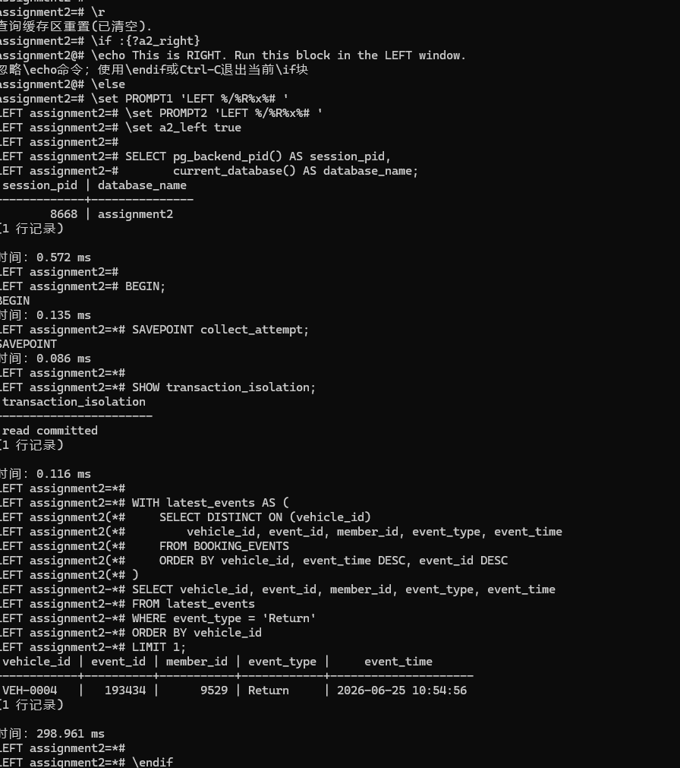
Comments:

Screenshot Q4.1 (2) | Marks: /0.5
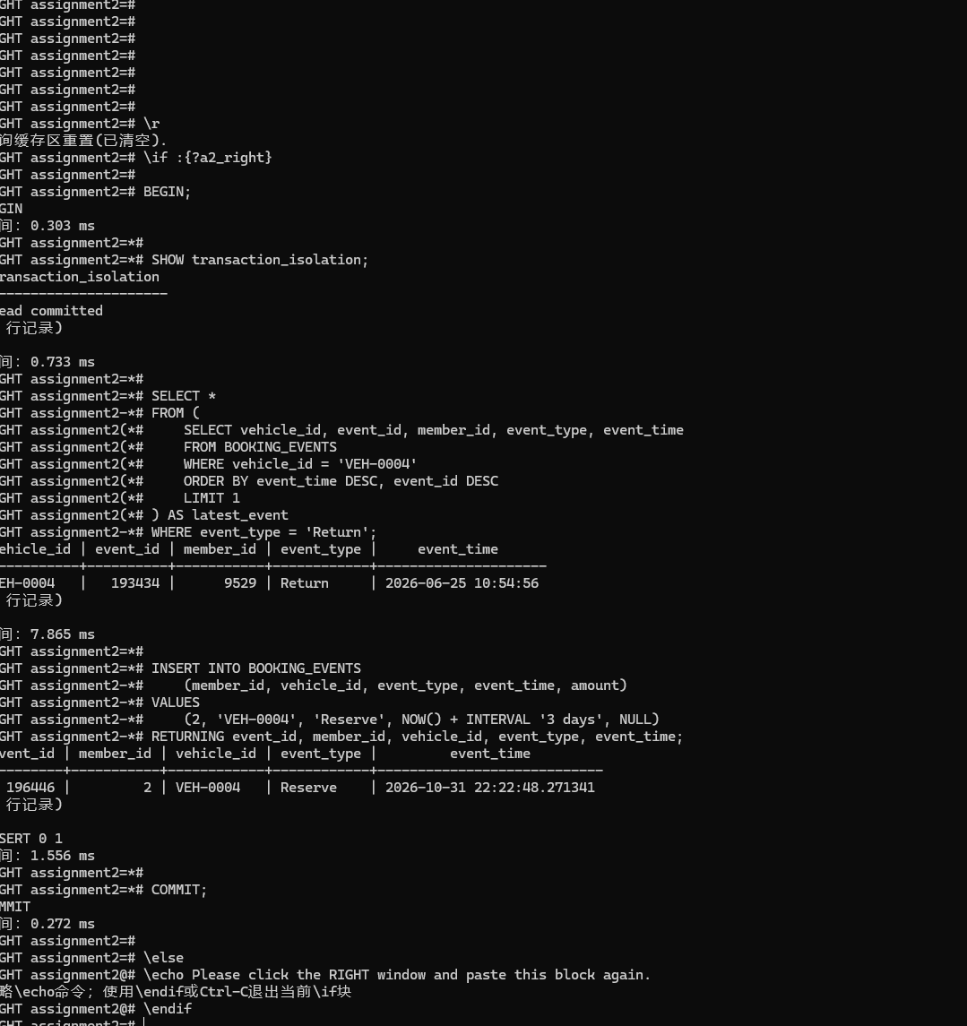
Comments:

Screenshot Q4.1 (3) | Marks: /1
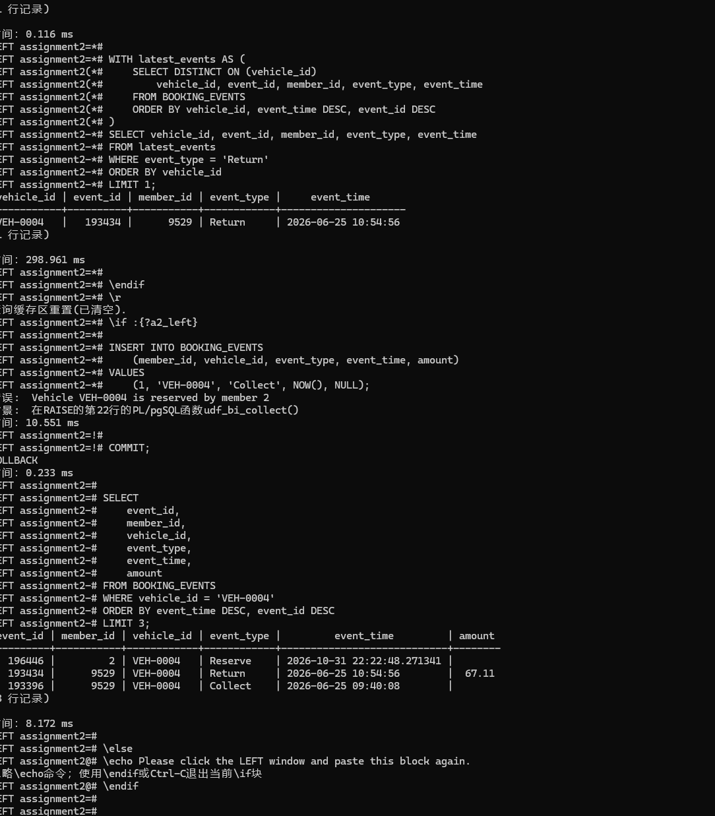
Comments:

Screenshot Q4.1 (4) | Marks: /2.5
The schedule is T1 BEGIN and availability read; T2 BEGIN and availability read; T2 Reserve and COMMIT; T1 Collect attempt; trigger exception; T1 ROLLBACK. T1 initially sees an available car, but that answer becomes stale before its next operation.
At READ COMMITTED, each statement uses a fresh snapshot. The Collect attempt runs after T2 has committed, so the trigger can see the committed Reserve. The trigger orders events by event time and treats that future-dated reservation as the latest state. Because it belongs to member 2, it refuses a Collect by member 1.
An ordinary SELECT reads without a row lock that reserves this car. Its ACCESS SHARE relation lock is compatible with the other transaction's insertion, so it does not prevent T2 from changing the answer. T1 stays open but does not retain its first statement's snapshot for later statements. In this schedule the rejection is a business-rule exception, with no circular lock wait.
For the co-operative, the person at the parking bay is refused the car even though the other person reserved it three days ahead. The simplified trigger makes a future reservation an immediate hold. Coordinating availability checks and writes would address races, while interval-aware booking rules would also be needed to distinguish available now from reserved later.
Comments:

Screenshot Q4.2 | Marks: /3
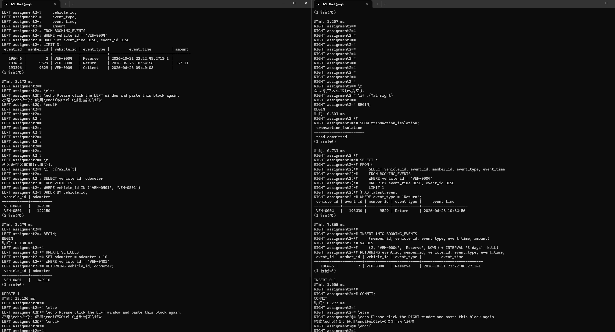
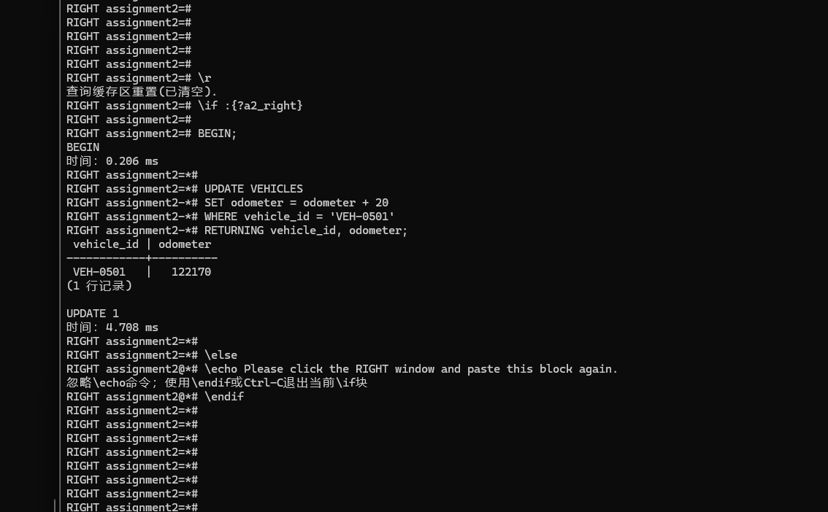
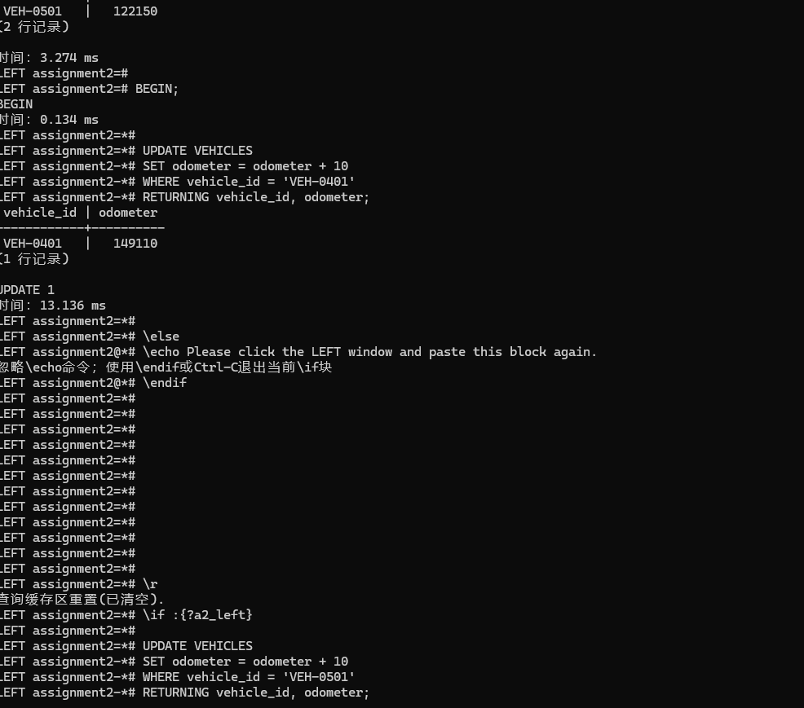
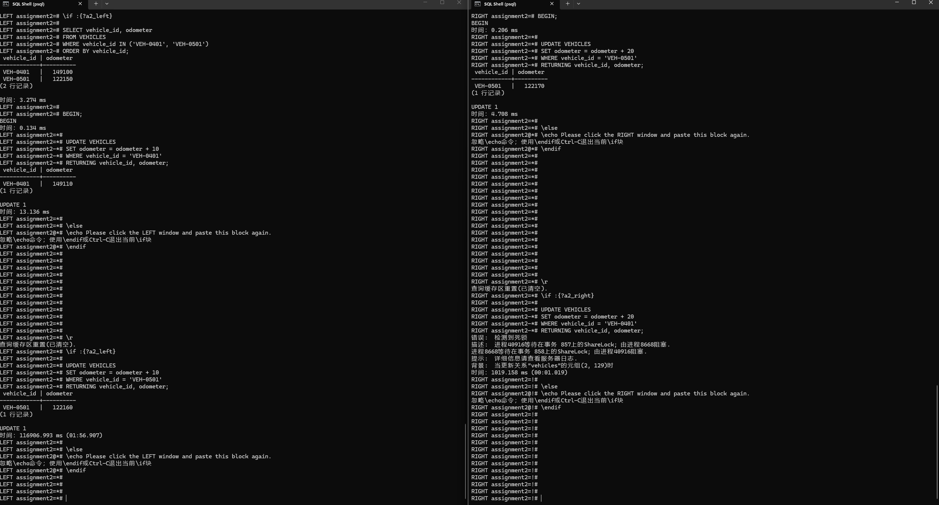
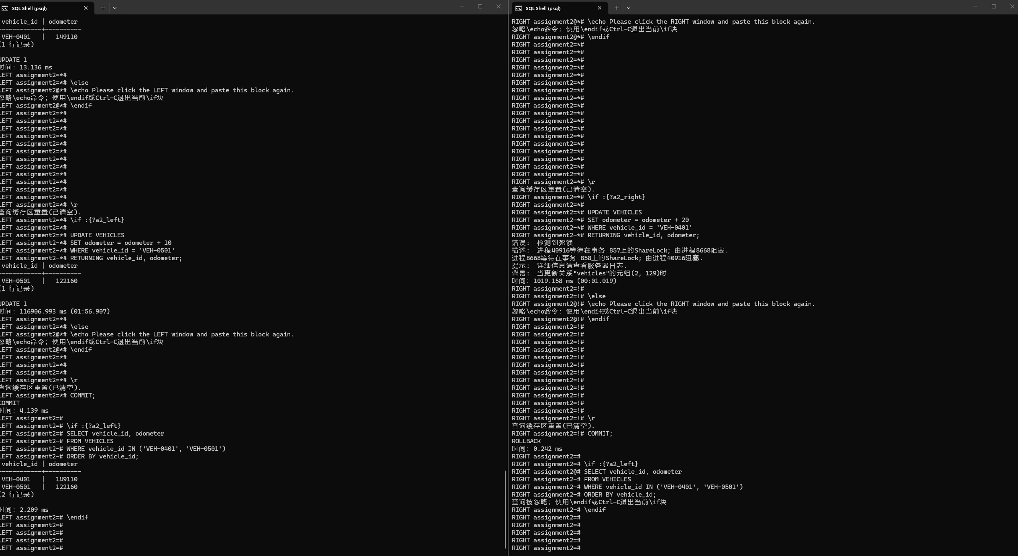
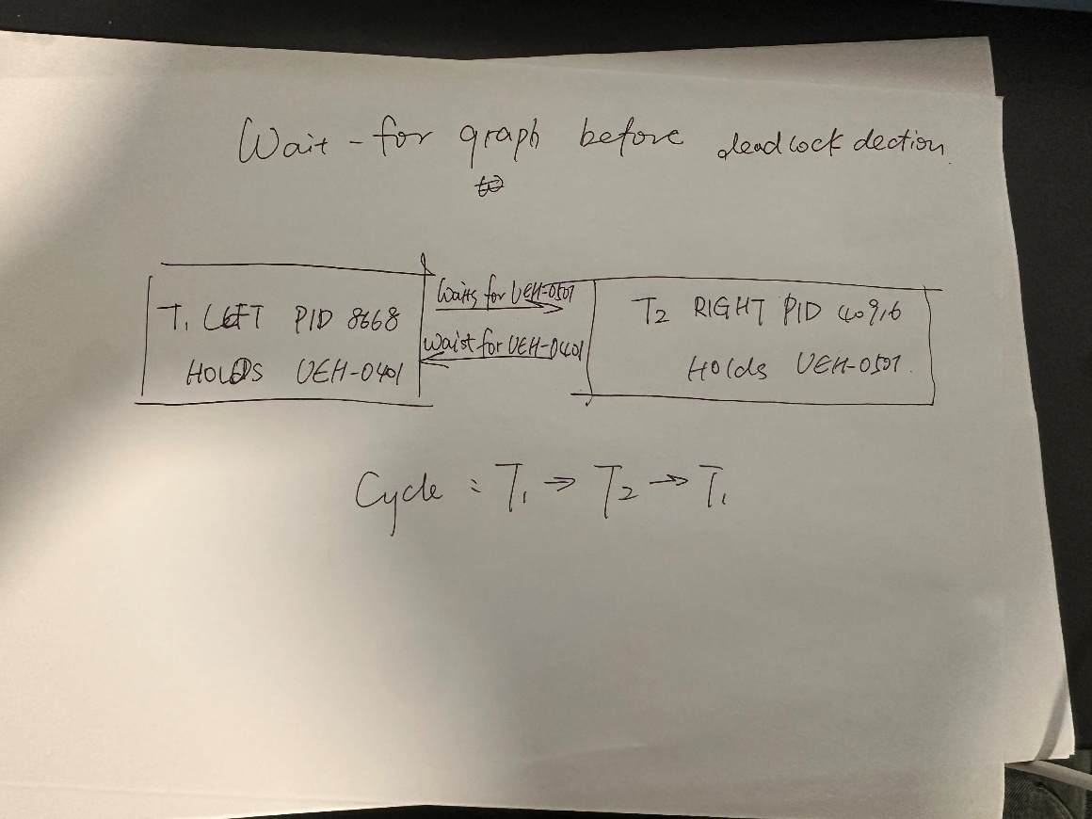
Deadlock explanation
T1 updates VEH-0401 by 10 and holds its row lock. T2 updates VEH-0501 by 20 and holds the other row lock. T1 then requests VEH-0501 and waits. While it is waiting, T2 requests VEH-0401, completing the cycle. Both updates cannot finish until the other transaction ends.
PostgreSQL detects the deadlock and aborts T2 in this recorded run. T2's earlier +20 on VEH-0501 is undone and its locks are released. T1's waiting update resumes, returning 122160, and T1 commits. T2's attempted COMMIT reports ROLLBACK. Final values are VEH-0401 = 149110 and VEH-0501 = 122160.
The full original error is shown below and transcribed without translating its diagnostic text. T1's reported 116906.993 ms includes the time spent waiting while the next command was entered in the other window. T2's error took 1019.158 ms. These are not ordinary update processing times.
The wait-for graph immediately before detection has T1 -> T2 for VEH-0501 and T2 -> T1 for VEH-0401. Its cycle T1 -> T2 -> T1 explains why neither could proceed. The photographed hand drawing marks both held resources and both waiting edges.
A consistent ascending vehicle_id lock order would prevent this cycle: every correction transaction must acquire VEH-0401 before VEH-0501. A transaction blocked on the first row would then hold no later row needed by its predecessor. The co-operative would pay with more waiting or queuing when corrections overlap, while unrelated vehicles could still be processed concurrently. The victim can differ on a rerun, so the outcome here is based on the actual screenshot.
Full diagnostic text from the recorded error
错误: 检测到死锁
描述: 进程40916等待在事务 857上的ShareLock; 由进程8668阻塞.
进程8668等待在事务 858上的ShareLock; 由进程40916阻塞.
提示: 详细信息请查看服务器日志.
背景: 当更新关系"vehicles"的元组(2, 129)时
Technical references
PostgreSQL 18 Using EXPLAIN
PostgreSQL 18 Materialized Views
PostgreSQL 18 Indexes on Expressions
PostgreSQL 18 Explicit Locking and Deadlocks
Comments:

Screenshot P | Marks: /2
Comments:

Penalty: _______________
Reason of the Penalty
(Late Submission/No Show to Tutor/Purely AI Generated Solutions): ___________

Final Marks： ———————— / 30

---ooo000OOO000ooo---

