Submission Template for

INFS2200/INFS7903 Assignment 2
Semester 2, 2026

Submission of Screenshot for Assignment 2

Submitted by:
Student Name | Student ID | Practical Session | Tutor Name
Yuyang Gong | 49079984 | Friday 9:00–10:00 | Mr. Li, Jiayun

About AI Usage:
Did you use AI in this assignment? | Yes.
The purpose of AI used in this assignment? | To develop SQL, troubleshoot PostgreSQL, explain plans and transactions, and prepare the report.
To what extend that AI is used in this submitted work? | AI generated substantial SQL and explanatory text, checked the files in an isolated local database, supplemented incomplete output captures, and assembled and formatted this report. The interactive screenshots and hand-drawn graph were supplied by the student.
Did you discuss your AI usage with the tutor during the “Show to Tutor” Lab sessions? | No. A2 has not yet been shown to the tutor, and this AI use has not yet been discussed.

Screenshot Q1.1 (1) | Marks: /1
SQL for Q1.1.1
CREATE VIEW V_BUSIEST_BAYS AS
WITH collection_counts AS (
SELECT
m.body_type,
s.station_id,
s.station_name,
COUNT(*) AS collections
FROM BOOKING_EVENTS e
JOIN VEHICLES v
ON v.vehicle_id = e.vehicle_id
JOIN MODELS m
ON m.model_code = v.model_code
JOIN STATIONS s
ON s.station_id = v.station_id
WHERE e.event_type = 'Collect'
GROUP BY
m.body_type,
s.station_id,
s.station_name
),
ranked_stations AS (
SELECT *,
ROW_NUMBER() OVER (
PARTITION BY body_type
ORDER BY collections DESC, station_id
) AS rn
FROM collection_counts
)
SELECT body_type, station_name, collections
FROM ranked_stations
WHERE rn = 1
ORDER BY collections DESC, body_type;
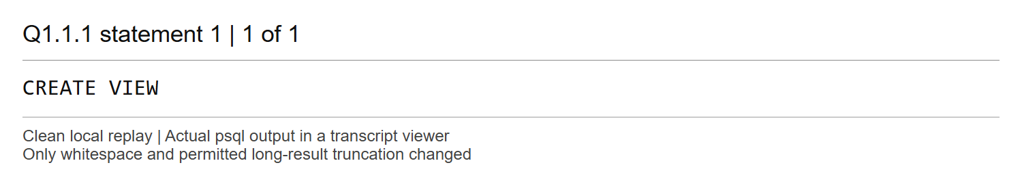
Comments
The first CTE counts Collect events for each body type and station. ROW_NUMBER partitions those counts by body type and picks the largest count; station_id resolves ties deterministically so exactly one station is returned per represented body type. The final ORDER BY puts the largest winner first.
The schema records a station on VEHICLES, rather than on BOOKING_EVENTS. The station reported is therefore the vehicle's recorded station, which is the location available in the supplied schema.

Screenshot Q1.1(2) | Marks: /0.5
Complete results and plans in Q1 to Q3.1 below are from a clean local replay of the submitted SQL. These supplement the earlier screenshots whose long plans were clipped. Q3.2 and Q4 retain the recorded interactive runs; their separate provenance is stated where used.
SQL for Q1.1.2
SELECT * FROM V_BUSIEST_BAYS;
EXPLAIN (ANALYZE, BUFFERS)
SELECT * FROM V_BUSIEST_BAYS;
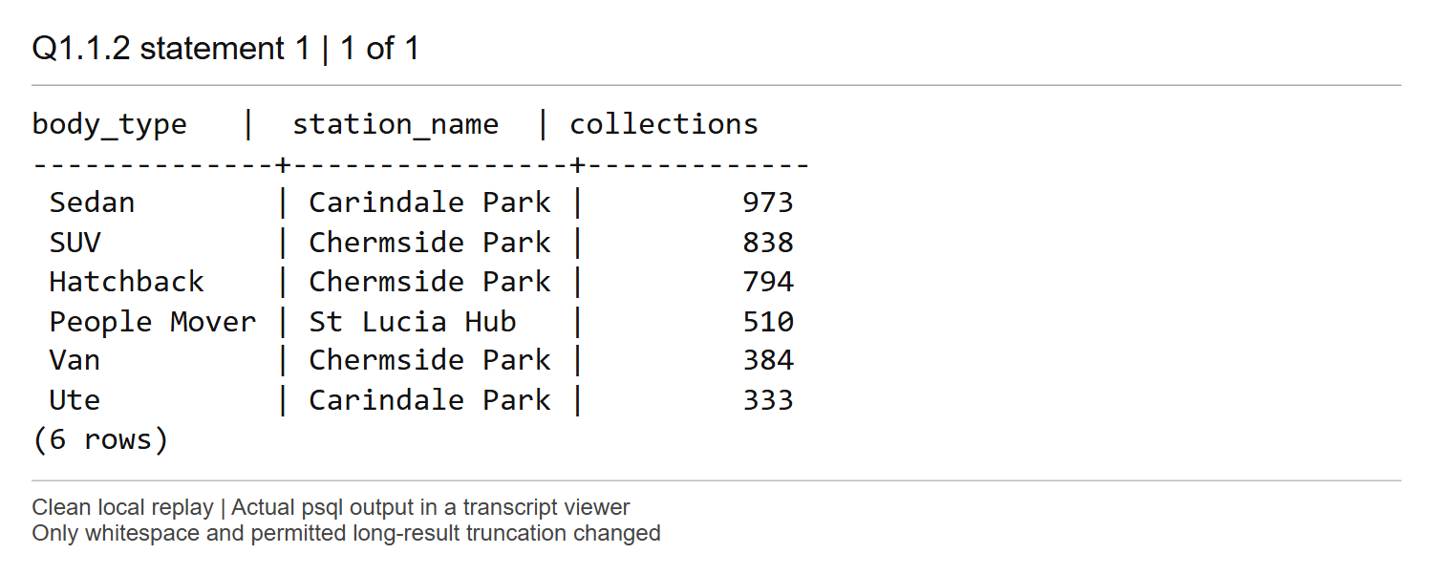
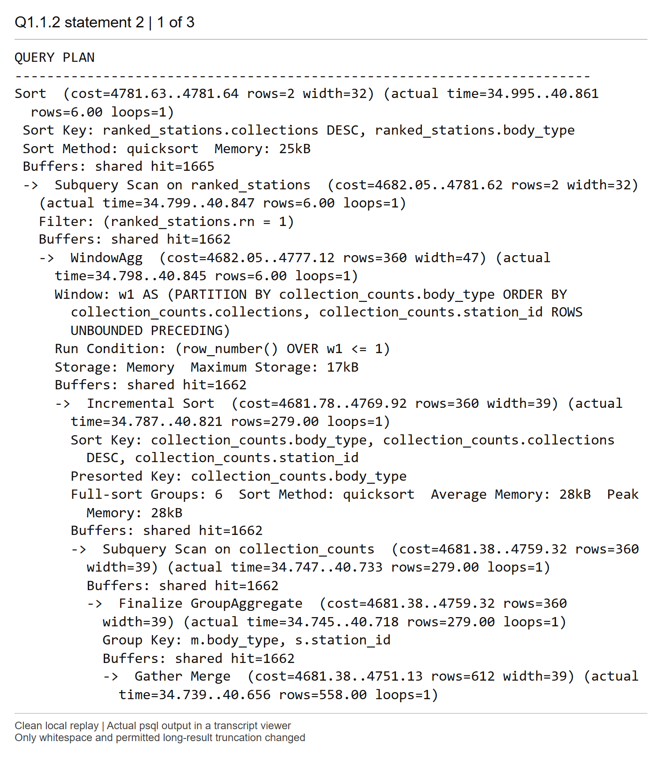
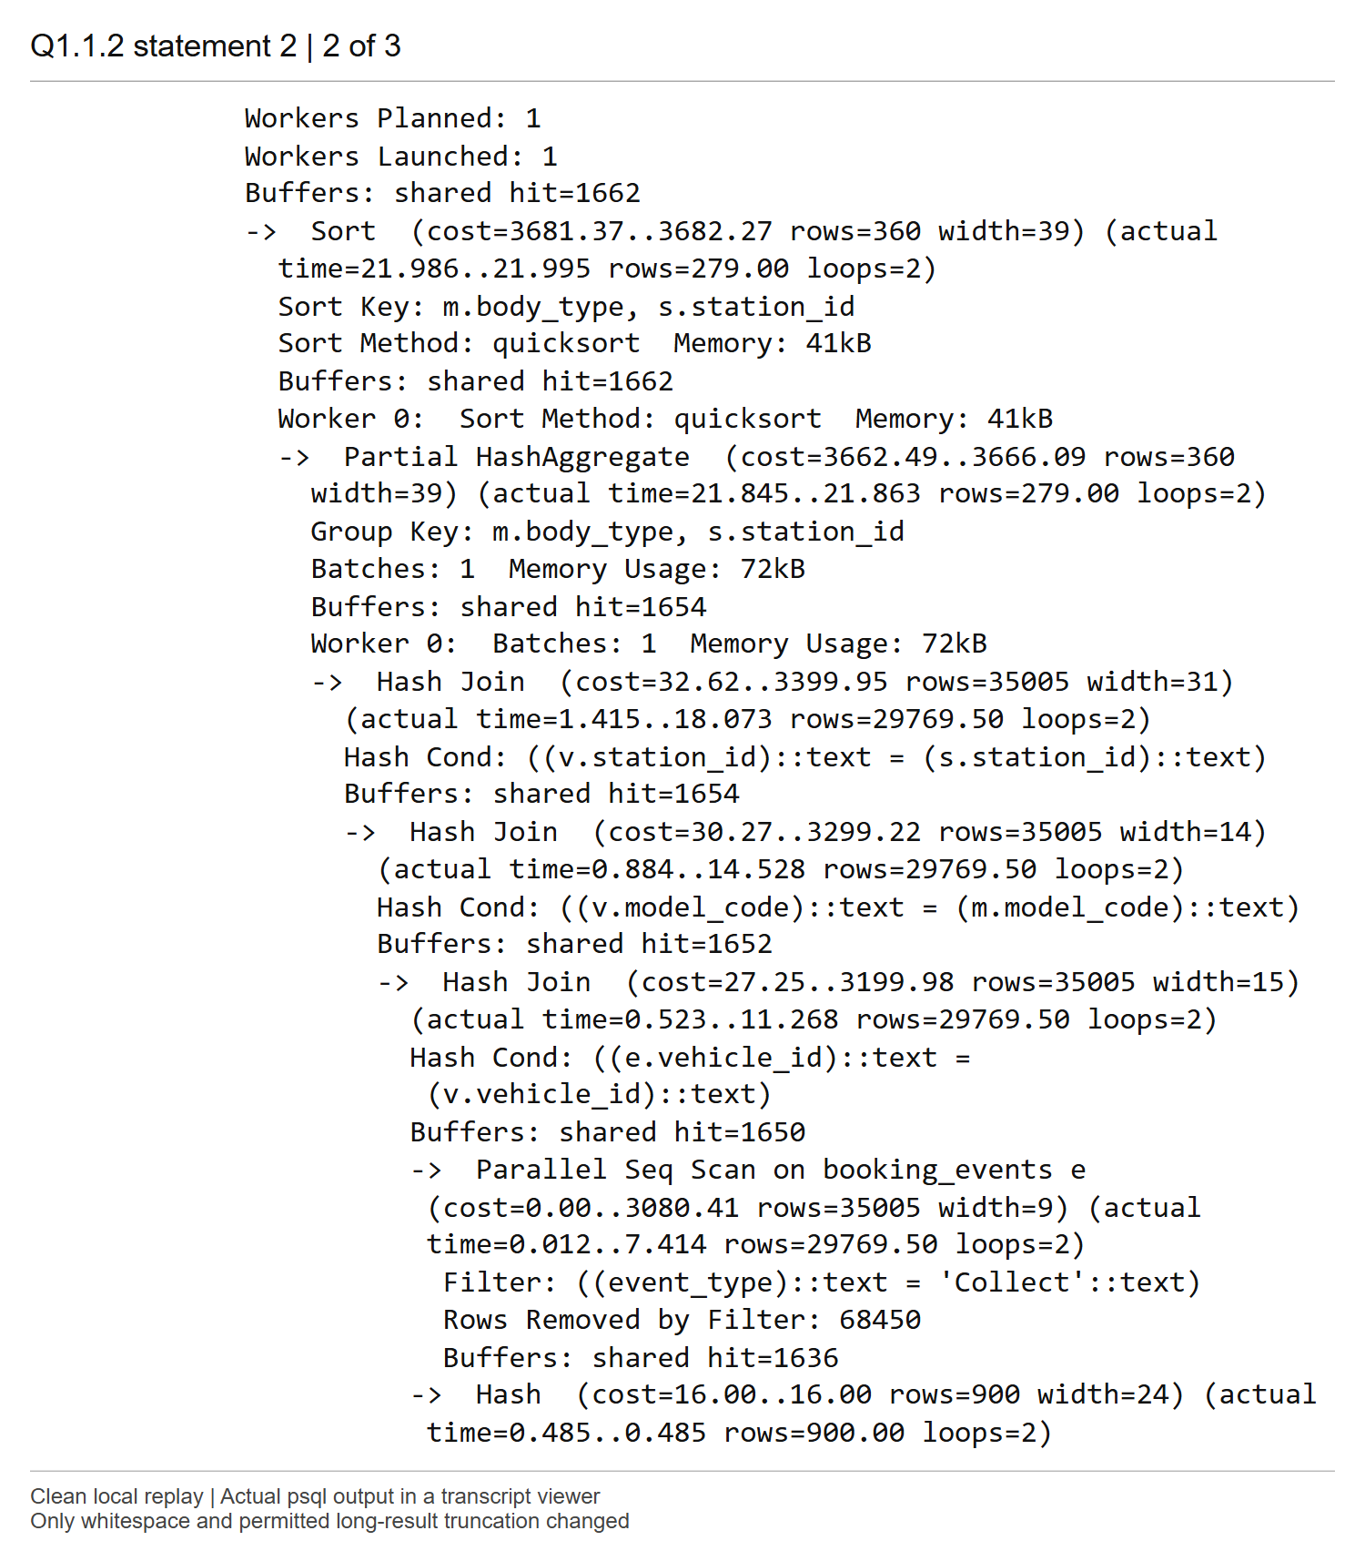
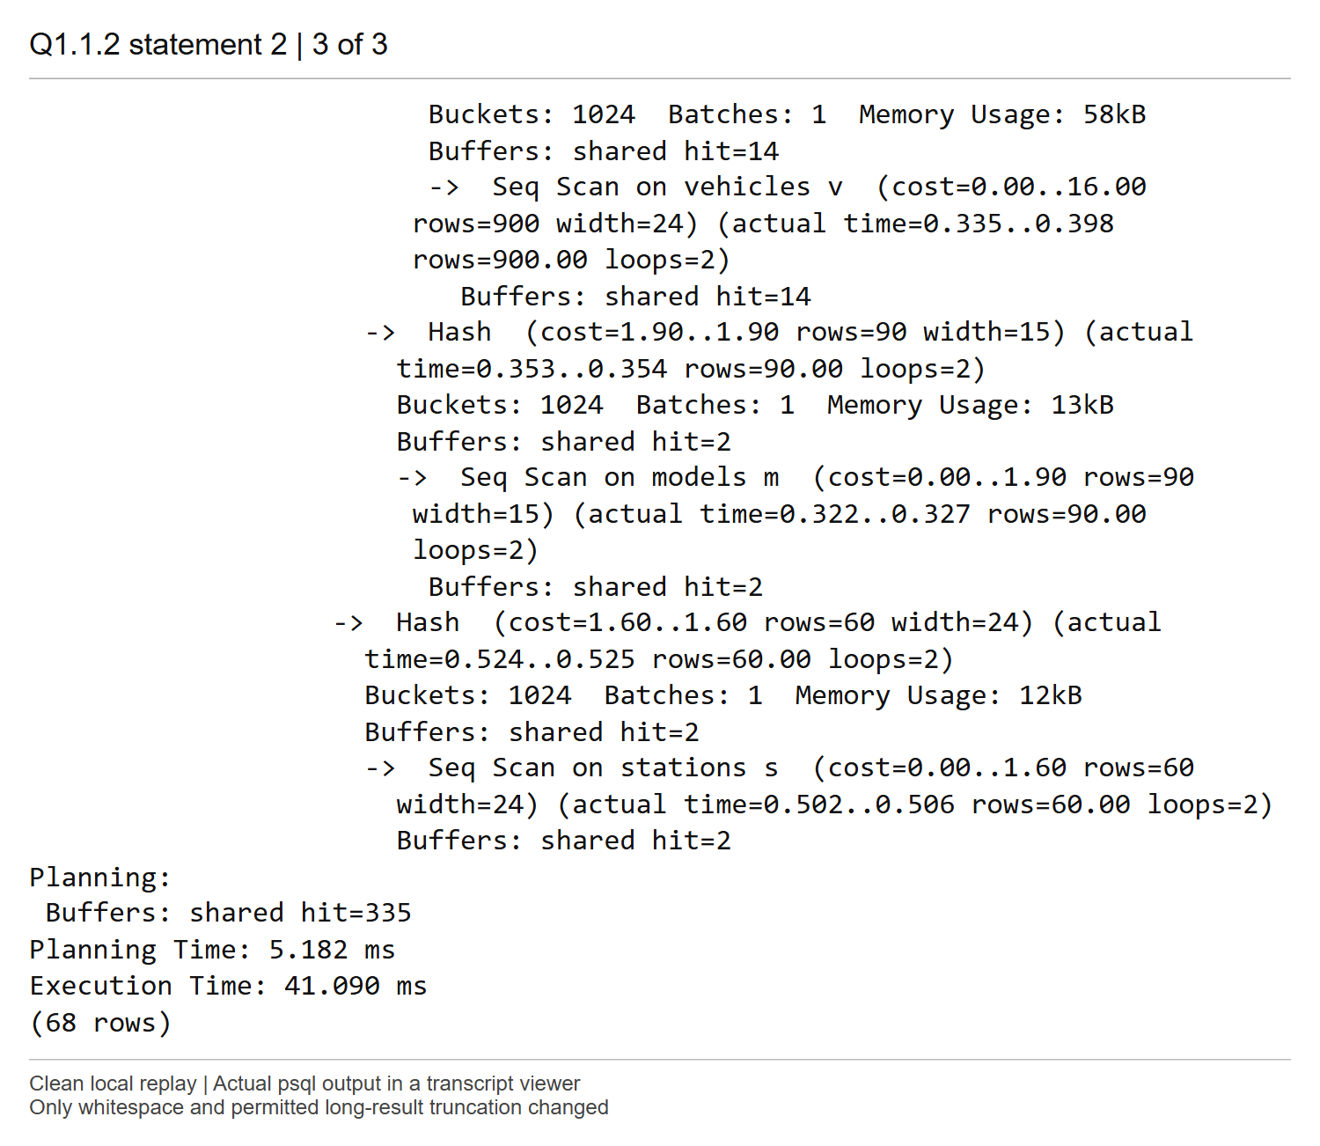
Comments
The view returns six rows. Sedan at Carindale Park leads with 973 collections, followed by SUV 838, Hatchback 794, People Mover 510, Van 384 and Ute 333. The top node estimates 2 rows but returns 6; its cost is 4781.63..4781.64 and execution takes 41.090 ms.
A Parallel Seq Scan filters BOOKING_EVENTS to Collect events. Its 29,769.5 actual rows per loop across two loops represent 59,539 collections in total. Hash joins attach vehicle, model and station attributes. Partial aggregation and Finalize GroupAggregate reduce these events to 279 body-type/station groups; incremental sorting and WindowAgg select one winner per body type, and the final sort orders the six winners. The small final result does not avoid processing the underlying event log.

Screenshot Q1.2 | Marks: /1.5
SQL for Q1.2
CREATE VIEW V_ACCOUNT_LIABILITY AS
WITH RECURSIVE account_tree AS (
SELECT member_id, member_id AS account_id
FROM MEMBERS
WHERE sponsor_id IS NULL
UNION ALL
SELECT child.member_id, parent.account_id
FROM MEMBERS child
JOIN account_tree parent
ON child.sponsor_id = parent.member_id
)
SELECT
root.member_id,
root.member_name,
SUM(e.amount) AS total_amount
FROM account_tree t
JOIN MEMBERS root
ON root.member_id = t.account_id
JOIN BOOKING_EVENTS e
ON e.member_id = t.member_id
WHERE e.event_type IN ('Return', 'Incident')
AND e.event_time >= TIMESTAMP '2026-01-01'
AND e.event_time < TIMESTAMP '2026-07-01'
GROUP BY root.member_id, root.member_name
ORDER BY total_amount DESC, root.member_id
LIMIT 10;
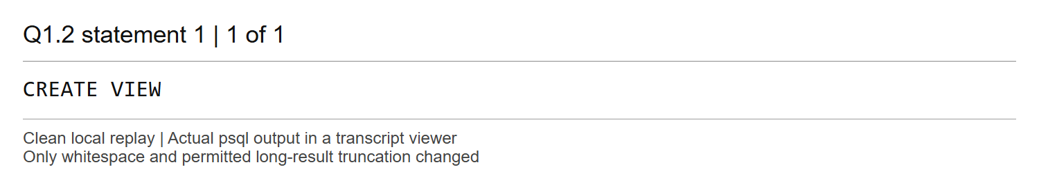
Comments
The recursive seed maps each unsponsored account to itself. Each recursive step maps a sponsored child to the same root account as its parent, so every member in the supplied sponsorship forest maps to exactly one ultimately liable account. Joining charges to this mapping bills personal charges and every level of sponsored charges to the root, without counting an event at several intermediate accounts.
Only Return fares and Incident damage charges are included. The half-open timestamp range from 2026-01-01 up to, but excluding, 2026-07-01 includes all of 30 June. Totals are sorted descending, with member_id as a deterministic tie-breaker, and limited to ten accounts. The result is shown in Q1.3 Query A. An independent upward traversal produced the same ten rows.

Screenshot Q1.3 (2) | Marks: /0.5
Q1.3 part 1 creates MV_ACCOUNT_LIABILITY with the same recursive query. Query A and Query B and their full plans follow.
SQL for Q1.3.1
CREATE MATERIALIZED VIEW MV_ACCOUNT_LIABILITY AS
WITH RECURSIVE account_tree AS (
SELECT member_id, member_id AS account_id
FROM MEMBERS
WHERE sponsor_id IS NULL
UNION ALL
SELECT child.member_id, parent.account_id
FROM MEMBERS child
JOIN account_tree parent
ON child.sponsor_id = parent.member_id
)
SELECT
root.member_id,
root.member_name,
SUM(e.amount) AS total_amount
FROM account_tree t
JOIN MEMBERS root
ON root.member_id = t.account_id
JOIN BOOKING_EVENTS e
ON e.member_id = t.member_id
WHERE e.event_type IN ('Return', 'Incident')
AND e.event_time >= TIMESTAMP '2026-01-01'
AND e.event_time < TIMESTAMP '2026-07-01'
GROUP BY root.member_id, root.member_name
ORDER BY total_amount DESC, root.member_id
LIMIT 10;
SQL for Q1.3.2
-- Query A: retrieve the ordinary view results.
SELECT * FROM V_ACCOUNT_LIABILITY;
-- Query A: report the ordinary view execution plan.
EXPLAIN (ANALYZE, BUFFERS)
SELECT * FROM V_ACCOUNT_LIABILITY;
-- Query B: retrieve the materialized view results.
SELECT * FROM MV_ACCOUNT_LIABILITY;
-- Query B: report the materialized view execution plan.
EXPLAIN (ANALYZE, BUFFERS)
SELECT * FROM MV_ACCOUNT_LIABILITY;
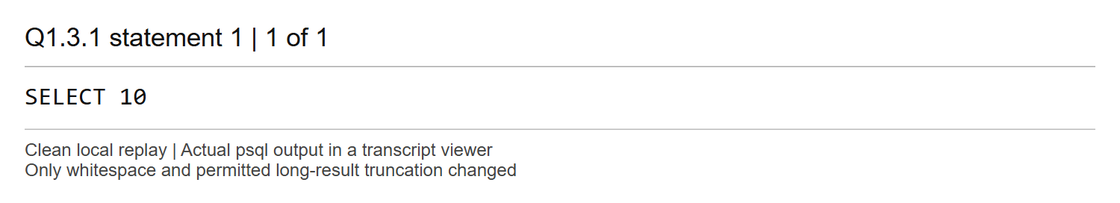
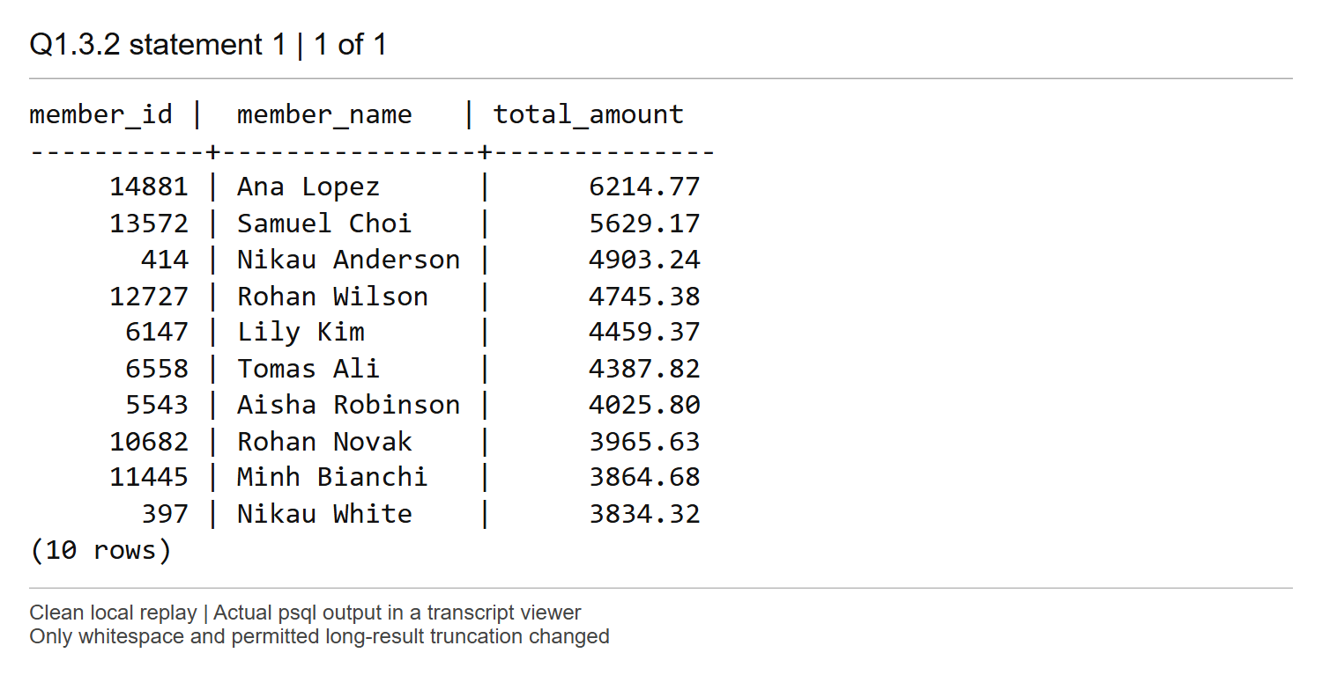
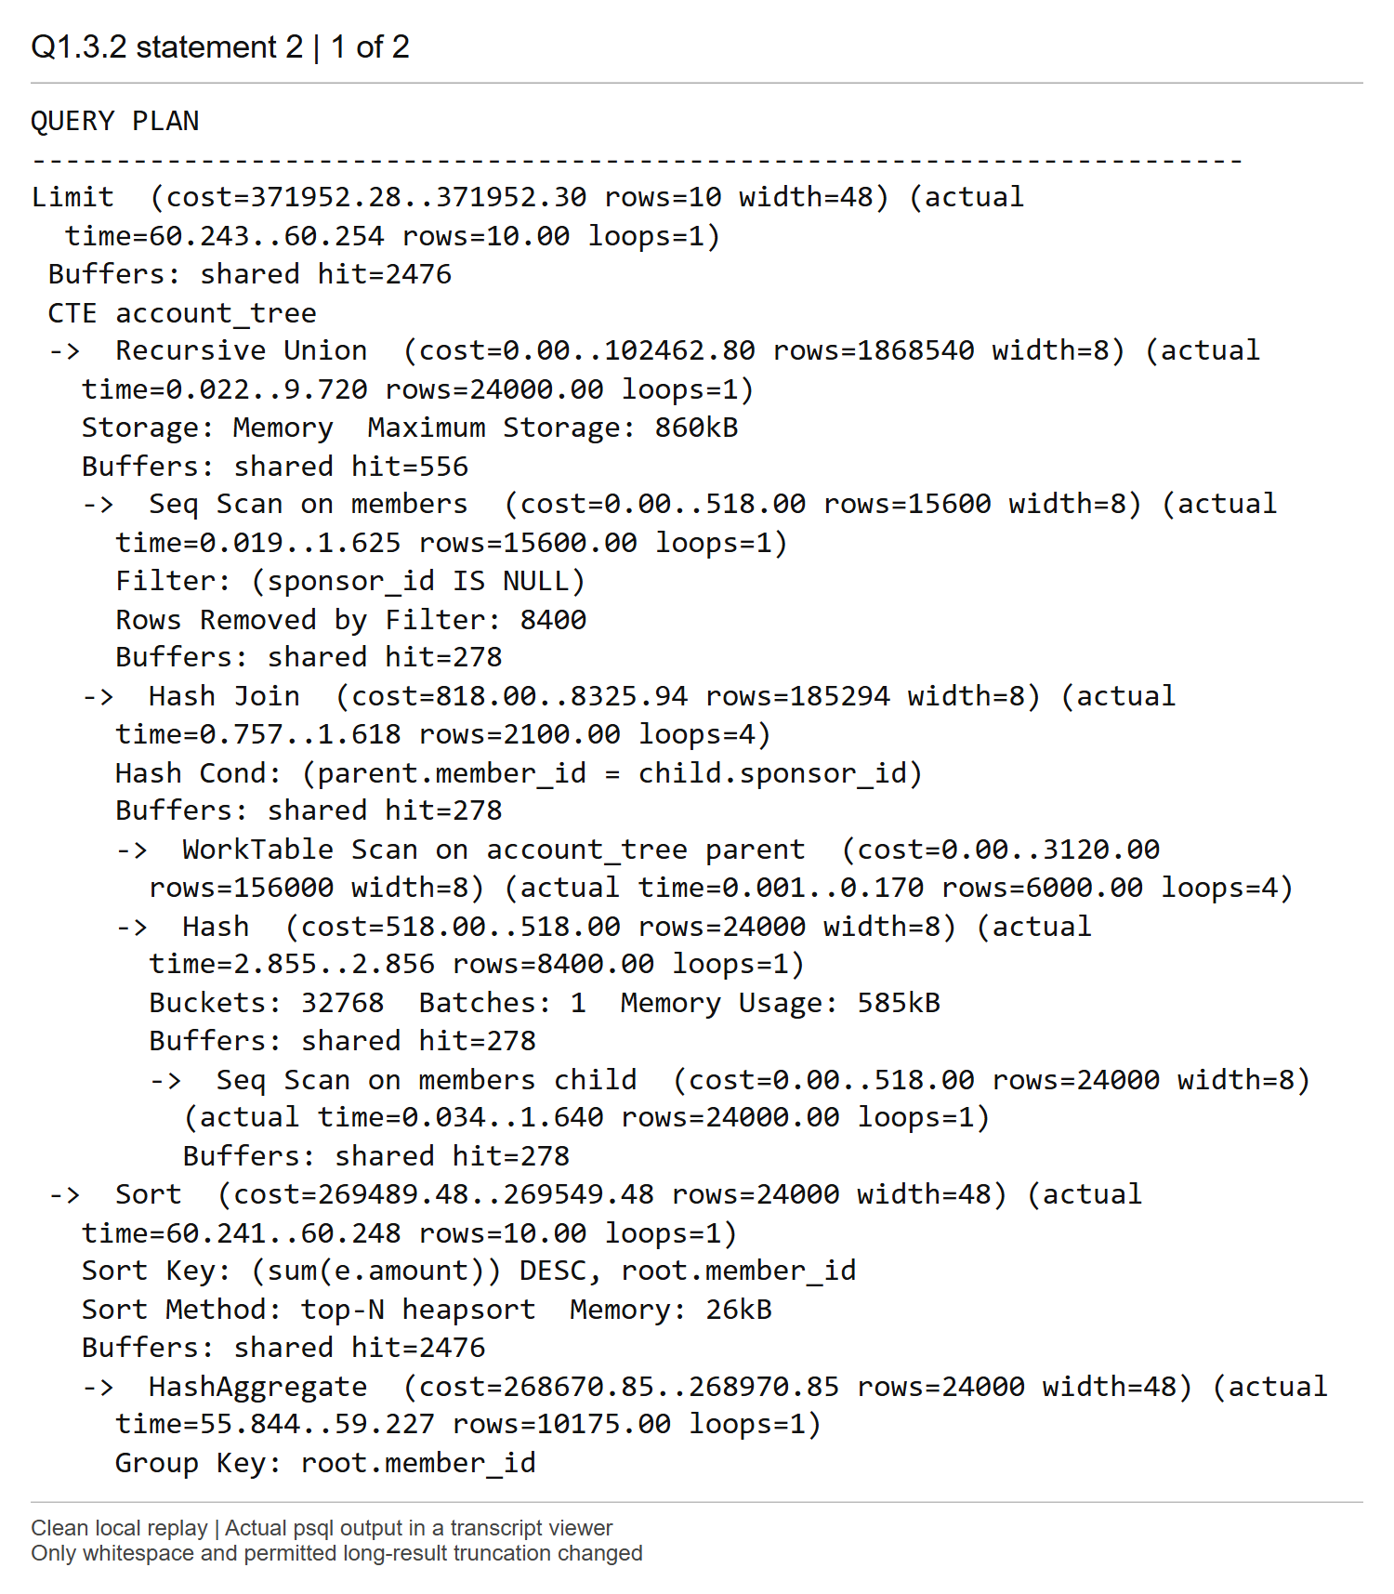
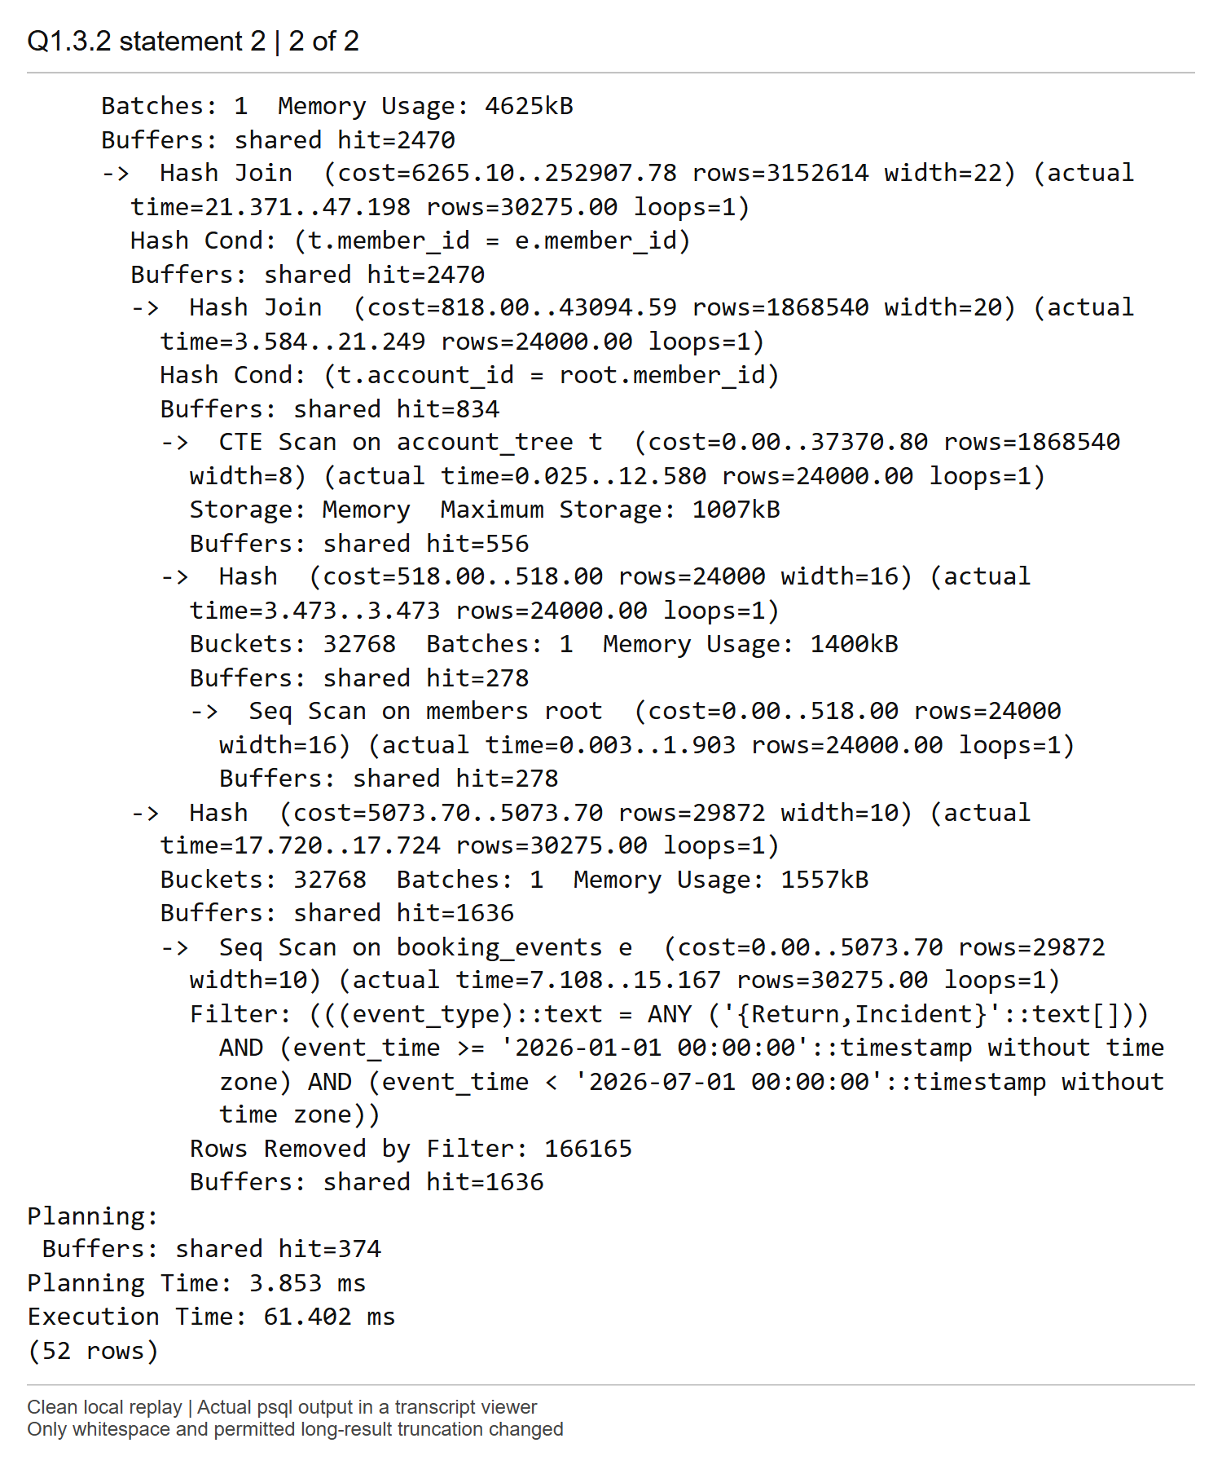
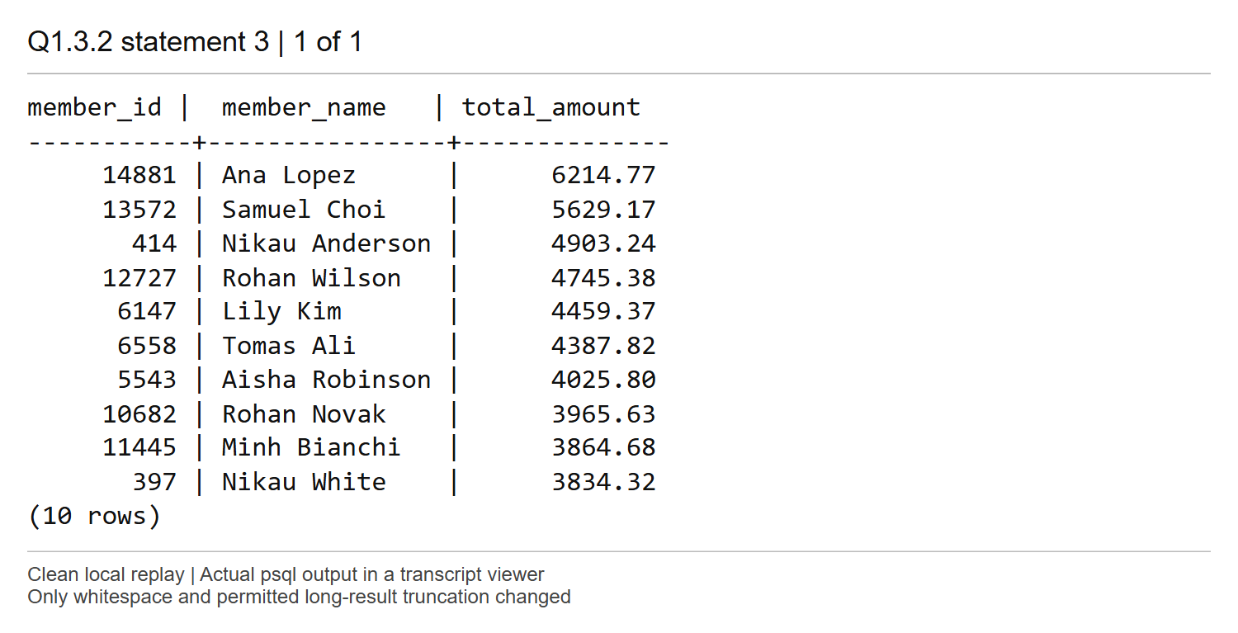
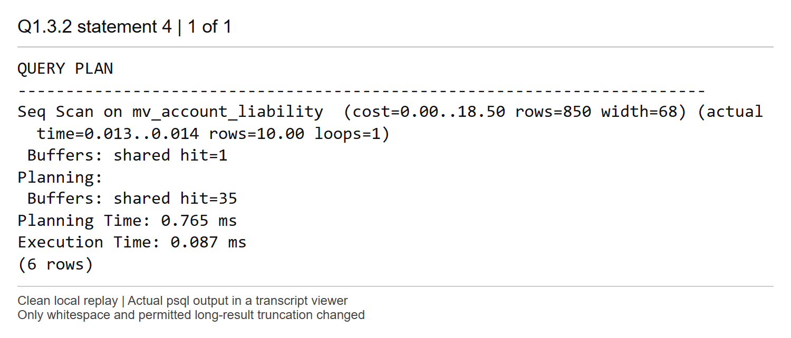
Comments
Both queries initially return the same ten accounts, led by Ana Lopez (14881) with 6,214.77. Query A expands the ordinary view into Recursive Union, joins, HashAggregate and a top-N sort. It builds the 24,000-member account mapping and aggregates 30,275 eligible events. Its top cost is 371952.28..371952.30; execution takes 61.402 ms.
Query B scans only the stored ten-row materialized result, with cost 0.00..18.50 and execution time 0.087 ms. The plan estimates 850 rows but actually returns 10 because the newly created materialized relation has not been analyzed. This estimate does not mean that 850 result rows were stored. The materialized view avoids recomputing recursion, joins and aggregation at read time. SQL consumers needing guaranteed output order should use an explicit ORDER BY when reading a stored relation.

Screenshot Q1.3 (3) | Marks: /0.5
SQL for Q1.3.3
INSERT INTO BOOKING_EVENTS
(member_id, vehicle_id, event_type, event_time, amount)
SELECT member_id,
'VEH-0001',
'Incident',
TIMESTAMP '2026-05-04 09:15:00',
90000.00
FROM MEMBERS
WHERE sponsor_id IS NOT NULL
ORDER BY member_id DESC
LIMIT 1;
SELECT * FROM V_ACCOUNT_LIABILITY;
SELECT * FROM MV_ACCOUNT_LIABILITY;
REFRESH MATERIALIZED VIEW MV_ACCOUNT_LIABILITY;
SELECT * FROM MV_ACCOUNT_LIABILITY;
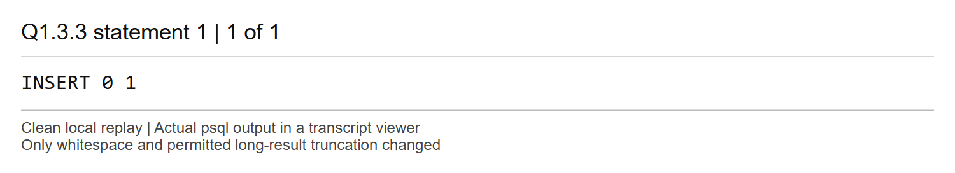
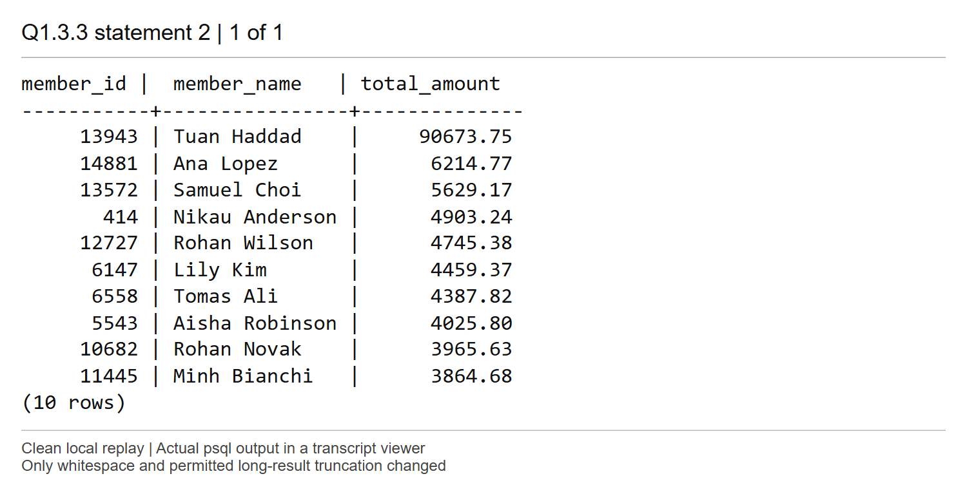
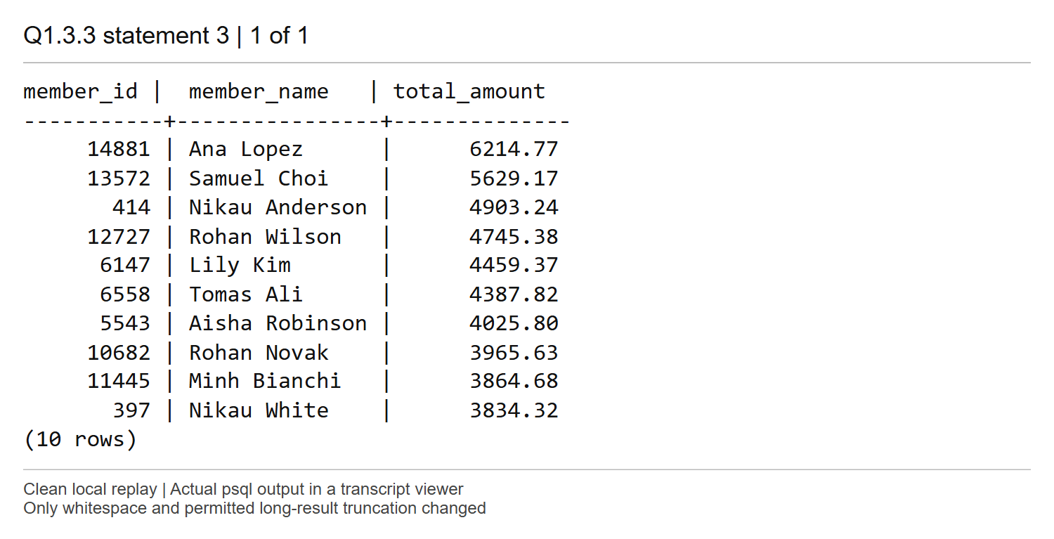
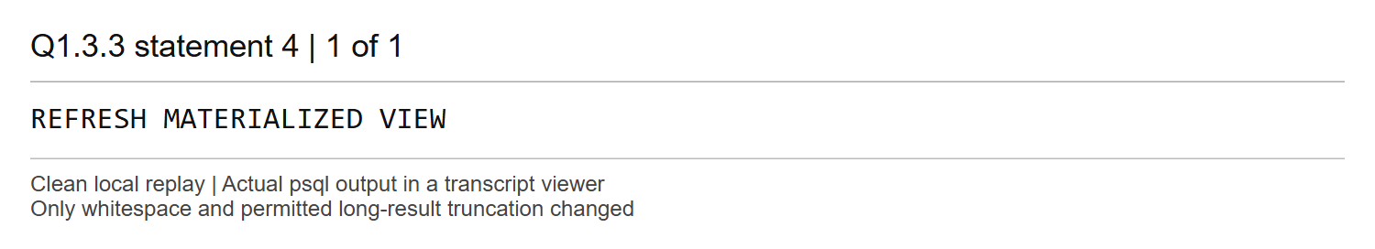
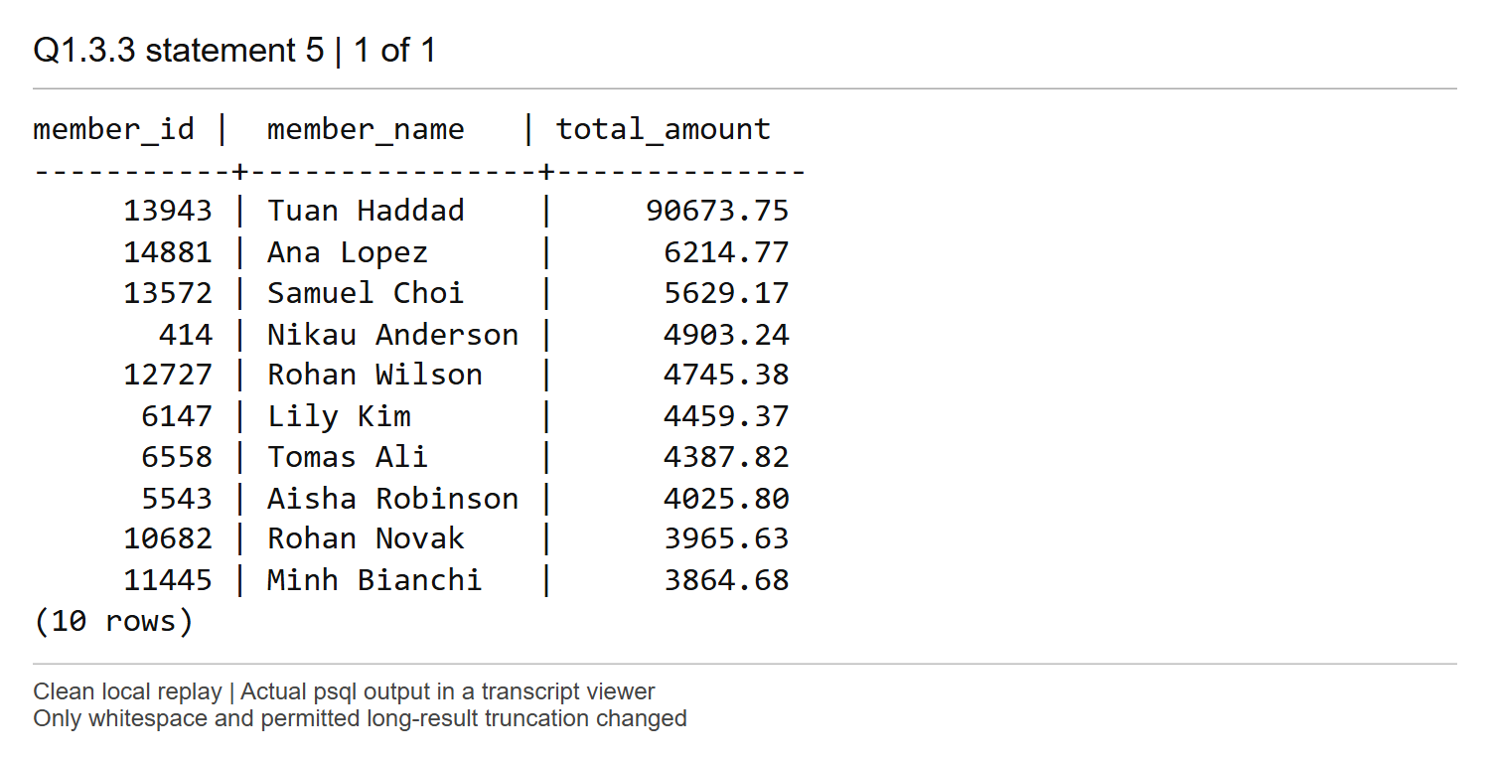
Comments
The supplied INSERT chooses member 24000. Its sponsorship chain is 24000 -> 22086 -> 18148 -> 13943, so the additional 90,000.00 is billed to Tuan Haddad (13943). Query A immediately puts that account first at 90,673.75. Query B still shows the earlier top ten, led by Ana Lopez, and does not include Tuan Haddad. After REFRESH, Query B shows the same updated ten rows as Query A; account 397 drops out of the top ten.
A materialized view trades faster reads for extra storage, refresh work and potentially stale answers between refreshes. An ordinary view computes an answer from the data visible to each query.

Screenshot Q2.1 (1) | Marks: /0.5
SQL for Q2.1.1
-- Create a composite index with event_type as the leading column.
CREATE INDEX IDX_EVENT_TYPE_TIME
ON BOOKING_EVENTS (event_type, event_time);
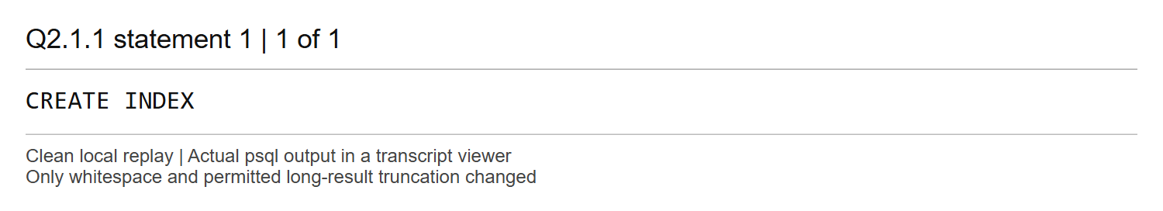
Comments
This B-tree index has event_type as its first key and event_time as its second key, in the required order. It orders timestamps within each event type.

Screenshot Q2.1 (2) | Marks: /1.5
SQL for Q2.1.2
-- Retrieve the busiest station for each body type after creating the index.
SELECT * FROM V_BUSIEST_BAYS;
-- Compare this plan with the plan recorded in Q1.1 before creating the index.
EXPLAIN (ANALYZE, BUFFERS)
SELECT * FROM V_BUSIEST_BAYS;
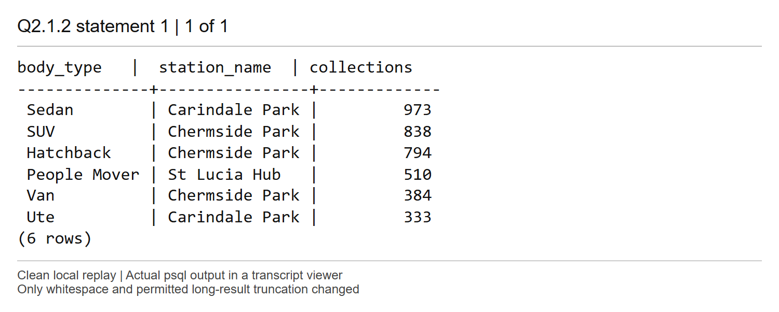
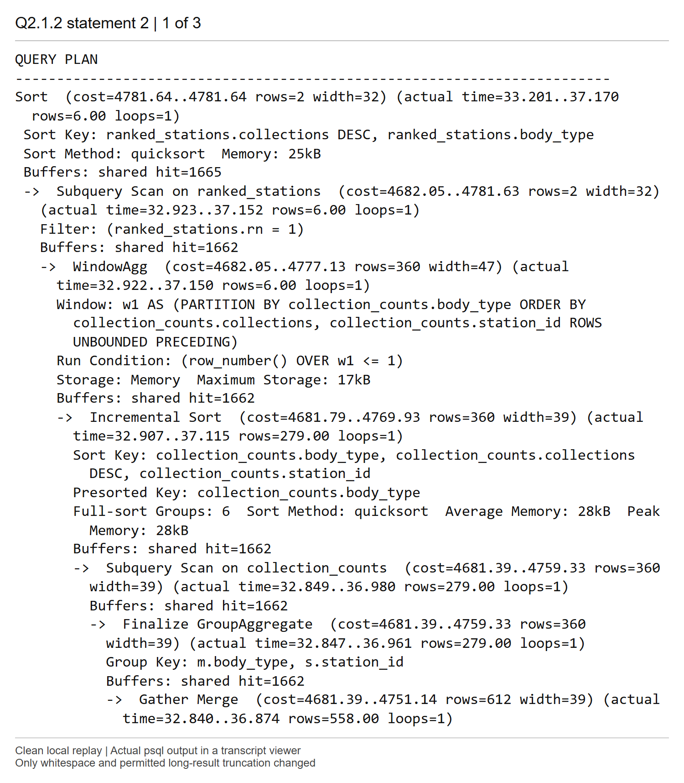
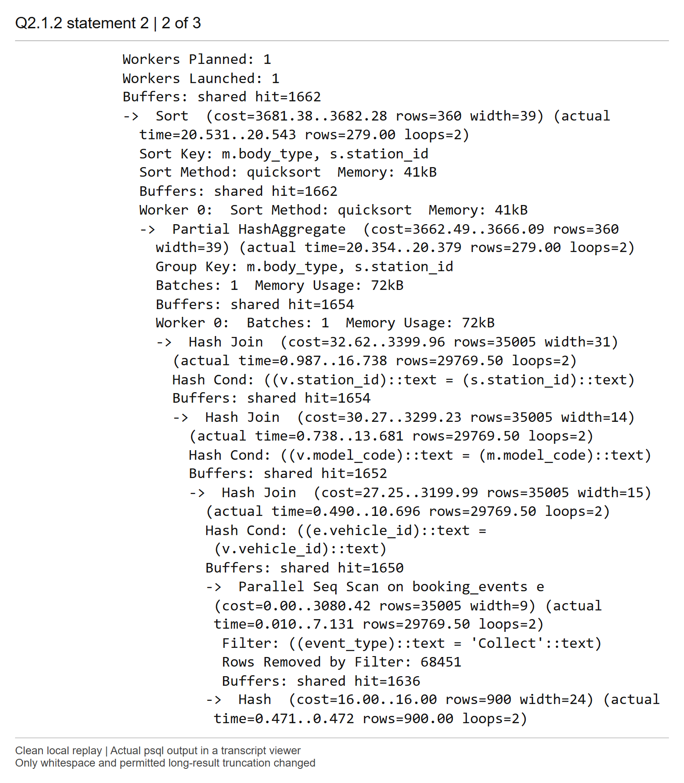
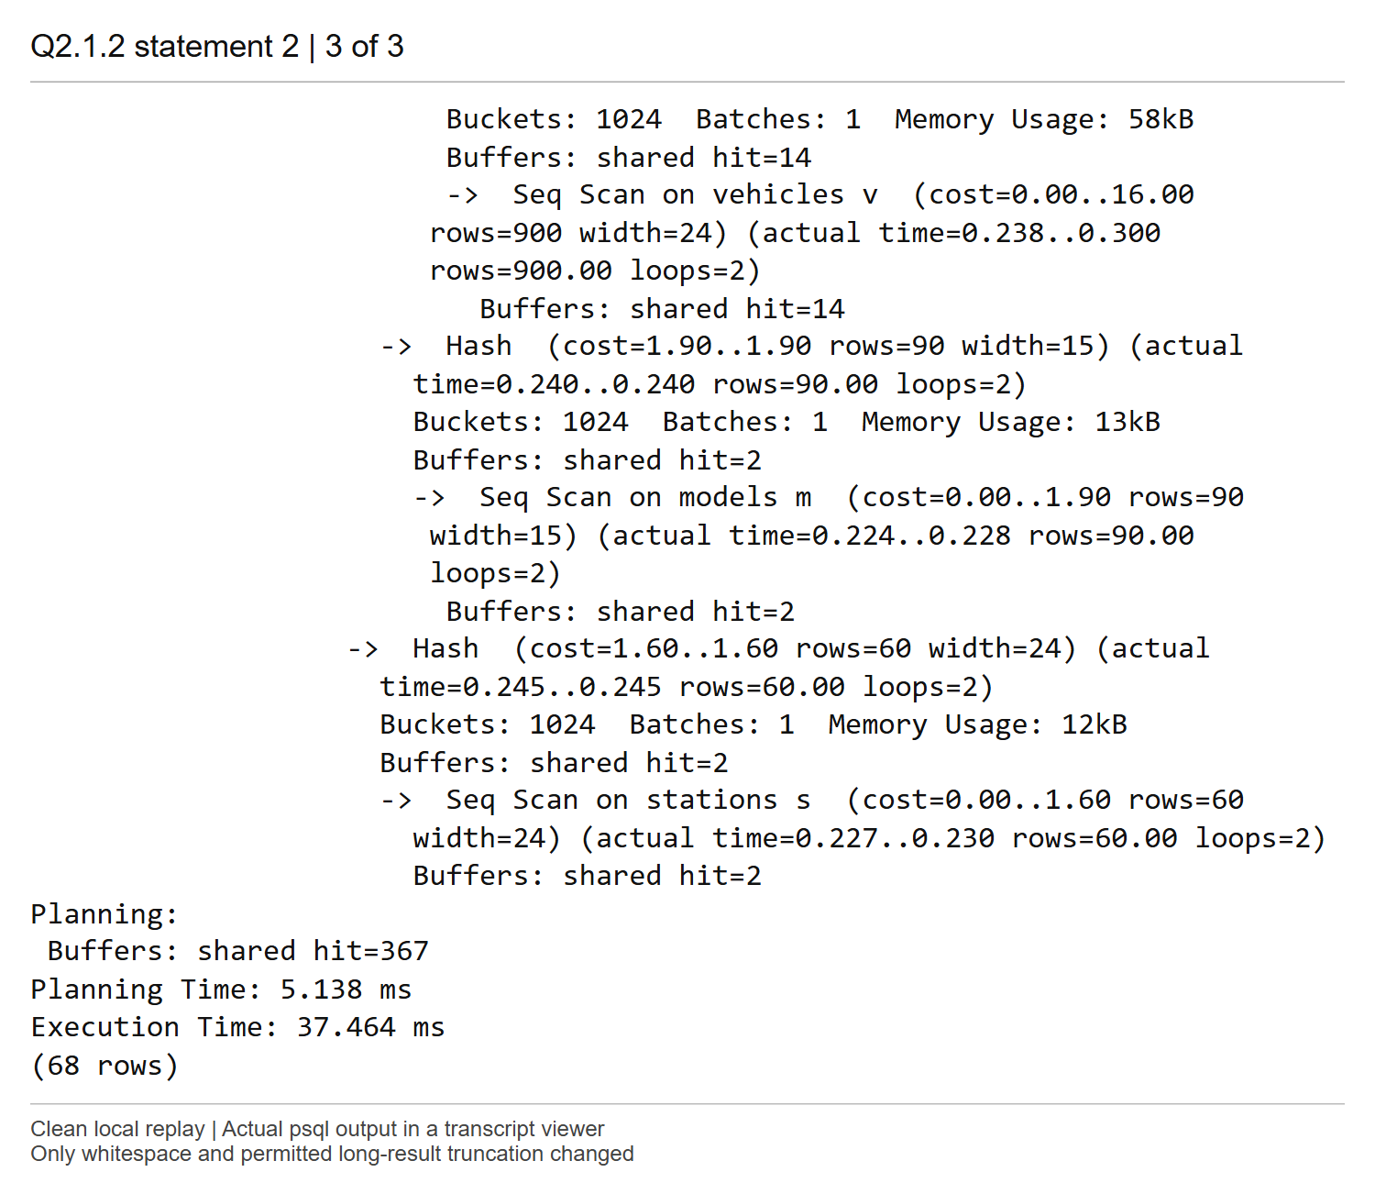
Comments
The six result rows are unchanged. The plan remains a Parallel Seq Scan of the event log followed by hash joins, aggregation, ranking and sorting; IDX_EVENT_TYPE_TIME is not used. Its top cost is 4781.64..4781.64 versus 4781.63..4781.64 before the index, and execution is 37.464 ms versus 41.090 ms. These small timing differences are single-run variation, not evidence of an index benefit.
Collect matches 59,539 of the 196,441 events now present, about 30.31 percent. Those events are distributed throughout the heap, and the query also needs vehicle_id, which this index does not contain. An index path would traverse many index entries and fetch many heap pages, whereas a parallel sequential scan reads the table efficiently. There is no timestamp condition, so the second index column does not narrow this query. Adding an index gives the planner another option; it does not require its use.

Screenshot Q2.1 (3) | Marks: /1
SQL for Q2.1.3
-- Count incidents and sum their charges for March 2026.
SELECT COUNT(*), SUM(amount)
FROM BOOKING_EVENTS
WHERE event_type = 'Incident'
AND event_time >= TIMESTAMP '2026-03-01'
AND event_time < TIMESTAMP '2026-04-01';
-- Report the execution plan for the March incidents query.
EXPLAIN (ANALYZE, BUFFERS)
SELECT COUNT(*), SUM(amount)
FROM BOOKING_EVENTS
WHERE event_type = 'Incident'
AND event_time >= TIMESTAMP '2026-03-01'
AND event_time < TIMESTAMP '2026-04-01';
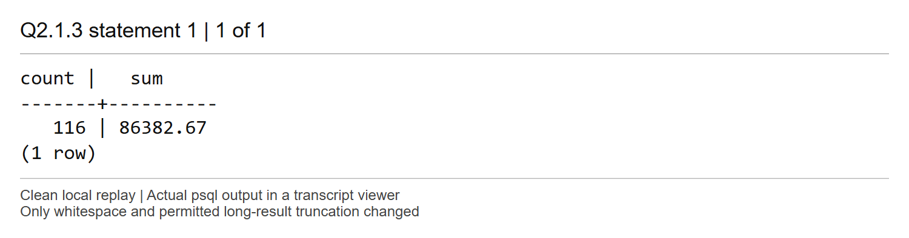
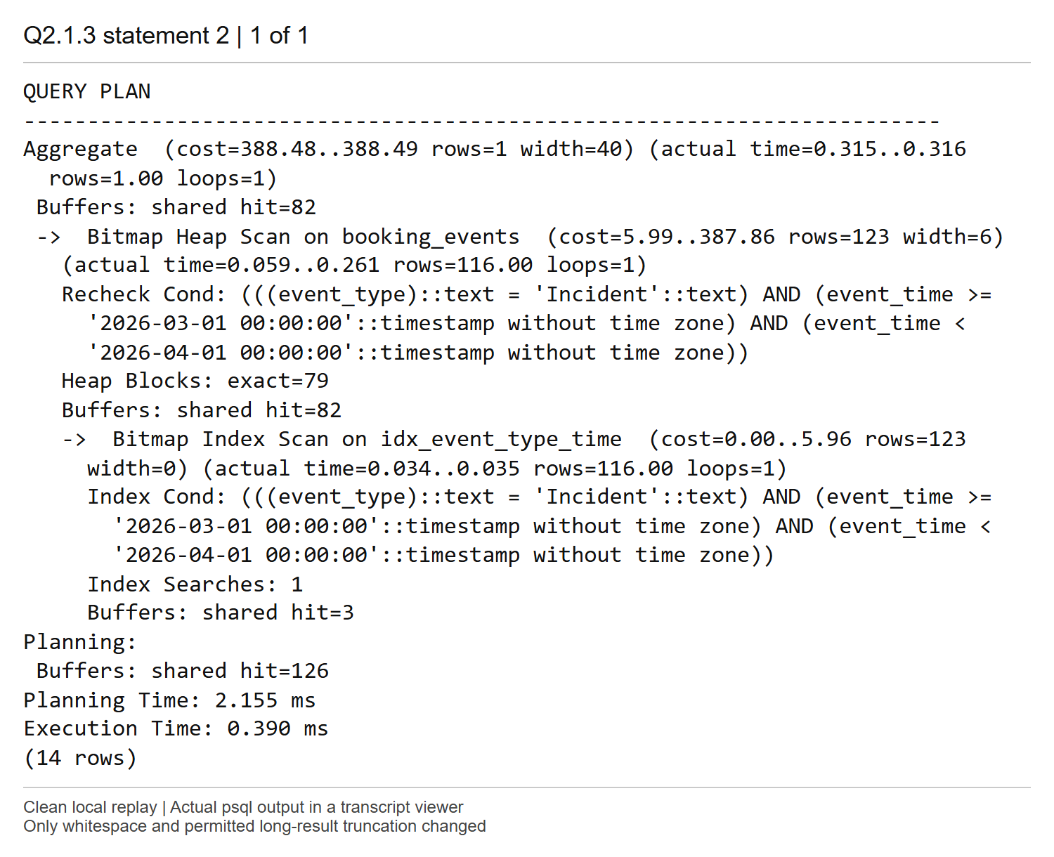
Comments
The query returns count 116 and sum 86,382.67. The aggregate estimates and returns one result row, with cost 388.48..388.49 and execution time 0.390 ms. Its child Bitmap Index Scan finds 116 matching entries, versus 123 estimated, and Bitmap Heap Scan visits 79 exact heap blocks before computing the aggregate.
Incident equality fixes the leading key, and the lower and upper March timestamp bounds restrict the second key to a short contiguous range within Incident entries. These 116 events are about 0.059 percent of the table, so the bitmap index path avoids most rows and pages. The plan needs heap access for amount, which is not stored in the index. This is much more selective than the all-time Collect query in Q2.1 part 2.

Screenshot Q2.2(1) | Marks: /1
SQL for Q2.2.1
-- Extract provider domains, fold case, and count members per domain.
SELECT LOWER(SPLIT_PART(email, '@', 2)) AS provider_domain,
COUNT(*) AS member_count
FROM MEMBERS
GROUP BY LOWER(SPLIT_PART(email, '@', 2))
ORDER BY member_count DESC, provider_domain;
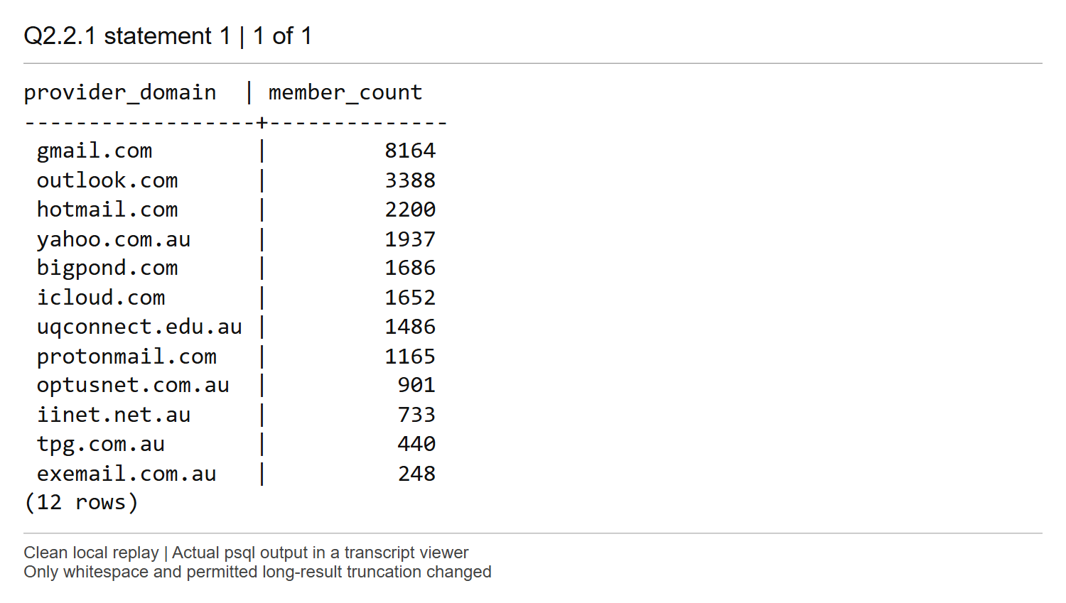
Comments
LOWER(SPLIT_PART(email, '@', 2)) extracts the part after @ and normalizes its case before grouping. The query reports 12 domains accounting for all 24,000 members, with gmail.com first at 8,164 members. exemail.com.au has 248 members. The secondary alphabetical ordering makes equal counts reproducible.

Screenshot Q2.2 (2) | Marks: /1
SQL for Q2.2.2
-- Report the domain-count query plan before creating the expression index.
EXPLAIN (ANALYZE, BUFFERS)
SELECT LOWER(SPLIT_PART(email, '@', 2)) AS provider_domain,
COUNT(*) AS member_count
FROM MEMBERS
GROUP BY LOWER(SPLIT_PART(email, '@', 2))
ORDER BY member_count DESC, provider_domain;
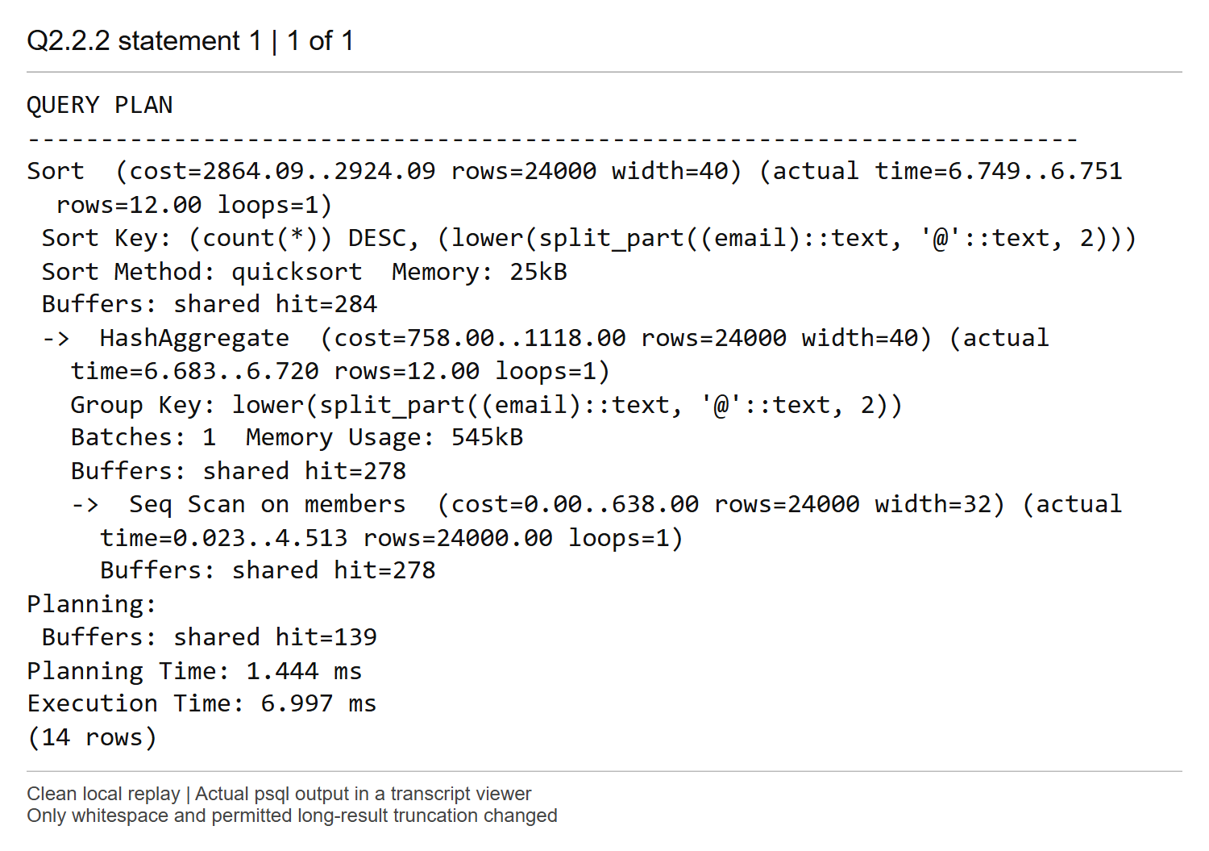
Comments
The plan performs a Seq Scan of all 24,000 MEMBERS rows, computes the normalized domain, uses HashAggregate for the counts, and sorts the resulting 12 groups by count descending. The top cost is 2864.09..2924.09 and execution time is 6.997 ms. It estimates 24,000 groups but actually returns only 12, reflecting the lack of statistics for this derived expression at this point.
Every member contributes to the requested whole-population counts, so a complete scan is appropriate. Hash aggregation has a single batch and the final quicksort uses only 25 kB; neither step spills to disk in this run.

Screenshot Q2.2 (3) | Marks: /1
The UNIQUE B-tree on email orders complete addresses from their first character, so members sharing a domain can be scattered across many different address prefixes. It cannot provide a selective lookup or grouping order on the normalized domain expression; although a full index-only scan could still read every email and compute the domain, it would still have to examine the whole population.
Comments
No SQL file is required for this explanation-only part.

Screenshot Q2.2 (4) | Marks: /0.5
SQL for Q2.2.4
-- Index the same normalized domain expression used in the queries.
CREATE INDEX IDX_MEMBER_DOMAIN
ON MEMBERS (LOWER(SPLIT_PART(email, '@', 2)));
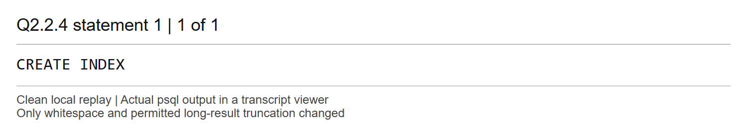
Comments
The expression in IDX_MEMBER_DOMAIN exactly matches LOWER(SPLIT_PART(email, '@', 2)) in the queries, including the case folding. PostgreSQL can therefore look up a normalized domain directly in this index.

Screenshot Q2.2 (5) | Marks: /1.5
The domain-count query keeps its Seq Scan -> HashAggregate -> Sort plan, estimates 24,000 groups and returns 12. Its top cost stays 2864.09..2924.09; execution is 5.274 ms compared with 6.997 ms before the index. All 24,000 members still have to contribute to the counts, and an index ordered by domain cannot directly satisfy ORDER BY COUNT(*) DESC.
The rare-provider lookup instead uses Bitmap Index Scan on IDX_MEMBER_DOMAIN followed by Bitmap Heap Scan. It returns 248 members, about 1.03 percent of MEMBERS, versus 120 estimated, with cost 5.22..226.08 and execution time 0.510 ms. The bitmap batches access to 164 exact heap blocks; heap access is needed for member_id, member_name and email. The index avoids evaluating the domain predicate on every member. Its advantage is selective access, rather than speeding every query that mentions the expression.
SQL for Q2.2.5
-- Report the domain-count query plan after creating the expression index.
EXPLAIN (ANALYZE, BUFFERS)
SELECT LOWER(SPLIT_PART(email, '@', 2)) AS provider_domain,
COUNT(*) AS member_count
FROM MEMBERS
GROUP BY LOWER(SPLIT_PART(email, '@', 2))
ORDER BY member_count DESC, provider_domain;
-- Report the selective lookup plan for a rare provider domain.
EXPLAIN (ANALYZE, BUFFERS)
SELECT member_id, member_name, email
FROM MEMBERS
WHERE LOWER(SPLIT_PART(email, '@', 2)) = 'exemail.com.au';
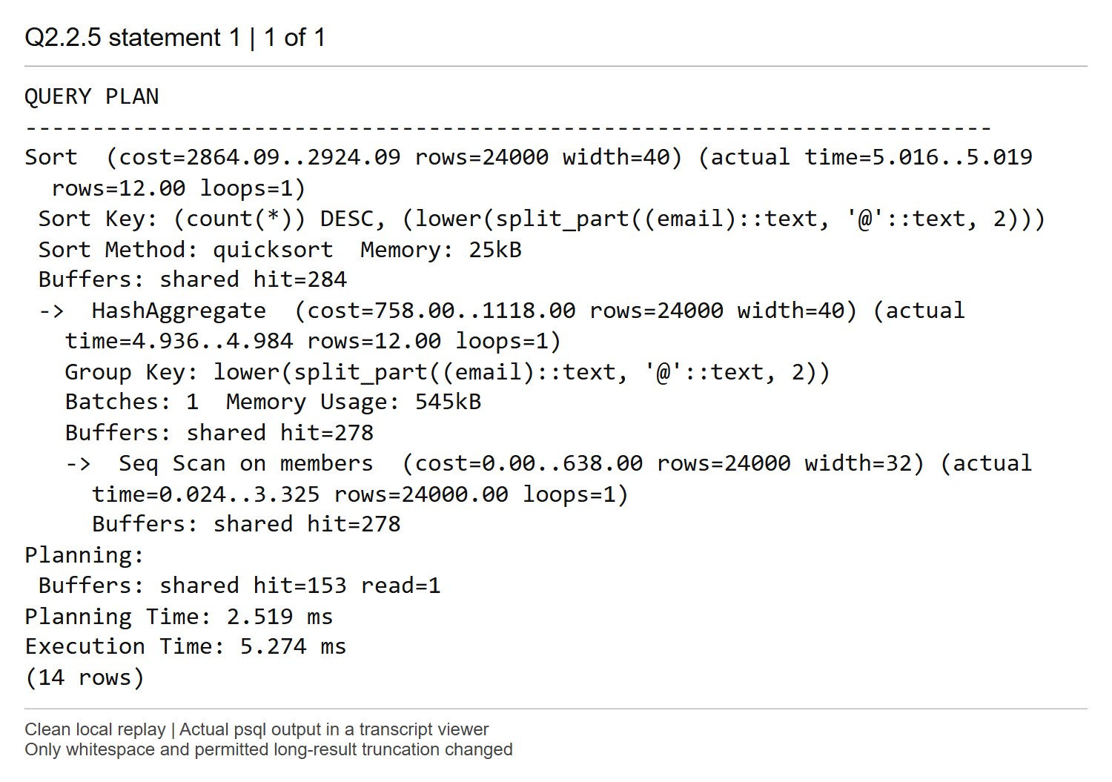
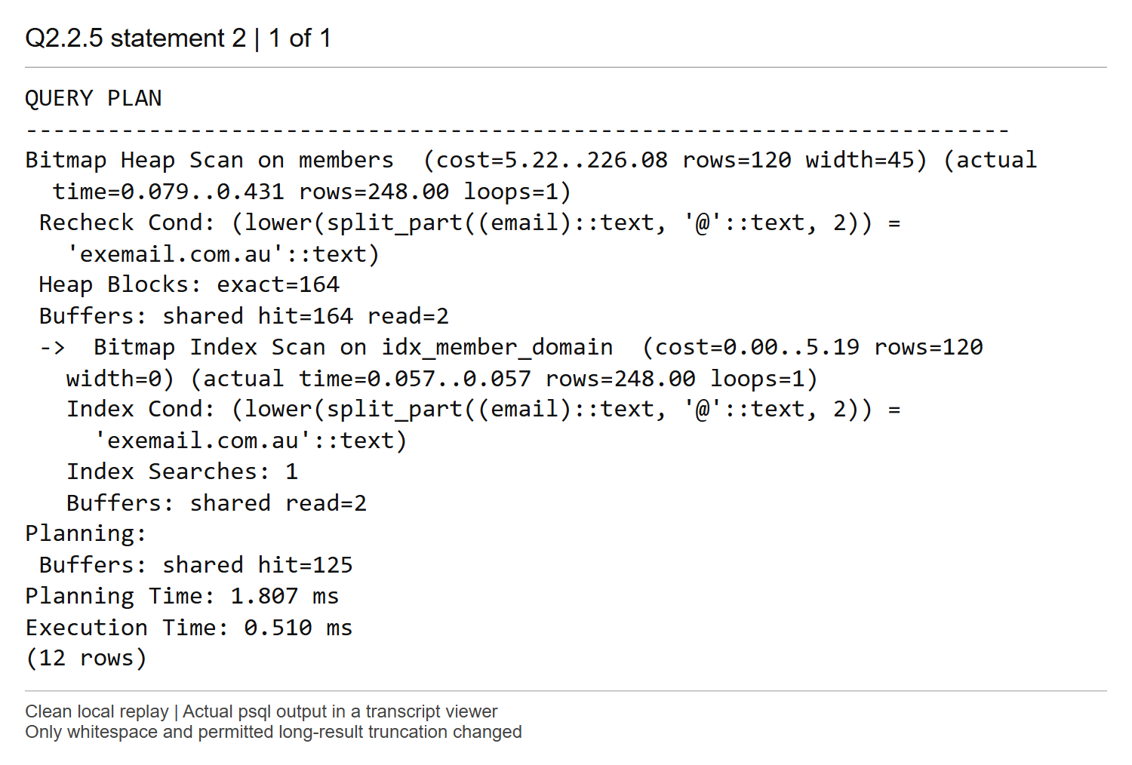
Comments
Both plans are shown in full. The second query is reported with EXPLAIN ANALYZE, so the 248 result tuples are counted by the plan rather than printed.

Screenshot Q3.1 (1) | Marks: /1.5
SQL for Q3.1.1
-- Statement A: find vehicles with no Collect event using NOT EXISTS.
SELECT v.vehicle_id
FROM VEHICLES v
WHERE NOT EXISTS (
SELECT 1
FROM BOOKING_EVENTS e
WHERE e.vehicle_id = v.vehicle_id
AND e.event_type = 'Collect'
)
ORDER BY v.vehicle_id;
-- Statement B: find the same vehicles using a left join and a NULL check.
SELECT v.vehicle_id
FROM VEHICLES v
LEFT JOIN BOOKING_EVENTS e
ON e.vehicle_id = v.vehicle_id
AND e.event_type = 'Collect'
WHERE e.vehicle_id IS NULL
ORDER BY v.vehicle_id;
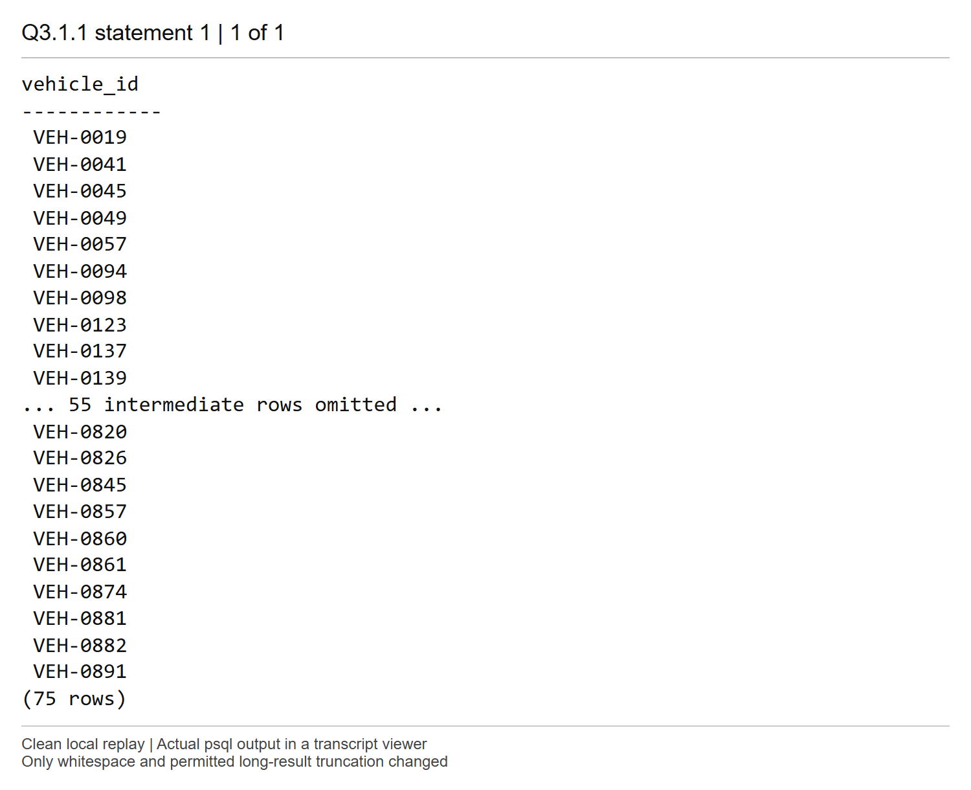
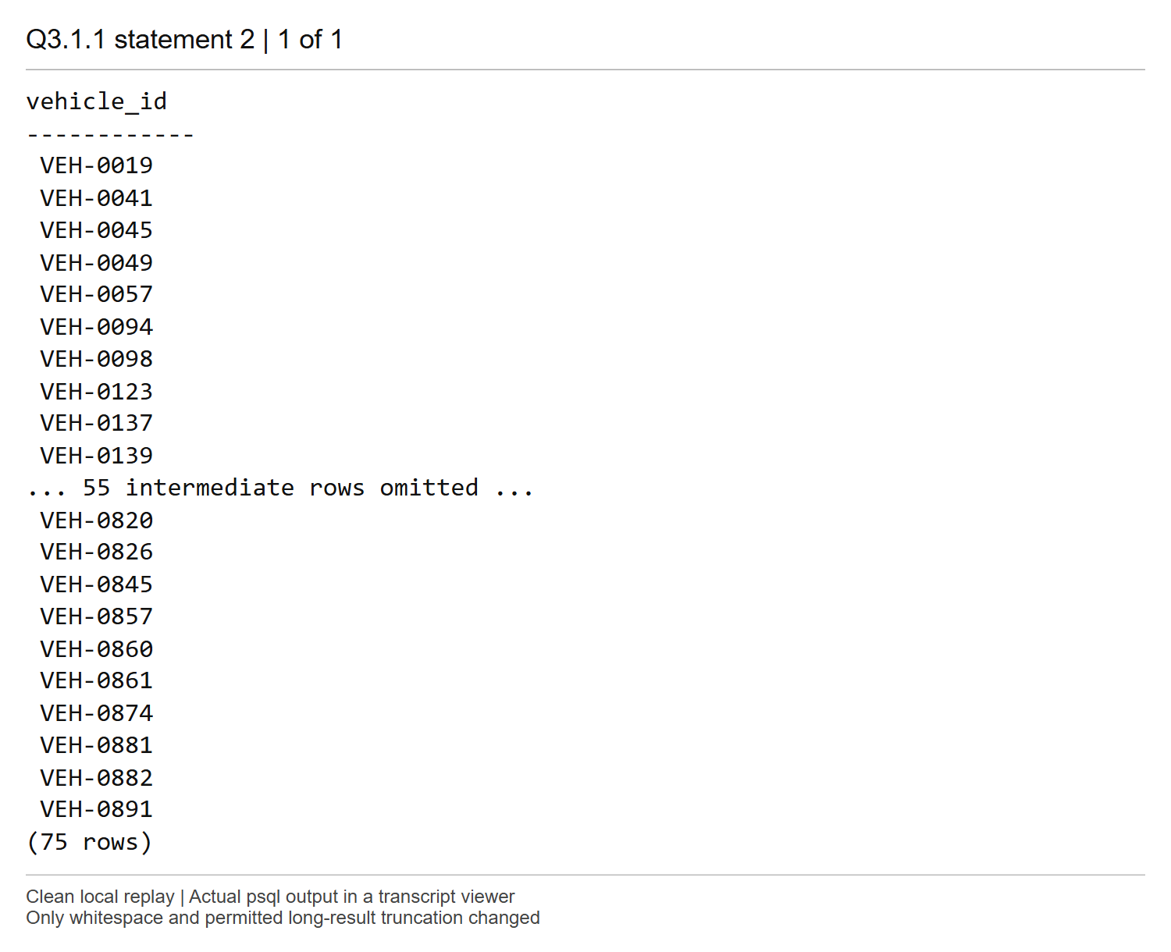
Comments
Both statements return the same 75 vehicle IDs, ordered by vehicle_id. Statement A uses a correlated NOT EXISTS test. Statement B places the Collect predicate in the LEFT JOIN condition and keeps rows with no matching event vehicle_id. The matched-side vehicle_id is NOT NULL in the schema, so NULL identifies an unmatched vehicle unambiguously.
Putting event_type in WHERE instead of ON would remove the unmatched rows and break the outer-join solution. Independent EXCEPT ALL checks in both directions found no differences. The screenshots show the first ten and last ten rows of each 75-row result.

Screenshot Q3.1 (2) | Marks: /1.5
SQL for Q3.1.2
-- Report the execution plan for Statement A.
EXPLAIN (ANALYZE, BUFFERS)
SELECT v.vehicle_id
FROM VEHICLES v
WHERE NOT EXISTS (
SELECT 1
FROM BOOKING_EVENTS e
WHERE e.vehicle_id = v.vehicle_id
AND e.event_type = 'Collect'
)
ORDER BY v.vehicle_id;
-- Report the execution plan for Statement B.
EXPLAIN (ANALYZE, BUFFERS)
SELECT v.vehicle_id
FROM VEHICLES v
LEFT JOIN BOOKING_EVENTS e
ON e.vehicle_id = v.vehicle_id
AND e.event_type = 'Collect'
WHERE e.vehicle_id IS NULL
ORDER BY v.vehicle_id;
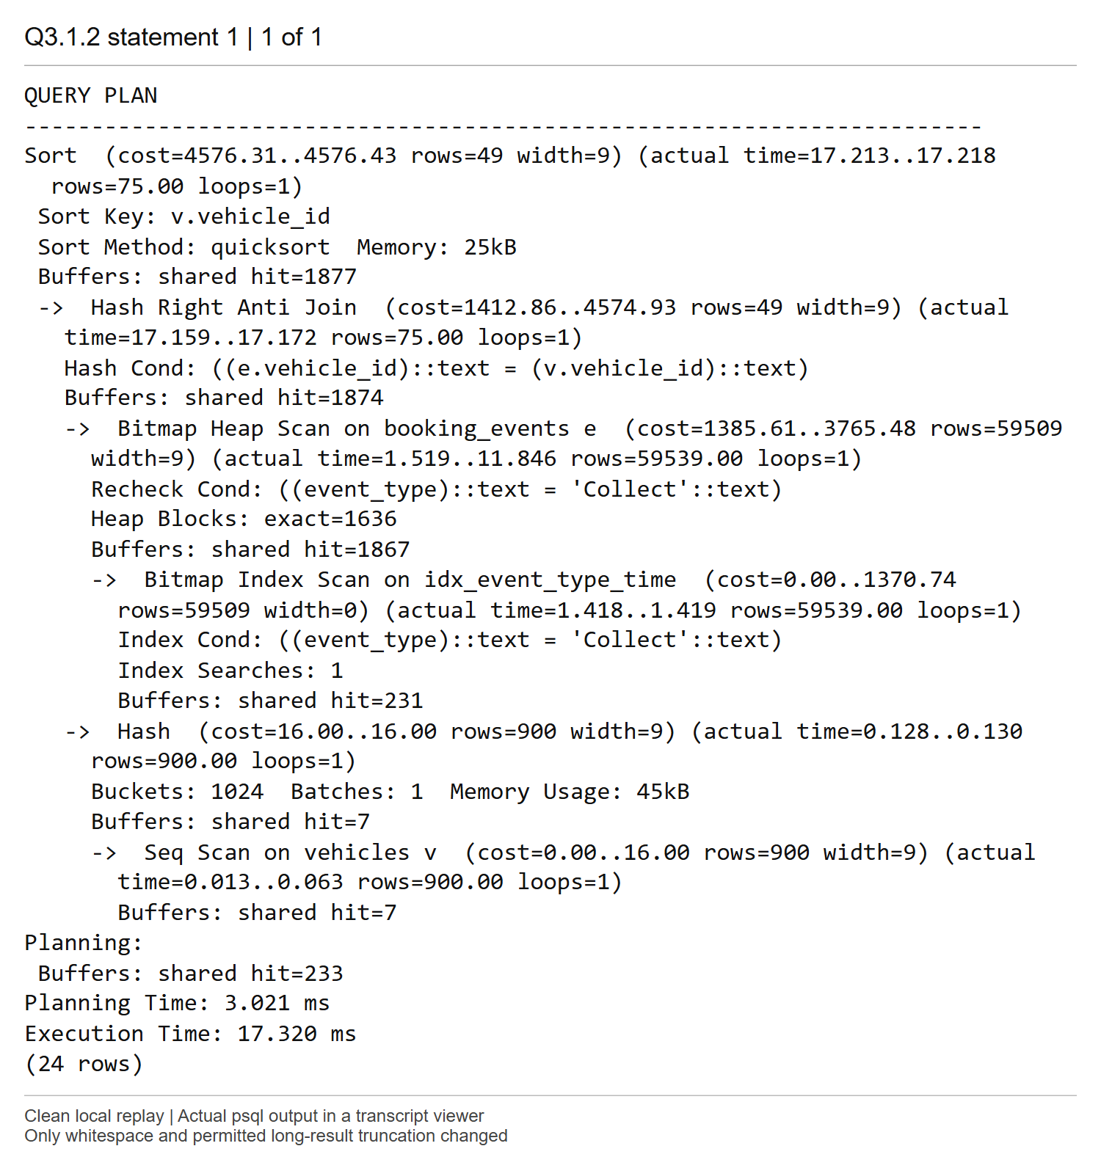
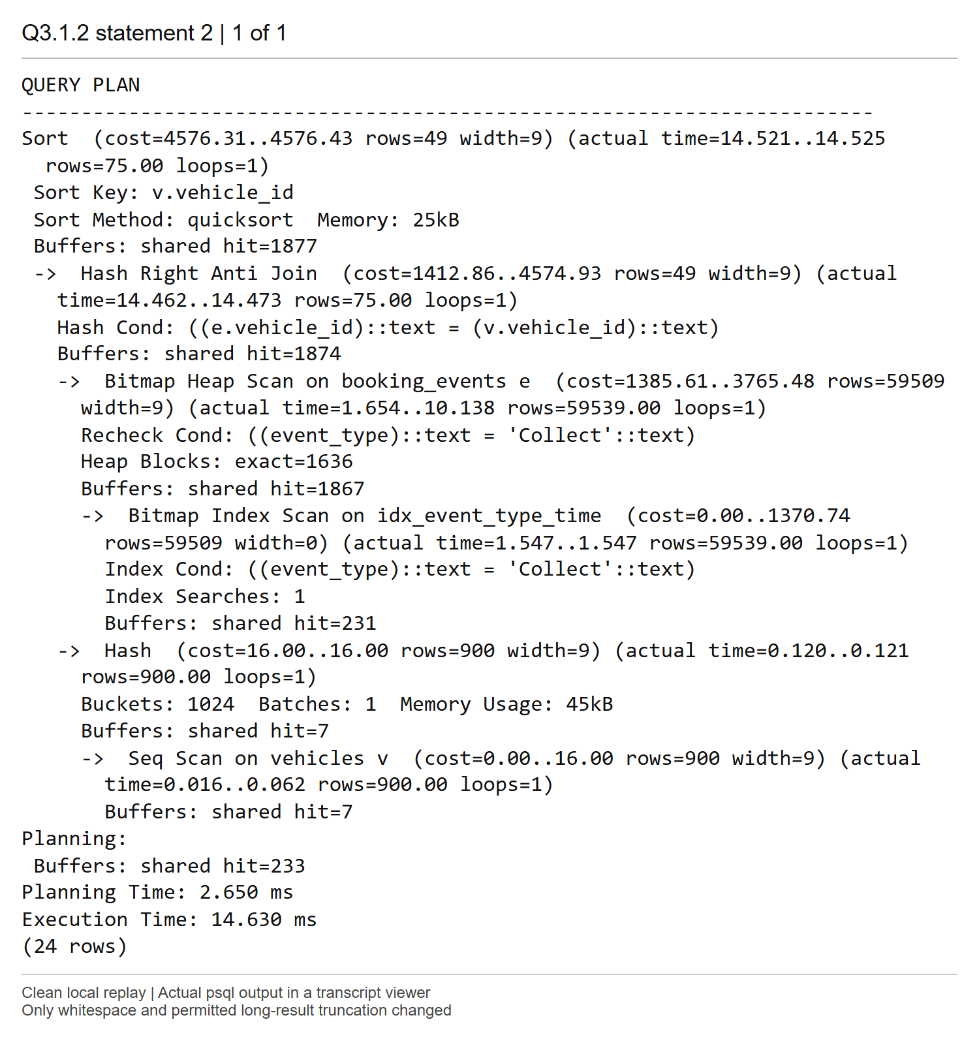
Comments
The two plans have the same operator structure and cost 4576.31..4576.43. Both return 75 rows, versus 49 estimated, using Hash Right Anti Join and a final vehicle_id sort. Statement A takes 17.320 ms and Statement B 14.630 ms in these runs.
PostgreSQL decorrelates NOT EXISTS and recognizes the outer-join NULL filter as the same anti-join operation. It hashes the small set of 900 vehicles and scans 59,539 Collect events through a bitmap index/heap path, keeping the vehicle rows without any match. The Right direction describes the physical join inputs chosen by the optimizer; it preserves the intended vehicle-side anti-join semantics. Neither syntax forces a separate full event scan for each vehicle. The minor time difference does not establish a consistent performance difference.

Screenshot Q3.2 (1) | Marks: /2
SQL for Q3.2 part 1 of 2
-- Run every section in the same Query Tool connection.
-- Keep IDX_EVENT_TYPE_TIME from Q2.1 in place.
-- Setting 1: allow index, index-only, bitmap, and sequential scans.
SET enable_indexscan = on;
SET enable_indexonlyscan = on;
SET enable_bitmapscan = on;
SET enable_seqscan = on;
-- Plan C1: Query C under Setting 1.
EXPLAIN (ANALYZE, BUFFERS)
SELECT * FROM BOOKING_EVENTS WHERE event_type < 'Collect';
-- Plan D1: Query D under Setting 1.
EXPLAIN (ANALYZE, BUFFERS)
SELECT * FROM BOOKING_EVENTS WHERE event_type >= 'Collect';
-- Setting 2: allow index access and suppress sequential scans.
SET enable_indexscan = on;
SET enable_indexonlyscan = on;
SET enable_bitmapscan = on;
SET enable_seqscan = off;
-- Plan C2: Query C under Setting 2.
EXPLAIN (ANALYZE, BUFFERS)
SELECT * FROM BOOKING_EVENTS WHERE event_type < 'Collect';
-- Plan D2: Query D under Setting 2.
EXPLAIN (ANALYZE, BUFFERS)
SELECT * FROM BOOKING_EVENTS WHERE event_type >= 'Collect';
-- Setting 3: suppress all three index access types and allow sequential scans.
SET enable_indexscan = off;
SET enable_indexonlyscan = off;
SET enable_bitmapscan = off;
SET enable_seqscan = on;
SQL for Q3.2 part 2 of 2
-- Plan C3: Query C under Setting 3.
EXPLAIN (ANALYZE, BUFFERS)
SELECT * FROM BOOKING_EVENTS WHERE event_type < 'Collect';
-- Plan D3: Query D under Setting 3.
EXPLAIN (ANALYZE, BUFFERS)
SELECT * FROM BOOKING_EVENTS WHERE event_type >= 'Collect';
-- Restore all four scan settings before proceeding to another question.
SET enable_indexscan = on;
SET enable_indexonlyscan = on;
SET enable_bitmapscan = on;
SET enable_seqscan = on;
Plan C1 original pgAdmin output
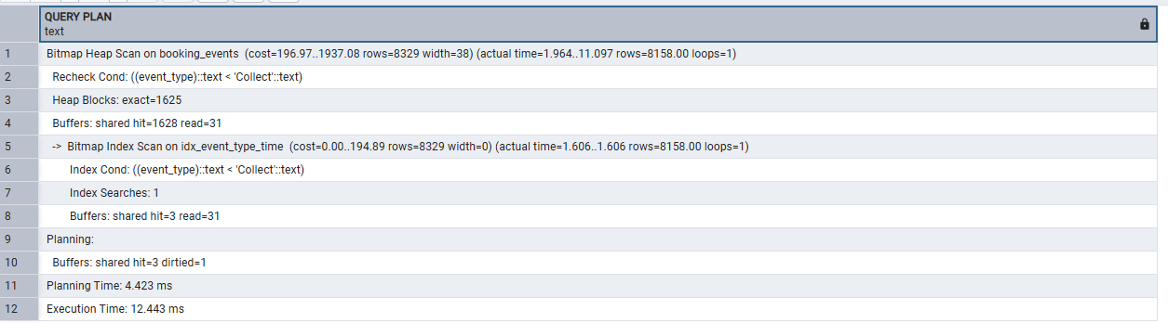
Plan C1 transcription
Bitmap Heap Scan on booking_events (cost=196.97..1937.08 rows=8329 width=38)
(actual time=1.964..11.097 rows=8158.00 loops=1)
Recheck Cond: ((event_type)::text < 'Collect'::text)
Heap Blocks: exact=1625
Buffers: shared hit=1628 read=31
-> Bitmap Index Scan on idx_event_type_time (cost=0.00..194.89 rows=8329 width=0)
(actual time=1.606..1.606 rows=8158.00 loops=1)
Index Cond: ((event_type)::text < 'Collect'::text)
Index Searches: 1
Buffers: shared hit=3 read=31
Planning:
Buffers: shared hit=3 dirtied=1
Planning Time: 4.423 ms
Execution Time: 12.443 ms
Plan D1 original pgAdmin output
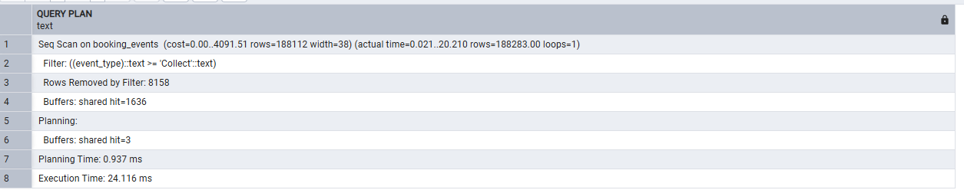
Plan D1 transcription
Seq Scan on booking_events (cost=0.00..4091.51 rows=188112 width=38) (actual
time=0.021..20.210 rows=188283.00 loops=1)
Filter: ((event_type)::text >= 'Collect'::text)
Rows Removed by Filter: 8158
Buffers: shared hit=1636
Planning:
Buffers: shared hit=3
Planning Time: 0.937 ms
Execution Time: 24.116 ms
Plan C2 original pgAdmin output
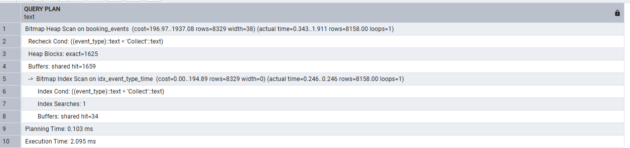
Plan C2 transcription
Bitmap Heap Scan on booking_events (cost=196.97..1937.08 rows=8329 width=38)
(actual time=0.343..1.911 rows=8158.00 loops=1)
Recheck Cond: ((event_type)::text < 'Collect'::text)
Heap Blocks: exact=1625
Buffers: shared hit=1659
-> Bitmap Index Scan on idx_event_type_time (cost=0.00..194.89 rows=8329 width=0)
(actual time=0.246..0.246 rows=8158.00 loops=1)
Index Cond: ((event_type)::text < 'Collect'::text)
Index Searches: 1
Buffers: shared hit=34
Planning Time: 0.103 ms
Execution Time: 2.095 ms
Plan D2 original pgAdmin output
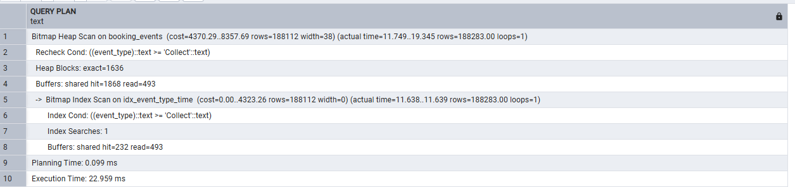
Plan D2 transcription
Bitmap Heap Scan on booking_events (cost=4370.29..8357.69 rows=188112 width=38)
(actual time=11.749..19.345 rows=188283.00 loops=1)
Recheck Cond: ((event_type)::text >= 'Collect'::text)
Heap Blocks: exact=1636
Buffers: shared hit=1868 read=493
-> Bitmap Index Scan on idx_event_type_time (cost=0.00..4323.26 rows=188112
width=0) (actual time=11.638..11.639 rows=188283.00 loops=1)
Index Cond: ((event_type)::text >= 'Collect'::text)
Index Searches: 1
Buffers: shared hit=232 read=493
Planning Time: 0.099 ms
Execution Time: 22.959 ms
Plan C3 original pgAdmin output
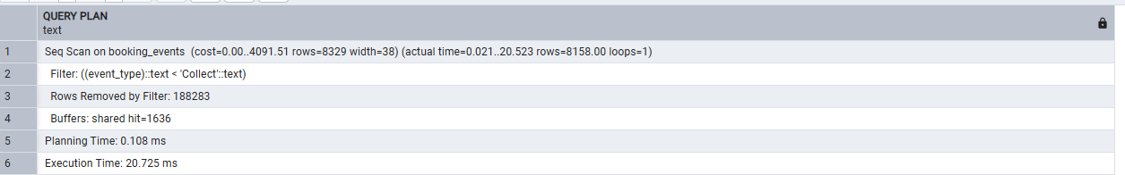
Plan C3 transcription
Seq Scan on booking_events (cost=0.00..4091.51 rows=8329 width=38) (actual
time=0.021..20.523 rows=8158.00 loops=1)
Filter: ((event_type)::text < 'Collect'::text)
Rows Removed by Filter: 188283
Buffers: shared hit=1636
Planning Time: 0.108 ms
Execution Time: 20.725 ms
Plan D3 original pgAdmin output
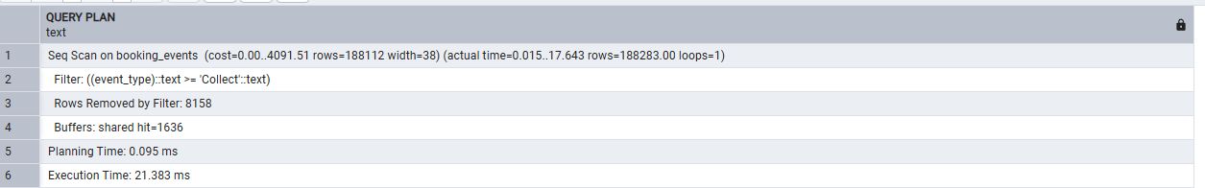
Plan D3 transcription
Seq Scan on booking_events (cost=0.00..4091.51 rows=188112 width=38) (actual
time=0.015..17.643 rows=188283.00 loops=1)
Filter: ((event_type)::text >= 'Collect'::text)
Rows Removed by Filter: 8158
Buffers: shared hit=1636
Planning Time: 0.095 ms
Execution Time: 21.383 ms
Original reset commands and successful execution
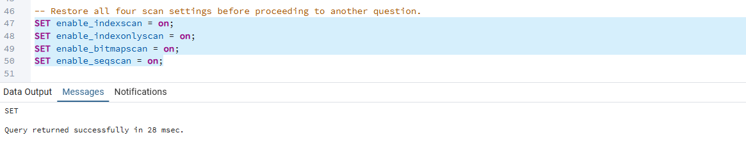
Comments
The six plans in this section are the original interactive pgAdmin measurements. Each native output is followed by a faithful text transcription so that long plan lines remain readable. No planner values have been replaced with replay values.
The same connection was used for all three settings. Index scans include index-only and bitmap access. IDX_EVENT_TYPE_TIME remained present. The script restores all four switches to on at the end.
The six complete plans are labelled C1, D1, C2, D2, C3 and D3 in execution order. Their comparison follows in Q3.2 part 2.

Screenshot Q3.2 (2) | Marks: /2
Queries C and D partition 196,441 events at this stage. C returns 8,158 rows (4.15 percent), while D returns 188,283 (95.85 percent). The opposite inequalities on the same indexed column therefore have very different selectivities.
C1 uses Bitmap Index Scan on IDX_EVENT_TYPE_TIME followed by Bitmap Heap Scan. Its cost is 196.97..1937.08, with 8,329 rows estimated and 8,158 returned. Planning takes 4.423 ms and execution 12.443 ms. It visits 1,625 exact heap blocks; total buffers are 1,628 shared hits and 31 reads. Selective index access costs less than scanning and filtering the whole event log, even though the matching events are spread across many heap pages.
D1 uses Seq Scan, with cost 0.00..4091.51, 188,112 estimated rows and 188,283 actual rows. Planning takes 0.937 ms and execution 24.116 ms. It reads the heap through 1,636 shared buffer hits and removes 8,158 nonmatching rows. Returning almost the whole table makes a sequential pass cheaper in the cost model than traversing many index entries and then visiting almost every heap page.
C2 retains the bitmap plan and the same cost and row estimates when sequential scans are suppressed. Planning takes 0.103 ms and execution 2.095 ms. All 1,659 buffer accesses are hits, including 34 for the index. The change from C1 includes a warmer cache; suppressing a scan type did not change the chosen access method, so the faster time cannot be attributed to a new plan.
D2 uses Bitmap Index Scan plus Bitmap Heap Scan because sequential scans are suppressed. Its cost rises to 4370.29..8357.69. It still returns 188,283 rows versus 188,112 estimated and visits all 1,636 heap blocks, with 1,868 shared hits and 493 reads overall. Planning takes 0.099 ms and execution 22.959 ms. This is slightly faster than D1 in this single run despite the higher estimated cost. It does not establish that bitmap access is generally better for this broad predicate; cache state and measurement variation affect elapsed time.
C3 uses Seq Scan after index, index-only and bitmap scans are suppressed. Its cost is 0.00..4091.51, with 8,329 rows estimated and 8,158 returned. It discards 188,283 rows and has 1,636 shared hits. Planning takes 0.108 ms and execution 20.725 ms, slower than both bitmap C runs. Removing the selective index option forces a full-table read and filter.
D3 also uses Seq Scan, with the same cost and row estimates as D1. Planning takes 0.095 ms and execution 21.383 ms. It returns 188,283 rows, discards 8,158 and has 1,636 shared hits. This remains the natural access method for a query needing nearly every row.
Planner costs are estimates in cost units, not milliseconds. The comparison shows how row selectivity, page access and extra index work influence the chosen method. The switches discourage scan methods; they are useful for this experiment but should not replace normal planner choices in production. All four switches were restored to on.
Comments
The measured D2 time has been retained even though it is below D1. Single executions support a plan explanation, not a general performance ranking.

Screenshot Q4.1 (1) | Marks: /2
SQL for Q4.1.1
-- Connection 1: keep this connection and its transaction open after this file.
-- Identify the connection used for this experiment.
SELECT pg_backend_pid() AS session_pid,
current_database() AS database_name;
BEGIN;
SAVEPOINT collect_attempt;
SHOW transaction_isolation;
-- Find each vehicle's latest event before checking whether it is a Return.
WITH latest_events AS (
SELECT DISTINCT ON (vehicle_id)
vehicle_id, event_id, member_id, event_type, event_time
FROM BOOKING_EVENTS
ORDER BY vehicle_id, event_time DESC, event_id DESC
)
SELECT vehicle_id, event_id, member_id, event_type, event_time
FROM latest_events
WHERE vehicle_id = 'VEH-0004'
AND event_type = 'Return'
ORDER BY vehicle_id
LIMIT 1;
-- The availability check is fixed to the vehicle selected in the recorded run.
-- Leave this transaction open.
-- Continue with Q4.1 (2) in Connection 2 before returning to Connection 1.
Original LEFT connection and availability check
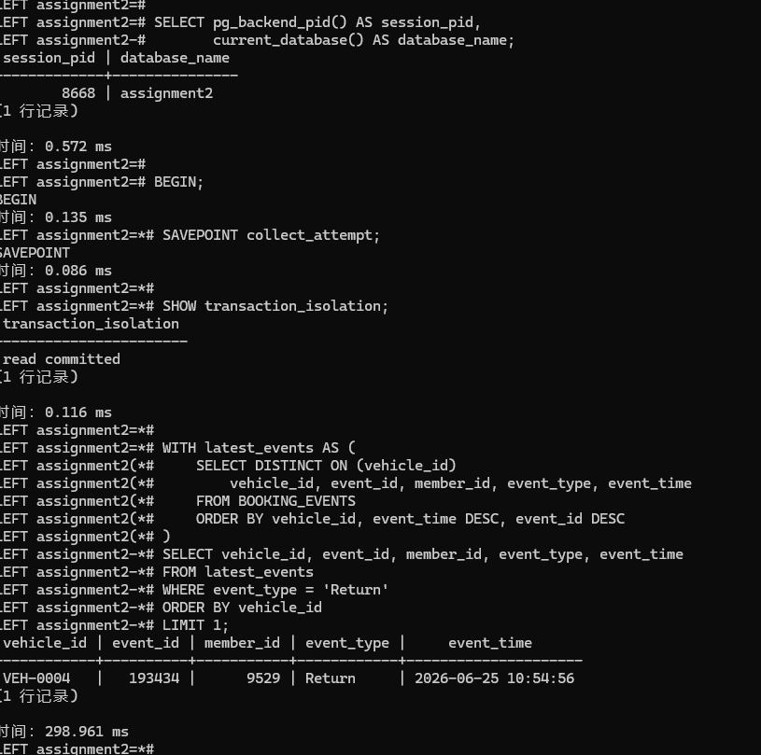
Comments
LEFT is connection 1, PID 8668; RIGHT is connection 2, PID 40916. Both connect to assignment2. The recorded experiment uses VEH-0004, chosen after earlier practice attempts had reserved vehicles 0001 to 0003.
The original first query selected the first available vehicle. The submitted replay script fixes that recorded choice to VEH-0004, which also has a latest Return in the fresh supplied data. This makes the two sessions use the same car without depending on practice records.
Connection 1 begins a READ COMMITTED transaction and returns VEH-0004. Its latest event is Return 193434, by member 9529 at 2026-06-25 10:54:56. DISTINCT ON selects the most recent event across every event type first; only the outer query tests for Return. This avoids treating an old Return as current availability.
The transaction stays open. SAVEPOINT collect_attempt is present as a recovery aid, but no rollback to it was used in the final recorded attempt.

Screenshot Q4.1 (2) | Marks: /0.5
SQL for Q4.1.2
-- Connection 2: run this file while Connection 1 remains in its open transaction.
-- Identify the independent connection used for the reservation.
SELECT pg_backend_pid() AS session_pid,
current_database() AS database_name;
BEGIN;
SHOW transaction_isolation;
-- Check the same vehicle selected by Connection 1.
SELECT *
FROM (
SELECT vehicle_id, event_id, member_id, event_type, event_time
FROM BOOKING_EVENTS
WHERE vehicle_id = 'VEH-0004'
ORDER BY event_time DESC, event_id DESC
LIMIT 1
) AS latest_event
WHERE event_type = 'Return';
-- Reserve the vehicle for member 2 three days in the future.
INSERT INTO BOOKING_EVENTS
(member_id, vehicle_id, event_type, event_time, amount)
VALUES
(2, 'VEH-0004', 'Reserve', NOW() + INTERVAL '3 days', NULL)
RETURNING event_id, member_id, vehicle_id, event_type, event_time;
COMMIT;
-- Return to Connection 1 only after this COMMIT succeeds.
Original RIGHT reservation and successful commit
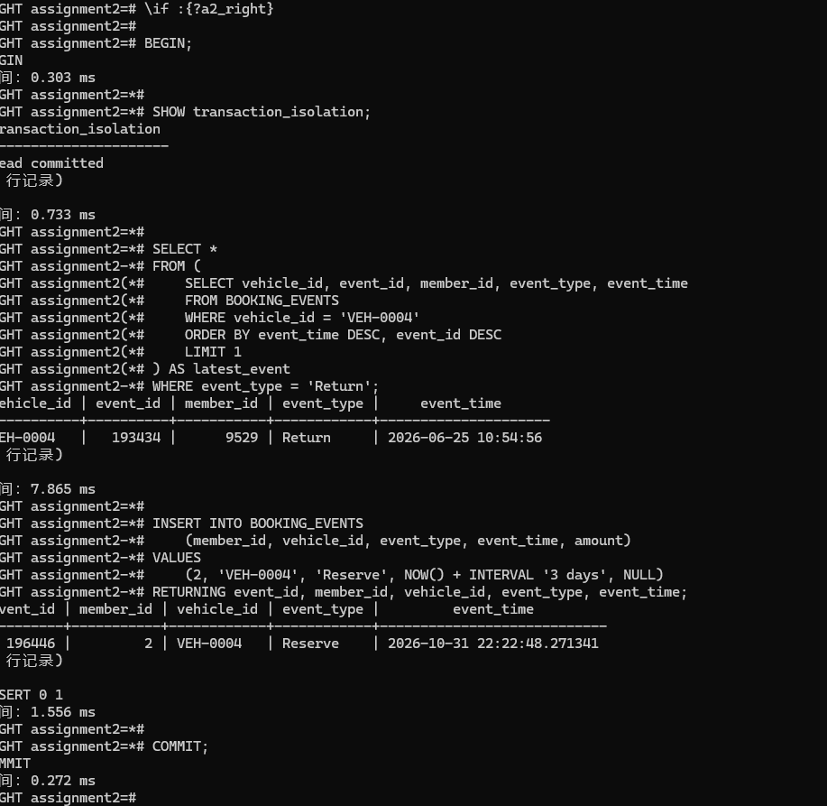
Comments
Connection 2 also reports READ COMMITTED and sees the same Return while connection 1 is still open. It inserts a Reserve for member 2 at NOW() + INTERVAL '3 days' and commits. The recorded event is 196446 at 2026-10-31 22:22:48.271341. The earlier plain SELECT in connection 1 did not reserve or lock this vehicle against a new booking event.

Screenshot Q4.1 (3) | Marks: /1
SQL for Q4.1.3
-- Connection 1: use the original open transaction after Connection 2 commits.
-- Do not reconnect or start a new transaction before running these statements.
-- Attempt to collect the same vehicle for a different member.
INSERT INTO BOOKING_EVENTS
(member_id, vehicle_id, event_type, event_time, amount)
VALUES
(1, 'VEH-0004', 'Collect', NOW(), NULL);
-- After the expected trigger error, COMMIT ends the failed transaction as
ROLLBACK.
COMMIT;
-- Check the latest recorded events after the transaction has ended.
SELECT event_id, member_id, vehicle_id, event_type, event_time, amount
FROM BOOKING_EVENTS
WHERE vehicle_id = 'VEH-0004'
ORDER BY event_time DESC, event_id DESC
LIMIT 3;
Original LEFT rejection and transaction rollback
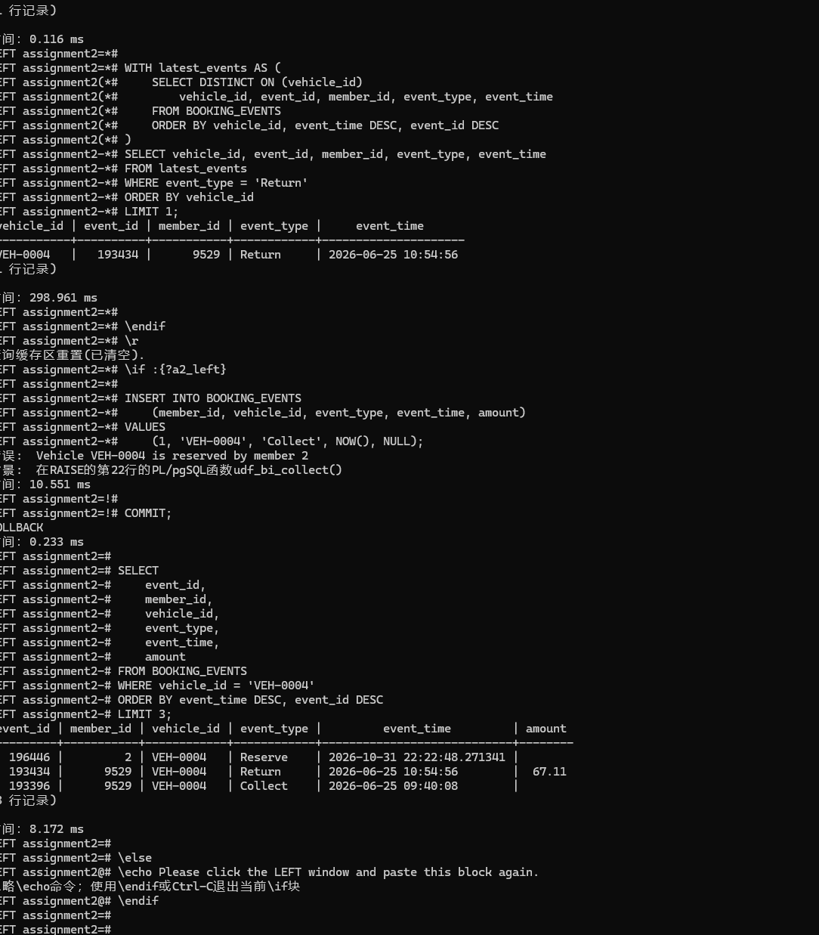
Original final three recorded events
Comments
After connection 2 commits, connection 1 attempts Collect for member 1. The trigger rejects it with: Vehicle VEH-0004 is reserved by member 2. The context identifies udf_bi_collect(), RAISE at line 22. The transaction enters the failed state, and COMMIT reports ROLLBACK.
The final three events are Reserve 196446 for member 2, historical Return 193434 for member 9529 (67.11), and historical Collect 193396 for member 9529. Only the new Reserve survives this experiment. The displayed historical Collect is not the rejected new Collect. A serial sequence may advance even when an insertion fails.

Screenshot Q4.1 (4) | Marks: /2.5
The schedule is T1 BEGIN and availability read; T2 BEGIN and availability read; T2 Reserve and COMMIT; T1 Collect attempt; trigger exception; T1 ROLLBACK. T1 initially sees an available car, but that answer becomes stale before its next operation.
At READ COMMITTED, each statement uses a fresh snapshot. The Collect attempt runs after T2 has committed, so the trigger can see the committed Reserve. The trigger orders events by event_time and treats that future-dated reservation as the latest state. Because it belongs to member 2, it refuses a Collect by member 1.
An ordinary SELECT reads without a row lock that reserves this car. Its ACCESS SHARE relation lock is compatible with the other transaction's insertion, so it does not prevent T2 from changing the answer. T1 stays open but does not retain its first statement's snapshot for later statements. In this schedule the rejection is a business-rule exception, with no circular lock wait.
For the co-operative, the person at the parking bay is refused the car even though the other person reserved it three days ahead. The simplified trigger makes a future reservation an immediate hold. Coordinating availability checks and writes would address races, while interval-aware booking rules would also be needed to distinguish available now from reserved later.
Comments
A snapshot is a consistent read of visible data; it does not reserve the object that was read. PostgreSQL 18 Transaction Isolation and Explicit Locking support this interpretation; references appear at the end.

Screenshot Q4.2 | Marks: /3
In the recorded run T1 is LEFT, PID 8668, and T2 is RIGHT, PID 40916. Initial odometers are 149100 for VEH-0401 and 122150 for VEH-0501. The following SQL lists every statement in the order sent; it must be executed a labelled section at a time across the two connections.
T1 updates VEH-0401 by 10 and holds its row lock. T2 updates VEH-0501 by 20 and holds the other row lock. T1 then requests VEH-0501 and waits. While it is waiting, T2 requests VEH-0401, completing the cycle. Both updates cannot finish until the other transaction ends.
PostgreSQL detects the deadlock and aborts T2 in this recorded run. T2's earlier +20 on VEH-0501 is undone and its locks are released. T1's waiting update resumes, returning 122160, and T1 commits. T2's attempted COMMIT reports ROLLBACK. Final values are VEH-0401 = 149110 and VEH-0501 = 122160.
The full original error is shown below and transcribed without translating its diagnostic text. T1's reported 116906.993 ms includes the time spent waiting while the next command was entered in the other window. T2's error took 1019.158 ms. These are not ordinary update processing times.
SQL for Q4.2.1 part 1 of 2
-- Execute the labelled sections in order in two independent connections.
-- Do not execute this entire file in a single connection.
-- The deadlock victim may differ on a rerun.
-- Connection 1: record the initial odometers.
SELECT vehicle_id, odometer
FROM VEHICLES
WHERE vehicle_id IN ('VEH-0401', 'VEH-0501')
ORDER BY vehicle_id;
-- Connection 1: begin and update the first vehicle.
BEGIN;
UPDATE VEHICLES
SET odometer = odometer + 10
WHERE vehicle_id = 'VEH-0401'
RETURNING vehicle_id, odometer;
-- Connection 2: begin and update the other vehicle first.
BEGIN;
UPDATE VEHICLES
SET odometer = odometer + 20
WHERE vehicle_id = 'VEH-0501'
RETURNING vehicle_id, odometer;
-- Connection 1: this statement waits for Connection 2.
UPDATE VEHICLES
SET odometer = odometer + 10
WHERE vehicle_id = 'VEH-0501'
RETURNING vehicle_id, odometer;
-- Connection 2: this statement completes the wait-for cycle.
UPDATE VEHICLES
SET odometer = odometer + 20
WHERE vehicle_id = 'VEH-0401'
RETURNING vehicle_id, odometer;
SQL for Q4.2.1 part 2 of 2
-- Connection 2: COMMIT reported ROLLBACK in the recorded run.
COMMIT;
-- Connection 1: commit and report the final odometers.
COMMIT;
SELECT vehicle_id, odometer
FROM VEHICLES
WHERE vehicle_id IN ('VEH-0401', 'VEH-0501')
ORDER BY vehicle_id;
Original two-session context and first LEFT update
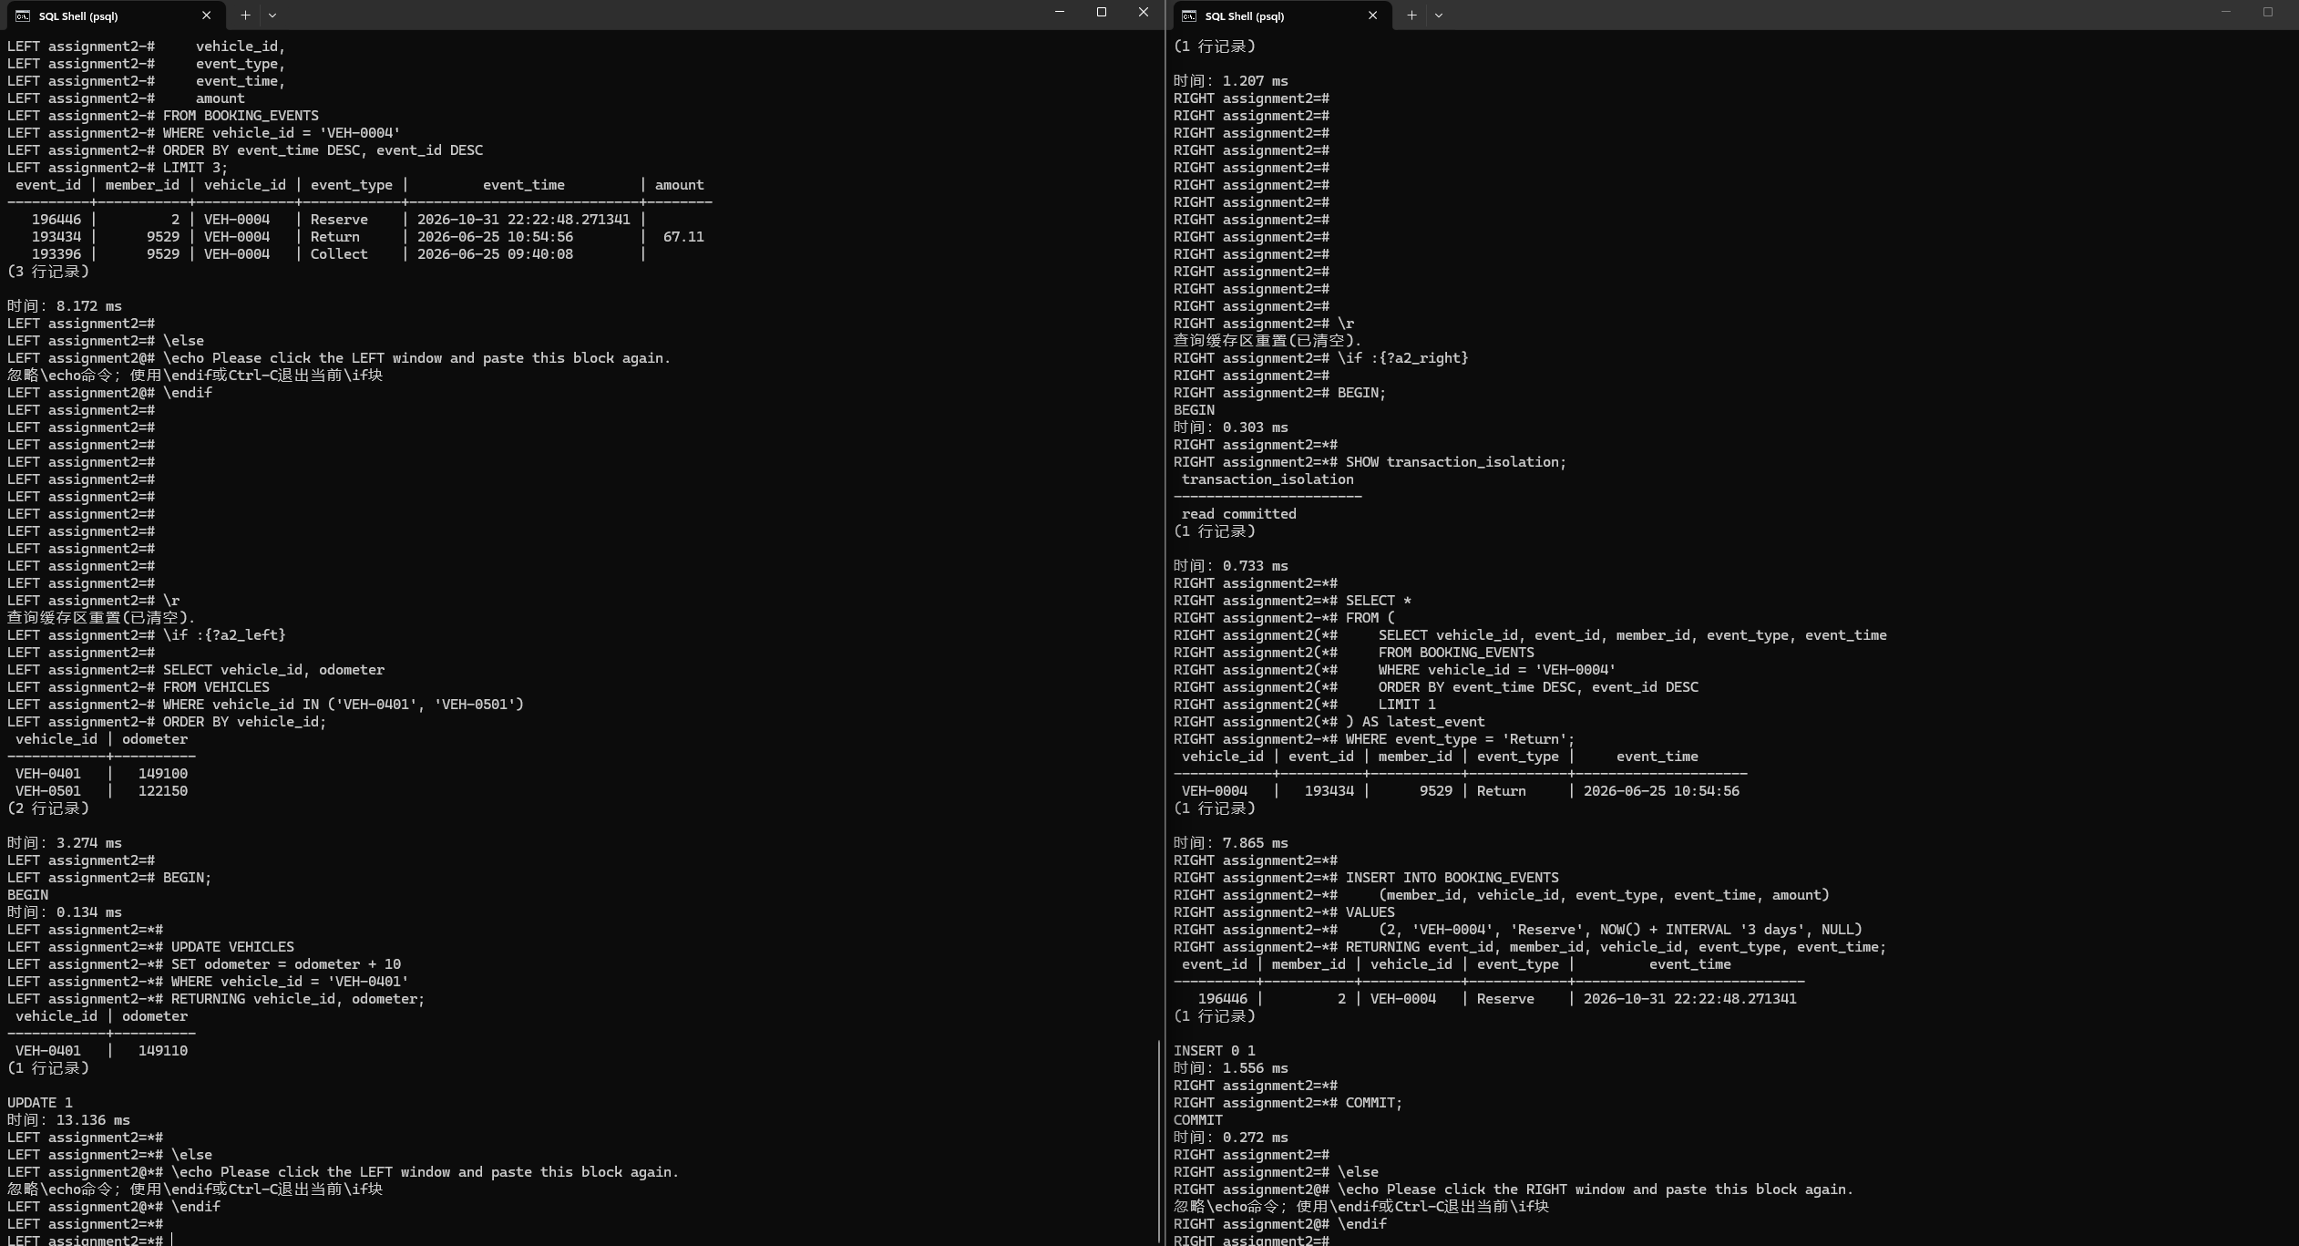
Initial odometers and LEFT first update detail
Original RIGHT first update
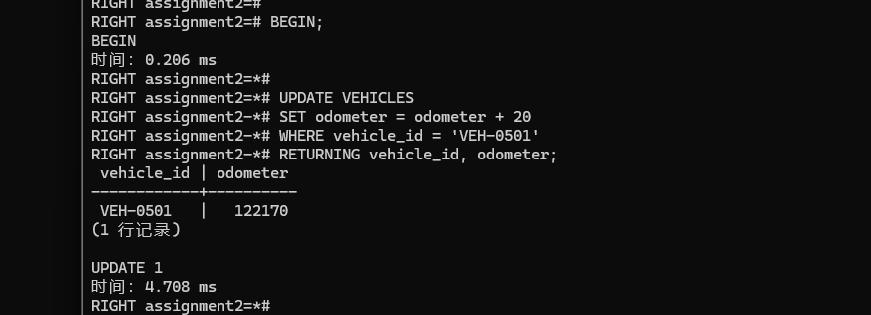
Original LEFT second update waiting
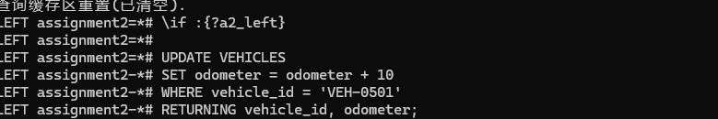
Original two-session deadlock and resolution
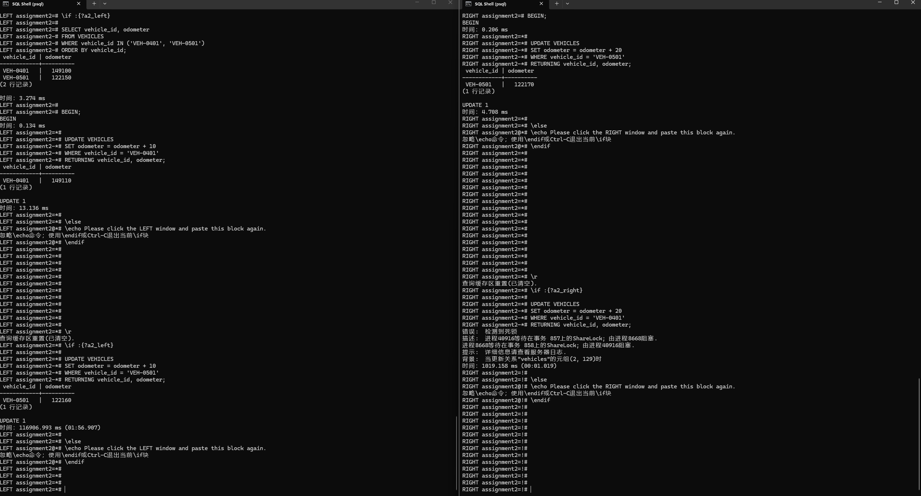
Full original deadlock diagnostic in RIGHT
Full diagnostic transcription
错误: 检测到死锁
描述: 进程40916等待在事务 857上的ShareLock; 由进程8668阻塞.
进程8668等待在事务 858上的ShareLock; 由进程40916阻塞.
提示: 详细信息请查看服务器日志.
背景: 当更新关系"vehicles"的元组(2, 129)时
Original commits and final odometers in both sessions
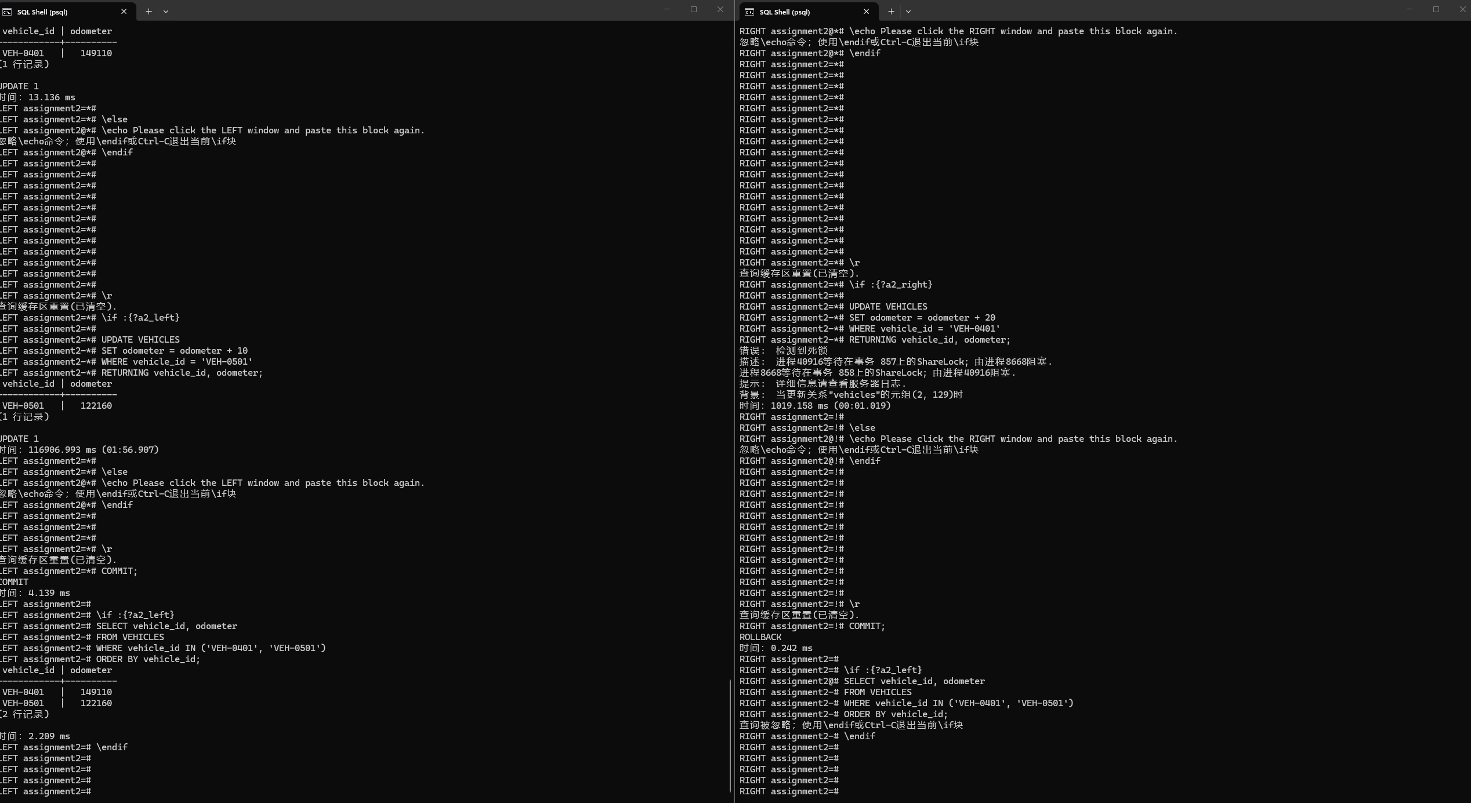
Final LEFT verification
RIGHT attempted COMMIT reports ROLLBACK
Hand-drawn wait-for graph immediately before detection
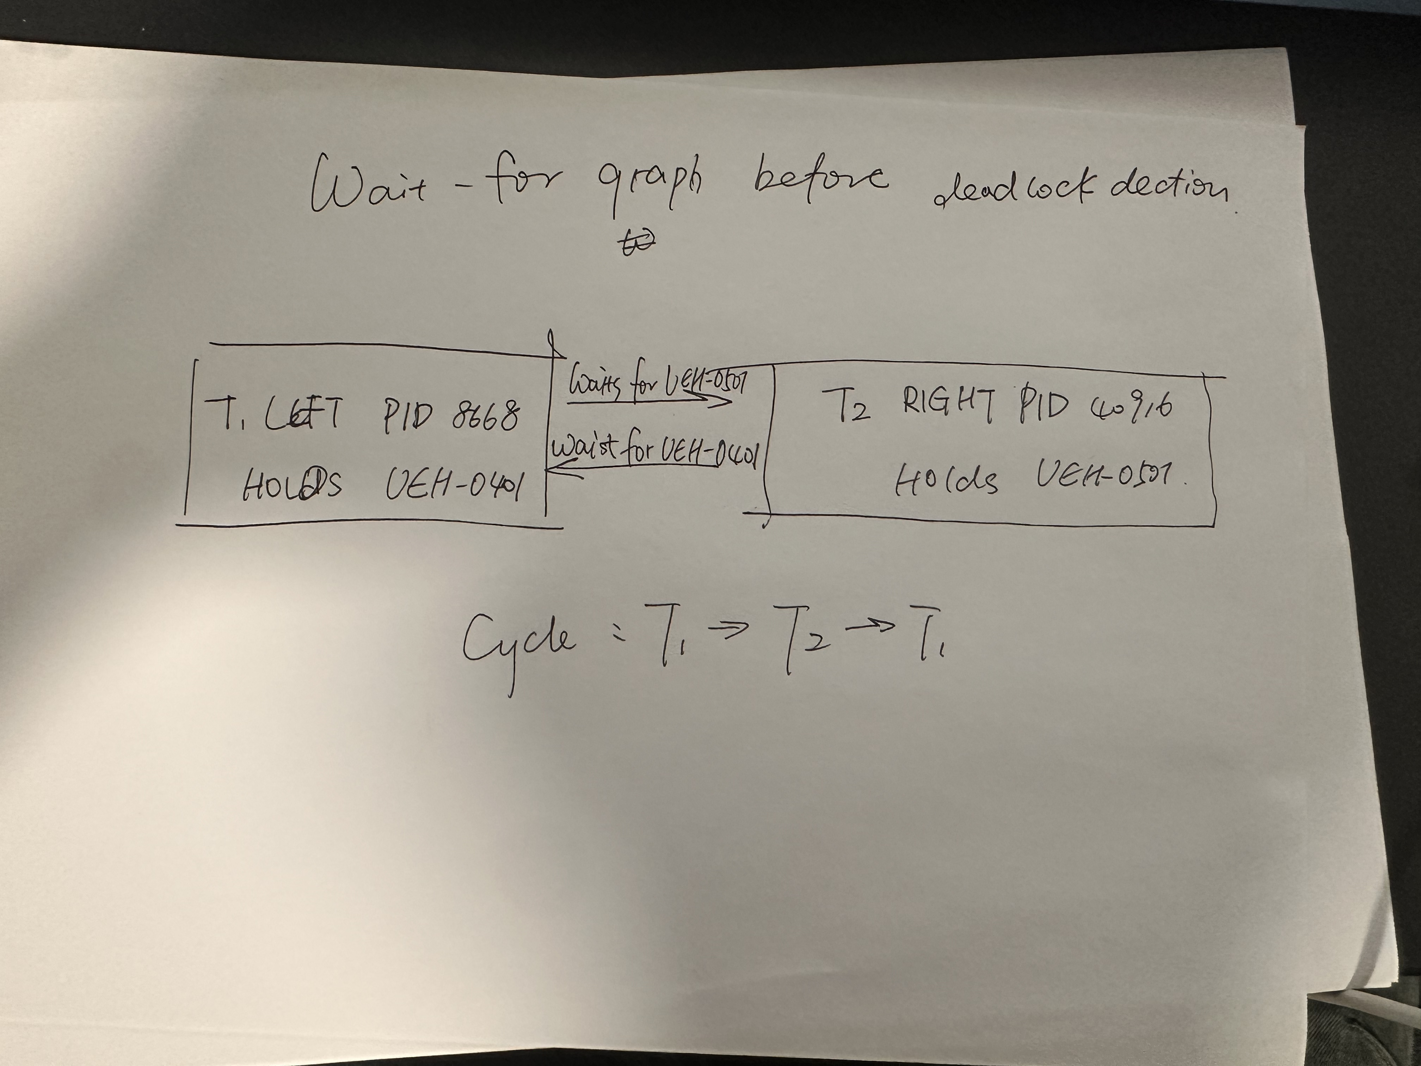
Comments
The wait-for graph immediately before detection has T1 -> T2 for VEH-0501 and T2 -> T1 for VEH-0401. Its cycle T1 -> T2 -> T1 explains why neither could proceed. The photographed hand drawing marks both held resources and both waiting edges.
A consistent ascending vehicle_id lock order would prevent this cycle: every correction transaction must acquire VEH-0401 before VEH-0501. A transaction blocked on the first row would then hold no later row needed by its predecessor. The co-operative would pay with more waiting or queuing when corrections overlap, while unrelated vehicles could still be processed concurrently. The victim can differ on a rerun, so the outcome here is based on the actual screenshot.

Screenshot P | Marks: /2
The accompanying ZIP contains exactly 20 SQL files at its root. Load the supplied dataset once, then run the files in question order. Q4 requires two persistent psql connections and the labelled statement order.
Q1 to Q3.1 use a clean PostgreSQL 18.6 replay with UTF-8, C collation and Australia/Brisbane timezone. Labelled transcript-viewer captures contain genuine psql stdout, reflowed for display. Ordinary lists over 20 rows show the first and last ten; all plan lines are retained.
Q3.2 and Q4 retain the original interactive evidence. Word crops preserve the source image bytes. A separate replay reproduced the trigger rejection and a deadlock; IDs, timestamps, estimates, times and the victim may differ on reruns. Equivalence checks found no differences for either Q3.1 or an independent upward liability traversal.
The supplied assignment and FleetDB dataset define the task. PostgreSQL 18 documentation consulted for the explanations is listed below.
Using EXPLAIN
https://www.postgresql.org/docs/18/using-explain.html
Multicolumn Indexes
https://www.postgresql.org/docs/18/indexes-multicolumn.html
Indexes on Expressions
https://www.postgresql.org/docs/18/indexes-expressional.html
Materialized Views
https://www.postgresql.org/docs/18/rules-materializedviews.html
Query Planning Configuration
https://www.postgresql.org/docs/18/runtime-config-query.html
Transaction Isolation
https://www.postgresql.org/docs/18/transaction-iso.html
Explicit Locking
https://www.postgresql.org/docs/18/explicit-locking.html
Comments
Tutor status: A2 has not yet been shown to the tutor, and the use of AI has not yet been discussed. No completed discussion or independent student review is claimed. The marking fields below are left blank for the teaching team.
Penalty: _______________
Reason of the Penalty
(Late Submission/No Show to Tutor/Purely AI Generated Solutions): ___________
Final Marks： ———————— / 30
---ooo000OOO000ooo---

