**Architecture and Design Document**

**StuddiBuddi**



Hunter Davis

Oscar Gepiga

Tymee Kong

Tanner Mindrum

Shihong Sun

CECS 491A

Jean Tsao

3/16/2020

**Diagrams**

Language diagram:

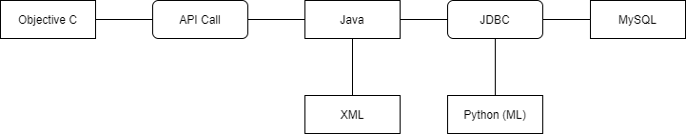

Interface diagram:

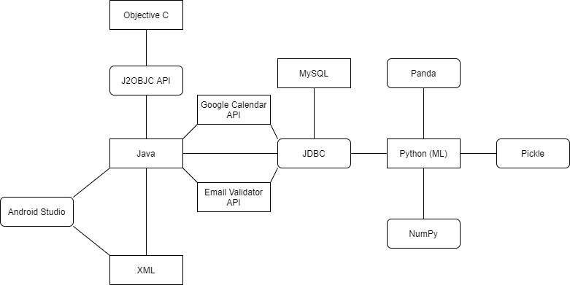

Deployment Diagram:

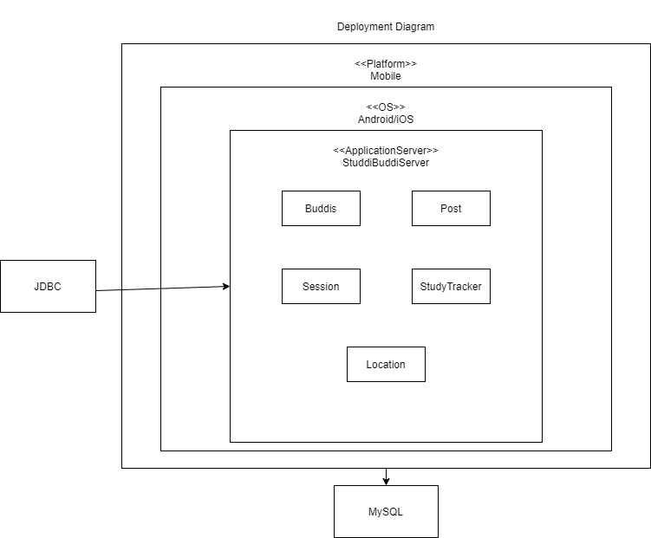

Class Diagram:

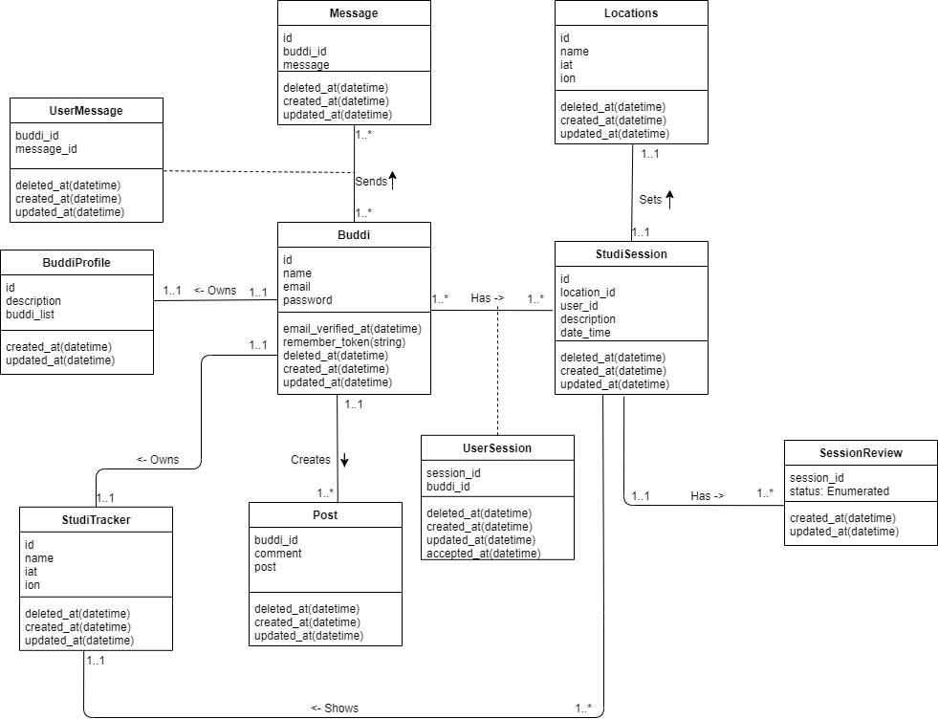

Use case Diagram:

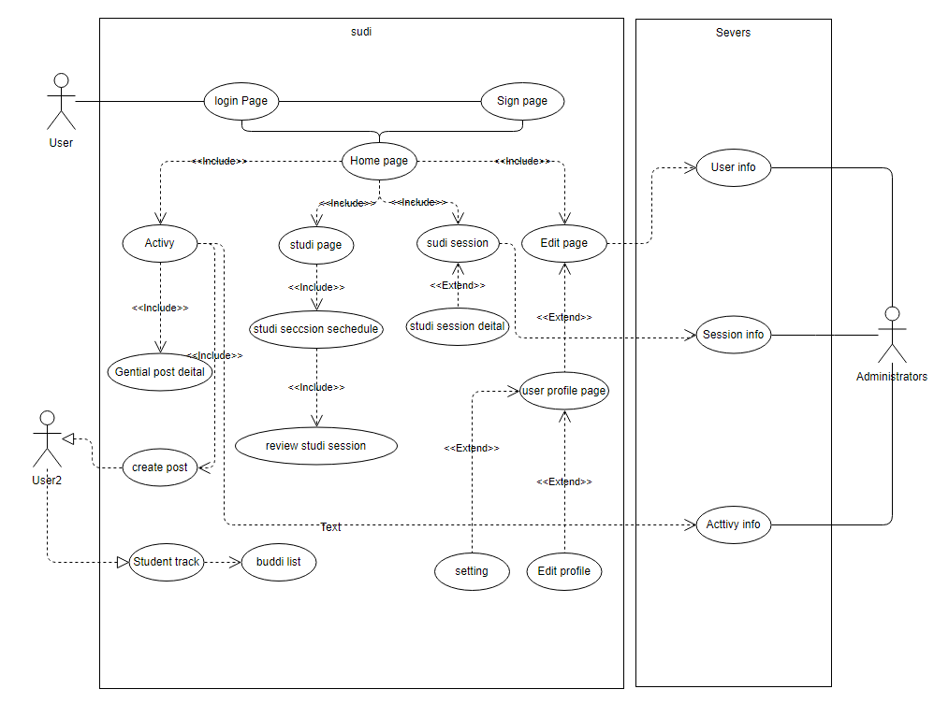

Activity diagram

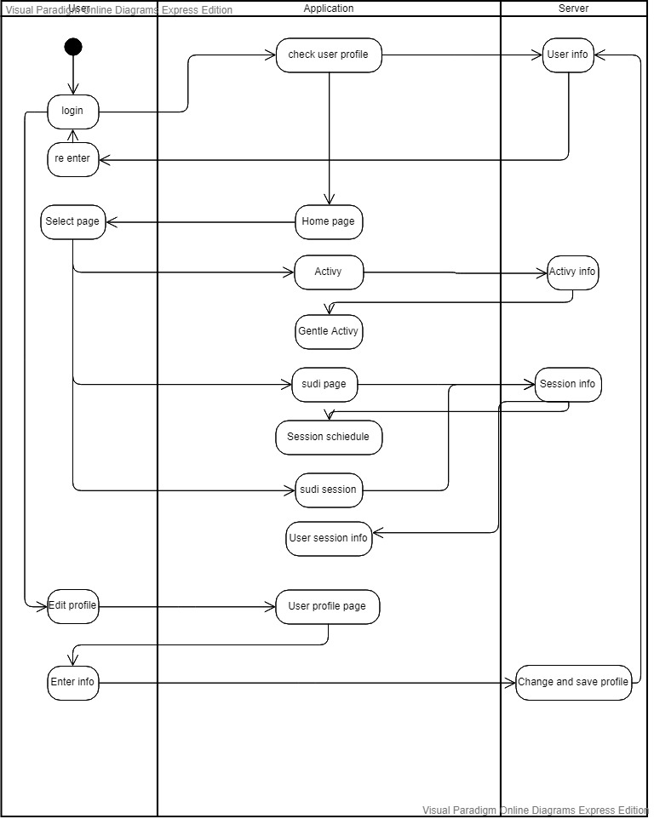

**Tradeoff Analysis**

Mobile vs Web Tradeoff Analysis

|  |  |  |  |
| --- | --- | --- | --- |
| Criterion | Weight | Mobile | Web |
| Our Technical experience | 15 | 10 | 5 |
| Primary Market Research Results | 30 | 25 | 15 |
| User Base (for our demographic) | 30 | 25 | 15 |
| Accessibility | 10 | 10 | 8 |
| Desired Features | 15 | 12 | 9 |
| Total | 100 | 82 | 52 |

For the tradeoff of Mobile vs Web, we heavily took our primary market research and demographic into account. We understand that a quick and efficient study session planning software would be much more useful in the hands of students as a mobile app rather than a webapp that would be more focused on a user planning their sessions through a laptop, where the quick streamlined experience would be slowed down. On a mobile phone, we could tailor this experience to busy students and provide ease-of-use to the end user.

Android vs iOS Tradeoff Analysis

|  |  |  |  |
| --- | --- | --- | --- |
| Criterion | Weight | Android | Apple |
| Our Technological Experience | 20 | 15 | 5 |
| Accessibility | 10 | 8 | 7 |
| Audience | 10 | 7 | 8 |
| Timeline | 5 | 3 | 4 |
| Software Features | 20 | 15 | 10 |
| Hardware Features | 25 | 23 | 20 |
| Performance | 10 | 8 | 8 |
| Total | 100 | 79 | 65 |

In our analysis of Android vs iOS, we took into consideration the devices of our teammates and our technological experience. We have some experience in Android development, and we figured any person in the class could run an android emulator on their laptops and be able to try our platform. We are planning on using an API to port to iOS, but we figured to start development in Android for the time being.

Database Tradeoff Analysis

|  |  |  |  |
| --- | --- | --- | --- |
| Criterion | Weight | MySQL | Firebase |
| Design | 20 | 17 | 10 |
| Model | 20 | 18 | 12 |
| Community | 5 | 5 | 1 |
| Standardization | 20 | 18 | 10 |
| Schema | 5 | 2 | 3 |
| Flexibility | 20 | 10 | 13 |
| Experience | 10 | 10 | 0 |
| Total | 100 | 80 | 49 |

In analyzing these two Database platforms, we allocated weight to the importance to our team. We ultimately decide in using MySQL largely to our team’s experience in developing using the database. We also wanted to emphasize a full stack development process throughout this class, to give ourselves experience in this type of development. MySQL works in our advantage because we can model tables that follow our class design. While MySQL isn’t as flexible as Firebase, it will work well in our program because it will act as the main source of data for our program and we will rarely have to change the database with the way we are designing our application. Also, MySQL allows us to use JDBC in our application, which will be an easy way to query and add data into our main database.

**Risk Management**

|  |  |  |  |  |  |
| --- | --- | --- | --- | --- | --- |
| ID | Description | Mitigation Scheme | Severity Level | Date of Identification | Status |
| 1 | Machine learning Model selection | Analyze the data and find which model is most fit to use | Low | 3/7/2020 | Not started |
| 2 | Student identity check | Student Email check, maybe student ID check in future | Medium | 3/7/2020 | Not started |
| 3 | User privacy protection | Encrypting our database and using a salt password | High | 3/7/2020 | Not started |
| 4 | User safety protection | Allowing the user to share location and status to an  Emergency contact | High | 3/7/2020 | Not started |
| 5 | User account recovery | Answering security questions or have a code be sent to their phone number | High | 3/8/2020 | Not started |
| 6 | Filtering appropriate posts | Analyze posts that a user can create and determine if that post is appropriate | High | 3/8/2020 | Not started |
| 7 | User profile vulnerability | Allows users to make their profile private so only friends can view their profile. | High | 3/8/2020 | Not started |