### 一、下载

<https://www.elastic.co/cn/downloads/elasticsearch>

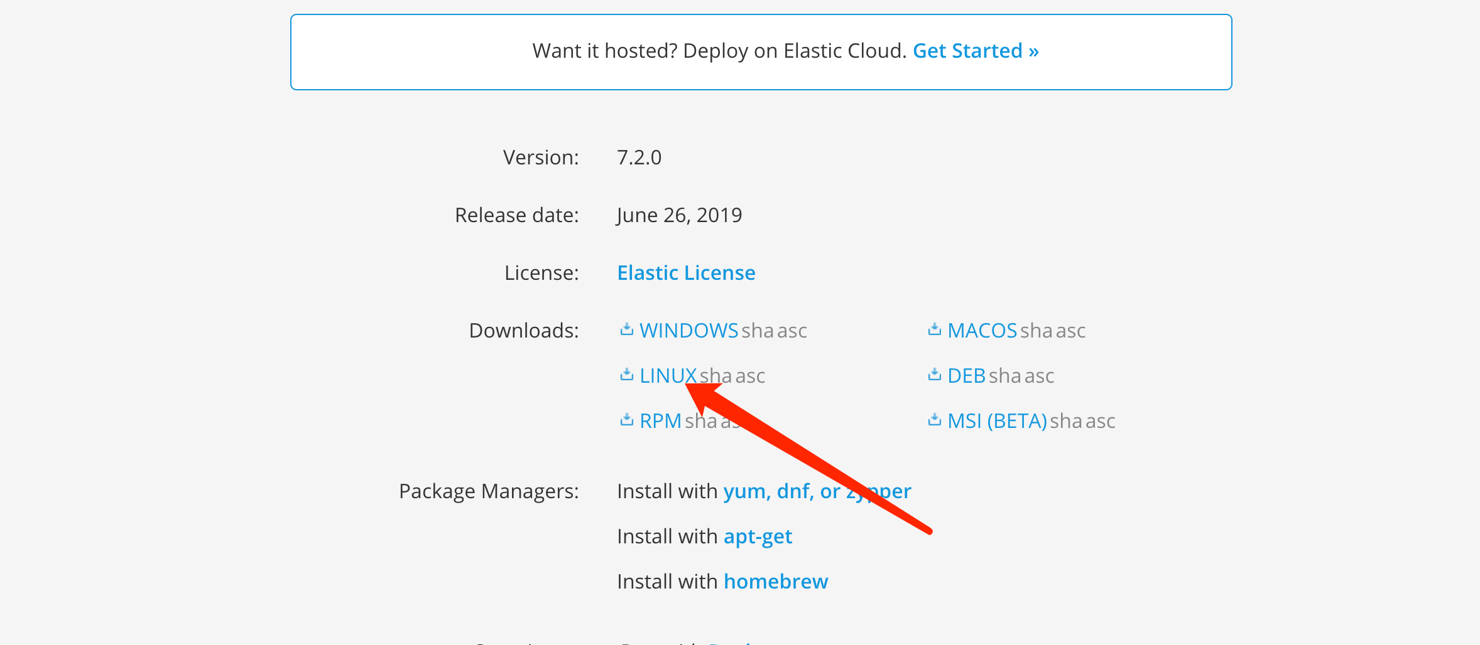

### 解压

tar -xvf elasticsearch-7.2.0-linux-x86_64.tar.gz

### 启动

./bin/elasticsearch

