USE HAND TOOLS (UHT)
What is a Tool?
A tool is a handheld device that aids in accomplishing a task.

PROPER TOOL SELECTION
Tools range from a traditional metal cutting part of a machine to an element of a computer program that activates and controls a particular function.
Preparing for the task to be undertaken includes proper tool selection.

1. How do you select the best tool for the job? First, know and understand in detail the scope of work to be accomplished, second, plan for the scope taking into account the sequence of tasks.
2. Selecting the best tool for each task requires training in the proper use of the tools, field experience in their safe use, and following the manufacturer’s guidance and instructions for that specific tool.
3. When obtaining the tool all the associated tooling and consumable parts, as recommended by the manufacturer, must be included. In addition, related consumable parts must also be selected and used according to their manufacturer’s instructions.
Safe Use of tools
Once selected, use the tool for the purpose for which it was designed. Not all tools come with detailed instructions, but there are those that do spell out the safety ―Do’s and Don’ts for your safety. If there are set-up/use options, operator judgment must always be based on what is the safest way to use the tool.
Environmental Safety and Health Program requires the following:
• All tools be kept in good condition with regular maintenance
• The right tool be used for the job
• Each tool be examined before use AND damaged or defective tools NOT to be used
• Tools be operated according to manufacturer’s instructions
• The right protective equipment for the tool and activity be used
HARDWARE TOOLS
To complete hardware repairs, it is important to have a toolkit that should contain all of the necessary tools. As you gain experience, you will learn which tools to have available for different types of jobs. Hardware tools are grouped into these four categories:
• Electro-Static Discharge (ESD) tools
• Hand tools
• Cleaning tools
• Diagnostic tools
ELECTRO-STATIC DISCHARGE (ESD) TOOLS
Static electricity is easily generated by friction on carpets, tile flooring, clothing, hair, fabric, and etc. The friction of moving air alone will charge suspended particles and cause the buildup of static electrical charges on people and objects in the environment. Grounded antistatic work mats used with antistatic wrist straps provide the most basic means for the controlled discharge of electrostatic electricity.

Examples of ESD Tools:
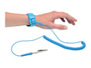

Anti-static wrist strap – used to prevent ESD damage to computer equipment.



Anti-static mat – used to stand on or place hardware on to prevent static electricity from building up.

HAND TOOLS
A hand tool is a device for performing work on a material or a physical system using only hands. The hand tools can be manually used employing force, or electrically powered, using electrical current.
Examples of Hand Tools:

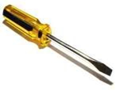

Flat head screwdriver – used to loosen or tighten slotted
screws.
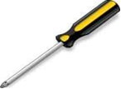

Philips head screwdriver – used to loosen or tighten crosshead screws.
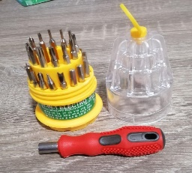

Precision screwdriver – a precision screwdriver is a hand tool with a similar intended use as a standard screwdriver but possessing a smaller form factor and a sleeker handle design, used primarily for work on small and intricate devices.
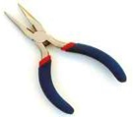

Needle-nose plier – used to hold small parts.
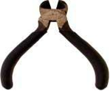

Wire (side) cutter – used to strip and cut wires.
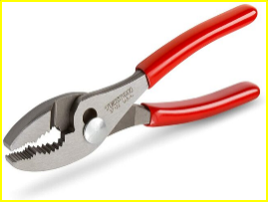

Mechanical Plier – a hand tool used to hold objects firmly
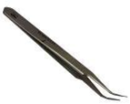

Tweezers – used to manipulate small parts
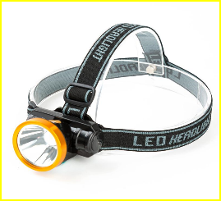

Head-mounted Flashlight – used to light up areas that you cannot see well.

CLEANING TOOLS
Having the appropriate cleaning tools is essential when maintaining or repairing computers. Using these tools ensures that computer components are not damaged during cleaning.

Examples of Cleaning Tools:

Lint-free cloth – used to clean different computer components without scratching or leaving debris.

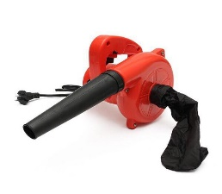

Compressed air (blower) – used to blow/suck dust and debris from different computer parts without touching the components.


Cable ties –used to bundle cables neatly inside and outside of a computer.
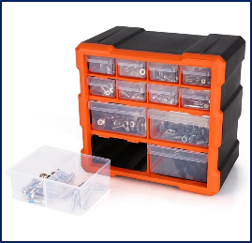

Parts organizer – used to hold screw, jumpers, fasteners and other small parts and prevents them from getting mixed together.

DIAGNOSTIC TOOLS
Computers are easier to use and more dependable with each new generation of hardware and operating system update, but that doesn't mean they're problem-free. Here's the most popular tools for diagnosing your computer problems:
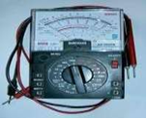

Multi meter Tester – used to test the integrity of circuits and the quality of electricity in computer components.
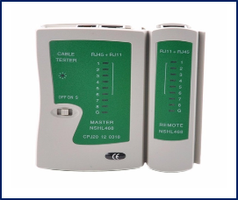

LAN (Network) Tester – used in the workplace and are ideal for technical service professionals and network administrators, it can determine IP addresses, identify polarity, connected port and link connectivity.

