# **AI-BASED HOUSE PRICE PREDICTION**

# **WITH MACHINE LEARNING**

**Objective:**

House price prediction refers to the process of using machine learning techniques to estimate or forecast the selling price of residential properties, such as houses or apartments. This predictive modelling typically involves considering various property attributes and characteristics, such as size, location, number of bedrooms, amenities, and more, to make accurate predictions about what a property is likely to sell for in the real estate market. House price prediction models are valuable tools for homebuyers, sellers, real estate professionals, and investors, helping them make informed decisions in the housing market.

**Data Loading:**

Load the given dataset into our program. Use libraries like Pandas and Numpy for loading and mathematical operations in dataset.

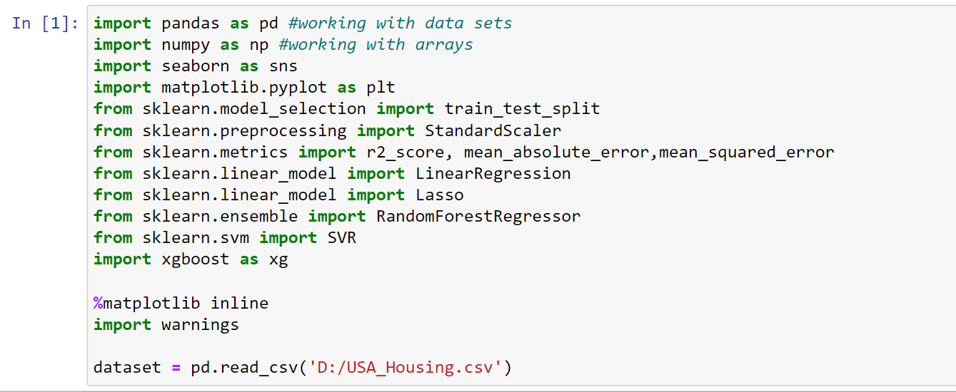

**Data Exploration:**

Explore the dataset to understand its structure and features. This step helps to gain insights into the data and decide which features are relevant for our prediction model.

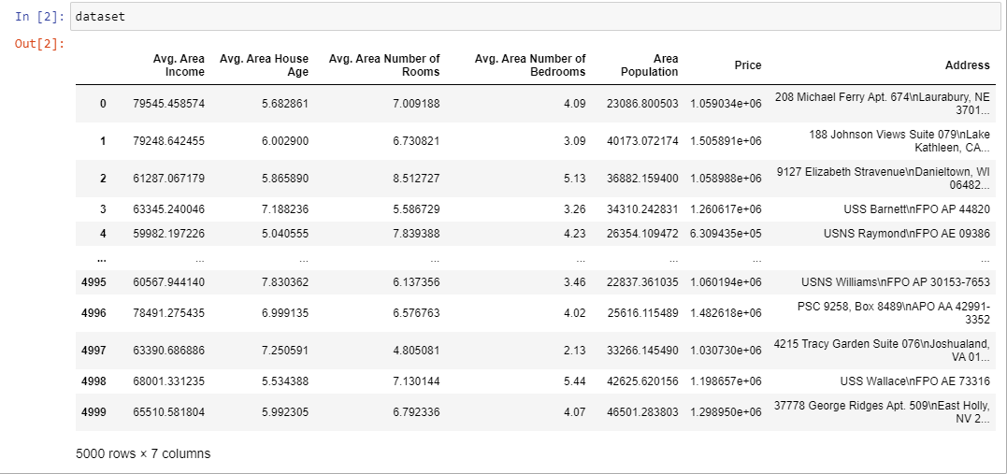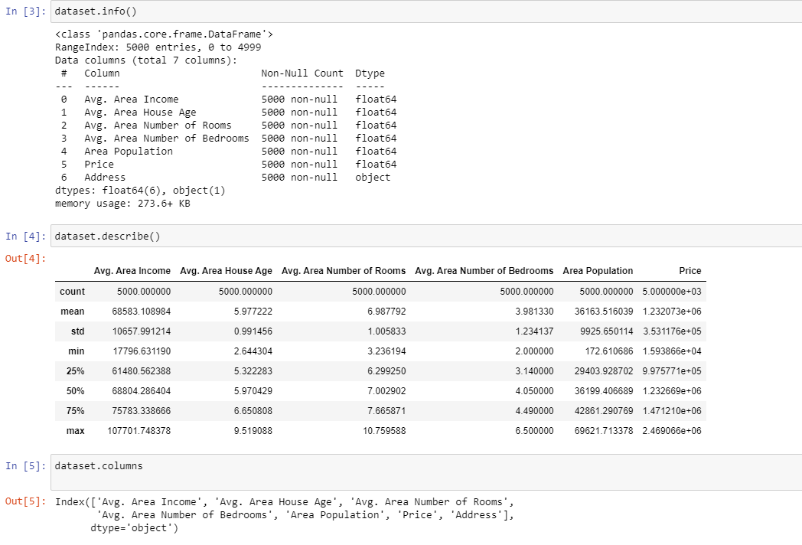

**Data preprocessing:**

In this given dataset there is no non-null values or any missing values .So, we no need to preprocess it.

**Visualization:**

Visualization is the representation of data or information in a graphical or pictorial format. Here ,we used some visualization to make the predictions understandable to people. Here we used Hist plot that helps to visualize dataset distributions (Count VS Price)

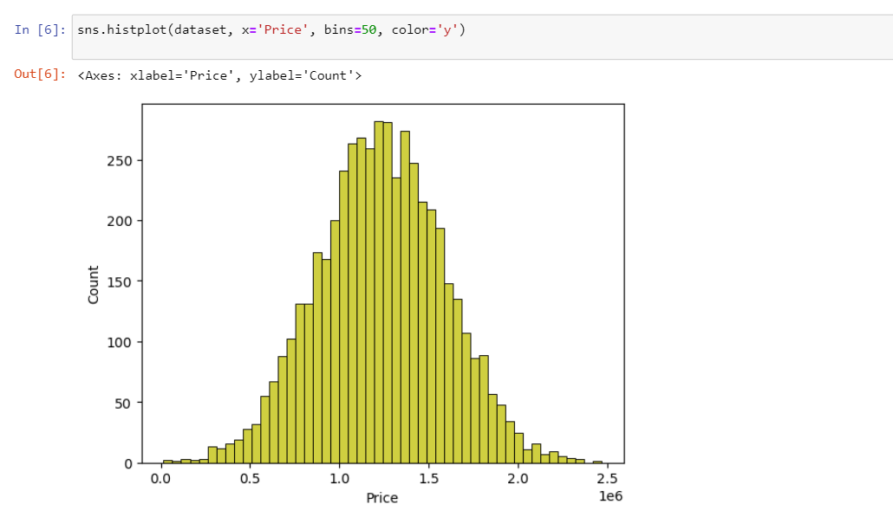

Box plot is used to graphically depicting groups of numerical data through their quartiles

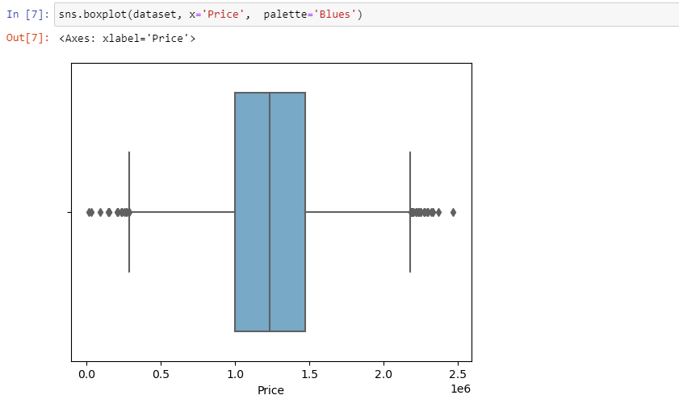

Joint plot is used to understand the relationship between ‘Avg. Area House Age’ VS ‘Price’.

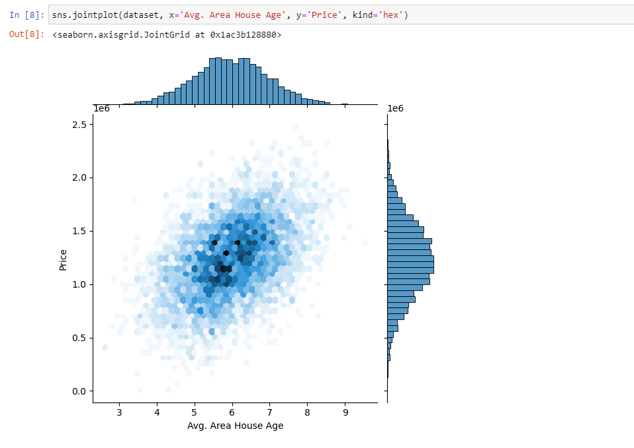

Correlation is used to find pairwise correlation of all the columns in the dataset.

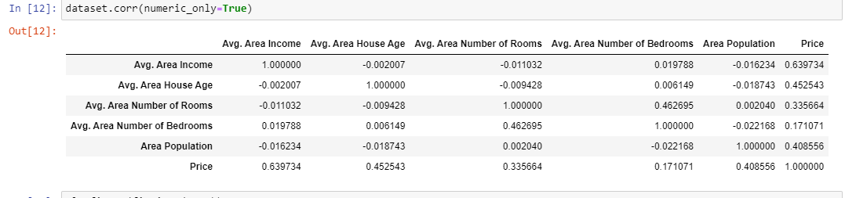

Here Histogram is used to show frequency distributions. It uses array of data as parameters.

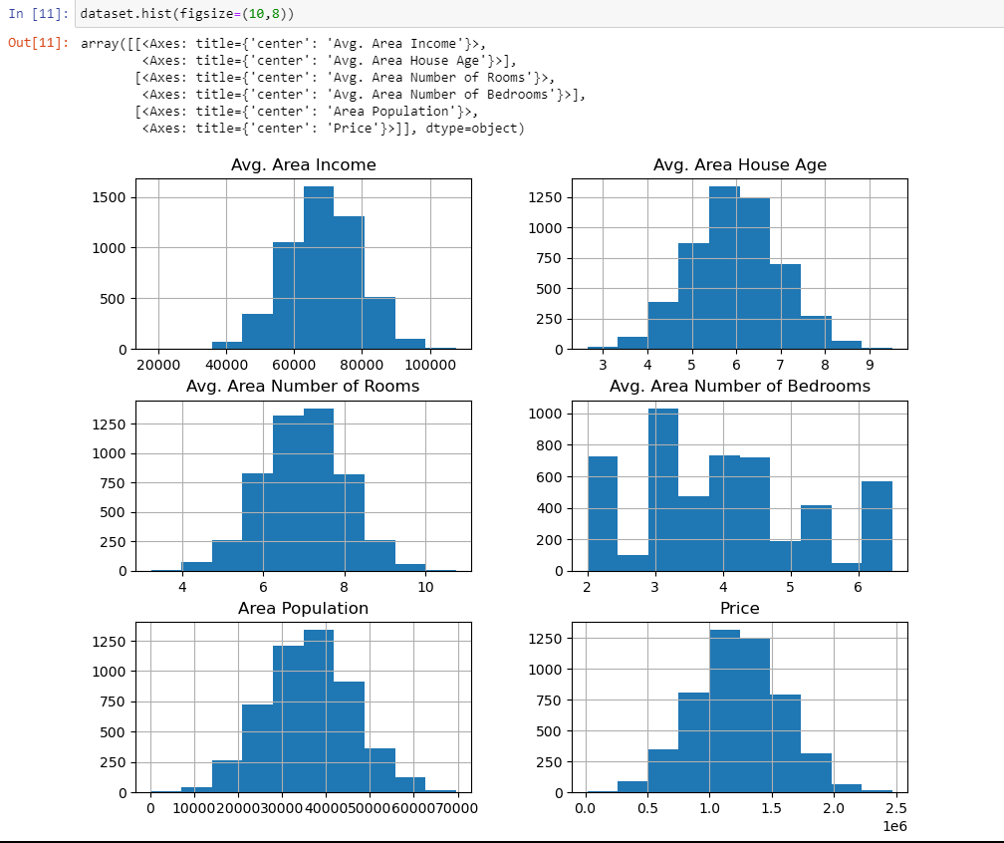

**CONCLUSION:**

The AI phase 3 House price prediction project, our focus was on loading and preprocessing the dataset. This is a crucial first step in any machine learning project as it ensures that the data is in a suitable format for model training. Now that the dataset has been properly loaded and pre-processed, we are ready to move on to the next stages, which typically include model selection, training, and evaluation.

In conclusion, the successful loading and preprocessing of the House price prediction dataset are vital steps in the development of the prediction model. They enable us to work with the data effectively and pave the way for the model's construction. In the subsequent phases, our focus will be on model building, training, and evaluation, with the aim of creating an accurate and valuable house price prediction system.