# AI-BASED HOUSE PRICE PREDICTION

# WITH MACHINE LEARNING

**Objective:**

House price prediction refers to the process of using machine learning techniques to estimate or forecast the selling price of residential properties, such as houses or apartments. This predictive modelling typically involves considering various property attributes and characteristics, such as size, location, number of bedrooms, amenities, and more, to make accurate predictions about what a property is likely to sell for in the real estate market. House price prediction models are valuable tools for homebuyers, sellers, real estate professionals, and investors, helping them make informed decisions in the housing market.

**Data Loading:**

Load the given dataset into our program. Use libraries like Pandas and Numpy for loading and mathematical operations in dataset.

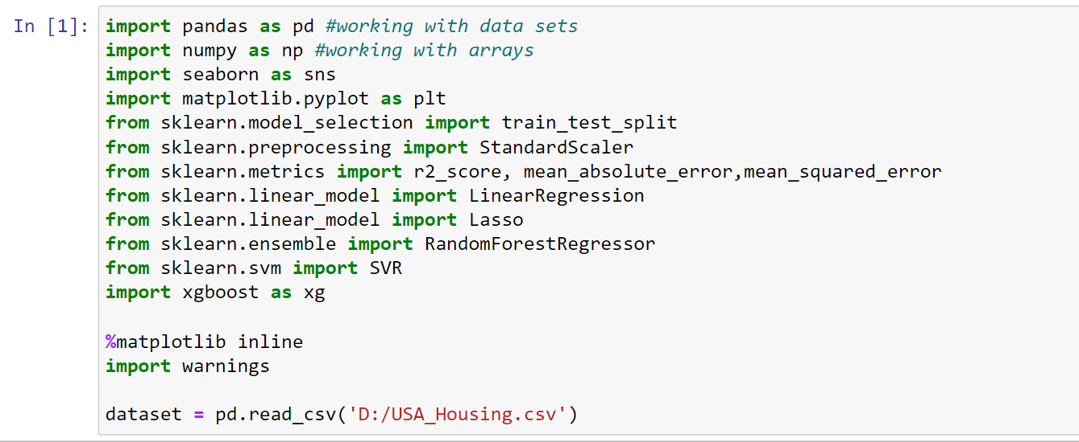

**Data Exploration:**

Explore the dataset to understand its structure and features. This step helps to gain insights into the data and decide which features are relevant for our prediction model.

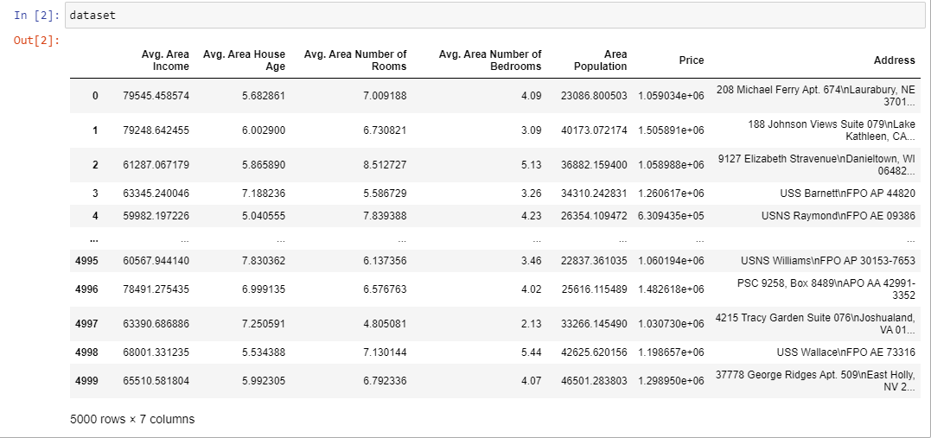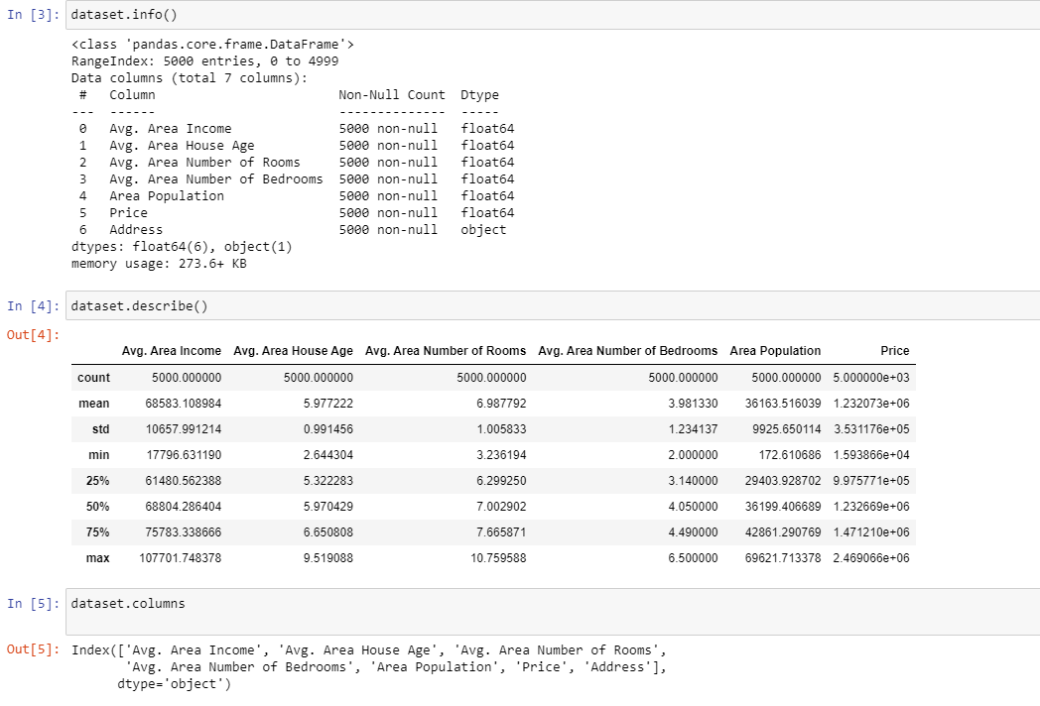

**Data preprocessing:**

In this given dataset there is no non-null values or any missing values .So, we no need to preprocess it.

**Visualization:**

Visualization is the representation of data or information in a graphical or pictorial format. Here ,we used some visualization to make the predictions understandable to people. Here we used Hist plot that helps to visualize dataset distributions (Count VS Price)

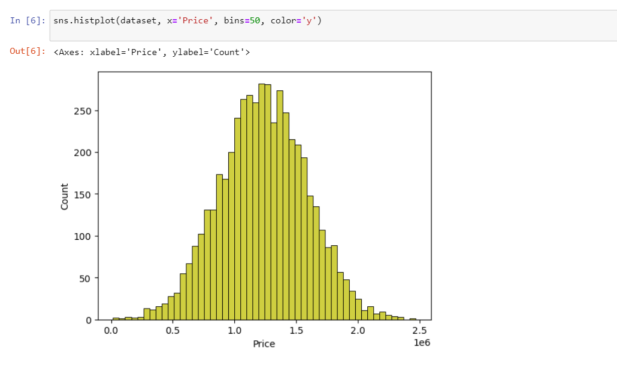

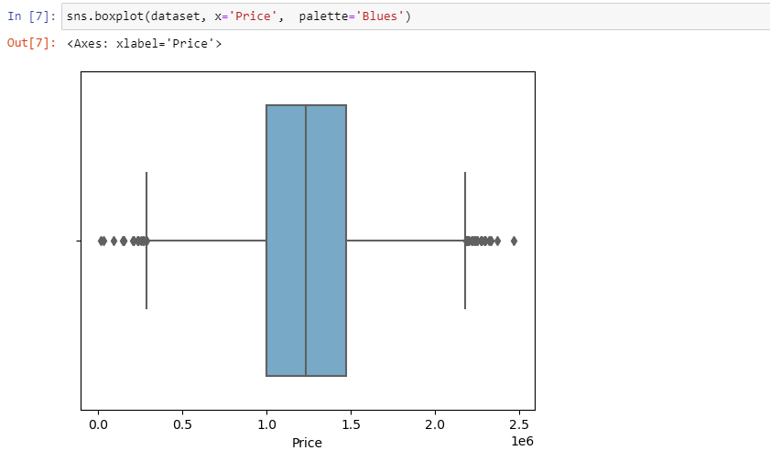

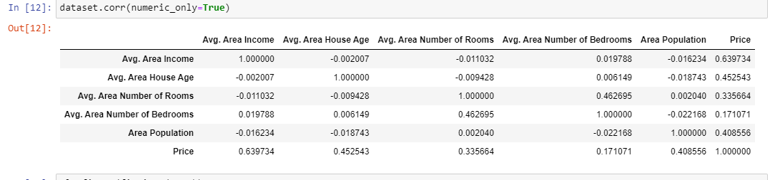

Here Histogram is used to show frequency distributions. It uses array of data as parameters.

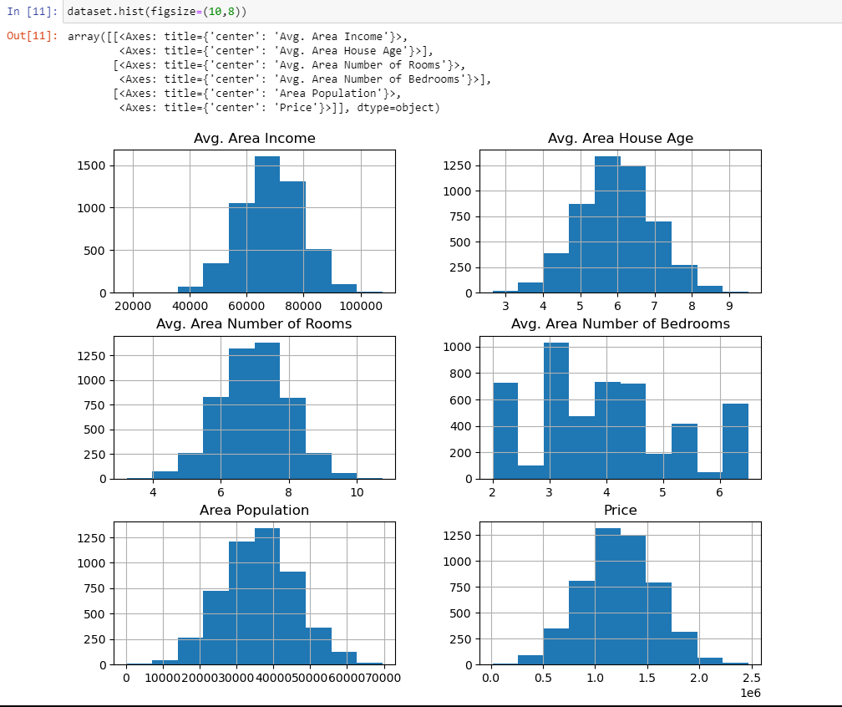

**TRAIN TEST SPLIT**

● The train-test split is a technique for evaluating the performance of a machine learning algorithm.

● Train Dataset: Used to fit the machine learning model.

● Test Dataset: Used to evaluate the fit machine learning model.

● Common split percentages include:

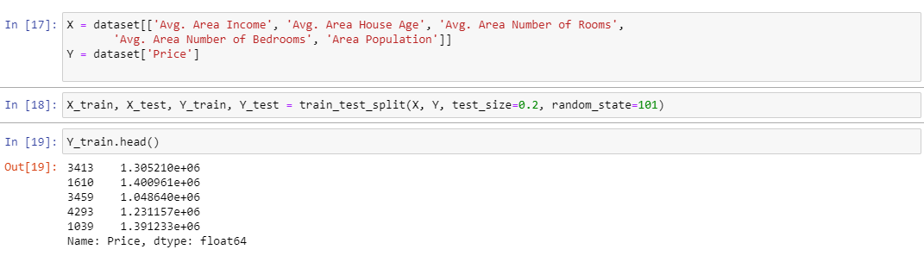





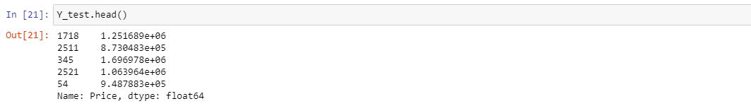

**LINEAR REGRESSION:**

Linear regression analysis is used to predict the value of a variable based on the value of another variable. The variable you want to predict is called the dependent variable. The variable you are using to predict the other variable's value is called the independent variable.

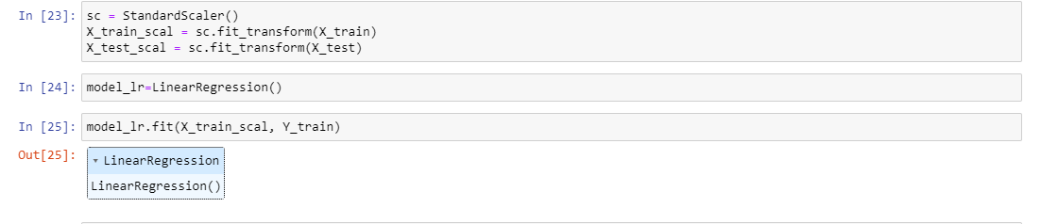

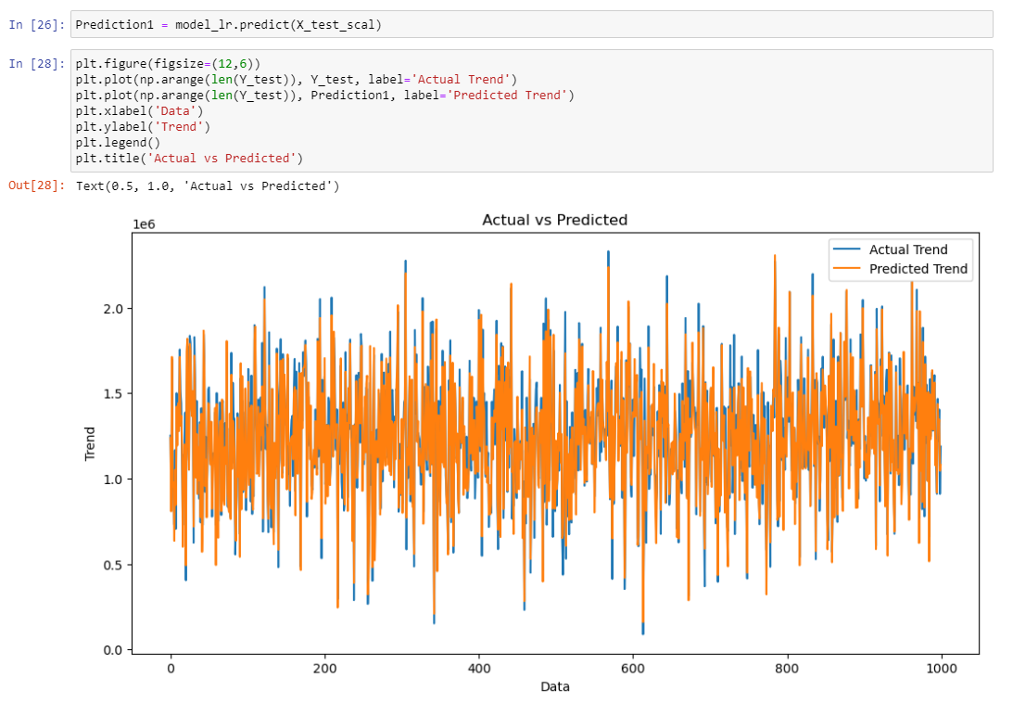

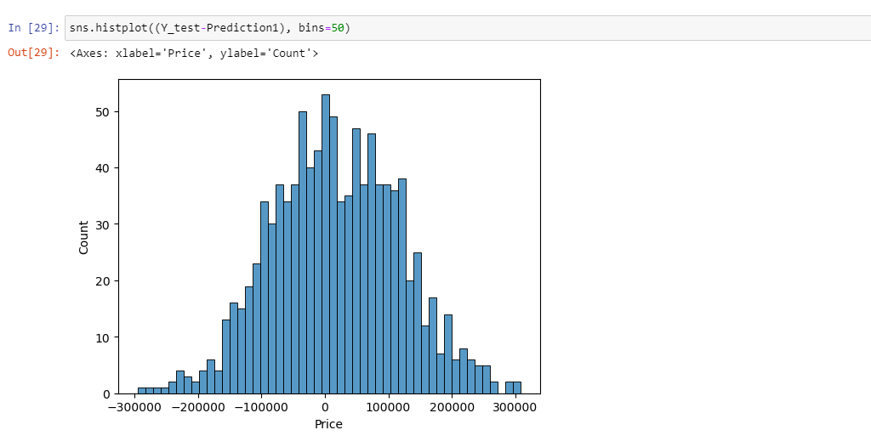

**EVALUATING ITS PERFORMANCE:**

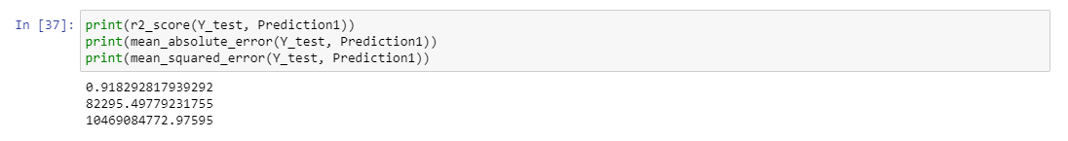

**SUPPORT VECTOR REGRESSION:**

The goal of SVR is to find a function that approximates the relationship between the input variables and a continuous target variable, while minimizing the prediction error .

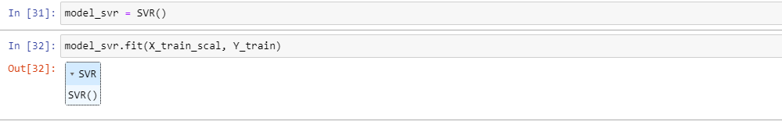

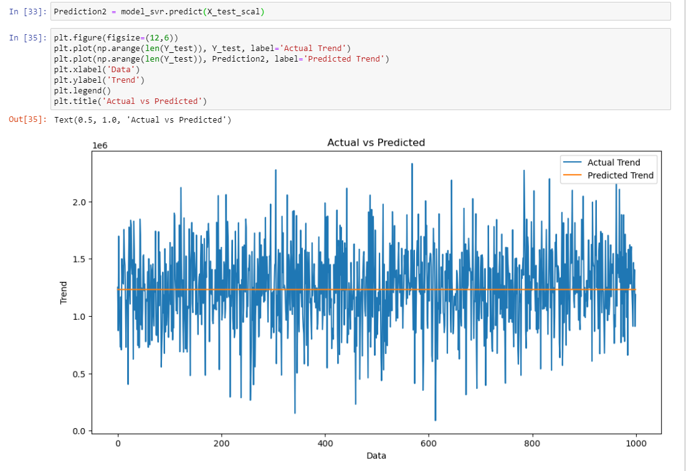

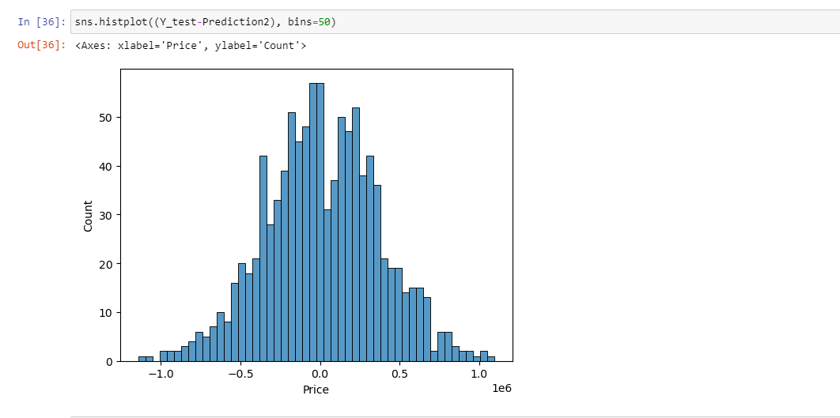

**EVALUATING ITS PERFORMANCE:**

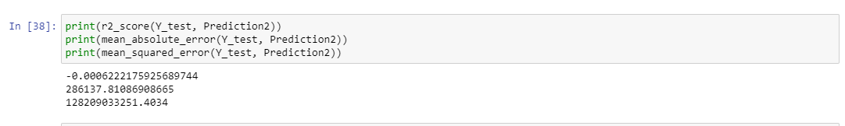

**CONCLUSION:**

The AI phase 4 House price prediction project, our focus was on building the project by selecting a machine learning algorithm , training the model and evaluating its performance for dataset. In previous phase that the dataset has been properly loaded and pre-processed, Now the dataset has completed next stage which typically include model selection, training, and evaluation.