
HYDERABAD INSTITUTE FOR TECHNOLOGY AND MANAGEMENT SCIENCES
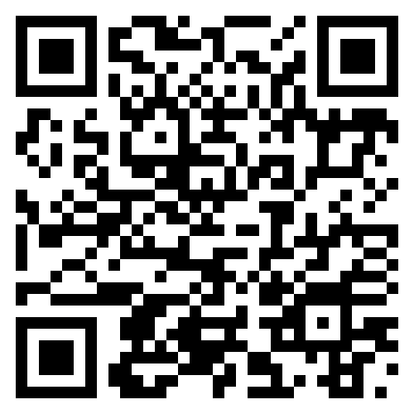
COURSE: CIVIC AND COMMUNITY ENGAGEMENT
Responsible Use of Social Media

Name: ___________________ Class: ___________ School: ___________________

PART 1: PRE-WORKSHOP
Please circle the number that best describes your current knowledge.
1. How much time do you spend on social media daily?
[ ] 1 hour [ ] 2–3 hours [ ] 4 or more hour
2. If a stranger sends you a friend request, what do you do?
[ ] Accept it [ ] Ignore it [ ] Talk to them
3. Do you share your password with friends?
[ ] Yes [ ] No [ ] Sometimes
4. Do you think everything on the internet is true?
[ ] Yes [ ] No [ ] Not Sure
5. Do you use your phone before sleeping?
[ ] Yes [ ] No
6. Do you know what “Report” or “Block” means?
[ ] Yes [ ] No

PART 2: POST-WORKSHOP
Please circle the number that best describes your current knowledge.
1. What is a safe daily screen time?
[ ] Unlimited [ ] 2–3 hours [ ] 8 hours
2. If a stranger sends you a message, what should you do?
[ ] Reply [ ] Ignore / Block [ ] Share personal info
3. What should you do with fake news?
[ ] Share it [ ] Ignore [ ] Check (verify) it
4. Who should you share your password with?
[ ] Friends [ ] Family [ ] No one

5. What should you do if someone bullies you online?
[ ] Reply [ ] Ignore and Report

