Recursive Functions

A definition that defines an object in terms of itself is said to be recursive. This theoretical mathematical topic serves as an introduction to recursive programming (which is supported by most high-level languages today). It also provides a framework for analyzing algorithms (determining the running time and/or space required) which contain loops or recursive sections.

Many expressions may be defined recursively in a very simple and elegant manner. The art of recursive thinking is an important skill. Applications of recursion appear in many areas of mathematics (factorials, compound interest, difference equations, etc.)

Recursion is related to the mathematical concept of recurrence relationships. The field of fractals and dynamical analysis also makes recursion essential. Most tree algorithms (see Data Structures) are recursive in nature.

In this round recursive relationships will be shown not in the context of a programming language but usually in functional notation from mathematics or in an algorithmic description.

References

Roberts, Eric S. Thinking Recursively, Wiley (1986).
Rohl, J.S. Recursion via Pascal, Cambridge University Press (1984).
Wirth, Niklaus. Algorithms + Data Structures = Programs, Prentice-Hall (1976), Chapter 3.

Sample Problems

Consider the following recursive algorithm for painting a square:  1. Given a square.  2. If the length of a side is less than 2 feet, then stop.  3. Divide the square into 4 equal size squares (i.e., draw a “plus” sign inside the square).  4. Paint one of these 4 small squares.  5. Repeat this procedure (start at step 1) for each of the 3 unpainted squares.  If this algorithm is applied to a square with a side of 16 feet (having a total area of 256 sq. feet), how many square feet will be painted? | In the first pass, we get four squares of side 8. One is painted; three are unpainted. Next, we have 3*4 squares of side 4: three are painted (area=3*4²), nine are not. Next, we have 9*4 squares of side 2: nine are painted (area = 9*2²), 27 are not. Finally, we have 27*4 squares of side 1: twenty-seven are painted. Therefore, the total painted is  1*8² + 3*4² + 9*2² + 27*1² = 175.
Evaluate f(12, 6), given:  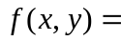{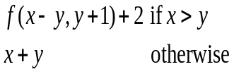 | Evaluate the function as follows:  f(12, 6) = f(6, 5)+2  = (f (1, 4)+2)+2  = f(1, 4)+4  = (1+4)+4  = 9
Find f(6), given:  {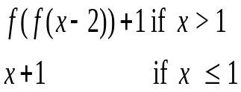 | Working backwards, we get  f(0)= 1  f(1) = 2  f(2) = f(f(0))+1 = f(1)+1 = 2+1 = 3  f(3) = f(f(1))+1 = f(2)+1 = 3+1 = 4  f(4) = f(f(2))+1 = f(3)+1 = 4+1 = 5  f(5) = f(f(3))+1 = f(4)+1 = 5+1 = 6  f(6) = f(f(4))+1 = f(5)+1 = 6+1 = 7
Find f(84,63), given:  {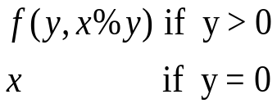  Given that the operator % means modulus or the remainder when dividing x by y. | This is Euclid’s Algorithm for finding the greatest common factor of two positive integers written recursively. It evaluates:  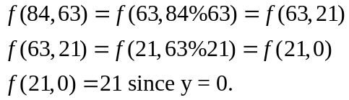  Therefore, the GCF of 84 and 63 is 21.
One of the best known recursive functions, Ackerman’s Function, is defined below. Evaluate A(2, 3).  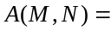{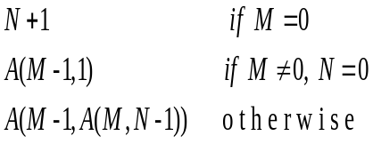  Challenge for the bored:  Evaluate A(n, m) in terms of n and m. | Ackerman’s Function is infamous for its potential growth. In fact, we don’t have room here to give a full explanation of the problem. For details, refer to the 1981-82 ACSL All-Star Contest.  By evaluating A(1,0), A(1,1), A(1,2) and A(1,3), we see that in general, A(1, x)=2+x.  If we evaluate A(2,0), A(2,1), …, we see that in general, A(2,x)=2x+3. To solve our problem, we substitute x=3 and we get an answer of 9.

