**SDA lab project**

**Submitted By:** Hadi Raza (FA22-BSE-057)

**Submitted To:** SirMukhtiar Zamin

**Date:** 7th November, 2024.

***Book Wala***

**Report**

We are developing an online platform that offers users access to a wide range of licensed books. Our goal is to enhance the reading experience, making it easier for users to dive into literature, track their progress, and connect with fellow readers.

**Benefits**

1. **Enhanced Reading Skills**: Our app promotes regular reading, helping users improve their comprehension and retention abilities.
2. **Improved Speaking Skills**: Engaging with books and participating in discussions can boost vocabulary and communication skills.
3. **Community Interaction**: Users can leave reviews and comments, fostering discussions that create a sense of community and shared learning.

**Features**

* **Varied Book Selection**: A broad assortment of genres to cater to diverse interests.
* **Highlighting Tool**: Users can mark key passages for easy reference.
* **Bookmarking**: Save progress effortlessly to resume reading whenever convenient.
* **Personalized Recommendations**: Tailored book suggestions based on individual reading history and preferences.

**Target Audience**

* **Students**: Aimed at those looking to enhance their reading and comprehension skills.
* **Book Lovers**: Readers who enjoy discussing and sharing insights about literature.
* **Language Learners**: Individuals seeking to improve their language skills through reading.

**Potential Challenges**

* **User Experience**: Creating a welcoming environment for all users.
* **Sustaining Motivation**: Keeping users engaged and encouraging consistent reading habits.
* **App Maintenance**: Ensuring the platform remains updated and free from technical issues.

**Conclusion**

Our web app has the potential to greatly enhance users’ reading and speaking abilities by encouraging regular engagement with literature and facilitating effective communication. By offering a platform that promotes literacy and discussion, we aim to empower users to become more confident readers and communicators, ultimately contributing to a more literate and articulate community.

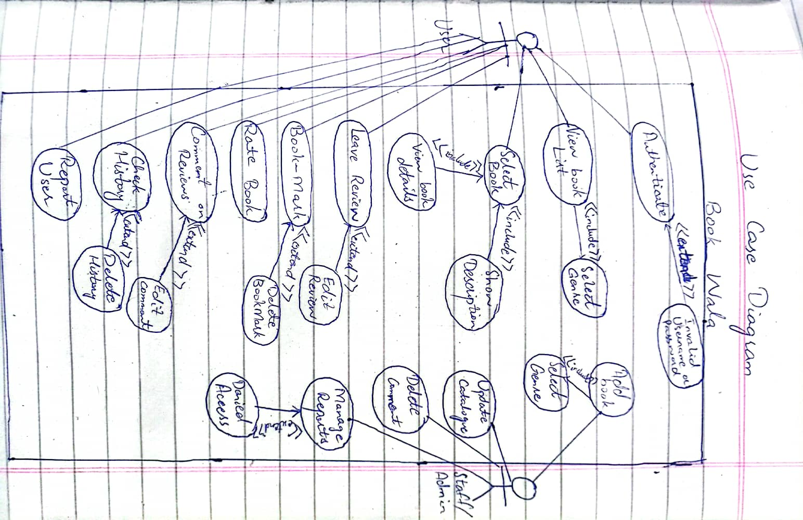**Use Case Diagram:**

**Fully-Dressed Use Case Diagram:**

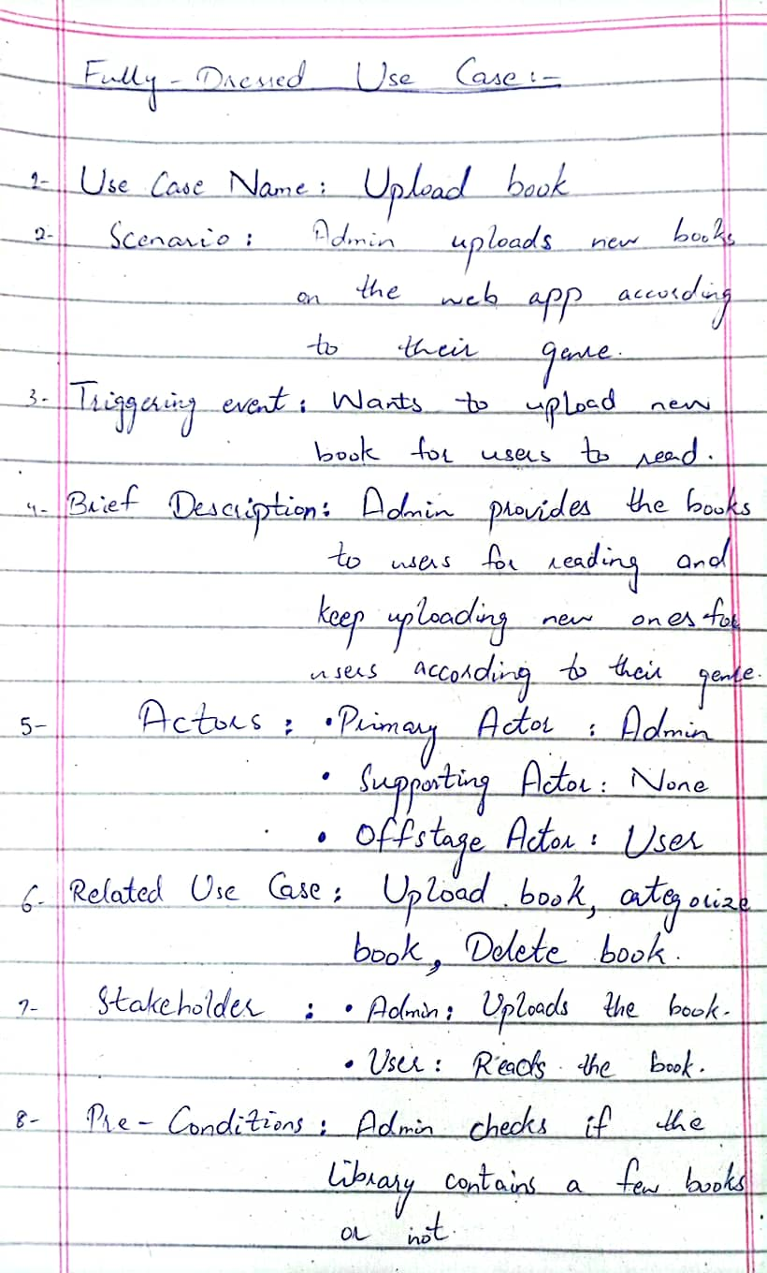

**SSD:-**

**Communication Diagram:-**

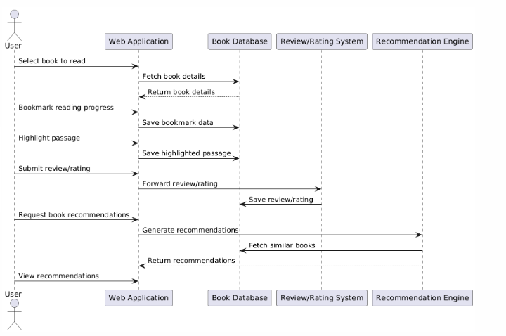

**Code:-**

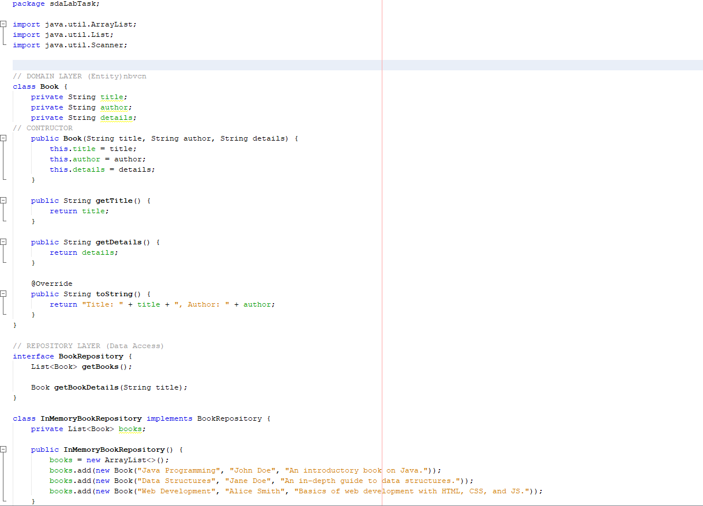

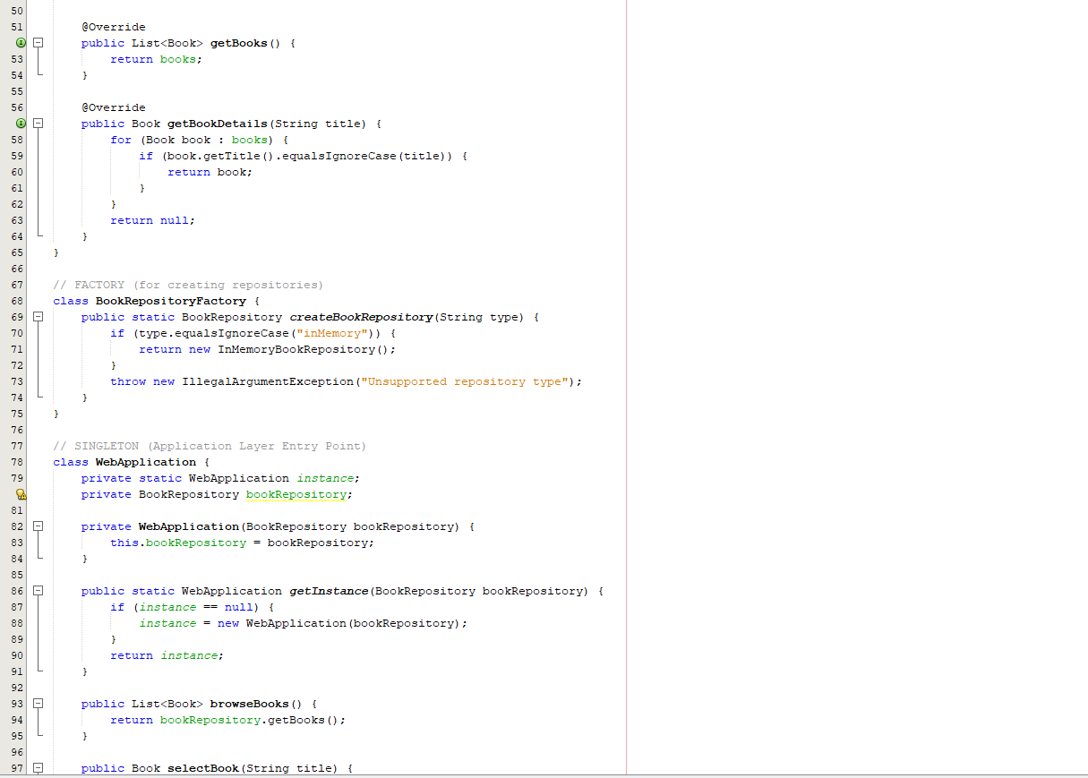

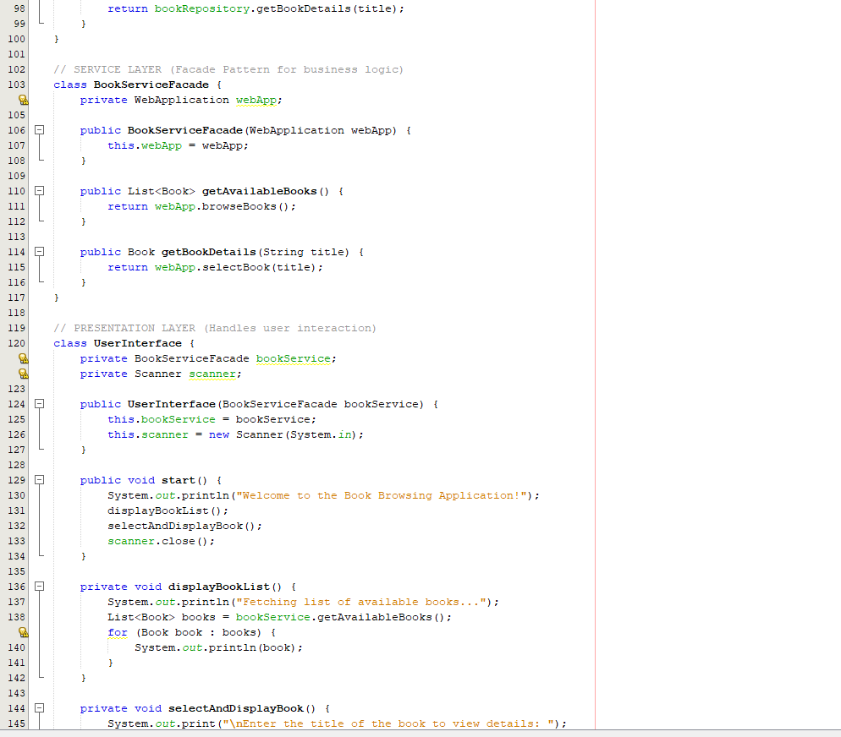

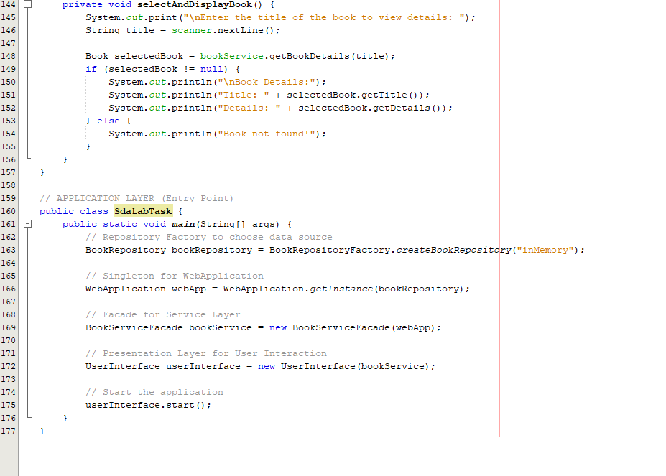

**Code with GUI:-**



