ГУАП

КАФЕДРА № 43

ОТЧЕТ   
ЗАЩИЩЕН С ОЦЕНКОЙ

ПРЕПОДАВАТЕЛЬ

|  |  |  |  |  |
| --- | --- | --- | --- | --- |
| Старший преподаватель |  |  |  | Н.В Путилова |
| должность, уч. степень, звание |  | подпись, дата |  | инициалы, фамилия |

|  |
| --- |
| ОТЧЕТ О ЛАБОРАТОРНОЙ РАБОТЕ №6  Разработка SQL запросов: запросы с подзапросами |
| **по дисциплине: Проектирование баз данных** |
|  |
|  |

РАБОТУ ВЫПОЛНИЛ

|  |  |  |  |  |  |
| --- | --- | --- | --- | --- | --- |
| СТУДЕНТ ГР. | 4134к |  |  |  | Столяров Н.С. |
|  |  |  | подпись, дата |  | инициалы, фамилия |

Санкт-Петербург

2023

Задание

По аналогии с примерами, приведенными в п. 1 и 2 реализовать запросы а) .. в), указанные в варианте задания. Все запросы должны не содержать вложенных запросов или агрегатных функций. (Используйте псевдонимы)

Задание(19 вариант): туристический путеводитель: город, достопримечательность, адрес, тип достопримечательности (памятник, архитектурный комплекс, природный комплекс), дата создания

а. достопримечательности, в которых есть слово «Дворец», но с него название не начинается

б. город без улиц

в. улица, на которой есть и памятники, и музеи

г. город, в котором нет памятников, но архитектурные комплексы

д1. улица, на которой музеев больше среднего

е. улица с самыми старыми достопримечательностями

ж1. тип достопримечательностей, который есть во всех городах, где есть достопримечательности

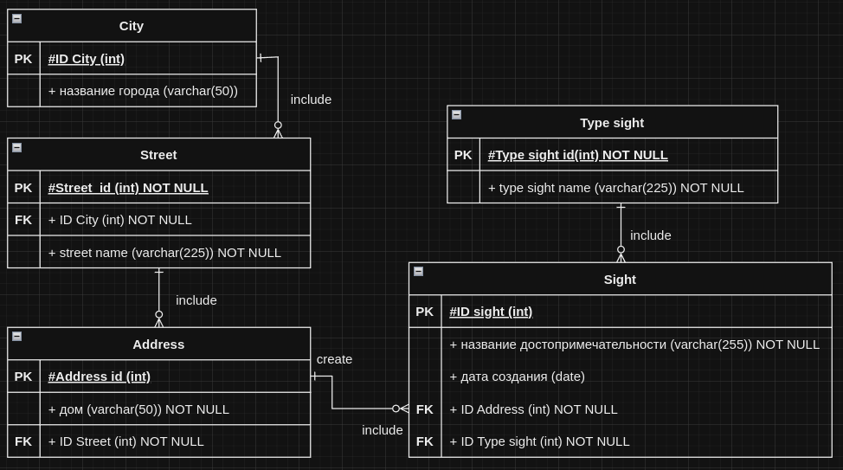

Скрипты

Г) г. город, в котором нет памятников, но архитектурные комплексы

--1

--город, в котором нет памятников, но архитектурные комплексы

select * from City

join Street on City.IDCity = Street.IDCity

join Addres on Addres.IDStreet = Street.IDStreet

join Sight on Sight.IDAdress = addres.idadress

join typesight on typesight.idtypesight = sight.idtypesight

where sight.namesight = 'Архитектурный комплекс'

except

select * from City

join Street on City.IDCity = Street.IDCity

join Addres on Addres.IDStreet = Street.IDStreet

join Sight on Sight.IDAdress = addres.idadress

join typesight on typesight.idtypesight = sight.idtypesight

where sight.namesight = 'Памятник'

;

select * from City

join Street on City.IDCity = Street.IDCity

join Addres on Addres.IDStreet = Street.IDStreet

join Sight on Sight.IDAdress = addres.idadress

join typesight on typesight.idtypesight = sight.idtypesight

left join

(select City.* from City

join Street on City.IDCity = Street.IDCity

join Addres on Addres.IDStreet = Street.IDStreet

join Sight on Sight.IDAdress = addres.idadress

join typesight on typesight.idtypesight = sight.idtypesight

where sight.namesight = 'Памятник') as tt on city.IDCity = tt.IDCity

where sight.namesight = 'Архитектурный комплекс' and tt.IDCity is null;

--2

--город, в котором нет памятников, но архитектурные комплексы

select * from City

join Street on City.IDCity = Street.IDCity

join Addres on Addres.IDStreet = Street.IDStreet

join Sight on Sight.IDAdress = addres.idadress

join typesight on typesight.idtypesight = sight.idtypesight

where sight.namesight = 'Архитектурный комплекс'

and City.idcity not in(

select City.idcity from City

join Street on City.IDCity = Street.IDCity

join Addres on Addres.IDStreet = Street.IDStreet

join Sight on Sight.IDAdress = addres.idadress

join typesight on typesight.idtypesight = sight.idtypesight

where sight.namesight = 'Памятник'

)

;



д) улица, на которой музеев больше среднего

SELECT distinct s.IDStreet, s.StrretName as MuseumsCount

FROM Street s

JOIN Addres a ON s.IDStreet = a.IDStreet

JOIN Sight si ON a.IDAdress = si.IDAdress

join typesight ty on ty.IDTypeSight = si.IDTypeSight

where ty.TypeSightName = 'Музей'

GROUP BY s.IDStreet, s.StrretName

HAVING COUNT(distinct si.IDSight) > (SELECT AVG(NULLIF(MuseumsCount,0)) FROM

(SELECT s.IDStreet, COUNT(distinct si.IDSight) as MuseumsCount

FROM Street s

left JOIN Addres a ON s.IDStreet = a.IDStreet

left JOIN Sight si ON a.IDAdress = si.IDAdress

left join typesight ty on ty.IDTypeSight = si.IDTypeSight

and ty.TypeSightName = 'Музей'

group by s.IDStreet) as x

);

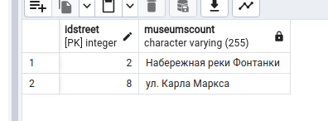



е) улица с самыми старыми достопримечательностями

SELECT Street.StrretName

FROM Street

JOIN Addres ON Addres.IDStreet = Street.IDStreet

JOIN Sight ON Sight.IDAdress = Addres.IDAdress

where Sight.CreateDate <= ALL (SELECT Sight.CreateDate FROM Sight WHERE Sight.CreateDate IS NOT NULL);

SELECT Street.StrretName

FROM Street

JOIN Addres ON Addres.IDStreet = Street.IDStreet

JOIN Sight ON Sight.IDAdress = Addres.IDAdress

where Sight.CreateDate = (SELECT MIN(Sight.CreateDate) FROM Sight WHERE Sight.CreateDate IS NOT NULL);

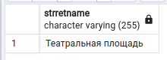

ж 1) тип достопримечательностей, который есть во всех городах, где есть достопримечательности

SELECT TypeSight.TypeSightName

FROM TypeSight

WHERE NOT EXISTS (

SELECT DISTINCT City.IDCity

FROM City

WHERE NOT EXISTS (

SELECT Addres.IDAdress

FROM Addres

JOIN Sight ON Sight.IDAdress = Addres.IDAdress

join street str on str.idstreet = Addres.idstreet

WHERE Sight.IDTypeSight = TypeSight.IDTypeSight

and str.idcity = City.idcity

)

AND EXISTS (

SELECT Addres.IDAdress

FROM Addres

join street as str2 on str2.idstreet = Addres.idstreet

JOIN Sight ON Sight.IDAdress = Addres.IDAdress

where str2.idcity = City.idcity

)

);

-------------------------------------------------------------------------

SELECT TypeSight.TypeSightName

FROM TypeSight

WHERE NOT EXISTS (

SELECT DISTINCT cit.IDCity

FROM City as cit

join street as str2 on str2.idcity = cit.idcity

join addres as adr on str2.idstreet = adr.idstreet

JOIN Sight ON Sight.IDAdress = adr.IDAdress

WHERE NOT EXISTS (

SELECT Addres.IDAdress

FROM Addres

JOIN Sight ON Sight.IDAdress = Addres.IDAdress

join street str on str.idstreet = Addres.idstreet

WHERE Sight.IDTypeSight = TypeSight.IDTypeSight

and str.idcity = cit.idcity

)

);

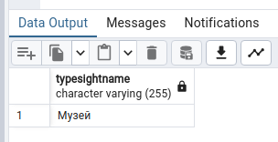

2) select typesight.typesightname

FROM City

join street as str on str.idcity = City.idcity

join Addres as ad on str.idstreet = ad.idstreet

join sight on sight.idadress = ad.idadress

join typesight on typesight.idtypesight = sight.idtypesight

group by typesight.typesightname

having count(distinct City.idcity) = (SELECT count(distinct City.idcity)

FROM City

join street as str on str.idcity = City.idcity

join Addres as ad on str.idstreet = ad.idstreet

join sight on sight.idadress = ad.idadress

join typesight on typesight.idtypesight = sight.idtypesight

)



SELECT typesight.typesightname

FROM City

JOIN street AS str ON str.idcity = City.idcity

JOIN Addres AS ad ON str.idstreet = ad.idstreet

JOIN sight ON sight.idadress = ad.idadress

JOIN typesight ON typesight.idtypesight = sight.idtypesight

GROUP BY typesight.typesightname

HAVING COUNT(DISTINCT City.idcity) = ALL (

SELECT COUNT(DISTINCT City.idcity)

FROM City

JOIN street AS str ON str.idcity = City.idcity

JOIN Addres AS ad ON str.idstreet = ad.idstreet

JOIN sight ON sight.idadress = ad.idadress

JOIN typesight ON typesight.idtypesight = sight.idtypesight

);

----------------

SELECT typesight.typesightname

FROM City

RIGHT JOIN street AS str ON str.idcity = City.idcity

RIGHT JOIN Addres AS ad ON str.idstreet = ad.idstreet

RIGHT JOIN sight ON sight.idadress = ad.idadress

RIGHT JOIN typesight ON typesight.idtypesight = sight.idtypesight

GROUP BY typesight.typesightname

HAVING COUNT(DISTINCT City.idcity) = ALL (

SELECT COUNT(DISTINCT City.idcity)

FROM City

RIGHT JOIN street AS str ON str.idcity = City.idcity

RIGHT JOIN Addres AS ad ON str.idstreet = ad.idstreet

RIGHT JOIN sight ON sight.idadress = ad.idadress

RIGHT JOIN typesight ON typesight.idtypesight = sight.idtypesight

);

----------------

SELECT TypeSight.TypeSightName

FROM TypeSight

WHERE NOT EXISTS (

SELECT DISTINCT cit.IDCity

FROM City as cit

join street as str2 on str2.idcity = cit.idcity

join addres as adr on str2.idstreet = adr.idstreet

JOIN Sight ON Sight.IDAdress = adr.IDAdress

WHERE NOT EXISTS (

SELECT Addres.IDAdress

FROM Addres

JOIN Sight ON Sight.IDAdress = Addres.IDAdress

join street str on str.idstreet = Addres.idstreet

WHERE Sight.IDTypeSight = TypeSight.IDTypeSight

and str.idcity = cit.idcity

)

);