ГУАП

КАФЕДРА № 43

ОТЧЕТ   
ЗАЩИЩЕН С ОЦЕНКОЙ

ПРЕПОДАВАТЕЛЬ

|  |  |  |  |  |
| --- | --- | --- | --- | --- |
| Старший преподаватель |  |  |  | Н.В Путилова |
| должность, уч. степень, звание |  | подпись, дата |  | инициалы, фамилия |

|  |
| --- |
| ОТЧЕТ О ЛАБОРАТОРНОЙ РАБОТЕ №7  Хранимые процедуры |
| **по дисциплине: Проектирование баз данных** |
|  |
|  |

РАБОТУ ВЫПОЛНИЛ

|  |  |  |  |  |  |
| --- | --- | --- | --- | --- | --- |
| СТУДЕНТ ГР. | 4134к |  |  |  | Столяров Н.С. |
|  |  |  | подпись, дата |  | инициалы, фамилия |

Санкт-Петербург

2023

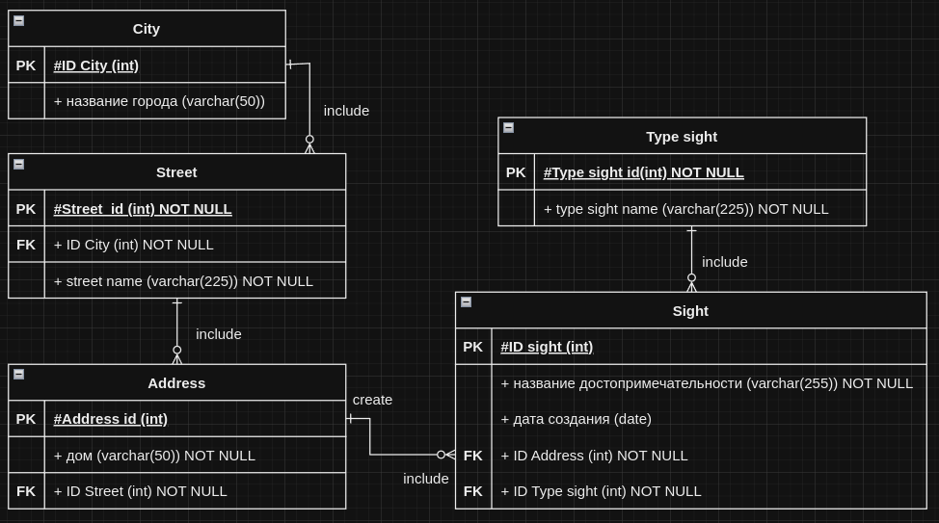  
  
**вставка улицы по городу если нет города вставка города**

|  |
| --- |
| -- вставка улицы по городу если нет города вставка города  CREATE OR REPLACE FUNCTION ins_street (_NameCity varchar(50),_StrretName varchar(225))  RETURNS VOID AS $$  declare  new_id_city int;  new_id_street int;  BEGIN  if not exists(select * from city where NameCity = _NameCity) then  begin  select COALESCE(max(IDCity) + 1,0) into new_id_city from city;  insert into city (IDCity,NameCity) values (new_id_city,_NameCity);  end;  else  select IDCity into new_id_city from city where NameCity = _NameCity;  end if;  select COALESCE(max(IDStreet) + 1,0) into new_id_street from street;  insert into street (IDStreet,IDCity,StrretName) values (new_id_street,new_id_city,_StrretName);  END;  $$ LANGUAGE plpgsql;  DROP FUNCTION ins_street;  select ins_street('123','StrretName'); |

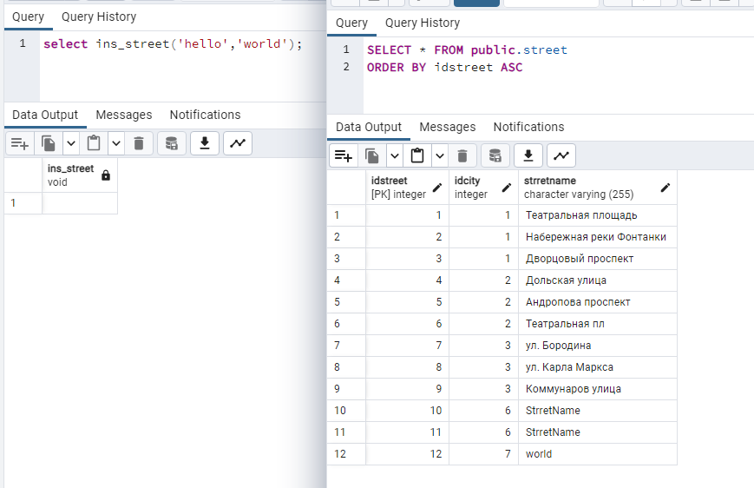

**удаление sight и type sight если на него больше не чего не указывает**

|  |
| --- |
| CREATE OR REPLACE FUNCTION del_sight_clear_typesight(IDSight_del int)  RETURNS VOID AS $$  declare  IDTypeSight_del int;  begin  select IDTypeSight into IDTypeSight_del from Sight where IDSight = IDSight_del;  delete from Sight where IDSight = IDSight_del;  if not exists(select * from Sight where IDTypeSight = IDTypeSight_del)  then delete from TypeSight where IDTypeSight = IDTypeSight_del;  end if;  END;  $$ LANGUAGE plpgsql;  select del_sight_clear_typesight(8);  select del_sight_clear_typesight(11); |

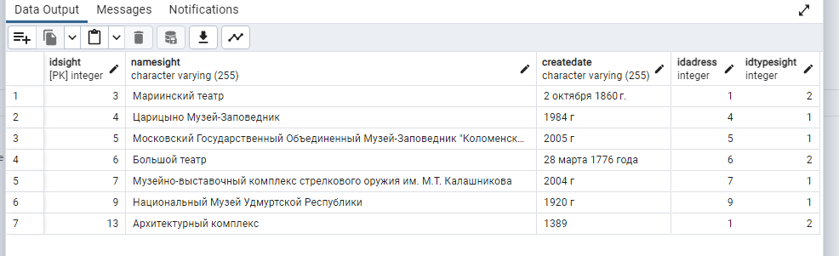

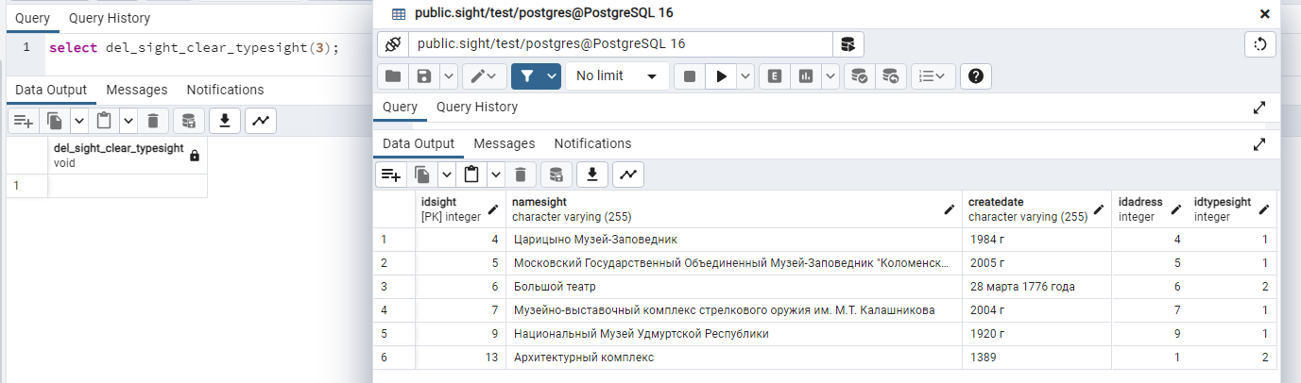

**удаление адреса и всех sight которые на него указывют (каскадное удаление)**

|  |
| --- |
| CREATE OR REPLACE FUNCTION del_addres_cascade(IDAdress_del int)  RETURNS VOID AS $$  begin  delete from Sight where IDAdress = IDAdress_del;  delete from addres where IDAdress = IDAdress_del;  end;  $$ LANGUAGE plpgsql;  select del_addres_cascade(8); |

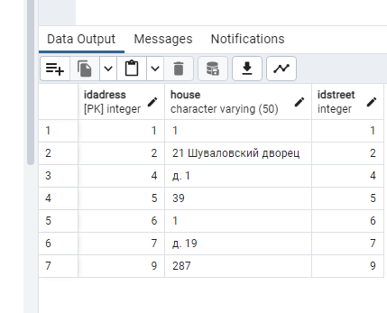

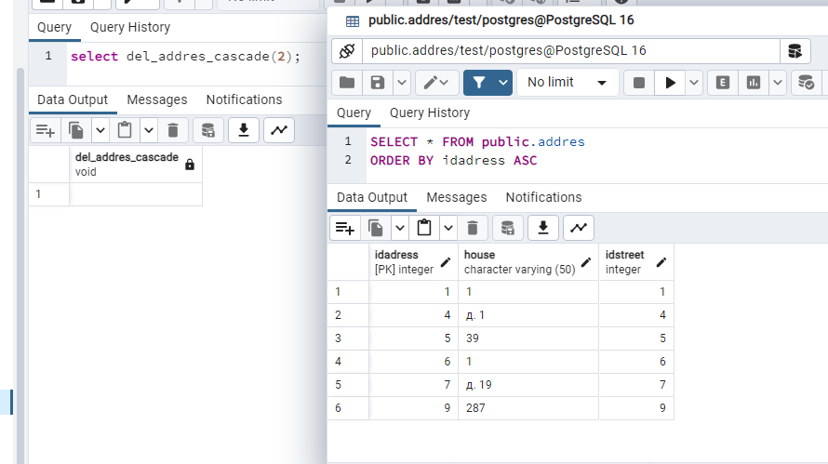**возврат количества городов**

|  |
| --- |
| -- возврат количество городов  CREATE OR REPLACE FUNCTION count_city_fun()  RETURNS INT AS $$  declare  val int default 0;  begin  select COALESCE(count(IDCity),0) into val from city;  return val;  end;  $$ LANGUAGE plpgsql; |

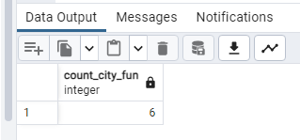

**формирование статистики во временной таблице**

|  |
| --- |
| -- формирование статистики во временной таблице  CREATE OR REPLACE FUNCTION city_statistics ()  RETURNS TABLE (  -- id_stat int,  IDCity int,  count_street int,  count_addres int  ) as $$  begin  create temporary table if not exists city_stat (  -- id_stat serial primary key,  IDCity int,  count_street int,  count_addres int  );  insert into city_stat(IDCity,count_addres,count_street)  select City.IDCity, count(IDAdress) as count_addres,count(street.IDStreet) as count_street from City  left join street on street.IDCity = City.IDCity  left join addres on addres.IDStreet = street.IDStreet  group by City.IDCity;  RETURN QUERY SELECT * FROM city_stat;  drop table city_stat;  end;  $$ LANGUAGE plpgsql;  DROP FUNCTION city_statistics;  select * from city_statistics(); |

