**Customer 365 Project**

**Customer Unique ID**

**Design Documentation**

For

Toyota Motor Thailand Co., Ltd



Prepared by

4Plus Consulting Company Limited



**Document Signoff**

The following table identifies all management authorities who have successively approved the present issue of this document.

|  |  |  |  |  |
| --- | --- | --- | --- | --- |
| **No.** | **Reviewer** | **Unit/Department** | **Signature** | **Date** |
| 1 |  |  |  |  |
| 2 |  |  |  |  |
| 3 |  |  |  |  |
| 4 |  |  |  |  |
| 5 |  |  |  |  |
| 6 |  |  |  |  |
| 7 |  |  |  |  |
| 8 |  |  |  |  |
| 9 |  |  |  |  |
| 10 |  |  |  |  |

*Your signature indicates that you have read and understand this document which addresses all areas of the business requirements.

**Document Tracking**

The following table records the complete history of the successive editions of the present document.

|  |  |  |  |
| --- | --- | --- | --- |
| Date | Version | Author | Change Description |
| 12/07/2021 | 0.1 | Jakapan N. | Initial Document |
|  |  |  |  |
|  |  |  |  |
|  |  |  |  |
|  |  |  |  |
|  |  |  |  |
|  |  |  |  |
|  |  |  |  |

**Table of Contents**

Document Objective 1

1. Overall UID Process 1

2. Source of Customer Data 2

2.1. Select source of customer data 2

2.2. Select active customer for UID Generation 3

Document Objective

The objectives of this document are to summarize Customer Unique ID process design including the following topics.

1. Overall UID Process
2. Source of Customer Data
3. Customer Data Cleansing
4. UID Merging Rule
5. Main Profile Selection
6. Output Table from UID Process

# Overall UID Process

UID Generation Program consist of 5 main processes as illustrated below.

Choose Customer Data

The process of choosing customer data including the following:

* Select source of customer data
* Select active customer for UID generation

Clean Customer Data

The process of customer data cleansing is to improve data quality by eliminating incorrected data format on the following customer attributes:

* Customer name
* Mobile number
* Telephone number
* Email
* Date of Birth
* Citizen ID

Prepare Customer Temp Table

The process of customer temp table preparation is to standardize the customer attributes from different sources into the single table. The table then use as a source of UID generation program.

Generate UID

The process of UID generation is to assigned customer primary key using for reference to customer data from different sources. Result of UID generation process is customer mapping table that will be used in main profile selection in the next step.

Select Customer Main Profile

The process of customer main profile selection is to select customer attribute value from different sources in customer mapping table. The result is customer master that containing of the representative customer attributes.

# Source of Customer Data

## Select source of customer data

There are 11 customer data sources which are divided into 2 parts according to delivery sprint. The 1st sprint is focusing on 2 main data sources including Topserv & DDMS while the other sources will be added in the 2nd sprint.

| **No.** | **Data Source** | **Delivery Sprint** | **Status** |
| --- | --- | --- | --- |
| 1 | Topserv | 1st Sprint | Data Source Confirmed |
| 2 | DDMS | 1st Sprint | Data Source Confirmed |
| 3 | CR-Web | 2nd Sprint | Will be added later |
| 4 | T-Target | 2nd Sprint | Will be added later |
| 5 | Smart Event | 2nd Sprint | Will be added later |
| 6 | Test A Car | 2nd Sprint | Will be added later |
| 7 | TDEX | 2nd Sprint | Will be added later |
| 8 | T-Connect | 2nd Sprint | Will be added later |
| 9 | Used Car | 2nd Sprint | Will be added later |
| 10 | T-Privilege | 2nd Sprint | Will be added later |
| 11 | E-Toyota Club | 2nd Sprint | Will be added later |

## Select active customer for UID Generation

1. Topserv

There are millions of customer records which we are going to generate UID for them. However, this enormous size of data might impact the processing times of UID generation program. Thus, we considered to filter out some customers who are not active to reduce workload of the program. The diagram below shows the active customer which we are going to feed to the program.

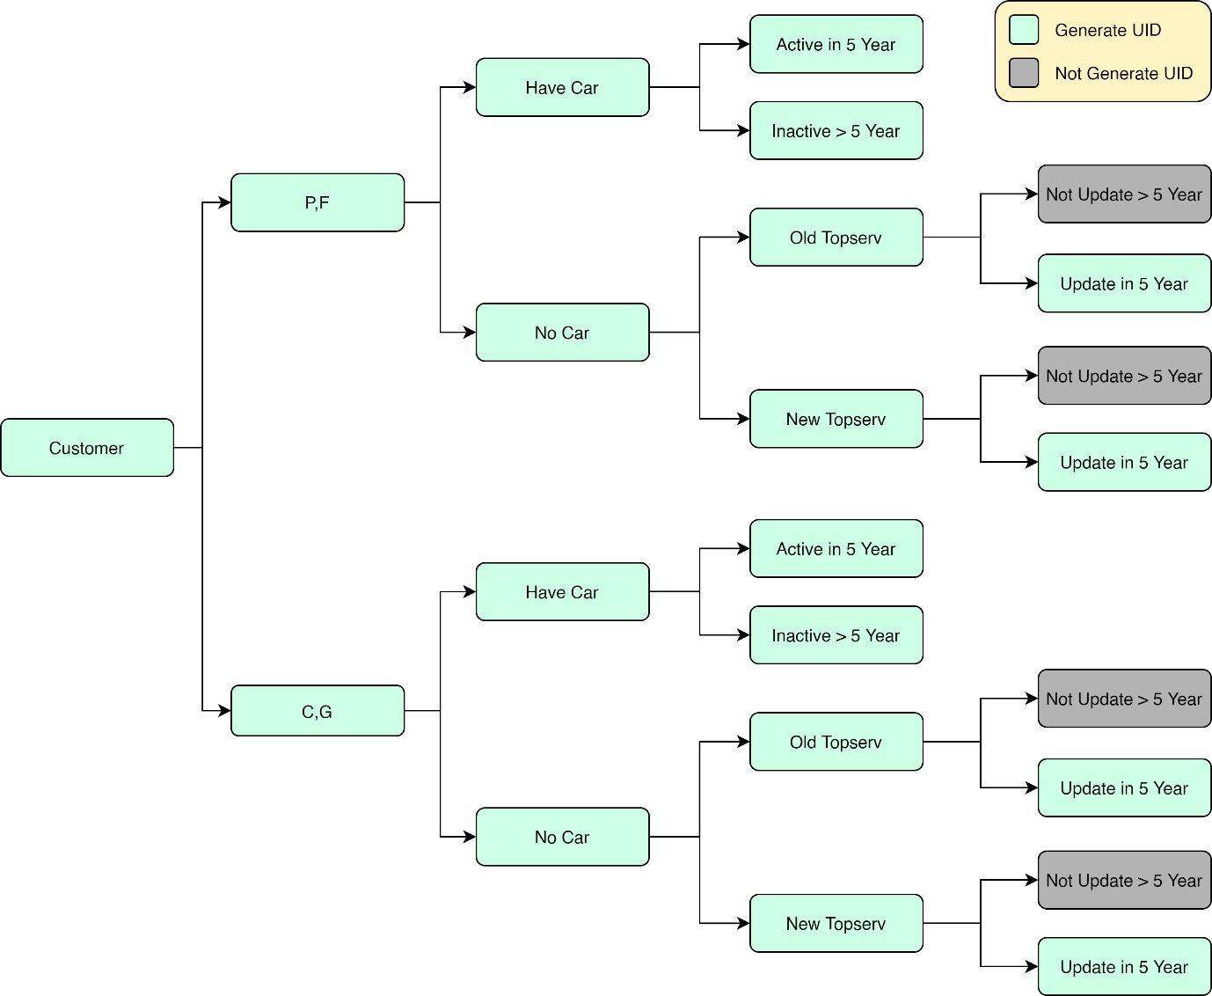

The diagram shows that we are going to select active customer starting from dividing customer types into 2 groups which are 1) Thai Personal (P) and Foreigner (F) and 2) Corporate (C) and Government (G). Each group has the same definition of active customer which is describing in 3 main steps including the following.

1st Step: Vehicle Ownership

The first step is to separate customer by finding vehicle ownership of customer which are categorized into 2 groups which are 1) Have Car and 2) No Car. The following source data used in finding the group is specified in the table shown below.

|  |  |
| --- | --- |
| **Source Data** | **Meaning** |
| master_c365_topserv_customer | Customer Master of Topserv System |
| master_c365_topserv_vehicle | Vehicle Master of Topserv System |

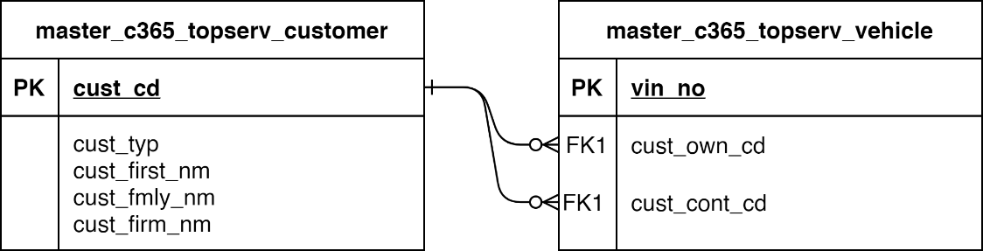

**Example Data**

The following table shows an example of relationship of customer and vehicle which are categorized into 2 groups: 1) Have Car and 2) No Car

|  |  |  |  |  |
| --- | --- | --- | --- | --- |
| **Ownership Group** | **cust_cd** | **vin_no** | **cust_own_cd** | **cust_cont_cd** |
| Have Car | C11901026 | MR0ER39G707808416 | C11901026 | C12764034 |
| Have Car | C12764034 | MR0ER39G707808416 | C11901026 | C12764034 |
| No Car | C12130767 |  |  |  |

2nd Step: Customer Activeness

Customer Activeness is defined according to the Vehicle Ownership groups. The following source data used in finding the group is specified in the table shown below.

|  |  |
| --- | --- |
| **Source Data** | **Meaning** |
| master_c365_topserv_customer | Customer Master of Topserv System |
| master_c365_topserv_vehicle | Vehicle Master of Topserv System |

Customer Activeness are defined using the following condition.

| **Customer Activeness** | **Definition** | **Calculation fields** | **Formula** |
| --- | --- | --- | --- |
| Active in 5 Year | Customer who is an owner or a contact of a vehicle that has last serviced date within 5 Years from current year. | * last_srv_dt * current_date   *(using NOW() function)* | Year(current_date) – Year(last_srv_dt) <= 5 |
| In Active in 5 Year | Customer who is an owner or a contact of a vehicle that has last serviced date more than 5 Years from current year. | * last_srv_dt * current_date   *(using NOW() function)* | Year(current_date) – Year(last_srv_dt) > 5 |
| Old Topserv | Customer data from Topserv legacy systems which are migrated to the current system. | * dm_con_dt | dm_con_dt is not null |
| New Topserv | Customer data from the current Topserv system. | * dm_con_dt | dm_con_dt is null |

3rd Step: Customer Update Date

Customer Update Date will be used to filter out inactive customer from the Old Topserv group, defined in the previous step. The following source data used in finding the group is specified in the table shown below.

|  |  |
| --- | --- |
| **Source Data** | **Meaning** |
| master_c365_topserv_customer | Customer Master of Topserv System |

Customer Update Date are defined using the following condition.

| **Customer Update Date** | **Definition** | **Calculation fields** | **Formula** |
| --- | --- | --- | --- |
| Not update > 5 Year | Customer from legacy Topserv system whose data are not updated more than 5 years. | * upd_dt | Year(current_date) – Year(upd_dt) > 5 |
| Update in 5 Year | Customer from legacy Topserv system whose data are updated within 5 years. | * upd_dt | Year(current_date) – Year(upd_dt) <= 5 |

1. DDMS

Customer Data from DDMS are classified into 2 main types including the following

1) A-Card is a first step of purchasing a new vehicle. Customer recorded in this step are defined as prospect customer who interest in buying a new car by giving their information to dealers but not yet decide to book a car.

2) Booking is the next step of open an A-Card. Customer will book a car with dealer and gave their information to dealer. In this step, customer data quality is better than the data recorded in A-Card.

The following diagram represent a process from opening an A-Card to Retail Sales.

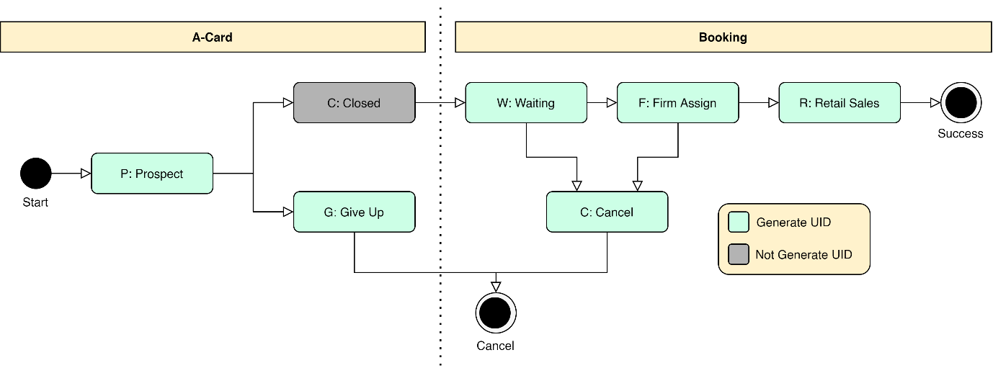

According to the diagram illustrated above, we will exclude customer from A-Card which status is “C: Closed” because these customer records are duplicate with customer from Booking. Other statuses are included in UID generation process.

# Customer Data Cleansing

Customer Data Cleansing is the process of preparing the data to be ready for merging rule in UID generation program. Attributes in this process consist of 6 main attributes including the following.

* Customer name
* Mobile number
* Telephone number
* Email
* Date of Birth
* Citizen ID

## Customer name

Topserv

|  |  |
| --- | --- |
| **Source Data** | **Meaning** |
| master_c365_topserv_customer | Customer Master of Topserv System |

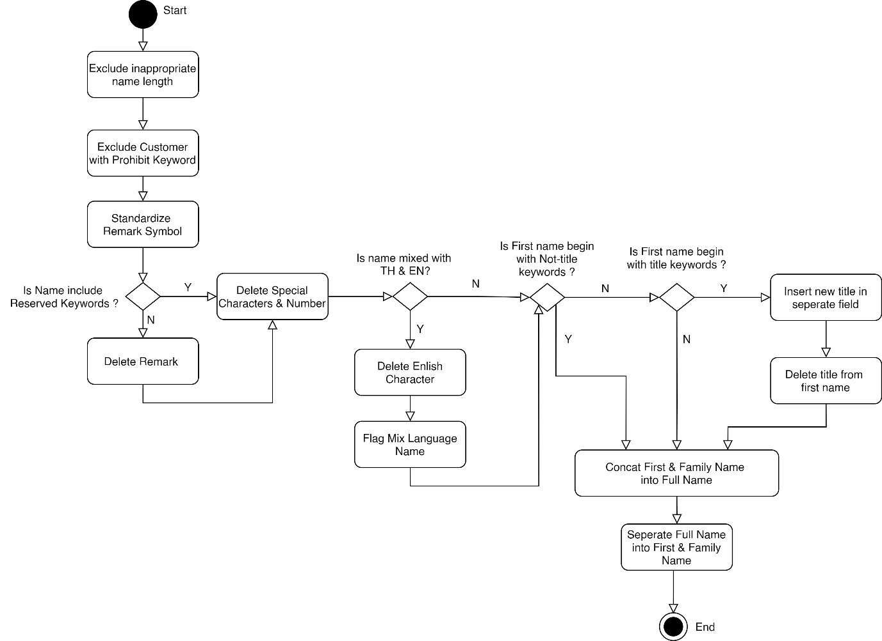

| **No.** | **Node** | **Type** | **Calculation** | **Reference Config** |
| --- | --- | --- | --- | --- |
| 1 | Exclude inappropriate name length | Activity | First Name Length >= 100 or Family Name Length >= 100 |  |
| 2 | Exclude customer with prohibit keywords | Activity | Prohibit keywords in First Name or Family Name | cnf_prohibit_cust_keywords |
| 3 | Standardize remark symbol | Activity | Replace remark symbol including (*text*), [*text*], {*text*} into \**text\** |  |
| 4 | Does Name include reserved keywords? | Decision | Check string in First Name and Family. Does it contain the reserved keywords from configuration? | cnf_reserve_cust_keywords |
| 5 | Delete Remark | Activity | When found remark text in name *(*text*)* and the text is not in reserved keywords then remove text after ‘*’ |  |
|  | Is name mixed with  TH & EN? | Decision | Finding Mixed Language Characters in First Name or Family Name |  |
|  | Delete English Character | Activity | Replace English Character with space |  |
|  | Flag mix language name | Activity | Set is_mix_lang = ‘Y’ if First Name or Family Name is mixed language |  |
|  |  |  |  |  |