**NATIONAL INSTITUTE OF TECHNOLOGY, TIRUCHIRAPPALLI-15**



**Department of Computer Applications**

**STUDENT REGISTRATION**

**PROJECT WORK**

*Submitted By*

**YASH KARIL -205119111**

*Under the guidance of*

**Dr.U.Vignesh**

*Submitted in fulfillment of the project in PL/SQ*

**NATIONAL INSTITUTE OF TECHNOLOGY, TIRUCHIRAPPALLI - 15**



**CERTIFICATE**

*This is to certify that****, YASH KARIL*** *student of 2 nd semester MCA (batch 2019-2022) of National Institute of Technology, Tiruchirappalli has successfully completed the project* ***STUDENT REGISTRATION*** *in PL/SQL**under the guidance of* **Dr.U.Vignesh.**

Signature

(Dr.U.Vignesh)

**CONTENTS**

|  |  |  |
| --- | --- | --- |
| **Ser. No** | **Description** |  |
| 1 | Abstract |  |
| 2 | Schema and Tables Descriptions |  |
| 3 | Creation of Tables using SQL |  |
| 4 | Defining Code For Tables |  |
| 5 | Procedures |  |

**ABSTRACT**

Student Management System

The project on Student management system is for maintaining all the records of the student present in a system. The main motive of this project is to maintain a database for all the student present in the student management system and recover it when necessary, for our convenience.

This project will teach how to do basic database functions that are CREATE RETIEVE UPDATE and DELETE. using Mysql Database. The INSERT, SELECT, UPDATE and DELETE statements can be used in any database system, because this is support by all relational database systems.

We will INSERT, SELECT, UPDATE and DELETE in database by writing code to manage the **records** table in the database named **linda**.  **records** table consist of following columns **name,mobile,course**.

.

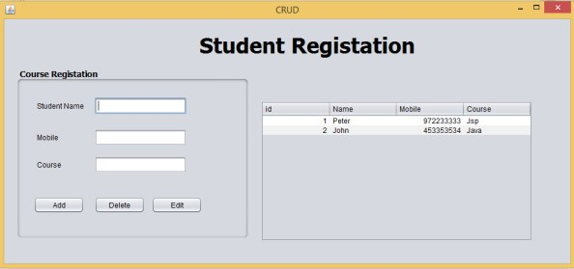

## ****Feature of projects****

The system shall be able to record student details : name,mobile,course.

The system  shall be able to retrieve the student details : name,mobile,course.

Then system shall be able to Edit and Delete the student details : name,mobile,course .

### Create the Database name linda

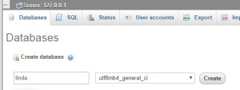

### After created the database have to create the table which name is “records”  the table consist of following Columns  name,mobile,course.

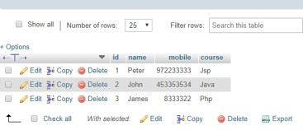

## ****AddRecords****

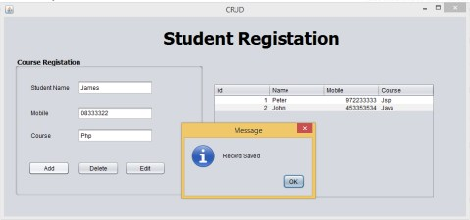

you can use the following code snippet to add the records in to database. paste the code inside the add button

|  |  |
| --- | --- |
| 1  2  3  4  5  6  7  8  9  10  11  12  13  14  15  16  17  18  19  20  21  22  23  24  25 | String name =txtname.getText();    String age =txtmobile.getText();    String course =txtcourse.getText();            try {              Class.forName("com.mysql.jdbc.Driver"); //Register the mysql driver              con1 = DriverManager.getConnection("jdbc:mysql://localhost/linda","root","");              insert = con1.prepareStatement("insert into record (name,mobile,course)values(?,?,?)");              insert.setString(1,name);              insert.setString(2,age);              insert.setString(3,course);              insert.executeUpdate();              JOptionPane.showMessageDialog(this, "Record Saved");                  txtname.setText("");              txtmobile.setText("");              txtcourse.setText("");              table_update();            } catch (ClassNotFoundException ex) {              Logger.getLogger(crud.class.getName()).log(Level.SEVERE, null, ex);          } catch (SQLException ex) {              Logger.getLogger(crud.class.getName()).log(Level.SEVERE, null, ex);          } |

## View Records

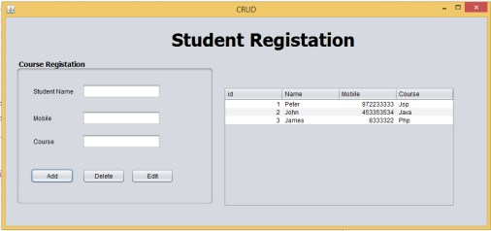

you can use the following code snippet to retrieve the data stored in the database and present it to users in a proper format. create a method **table_update() .**paste the method inside the constructor of the class.when the form is loaded all the records will be shown on the jTable.

|  |  |
| --- | --- |
| 1  2  3  4  5  6  7  8  9  10  11  12  13  14  15  16  17  18  19  20  21  22  23  24  25  26  27 | private void table_update() {          int CC;          try {              Class.forName("com.mysql.jdbc.Driver");              con1 = DriverManager.getConnection("jdbc:mysql://localhost/linda","root","");              insert = con1.prepareStatement("SELECT * FROM record");              ResultSet Rs = insert.executeQuery();                ResultSetMetaData RSMD = Rs.getMetaData();              CC = RSMD.getColumnCount();              DefaultTableModel DFT = (DefaultTableModel) jTable1.getModel();              DFT.setRowCount(0);                while (Rs.next()) {                  Vector v2 = new Vector();                    for (int ii = 1; ii <= CC; ii++) {                      v2.add(Rs.getString("id"));                      v2.add(Rs.getString("name"));                      v2.add(Rs.getString("mobile"));                      v2.add(Rs.getString("course"));                  }                  DFT.addRow(v2);              }          } catch (Exception e) {          }      } |

### Form Constructor

|  |  |
| --- | --- |
| 1  2  3  4  5 | public crud()       {          initComponents();          table_update();  // when the form is loaded all the records will be shown on the jTable.       } |

## ****Edit return****

you can use the following code snippet to select row of the jTable.after selected the row records will displyed in a relavent jTextfields.

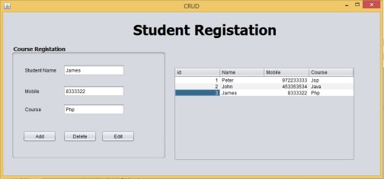

**Paste code inside the jTableMouseClicked event**

|  |  |
| --- | --- |
| 1  2  3  4  5  6 | DefaultTableModel model = (DefaultTableModel) jTable1.getModel();    int selectedIndex = jTable1.getSelectedRow();      txtname.setText(model.getValueAt(selectedIndex, 1).toString());    txtmobile.setText(model.getValueAt(selectedIndex, 2).toString());    txtcourse.setText(model.getValueAt(selectedIndex, 3).toString()); |

## ****Edit****

you can use the following code snippet to Edit the records.

.

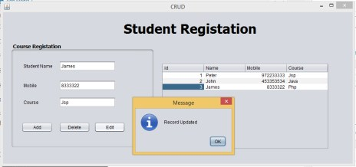

#### ****Paste code inside the Edit button.****

|  |  |
| --- | --- |
| 1  2  3  4  5  6  7  8  9  10  11  12  13  14  15  16  17  18  19  20  21  22  23  24  25  26  27  28  29 | DefaultTableModel model = (DefaultTableModel) jTable1.getModel();              int selectedIndex = jTable1.getSelectedRow();              try {                int id = Integer.parseInt(model.getValueAt(selectedIndex, 0).toString());              String name =txtname.getText();              String mobile =txtmobile.getText();              String course =txtcourse.getText();                Class.forName("com.mysql.jdbc.Driver");              con1 = DriverManager.getConnection("jdbc:mysql://localhost/linda","root","");              insert = con1.prepareStatement("update record set name= ?,mobile= ?,course= ? where id= ?");              insert.setString(1,name);              insert.setString(2,mobile);              insert.setString(3,course);              insert.setInt(4,id);              insert.executeUpdate();              JOptionPane.showMessageDialog(this, "Record Updated");              txtname.setText("");              txtmobile.setText("");              txtcourse.setText("");              table_update();              } catch (ClassNotFoundException ex) {            } catch (SQLException ex)  {    } |

## ****Delete****

you can use the following code snippet to Delete the records.

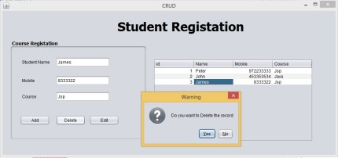

#### ****Paste code inside the Delete button.****

|  |  |
| --- | --- |
| 1  2  3  4  5  6  7  8  9  10  11  12  13  14  15  16  17  18  19  20  21  22  23  24  25  26  27  28 | DefaultTableModel model = (DefaultTableModel) jTable1.getModel();            int selectedIndex = jTable1.getSelectedRow();              try {                int id = Integer.parseInt(model.getValueAt(selectedIndex, 0).toString());              int dialogResult = JOptionPane.showConfirmDialog (null, "Do you want to Delete the record","Warning",JOptionPane.YES_NO_OPTION);              if(dialogResult == JOptionPane.YES_OPTION){                Class.forName("com.mysql.jdbc.Driver");              con1 = DriverManager.getConnection("jdbc:mysql://localhost/linda","root","");              insert = con1.prepareStatement("delete from record where id = ?");                insert.setInt(1,id);              insert.executeUpdate();              JOptionPane.showMessageDialog(this, "Record Delete");              txtname.setText("");              txtmobile.setText("");              txtcourse.setText("");                table_update();               }            } catch (ClassNotFoundException ex) {            } catch (SQLException ex) {            } |