WEEK 4
#1 Create given tables and insert given values into them.

Table - CLIENT_MASTER
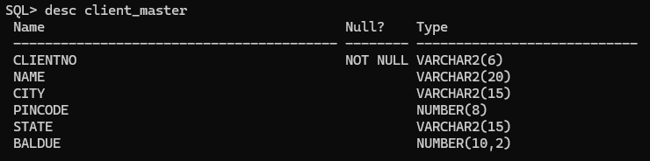
CREATE TABLE CLIENT_MASTER (CLIENTNO VARCHAR2(6) PRIMARY KEY, NAME VARCHAR2(20), CITY VARCHAR2(15), PINCODE NUMBER(8), STATE VARCHAR2(15), BALDUE NUMBER(10,2));
Values into CLIENT_MASTER
INSERT INTO CLIENT_MASTER VALUES ('C00001','Ivan Bayross','Mumbai',400054,'Maharashtra',15000);
INSERT INTO CLIENT_MASTER VALUES ('C00002','Mamta Muzumder','Madras',780001,'Tamil Nadu',1000);
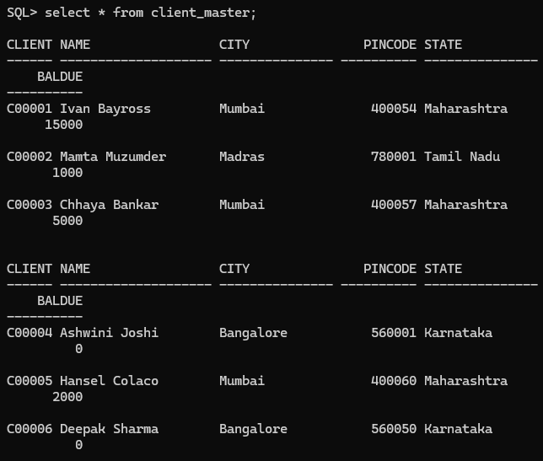
INSERT INTO CLIENT_MASTER VALUES ('C00003','Chhaya Bankar','Mumbai',400057,'Maharashtra',5000);
INSERT INTO CLIENT_MASTER VALUES ('C00004','Ashwini Joshi','Bangalore',560001,'Karnataka',0);
INSERT INTO CLIENT_MASTER VALUES ('C00005','Hansel Colaco','Mumbai',400060,'Maharashtra',2000);
INSERT INTO CLIENT_MASTER VALUES ('C00006','Deepak Sharma','Mangalore',560050,'Karnataka',0);

TABLE – SALESMAN_MASTER
CREATE TABLE SALESMAN_MASTER (SALESMANNO VARCHAR2(6) PRIMARY KEY, SALESMANNAME VARCHAR2(20), ADDRESS1 VARCHAR2(30), ADDRESS2 VARCHAR2(30), CITY VARCHAR2(20), PINCODE NUMBER(8), STATE VARCHAR2(20), SALAMT NUMBER(8,2));
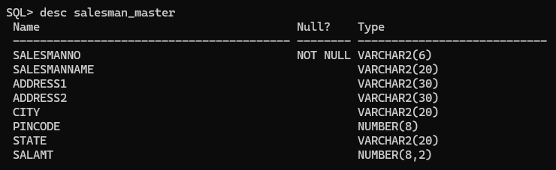

Values into SALESMAN_MASTER
INSERT INTO SALESMAN_MASTER VALUES ('S00001','Aman','A/14','Worli','Mumbai',400002,'Maharashtra',3500);
INSERT INTO SALESMAN_MASTER VALUES ('S00002','Omkar','65','Nariman','Mumbai',400001,'Maharashtra',4000);
INSERT INTO SALESMAN_MASTER VALUES ('S00003','Raj','P-7','Bandra','Mumbai',400032,'Maharashtra',5000);
INSERT INTO SALESMAN_MASTER VALUES ('S00004','Ashish','A/5','Juhu','Mumbai',400044,'Maharashtra',3500);
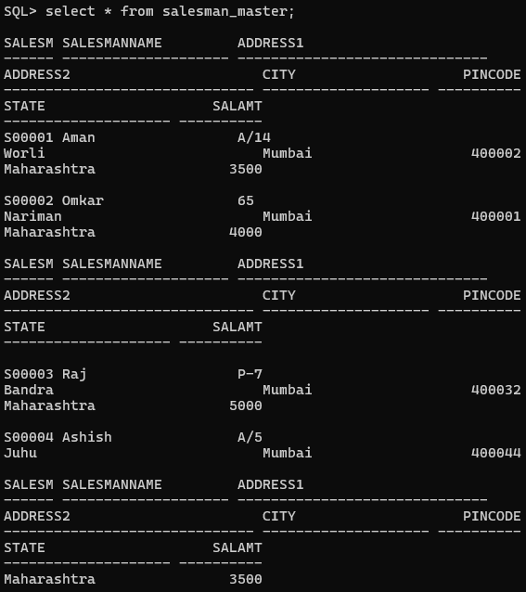

TABLE - PRODUCT_MASTER
CREATE TABLE PRODUCT_MASTER (PRODUCTNO VARCHAR2(6) PRIMARY KEY, DESCRIPTION VARCHAR2(15), PROFITPERCENT NUMBER(4,2), UNITMEASURE VARCHAR2(10), QTYONHAND NUMBER(8), REORDERLVL NUMBER(8), SELLPRICE NUMBER(8,2), COSTPRICE NUMBER(8,2));
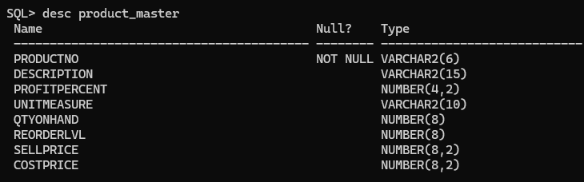

Values into PRODUCT_MASTER
INSERT INTO PRODUCT_MASTER VALUES ('P00001','T-Shirts',5,'Piece',200,50,350,250);
INSERT INTO PRODUCT_MASTER VALUES ('P0345','Shirts',6,'Piece',150,50,500,350);
INSERT INTO PRODUCT_MASTER VALUES ('P06734','Cotton Jeans',5,'Piece',100,20,600,450);
INSERT INTO PRODUCT_MASTER VALUES ('P07865','Jeans',5,'Piece',100,20,750,500);
INSERT INTO PRODUCT_MASTER VALUES ('P07868','Trousers',2,'Piece',150,50,850,550);
INSERT INTO PRODUCT_MASTER VALUES ('P07885','Pull Overs',2.5,'Piece',80,30,700,450);
INSERT INTO PRODUCT_MASTER VALUES ('P07965','Denim Shirts',4,'Piece',100,40,350,250);
INSERT INTO PRODUCT_MASTER VALUES ('P07975','Lycra Tops',5,'Piece',70,30,300,175);
INSERT INTO PRODUCT_MASTER VALUES ('P08865','Skirts',5,'Piece',75,30,450,300);
