|  |  |
| --- | --- |
|  | **CHAPTER 4**  **RESULTS** |

**4.1 SNAPSHOT**

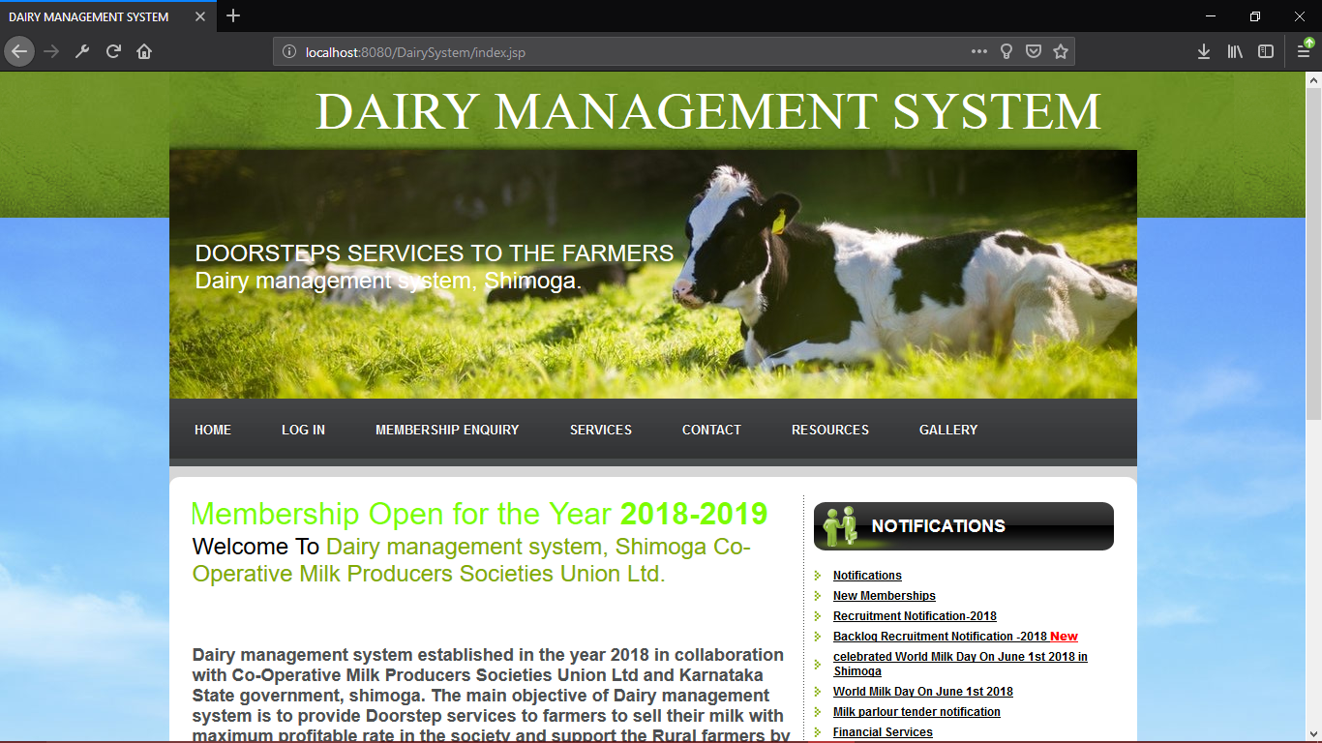

**Fig 4.1: Home Page**

Figure 4.1 shows Home page is a welcome page of Dairy management System.

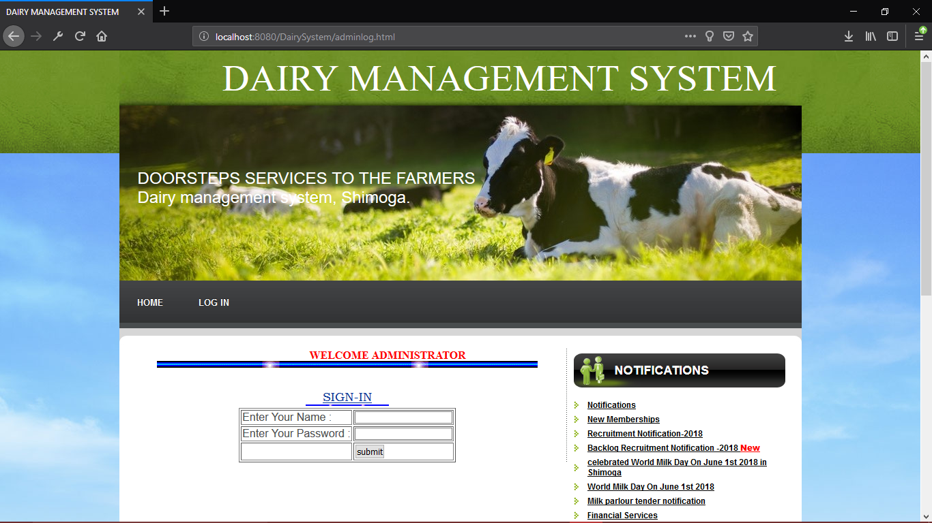

**Fig 4.2: Admin login**

Figure 4.2 shows Admin Login page of Dairy management System.