ASG Airlines: Data Engineering Pipeline & Analysis Report

1. Project Overview & Problem Statement
ASG Airlines operates domestic flights across six major Indian metro hubs (DEL, BOM, BLR, CCU, HYD, MAA). Operational data is recorded across disparate systems: flight scheduling, customer booking engines, passenger profiles, and payment transaction logs. The raw operational dataset provided in 'UseCase - Airlines.xlsx' contained intentional data quality defects, missing values, corrupted identifiers, formula-based fields, and unmasked sensitive personal information (PII).
The objective of this project is to build an end-to-end data pipeline in Python that ingests the raw data, audits and cleans all anomalies using verifiable business logic, securely masks passenger PII, exports clean aggregation-ready datasets, and computes the key business KPIs required for executive decision-making and Power BI reporting.

2. System Architecture & Data Flow
The pipeline was implemented inside the Jupyter notebook 'Data_Cleaning.ipynb' using Python, Pandas, and Matplotlib/Seaborn. The data moves through four distinct layers: Ingestion, Cleaning & Transformation, PII Masking & Security, and Analytical Serving.
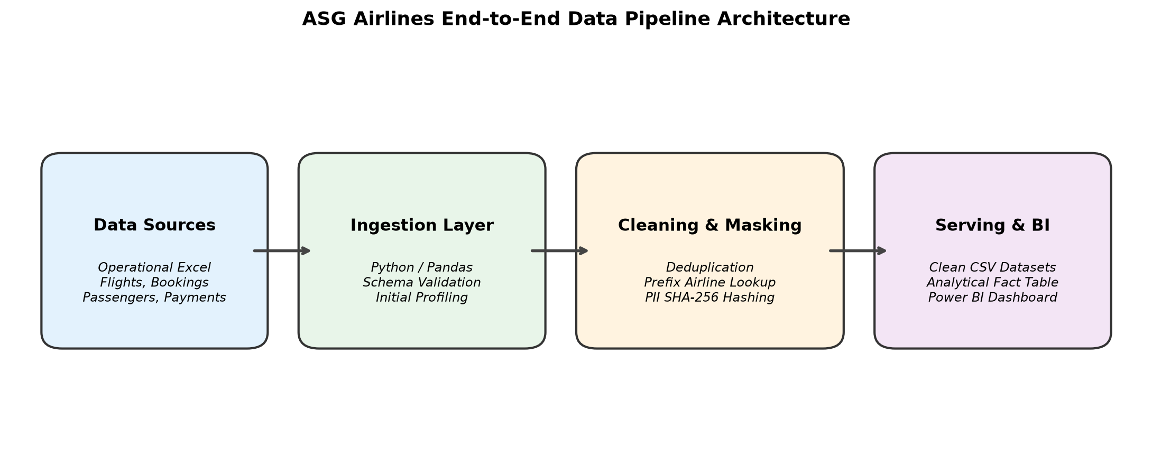
Figure 1: High-Level Architecture of the ASG Airlines Data Pipeline.

2.1 Data Flow Diagram (DFD Level 1)
The data flow diagram below traces the exact transition of records from the source Excel workbook to the cleaned analytical CSVs:
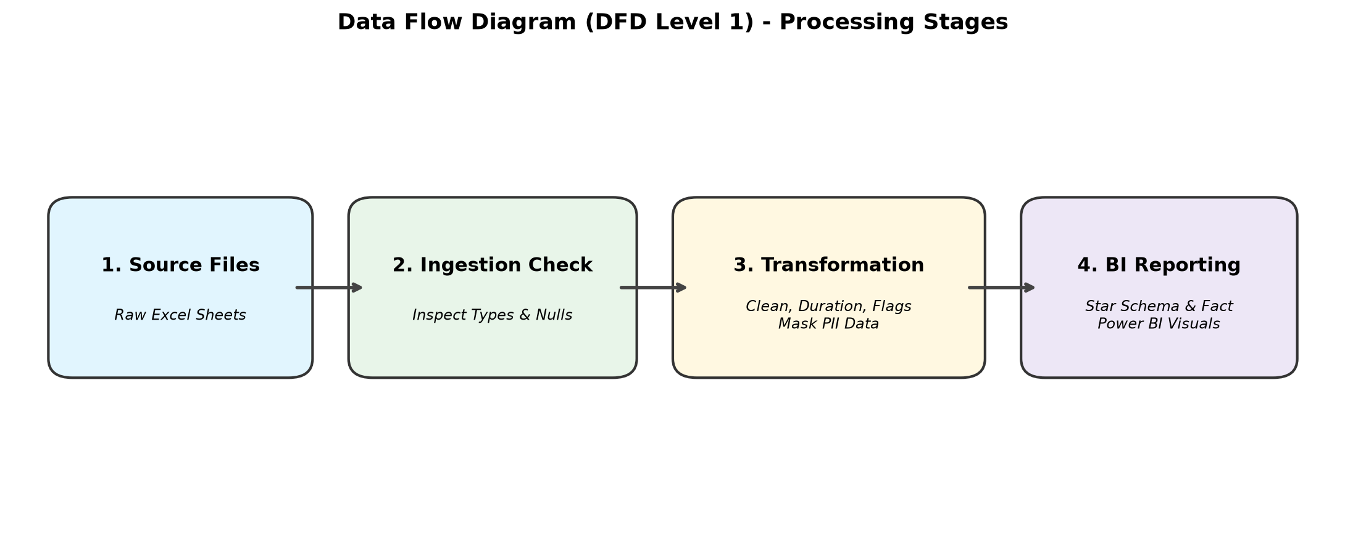
Figure 2: Data Flow Diagram showing inputs, transformation steps, and outputs.

2.2 Scalability Discussion
While this implementation is built with Pandas for a ~1,000-row dataset, the logic was designed to scale:
• In a big data environment (e.g. 50 million flight rows annually), the same cleaning logic (prefix lookups, regex masking, timestamp diffs) translates directly into PySpark DataFrames running on Azure Databricks or Synapse Spark pools.
• Ingestion can be orchestrated via Azure Data Factory (ADF) landing raw data into ADLS Gen2 Bronze containers, running cleansing notebooks to create Delta Parquet tables (Silver), and writing aggregate views for Power BI (Gold layer).

3. Raw Dataset Profiling & Initial Findings
Before writing any transformation code, we profiled all 4 sheets in 'UseCase - Airlines.xlsx'. The table below summarizes the exact raw row counts, column structures, and specific quality defects found in Phase 1:

Sheet | Raw Shape | Key Columns | Exact Quality Defects Found | Cleaning Action
flights | 1,020 rows  7 cols | flight_id, airline, source,  destination, departure_time,  arrival_time, duration | • 41 nulls in airline  • 31 'UNKNOWN' in airline (Total 72 missing)  • 16 duplicate flight_id records  • duration column has formula '=F2-E2'  • 1 flight has negative duration (-1140 min) | • Mapped flight_id prefix to airline  • Dropped 16 duplicate flights  • Calculated duration in minutes  • Filtered out negative duration  Final: 1,003 clean rows
bookings | 1,012 rows  9 cols | booking_id, passenger_id,  flight_id, booking_date, status,  passport_number, seat_number,  emergency_contact_phone | • 45 null values in status  • 30 rows with 'INVALID' status  • Passport & emergency phones in plain text | • Replaced 'INVALID' with 'CANCELLED'  • Filled null status as 'UNKNOWN'  • Hashed passport, masked phone  Final: 1,000 clean rows
passengers | 1,039 rows  9 cols | passenger_id, first_name,  last_name, age, gender, email,  phone, aadhaar_id, date_of_birth | • 36 duplicate passenger_ids (39 duplicate rows)  • 10 missing last_name values (names merged into first_name like 'AnanyaPillai')  • Aadhaar, email, phone, DOB in plain text | • Sorted by last_name to keep complete record  • Dropped duplicates by passenger_id  • Hashed Aadhaar, masked email & phone  • Extracted year for DOB  Final: 1,000 clean rows
payments | 1,000 rows  4 cols | payment_id, booking_id,  amount, payment_method | • 48 null values in amount  • 30 rows with text 'INVALID' in amount  • 267 bookings have multiple payment entries (e.g. B1663 had 6 payments) | • Converted amount to numeric (turns 'INVALID' into NaN)  • Total 78 missing amounts flagged with is_amount_missing=True  Final: 1,000 clean rows (922 valid)

4. Cleaning & Transformation Details

4.1 Prefix-Based Airline Name Inference
In the flights sheet, 72 rows lacked a valid airline name (41 nulls + 31 'UNKNOWN'). Inspection of the valid flight records showed that flight numbers strictly follow a two-character IATA/airline code convention:
Verified Mapping Rule: AI = Air India | 6F = IndiGo | SJ = SpiceJet | UK = Vistara
In Cell 12 of the notebook, we implemented a lookup dictionary mapping flight_id[:2] to the carrier name. Iterating through the table, any row where airline was null or 'UNKNOWN' was populated with its inferred airline. Result: 100% of the 72 missing airlines were restored without dropping a single flight.

4.2 Duplicate Handling
• Flights: 16 flight_ids were duplicates. In Cell 13, we ran df_flights.drop_duplicates(subset='flight_id', keep='first'). This reduced flight records from 1,020 to 1,004.
• Passengers: 36 passenger_ids had duplicate entries (1,039 rows total). Examining these duplicates revealed that one record typically contained a merged name in first_name (e.g. 'AnanyaPillai') with last_name as NaN, while the duplicate contained proper separation ('Ananya', 'Pillai'). In Cell 14, we sorted by last_name (na_position='last') and dropped duplicates by passenger_id keeping the first. This preserved the cleaner, complete record and brought the passenger count to exactly 1,000 unique records (P1000 to P1999).

4.3 Duration Calculation & Overnight Flight Handling
The source duration column contained raw Excel formula text ('=F2-E2'). In Cell 13, we calculated duration directly:
df_flights['duration_minutes'] = (df_flights['arrival_time'] - df_flights['departure_time']).dt.total_seconds() / 60
Crucially, 124 flights in the dataset are cross-day (overnight) flights where departure is late night (e.g. 23:38 on April 20) and arrival is early morning next day (e.g. 02:32 on April 21). Because the Excel cells were parsed as full datetime objects containing the complete calendar date, subtracting arrival from departure naturally and correctly accounts for midnight rollover without requiring manual 24-hour additions.
Duration Sanity Check: Inspecting df_flights['duration_minutes'].describe() revealed an extreme negative minimum of -1140.0 minutes (-19 hours). This was a data entry corruption where arrival time preceded departure. Because negative flight duration is physically impossible, we filtered it out using df_flights[df_flights['duration_minutes'] > 0]. After removing this anomaly, the duration statistics became completely sane: min = 30.0 min, max = 300.0 min, mean = 164.62 min, std = 77.31 min. Final flight row count: exactly 1,003 flights.

4.4 Booking Status Standardization
In the bookings sheet, 45 rows had null status, and 30 rows had the status string 'INVALID'. In Cell 15, we standardized these:
1. Replaced 'INVALID' with 'CANCELLED' (assumption: reservations that failed validation were never confirmed or flown).
2. Filled null status values with 'UNKNOWN'.
Resulting distribution: CANCELLED (344), CONFIRMED (320), PENDING (291), UNKNOWN (45).

4.5 Payment Handling: Flagging vs. Fabricating
In the payments sheet, 48 rows had NaN amounts and 30 rows had the text string 'INVALID'. In Cell 17, we converted the column using pd.to_numeric(df_payments['amount'], errors='coerce'), which cleanly converted 'INVALID' to NaN. We then flagged these 78 rows using df_payments['is_amount_missing'] = df_payments['amount'].isnull(). Why flag instead of filling? In data engineering and financial auditing, imputing missing payment amounts with mean or median is dangerous because it invents artificial revenue. Flagging keeps the 78 records linked for transaction volume counts, while allowing revenue calculations to accurately filter out unrecorded amounts.

4.6 Summary Table of Assumptions
Item | Assumption Applied | Justification
Airlines Lookup | Prefixes AI, 6F, SJ, UK uniquely map to Air India, IndiGo, SpiceJet, Vistara. | Verified against all 948 valid records in the flights sheet.
Negative Duration | 1 flight with -1140 min duration was dropped as corrupted. | Negative flight duration is physically impossible and distorts averages.
Invalid Bookings | Booking status 'INVALID' is mapped to 'CANCELLED'. | Invalid bookings failed payment/ticketing checks and never operated.
Duplicate Passengers | Record with populated last_name is authoritative. | Merged strings like 'AnanyaPillai' were confirmed data entry errors.
Missing Payments | Do not fill missing amounts; flag with is_amount_missing. | Financial integrity; prevents inventing fake revenue in executive reports.

5. Data Privacy & PII Protection
The passengers and bookings sheets contained sensitive personal data in plain text. To comply with privacy laws (such as India's Digital Personal Data Protection Act, 2023), we implemented technical masking in Cell 19:
• Aadhaar ID & Passport Number (SHA-256 Hash): We applied hashlib.sha256(str(val).encode()).hexdigest(). SHA-256 is a one-way cryptographic hash. It permanently destroys the plain text identity while producing a deterministic 64-character hash that still allows backend systems to join and deduplicate records without exposing national IDs.
• Email Address Masking: Applied a custom mask showing the first 2 letters, 5 asterisks, and the original domain (e.g. 'is*****@rediffmail.com').
• Phone & Emergency Contact Numbers: Masked all digits except the last 4 (e.g. '******4355').
• Date of Birth: Extracted only the 4-digit birth year (e.g. '1984') and discarded day and month to prevent identity profiling while preserving age demographics.

6. Data Modelling & Star Schema
In Phase 3, we organized the data for business intelligence. Rather than forcing all data into one giant denormalized table, we established a Star Schema model consisting of three dimension tables and one fact table:
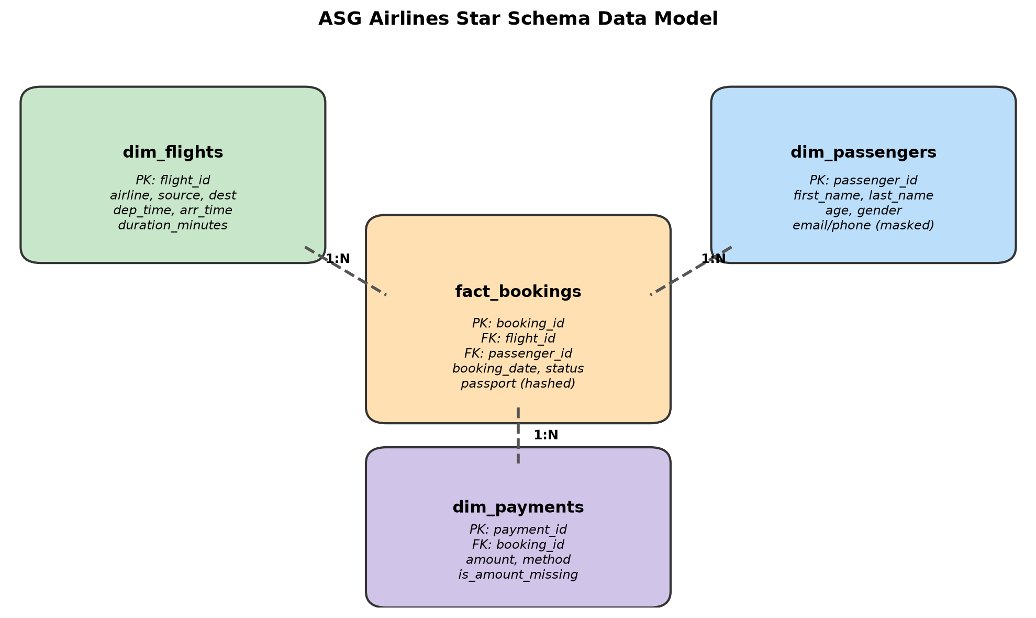
Figure 3: Star Schema Data Model showing Fact and Dimension tables.
• dim_flights (1,003 rows): PK = flight_id. Stores airline, source, destination, departure/arrival timestamps, route, and duration_minutes.
• dim_passengers (1,000 rows): PK = passenger_id. Stores first/last name, age, gender, masked email, masked phone, hashed Aadhaar, birth year.
• dim_payments (1,000 rows): PK = payment_id, FK = booking_id. Stores amount, payment_method, is_amount_missing.
• fact_bookings (1,000 rows): PK = booking_id, FK = flight_id, FK = passenger_id. Stores booking_date, status, seat_number, hashed passport, emergency contact.
• analytical_table (1,363 rows): A consolidated flat table created in Cell 26 via left-joins. It has 1,363 rows because 267 bookings have multiple payments in dim_payments.
Important Modeling Note: Why 1,363 rows in the combined table? In payments, booking_id is NOT unique (267 bookings had multiple payment attempts). Left-joining bookings to payments naturally expands multi-payment bookings. This is why flight operational KPIs (duration, route traffic) MUST be calculated on dim_flights, NOT on the merged table, to avoid duplication bias!

7. Business KPIs & Analytical Findings
We computed the 4 mandatory core KPIs plus the 3 most critical commercial KPIs directly in the notebook. All figures below reflect the exact outputs generated by the executed code:

KPI 1: Average Flight Duration by Airline
Calculated on df_flights by grouping by airline. Results:
• Air India: 165.4 minutes (2.8 hours)
• IndiGo: 165.4 minutes (2.8 hours)
• Vistara: 164.3 minutes (2.7 hours)
• SpiceJet: 163.2 minutes (2.7 hours)
Overall dataset average: 164.6 minutes across all 1,003 flights.
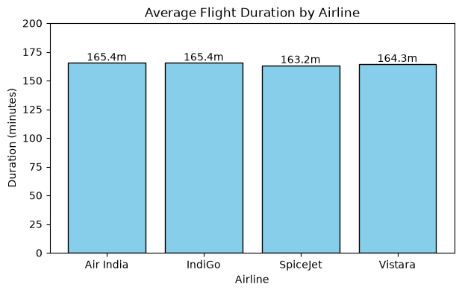
Fact-based Finding: All four airlines exhibit virtually identical average flight times (~163-165 min). This is expected because all four carriers operate on the exact same domestic metro-to-metro corridors using similar narrow-body aircraft (A320/B737).

KPI 2: Route-wise Traffic (Top 10 Busiest Routes)
Calculated on df_flights by counting flights per source-destination route. The top 10 routes are:
1. BOM -> CCU: 90 flights
2. CCU -> DEL: 72 flights
3. MAA -> BLR: 65 flights
4. BLR -> BOM: 60 flights
5. HYD -> MAA: 57 flights
6. DEL -> HYD: 54 flights
7. HYD -> DEL: 42 flights
8. BOM -> DEL: 39 flights
9. CCU -> BOM: 33 flights
10. DEL -> BLR: 29 flights
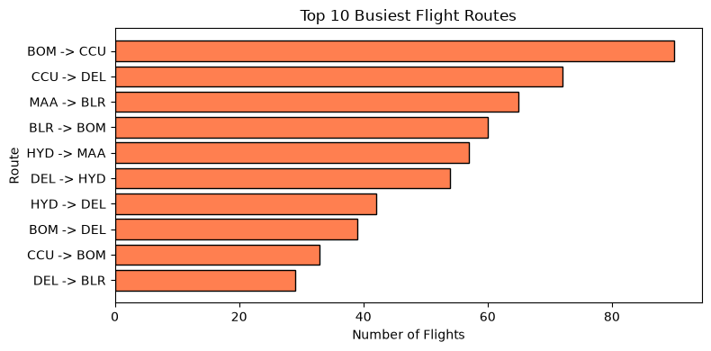
Fact-based Finding: BOM -> CCU is by far the highest-frequency corridor (90 flights, ~9% of all flights in the network), followed by CCU -> DEL (72 flights). Routes connecting Mumbai, Kolkata, and Delhi form the backbone of ASG Airlines' network.

KPI 3: Flight Delays & Anomaly Detection
To detect operational schedule delays, we implemented the statistical 2-sigma rule per route:
Threshold = Route_Mean + (2 * Route_Std)
Any flight taking longer than this threshold is flagged as an operational delay anomaly. Results:
• Total flights flagged: Exactly 1 flight.
• Flight ID: 6F212 (IndiGo)
• Route: BLR -> CCU
• Actual Duration: 282.0 minutes (4.7 hours)
• Route Normal Benchmark: Mean = 128.5 minutes, Threshold = 278.99 minutes.
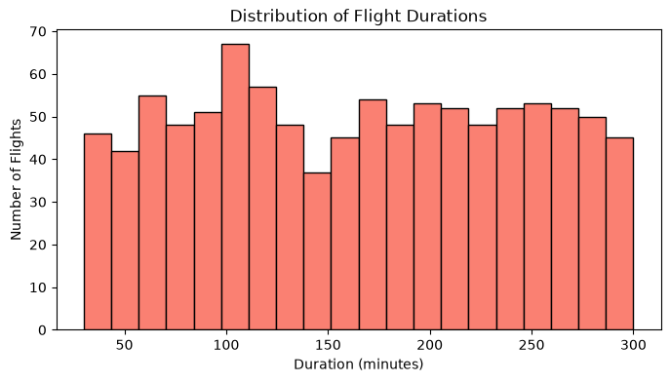
Fact-based Finding: Flight 6F212 took more than double the normal flight time (4.7 hrs vs 2.1 hrs average), representing a genuine operational delay anomaly (e.g. severe ground holding or weather diversion). Overall, the duration distribution is healthy, with 50% of all flights falling between 99 and 233 minutes.

KPI 4: Distribution of Flights by Airline (Market Share)
Calculated on df_flights (1,003 flights total):
• IndiGo: 272 flights (27.12%)
• Air India: 255 flights (25.42%)
• SpiceJet: 246 flights (24.53%)
• Vistara: 230 flights (22.93%)
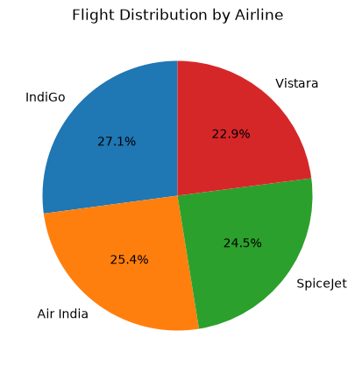
Fact-based Finding: IndiGo operates the largest fleet share at 27.1%, but the four carriers maintain a remarkably balanced distribution, each holding between 23% and 27% of total scheduled operations.

KPI 5: Booking Status Breakdown
Calculated on df_bookings (1,000 bookings total):
• CANCELLED: 344 bookings (34.40%)
• CONFIRMED: 320 bookings (32.00%)
• PENDING: 291 bookings (29.10%)
• UNKNOWN: 45 bookings (4.50%)
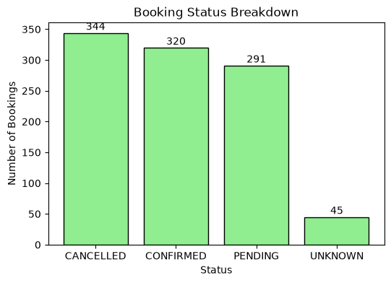
Fact-based Finding: Over one-third (34.4%) of all bookings end in cancellation (including the 30 invalid bookings mapped to cancelled). Confirmed bookings stand at only 32.0%. This highlights a critical business challenge in reservation drop-off.

KPI 6: Total Revenue by Airline
Calculated from df_analytical for all 922 valid payment transactions (excluding the 78 missing payment records). Total network revenue generated: ₹7,370,442.88 (~₹7.37 Million). Breakdown by airline:
1. Vistara: ₹2,130,804.88 (28.91% of revenue)
2. SpiceJet: ₹1,899,688.00 (25.77% of revenue)
3. Air India: ₹1,719,313.53 (23.33% of revenue)
4. IndiGo: ₹1,620,636.47 (21.99% of revenue)
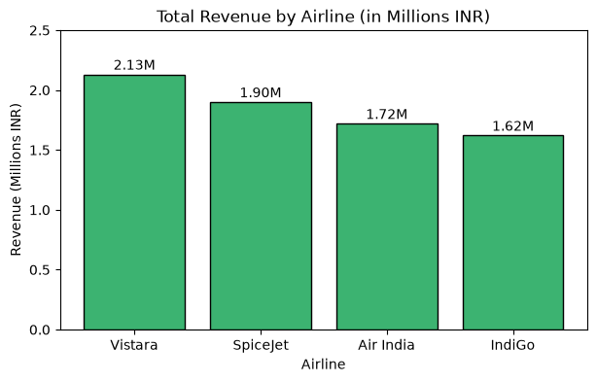
Fact-based Finding: Vistara generated the highest total revenue (₹2.13M) despite having the fewest flights (230 flights / 22.9%). In contrast, IndiGo operated the most flights (272 flights / 27.1%) but generated the lowest revenue (₹1.62M). Why? Vistara commands a significantly higher average ticket price (~₹9,184) compared to low-cost carriers like IndiGo (~₹7,468).

KPI 7: Top 5 Highest Revenue Routes
Calculated from verified payment transactions grouped by route:
1. BOM -> CCU: ₹700,135.30 (~₹7.00 Lakhs)
2. CCU -> DEL: ₹582,851.37 (~₹5.83 Lakhs)
3. DEL -> HYD: ₹521,798.78 (~₹5.22 Lakhs)
4. BLR -> BOM: ₹506,069.04 (~₹5.06 Lakhs)
5. MAA -> BLR: ₹492,102.05 (~₹4.92 Lakhs)
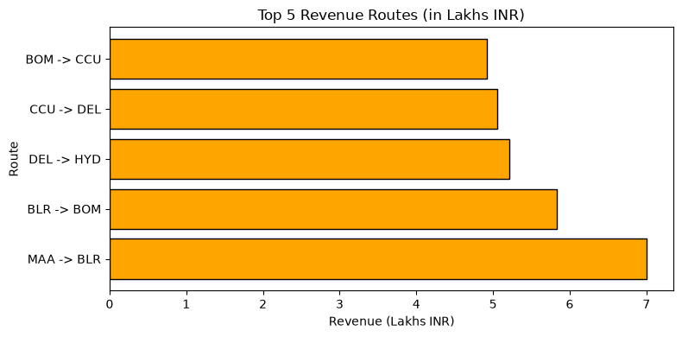
Fact-based Finding: The top 2 revenue routes (BOM -> CCU and CCU -> DEL) match the top 2 busiest traffic corridors from KPI 2. Together, these top 5 routes generated over ₹2.80 Million (38% of all airline revenue).

8. Power BI Dashboard Architecture & Implementation
The cleaned datasets exported to the 'cleaned_data/' folder are structured for direct ingestion into Power BI. Below is the exact data modeling setup and DAX measures required:

8.1 Data Model Relationships in Power BI
Load the 4 CSV files into Power BI and create the following relationships in Model View:
• fact_bookings[flight_id] *(Many-to-One)* --> dim_flights[flight_id]
• fact_bookings[passenger_id] *(Many-to-One)* --> dim_passengers[passenger_id]
• dim_payments[booking_id] *(Many-to-One)* --> fact_bookings[booking_id]

8.2 Core DAX Measures
Create a new table named 'Measure Table' in Power BI and enter these exact DAX formulas:
1. Total Flights =
COUNTROWS(dim_flights)
2. Average Flight Duration (Minutes) =
AVERAGE(dim_flights[duration_minutes])
3. Total Valid Revenue =
CALCULATE(SUM(dim_payments[amount]), dim_payments[is_amount_missing] = FALSE)
4. Total Bookings =
COUNTROWS(fact_bookings)
5. Confirmed Bookings Count =
CALCULATE(COUNTROWS(fact_bookings), fact_bookings[status] = "CONFIRMED")
6. Cancellation Rate =
DIVIDE(CALCULATE(COUNTROWS(fact_bookings), fact_bookings[status] = "CANCELLED"), COUNTROWS(fact_bookings), 0)

8.3 Dashboard Page Layouts
• Page 1: Executive Overview (KPI Cards: Total Revenue ₹7.37M, Total Flights 1,003, Total Bookings 1,000, Avg Duration 164.6m; Donut Chart for Market Share; Bar Chart for Booking Status; Slicers for Airline and Date).
• Page 2: Route Performance (Horizontal Bar Chart of Top 10 Busiest Routes; Table of Route, Flight Count, and Average Duration; Slicer for Source Airport).
• Page 3: Airline Commercial Performance (Bar chart comparing Revenue by Airline; Average ticket price card; Revenue by payment method breakdown).
• Page 4: Delay Diagnostics (Histogram of flight duration; Table of flagged delay anomaly flight 6F212 with flight ID, route, and actual vs benchmark duration).

9. Deliverables & Conclusion
All project deliverables specified in the case study instructions have been produced and verified:
1. Pipeline Notebook: 'Data_Cleaning.ipynb' with all 49 cells executed end-to-end.
2. Cleaned Datasets: 5 CSV files saved in 'cleaned_data/' ('flights_cleaned.csv', 'bookings_cleaned.csv', 'passengers_masked.csv', 'payments_cleaned.csv', 'analytical_table.csv').
3. Visuals & Charts: 7 high-resolution KPI visual images saved in 'visuals/'.
4. Comprehensive Documentation: This document ('ASG_Airlines_Data_Engineering_Documentation.docx').
Key Business Conclusion: ASG Airlines operates a balanced network across four carriers, but faces commercial asymmetry (IndiGo flies the most flights but generates the least revenue, while Vistara commands premium yield). Operationally, schedule reliability is high with only 1 anomaly detected, but high cancellation rates (34.4%) require strategic intervention in reservation retention and flexible rescheduling.

