

Safety Plan Lane Assistance

**Document Version: 1.0**

**Template Version 1.0, Released on 2017-06-21**



# Document history

|  |  |  |  |
| --- | --- | --- | --- |
| Date | Version | Editor | Description |
| 2017/12/08 | 1.0 | Dongmin Kim | First ver. document about safety plan. |
|  |  |  |  |
|  |  |  |  |
|  |  |  |  |
|  |  |  |  |

# Table of Contents

Document history

Table of Contents

Introduction

Purpose of the Safety Plan

Scope of the Project

Deliverables of the Project

Item Definition

Goals and Measures

Goals

Measures

Safety Culture

Safety Lifecycle Tailoring

Roles

Development Interface Agreement

Confirmation Measures

# Introduction

## Purpose of the Safety Plan

The purpose of the safety plan is to provide an overall framework for the Lane Assistance system, and to achieve functional safety for this system.

## Scope of the Project

For the lane assistance project, the following safety lifecycle phases are in scope:

Concept phase

Product Development at the System Level

Product Development at the Software Level

The following phases are out of scope:

Product Development at the Hardware Level

Production and Operation

## Deliverables of the Project

The deliverables of the project are:

Safety Plan

Hazard Analysis and Risk Assessment

Functional Safety Concept

Technical Safety Concept

Software Safety Requirements and Architecture

# Item Definition

The lane assistance system alerts the driver that the vehicle has accidentally departed its lane, and attempts to steer the vehicle back toward the center of the lane.

The Lane Assistance System will have two functions:

1. **Lane departure warning**: the lane departure warning function shall apply an oscillating steering torque to provide the driver a haptic feedback.
2. **Lane keeping assistance**: the lane keeping assistance function shall apply the steering torque when active in order to stay in ego lane.

Include three sub-systems:

* Camera system
* Electronic Power Steering system
* Car Display system

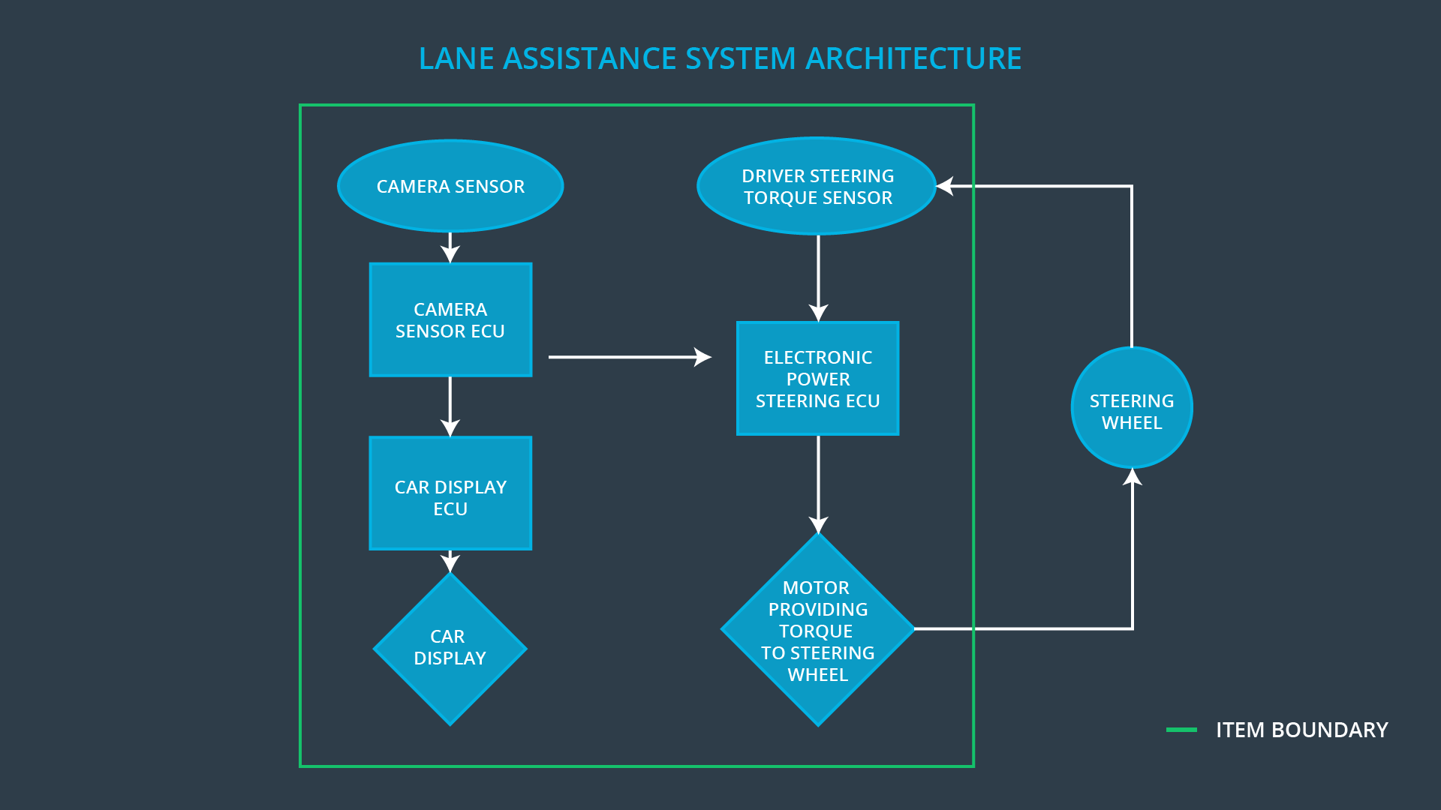

# Goals and Measures

## Goals

The lane keeping assistance function shall be time limited and the additional steering torque shall end after a given time interval so that the driver cannot misuse the system for autonomous driving.

## Measures

|  |  |  |
| --- | --- | --- |
| Measures and Activities | Responsibility | Timeline |
| Follow safety processes | All Team Members | Constantly |
| Create and sustain a safety culture | All Team  Members | Constantly |
| Coordinate and document the planned safety activities | Safety manager | Constantly |
| Allocate resources with adequate functional safety competency | Project Manager | Within 2 weeks of start of project |
| Tailor the safety lifecycle | Safety Manager | Within 4 weeks of start of project |
| Plan the safety activities of the safety lifecycle | Safety Manager | Within 4 weeks of start of project |
| Perform regular functional safety audits | Safety Auditor | Once every 2 months |
| Perform functional safety pre-assessment prior to audit by external functional safety assessor | Safety Manager | 3 months prior to main assessment |
| Perform functional safety assessment | Safety Assessor | Conclusion of functional safety activities |

# Safety Culture

* **High priority**: safety has the highest priority among competing constraints like cost and productivity
* **Accountability**: processes ensure accountability such that design decisions are traceable back to the people and teams who made the decisions
* **Rewards**: the organization motivates and supports the achievement of functional safety
* **Penalties**: the organization penalizes shortcuts that jeopardize safety or quality
* **Independence**: teams who design and develop a product should be independent from the teams who audit the work
* **Well defined processes**: company design and management processes should be clearly defined
* **Resources**: projects have necessary resources including people with appropriate skills
* **Diversity**: intellectual diversity is sought after, valued and integrated into processes
* **Communication**: communication channels encourage disclosure of problems

# Safety Lifecycle Tailoring

The following safety lifecycle phases are in scope:

Concept phase

Product Development at the System Level

Product Development at the Software Level

The following phases are out of scope:

Product Development at the Hardware Level

Production and Operation

# Roles

|  |  |
| --- | --- |
| Role | Org |
| Functional Safety Manager- Item Level | OEM |
| Functional Safety Engineer- Item Level | OEM |
| Project Manager - Item Level | OEM |
| Functional Safety Manager- Component Level | Tier-1 |
| Functional Safety Engineer- Component Level | Tier-1 |
| Functional Safety Auditor | OEM or external |
| Functional Safety Assessor | OEM or external |

# Development Interface Agreement

The purpose of a development interface agreement is to clarify the responsibilities of the different parties involved in a functional safety project, to describe the work products that each company will provide and help avoid disputes between companies.

Responsibilities of Tier-1 is to analyze and modify three sub-systems (Camera system, Electronic Power Steering system, Car Display system) from a functional safety viewpoint.

Responsibilities of OEM is to design and develop the Lane Assistance system in Item level and to audit and assess this project.

# Confirmation Measures

Confirmation measures serve two purposes:

* that a functional safety project conforms to ISO 26262, and
* that the project really does make the vehicle safer.

Confirmation review is to ensure that the project complies with ISO 26262. As the product is designed and developed, an independent person would review the work to make sure ISO 26262 is being followed.

Functional safety audit is checking to make sure that the actual implementation of the project conforms to the safety plan.

Functional safety assessment is to confirm that plans, designs and developed products actually achieve functional safety.

A safety plan could have other sections that we are not including here. For example, a safety plan would probably contain a complete project schedule.

There might also be a "Supporting Process Management" section that would cover "Part 8: Supporting Processes" of the ISO 26262 functional safety standard. This would include descriptions of how the company handles requirements management, change management, configuration management, documentation management, and software tool usage and confidence.

Similarly, a confirmation measures section would go into more detail about how each confirmation will be carried out.