

Functional Safety Concept Lane Assistance

**Document Version: 1.0**

**Template Version 1.0, Released on 2017-06-21**



# Document history

|  |  |  |  |
| --- | --- | --- | --- |
| Date | Version | Editor | Description |
| 2017/12/10 | 1.0 | Dongmin Kim | First attempt |
|  |  |  |  |
|  |  |  |  |
|  |  |  |  |
|  |  |  |  |

# Table of Contents

Document history

Table of Contents

Purpose of the Functional Safety Concept

Inputs to the Functional Safety Analysis

Safety goals from the Hazard Analysis and Risk Assessment

Preliminary Architecture

Description of architecture elements

Functional Safety Concept

Functional Safety Analysis

Functional Safety Requirements

Refinement of the System Architecture

Allocation of Functional Safety Requirements to Architecture Elements

Warning and Degradation Concept

# Purpose of the Functional Safety Concept

Purpose of the functional safety concept is to identify new requirements at the general functionality of the lane assistance system and to allocate these requirements.

# Inputs to the Functional Safety Concept

## Safety goals from the Hazard Analysis and Risk Assessment

|  |  |
| --- | --- |
| **ID** | **Safety Goal** |
| Safety_Goal_01 | The oscillating steering torque from the lane departure warning function shall be limited. |
| Safety_Goal_02 | The lane keeping assistance function shall be time limited, and the additional steering torque shall end after a given time interval so that the driver cannot misuse the system for autonomous driving. |

## Preliminary Architecture

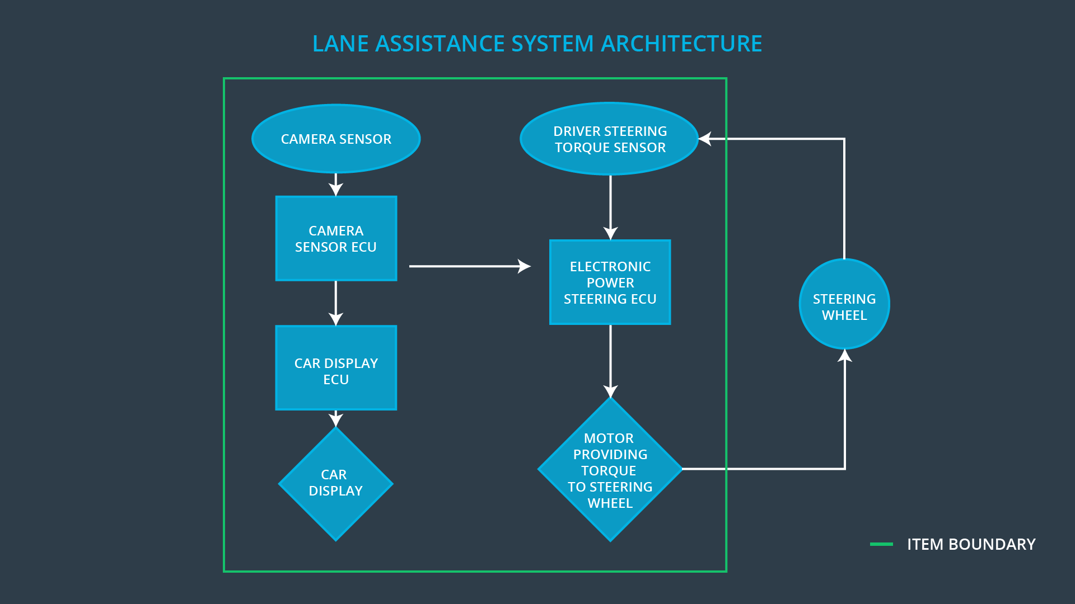

### Description of architecture elements

|  |  |
| --- | --- |
| **Element** | **Description** |
| Camera Sensor | The camera sensor reads in images from the road. |
| Camera Sensor ECU | The camera sensor ECU is to detect lane lines and determine when the vehicle leaves the lane by mistake. |
| Car Display | The car display shows information about lane assistance system. |
| Car Display ECU | The car display ECU converts the incoming data from the camera subsystem into information for the driver. |
| Driver Steering Torque Sensor | The driver steering torque sensor is sensing the steering torque. |
| Electronic Power Steering ECU | The electronic power steering ECU measures the torque provided by the driver and then adding an appropriate amount of torque based on a lane assistance system torque request. |
| Motor | The motor provides torque to steering wheel. |

# Functional Safety Concept

The functional safety concept consists of:

* Functional safety analysis
* Functional safety requirements
* Functional safety architecture
* Warning and degradation concept

## Functional Safety Analysis

|  |  |  |  |
| --- | --- | --- | --- |
| **Malfunction ID** | **Main Function of the Item Related to Safety Goal Violations** | **Guidewords (NO, WRONG, EARLY, LATE, MORE, LESS)** | **Resulting Malfunction** |
| Malfunction_01 | Lane Departure Warning (LDW) function shall apply an oscillating steering torque to provide the driver a haptic feedback | MORE | The lane departure warning function applies an oscillating torque with very high torque amplitude (above limit). |
| Malfunction_02 | Lane Departure Warning (LDW) function shall apply an oscillating steering torque to provide the driver a haptic feedback | MORE | The lane departure warning function applies an oscillating torque with very high torque frequency (above limit). |
| Malfunction_03 | Lane Keeping Assistance (LKA) function shall apply the steering torque when active in order to stay in ego lane | NO | The lane keeping assistance function is not limited in time duration which leads to misuse as an autonomous driving function. |

## Functional Safety Requirements

Lane Departure Warning (LDW) Requirements:

|  |  |  |  |  |
| --- | --- | --- | --- | --- |
| **ID** | **Functional Safety Requirement** | **ASIL** | **Fault Tolerant Time Interval** | **Safe State** |
| Functional  Safety  Requirement  01-01 | The lane keeping item shall ensure that the lane departure oscillating torque amplitude is below Max_Torque_Amplitude. | C | 50ms | LDW is turned off and warning icon is displayed on the car display. |
| Functional  Safety  Requirement  01-02 | The lane keeping item shall ensure that the lane departure oscillating torque frequency is below Max_Torque_Frequency. | C | 50ms | LDW is turned off and warning icon is displayed on the car display. |

Lane Departure Warning (LDW) Verification and Validation Acceptance Criteria:

|  |  |  |
| --- | --- | --- |
| **ID** | **Validation Acceptance**  **Criteria and Method** | **Verification Acceptance**  **Criteria and Method** |
| Functional  Safety  Requirement  01-01 | Validate the max torque amplitude is reasonable value. | Verify when the torque amplitude crosses the limit, the lane assistance output is set to zero within the 50ms fault tolerant time interval. |
| Functional  Safety  Requirement  01-02 | Validate the max torque frequency is reasonable value. | Verify when the torque frequency crosses the limit, the lane assistance output is set to zero within the 50ms fault tolerant time interval. |

Lane Keeping Assistance (LKA) Requirements:

|  |  |  |  |  |
| --- | --- | --- | --- | --- |
| **ID** | **Functional Safety Requirement** | **ASIL** | **Fault Tolerant Time Interval** | **Safe State** |
| Functional  Safety  Requirement  02-01 | The electronic power steering ECU shall ensure that the lane keeping assistance torque is applied for only Max_Duration. | B | 500ms | LKA is turned off and warning icon is displayed on the car display. |

Lane Keeping Assistance (LKA) Verification and Validation Acceptance Criteria:

|  |  |  |
| --- | --- | --- |
| **ID** | **Validation Acceptance**  **Criteria and Method** | **Verification Acceptance**  **Criteria and Method** |
| Functional  Safety  Requirement  02-01 | Validate the max duration is reasonable value. | Verify when the max duration crosses the limit, the lane assistance output is set to zero within the 500ms fault tolerant time interval. |

## Refinement of the System Architecture

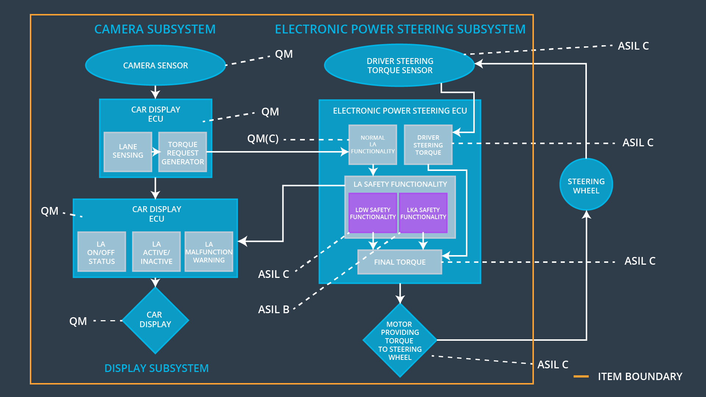

## Allocation of Functional Safety Requirements to Architecture Elements

|  |  |  |  |  |
| --- | --- | --- | --- | --- |
| **ID** | **Functional Safety Requirement** | **Electronic Power Steering ECU** | **Camera ECU** | **Car Display ECU** |
| Functional  Safety  Requirement  01-01 | The lane keeping item shall ensure that the lane departure oscillating torque amplitude is below Max_Torque_Amplitude. | **O** |  |  |
| Functional  Safety  Requirement  01-02 | The lane keeping item shall ensure that the lane departure oscillating torque frequency is below Max_Torque_Frequency. | **O** |  |  |
| Functional  Safety  Requirement  02-01 | The electronic power steering ECU shall ensure that the lane keeping assistance torque is applied for only Max_Duration. | **O** |  |  |

## Warning and Degradation Concept

|  |  |  |  |  |
| --- | --- | --- | --- | --- |
| **ID** | **Degradation Mode** | **Trigger for Degradation Mode** | **Safe State invoked?** | **Driver Warning** |
| WDC-01 | LDW is turned off and warning icon is displayed on the car display. | The LDW torque crosses Max_Torque_Amplitude or Max_Toque_ Frequency. | YES | Warning icon is displayed on the car display. |
| WDC-02 | LKA is turned off and warning icon is displayed on the car display. | LKA is activated longer than Max_Duration. | YES | Warning icon is displayed on the car display. |